Cairo University Faculty of Computers and Information



**CS352 – Software Engineering II**

**Phase 2 Template**

**2017**

**Project Team**

|  |  |  |  |
| --- | --- | --- | --- |
| **ID** | **Name** | **Email** | **Mobile** |
| 201040189 | Omar Mohamed Osman | omar\_13316@hotmail.com | 01008232911 |
| 20140106 | Khaled Taher | khaled@stud.fci-cu.edu.eg | 01113096654 |

**[Ragia Mohamed Aboulfadl]**

Contents

[Class diagram design 2](#_Toc481259747)

[Trello 8](#_Toc481259748)

[8](#_Toc481259749)

[Github repository link 8](#_Toc481259750)

# Class diagram design

User Subsystem

Course Subsystem

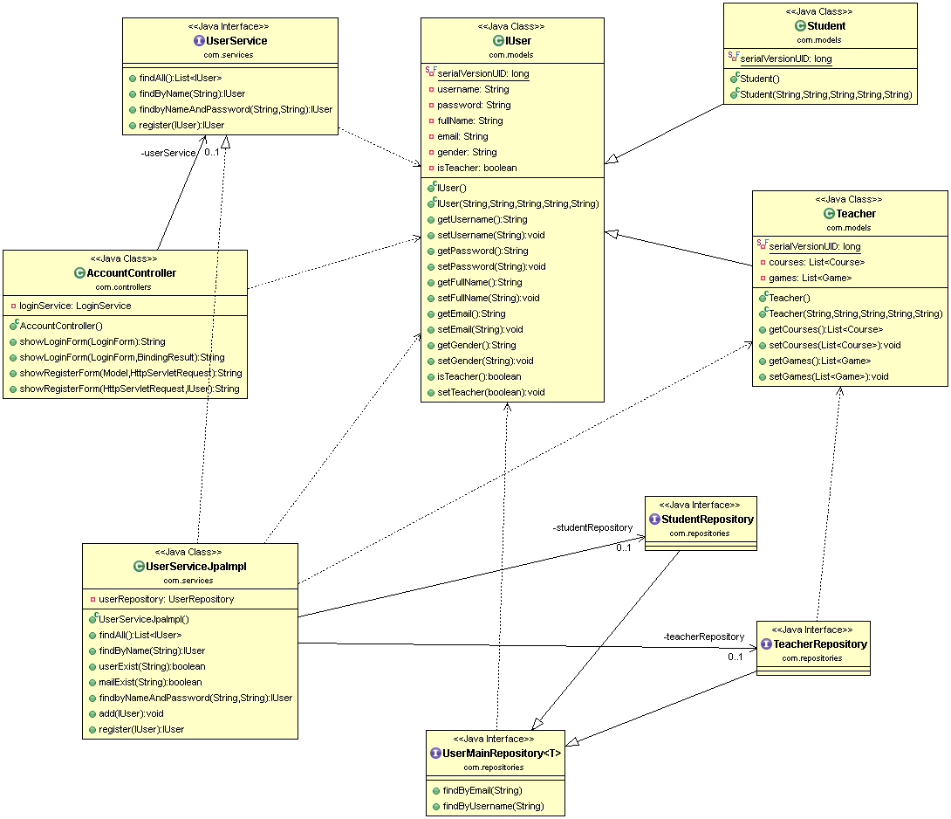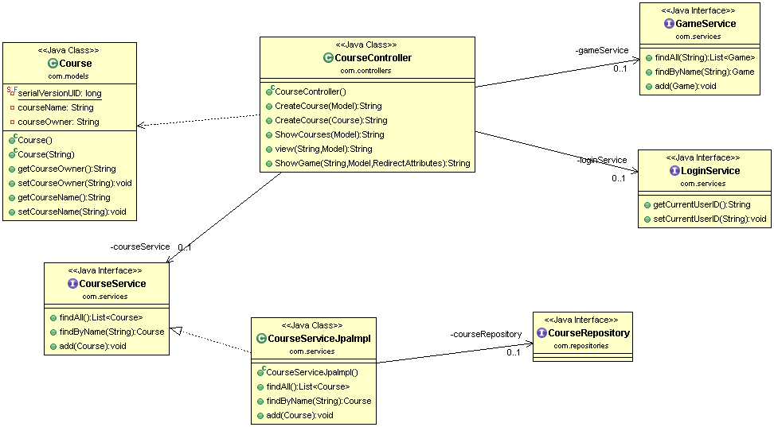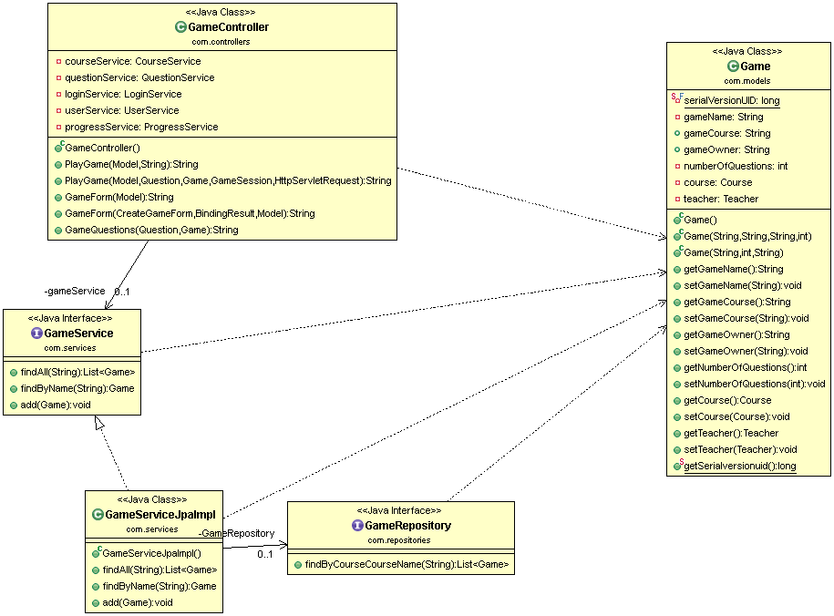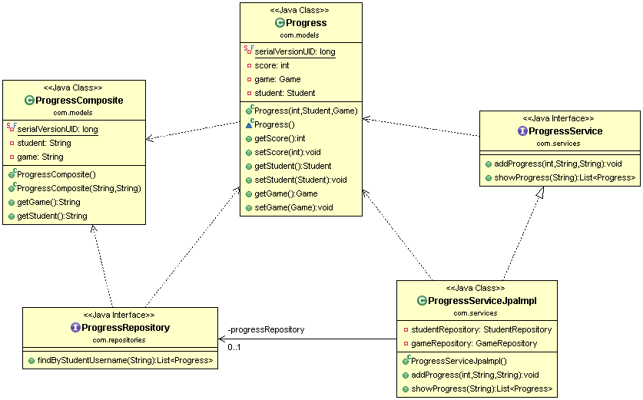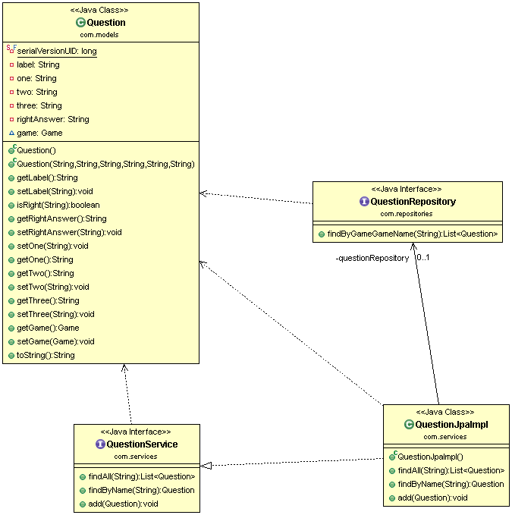

# Trello

# E:\Programming\git projects\SW2_Project\Phase2\Documents\Trello.png

# Github repository link

https://github.com/OmarOsman/SW2