

Department of Computer Science Institute for System Architecture, Chair for Computer Networks

# Internet and Web Applications

**Introduction**

Network enabled applications

### Internet applications

BitTorrent

(File distribution system)

…

Git

(Version management)

Subset of important

* applications,
* mechanisms,
* protocols and
* languages

that are associated

### Web applications

with these two categories will be

Web search engines

Web feeds

discussed in the lecture

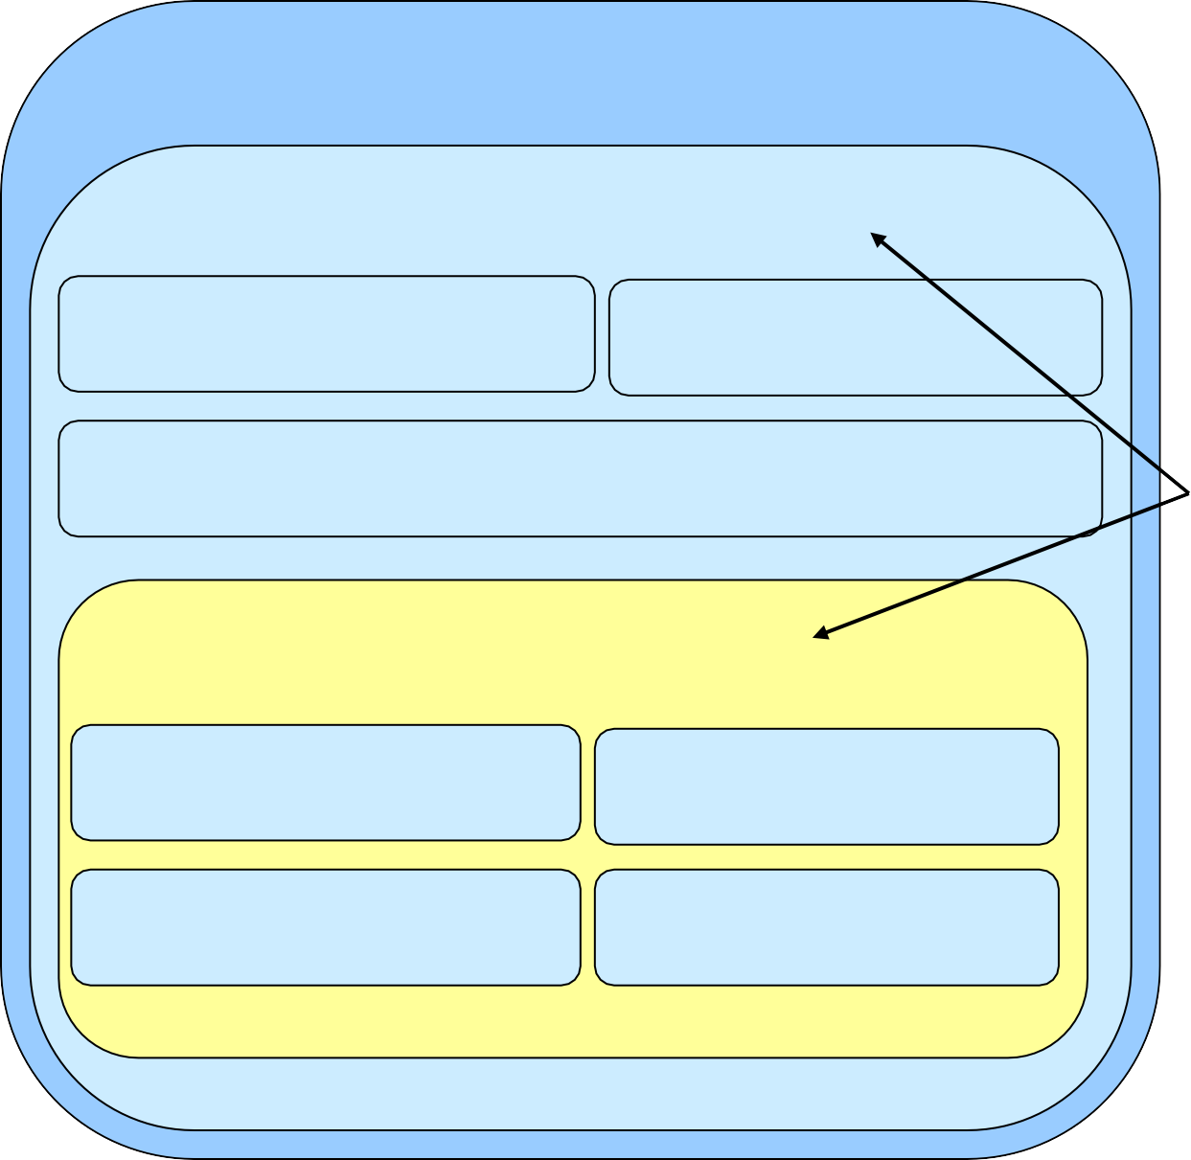

Weblogs …

1. Introduction
2. Basic aspects of Web applications
3. Interaction models in the World Wide Web
4. Extensible Stylesheet Language / Cascading Style Sheets
5. Semantic Web
6. Web Application Frameworks
7. Subscription Services
8. Web Crawling and Web Search
9. Content and File Management, Wikis 10.File Sharing
10. Load Balancing and Content Distribution
11. Business Models
    * The World Wide Web is a system of hypertext documents that are viewable by a web browser
    * Hypertext documents are documents with internal cross- references to other documents
    * Runs as service/application on top of the Internet protocols
    * Originally based on three fundamental mechanisms:

**Application protocol**

(Hypertext Transfer Protocol)

**Web**

**Document description format**

(Hypertext Markup Language (HTML))

**Document addressing mechanism**

(Uniform Resource Identifiers)

* + Web 2.0 is a **buzzword** for describing modern forms of applications and services that are accessible by the web browser such as wikis or weblogs
  + These applications often have a high social component and appealing user interfaces in common and are based on enhanced interaction models and new document representations discussed in this lecture

**Increasing importance**

**Application protocol**

(Hypertext Transfer Protocol)

**Protocol improvements Ajax**

**Comet / HTTP Streaming**

**Web Sockets**

**of client-side logic Social**

**New business**

### Web 2.0

**communities**

**models Social software**

**. . .**

**Document description format Document addressing mechanism**

(Uniform Resource Identifiers)

1. **HTML RSS Atom RDF HTML5 …**
   * Web 3.0 or the *Semantic Web* is a **vision** of *semantically*

interconnected data in the Web

* + While Web 2.0 has been a technological evolution, Web 3.0 is a conceptual evolution of the Web based on the enhanced technological environment
  + Focus is not set to documents but to **data** thus becoming

### Linked Data

* + Important formats are: RDF, RDFS, OWL (see chapter 5) as well as Microformats

*“I have a dream for the Web [in which computers] become capable of analyzing all the data on the Web – the content, links, and transactions between people and computers. A ‘Semantic Web’, which should make this possible, has yet to emerge, but when it does, the day-to-day mechanisms of trade, bureaucracy and our daily lives will be handled by machines talking to machines. The ‘intelligent agents’ people have touted for ages will finally materialize.”*

*(Tim Berners-Lee, inventor of the original World Wide Web in Weaving the Web* ISBN 0-7528-2090-7)



Department of Computer Science Institute for System Architecture, Chair for Computer Networks

# Basic knowledge

* + Extensible Markup Language (**XML**)
    - Language for describing, processing and exchanging data
  + Extensible Hypertext Markup Language (**XHTML**)
    - XML reformulation اعاده صياغه of HTML
  + XML validation languages
    - Document Type Definition (**DTD**)

### XML Schema

* + XML Processing Models
    - Document Object Model (**DOM**)
    - Simple API for XML (**SAX**)
  + Selected alternatives to XML
  + Mechanism for message content type description

### JavaScript

* + Cascading Style Sheets (**CSS**)
  + The Extensible Markup Language (XML) is a general purpose **meta-language** for representation, exchange and processing of data
  + Basis for many web related formats

Extensible Stylesheet language

(XSL)

Atom

Extensible Hypertext Markup Language (XHTML)

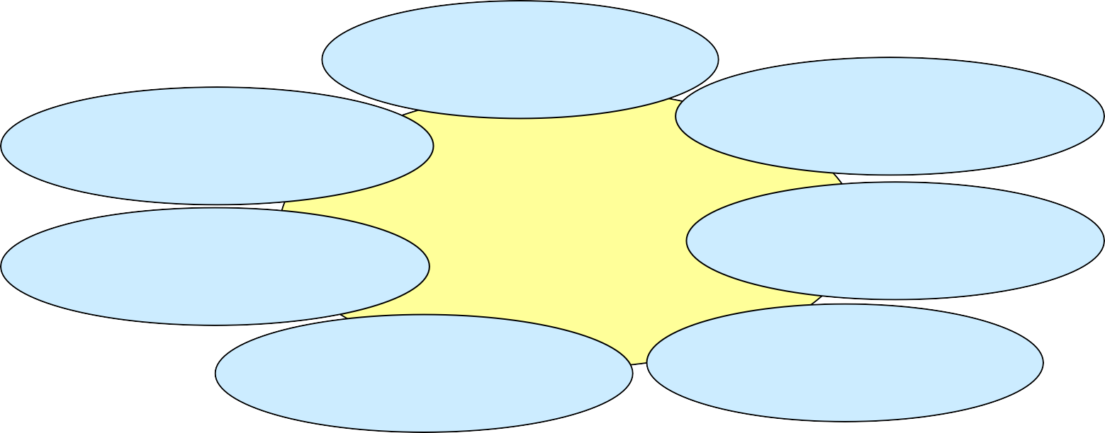**XML**

XML Serialization of the Resource Description Framework (RDF)

XML Schema

Really Simple

Syndication …

(RSS)

* + XML documents are organised in a simple tree structure with the documents’ elements as nodes
  + Every node might have content and parameters
  + An element’s content is one of
    - Empty content (no value)
    - Simple content (text values)
    - Element content (further “tags”)
    - Mixed content (simple and element content)

**Root** element

**Parent** element of “author”, “title”, “isbn”

book id=42

bookstock

book id=43

book id=44

**Element content**

author title

isbn …

**Child** element of node “bookstock”

Three **siblings**

(sister elements)

*text text text*

**Simple content**

**Parameter** “id” with value “44”

slide 10

XML terminology

Document’s character encoding (UTF-8, UTF-16, ISO-8859-1, …)



Attribute “id”

Attribute’s value “42”

**Start tag** of element “title”

**End tag** of element “book”

Comment

<?xml version="1.0" encoding="UTF-8"?>

<bookstock>

<book id="42">

<title>TCP/IP Illustrated</title>

<author>W.R. Stevens</author>

<isbn>0201633469</isbn>

</book>

<book id="43">

<title>Mobile Web Services</title>

<author>F. Hirsch</author>

<author>J. Kemp</author>

<isbn>0470015969</isbn>

</book>

…

</bookstock>

<!– End of document -->

XML declaration

Start of document’s root element

Start of child element of “bookstock”

Siblings

Parent of elements “title”, “author”, “isbn”

Element content of “book”

Simple content of “isbn” (text content)

* + Main important syntactical rules for XML data are:
    - Non-empty elements need to have a start tag and an end tag (<X>content</X>) - If an element is empty it can directly be delimited (<X/>)
    - Exactly one root element exists
    - All attribute values are quoted (single or double quotes)
    - Nested tags do not overlap (<X><Y></X></Y> is not allowed)
    - XML is case sensitive: <X></x> is incorrect
    - The XML tags, tag content etc. must comply to the given charset (default: UTF-8)
  + Syntactically correct XML documents are called **well- formed**
  + Different contributors might use the same element names to refer to different things
  + If such elements are mixed in one file **name conflicts** will occur

If a computer program should find all book titles and scans the XML file for “title” elements it assumes the data file’s title to be a book title

<datafile>

<author>Charlie Brown</author>

<title>Book list</title>

<bookstock>

<book>

<title>TCP/IP Illustrated</title>

<author>W.R. Stevens</author>

<isbn>0201633469</isbn>

<price>41,89</price>

</book>

</bookstock>

</datafile>

## XML namespaces

Imports namespace and binds it to prefix

<datafile xmlns:a="[http://www.example.com/doc/"](http://www.example.com/doc/) xmlns:b="[http://www.example.com/myNs/"](http://www.example.com/myNs/) >

<a:author>Charlie Brown</a:author>

<a:title>Book list</a:title>

<b:bookstock>

<b:book>

<b:title>TCP/IP Illustrated</b:title>

<b:author>W.R. Stevens</b:author>

<b:isbn>0201633469</b:isbn>

<b:price>41,89</b:price>

</b:book>

</b:bookstock>

</datafile>

No name conflicts occur because elements are bound to different namespaces

* + Name conflicts are solved by **XML namespaces** which are used to qualify elements and attributes by unique identifiers
  + These identifiers are web addresses that might point to non existing resources
  + A prefix can be associated with one namespace that is attached to all elements that belong to this namespace
  + Typically standardised XML dialects define a namespace that is imported by all documents using this dialect

slide 14

* + A **valid** XML document is related to and conforms to further information describing its structure and data types used therein
  + Two often used type definition languages are:

### Document Type Definition (DTD)

* + Defines a list of legal elements
  + Referenced from or embedded in related XML document
  + Main shortcoming:
    - Capabilities are limited (especially limited possibilities for type definitions)

Element “author” is child element of “book” and of type PCDATA

<!DOCTYPE note [

<!ELEMENT book (title,author,isbn)>

<!ELEMENT title (#PCDATA)>

<!ELEMENT author (#PCDATA)>

<!ELEMENT isbn (#PCDATA)>

]>

(simple character data)

### XML Schema

* + XML dialect that enables definition of various data types
  + Defines two categories of types:
    - Simple types (such as string, integer etc.)
    - Complex types (such as sequences of other types)

Element “book” contains child elements “title”, “author”, “isbn” which are all of type “string”

<?xml version="1.0" encoding="UTF-8"?>

<xs:schema xmlns:xs="<http://www.w3.org/2001/XMLSchema>" >

<xs:element name="book">

<xs:complexType>

<xs:sequence>

<xs:element name="title" type="xs:string"/>

<xs:element name="author" type="xs:string"/>

<xs:element name="isbn" type="xs:string"/>

</xs:sequence>

</xs:complexType>

</xs:element>

…

</xs:schema>

* + Besides HTML5 (discussed in chapter 2), one wide-spread application of XML is the Extensible Hypertext Markup Language (XHTML)
  + Its language constructs and thus its expressive power were deduced from HTML
  + High degree of standardisation and stricter syntax leads to further unification of browser engines
  + Use of XML for Hypertext documents makes processing by regular XML tools possible (e.g. for style definition or syntax validation)
  + Extensible by further XML languages such as MathML for embedding mathematic expressions into web documents
  + XHTML documents may be validated by a DTD
    - E.g. XHTML 1.1:

<http://www.w3.org/TR/xhtml11/DTD/xhtml11.dtd>

References to associated DTD

Defines default namespace

Empty elements are directly closed

<?xml version="1.0" encoding="UTF-8"?>

<!DOCTYPE html PUBLIC "-//W3C//DTD XHTML 1.1//EN"

"<http://www.w3.org/TR/xhtml11/DTD/xhtml11.dtd>">

<html xmlns="[http://www.w3.org/1999/xhtml"](http://www.w3.org/1999/xhtml) xml:lang="en">

<head>

<title>XHTML Example</title>

</head>

<body>

<h3>Available books</h3>

<br/>

<table>

<tr><td>Title</td><td>Author</td></tr>

<tr><td>TCP/IP Illustrated, Volume 1</td><td>W.R. Stevens</td></tr>

<tr><td>Mobile Web Services</td><td>F. Hirsch / J. Kemp</td></tr>

<tr><td>Hacking RSS and Atom</td><td>L.M. Orchard</td></tr>

</table>

</body>

</html>

* + The Document Object Model (DOM) is an application programming interface standardised by the W3C for accessing and manipulating XML documents
  + DOM interprets the document in its **logical tree structure** thus making it necessary to load a tree representation of the document into memory
  + It renders it possible to traverse through the tree or to directly access elements by an id

var elem = document.getElementById("42")

var child = elem.getElementsByTagName("author")[0] var secondChild = child.childNode

book id=42

bookstock

book id=43

book id=44

var value = secondChild.nodeValue

author title

isbn …

*text text text*

// Application (SAX handler excerpt) public void startDocument (){

System.out.println("Start document");

}

public void startElement (…){

…

}

public void characters (…){

…

}

public void endElement (…){

…

}

public void endDocument (){ System.out.println("End document");}

SAX Parser

<?xml version="1.0">

R

<bookstock> E

Text A

</bookstock> D

* The Simple API for XML is a **event-based** mechanism for XML processing
* Principle:

1. A program that e.g. is intended to extract information from an XML file registers event handlers at a SAX parser
2. The parser reads the XML document sequentially from the beginning to the end
3. Every time the parser reads an element, attribute, special character etc. it generates an event that is delegated to the associated event handler

Input document Event handler output

SAX

Start document

Start element: bookstock Characters: "\n"

Start element: book(Attributes:id=42;) Characters: "\n"

Start element: title

Characters: "TCP/IP Illustrated" End element: title

Characters: "\n" Start element: author

Characters: "W.R. Stevens" End element: author Characters: "\n"

Start element: isbn Characters: "0201633469" End element: isbn Characters: "\n"

End element: book Characters: "\n"

. . .

End element: bookstock End document

<?xml version="1.0"

encoding="UTF-8"?>

<bookstock>

<book id="42">

<title>TCP/IP Illustrated</title>

<author>W.R. Stevens</author>

<isbn>0201633469</isbn>

</book>

<book id="43">

<title>Mobile Web Services</title>

<author>F. Hirsch</author>

<author>J. Kemp</author>

<isbn>0470015969</isbn>

</book>

</bookstock>

* + Though XML is intensively applied, XML documents have a certain overhead and contain redundant information
  + Alternatives applied in Web applications include:
    - **JSON** (JavaScript Object Notation, discussed in chapter 3)
    - **YAML** (YAML Ain’t Markup Language)
      * Compact text-based and human readable data serilization format
      * Superset of JSON
      * Offers lists, associative arrays and scalars for structuring data
      * Enables cross-references between nodes
      * Hierarchies are realized by indentation

E.g. YAML list in block format

lectures:

* 'Internet and Web Applications'
* 'Distributed Systems'
* 'Mobile Communication and Computing'

Overview of interaction on the Web

* + The Web is based on a classical client-server architecture
  + Client fetches **documents** (addressed by an Uniform Resource Identifier) from the server using the Hypertext Transfer Protocol (HTTP)
  + Documents may have different types of content (text, images, …)
  + Content of one document may consist of different sections interpreted by the client such HTML CSS Javascript

1

Request document

Client (Web Browser)

Interpret document

|  |  |  |  |
| --- | --- | --- | --- |
| Web Server |  | | |
|  | XHTML Document  Displayed data  *(Text)*  Layout and Style  *(CSS)*  Program Logic  *(JavaScript)* |  |
|  | | |

 slide 23

2

* + In order to find an appropriate interpreter program for received content on the client side the content’s meta information specifies a content type (sometimes referred to as “media type” or “MIME type”)
  + Format:

### Content-Type ":" type "/" subtype

* + Examples:
* Content-Type: applicati on/xml *(for general XML content)*
* Content-Type: video/mpeg *(for MPEG encoded content)*
* Content-Type: image/jpeg *(for JPEG encoded content)*

Header part of received message

Message received by a client

…

Content-Type: application/xml Content-Length: 136713

…

***Content***



* + Client manages data structure that maps known content types to responsible applications
  + After the client has received a document it analyses the document’s content type information
  + If the client is not responsible for the type of content it looks up an appropriate application and initiates handling of the document by this application



3

Client (Web Browser)

// Client’s code fragment if(notResponsible){

document = response; format = response.getType();

program = database.lookup(format); application = start(program); application.delegateTo(document);

}

|  |  |  |
| --- | --- | --- |
| Server | Reque 1 ocument  st d | |
|  | Content-Type: text/plain  …  *Content* |
| 2 | |

|  |  |
| --- | --- |
| type | application |
| … | … |
| … | … |

* + JavaScript is an **object based** wide-spread script language (standardised under the name ‘ECMAScript’) often used for client-side execution
  + May be embedded into (X)HTML documents or linked from them
  + After the web browser has identified code segments it forwards them for execution to the JavaScript engine
  + The result of execution might influence the original document’s content or force an additional reaction (e.g. open new browser window)

Definition of function hello



<html>

<head>

*<script language="JavaScript" type="text/javascript"> function hello() { alert("Hello!"); }*

*</script>*

</head>

<body onLoad="hello()">

This is a simple JavaScript example.

</body>

</html>

result

JavaScript engine

When loading the page the function “hello” is called

* + Important security concept is the **sandbox principle** which permits script logic that is running inside the JavaScript engine access only to objects inside the browser per default

Web browser

direct access

…

Network resources

File system

JavaScript engine

* + Java Script is often used in combination with DOM leading to a dynamically changeable structure of an XHTML document

DOM-view of an XHTML

JavaScript code (DOM API)

document

* + Cascading Style Sheet language is a client-side language for defining layout of mark-up language elements
  + Simplifies uniform design and its maintenance of web pages
  + CSS description may be directly embedded into (X)HTML file or linked from it (e.g. <link rel="stylesheet" href="main.css">)
  + If style definitions are given as external file the layout of all associated (X)HTML pages can be changed by editing this single file

(X)HTML

page

(X)HTML

page

* + The CSS file contains a number of selectors

CSS

file

(X)HTML

page

(e.g. (X)HTML

tags or self defined names) whose properties are defined

* + These selectors refer to elements of (X)HTML files (e.g. to tag with specific name or attribute)

*Selector*

{

*property1*: *valuesX*; *property2: valuesY*;

…

}

main.css

input{ font-size: 110%; color: red; background: #ffff00; }

.top{ padding-top: 20px; } p{ font-size: 16pt;

font-family: "Garamond", serif; font-weight: bold; }

#fat { font-weight: bold; }

20

pixel

20

pixel

index.html

<head>…

<link rel="stylesheet" href="main.css">

</head>

<body>

<div class="top">

<img src="/banner.jpg"/>

</div>

<p class="top">

Welcome to the Samoa Webmailer Service!

</p>

<div id="fat">

Please enter mail address and password.</div>

<form method="post" action="login">

<input type="text" name="id"/><br/>

<input type="password" name="password"/>

<br/><input type="submit" value="login"/>

</form>

</body>

bold; Garamond as font bold

yellow (#ffff00) background; red font

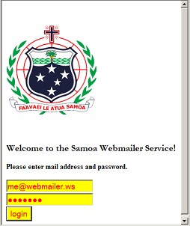

Links at World Wide Web Consortium (W3C):

XML home <http://www.w3.org/XML>

XML Schema home <http://www.w3.org/XML/Schema> XHTML 1.0 <http://www.w3.org/TR/xhtml1/>

XHTML 1.1 <http://www.w3.org/TR/xhtml11/>

HTML 5 <http://www.w3.org/TR/2014/REC-html5-20141028/>

DOM home <http://www.w3.org/DOM/> Further Links

YAML-Spezifikation <http://www.yaml.org/spec/1.2/spec.html> SAX home <http://www.saxproject.org/>

JavaScript https://developer.mozilla.org/en/About_JavaScript at mozilla.org

Article about Web 2.0 <http://oreilly.com/web2/archive/what-is-web-20.html>