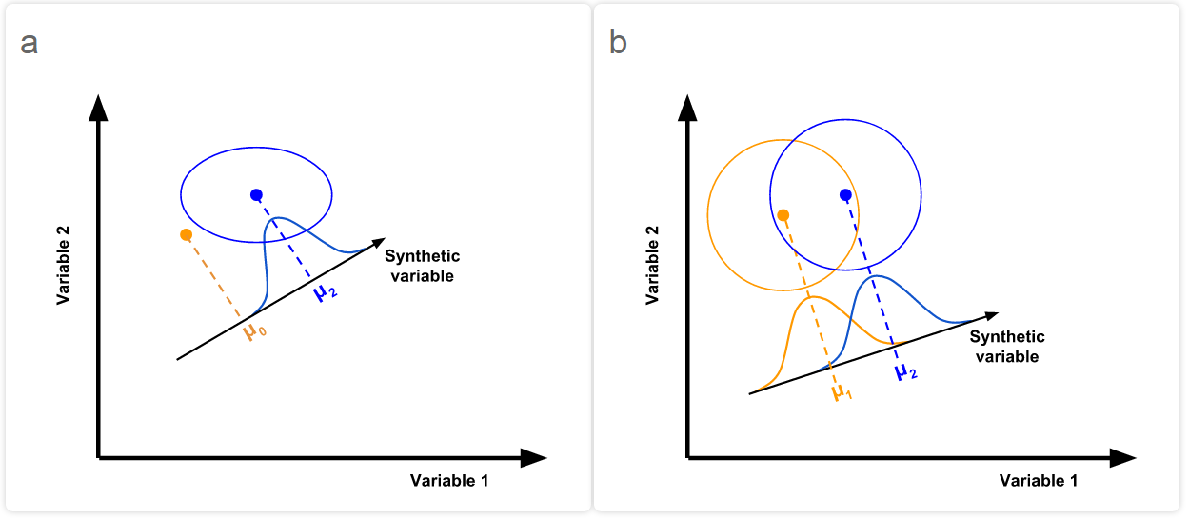

**Figure 1: Schematic illustrating the logic of a one- and two-way Hotelling's T2 test in a simple, two-dimensional space.** Linear combinations of the original variables are used to build a synthetic variable that best separates either a group from a hypothetical mean (μ0; a), or two groups of multivariate-normal data (b). In other words, the maximum possible T2 value is found. Points indicate multivariate means of each population and circles indicate multivariate dispersion. The significance of this separation may be tested by comparison of transformed T2 values to an F-distribution.