**Job Posting Report (Data Analysis using Power BI)**

**1. Project Introduction**

* **Project Overview:** This project focuses on analyzing job postings from Kaggle's dataset to understand job trends, types, skills required, and company insights in the U.S. tech sector.
* **Objectives:**
  1. Clean and preprocess the job posting data.
  2. Gain insights into job positions, seniority levels, and popular skills.
  3. Provide actionable insights for job seekers and businesses.
* **Target Audience:** Job seekers, companies, recruiters, and individuals interested in U.S. tech job trends and right final project to DEBI Power Bi track

**2. Scope of Work**

* **Data Sources:** Kaggle job posting dataset.
* **Data Domain:** Job titles, companies, countries, number of applicants, job location, skills, and job types.

**3. Analysis Methodology**

* **Analysis Tools:** Power BI, including Power Query for data transformation and DAX for calculation.
* **Data Cleaning Process:**
  1. **Change data types** where necessary for consistency.
  2. **Remove irrelevant columns** like "Job Title Additional Info" and "Job Skills" to focus on key data.
  3. **Handle missing values** in the "Number of Applicants" column by replacing null values with 0.
  4. **Create a new column** "Company Type" based on "Company Size," categorizing companies into 4 distinct types, and removing the original "Company Size" column.
  5. **Create a "Job Location State" column** by deriving it from "Job Location," and replace 'US' with 'Unknown' for more granularity.
  6. **Check and remove duplicates** to ensure data integrity.
  7. **Correct data errors** found during the preprocessing phase.
  8. **Remove rows with missing values** from the "Company Name" column (61 rows removed).
  9. **Add Job Status Column** based on Remote or On-Site workplace extracted from "Job Title Additional Info" column.
  10. **Extract three categories** "Startup, Medium-Sized and Large-Sized" out of Company Size field instead of categorizing them by the number of employees, "51-200 employees" for example.

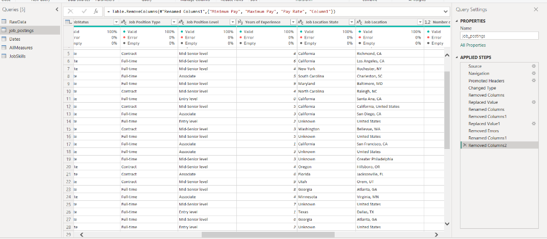

* **Date Table Creation:**
  1. A separate date table was created, with columns for quarters, months, and days, improving the accuracy of time-based analysis.
* **Job Skills Table:**
  1. **Create a new "Job Skills" table** to identify the most in-demand individual skills.
  2. **Clean the table** by retaining only the relevant "Job Skills" column.
  3. **Use the TRIM and CLEAN functions** to improve the text format.
  4. **Perform additional cleaning steps** to remove unwanted characters or text from the "Job Skills" column.
  5. **Split the "Job Skills" column by delimiter** to distinguish multiple skills listed together.
  6. **Remove blank rows** (2,210 rows) to ensure data quality.
* **Data Model:**
  1. Establish a **many-to-one relationship** between "Posting ID" and the main dataset.
  2. Implement relevant **measures** throughout the project to track key metrics.

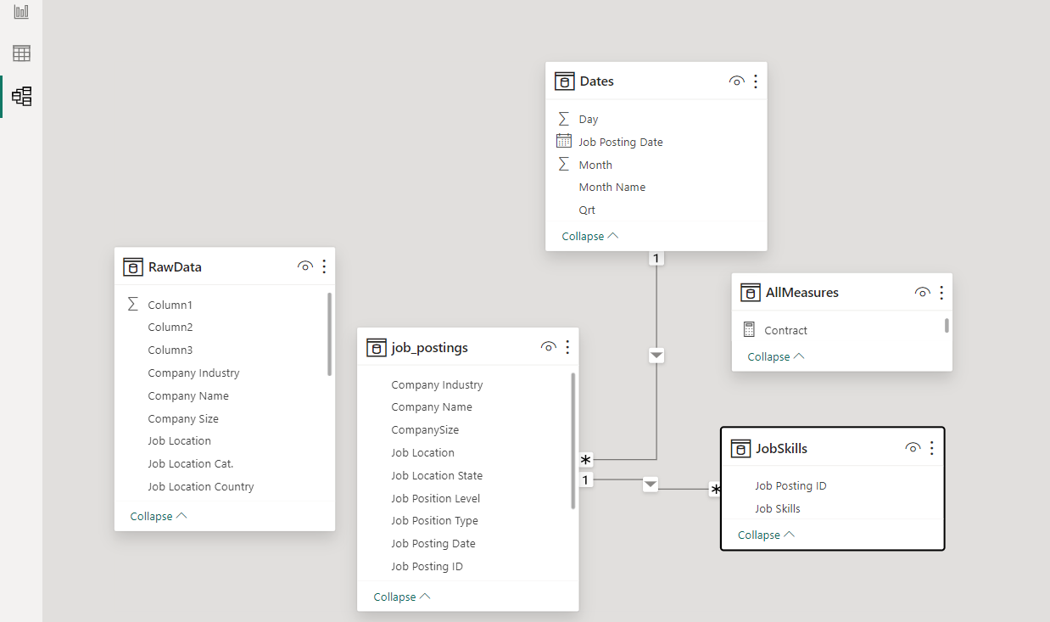

**4. Analysis Results**

* **Graphs and Visualizations:** Multiple Power BI visualizations were created, focusing on:
  1. **Total number of job postings** in the dataset.
  2. **Number of countries** represented by job postings.
  3. **Variety of job titles** in different sectors.
  4. **Total number of applications** across all job postings.
  5. **Breakdown of job positions** by type and seniority level.
  6. **Types of work** (e.g., remote, on-site).
  7. **Methods of salary payment** across jobs.
  8. **Breakdown of company types.**
  9. **Top 10 most in-demand skills** identified from the skills table.
* **Conclusions:** The analysis highlights key job trends in the U.S. tech field, with remote work being a growing trend and certain skills in high demand. The dataset also shows the variety of job types and the importance of company size in determining job postings.
* **Recommendations:** Job seekers should focus on developing the top 10 most required skills and pay attention to senior roles, while companies should cater to the growing demand for flexible work options.

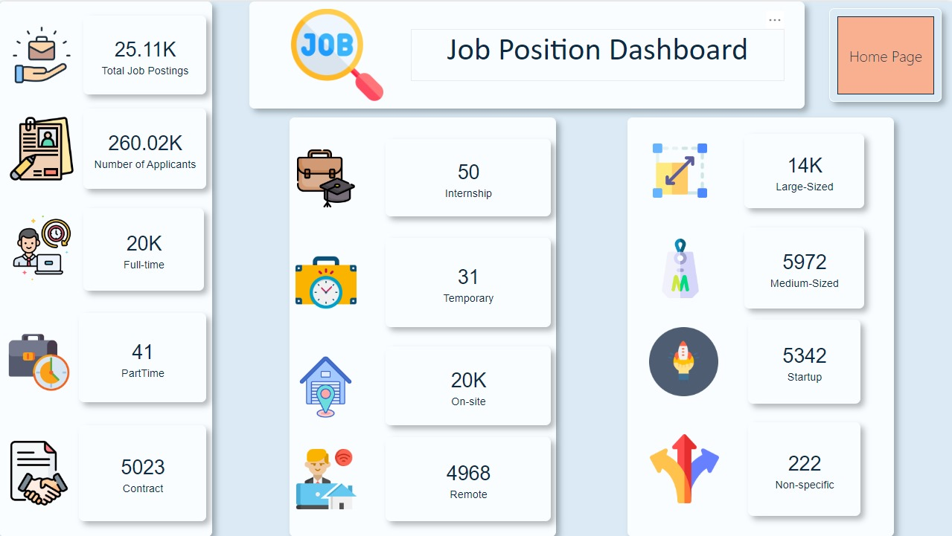

**5. Challenges and Solutions**

* **Challenges:** Handling missing data in key columns, such as "Number of Applicants," and managing large blank rows in the "Job Skills" table.
* **Solutions:** Null values were replaced appropriately, irrelevant columns removed, and text cleaning was performed rigorously on the "Job Skills" data.

**6. Project Future**

* **Next Steps:** Future analysis could expand to other industries beyond the U.S. tech sector, and job postings can be tracked over time for emerging trends.
* **Future Recommendations:** Continuously refine the data model and measures, incorporating more nuanced analysis of job levels, salary data, and specific technical skills.

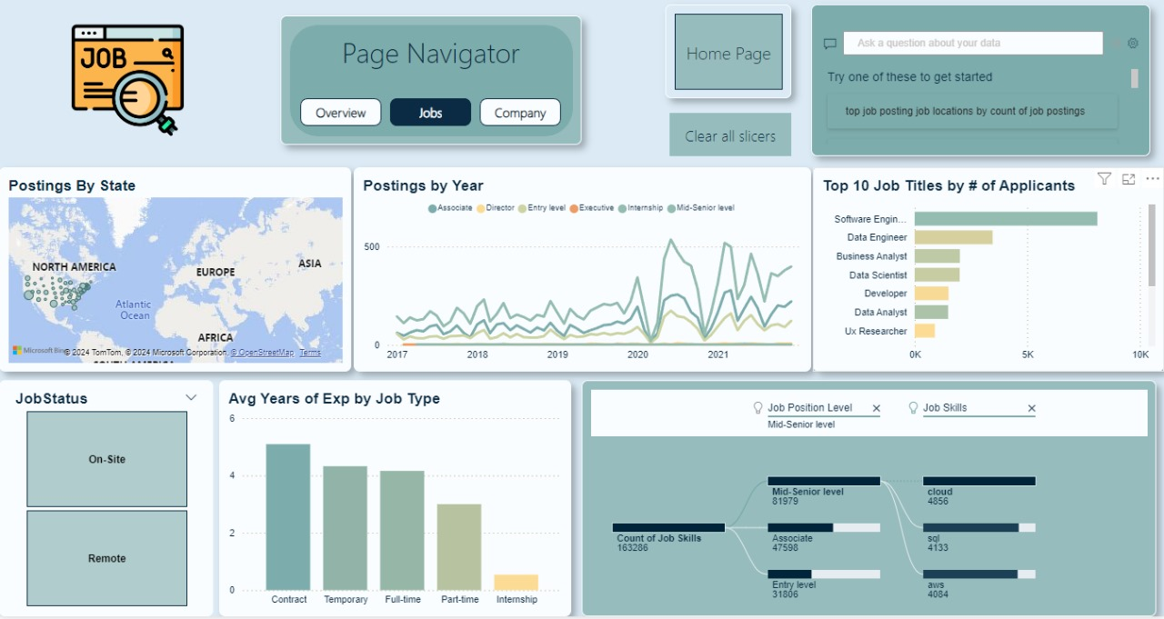

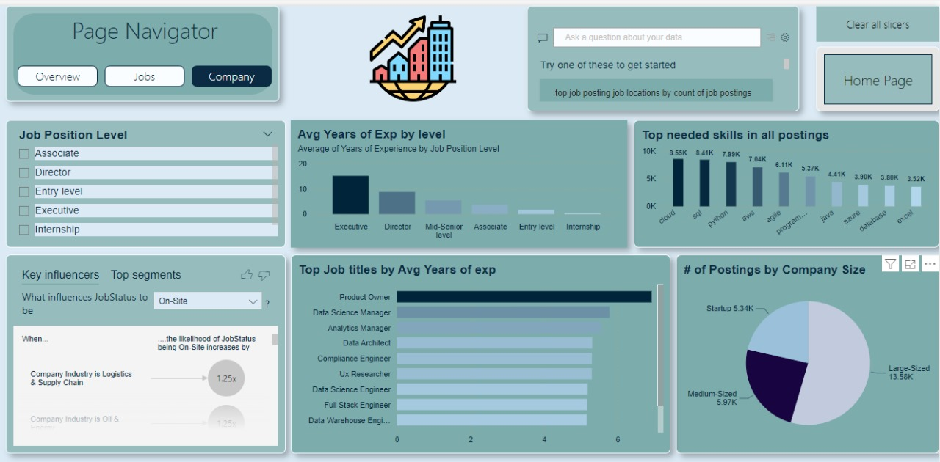

**7. Appendices and References**

* **Data References:** Kaggle job posting dataset.
* **Scientific References:** N/A for this analysis.
* **Appendices:** Additional documentation of Power BI steps or scripts can be included for reproducibility.

**8. Conclusion**

* **Summary:** This project provided comprehensive insights into job postings in the U.S. tech industry, focusing on trends in job types, skills, and company characteristics.
* **Acknowledgments:** Special thanks to Kaggle for the dataset and contributors who assisted in data preprocessing and model creation.

**Mission and Deeper Insights:**

1. **Types of Work in U.S. Tech Field:** The dataset offers insights into the balance between remote and on-site work, highlighting a significant shift towards remote jobs in tech.
2. **Senior and Expert-Level Roles:** Senior roles are in high demand, reflecting the industry's need for experience and specialized knowledge.
3. **Criteria for Senior Professionals:** To be considered a "Senior," one typically needs several years of experience and mastery in key technical areas.
4. **What’s Next for Seniors:** Senior professionals are encouraged to seek opportunities in large companies to gain experience before potentially starting their own businesses or taking on more leadership responsibilities.

**What can I do if I’m an owner company?**

From this data can help to understand the standard for other companies and the skills require globally

**If I’m a job seeker?**

You can utilize this to understand what the company is looking for and to gain this skills from courses or scholarships etc.

**if I’m a normal person looking for a business to launch**

You can provide courses regarding these skills