10/12/2022

Data Warehouse

Team [3]



1. **Bus Matrix:**

|  |  |  |  |  |  |  |  |  |
| --- | --- | --- | --- | --- | --- | --- | --- | --- |
| Facts\Dimensions | Flight | Passenger | Class | Date | Reservation channel | Fair base | Interaction | Stay type |
| Overnight | **✓** | **✓** |  | **✓** |  |  |  | **✓** |
| Reservation | **✓** | **✓** | **✓** | **✓** | **✓** | **✓** |  |  |
| Customer care | **✓** | **✓** |  | **✓** |  |  | **✓** |  |

1. **Logical Model**

**Note: This model has been built using drawsql (Web application)**

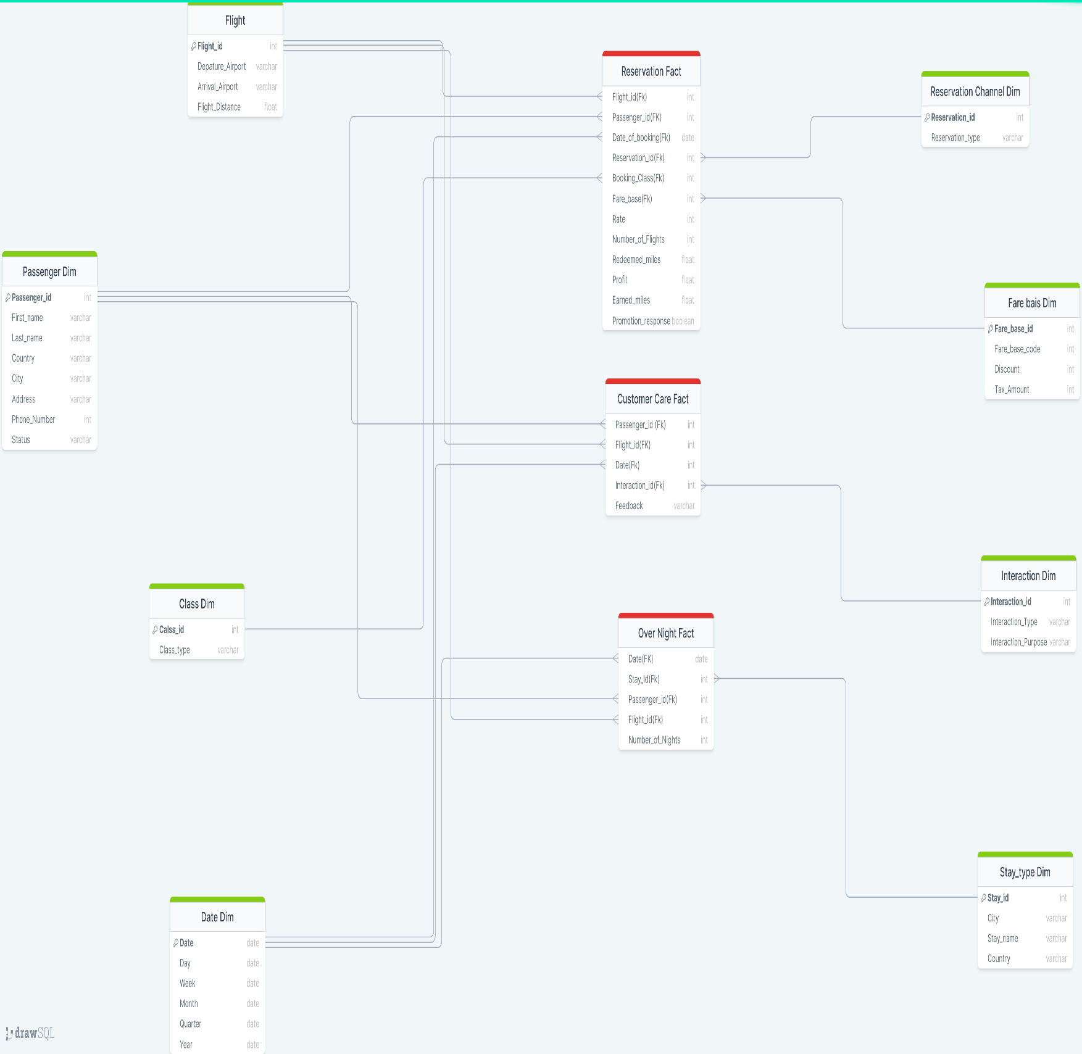 [**https://drawsql.app/teams/dwh-1/diagrams/dwh-2**](https://drawsql.app/teams/dwh-1/diagrams/dwh-2)

1. **More details about Logical Model**

* Business Case:

Analyze the current business processes and expand the company by discovering new opportunities

* Granularity:

Atomic per reservation

Daily

* Dimensions:

Flight_dim (#flight_id, departure_airport, arrival_airport, flight_distance)

Flight_dimension: is essential to describe all used fact tables

flight_id: acts as a primary key for the table

departure_airport: to describe the primary key attributes

arrival_airport: to describe the primary key attributes

flight_distance: is an important attribute in the case study

Passenger_dim (#passenger_id, first_name, last_name, country, city, address, phone_number, status)

Passenger_dim: to describe the main profitable unit in the business

Passenger_id: acts as a primary key

First_name:

Last_name:

Country: essential to make location analysis

City: essential to make location analysis

Address:

Phone_number: to be able to reach customer

Status: customer segmentation is one of the most important attributes regarding business analysis to help business and marketing campaigns

Class_dim (#class_id, class_type)

Class_id: acts as a primary key

Class_type: to describe which package the customer purchases

Date_dim (#Date_key, Date_A, year, month, week, day)

Date_dim: is used in all tables to be able to make timeline analysis and historical analysis

Date_key: acts as a primary key

Date_A: the real dates in the dataset

Year:

Month:

Week:

Day: satisfying the level of granularity

Reservation_channel_dim (#reservation_id, reservation_type)

Reservation_channel_dim: essential for investing and making offers

Reservation_id: acts as a primary key

Reservation_type: essential for financial team analysis

Fare_base_dim (#fare_base_id, fare_base_code, discount, tax_amount)

Fare_base_dim: its an international reservation classification

Fare_base_id: acts as a primary key

Fare_base_code: to show the type of reservation features and details

Discount: related to the fare base code

Tax_amount: also is known as per fare base code

Interaction_dim (#Interaction_id, interaction_type, interaction_purpose)

Interaction_dim: to describe the type of customer care service and improve the company services

Interaction_id: acts as a primary key

Interaction_type: (face to face, call center support, etc..)

Interaction_purpose: (complain, inquiry, etc….)

Stay_type_dim (#stay_id, city, stay_name, country)

Stay_type_dim: to make analysis on the company customers to explain a probable area of investment and business extension

City: location for analysis

Stay_name: the type of stay is very important for targeting a new business

Country: location for analysis

* Facts:

We found many different analysis areas; therefore, a lot of fact tables have been generated using **(Galaxy Schema)**

Reservation_fact:

**Profit**: one of the most important KPIs for the business success and very essential to evaluate different dimensions of business

**Number of flights**: to check the passengers flights quantity to widen the area of analysis

**Rate**: based on the case study the business gives a high priority to any type of feedback coming from his customer to improve his service

**Earned miles:** an essential measure to track the customer usage to improve customer loyalty

**Redeemed miles:** an essential measure to track the customer usage

**Promotion response**: the business needs to measure the success of the marketing campaigns

Customer_care_fact:

**Feedback**: the case gives a very high priority to the customer’s feedback to enhance the business so creation of a measure for the feedback is not a choice

Over_night_fact:

**Number of overnights**: In order to widen the area of investment, the overnights is very essential measure analyze and generate new opportunities

1. **Logical data model to physical data model (Done)**
2. **& 6- SQL Queries**

* select sum(profit), reservation_type

from reservation_channel_dim , reservation_fact

where reservation_channel_dim.reservation_id = reservation_fact.reservation_id

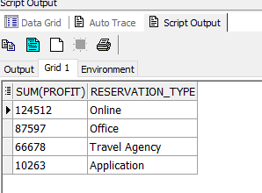group by reservation_type;

* select year, quarter, sum(profit)

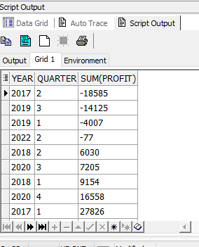from reservation_fact, date_dim

where reservation_fact.date_of_booking = date_dim.date_key

group by year, quarter

order by sum (profit);

* select fare_base_code, avg(profit), sum(tax_amount)

from reservation_fact, fare_bais_dim

where reservation_fact.fare_base = fare_bais_dim.fare_base_id

group by fare_base_code;

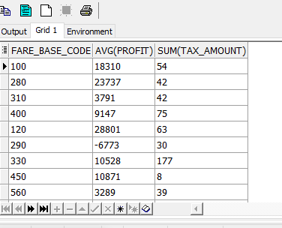

* select status, count(status) as "Total status"

from passenger_dim

group by status

order by count(status);

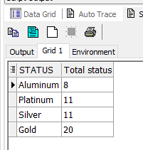

* SELECT onf.number_of_nights, onf.flight_id, std.country, dd.year

FROM stay_type_dim std, over_night_fact onf, date_dim dd

WHERE std.stay_id = onf.stay_id

AND onf.date_key = dd.date_key

ORDER BY onf.number_of_nights;

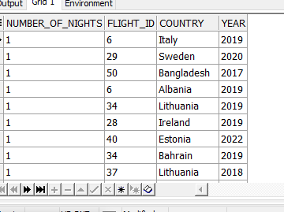

Thank You

Ali Mostafa

Hassan Essam

Khaled Magdy

Mazen Magdy

Mohannad Riffat