**A**

**PROJECT REPORT**

**ON**

**Development of “BUS TICKET MANAGEMENT SYSTEM” for TT Bus Paribahan**

**Prepared** **By**

Team Number: 07

Team Name: Leaf

Sec: E

|  |  |
| --- | --- |
| ID | Name |
| 17103212 | Md Khaledul Islam |
| 17103263 | Afsana Akter Lija |
| 17103272 | Md. Abir Hasan |
| 17203106 | Mohammad Iqbal Hossain |

In partial fulfillment of the requirements for the award of Bachelor of Computer Science in Computer Science and Engineering



**Department of Bachelor of Science in Computer Science and Engineering**

College of Engineering and Technology

**IUBAT—International University of Business Agriculture and Technology**

Dhaka, Bangladesh

**Fall 2019**

**A**

**PROJECT REPORT**

**ON**

**BUS TICKET MANAGEMENT SYSTEM**

# Letter of Transmittal

1st December 2019

The Chair

Defense Committee

Department of Computer Science and Engineering

IUBAT–International University of Business Agriculture and Technology

4 Embankment Drive Road, Sector 10, Uttara Model Town

Dhaka 1230, Bangladesh

Subject: Letter of Transmittal.

Dear Sir,

It is my pleasure to submit here with my dissertation, which has been prepared under the sound and dynamic leadership of a personality like you.

This paper is about “Bus Ticket Management System”. I have tried my level best to collect the relative information as possible in preparing the report. During preparation of the report I have experienced practically a lot that will help me a great in my career. It has enlightened my practical knowledge regarding the dividend and its impact on stock price. I will be able to explain anything for more clarification if necessary.

I would like to thank you, for giving me the opportunity to do a report on the above mentioned topic.

Yours sincerely,

Md Khaledul Islam

On behalf of Group :07

# Letter of Authorization

Date: 1st December, 2019

Md.Khaledul Islam

ID#17103212

On behalf of Group:07

Dear

I hereby authorized you to develop “Bus Ticket Management System” to fulfil the requirement of the project of course CSC 387 to complete this course.

I wish you complete the project successfully as the part of the completion of the course.

………………………………

M.M. Rakibul Hasan

Lecturer, Department of CSE, IUBAT

# Student’s Declaration

This is to certify that the work presented in this paper titled, **“**Bus Ticket Management System**”**, is the outcome of the investigation and research carried out by the following students under the supervision of M.M Rakibul Hasan, Faculty, Department of Computer Science and Engineering, International University of Business Agriculture and Technology.

MdKhaledulIslam

ID:17103212

On Behalf of Group: 07

# Acknowledgement

At first, we would like to thank Almighty for His blessing. Without His concern nothing can be possible.

We would like to express our heartiest gratitude to our honorable supervisor, M.M Rakibul Hasan, Faculty, Department of Computer Science and Engineering, International University of Business Agriculture and Technology, for his guidance, encouragement, motivation and support to prepare this paper by spending his valuable time to review and evaluate this paper.

We are very grateful to the Department of Computer Science and Engineering (CSE) of IUBAT—International University of Business Agriculture and Technology for providing their all-out support during the work. Especially we would like to thank to our Chair Prof Dr. Md. Abdul Haque, Department of Computer Science and Engineering and Coordinator Dr. Utpal Kanti das, Department of Computer Science and Engineering.

Finally, we express our gratitude to our parents and classmates for always being motivating and supportive.

Dhaka

November 2019

Group No: 07

# Supervisor’s Declaration

This paper titled **“**Bus Ticket Management System**”** submitted by the group as mentioned below has been accepted as satisfactory in partial fulfillment of the requirement for the degree of Bachelor of Science in Computer Science and Engineering in December 2019.

Group Name: Leaf

Group Number: 07

ID Name

17103212 Md Khaledul Islam

17103263 Afsana Akter Lija

17103052 Md. Abir Hasan

17203106 Mohammad Iqbal Hossain

Supervisor:

M.M Rakibul Hasan

Faculty

Department of Computer Science and Engineering

International University of Business Agriculture and Technology

# Abstract

This project addresses the study and development of an Online Bus Ticketing System web portal to enable users, both the bus operators and the customers to make an online bus ticket sale/ purchase and act as an operation tool for bus operators to operate their organization effectively. Traditionally, bus ticket purchase has been over the counter in bus terminals, however, today it has evolved with the rapid expansion of e-commerce. Thus, prior to developing the system, this research critically assesses and study the reason behind the evolution and the current e-ticketing systems. This project also addresses the problems faced by customers and bus operators especially on illegal bus operators, long wait to purchase a bus ticket, unsafe environment and many more. The research studies some issues on implementation and also recommendations on how Online Bus Ticketing System web portal can take place effectively. This research recommends on a star ranking system based on monthly sales, bus operator popularity and law traffic offences. This research also recommends a Decision Support System to deal with the customer’s requirement whereby it provides reliable choices to a customer to make decision. This research includes the development of a prototype Online Bus Ticketing System web portal to support the research objective. This web portal will assist in future development that would support a fully integrated system that links bus operators to customers, bus operators to bus operators, bus operators to other mode of transport providers, bus operator to businesses and bus operators to government agencies.

# Table of Contents

Letter of Transmittal 3

Letter of Authorization 4

Student’s Declaration 5

Acknowledgement 6

Supervisor’s Declaration 7

Abstract 8

Table of Contents 9

List of Figures 12

List of Tables 13

Chapter 01: Organization Part 14

1.1 Organization Vision 14

1.2 Organization Mission **Error! Bookmark not defined.**

Chapter 02: Project Introduction 15

2.1 Introduction 15

2.2 Background of Study 15

2.3 Problem Statements 15

2.4 Proposed Solution 16

2.5 Objectives 16

2.5.1. Broad Objectives 16

2.5.2 Specific Objective 16

2.5.3 Prototyping 17

2.6 Project Justification 18

2.7 Project Scope 18

2.8 Project Limitations: 18

2.9 Process model 18

2.9.1 Iterative Process Model 18

2.9.2. Advantages of Iterative Process Model 19

2.10 Feasibility Study 20

2.10.1 Social operational feasibility 20

2. 10.2 Legal feasibility 20

2. 10.3 Economic feasibility 20

2. 10.4 Technical feasibility 21

2. 10.5 Schedule feasibility 21

2. 10.6 Operational feasibility 21

Chapter 3 - Requirement Engineering 22

3.1 Requirement Analysis 22

3.1.1. Hardware Requirements 22

3.1.2. Software Requirements 22

3.2 Cost Estimation 22

3.2.1 Hardware Cost 22

3.2.2. 22

Software Cost 22

3.2 Requirements Engineering 22

3.2.1 User Requirements 22

3.2.2 System Requirements 23

3.2.3 Functional Requirements 23

3.2.4 Non-Functional Requirements 24

3.2.5 Domain requirements 24

3.2.5 Database requirements 24

3.3 System Modelling 25

3.3.1 Data Flow Diagram 25

3.3.2 Use Case Symbol 26

3.3.3 Use Case Diagram 27

Chapter 4 - System Planning 28

4.1 Project planning objectives 28

4.2 Process Based Estimation 28

4.2.1 Project Schedule 29

4.2.2 Project Schedule Chart / PERT Diagram 30

Chapter 5 - Risk Management 31

5.1 Risk Engineering 31

5.2 The RMMM Plan 32

Chapter 6 - System Analysis 39

6.1 Analysis Principles 39

6.1.1 The Information Domain 39

6.1.2 Modeling 41

6.1.2 Partitioning (Divide) 41

Chapter 7 – System Design and Implementation 43

7.1 Introduction 43

7.2 System Functional Design 43

7.2.1 Structure Design 43

7.3 Data Flow Diagram 45

7.3.1 DFD of project 47

7.4 Database Design 47

7.4.1 Data Dictionary 47

7.5.1 Entity Relationship Model 53

Chapter 8 - Quality Assurance 54

8.1 Introduction 54

8.2 Testing 54

8.2.1 Unit Testing 54

8.2.2 Integration Testing 57

8.2.3 Acceptance Testing 57

8.3 Conclusion 59

Chapter 9 – Conclusion 60

9.1 Introduction 60

9.2 Outcomes of the research 60

9.3 Limitations of the research 61

9.4 Future work of the research 61

9.5 Conclusion 62

Bibliography 63

Contribution Table 67

# List of Figures

Figure 1 Diagram of Iterative process model 19

Figure 2 data flow diagram for current system 25

Figure 3 Diagram of use case symbols 26

Figure 4 Diagram of use case 27

Figure 5 Project Scheduling Gantt Chart 29

Figure 6 PERT Diagram for Bus Ticket Management System 30

Figure 7 Information Flow of transformation 40

Figure 8 Horizontal Partitioning 42

Figure 9 Vertical Partitioning 42

Figure 10 Structure Design of Bus Ticket Management System(main) 43

Figure 11 Structure Design of Bus Ticket Management System(Administrator Section) 44

Figure 12 Structure Design of Bus Ticket Management System (Authority Module) 44

Figure 13 Structure Design of Bus Ticket Management System (Customer Module) 45

Figure 14 Data Flow Diagram 46

Figure 15 DFD of project 47

Figure 16 Entity Relationship Model 53

Figure 17 Rating for Feature 57

Figure 18 Familiarity of Usage 58

Figure 19 Helpful In daily operations 59

# List of Tables

|  |
| --- |
| Table 1 Hardware Cost 22  Table 2 Software Cost 22  Table 3 Project Risk(PR01) 32  Table 4 Project Risk(PR02) 33  Table 5 Project Risk(PR03) 33  Table 6 Technical Risks(TR01) 34  Table 7 Technical Risks(TR02) 35  Table 8 Technical Risks(TR03) 36  Table 9 Business Risk(BR01) 37  Table 10 Business Risk(BR02) 37  Table 11 Business Risk(BR03) 38  Table 12 Table Name: Schedule 47  Table 13 Table Name: Seats Status 48  Table 14 Table Name: Admin 48  Table 15 Table Name: Authority 49  Table 16Table Name: Ranking 49  Table 17 Table Name: FAQs 49  Table 18 Table Name: Feedback 49  Table 19 Table Name: Forum 49  Table 20 .Table Name: News 50  Table 21 Table Name: Places 50  Table 22 Table Name: Polling 50  Table 23 Table Name: Replyfeedback 50  Table 24 Table Name: Status 50  Table 25 Table Name: Serviceprovider 51  Table 26 Table Name: Staff 51  Table 27 Table Name: Summonses 51  Table 28 Table Name: Member 52  Table 29 Table Name: Sales 52  Table 30 Unit Testing for Administrator login module 55 |

# Chapter 01: Organization Part

## Organization Overview

TT Bus Paribahan is known for its higher quality bus service and a good number of quality driver. The company was established in 2002 for the requirement of quality bus among the country.

## 1.2 Mission Statement

To improve our customer’s lives and our community through passenger transportation services.

## 1.3 Vision for our Customers

Make travel convenient, enjoyable and beneficial for all who use our services by exceeding our customers’ expectations and enabling them to achieve their travel and transportation goals.

## 1.4 Vision for our Workforce

To make it enjoyable and rewarding to do our daily work by working with the best people in the industry and having them compensated as such. To have each individual’s ability to contribute limited only by their desire to contribute.

# Chapter 02: Project Introduction

## 2.1 Introduction

Our project is to computerize traveling company to manage data, so that all the transactions become fast and there should not be any error in transaction like calculation mistake, bill generation and other things. It replaces all the paper work. It keeps records of all bills also, giving to ensure 100% successful implementation of the computerized Bus reservation system. Our reservation system has three modules. First module helps the customer to enquire the availability of seats in a particular bus at particular date. Second module helps him to reserve a ticket. Using third module he can cancel a reserved ticket.

## 2.2 Background of Study

This chapter aims to describe the project background, problem statement, objectives, scopes, project significance and expected output of the system. The system is Bus Ticket Booking System. This is the project on the online ticketing system of modern coast bus company, which in most cases; the company has problems with their ticketing and scheduling process. This project intends to computerize its semi computerized ticketing system to provide better customer service. Because of that, the company can provide the easier way of travelling to the customer or passenger. Electronic tickets, or e-tickets, give evidence that their holders have permission to enter a place of entertainment, use a means of transportation, or have access to some Internet services. Bus Ticket Reservation System enables the bus company's customer to buy bus ticket online-ticket is the easiest and quickest way to take bus. The online system is a new system because it’s just getting roots in bus company globally and even in Kenya. Currently, staff at the bus ticket counter is using an internal system to sell ticket at the counter. Customer is unable to buy bus ticket online at this moment and has to go to the counter to buy bus ticket. Sometimes, customer needs to queue up a long queue to buy bus ticket and ask for information. Besides that, customer also not allows buying bus ticket through telephone and Transnational’s telephone line is always busy. This brings a lot of inconvenience to the customers.

Online Bus Ticket Reservation System enables the customer to buy bus ticket, make payment, cancel reservation and ask for information online easily. Furthermore, staff can sell bus ticket using Bus Ticket Reservation System after check bus ticket availability for the customer and print the bus ticket to the customer that queue up in the counter.

## 2.3 Problem Statements

The System that is being used by the staff at the counter currently is an internal system and just used to sell the bus ticket at the counter. Customer has to go to the counter to buy bus ticket or ask for bus schedule. Furthermore, customers need to pay cash when they buy the bus ticket and sometimes needs to queue up long time to get the bus ticket. Besides that, customer also not allowed to buy bus ticket through telephone and the bus company's telephone has been always-busy line.

## 2.4 Proposed Solution

The solution to this problem is to create an online portal for buying bus ticket system. Customer can buy the bus ticket over the Internet, 24 hours a day, 7 days a week and the bus ticket can't be lost, stolen or left behind.

In addition, the online system lets the customers check the availability of the bus ticket before they buy bus ticket.

## 2.5 Objectives

The main objectives of the online system include:

•To provide a web-based bus ticket buying functions. Customer can buy bus ticket through the online system and no need to queue up to buy bus ticket at the counter.

•To enable customer to check the availability of the bus ticket online. Customer can check the time departure and arrival for every Transnational’s bus through the system.

•To ease the bus ticket payment by online. Customer has to pay the bus ticket by online

•To reduce the number of staff at the point of sale. The number of staff at the counter can be reduced after the online buying bus ticket system launch.

### 2.5.1. Broad Objectives

The broad objective of this project is to develop a software to maintain the track records of sells info, staff info, monthly sells info, report and other related issues.

### 2.5.2 Specific Objective

1. To design and develop a web-based bus reservation management system for the admin staff of TT Express

2. To design and develop a functional mobile application of bus ticket reservation system for TT Express

3. To test the systems developed in objective 1 and 2 at end user premise.

### 2.5.3 Prototyping

A prototype can effectively provide the users a look-and-feel and convey a sense of how the system will work. The software application comprises of 10 forms, 1 module and 6 data reports. The functions used in this application are discussed below:

Form 1. Loading Form: This is the first form of our software in which the application is loading. This loading is shown by progress bar.

Form 2. Login Form: This form allows any user in logon to the software only if he/she has a correct password. This software is password protected.

Form 3. Current Booking: This form is used to reserve the seat on the present day at which bus is traveling. Only essential fields are included in this form like seat number, destination and time.

Form 4. Advance Booking: This form is used to reserved seats in advance. It includes all essential fields required in this form like name, age, address, contact number of the passenger, seat number, departure time, day of traveling, category, destination and amount.

Form 5. Cancellation Form: This form is used to cancel the reserved seat. The input to this form is only the ticket number, once it is entering the whole entry is displayed from the database.

Form 6. Seat Status: This form displays the reserved seats for a particular bus at particular destination. What kind of seat is available (general, window or front) it displays all properties?

Form 7. Enquiry: This form enquires about the route to the destination, fare to be paid for the destination and categories of bus available for the destination.

Form 8. Cancel List: This form consists of a calendar to display the list of the cancel tickets. The date selected in the calendar displays all entries for that particular date.

Form 9. Reservation Report: This form also consists a calendar to display list of those passenger who have reserved seats on that particular date.

Form 10. Current Report: This form displays the list of those passenger who have reserved seat on that particular day.

Data Report 1. Bus list is a chart that displays a list of all buses having fields name as bus_id, source, destination, time, category, amount, kilometers and bypass.

Data Report 2. Reservation is the list of those passengers who have reserved seats and this list is displayed according to the date mentioned in the query.

Data Report 3. Current booking is the list of those passengers who have reserved seats on the day of traveling.

Data Report 4. Cancellation is the list of those passengers who have cancelled their tickets and list is displayed according to the date mentioned in the query

## 2.6 Project Justification

As mentioned in the previous section, the online system is just getting its roots in the country’s transport system. It is very important to company's customer, Bus Company and all. It is important to customer because customer can check availability of the bus ticket, buy bus ticket, cancel bus ticket and pay the bus ticket online. E-ticket is different with traditional paper ticket because e-ticket is safer, faster, reliable and cheaper. Besides that, this concept can be used by others bus company so that their customers will be satisfied. The profit for the bus company will be increased because the online system will attract more customers and no need to hire many staffs at the counter to sell bus ticket because ticket can be sold efficiency online. Furthermore, the owner can schedule bus roots based on the margin returns. This is done through bus performance comparison. The factors of comparison in this module include but not limited to: the route, operational costs in a particular route and the number of breakdowns per bus

## **2.7 Project Scope**

The system is web based application. The users will gain access to the available buses per certain route and available seats by logging in through the customer’s portal.

The staff will access the system by logging in via the staff portal where they can compare bus performance and monitor other related business performance issues.

## **2.8 Project Limitations:**

* Payment gateway: Online payment gateway is not added yet.
* User acceptance: some members of the staff may not be of the opinion that the counter system be made online for the fear that this may lead to loss of job.
* Computer literacy level: the intended customers may not possess the relevant ICT skills. to benefit from the proposed system. This may cause the company to some costs by offering to train their customers.
* Limited system testing: improper unit and system testing may pose some usability issues such as delays in some modules.

## **2.9 Process model**

### 2.9.1 Iterative Process Model

For this project we have used Iterative process model. In Iterative model, iterative process starts with a simple implementation of a small set of the software requirements and iteratively enhances the evolving versions until the complete system is implemented and ready to be deployed. The basic idea behind this method is to develop a system through repeated cycles (iterative) and in smaller portions at a time (incremental).

The Feature of Iterative Process Model

❖ Requirements of the complete system are clearly defined and understood.

❖ Major requirements must be defined; however, some functionalities or requested enhancements may evolve with time.

❖ There are some high risk features and goals which may change in the future.

❖ Better suited for large and mission-critical projects.

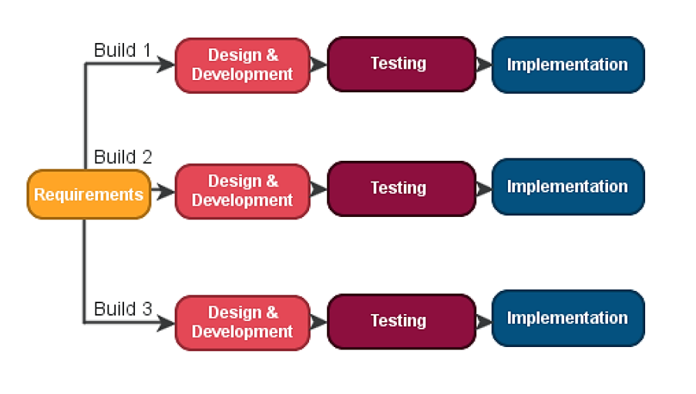

Figure 1 Diagram of Iterative process model

### 2.9.2. Advantages of Iterative Process Model

❖ Some working functionality can be developed quickly and early in the life cycle.

❖ Results are obtained early and periodically.

❖ Parallel development can be planned.

❖ Progress can be measured.

❖ Easier to manage risk.

## 2**.10 Feasibility Study**

The feasibility study was intended to examine the current system and determine whether there was need for a new system to replace it or not. It tended to check whether the current system was viable. Basically, this was meant to analyze the feasibility of a new system through cost-benefit analysis. It included: Legal feasibility, operational feasibility, economic feasibility, technical feasibility and schedule feasibility.

### 2.10.1 Social operational feasibility

This is a measure of how well a proposed system solves the problems, and takes advantage of the opportunities identified during scope definition and how it satisfies the requirements identified in the requirements analysis phase of system development. It dealt with the effect of the system on the current society within the company.

The operational feasibility assessment focused on the degree to which the proposed development projects fitted in with the existing business environment and objectives with regard to development schedule, delivery date, corporate culture, and existing business processes.

To ensure success, desired operational outcomes were imparted during design and development. These included such design-dependent parameters such as reliability, maintainability, supportability, usability, predictability, disposability, sustainability, affordability and others. These parameters were considered at the early stages of design where desired operational behaviors ere to be realized. A system design and development required appropriate and timely application of engineering and management efforts to meet the previously mentioned parameters. A system may serve its intended purpose most effectively when its technical and operating characteristics are engineered into the design. Therefore, operational feasibility is a critical aspect of systems engineering that needed to be an integral part of the early design phase. The Modern coast bus ticket booking system solutions was found reliable and adaptable therefore making it operationally feasible.

### 2. 10.2 Legal feasibility

This study was conducted to determine whether the proposed system conflicted with legal requirements. These were data processing system must comply with the Local Data Protection Acts. Any legal aspects associated with the new system were assessed and then adequate measures taken to protect the interest of clients at Modern coast bus ticket booking system. The Modern coast bus ticket booking system Solutions went through this stage successfully and the system was found feasible.

### 2. 10.3 Economic feasibility

The purpose of the economic feasibility assessment was to determine the positive economic benefits to the organization that the proposed system had to provide. It included quantification and identification of all the benefits expected. This assessment typically involved a Cost-Benefits Analysis (CBA). Undoubtedly the Modern coast online bus company booking system was found economically feasible and no possibility of it outliving its usefulness in the near future.

### 2. 10.4 Technical feasibility

The assessment focused on gaining an understanding of the present technical resources of ticket booking sector and their applicability in the proposed system. This was aimed at evaluating both hardware and software required for the new system. It also determined whether the current facilities were adequate for the new system implementation.

### 2. 10.5 Schedule feasibility

Schedule feasibility is a measure of how reasonable the project timetable is. The project would fail if it took too long to be completed before it is useful. However, this means estimating how long the system would take to develop, and if it can be completed in a given time period using some methods like payback period. According to the time schedule of this system, it was clear that the project would be scheduled feasible since it would take approximately 3 months which was a relatively short period for such a system.

### 2. 10.6 Operational feasibility

Operational feasibility criteria measure the urgency of the problem (survey and study

phases) or the acceptability of a solution (selection, acquisition and design phases). How do you

measure operational feasibility?

# Chapter 3 - Requirement Engineering

## 3.1 Requirement Analysis

### 3.1.1. Hardware Requirements

❖ A minimum of Pentium 4 with a speed of 1.3 GHz.

❖ A minimum RAM capacity of at least 512MB.

❖ Hard disk capacity of at least 100mb free space.

### 3.1.2. Software Requirements

❖ Windows 7 and above.

❖ Xampp Server.

❖ Web Browser (Firefox or Chrome)

## 3.2 Cost Estimation

### 3.2.1 Hardware Cost

Table 1 Hardware Cost

|  |  |  |  |
| --- | --- | --- | --- |
| **Name** | **Quantity** | **Unit Rate** | **Total(Tk)** |
| CPU | 1 | 15000 | 15000 |
| Monitor | 1 | 7000 | 7000 |
| Keyboard | 1 | 350 | 350 |
| Mouse | 1 | 250 | 250 |

### 3.2.2.

Table 2 Software Cost

### Software Cost

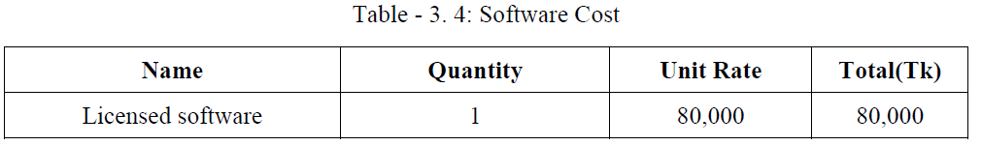

## 3.2 Requirements Engineering

### 3.2.1 User Requirements

The system is very simple in design and to implement. The system requires very low system resources and the system will work in almost all configurations. It has got following features:

• It will ensure data accuracy.

• Records will be efficiently maintained by DBMS.

• Availability of seats can be enquired easily.

• Passengers can also cancel their tickets easily.

• Minimum time needed for the various processing.

• It will provide better Service.

Shuchi, G. (2008) stated that system design is to create a technical solution that satisfies the functional requirements for the system. At this point in the project life cycle there should be a Functional Specification, written primarily in business terminology, containing a complete description of the operational needs of the various organizational entities that will use the new system. The challenge is to translate all of this information into Technical Specifications that accurately describe the design of the system, and that can be used as input to System Construction.

### 3.2.2 System Requirements

So as to be in a position to automate the manual system at Modern coast bus ticket booking system, an automated system was required. This system allows users to perform their booking while in remote environments. Due to this, several requirements were thus required in order to come up with a system that will allow this. Such requirements will be classified into three; functional, non- functional and domain requirements.

### 3.2.3 Functional Requirements

These requirements are those that enable the system to operate. These requirements focus mainly on what the system should do. They include:

* Users have to register themselves by creating accounts to gain access to the system’s services.
* User authentication by use of password.
* The system has two database views; the super administrator has more privileges than the other users. The system shall validate users accessing data in the system through use of password and username validation and verification. A login dialog box will be used for these purposes.
* The categories of users allowed to access data in the system are:

i) Administrator,

ii) Customers (clients)

The super Admin will be responsible for making changes to the database while the members will only be allowed to view the contents of the database

### 3.2.4 Non-Functional Requirements

These requirements focus on how the system works or how the system should behave by providing its quality attributes. These requirements include:

* The system should be able to handle an unlimited number of users at a time.
* Documentation: the system will be documented and PDF manuals will be available for users when the system goes live.
* Recover-ability: the system will be regularly backed up so that it can be recovered in case data is lost for some reason.
* Design constraints: The software will be developed with MySQL database back end.
* The system will not work in the absence of internet
* The system will only require the registered users to log in to the system.

The system will only allow the super admin to change data on the database and not any other user

### 3.2.5 Domain requirements

* This system will not be in a position to operate in environments which are not accessible to internet
* The system will also require the user to have access to a computer/a laptop, a smart phone or any other device that has internet access.
* The system will be by those people basic computer skills.
* People with visual impairments will not use the system unless there is assistance from people without visual challenges.

### 3.2.5 Database requirements

* A common repository of data will be needed. This implies that the new system will require a database for data storage and retrieval for the purposes of processing and feedback information.
* The database will require a number of tables to record various entries that the uses will enter into the system.

## 3.3 System Modelling

### 3.3.1 Data Flow Diagram

In this section, diagramming tools are used to help users understand the flow of data for the existing system of operation at Modern coast bus ticket booking system. Since the system is a manual one, below (see Fig 3) is a Data Flow Diagram on how data flows.

**Issue form**

Manager verifies the form

Customer consultation

Customer fills the form

**Customer arrival Attendant’s**

**At attendant’s desk information**

**Customer details**

**Verified details**

Form file

Figure 2 data flow diagram for current system

Figure 2 below illustrates the activities that take place with the current system at modern coast bus ticket booking when a client is booking.

### 3.3.2 Use Case Symbol

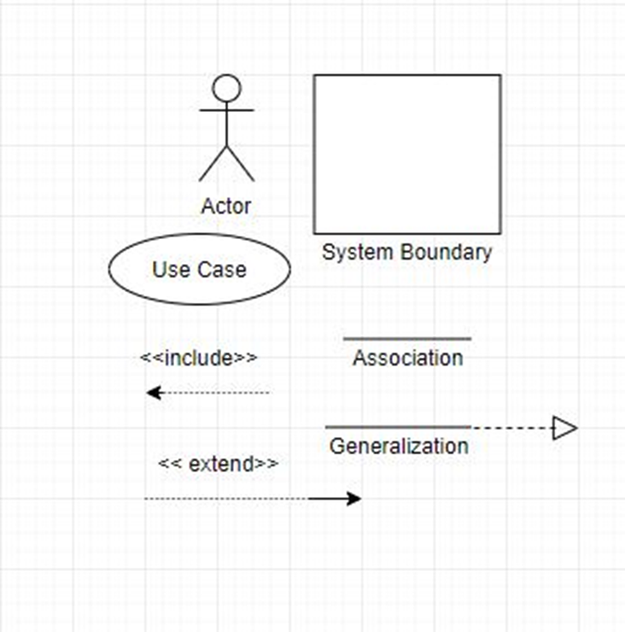

Figure 3 Diagram of use case symbols

### 3.3.3 Use Case Diagram



Figure 4 Diagram of use case

# Chapter 4 - System Planning

## 4.1 Project Planning objectives

The objective of software project planning is to provide a framework that enables the management to make reasonable estimates of resources, cost, and schedule. These estimates are made within limited time frame at the beginning of a software project and should be updated regularly as the project progresses. In addition, estimates should attempt to define best case and worst case scenarios so that project outcomes can be bounded.

## **4.2 Process Based Estimation**

Software cost and effort estimation will never be an exact science. Too may variables—human, technical, environmental, political—can affect the ultimate cost of software and effort applied to develop it. However, software project estimation can be transformed a black art to a series of systematic steps that provide estimates with acceptable risk. To achieve reliable cost and effort estimates, a number of options arise:

1. Delay estimation until late in the project (since, we can achieve 100% accurate estimates after the project is complete!)

2. Base estimates on similar projects that have already been completed.

3. Use relatively simple decomposition techniques to generate project cost and effort estimates.

4. Use one or more empirical models for software cost and effort estimation.

Unfortunately, the first option, however attractive, is not practical. Cost estimates must be provided ―Up front‖. However, we should recognize that the longer we wait, the more we know, and the more we know, the less likely we are to make serious errors in our estimates. The second option can work reasonably well, if the current project is quite similar to past efforts and other project influences (e.g., the customer, business conditions, the SEE, deadlines) are equivalent. Unfortunately, past experience has not always been a good indicator of future results. The remaining options are viable approaches the software project estimation. Ideally, the techniques noted for each option be applied in tandem; each used as cross check for the other. Decomposition techniques take a ―divide and conquer‖ approach to software project estimation. By decomposing a project into major functions and related software engineering activities, cost and effort estimation can be performed in the stepwise fashion. For more details Empirical estimation models can be used to complement decomposition techniques and offer a potentially valuable estimation approach in their own right. A model based on experience (historical data) and takes the form D = f (vi) Where d is one of a number of estimated values (e.g., effort, cost, project duration and we are selected independent parameters (e.g., estimated LOC (line of code)). Each of the viable software cost estimation options is only as good as the historical data used to seed the estimate. If no historical data exist, costing rests on a very shaky foundation.

### 4.2.1 Project Schedule

This project will comprise all the activities involved in SDLC (see Fig 1). All these activities have been summarized in a Gantt chart below.

|  |  |  |  |  |  |  |  |  |  |  |  |  |  |  |
| --- | --- | --- | --- | --- | --- | --- | --- | --- | --- | --- | --- | --- | --- | --- |
| Weeks activity | 1 | 2 | 3 | 4 | 5 | 6 | 7 | 8 | 9 | 10 | 11 | 12 | 13 | 14 |
| Problem  Definition |  |  |  |  |  |  |  |  |  |  |  |  |  |  |
| Requirement  Identification |  |  |  |  |  |  |  |  |  |  |  |  |  |  |
| Analysis |  |  |  |  |  |  |  |  |  |  |  |  |  |  |
| Design |  |  |  |  |  |  |  |  |  |  |  |  |  |  |
| Implementation testing documenting |  |  |  |  |  |  |  |  |  |  |  |  |  |  |

Figure 5 Project Scheduling Gantt Chart

Program evaluation and review technique (PERT) and critical path method (CPM) are two project scheduling methods that can be applied to software development. These techniques are driven by following information: Estimates of Effort A decomposition of the product function The selection of the appropriate process model and task set Decomposition of tasks PERT chart for this application software is illustrated in figure 3.1. The critical Path for this Project is Design, Code generation and Integration and testing.

### 4.2.2 Project Schedule Chart / PERT Diagram

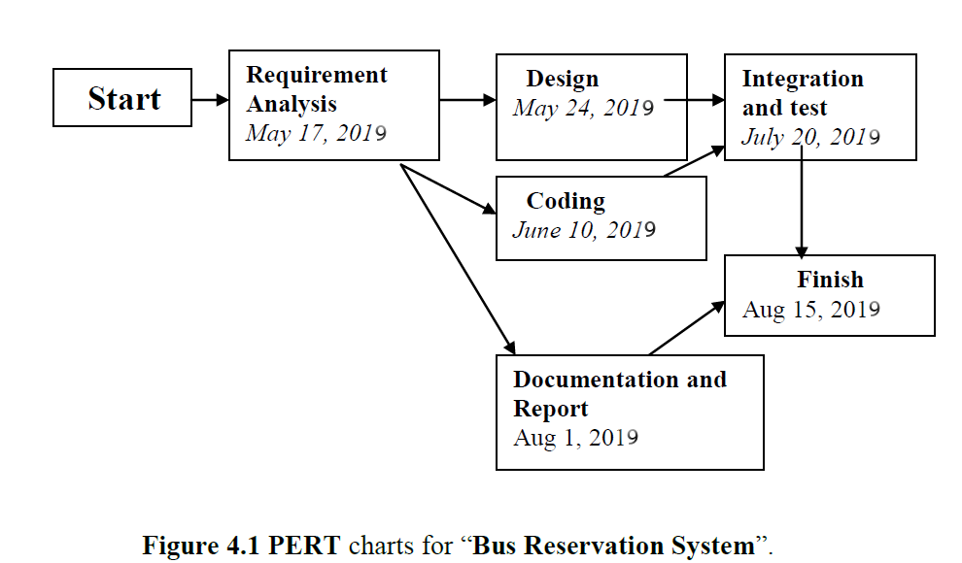

Figure 6 PERT Diagram for Bus Ticket Management System

# Chapter 5 - Risk Management

## 5.1 Risk Engineering

A risk is a serious problem that might or might not happen. It is necessary to analyze the potential

risks in a project. If the risks of a software project are not properly analyzed and estimated, many problems can plague the software project. Risk analysis and management are a series of steps that help a software team to understand and manage uncertainty.

There are different categories of risks that should be considered in any software project. The following categories of risks have been considered in this software project.

• Project risks: These risks threaten the project plan. If these risks become real, it is likely that the project schedule will slip and that costs will increase. Project risks identify potential budgetary, schedule, personnel, resource, customer and requirement problems and their impact on the software project.

•     Technical risks: These risks threaten the quality and timeliness of the software to be produced. If a technical risk becomes a reality, implementation may become difficult or

impossible. Technical risks identify potential design, implementation, interface, verification and maintenance problems. Moreover, specification ambiguity, technical uncertainty, technical obsolescence is also risk factors.

• Business risks: These risks threaten the viability of the software to be built. The business risks can be :

1. Building a system that no one really wants – market risks.

2. Building a system that no longer fits into the overall business strategy for the company – strategic risks.

3. Building a system whose business needs have been changed.

4. Losing the support of senior management due to a change in focus or a change in people management risks.

5. Losing budgetary or personnel commitment – budget risks.

## 5.2 The RMMM Plan

**Project** **Risks:**

Table 3 Project Risk(PR01)

|  |  |
| --- | --- |
| Project Risk(PR01) | |
| Name | Changes the requirements |
| Impact | Marginal |
| Description | Customer may change their requirements. |
| Mitigation & Monitoring | Requirements are redefined by the client due  to time or business needs. Meeting will be held with the client regularly. |
| Management | Emergency meeting between both parties to identify new project requirements and goals. |
| Status | Not occur |

Table 4 Project Risk(PR02)

|  |  |
| --- | --- |
| Project Risk(PR02) | |
| Name | Poor Quality Documentation |
| Impact | Catastrophic |
| Description | Quality of documentation may poor |
| Mitigation & Monitoring | Meeting will be held routinely to offer documentation suggestions and topics. The progress on documentation will also have a monitor in each meeting. |
| Management | We will call a meeting and discuss about quality improvement of documentation. The addition of new topics or removal of unnecessary topics into the documentation will assigned to responsible person. |
| Status | Monitoring it. |

Table 5 Project Risk(PR03)

|  |  |
| --- | --- |
| Project Risk(PR03) | |
| Name | Lack of Development Experience. |
| Impact | Catastrophic |
| Description | Lack of developmental experience of the members. |
| Mitigation & Monitoring | Each member of the team should watch and see areas where another team member may be weak. |
| Management | The members who have the most experience |

|  |  |
| --- | --- |
|  | in a particular area will be required to help for  overcome problem arises for this risk. |
| Status | We are not facing such kind of problem yet. |

**Technical** **Risks:**

Table 6 Technical Risks(TR01)

|  |  |
| --- | --- |
| Technical Risks(TR01) | |
| Name | Computer Crash |
| Impact | Catastrophic |
| Description | Computer may crash due to several reasons. |
| Mitigation & Monitoring | We should take proper follow up of  computers. We also take regular data backup every day and we can use IPS to stop unexpected shutdown. |
| Management | If our computer has been crashed then we will restore backup. |
| Status | We are not facing such kind of problem yet. |

Table 7 Technical Risks(TR02)

|  |  |
| --- | --- |
| Technical Risks(TR02) | |
| Name | Technology Doesn’t Meet Specifications. |
| Impact | Catastrophic |
| Description | Customer doesn’t have the technology to their desired specification. |
| Mitigation & Monitoring | Ensures that the product we are producing,  and the specifications of the customer are equivalance |
| Management | The customer should be immediately notified and whatever steps necessary to rectify this problem should be done. Preferably a meeting should be held between the development team and the customer to discuss at length this issue. |
| Status | We are not facing such kind of problem yet. |

Table 8 Technical Risks(TR03)

|  |  |
| --- | --- |
| Technical Risks(TR03) | |
| Name | Poor Training Skill in Team Members. |
| Impact | Catastrophic |
| Description | Poor Training Skill in Team Members to  Train the Client. |
| Mitigation & Monitoring | The training team should have a clear knowledge about the entire functionality of the software. System analyst need to ensure and monitor it while training session start. |
| Management | We should arrange a meeting with the train team and come to a point to solve this problem. |
| Status | We are not facing such kind of problem yet. |

**Business** **Risks:**

Table 9 Business Risk(BR01)

|  |  |
| --- | --- |
| Business Risk(BR01) | |
| Name | Insufficient Budget |
| Impact | Marginal |
| Description | If the budget is low project may not complete |
| Mitigation & Monitoring | The project needs streaming server that is costly to set-up. We find several alternative streaming services to reduce the budget risk. |
| Management | Refinement in project goal. A new plan for regulate the budget. |
| Status | We are not facing such kind of problem yet. |

Table 10 Business Risk(BR02)

|  |  |
| --- | --- |
| Business Risk(BR02) | |
| Name | Not pay the installment of Software Cost. |
| Impact | Catastrophic |
| Description | Customer doesn’t pay for the installment of  Software Cost. |
| Mitigation & Monitoring | We should make a good communication  between customers and ensure that the entire  Installment will be completed. |
| Management | The only course of action available would be find out the reason and come in a solution. |
| Status | The risk has not been arisen yet. |

Table 11 Business Risk(BR03)

|  |  |
| --- | --- |
| Business Risk(BR03) | |
| Name | Late delivery of the project |
| Impact | Catastrophic |
| Description | The project may take more time to complete what was estimated. |
| Mitigation & Monitoring | Steps have been taken to ensure a timely delivery by determining the scope of project. |
| Management | The only course of action available would be to request an extension to the deadline from customer. |
| Status | Our project is completed in time |

# Chapter 6 - System Analysis

Software requirements analysis is a process of discovery, refinement, modeling, and specification. Requirement analysis proves the software designer with a representation of information, function, and behavior that can be translated to data, architectural interface, and component -level designs. To perform the job properly we need to follow as set of underlying concepts and principles of Analysis.

## 6.1 Analysis Principles

Over the past two decades, a large number of analysis modeling methods have been developed. Investigators have identified analysis problems and their caused and have developed a variety of modeling notations and corresponding sets of heuristics to overcome them. Each analysis method has a unique point of view. However, all analysis methods are related by a set of operational principles:

1. The information domain of a problem must be represented and understood.

2. The functions that the software is to perform must be defined.

3. The behavior of the software (as a consequence of external events) must be represented.

4. The models that depict information function and behavior must be partitioned in a manner that uncovers detail in layered (or hierarchical) fashion.

5. The analysis process should move from essential information toward

implementation detail. By applying these principles, we approach the problem systematically. The information domain is examined so that function may be understood more completely. Models are used so that the characteristics of function and behavior can be communicated in a compact fashion. Partitioning is applied to reduce complexity. Essential and implementation vies of the software are necessary to accommodate the logical constraints imposed any processing requirements and the physical constraints imposed by other system elements. We have tried to takes above said principles to heart so that we could provide an excellent foundation for design.

### 6.1.1 The Information Domain

All software applications can be collectively called data processing. Software is built to process data, to transform data from one form to another; that is, to accept input, manipulate it in some way, and produce output. This fundamental statement of objective is true whether we build batch software for a payroll system or realtime embedded software to control fuel flow to an automobile engine.

The first operational analysis principle requires an examination of the information domain and the creation of a data model. The information domain contains three different views of the data and control as each is processed by a computer program:

(1) information contend and relationships (the data model)

(2) information flow, and

(3) Information structure.

To fully understand the information domain, each of these views should be considered. Information content represents the individual data and control objects that constitute some larger collection of information transformed by the software. For example, the data object, Status declare is a composite of a number of important pieces of data: the aircraft’s name, the aircraft’s model, ground run, no of hour flying and so forth. Therefore, the content of Status declares is defined by the attributes that are needed to create it. Similarly, the content of a control object called System status might be defined by a string of bits. Each bit represents a separate item of information that indicates whether or not a particular device is onor off-line. Data and control objects can be related to other data and control objects. For example, the date object Status declare has one or more relationships with the objects like total no of flying, period left for the maintenance of aircraft an others. Information flow represents the manner in which date and control change as each moves through a system. Referring to figure 6.1, input objects are transformed to intermediate information (data and / or control), which is further transformed to output. Along this transformation path, additional information may be introduced from an existing date store ( e.g., a disk file or memory buffer). The transformations applied to the date are functions or sub functions that a program must perform. Data and control that move between two transformations define the interface for each function.

Figure 5.1 Information flow and transformation.

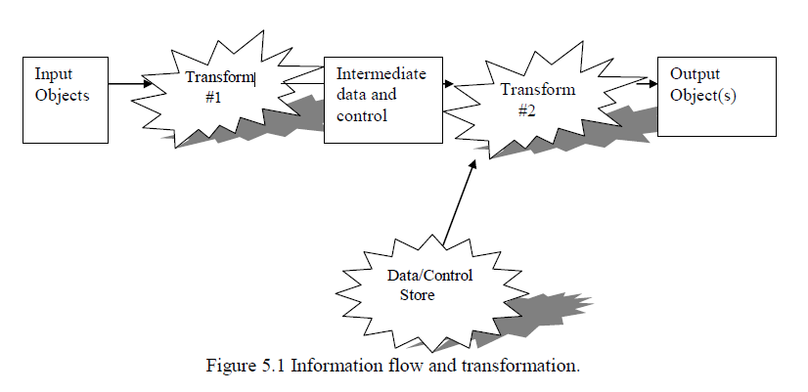

Figure 7 Information Flow of transformation

### 6.1.2 Modeling

The second and third operational analysis principles require that we build models of function and behavior. Functional models. Software transforms information, and in order to accomplish this, it must perform at lease three generic functions:

* Input
* Processing
* output.

The functional model begins with a single context level model (i.e., the name of the software to be built). Over a series of iterations, more and more functional detail is gathered, until a through delineation of all system functionality is represented. Behavioral models. Most software responds to events from the outside world. This stimulus/response characteristic forms the basis of the behavioral model. A computer program always exists in some state- an externally observable mode of behavior (e.g., waiting, computing, printing, and polling) that is changed only when some even occurs. For example, in our case the project will remain in the wait state until: We click OK command button when first window appears An external event like mouse click cause an interrupt and consequently main window appears by asking the username and password. This external system (providing password and username) signals the project to act in desired manner as per need. For more details please visit <http://techbrij.com> A behavioral model creates a representation of the states of the software and the events that cause software to change state.

### 6.1.2 Partitioning (Divide)

Problems are often too large and complex to be understood as a whole, for this reason, se tend to partition (divide) such problems into parts that can be easily under stood and establish interfaces between the part so that overall function can be accomplished. The fourth operational analysis principle suggests that the information, functional, and behavioral domains of software can be partitioned. In essence, partitioning decomposes problem intoits constituent parts. Conceptually, we establish a hierarchical representation of function or information and then partition and uppermost element by

(1) exposing increasing detail by moving vertically in the hierarchy or

(2) Functionally decomposing the problem my moving horizontally in the hierarchy.

To issulstate these partitioning approaches let us consider our project “Bus Reservation System”. Horizontal partitioning and vertical partitioning of Bus Reservation system is shown below.

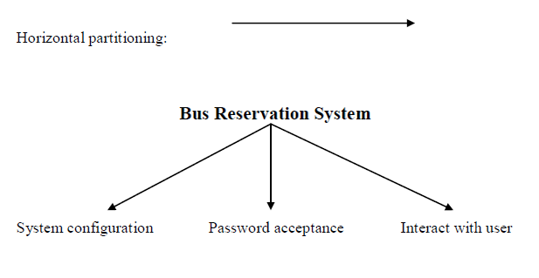

Figure 8 Horizontal Partitioning

During installation, the software (Bus Reservation System) used to program and configure the system. A master password is programmed for getting in to the software system. After this step only user can work in the environments (right corner naming operation, administration and maintenance) only. Vertical partitioning of Bus Reservation System function:

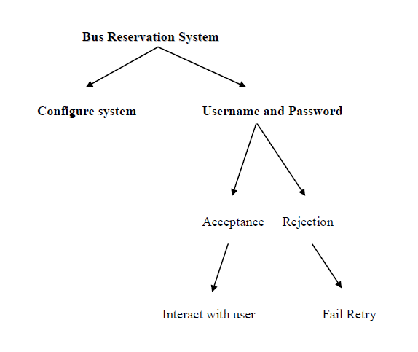

Figure 9 Vertical Partitioning

# Chapter 7 – System Design and Implementation

## 7.1 Introduction

This chapter is on system design which is completed before the development of the Online Bus Ticketing System web portal. System design is defined as those tasks that focus on the specification of the detailed computer-based solution (Whitten J.L et al., 2002). The purpose of the design phase is to transform the system requirements statement from the requirements analysis phase into design specifications for construction.

## 7.2 System Functional Design

### 7.2.1 Structure Design

The Structure Design of Online Bus Ticketing System web portal shows a bird’s eye view of the entire system. Generally, the Online Bus Ticketing System web portal allows easy accessibility to obtain information. Customer can browse the web portal to obtain various types of information such as bus schedule information, promotions, latest news, forums, feedback and star rating for bus operators. On the other hand, the Administrator would be able to assess the system to update the portal on bus schedule information, promotions, latest news, forums, feedback and report generation. A structure diagram has been created for the Online Bus Ticketing System web portal. The main system of the Online Bus Ticketing System web portal is divided into 2 major

sections, Administrator section and Customer section as shown in Figure 5.1.

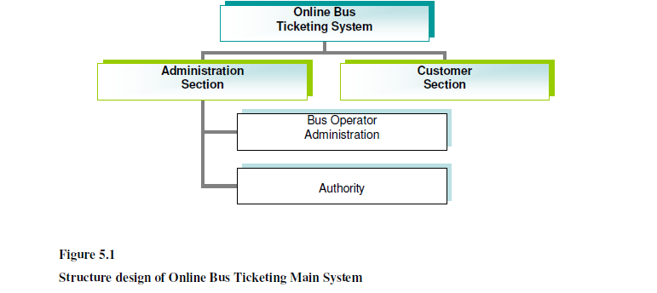

Figure 10 Structure Design of Bus Ticket Management System(main)

#### 7.2.1.1 Structure Chart for Administrator Section

For the Administrator section, there are 9 modules which are further divided into submodules. The modules are bus operator contact information, about the bus operator, bus information, forum, feedback, FAQ, latest news, bus information, member accounts, staff profile, purchase ticket, booking cancellation, reports and Authority links. The structure chart for Administrator section is shown in Figure 5.2, structure chart for

Authority module

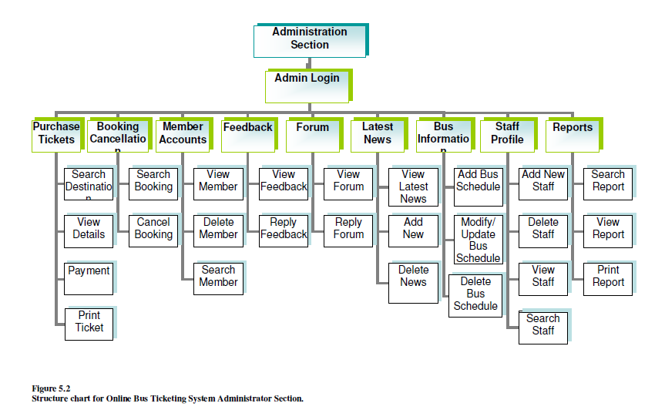

Figure 11 Structure Design of Bus Ticket Management System(Administrator Section)

#### 7.2.1.1 Structure Chart for Authority Module

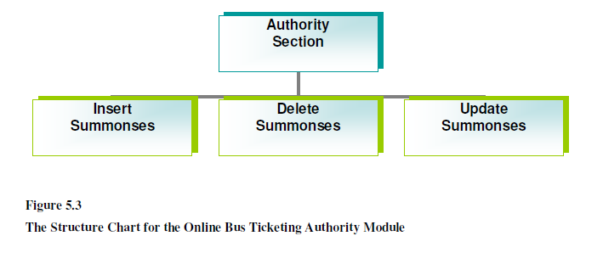

Figure 12 Structure Design of Bus Ticket Management System (Authority Module)

#### 7.2.1.2 Structure Chart for Customer Section

For the Customer section, there are 6 modules, consisting of Home, contact us, about us, forum, FAQ, booking cancellation and user poll. The structure chart of the Customer section is shown in Figure 5.4.

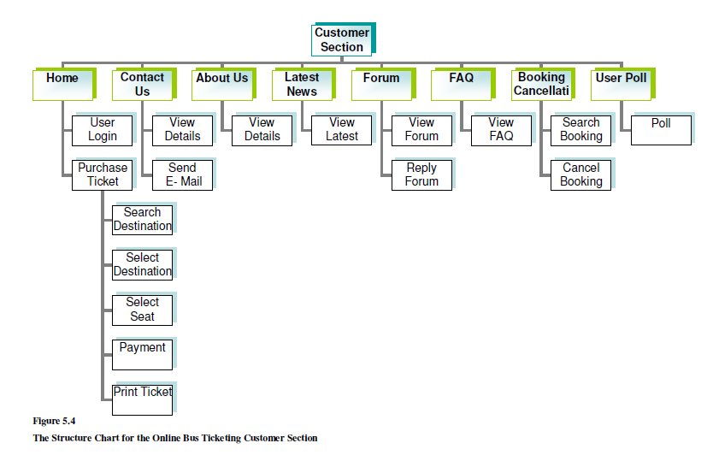

Figure 13 Structure Design of Bus Ticket Management System (Customer Module)

## 7.3 Data Flow Diagram

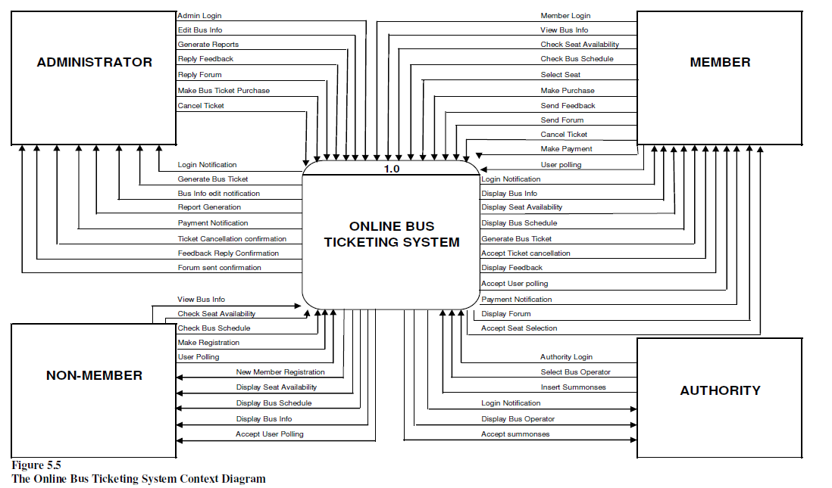

Figure 14 Data Flow Diagram

### 7.3.1 DFD of project

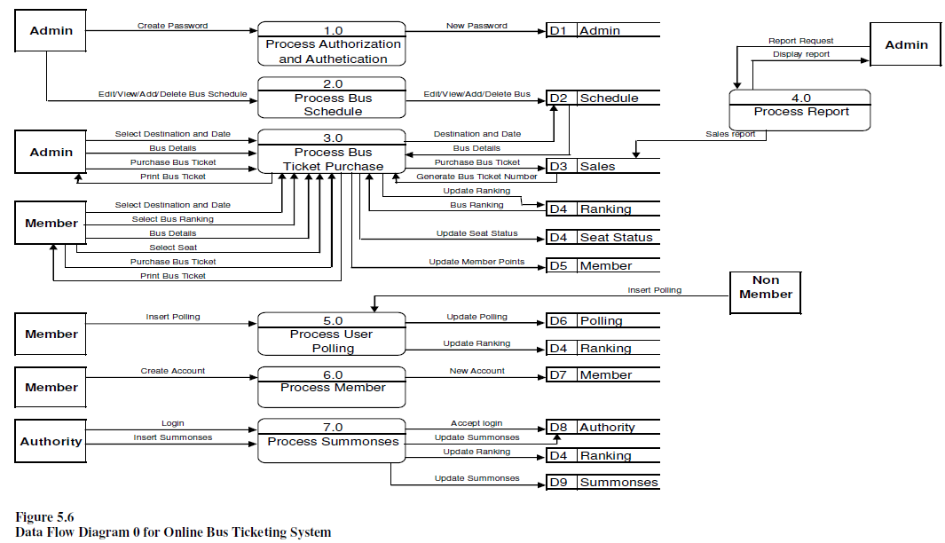

Figure 15 DFD of project

## 7.4 Database Design

### 7.4.1 Data Dictionary

The database consists of 18 tables and the structures of the tables are shown as following

Table 12 Table Name: Schedule

|  |  |  |  |
| --- | --- | --- | --- |
| **Field** | **Type** | **Size** | **Description** |
| **id** | Int | 11 | Bus ID |
| fld_provider | varchar | 255 | Bus Provider |
| fld_bustype | varchar | 255 | Bus Type |
| fld_busregnumber | varchar | 255 | Bus registration number |
| fld_origin | varchar | 255 | Bus Origin |
| fld_destination | varchar | 255 | Bus destination |
| fld_seats | Int | 15 | Number of seats |
| fld_sold | Int | 15 | Number of seats sold |
| fld_avaliable | Int | 15 | Number of seats available |
| fld_onwardj | varchar | 255 | Onward journey date |
| fld_onwarddate | varchar | 255 | Onward journey time |
| fl_adultfare | varchar | 255 | Adult fare |
| fld_child | varchar | 255 | Child fare |
| fld_rorigin | varchar | 255 | Bus return origin |
| fld_rdestination | varchar | 255 | Bus return destination |
| fld_rdate | varchar | 255 | Bus return journey date |
| fld_rtime | varchar | 255 | Bus return journey time |
| fld_rseats | Int | 10 | Bus return journey seats |
| fld_rsold | varchar | 10 | Bus return journey sold |
| fld_available | varchar | 10 | Bus return journey tickets available |
| star | Varchar | 50 | Bus star rating |

Table 13 Table Name: Seats Status

|  |  |  |  |
| --- | --- | --- | --- |
| **Field** | **Type** | **Size** | **Description** |
| **id** | Varchar | 150 | Seat ID |
| totalseats | Varchar | 150 | Total number of seats |
| selectedseats | Varchar | 150 | Selected seats |

Table 14 Table Name: Admin

|  |  |  |  |
| --- | --- | --- | --- |
| **Field** | **Type** | **Size** | **Description** |
| **id** | Varchar | 150 | Company ID |
| fld_companyname | varchar | 255 | Company name |
| fld_username | varchar | 255 | Company Username |
| fld_password | varchar | 255 | Company Password |
| fld_companydescription | Text | 255 | Company description |

Table 15 Table Name: Authority

|  |  |  |  |
| --- | --- | --- | --- |
| **Field** | **Type** | **Size** | **Description** |
| **id** | Varchar | 150 | Authority ID |
| username | Varchar | 100 | Authority user name |
| Pass | Varchar | 100 | Authority password |
| Post | varchar | 100 | Authority position |
| contactno | varchar | 100 | Authority contact number |
| icnumber | varchar | 100 | Authority IC number |

Table 16Table Name: Ranking

|  |  |  |  |
| --- | --- | --- | --- |
| **Field** | **Type** | **Size** | **Description** |
| **id** | varchar | 150 | Ranking ID |
| busop | varchar | 100 | Bus Operator Name |
| percentage | varchar | 100 | Ranking percentage |
| busopstar | varchar | 100 | Bus Operator star ranking |
| ticketstar | varchar | 100 | Ticket star ranking |

Table 17 Table Name: FAQs

|  |  |  |  |
| --- | --- | --- | --- |
| **Field** | **Type /** | **Size** | **Description** |
| **id** | Int | 11 | ID |
| fld_question | varchar | 255 | FAQ question |

Table 18 Table Name: Feedback

|  |  |  |  |
| --- | --- | --- | --- |
| **Field** | **Type** | **Size** | **Description** |
| **id** | Int | 11 | ID |
| Fld_username | varchar | 255 | Username |

Table 19 Table Name: Forum

|  |  |  |  |
| --- | --- | --- | --- |
| **Field** | **Type** | **Size** | **Description** |
| **id** | Int | 11 | ID |
| Fld_username | varchar | 255 | Username |
| Fld_subject | varchar | 255 | Forum Subject |
| Fld_message | varchar | 255 | Message |

Table 20 .Table Name: News

|  |  |  |  |
| --- | --- | --- | --- |
| **Field** | **Type** | **Size** | **Description** |
| **Id** | Int | 11 | ID |
| Fld_providername | varchar | 255 | Bus Operator name |
| Fld_subject | varchar | 255 | Subject |
| Fld_message | varchar | 255 | Message |

Table 21 Table Name: Places

|  |  |  |  |
| --- | --- | --- | --- |
| **Field** | **Type /** | **Size** | **Description** |
| **place_id** | Int | 6 | Destination ID |
| Places | Varchar | 50 | Destination |

Table 22 Table Name: Polling

|  |  |  |  |
| --- | --- | --- | --- |
| **Field** | **Type** | **Size** | **Description** |
| **id** | varchar | 150 | Polling ID |
| busop | Varchar | 100 | Bus Operator |

Table 23 Table Name: Replyfeedback

|  |  |  |  |
| --- | --- | --- | --- |
| **Field** | **Type** | **Size** | **Description** |
| **Id** | Int | 11 | ID |
| Fld_username | varchar | 255 | Username |
| Fld_subject | varchar | 255 | Subject |
| Fld_message | varchar | 255 | Message |

Table 24 Table Name: Status

|  |  |  |  |
| --- | --- | --- | --- |
| **Field** | **Type** | **Size** | **Description** |
| **id** | varchar | 150 | ID |
| totalseats | varchar | 150 | Total number of seats |
| selectedseats | varchar | 150 | Selected seats |
| username | varchar | 150 | Username |
| Date1 | varchar | 150 | Date |

Table 25 Table Name: Serviceprovider

|  |  |  |  |
| --- | --- | --- | --- |
| **Field** | **Type** | **Size** | **Description** |
| **id** | Int | 11 | ID |
| Fld_companyname | varchar | 255 | Company name |
| Fld_username | varchar | 255 | User name |
| Fld_password | varchar | 255 | Password |
| Fld_address | varchar | 255 | Address |
| Fld_age | varchar | 255 | Age |
| Fld_contact | varchar | 255 | Contact |
| Fld_icnumber | varchar | 255 | IC Number |

Table 26 Table Name: Staff

|  |  |  |  |
| --- | --- | --- | --- |
| **Field** | **Type** | **Size** | **Description** |
| **id** | Int | 11 | ID |
| Fld_name | varchar | 255 | Name |
| Fld_password | varchar | 255 | Password |
| Fld_companyname | varchar | 255 | Company Name |
| Fld_address | varchar | 255 | Address |
| Fld_contact | varchar | 255 | Contact number |
| Fld_age | Int | 20 | Age |
| Fid_icnumber | varchar | 255 | IC Number |
| Fld_pos | varchar | 100 | Position |

Table 27 Table Name: Summonses

|  |  |  |  |
| --- | --- | --- | --- |
| **Field** | **Type** | **Size** | **Description** |
| **id** | Varchar | 150 | Summonses ID |
| month | Varchar | 100 | Month |
| busop | Varchar | 100 | Bus Operator |

Table 28 Table Name: Member

|  |  |  |  |
| --- | --- | --- | --- |
| **Field** | **Type** | **Size** | **Description** |
| **id** | Int | 11 | ID number |
| fld_username | varchar | 255 | Username |
| fld_password | varchar | 255 | Password |
| fld_age | Int | 20 | Age |
| fld_address | varchar | 255 | Address |
| fld_contact_number | varchar | 255 | Contact number |
| fld_icnumber | varchar | 255 | IC number |
| email | varchar | 100 | E- Mail address |
| point | Int | 100 | Redemption point |

Table 29 Table Name: Sales

|  |  |  |  |
| --- | --- | --- | --- |
| **Field** | **Type** | **Size** | **Description** |
| **id** | Int | 11 | ID Number |
| fld_ticketnumber | varchar | 255 | Ticket number |
| fld_busnumber | varchar | 255 | Bus number |
| fld_serviceprovider | varchar | 255 | Bus Operator name |
| fld_username | varchar | 255 | Username |
| fld_origin | varchar | 255 | Bus origin |
| fld_destination | varchar | 255 | Bus destination |
| fld_onward | varchar | 255 | Bus onward journey |
| fld_onwarddeptime | varchar | 255 | Bus onward departure time |
| fld_returnjdate | varchar | 255 | Bus return date |
| fld_returnjtime | varchar | 255 | Bus return time |
| fld_onwardadults | Int | 10 | Bus onward number of adults |
| fld_onwardchilds | Int | 10 | Bus onward number of children |
| fld_returnadults | Int | 10 | Bus return number of adults |
| fld_returnchilds | Int | 10 | Bus return number of children |
| fld_address | varchar | 255 | Address |
| fld_contact | varchar | 255 | Contact |
| fld_totalamount | varchar | 255 | Total amount |
| fld_payment | varchar | 255 | Payment |
| fld_cardtype | varchar | 255 | Credit Card type |
| fld_cardnumber | varchar | 255 | Credit Card number |
| fld_securitynumber | varchar | 80 | Credit Card security number |
| fld_expiry | varchar | 255 | Credit Card expiry |

### 7.5.1 Entity Relationship Model

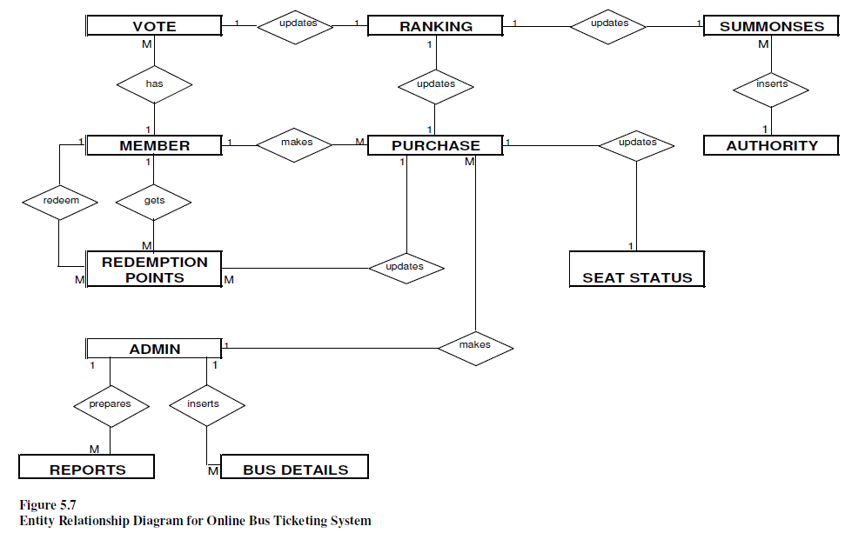

Figure 16 Entity Relationship Model

# Chapter 8 - Quality Assurance

## 8.1 Introduction

Testing involves operation of a system or application under a controlled condition and evaluating the results. The controlled conditions should include both normal and abnormal conditions. Testing should intentionally attempt to make things go wrong to determine if things happen when they should not or things do not happen when they should.

## 8.2 Testing

Testing is the process that is carried out to ensure that the system conforms to the specification and meets the requirements of the users, namely bus operators and customers. Testing had been conducted not only in the end but also during the development of the prototype system. Functional and interface testing were carried out for the module or for the whole system. Each and every link had been checked to make sure all the links are working correctly. Interface testing is carried out to identify that the interface works correctly and faults are not created because of interface errors.

### 8.2.1 Unit Testing

Unit Testing is to test software in terms of a unit, a module, a function, a specific section of code. This testing occurs while the software is being developed and before completion

(David Fletcher, 2000). For Unit Testing, test cases are designed to verify that an individual unit implements all design decisions made in the unit's design specification. A thorough unit test specification should include positive testing where the unit does what it is supposed to do, and also negative testing where the unit does not do anything that it is not supposed to do. Table 6.1 shows the Unit Testing for the Administrator login module.

Table 30 Unit Testing for Administrator login module

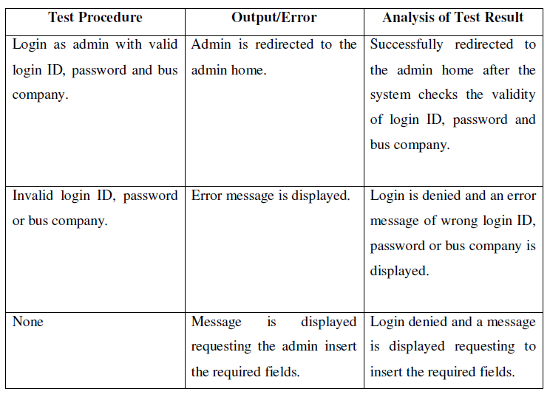

Table shows the Unit Testing for the Administrator Ticket Booking module. Unit Testing for the Administrator Ticket Booking module

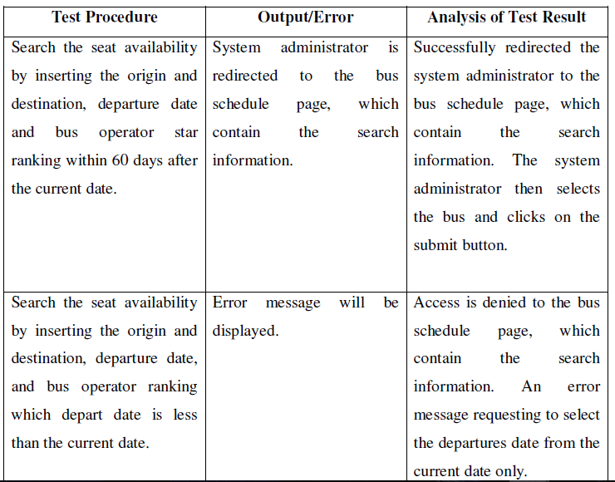

### 8.2.2 Integration Testing

Upon completion of Unit Testing, Integration Testing will begin. The purpose is to ensure the distinct components of the application still work in accordance to customer requirements. Test sets will be developed with the purpose of exercising the interfaces between the components. This activity is to be carried out by the bus operators and customers. Integration test will be complete when actual results and expected results are either in line or differences are explainable or acceptable based on the user input.

### 8.2.3 Acceptance Testing

Acceptance testing will give both Customers and Administrators the opportunity to verify the system functionality and usability prior to the system deployment. The users will test the system interaction with the database, using network communications, or interacting with other hardware or other applications. The system is tested with data supplied by the end users rather than simulated test data. Acceptance testing reveals errors and omissions in the system requirement definition because real data exercises the system in different ways from the test data. It also reveals requirements problem where the system’s facilities do not really meet the user’s need or the system performance is unacceptable. The testing process continues until the system developer and client agrees that the Online Bus Ticketing web portal is an acceptable implementation of the system requirement.

#### 8.2.3.1 Analysis of Bus Operator Administrator Acceptance Testing

In order to conduct the testing, ten testers had been invited from bus operators in Puduraya Bus Terminal. This testing was conducted in the office of the bus operators.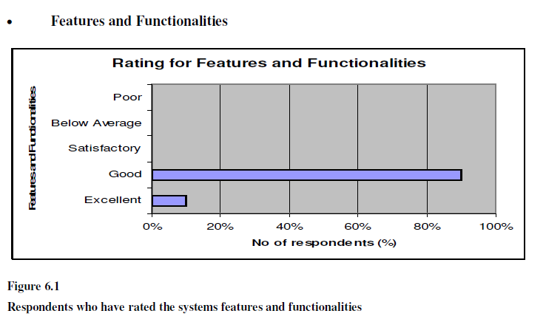

Figure 17 Rating for Feature

Based Figure 6.1, 9 of the respondents had rated the system as good and 1 had rated as excellent. This shows that the respondents are satisfied with the existing features and functionalities of the Online Bus Ticketing System web portal

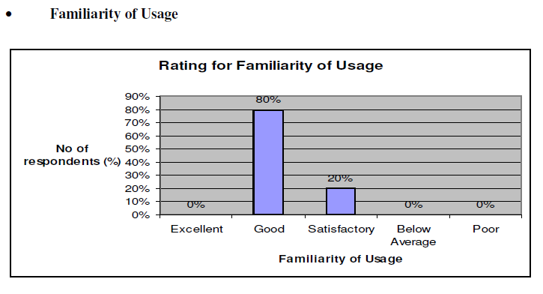

Figure 18 Familiarity of Usage

Based on Figure 6.2, 80% of the testers rated the familiarity of usage of the system is good and the rest as satisfactory. This shows that functions of the system are not different from the manual system and thus the objective of transforming a manual ticketing system to an online system has been met.

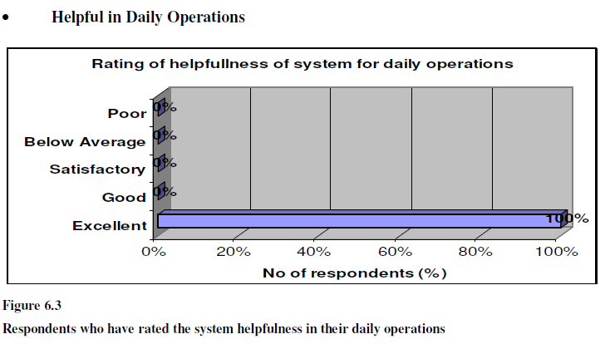

Figure 19 Helpful In daily operations

Based on Figure 6.3, all 10 respondents agreed that this system is helpful in their daily bus operations, thus this project’s objective of assisting bus operator’s operations and marketing decision through timely decision making through the deployment of Online Bus Ticketing System web portal and the phasing out of manual ticketing system has been achieved.

## 8.3 Conclusion

The Online Bus Ticketing system web portal can further be enhanced to meet the users’ requirements. All the Human Computer Interaction factors and the usability factors had been taken when designing the web portal. The web portal should allow all age groups to use and navigate easily. The web portal provides a lot of information for customers who would like to purchase a bus tickets or for those who are interested to know about the bus operators’ services. Even though the web portal is able to meet the user requirements, it still has room for improvement.

# Chapter 9 – Conclusion

## 9.1 Introduction

This chapter discusses on the outcome of this entire research, limitations of the research and last but not least the future outcome of this research. Finally, this chapter concludes the various issues that had been highlighted in the earlier chapters. Knowledge in terms of concept, theory, technical and practical aspects on Online Bus Ticketing System web portal had been gained.

## 9.2 Outcomes of the research

Based on the research objective that has been stated in the earlier chapter the following are the achievements:

The first objective has been successfully completed, which is to investigate and analyze the problems on the existing e-ticketing systems provided by individual bus operators. The problems of existing e-ticketing are clearly stated in Chapter 2 where a thorough study had been conducted by investigating existing bus e-ticketing systems in Bangladesh and overseas. Further improvement had been identified that need to be done on the existing bus ticketing systems.

The next objective is to identify the relevant features of various components and methods needed for an Online Bus Ticketing web portal. This objective has been highlighted clearly in Chapter 3 that includes the improvements needed on the existing e-ticketing systems through interviews and surveys. Based on the suggested information gathered, the relevant features of various components and methods needed for an Online Bus Ticketing System web portal is designed. This objective is also to assist bus operator’s operations and marketing decision through timely decision making via Management Information System. The system allows the system administrators to generate up to date reports from the system for future decision making.

The final objective identifies the improvements needed on the existing e-ticketing systems through interviews and surveys. With the suggested information gathered, the relevant features of various components and methods needed for an Online Bus Ticketing System web portal is designed. It also explains the involvement of Decision Support System that will provide option to a user based on the service level provided by the bus operator and thus gives power to the user to decide and choose which bus operator’s services to use.

This objective is very much important due to the high level of dependency that the user is having on the bus operator that could cause fatal if the services is not up to the standards drawn by the governing bodies This objective explains further on the development of an Online Bus Ticketing System web portal. The tools and methodology used, user requirements and other issues on designing the system are discussed.

## 9.3 Limitations of the research

There were few constraints that had been encountered during completing the research document. The first constrain was the inability to find any research document obtaining information on star ranking for bus operators. It was difficult to acquire any information on this area because there are no any governing bodies that award ratings to bus operators as how hotels and airliners are rated. It is discovered there are none of the bus e-ticketing sites offers star ranking for any of its bus operators. The second constraint was on the information gathered from the public on e-ticketing in Bangladesh. It is difficult to have a perfect percentage of statistics constructed. The opinion responded by public during data gathering process is too subjective and how genuine the opinion is questionable. The existence of e-ticketing in Bangladesh is still new for many and those who have the knowledge of e-ticketing still do not fully utilize the services.

## 9.4 Future work of the research

Some of the future work of the research for this Online Bus Ticketing web portal that can be taken into consideration are-

(a) Language Support

Online Bus Ticketing System web portal could be enhanced to provide more language support such as Bangla language version besides the current English language version. This will enable information to be displayed in the different language. As a result, this will broaden the usage of the system and interact with more customers.

(b) Enhanced User Interface

The user interface of the system can be enhanced to be more attractive, impressive and interactive when this web portal is converted to a real-time system.

(c) Increase Administrators Task

Administrator’s task can be further enhanced to include more features to ease maintenance process. For example, analytical tools, data mining, other relevant reports and database backup are recommended to be included in this Online Bus Ticketing web portal to provide more analytical function to the company.

(d) Common working community

The system can also be a “newsletter” to all employers and employees who are related to bus transportation in Bangladesh. Various information or news can be displayed to the targeted audience such as employment availability, bus operators’ news and so on.

## 9.5 Conclusion

Online Bus Ticketing System web portal is a system with its own strengths and limitations. A through study and implementation of an Online Bus Ticketing System web portal had been conducted. An investigation on all bus e-ticketing sites in Bangladesh and overseas had also been conducted, and the discovery that there are not many of these sites offers a collaborated bus operators services and none has an awarding star ranking to their bus operators, which will be considered a niche and vital information to the customers. Thus, an introduction of the Online Bus Ticketing web portal that collaborates all bus operators and star ranking feature for bus operators in Bangladesh as well as creating convenience to bus users, conducting virtual business transaction more efficiently, and over the Internet, which has already become a crucial part of our daily lives. Overall, Online Bus Ticketing System web portal has been successfully built and has achieved and fulfilled the objectives and requirements that are stated in the project proposal. The use of web-based approach brings along many benefits include the ability to access information anywhere and at any time of the day.

There is room for improvement on the suggested guidelines, study and implementation of Online Bus Ticketing System web portal. An important challenge is by providing awareness about a collaborated web portal of Online Bus Ticketing System in Bangladesh and the introduction of star ranking for all bus operators in Bangladesh. This will help to improve the country’s bus transport service industry by offering the best service in terms of performance, security and safety.

Finally, the useful information provided by the respondents towards the completion of this research document is greatly appreciated.

# Bibliography

**Adriana Harizanova, (2003)**, “Management Information System in tailoring industry” in

*Academic Open Internet Journal*, Volume 9, 2003, [Online] <www.acadjournal.com>

**Aeroline, (2006)**, [Online] <https://www.aeroline.com.my/index.html>, 5/4/2006

**Allen H., (2001)**, “Innovations in retail payments: e-payments”, Bank’s Market

Infrastructure Division, pg 429.

**Audrey Edwards, (2006)**, The Star, 19/10/2006

**Ballou S., (2003)**, MALICIOUS CODE – WHAT SHOULD WE DO?, September 18,

2003, pg 1

**Brae Canlen, (2000)**, “*Debit cards gaining favor with shoppers and retailers”***,** Home

Channel News, Oct 23, 2000

**Burnham, B., (1999)**, How to Invest in E-Commerce Stocks, New York, NY: McGraw-

Hill, 1999.

**Chaffey D, (2004),** *E- Business and E- Commerce Management*, 2nd Ed, Pearson, 2004,

Page 7 - 44

**Chow H.B. (2006)**, The Star, “Where motorists fear to tread”, 19/4/06

**Curtis, B., Krasner *et al*., (1987)**, “On building software process models under lamppost”

In proceeding of the *9th International Conference*

**David Fletcher, (2000)**, *Software Testing and Quality Assurance,* 31/7/2000, Page 2-4

**Dougles E.Comer, (2001)**, *Computer networks and internets with internet application*,

Prentice Hall, 2001

**E. Rescorla *et al*., (2005)**, “The Secure HyperText Transfer Protocol”, in Internet Draft,

EIT, July 2005.

**Echeck, (2006)**, What is eCheck? , [Online]

<http://www.echeck.org/overview/what.html>, 29/5/2006

**Epayment, (2006)**, [Online] *Types of E Payment*,

http://www.american.edu/initeb/sm4801a/epayment3.htm, 15/12/2006

**Farik Zolkepli, (2006),** The Star**,** *Safety main point when giving permits for festive season*

*buses*, 1/10/2006

**First Virtual, (2006)**, [Online] ,<www.fv.com>, 9/3/2006

295

**Fitzgerald and Dennis, (2002)***, Business Data Communications and Networking,* John

Wiley & Sons. Inc, 2002

**Fritscher M *et al*., (2003)**, “Security And Productivity Improvements – Sufficient For The

Success Of Secure Electronic Transaction?”, Department of Information Systems Vienna

University of Economics and Business Administration, Pg. 2

**G. J. Udo, (2001)**, “Privacy and security concerns as major barriers for e-commerce: a

survey study”, *Information Management & Computer Security,* Vol. 9, no. 4, pp. 165 –174,

2001.

**Gill P., (2006)**, The Star, “VIP bus tickets passengers travel in school and factory buses

instead”, 4/2/2006

**Greyhound, (2006)**, [Online] <http://www.greyhound.com>, 4/4/2006

**Gruman G., (2006)**, [Online] *Secure Electronic Transaction*,

http://www.computerworld.com/securitytopics/security/story/, 25/1/2006

**Haley F., (2005)**, “What's in your e-wallet? The smartcard is emerging as a major ecommerce

tool”, Black Enterprise , Nov 2005

**Householder A. *et al*., (2001)**, “Managing the Threat of “Denial-of-Service Attacks,

October 2001, Pg 1

**Info Merchant, (2006)**, [Online] *Online and Offline Debit Cards*,

<http://www.infomerchant.net/debitcardprocessing/debit_card_types.html>, 10/5/06

**Infopeople Project, (2003)**, [Online] <www.infopeople.com>

**James F. Courtney, (2000)**, “*Decision Making and Knowledge Management In Inquiring*

*Organizations: Toward A New Decision-Making Paradigm for DSS”*, June 2000

**Kenneth C. Laudon et al., (2004)**, “Management Information Systems – Managing the

Digital Firm”, Eight Edition, 2004

**Keretapi Tanah Malayu, (2006)**, [Online] *Introduction*,

<http://www.ktmb.com.my/section.cfm?id=143>, 14/3/2006

**Kiat.net, (2006)**,[Online] < http://www.kiat.net/klia/intro.html>, 14/3/06

**Kiat.net, (2006b), [Online]** *Intergrated Urban Transportation System*,

<http://www.kiat.net/malaysia/KL/transit.html>, 20/3/06

**Kuttner K.N *et al*., (2001)**,“Personal online payments”, in *Federal Reserve Bank of New*

*York Economic Policy Review*, December 2001, pages 35–50.

**L.G. Chai, (2005)**, “E-Banking in Malaysia: Opportunity and Challenges”, in *The Journal*

*of Internet Banking and Commerce*, Dec2005

296

**Lim, E., (2004)**, “Using portal technologies to develop the common user interface”, in

*Malaysian Journal of Library & Information Science 5*, No.1, 2004, pp.1-18

**Long & Long, (2004),** Computers - Information Technology in Perspective. 11th

Edition. Prentice Hall: New Jersey, 2004.)

**McDonald *et al*., (2002)**, *New Marketing; Transforming the Corporate Future*, Oxford;

Butterworth-Heinemann, Oxford, 2002

**McKitterick D. *et al*., (2003)**, “State of the Art Review of Mobile Payment Technology”,

2003, Pg 1-3

**Mobile money, (2006)**, [Online] *What is Mobile Money*, <http://www.mobilemoney.

com>, 11/6/06

**Moore D. *et al*, (2002)**, “Inferring Internet Denial-of-Service Activity”, 2002, Pg 2

**Ng Cheng Yee, (2006)**, The Star, 21/1/ 2006

**Noornina Dahlan *et al*., (2002)**, “USERS AND NON-USERS OF B2C: DO THEIR

PERCEPTIONS DIFFER?”

**Oxford English Dictionary, (2005)**, Oxford University Press, 2005

**Park May Berhad, (2006)**, [Online] <http://www.parkmayberhad.com/>, 15/3/06

**Pfleeger S.L., (2001)**, Software Engineering Theory and Practice, (2nd ed.). Upper Saddler

River, New Jersey: Prentice-Hall.

**Plusliner Sdn Bhd, (2006)**, [Online] <http://www.plusliner.com/index.asp>, 21/3/2006

**Pressman S. Roger, (2001)**, *Software Engineering: A Practitioner’s Approach,* 5th Edition.

New York: McGraw Hill, International, Inc.

**Rapid Bus, (2006)**, [Online] <http://www.putralrt.com.my/about_us.htm>, 20/3/2006

**S. Brands, (2000)**, “Electronic Cash on the Internet”, In *Proceedings of the Internet*

*Society 2000 Symposium on Network and Distributed System Security*, pages 64-84, 2000.

**S. Patton, (2005)**, The E-Business Research Center, [Online] *The ABC’s of B2C,*

<http://www.cio.com/ec/edit/b2cabc.html>, 17/10/2005

**Sathye, M, (1970)**, “Adoption of Internet banking by Australian consumers: An empirical

Investigation”, *International Journal of Bank Marketing,* No. 17(7), 1970 p. 324-334

**Sell it on the web, (2006)**, [Online] *How to build a Web store*,

<http://sellitontheweb.com/ezine/buildit50.shtml>, 9/3/2006

**Shy O. and Tarkka J., (2002)**, “The Market for Electronic Cash Cards”, in *Journal of*

*Money, Credit & Banking*, Volume 34, 2002

**Supercoach, (2006)**, [Online] *Konsortium Bus Ekspress Semenanjung*,

<http://www.supercoach.com.my/>, 22/3/2006

**Supercoach, (2006)**, [Online] *Konsortium Bus Ekspress Semenanjung*,

<http://www.supercoach.com.my/>, 22/3/06

**T. Ramayah *et al*., (2003)**, “Perceived Web Security and Online Transaction Intent”,

*Multimedia Cyberscape Journal (MMCJ)*, Vol. 1, 2003

**Tcatbus, (2006)**, [Online] *Tompkins Consolidated Area Transit* ,

<http://www.tcatbus.com/>, 30/5/2006

**Telecom Asia, (2004)**, “Online banking: where the money is?”, Nov, 2004

**The luxury buses, (2006)**, [Online] <http://www.theluxurybuses.com/>, 30/12/2006

**The North South Expressway, (2006)**, [Online] *The North South Expressway (NSE),*

<http://www.plus.com.my/exp_nse.asp>, 24/1/2006

**The Star, (2005)**, “Hong Leong Bank Terms Up With Mobile Money To Create

Innovation To Payment Industry”, Kuala Lumpur, September 21, 2005

**The Star, (2006a)**, “Conditions at bus terminal making them frown”, 19/4/2006

**The Star, (2006b)**, “Buy tickets only at bus counters”, 7/10/2006

**Trolin M., (2002)**, “A Universally Composable Scheme for Electronic Cash”, Pg 2

**Tubin G., (2005)**, “The Sky IS Falling: The Need for Stronger Consumer Online Banking

Authentication”, The Tower Group, Inc, Apr 2005, Pg 5

**UDA Holdings**, **(2006a)**, [Online] *Puduraya Kuala Lumpur, Facilities,*

<http://www.udaholdings.com.my/puduraya/facilities.htm>, 20/1/2003

**UDA Holdings, (2006b)**, [Online] *Puduraya*

<http://www.udaholdings.com.my/puduraya/>, 9/3/03

**Verisign, (2005)**, [Online] *Online Payment Processing What you Need to Know*,

<http://www.verisign.com/static/003190.pdf>, 11/11/2005

**Volanbusz, (2006)**, [Online] <http://www.volanbusz.hu>, 8/5/2006

**W.W. Tan *et al*., (2004)**, “Online Mobile Interstate Bus Reservation System in Malaysia”

in *The International Association of Science and Technology for Development,* Marbella,

Spain - September 1-3, 2004

298

**Welling, L et al., (2003)**, *PHP and MySQL Web Development* (2

nd

Edition), USA, Sams

Publishing

**Whitten J.L *et al*., (2002)**, *Systems Analysis and Design Methods,* 5th Edition, 2002.

**Wikepedia, (2006)**, [Online] *Puduraya,* <http://en.wikipedia.org/wiki/Puduraya>,

20/1/2006

**Yoris A. Au *et al*., (2001)**, “Should We Wait? Network Externalities, Compatibility and

Electronic Billing Adoption”, in *Journal of Management Information Systems*, Fall 2001,

Pg 4

**Yulihasri Eri *et al*., (2005)**, “Comparing Beliefs of Online shoppers and Online non

shoppers”, in *2nd International Conference on Business & Economics*, Padang, Indonesia

28th – 30th July 2005.

**Zahir S. *et al*., (2001)**, “Cross-cultural dimensions of Internet portals”, *Internet Research:*

*Electronic Networking Applications and Policy*, Vol.12, No.3, 2001, pp. 210-220.).

**Zwass V, (1996)**, in *International Journal of Electronic Commerce,* Volume 1, Number 1,

Fall, 1996, pp. 3 - 23.

**Malaysia Internet Usage Stats and Marketing Report, (2007)**, [Online]

http://www.internetworldstats.com/asia/my.htm, 1/3/2007

**G.A. Gorry et al., (1971)**, A Framework for Management Information Systems, Sloan

*Management Review 13, No. 1,*1971.

**H. A. Simon (1960)**, The New Science of Management Decision, Harper Brothers, New

York, 1960

**Susan Sproule *et al*., (2002)**, Knowledgeable Agents for Search and Choice Support in Ecommerce:

A Decision Support Systems Approach, 2002

**Nazariah, (2001)**, *Leveraging effective ICT strategies for sustainability*. RIFICTS

conference on Sectoral Planning for Information Technology, 24-28 July 2001.

# Contribution Table

|  |  |
| --- | --- |
| NAME | TASK |
| Md Khaledul Islam | Interface design,Coding,Report,Drawing diagram, Data collection |
| Afsana Akter Lija | Report |
| Md. Abir Hasan | Data collection |
| Mohammad Iqbal Hossain | Data collection |

Figure 18: Contribution