Real-Time Face Recognition Attendance System

Md Khaledul Islam (ID:17103212)

Umma Jannatul Ferduse(ID:17103030)

A Thesis in the Partial Fulfillment of the Requirements

for the Award of Bachelor of Computer Science and Engineering (BCSE)



Department of Computer Science and Engineering

College of Engineering and Technology

IUBAT – International University of Business Agriculture and Technology

Fall 2020

Real-Time Face Recognition Attendance System

Md Khaledul Islam(ID:17103212)

Umma Jannatul Ferduse(ID:17103030)

A Thesis in the Partial Fulfillment of the Requirements for the Award of Bachelor of Computer Science and Engineering (BCSE)

The thesis has been examined and approved,

_____________________________

Prof. Dr. Md. Abdul Haque

Chairman and Professor

Dept. of Computer Science and Engineering

_____________________________

Prof. Dr. Utpal Kanti Das

Coordinator and Professor

Nusrath Tabassum

_____________________________

Type your supervisor name

Supervisor

Department of Computer Science and Engineering

College of Engineering and Technology

IUBAT – International University of Business Agriculture and Technology

Fall 2020

## **Abstract**

Uniqueness or distinction of an individual face is the portrayal of one's character. In this venture face of an individual is utilized with the end goal of participation making consequently. Participation of the understudy is significant for each school, colleges and school. Regular philosophy for gauging participation is by calling the name or move number of the understudy and the participation is recorded. Time utilization for this object is a significant purpose of concern. Accept that the span for one subject is around an hour or 1 hour and to record participation takes 5 to 10 minutes. For each mentor this is utilization of time. To avoid these misfortunes, a programmed cycle is utilized in this task which depends on picture handling. In this venture face discovery and face acknowledgment is utilized. Face discovery is utilized to find the situation of face area and face acknowledgment is utilized for denoting the understudy's participation. The information base of the apparent multitude of understudies in the class is put away and when the essence of the individual understudy matches with one of the countenances put away in the information base then the participation is recorded.

## **Letter of Transmittal**

19 October 2019

The Chair

Thesis Defense Committee

Department of Computer Science and Engineering

IUBAT– International University of Business Agriculture and Technology

4 Embankment Drive Road, Sector 10, Uttara Model Town

Dhaka 1230, Bangladesh

**Subject:** Letter of Transmittal.

Dear Sir,

Type your body of the letter here. Select these texts and then type the text you wish to use in two paragraphs. Keep the format as it is.

Yours sincerely,

_____________

Author A and Author B

Author A’s Student ID and Author’s B Student ID

## **Student’s Declaration**

Select these texts and then type the text you wish to use. Keep the format as it is. Ensure here that there is no plagiarism or data falsification and materials used in your report as well as duly cited your contents that you used from various sources.

_____________

Author A and Author B

Author A’s Student ID and Author’s B Student ID

## **Supervisor’s Certification**

The supervisor’s certification of your thesis report is going to be added here. Keep the format as it is.

_______________________________

Type your Supervisor name

Type Your Supervisor Designation

Department of Computer Science and Engineering

IUBAT– International University of Business Agriculture and Technology

## **Acknowledgments**

Select these texts and then type the text you wish to use. Acknowledge the people who helped you in various way to complete this thesis report. Keep the format as it is.

**Table of Contents**

**Abstract** iii

**Letter of Transmittal** iv

**Student’s Declaration** v

**Supervisor’s Certification** vi

**Acknowledgments** vii

**List of Figures** x

**List of Tables** xi

**1.** **Introduction** 12

1.1 Background 13

1.2 Problem Statement 14

1.3 Aims and Objectives 16

1.4 Flow Chart 17

1.5 Proposal of the project 1

**2.** **Literature Review** 2

2.1 Student Attendance System 2

2.2 Digital Image Processing 2

2.3 Image Representation in a Digital Computer 3

2.4 Steps in Digital Image Processing 4

2.5 Definition of Terms and History 5

**3. Research Methodology** 23

3.1 Model Implementation 24

3.2 Design Requirements 25

3.2.1 Software Implementation 25

3.2.2 Hardware Implementation 26

**4. Result and Discussion** 31

**5. Conclusion** 35

5.1 Future Scope of Work 36

**References** 37

## **List of Figures**

Figure 1 Flow Chart 17

Figure 2 A diagram showing the steps in digital image processing 5

Figure 3 Haar Feature 8

Figure 4 Integral of Image 18

Figure 5 LBP Operation 21

Figure 6 The LBP operation Radius Change 22

Figure 7 Extracting The Histogram 21

Figure 8 Model Implement 24

Figure 9 Dataset sample 33

## **List of Tables**

Table 1 Advantages & Disadvantages of Different Biometric System 3

Table 2 Advantages & Disadvantages of Face Detection Methods Viola-Jones Algorithm 7

Table 3 Test data with results 32

Table 4 Face Detection & Recognition rate 33

## **Introduction**

Participation is prime significant for both the instructor and understudy of an instructive association. So it is essential to keep record of the participation. The issue emerges when we consider the conventional cycle of gauging participation in study hall.Calling name or move number of the understudy for participation isn't just an issue of time utilization yet in addition it needs energy. So a programmed participation framework can tackle every above issue.

There are some programmed attendances making framework which are presently utilized by much establishment. One of such framework is biometric strategy and RFID framework. In spite of the fact that it is programmed and a stride in front of customary strategy it neglects to meet the time limitation. The understudy needs to hang tight in line for giving participation, which is time taking.

This undertaking presents an automatic participation stamping framework, without any sort of impedance with the ordinary educating methodology. The framework can be likewise executed during test meetings or in other training exercises where participation is profoundly fundamental. This framework kills traditional understudy ID, for example, calling name of the understudy, or checking separate recognizable proof cards of the understudy, which can meddle with the continuous showing measure, yet in addition can be distressing for understudies during assessment meetings. What's more, the understudies need to enroll in the information base to be perceived. The enlistment should be possible on the spot through the easy to understand interface.

#### 1.1 Background

Face acknowledgment is critical in everyday life so as to distinguish family, companions or somebody we know about. We probably won't see that few stages have really taken so as to recognize human appearances. Human insight permits us to get data and decipher the data in the acknowledgment cycle. We get data through the picture extended at us, by explicitly retina as light. Light is a type of electromagnetic waves which are emanated from a source onto an item and extended to human vision. Robinson-Riegler,

G., and Robinson-Riegler, B. (2008) mentioned that after visual handling done by the human visual framework, we really characterize shape, size, form and the surface of the item so as to investigate the data. The examined data will be contrasted with different portrayals of articles or face that exist in our memory to perceive. Actually, it is a hard test to fabricate a robotized framework to have similar ability as a human to perceive faces. In any case, we need enormous memory to perceive various appearances, for instance, in the Universities, there are a ton of understudies with various race and sex, it is difficult to recall each face of the person without committing errors. So as to defeat human restrictions, PCs with practically boundless memory, high handling rate and force are utilized in face acknowledgment frameworks.

The human face is an interesting portrayal of individual character. Along these lines, face acknowledgment is characterized as a biometric strategy in which recognizable proof of an individual is performed by contrasting continuous catch picture and put away pictures in the information base of that individual (Margaret Rouse, 2012).

These days, face acknowledgment framework is predominant because of its straightforwardness and marvelous execution. For example, air terminal assurance frameworks and FBI use face acknowledgment for criminal examinations by following suspects, missing youngsters and medication exercises (Robert Silk, 2017). Aside from that, Facebook which is a famous person to person communication site execute face acknowledgment to permit the clients to label their companions in the photograph for diversion purposes (Sidney Fussell, 2018). Moreover, Intel Company permits the clients to utilize face acknowledgment to gain admittance to their online record (Reichert, C., 2017). Apple permits the clients to open their cell phone, iPhone X by utilizing face acknowledgment (deAgonia, M., 2017).

The work on face acknowledgment started in 1960. Woody Bledsoe, Helen Chan Wolf and Charles Bisson had presented a framework which required the executive to find eyes, ears, nose and mouth from pictures. The separation and proportions between the found highlights and the normal reference focuses are then determined and looked at. The investigations are additionally improved by Goldstein, Harmon, and Lesk in 1970 by utilizing different highlights, for example, hair tone and lip thickness to robotize the acknowledgment. In 1988, Kirby and Sirovich previously proposed guideline segment examination (PCA) to tackle face acknowledgment issue. Numerous investigations on face acknowledgment were then directed constantly until now (Ashley DuVal, 2012).

#### 1.2 Problem Statement

Conventional understudy participation checking procedure is frequently confronting a difficult situation. The face acknowledgment understudy participation framework accentuates its effortlessness by killing old style understudy participation stamping strategy, for example, calling understudy names or checking individual distinguishing proof cards. There are upsetting the showing cycle as well as motivations interruption for understudies during test meetings. Aside from calling names, participation sheet is passed around the homeroom during the talk meetings. The talk class particularly the class with an enormous number of understudies may think that its hard to have the participation sheet being passed around the class. Along these lines, face acknowledgment participation framework is proposed so as to supplant the manual marking of the presence of understudies which are difficult and causes understudies get occupied so as to finish paperwork for their participation. Moreover, the face acknowledgment based computerized understudy participation framework ready to defeat the issue of false methodology and instructors doesn't need to tally the quantity of understudies a few times to guarantee the presence of the understudies.

The paper proposed by Zhao, W et al. (2003) has recorded the challenges of facial ID. One of the troubles of facial ID is the ID among known and obscure pictures. Also, paper proposed by Pooja G.R et al. (2010) discovered that the preparation cycle for face acknowledgment understudy participation framework is moderate and tedious. Furthermore, the paper proposed by Priyanka Wagh et al. (2015) referenced that distinctive lighting and head presents are regularly the issues that could debase the exhibition of face acknowledgment based understudy participation framework.

Thus, there is a need to build up a continuous working understudy participation framework which implies the ID cycle must be done inside characterized time requirements to forestall oversight. The extricated highlights from facial pictures which speak to the personality of the understudies must be steady towards an adjustment in foundation, light, posture and appearance. High precision and quick calculation time will be the assessment purposes of the exhibition.

#### 1.3 Aims and Objectives

The goal of this task is to create face acknowledgment participation framework. Anticipated that accomplishments all together should satisfy the targets are:

* To recognize the face section from the video outline.
* To remove the helpful highlights from the face identified.
* To group the highlights so as to perceive the face identified.
* To record the participation of the distinguished understudy.

#### 1.4 Flow Chart

Figure Flow Chart

#### 1.5 Proposal of the project

We are setting up to plan a framework involving two modules. The principal module (face indicator) is a versatile part, which is fundamentally a camera application that catches understudy faces and stores them in a record utilizing PC vision face identification calculations and face extraction procedures. The subsequent module is a work area application that faces acknowledgment of the caught pictures (faces) in the record, denotes the understudies register and afterward stores the outcomes in an information base for future investigation.

## **Literature Review**

#### 2.1 Student Attendance System

Arun Katara et al. (2017) referenced weaknesses of RFID (Radio Frequency Identification) card framework, unique mark framework and iris acknowledgment framework. RFID card framework is executed because of its effortlessness. In any case, the client will in general assistance their companions to check in as long as they have their companion's ID card. The unique mark framework is surely powerful however not effective in light of the fact that it requires some investment for the confirmation cycle so the client needs to arrange and play out the check individually. Anyway for face acknowledgment, the human face is constantly uncovered and contain less data contrasted with iris. Iris acknowledgment framework which contains more detail may attack the security of the client. Voice acknowledgment is accessible, yet it is less precise contrasted with different strategies. Thus, face acknowledgment framework is proposed to be executed in the understudy participation framework.

#### 2.2 Digital Image Processing

Digital Image Processing is the processing of images which are digital in nature by a digital computer. Digital image processing techniques are motivated by three major applications mainly:

• Improvement of pictorial information for human perception

• Image processing for autonomous machine application

• Efficient storage and transmission.

Table Advantages & Disadvantages of Different Biometric System

|  |  |  |
| --- | --- | --- |
| System Type | Advantage | Disadvantages |
| RFID card system | Simple | Fraudulent usage |
| Fingerprint system | Accurate | Time-consuming |
| Voice recognition system |  | Less accurate compared to Others |
| Iris recognition system | Accurate | Privacy Invasion |

#### 2.3 Image Representation in a Digital Computer

An image is a 2-Dimensional light intensity function 𝐟 (𝐱,𝐲) = 𝐫 (𝐱,𝐲) × 𝐢 (𝐱,𝐲) - (2.0). Where, r (x, y) is the reflectivity of the surface of the corresponding image point. i (x,y) Represents the intensity of the incident light. A digital image f(x, y) is discretized both in spatial co-ordinates by grids and in brightness by quantization. Effectively, the image can be represented as a matrix whose row, column indices specify a point in the image and the element value identifies gray level value at that point. These elements are referred to as pixels or pels.

Typically following image processing applications, the image size which is used is𝟐𝟓𝟔 × 𝟐𝟓𝟔, elements, 𝟔𝟒𝟎 × 𝟒𝟖𝟎 pels or 𝟏𝟎𝟐𝟒 × 𝟏𝟎𝟐𝟒 pixels. Quantization of these matrix pixels is done at 8 bits for black and white images and 24 bits for colored images (because of the three color planes Red, Green and Blue each at 8bits)

#### 2.4 Steps in Digital Image Processing

Advanced picture handling includes the accompanying essential undertakings:

* Image Acquisition - An imaging sensor and the ability to digitize the sign created by the sensor.
* Preprocessing – Enhances the picture quality, separating, contrast improvement and so on
* Segmentation – Partitions an information picture into constituent pieces of items.
* Description/include Selection – separates the portrayal of picture objects reasonable for additional PC preparing.
* Recognition and Interpretation – Assigning a mark to the item dependent on the data gave by its descriptor.
* Interpretation relegates significance to a bunch of marked items.
* Knowledge Base – This aides for proficient preparing just as bury module collaboration.

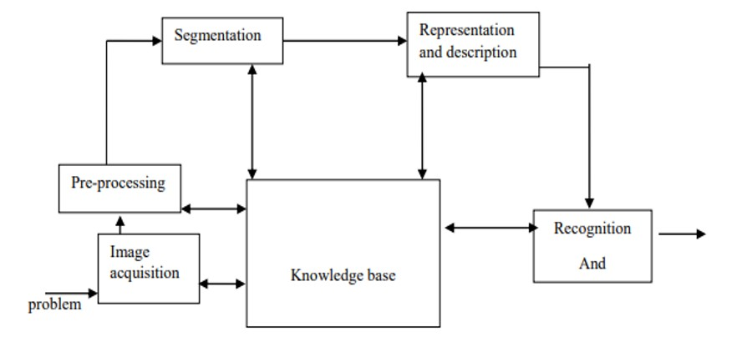

Figure A diagram showing the steps in digital image processing

#### 2.5 Definition of Terms and History

Face Detection:

Face identification is the way toward distinguishing and finding all the current appearances in a solitary picture or video paying little heed to their position, scale, direction, age and demeanor. Besides, the discovery ought to be regardless of incidental enlightenment conditions and the picture and video content.

A face Detector needs to tell whether a picture of self-assertive size contains a human face and assuming this is, where it is. Face identification can be performed dependent on a few signs: skin tone (for faces in shading pictures and recordings, movement (for faces in recordings), facial/head shape, facial appearance or a mix of these boundaries. Most face identification calculations are appearance based without utilizing other cues. An input picture is checked at all potential areas and scales by a sub window. Face location is acted like grouping the example in the sub window either as a face or a non-face. The face/nonface classifier is found out from face and non-face preparing models utilizing factual learning methods. Most present day calculations depend on the Viola Jones object recognition structure, which depends on Haar Cascades.

Face Recognition:

Face Recognition is a visual example acknowledgment issue, where the face, spoken to as a three dimensional item that is liable to differing brightening, present and different components, should be distinguished dependent on procured pictures.

Face Recognition is thusly just the undertaking of recognizing a previously identified face as a known or obscure face and in further developed cases telling precisely whose face it is.

Contrast between Face Detection and Face Recognition:

Face recognition addresses the inquiry, Where is the face? It distinguishes an article as a "face" and finds it in the info picture. Face Recognition then again responds to the inquiry who is this? Or on the other hand whose face right? It chooses if the identified face is somebody known or obscure dependent on the information base of faces it uses to approve this info image[8].It can thusly be seen that face discoveries yield (the distinguished face) is the contribution to the face recognizer and the face Recognition's yield is a ultimate conclusion for example face known or face obscure.

|  |  |  |
| --- | --- | --- |
| Face Detection Method | Advantages | Disadvantages |
| Viola Jones Algorithm | High detection Speed.  High Accuracy. | 1. Long Training Time. 2.Limited Head Pose. 3.Not able to detect dark faces. |
| Local Binary Pattern Histogram | 1.Simple computation.  2.High tolerance against the monotonic illumination changes. | 1.Only used for binary and grey images. 2.Overall performance is inaccurate compared to Viola-Jones Algorithm. |
| Ada Boost Algorithm | Need not to have any prior knowledge about face structure. | The result highly depends on the training data and affected by weak classifiers. |
| SMQT Features and SNOW Classifier Method | Capable to deal with lighting problem in object detection.  Efficient in computation. | The region contain very similar to grey value regions will be misidentified as face. |
| Neural-Network | High accuracy only if large size of image were trained. | Detection process is slow and computation is complex.  Overall performance is weaker than Viola-Jones algorithm. |

Table Advantages & Disadvantages of Face Detection Methods Viola-Jones Algorithm

Viola-Jones algorithm which was introduced by P. Viola, M. J. Jones (2001) is the most popular algorithm to localize the face segment from static images or video frame. Basically the concept of Viola-Jones algorithm consists of four parts. The first part is known as Haar feature, second part is where integral image is created, followed by implementation of Adaboost on the third part and lastly cascading process.

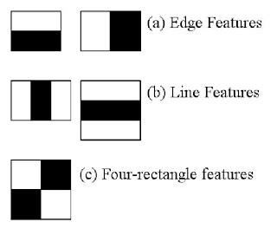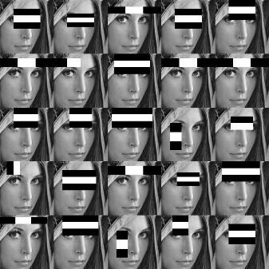

Figure Haar Feature

Viola-Jones algorithm analyses a given image using Haar features consisting of multiple rectangles (Mekha Joseph et al., 2016).

In the fig shows several types of Haar features. The features perform as window function mapping onto the image. A single value result, which representing each feature can be computed by subtracting the sum of the white rectangle(s) from the sum of the black rectangle(s) (Mekha Joseph et al., 2016).

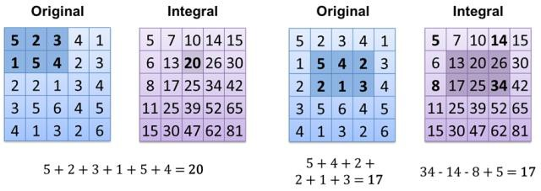

Figure Integral of Image

The value of integrating image in a specific location is the sum of pixels on the left and the top of the respective location. In order to illustrate clearly, the value of the integral image at location 1 is the sum of the pixels in rectangle A. The values of integral image at the rest of the locations are cumulative.

For instance, the value at location 2 is summation of A and B, (A + B), at location 3 is summation of A and C, (A + C), and at location 4 is summation of all the regions, (A + B + C + D) [11]. Therefore, the sum within the D region can be computed with only addition and subtraction of diagonal at location 4 + 1 − (2 + 3) to eliminate rectangles A, B and C.

Local Binary Patterns Histogram:

Local Binary Pattern (LBP) is a simple yet very efficient texture operator which labels the pixels of an image by thresholding the neighborhood of each pixel and considers the result as a binary number.

It was first described in 1994 (LBP) and has since been found to be a powerful feature for texture classification. It has further been determined that when LBP is combined with histograms of oriented gradients (HOG) descriptor, it improves the detection performance considerably on some datasets. Using the LBP combined with histograms we can represent the face images with a simple data vector.

LBPH algorithm work step by step:

LBPH algorithm work in 5 steps.

* Parameters: the LBPH uses 4 parameters:
* Radius: the radius is used to build the circular local binary pattern and represents the radius around the central pixel. It is usually set to 1.
* Neighbors: the number of sample points to build the circular local binary pattern. Keep in mind: the more sample points you include, the higher the computational cost. It is usually set to 8.
* Grid X: the number of cells in the horizontal direction. The more cells, the finer the grid, the higher the dimensionality of the resulting feature vector. It is usually set to 8.
* Grid Y: the number of cells in the vertical direction. The more cells, the finer the grid, the higher the dimensionality of the resulting feature vector. It is usually set to 8.

Training the Algorithm: First, we need to train the algorithm. To do so, we need to use a dataset with the facial images of the people we want to recognize. We need to also set an ID (it may be a number or the name of the person) for each image, so the algorithm will use this information to recognize an input image and give you an output. Images of the same person must have the same ID. With the training set already constructed, let’s see the LBPH computational steps.

Applying the LBP operation: The first computational step of the LBPH is to create an intermediate image that describes the original image in a better way, by highlighting the facial characteristics. To do so, the algorithm uses a concept of a sliding window, based on the parameters radius and neighbors.

The image below shows this procedure:

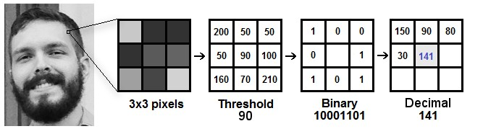

Figure LBP Operation

Based on the image above, let’s break it into several small steps so we can understand it easily:

* Suppose we have a facial image in grayscale.
* We can get part of this image as a window of 3x3 pixels.
* It can also be represented as a 3x3 matrix containing the intensity of each pixel (0~255).
* Then, we need to take the central value of the matrix to be used as the threshold.
* This value will be used to define the new values from the 8 neighbors.
* For each neighbor of the central value (threshold), we set a new binary value. We set 1 for values equal or higher than the threshold and 0 for values lower than the threshold.
* Now, the matrix will contain only binary values (ignoring the central value). We need to concatenate each binary value from each position from the matrix line by line into a new binary value (e.g. 10001101). Note: some authors use other approaches to concatenate the binary values (e.g. clockwise direction), but the final result will be the same.
* Then, we convert this binary value to a decimal value and set it to the central value of the matrix, which is actually a pixel from the original image.
* 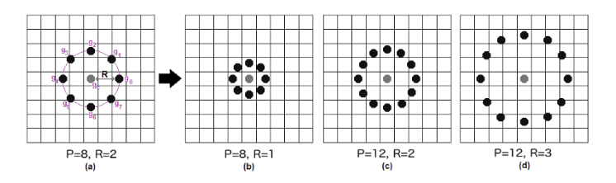At the end of this procedure (LBP procedure), we have a new image which represents better the characteristics of the original image

Figure The LBP operation Radius Change

It can be done by using bilinear interpolation. If some data point is between the pixels, it uses the values from the 4 nearest pixels (2x2) to estimate the value of the new data point.

Extracting the Histograms: Now, using the image generated in the last step, we can use the Grid X and Grid Y parameters to divide the image into multiple grids,

as can be seen in the following image:

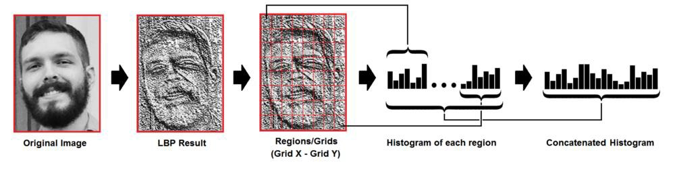

Figure Extracting The Histogram

Based on the image above, we can extract the histogram of each region as follows:

As we have an image in grayscale, each histogram (from each grid) will contain only 256 positions (0~255) representing the occurrences of each pixel intensity.

Then, we need to concatenate each histogram to create a new and bigger histogram. Supposing we have 8x8 grids, we will have 8x8x256=16.384 positions in the final histogram. The final histogram represents the characteristics of the image original image.

Performing the face recognition: In this step, the algorithm is already trained. Each histogram created is used to represent each image from the training dataset. So, given an input image, we perform the steps again for this new image and creates a histogram which represents the image.

So to find the image that matches the input image we just need to compare two histograms and return the image with the closest histogram.

We can use various approaches to compare the histograms (calculate the distance between two histograms), for example: Euclidean distance, chi-square, absolute value, etc. In this example, we can use the Euclidean distance (which is quite known) based on the following formula:

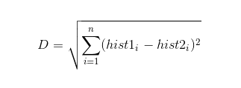

* + So the algorithm output is the ID from the image with the closest histogram. The algorithm should also return the calculated distance, which can be used as a ‘confidence’ measurement. Note: don’t be fooled about the ‘confidence’ name, as lower confidences are better because it means the distance between the two histograms is closer.

We can then use a threshold and the ‘confidence’ to automatically estimate if the algorithm has correctly recognized the image. We can assume that the algorithm has successfully recognized if the confidence is lower than the threshold defined.

## **3. Research Methodology**

Face detection involves separating image windows into two classes; one containing faces (turning the background (clutter). It is difficult because although commonalities exist between faces, they can vary considerably in terms of age, skin color and facial expression. The problem is further complicated by differing lighting conditions, image qualities and geometries, as well as the possibility of partial occlusion and disguise. An ideal face detector would therefore be able to detect the presence of any face under any set of lighting conditions, upon any background. The face detection task can be broken down into two steps. The first step is a classification task that takes some arbitrary image as input and outputs a binary value of yes or no, indicating whether there are any faces present in the image. The second step is the face localization task that aims to take an image as input and output the location of any face or faces within that image as some bounding box with (x, y, width, height).After taking the picture the system will compare the equality of the pictures in its database and give the most related result.

We will use Raspbian operating system, open CV platform and will do the coding in python language.

#### 3.1 Model Implementation

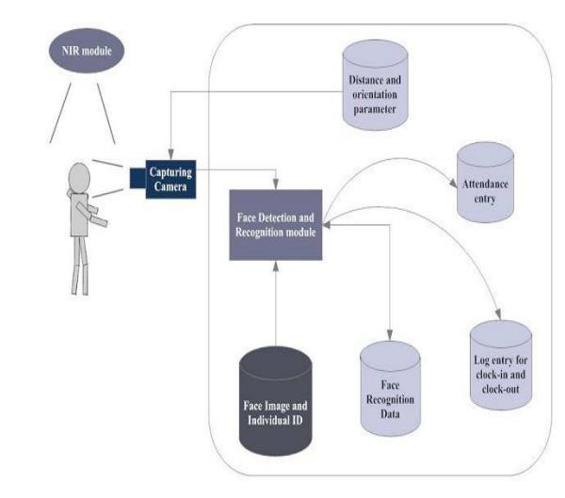

Figure Model Implement

The main components used in the implementation approach are open source computer vision library (OpenCV). One of OpenCV’s goals is to provide a simple-to-use computer vision infrastructure that helps people build fairly sophisticated vision applications quickly. OpenCV library contains over 500 functions that span many areas in vision. The primary technology behind Face recognition is OpenCV. The user stands in front of the camera keeping a minimum distance of 50cm and his image is taken as an input. The frontal face is extracted from the image then converted to gray scale and stored. The Principal component Analysis (PCA) algorithm is performed on the images and the eigen values are stored in an xml file. When a user requests for recognition the frontal face is extracted from the captured video frame through the camera. The eigen value is re-calculated for the test face and it is matched with the stored data for the closest neighbor.

#### 3.2 Design Requirements

We used some tools to build the HFR system. Without the help of these tools it would not be possible to make it done. Here we will discuss about the most important one.

##### 3.2.1 Software Implementation

**OpenCV**: We used OpenCV 3 dependency for python 3. OpenCV is library where there are lots of image processing functions are available. This is very useful library for image processing. Even one can get expected outcome without writing a single code. The library is cross-platform and free for use under the open-source BSD license. Example of some supported functions are given below:

* Derivation: Gradient / laplacian computing, contours delimitation
* Hough transforms: lines, segments, circles, and geometrical shapes detection
* Histograms: computing, equalization, and object localization with back projection algorithm
* Segmentation: thresholding, distance transform, foreground / background detection, watershed segmentation
* Filtering: linear and nonlinear filters, morphological operations
* Cascade detectors: detection of face, eye, car plates
* Interest points: detection and matching
* Video processing: optical flow, background subtraction, camshaft (object tracking)
* Photography: panoramas realization, high definition imaging (HDR), image inpainting

##### 3.2.2 Hardware Implementation

* Raspberry Pi 3
* Webcam
* Power Source
* Project Machine

## **4. Result and Discussion**

The step of the experiments process is given below:

Face Detection: Start capturing images through web camera of the client side:

* Pre-process the captured image and extract face image
* Calculate the eigen value of the captured face image and compared with eigen values of existing faces in the database.
* If eigen value does not matched with existing ones,save the new face image information to the face database (xml file).
* If eigen value matched with existing one then recognition step will done.

Face Recognition: Using PCA algorithm the following steps would be followed in for face recognition:

* Find the face information of matched face image in from the database.
* Update the log table with corresponding face image and system time that makes completion of attendance for an individual student.
* This section presents the results of the experiment conducted to capture the face into a grey scale image of 50x50 pixels.

Table Test data with results

|  |  |  |  |
| --- | --- | --- | --- |
| Test data | Expected Result | Observed | Pass/ fail |
| OpenCAM_CB() | Connects with the installed camera and starts playing. | Result Camera started. | Pass |
| LoadHaar Classifier() | Loads the HaarClassifier Cascade files for frontal face | Gets ready for Extraction. | Pass |
| ExtractFace() | Initiates the Paul-Viola Face extracting Frame work. | Face extracted | Pass |
| Learn() | Start the PCA Algorithm | Updates the facedata. xml | Pass |
| Recognize() | It compares the input face with the saved faces. | Nearest face | Pass |

Here is our data set sample.

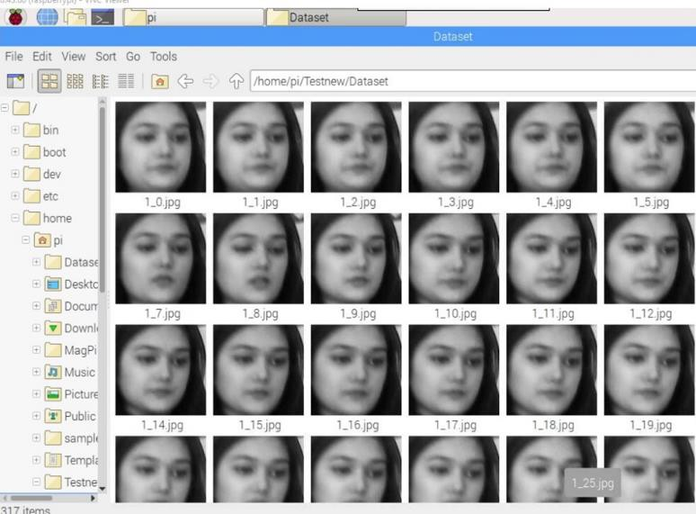

Figure Dataset sample

Table Face Detection & Recognition rate

|  |  |  |
| --- | --- | --- |
| Face Orientations | Detection Rate | Recognition Rate |
| O0 (Frontal face) | 98.7 % | 95% |
| 18º | 80.0 % | 78% |
| 54º | 59.2 % | 58% |
| 72º | 0.00 % | 0.00% |
| 90º(Profile face) | 0.00 % | 0.00% |

We performed a set of experiments to demonstrate the efficiency of the proposed method. 30 different images of 10 persons are used in training set. Figure 3 shows a sample binary image detected by the ExtractFace() function using Paul-Viola Face extracting Frame work detection method.

## **5. Conclusion**

#### 5.1 Future Scope of Work

There are so many future scope on this project. Some of them are

* + - Can improve security
    - Can use Neural Network for high accuracy
    - Can used in big factory or employee attendance
    - Can build on fully web base system

## **References**