**AD: Merve**

**SOYAD: ŞEN**

**NO: 240757048**

Step 1 – CREATE statement is main SQL command for data definition. The CREATE DATABASE statement is used to create a new SQL database.

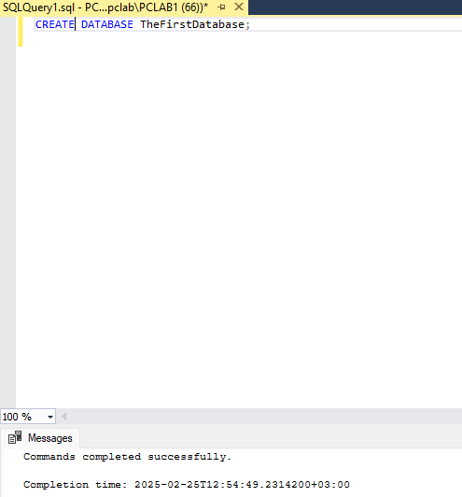

Step 2- The CREATE TABLE statement is used to create a new table in a database. Create a table named Address using the information provided in the following table

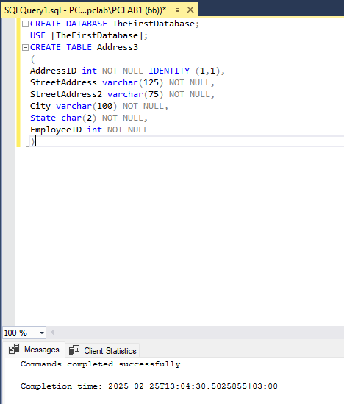

Step 3 - Create the second table named Employee for TheFirstDatabase.

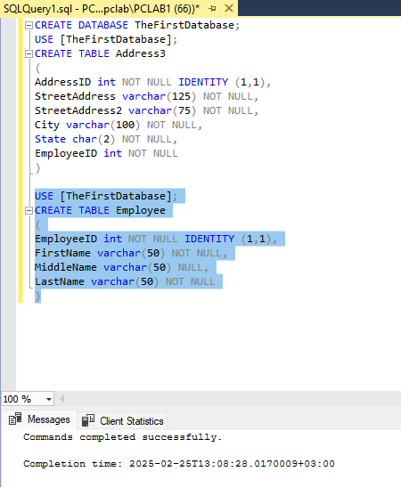

Step 4 - If you want to change one of your tables, you can add columns, change columns, and drop

columns using T-SQL.

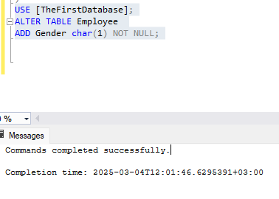

Step 5 - You can you insert data directly into columns or you can also derive columns from other columns. These columns are known as computed columns. Typically, computed columns will extend or enhance the data that is stored in traditional columns.

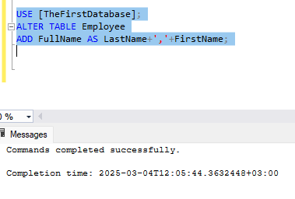

**PROCEDURE 2 - Adding constraints to a table**

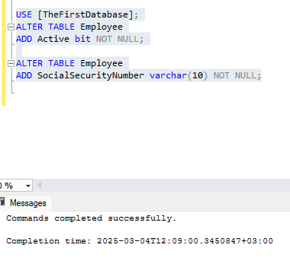Step 1 - SQL Server allows you to add several constraints to a table The primary goal of most constraints is data integrity. There are five constraints: primary key, default, unique, check, and foreign key.

Step 2 – We add the constraints: primary key, default and unique.

• A primary key is a column that contains a unique list of values Often an integer column is added to a table with the identity property and is used as the primary key.

• If you add an Active column to the Employee table that specifies whether an employee is currently working for the company, the default value will probably be true or 1. Therefore, you should set the default value for that column accordingly.

• For Social Security numbers to the Employee table. Since Social Security numbers are truly unique values, you should add a unique constraint to ensure that a given Social Security number is entered only once.

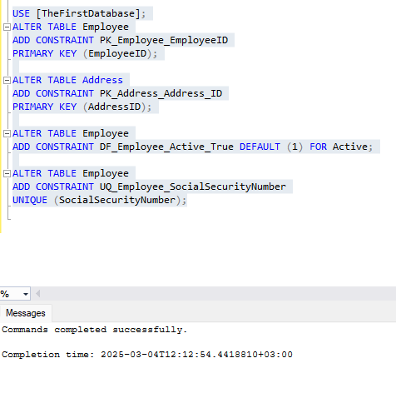

Step 3 - To ensure that only employee IDs that exist in the Employee table are inserted into the Address table, you need to create a foreign key constraint.

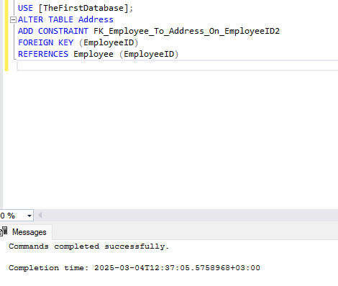

**PROCEDURE 3- INSERT, DELETE, and UPDATE Statements in SQL**

Step 1- Insert into statement is used to add one row or multiple rows to the table. Using this method, you can insert data into all columns, specific columns, identity columns, and several other variations.

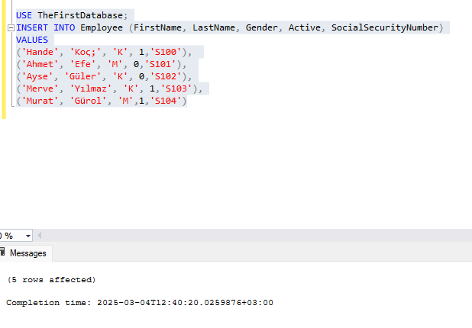 • We can add data to Employee table using T-SQL.

• We can add data to Address table using T-SQL

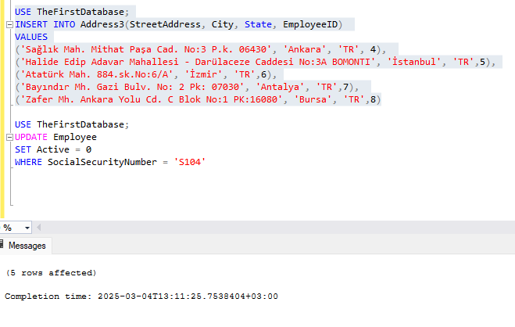

Note that; The column list is optional in the INSERT INTO statement, but for purposes of clarity, it's always recommended If it is not included, the values are inserted into the table based on the order of the columns. The identity columns are not included in the order.

Step 2- When you want to modify one row or several rows in table, you use UPDATE statement. You should be cautious when issuing an UPDATE statement, as it is highly unlikely that every row in a table needs updating. Therefore, always consider including a WHERE clause with every UPDATE statement.

• For the data in the Employee table where the social security number is S104, we change the value in the Active Column from 1 to 0.

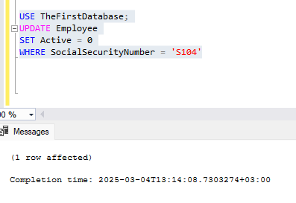

Step 3 - When you want to delete one row or several rows in table, you use DELETE statement. As with the UPDATE statement, always consider including a WHERE clause when executing a DELETE statement. If you do not include WHERE as part of the DELETE statement, all the data will be removed after the query is executed.

• We delete the data in the Address table where the Employee ID is 8.

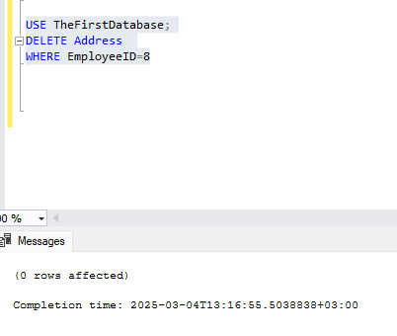

**PROCEDURE 4 - Basic Retrieval Queries in SQL**

Step 1- SELECT statement is one basic statement for retrieving information from a database.

• Retrieve the Full Name and Social Security Number of the Employee(s) whose name is

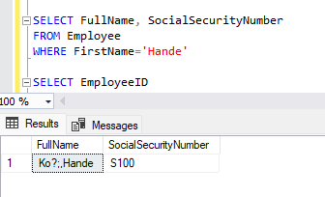

• Retrieve the Employee ID of all employees who live in TR

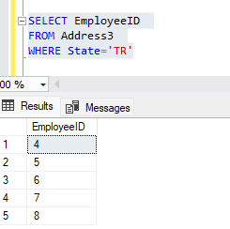

• Retrieve the First Name, Last Name, Gender and Street Address for all employees who live Antalya.

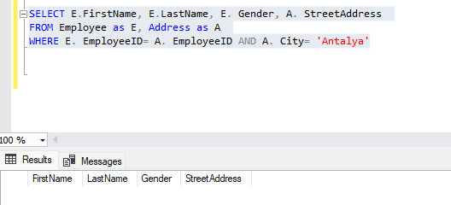

Step 2- CROSS PRODUCT returns all combinations of Employee and Address tables in the database

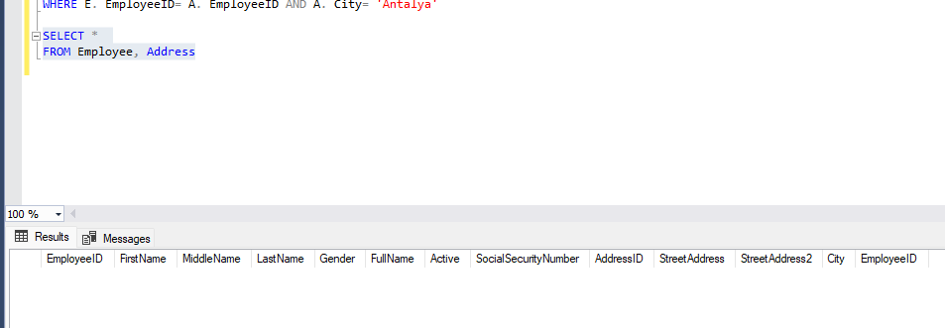

Step 3 – By placing DISTINCT immediately following the SELECT keyword, you remove any duplicates from the list. The following SQL statement selects only the DISTINCT values from the "Gender" column in the "Employee" table:

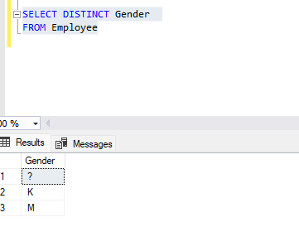

Step 4- The UNION ALL command combines the result set of two or more SELECT statements (allows duplicate values). The following SQL statement returns the Employe ID (duplicate values also) from both the "Employee" and the "Address" table:

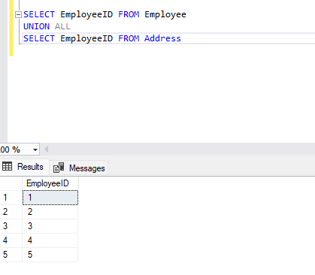

Step 5 - The UNION command combines the result set of two or more SELECT statements (only distinct values). The following SQL statement returns the Employe ID (only distinct values) from both the "Employee" and the "Address" table:

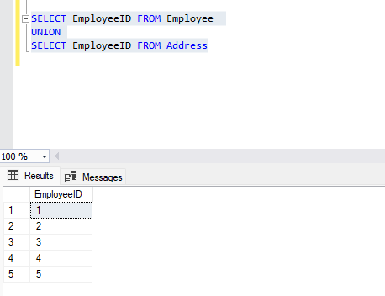

Note that; When writing a query with UNION and UNION ALL, both SELECT statements must contain the same number of columns, and the data types must match for each column.

Step 6 - We use ORDER BY clause for ordering of query results.

• We add keyword ASC to specify ascending order explicitly.

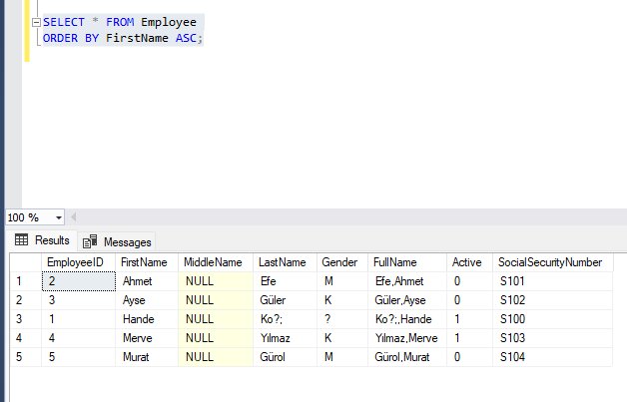

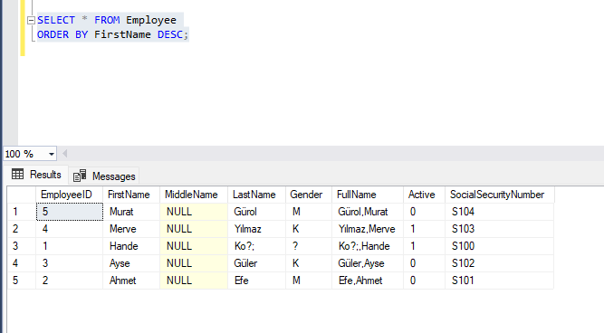• We add keyword DESC to see result in a descending order of values

SUMMARY In this Lab, you learned to create tables that contain columns of varying data types. You learned how to add constraints to the tables and columns that assist in ensuring the consistency and validity of the inserted or modified data. In addition, you learned to write the simple retrieval queries and insert, update, delete commands for the tables.