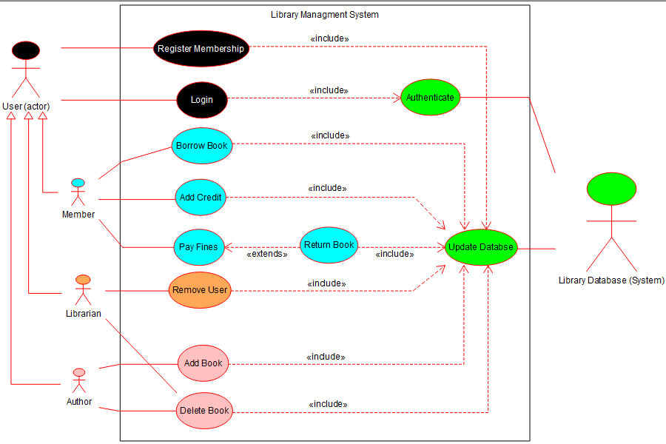

GUI Rough Idea

NOTE: TEXT IN RED IS EXTRA INFORMATION YOU DON’T NEED TO WORRY ABOUT, JUST GIVEN FOR CONTEXT.

EXTRA NOTE: I hope I didn’t make this too complicated. If you got any other ideas or modifications feel free to do them. You’re awesome! Stay Awesome! <3

**Screen 0 (Login Screen):**

* Standard login screen, entering false credentials shows an error pop-up.
* Contains a “Register” button that starts a new Registration Screen (screen 1) on click.
* *Successful login sends you to one of the other screens (no need to worry about implementation)*

**Screen 1 (Registration Screen):**

TBD

**Screen 2 (Member Screen):**

This screen contains:

* The user can select a book from a list of available books (Combo Box).
* A “Burrow” Button. On click:
  + If nothing is selected: a pop-up shows up saying something like “please select a book”.
  + If a book is selected, a pop-up shows up saying something like “you selected XYZ” (no need to worry about the functionality)
* A text field where a number can be entered (this is where a member can add the credit to their account)
* An “Add Credit” Button. On click, pop-up: “Added X amount”, where X is the value in the previous text field.
* Another combo box containing the books the user has currently borrowed.
* A “Pay Fines” Button. On click:
  + If not enough credit: a pop-up saying ”Not enough credit”
  + Otherwise: a pop-up saying “Fines payed, would you like to return the book?” + yes/no buttons

**Screen 3 (Librarian Screen):**

Contains:

* A combo list of available non-librarian users
* A “Remove User” button.
* A combo list of available books not borrowed by a user.
* A “Remove Book” button.

**Screen 4 (Author Screen):**

TBD