Tools for Software Development
Final Project Report
System Under Test: Demo Web Shop (demowebshop.tricentis.com)
Team: TeamVeryOrganized
ESIEA Summer School — Žilina, Slovakia — July 2026
Course: Tools for Software Development | Instructor: doc. Ing. Jozef Kostolný, PhD.

1. Introduction
This report documents the complete software testing project carried out by TeamVeryOrganized during the ESIEA Summer School course “Tools for Software Development”. Over six lab sessions, the team designed and executed a full, layered testing strategy against a public e-commerce sandbox application: unit testing, manual functional testing, and automated testing across the UI (Selenium, Robot Framework) and API (Postman) layers.
The goal of the project was not only to produce working test artifacts, but to demonstrate a coherent testing story: a rationale for what was tested, how tests were designed, what was automated and why, what defects were found, and what the team learned from the process. This report follows the structure requested by the course and consolidates the outputs of Labs 1 through 6 into a single deliverable.

2. Team and Roles
Prepared by: Khalid Oumarou (Documentation Lead)
The team is composed of six members, each owning one lab and its corresponding deliverables, with one member additionally responsible for repository structure and final report/presentation assembly.
Name | Role | Lab owned | Responsibilities
Simon Almeida | Test Manager | Lab 2 | JUnit unit testing, project/application selection, coordination
Antoine | Test Designer | Lab 3 | Test plan, manual test cases, test design techniques, defect reporting
Louis | Automation Tester (UI) | Lab 4 | Selenium WebDriver UI automation
Emilien | Automation Tester (UI) | Lab 5 | Robot Framework keyword-driven automation
Luccas Collas | API Tester | Lab 6 | Postman API test collection
Khalid Oumarou | Documentation Lead | Repository | Repository structure, GitHub access, final report and presentation assembly
Note: role mapping confirmed by the team; if any name/role pairing needs correction, update this table before submission.

3. Tested Application
Prepared by: Simon Almeida
Field | Value
Name | Demo Web Shop
URL | https://demowebshop.tricentis.com
Type | Public e-commerce sandbox (nopCommerce-based), maintained by Tricentis
API sandbox (Lab 6) | https://jsonplaceholder.typicode.com (Demo Web Shop exposes no public REST API)
The application was selected because it is publicly accessible with no installation required, exposes at least five independently testable features (search, product detail, cart, registration/login, checkout), contains realistic forms and validation logic, is a stable long-running public demo, and does not process real payments or sensitive personal data — making it safe and repeatable to test.

4. Test Scope

In scope
- User registration and login/logout
- Product search (including no-result handling)
- Product detail and add-to-cart
- Shopping cart management (update quantity, remove)
- Checkout with billing address and required-field validation
- Newsletter subscription (email validation)

Out of scope
- Real payments and order fulfilment
- Admin / back-office
- Performance and load testing
- Mobile-native applications
- Public REST API testing on Demo Web Shop itself (no API exposed; Lab 6 substitutes the JSONPlaceholder sandbox)

5. Test Plan
Prepared by: Antoine
Full details in docs/test-plan.md. Summary below.
Item | Value
Objectives | Verify the core user journey end to end (register → login → search → cart → checkout); verify input validation on key forms; confirm cart state transitions; build an automation candidate shortlist
Test types | Manual functional, UI, negative/validation, light regression
Environment | Google Chrome (stable), Windows 11, test date 2026-07-09
Entry criteria | App reachable; shared test account registered; Chrome installed
Exit criteria | All planned manual cases executed and recorded; every failed case has a matching defect report; 2–3 automation candidates selected

Test design techniques used (6)
- Equivalence partitioning — valid vs invalid email formats
- Boundary value analysis — password length, cart quantity edges
- Decision table — login outcomes for valid/invalid email × password combinations
- State transition — cart lifecycle (empty → added → updated → removed → empty)
- Use case testing — full purchase workflow
- Error guessing — empty required fields, whitespace-only inputs

Risk register
# | Risk | Impact | Mitigation
1 | Demo app changes or goes offline without notice | High | Check availability before each run; record app version/date tested
2 | Dynamic elements break locators | Medium | Prefer stable ids/names; avoid positional XPath
3 | No public REST API on the SUT | Medium | Lab 6 targets the JSONPlaceholder sandbox instead
4 | Login required for checkout flow | Low | One shared account, documented in the test plan
5 | Team member unavailable | Medium | Folder ownership + up-to-date docs so anyone can continue

6. Manual Test Cases
Prepared by: Antoine
12 manual test cases were designed and executed: 3 positive, 3 negative, 2 boundary/equivalence, 2 workflow, and 2 extra cases. Full detail (preconditions, test data, steps) is in manual-tests/manual-test-cases.md and the filled results in manual-tests/manual-test-cases.xlsx.
ID | Feature | Type | Technique | Result
TC-001 | Registration | Positive | Use case testing | Passed
TC-002 | Login | Positive | Use case testing | Passed
TC-003 | Search | Positive | Use case testing | Passed
TC-004 | Login | Negative | Decision table | Passed
TC-005 | Login | Negative | Error guessing | Passed
TC-006 | Registration | Negative | Equivalence partitioning | Passed
TC-007 | Registration (password length) | Boundary | Boundary value analysis | Passed
TC-008 | Newsletter | Boundary/equivalence | Equivalence partitioning | Passed
TC-009 | Search → Cart → Checkout | Workflow | Use case testing | Passed
TC-010 | Shopping cart | Workflow | State transition | Passed
TC-011 | Search (no results) | Negative/equivalence | Equivalence partitioning | Passed
TC-012 | Checkout (empty required field) | Boundary/validation | Boundary value / error guessing | Failed
11 of 12 cases (91.7%) passed as expected. TC-012 failed: the checkout form accepted an empty required “Last name” field. This failure was formally documented as BUG-001 (Section 7).

Automation candidates selected
- TC-002 (Login) — core journey, stable locators, objective assertion
- TC-003 (Search) — simple, deterministic, high regression value
- TC-010 (Cart add/remove) — clear state assertions
TC-009 (end-to-end purchase) was deliberately deferred to a later automation pass: it is high-value but long and more fragile. Exploratory/visual-judgement checks were intentionally excluded from automation, since their value lies in human observation rather than repeatable assertions.

7. Defect Report
Prepared by: Antoine
Field | Value
Defect ID | BUG-001
Title | Checkout continues with an empty required “Last name” field
Related test case | TC-012
Severity / Priority | Major / High
Status | Open
Environment | Demo Web Shop, Google Chrome, Windows 11

Steps to reproduce
- 1. Log in with the shared test account
- 2. Add any product to the cart
- 3. Open the cart, accept the terms of service, click Checkout
- 4. On the Billing address step, leave “Last name” empty; fill all other required fields
- 5. Click Continue

Expected vs. actual result
Expected: the form is blocked with an inline validation message (“Last name is required.”) and the user cannot proceed.
Actual: the form is accepted with the field empty and checkout advances to the next step, allowing an order to be placed with an incomplete billing name.
Suggested fix: enforce required-field validation on “Last name” both client-side and server-side, consistent with the “First name” field.

8. JUnit Exercise (Lab 2)
Prepared by: Simon Almeida
Class under test: com.tsd.rating.Rating (addRating(int), getAverageRating()). Framework: JUnit 5. Build/coverage: Maven + JaCoCo.
# | Test | Technique | Result
1 | averageOfSeveralValidRatingsIsComputedCorrectly | Positive / nominal | PASS
2 | minimumValidRatingOneIsAccepted | Boundary (lower, 1) | PASS
3 | maximumValidRatingFiveIsAccepted | Boundary (upper, 5) | PASS
4 | ratingOfZeroJustBelowMinimumIsRejected | Boundary (0, invalid) | PASS
5 | ratingOfSixJustAboveMaximumIsRejected | Boundary (6, invalid) | PASS
6 | negativeRatingIsRejected | Invalid input | PASS
7 | computingAverageWithoutAnyRatingThrowsException | Empty-state / error | PASS
8 | averageOfTwoRatingsIsCorrectedToExpectedValue | Formerly failing (fixed) | PASS
Test #8 initially asserted the wrong expected value (5.0 instead of the correct average 3.0 for ratings 2 and 4). It was left to fail on purpose to demonstrate that the suite correctly catches an incorrect expectation, then fixed.

Coverage (JaCoCo)
Metric | Result
Instructions | 94.0%
Branches | 100%
Lines | 92.9%
Methods | 75%
The only uncovered element is the secondary accessor getRatingCount(), never called by the current tests. All decision branches of addRating and getAverageRating (bounds 1–5, empty list) are fully covered.
What coverage shows: every line and branch of the business logic executed at least once — good confidence the code is not dead and that nominal, boundary and error paths are exercised. What coverage does NOT prove: it does not guarantee the absence of logic bugs, nor the strength of assertions; a line can execute without being meaningfully checked, and 100% coverage does not account for un-imagined cases.
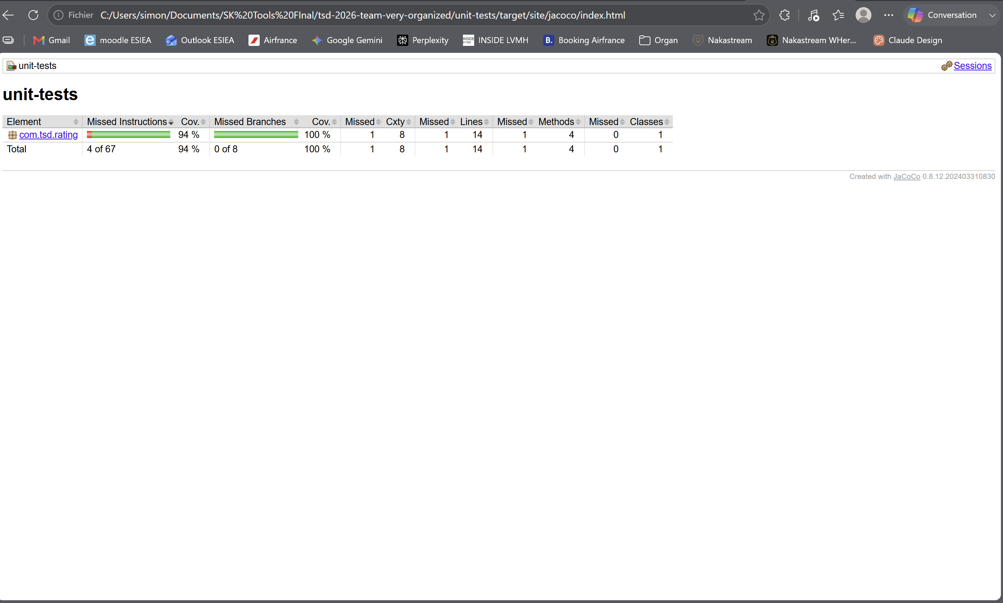
Figure 1 — JaCoCo coverage report (unit-tests module): 94% instructions, 100% branches.

9. Selenium Tests (Lab 4)
Prepared by: Louis
Tool: Selenium WebDriver 4 with Java + JUnit 5 (src/test/java/DemoWebShopUITest.java), executed from the repository root with mvn test.
Test | Assertion | Result
shouldLoginSuccessfully | Header account link contains the account email | PASS
shouldSearchProduct | Search input #Q retains value “book” | PASS
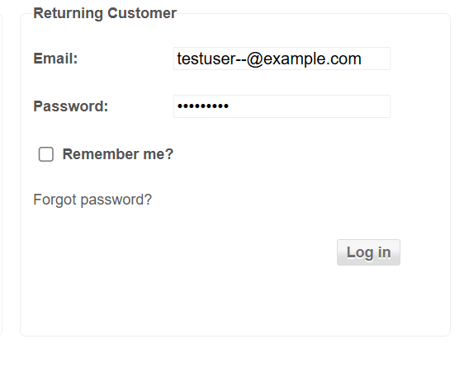
Figure 2 — Selenium test execution evidence (Lab 4).
Problem found: the positive login test depends on the shared account being registered on the site beforehand. Before registration, it failed with the account link not found; once the account existed, the test passed reliably. The search test has no such dependency.
What was deliberately kept manual: the multi-step checkout / billing form (TC-011). It is stateful and its value comes from judging on-screen validation messages, which is better assessed by a human than by a brittle multi-step automated script at this stage.

10. Robot Framework Tests (Lab 5)
Prepared by: Emilien
ID | Description | Type | Result
TC-001 | Login with valid credentials should succeed | Positive | PASS
TC-NEG-001 | Login with wrong password should show an error | Negative | PASS
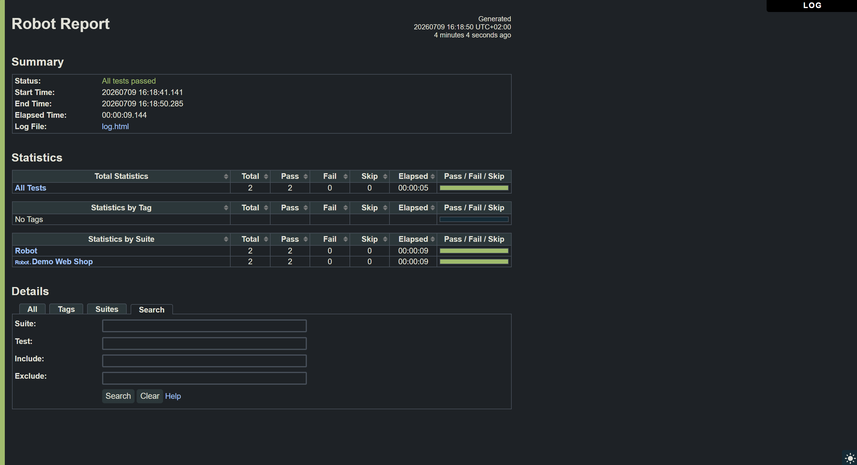
Figure 3 — Robot Framework report.html: 2 tests, 2 passed, 0 failed.

Custom keywords
- Open Browser To Login Page — opens Chrome on /login and checks the page title
- Submit Login Form — parameterised keyword: types email + password and clicks Log in
Variables used: ${BASE_URL}, ${BROWSER}, ${EMAIL}, ${PASSWORD}, ${VALID_SEARCH}. HTML report and log regenerated at reports/report.html and reports/log.html.
Final result: 2 tests, 2 passed, 0 failed.

Problem found and fixed: a real timing (race condition) bug
During execution, TC-001 initially failed intermittently with “Page should have contained text ‘Log out’ but did not”, even though a manual login with the same credentials succeeded. The keyword clicked “Log in” and immediately asserted on the resulting page with Page Should Contain, which checks the DOM exactly once at that instant — before the browser had finished redirecting to the logged-in page. A failure screenshot captured by Robot Framework at the moment of the assertion actually showed the account already logged in, confirming the diagnosis.
Fix: replaced the one-shot assertion with a polling wait, which retries for up to 5 seconds instead of checking a single instant:
Page Should Contain Log out
Wait Until Page Contains Log out timeout=5s
This is a textbook example of UI-automation flakiness caused by timing rather than by the application itself, and is referenced again in Lessons Learned (Section 14).

Selenium vs. Robot Framework — comparison
Criterion | Selenium (Java) | Robot Framework
Readability | Requires Java knowledge to read | Near-natural language, readable by non-developers
Development effort | Baseline | Equivalent — underlying keywords need the same locator/assertion work
Debugging | Stack traces point closer to the real cause | Errors often surface low-level WebDriver details (e.g. session exceptions), less direct
Reporting | Needs an external tool for HTML reports | report.html / log.html generated automatically
Scalability | Better suited to complex/conditional logic | Becomes limiting for rich conditional or data-driven scenarios
Verdict: Robot Framework was well suited to this project’s simple, linear UI smoke tests and produced the most reader-friendly reports; Selenium remains the stronger choice if the automation suite were to grow in logical complexity.

11. Postman / API Testing (Lab 6)
Prepared by: Luccas Collas
Collection: “TSD 2026 - TeamVeryOrganized - API Tests”, targeting the JSONPlaceholder sandbox (https://jsonplaceholder.typicode.com), since Demo Web Shop itself has no public REST API.
# | Method | Endpoint | Type | Assertions
1 | GET | /users | Positive | Status 200; non-empty list; first user has an email field
2 | GET | /users/1 | Positive | Status 200; id equals 1; required fields present (name, email)
3 | POST | /posts | Positive | Status 201; submitted title is echoed back
4 | GET | /users/999999 | Negative | Error / not-found status returned
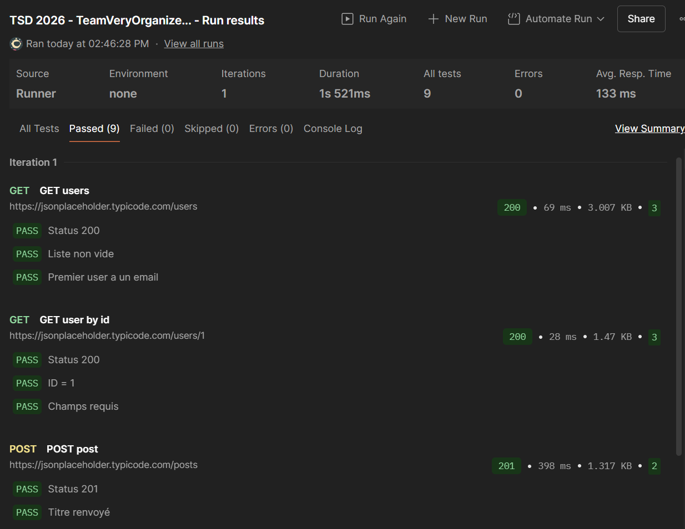
Figure 4 — Postman Collection Runner result: 4 requests, 9 assertions, all passed.
Result: 4 requests / 9 assertions, all passed. The collection is exportable and runnable both from the Postman Collection Runner and via the Newman CLI runner for potential CI/CD integration.

12. Results Summary
Prepared by: Khalid Oumarou (compiled from all lab owners)
Layer | Tool | Tests / Requests | Passed | Failed
Manual | Exploratory + scripted | 12 cases | 11 | 1 (BUG-001)
Unit | JUnit 5 + JaCoCo | 8 tests | 8 | 0
UI | Selenium | 2 tests | 2 | 0
UI | Robot Framework | 2 tests | 2 | 0
API | Postman | 4 requests / 9 assertions | 9 assertions | 0
Across all layers, 33 individual checks were executed (12 manual cases, 8 unit tests, 2 Selenium tests, 2 Robot tests, 9 Postman assertions); 32 passed and 1 failed, giving an overall pass rate of approximately 97%. The single failure is a real, reproducible defect (BUG-001), not a flaky or environmental failure — which is a positive signal about the reliability of the test suite itself. One additional automation issue was found and fixed during the project: an intermittent Robot Framework failure caused by a timing/race condition rather than an application defect (Section 10); once corrected, Robot Framework’s own pass rate is 2/2.

13. Limitations
Prepared by: Whole team
- The tested application changed mid-project (from an initial SauceDemo-based plan to Demo Web Shop); some early planning artifacts had to be re-aligned, costing coordination time.
- Demo Web Shop exposes no public REST API, so API testing (Lab 6) targets an unrelated sandbox (JSONPlaceholder) rather than the same system under test — this weakens the end-to-end coherence of the API layer relative to the UI/unit layers.
- UI automation (Selenium and Robot Framework) both depend on a single shared, manually pre-registered account; this is a single point of failure if the account or session state changes on the demo server.
- No performance, load, security, or accessibility testing was in scope.
- Automated UI coverage (4 tests total) is a small slice of the 12 documented manual cases; several validated behaviours (e.g. the full checkout workflow) remain manual only.
- The project was executed under a tight timeline (same-day Lab 6 and final submission), limiting the depth of exploratory testing and cross-review.

14. Lessons Learned
Prepared by: Whole team
- API tests (Postman) were the fastest to write and the most stable to run; UI tests were the most fragile, mainly due to authentication/session state and locator stability.
- UI automation that logs in requires the account to actually exist on the target system — registering the shared account first was the fix for both the Selenium and the Robot Framework flaky positive-login failures.
- Sharing a single browser/session across tests (encountered while developing Lab 5) can leak state between test cases; isolating each test with its own setup/teardown removes this class of bug.
- A Robot Framework login test failed intermittently even though the credentials were correct: the assertion (Page Should Contain) checked the page a single instant after the click, before the browser had finished redirecting. Replacing it with a polling wait (Wait Until Page Contains, 5s timeout) fixed it — a reminder that UI test flakiness is often a timing problem, not a data or application problem.
- Code coverage is a useful signal for spotting untested code paths, but it is not a proxy for test quality — strong assertions matter more than raw percentage.
- Robot Framework’s natural-language style and built-in HTML reporting made results easier to communicate to non-technical readers, at some cost to low-level debuggability compared to Selenium/Java.
- Centralising configuration (URLs, credentials, locators) in a single variables file made the automation suites easy to retarget and reduced duplication across test files.

15. Proposals for Improvement
The following improvements are proposed as natural next steps beyond the scope of this course project:
- Integrate the full suite (JUnit, Selenium, Robot Framework, Newman/Postman) into a CI/CD pipeline (e.g. GitHub Actions) to run on every push and surface regressions automatically.
- Replace the single shared UI account with a dedicated setup step (API-based or scripted account provisioning) to remove the current single point of failure in the UI automation.
- Expand automated UI coverage to include the end-to-end checkout workflow (TC-009) and the cart state-transition case (TC-010), which are currently manual-only or partially automated.
- Fix and re-verify BUG-001 (empty required “Last name” field), then add a regression test that specifically guards against this defect reappearing.
- Introduce data-driven testing (parameterised JUnit tests, Robot Framework test templates, or a Postman data file) to broaden boundary and equivalence coverage without duplicating test code.
- Adopt Newman with a scheduled run to give the API layer the same continuous-execution treatment as the UI layers, closing the coherence gap noted in the Limitations section.
- For future iterations, select a system under test that exposes both a UI and a matching public API, so all four test layers validate the same application end to end.

16. Conclusion
TeamVeryOrganized delivered a complete, layered testing project against the Demo Web Shop application: 8 unit tests with over 92% line coverage, 12 designed and executed manual test cases using six recognised design techniques, one formally documented defect, 4 automated UI tests split across two frameworks (Selenium and Robot Framework), and a 4-request Postman API collection with 9 passing assertions. Overall, 32 of 33 individual checks passed (≈ 97%), and the single failure corresponds to a genuine, reproducible application defect rather than test flakiness.
Beyond the numbers, the project demonstrated the full testing lifecycle taught in the course: choosing and scoping a system under test, designing tests deliberately rather than ad hoc, automating selectively based on stability and value, and documenting evidence honestly — including the one test that failed. The limitations and proposals above outline a realistic path to extend this work into a continuously-run, more tightly integrated test suite.

