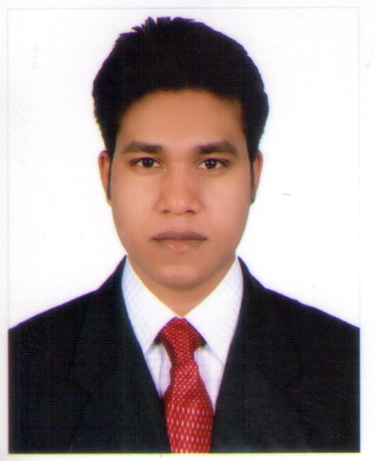
CURRICULUM VITA
OF
Md. Abdul Khalek
Ka-126, Joar Shahara Bazar, Vatara, Dhaka-1229.
Cell: 01738-646453
Email: akkhancse@gmail.com

Career Objective

Have a strong desire to dedicate myself for the profession where experience, research, study analysis & innovation are mandatory. In addition I am determined to offer honesty, efficiency, sincerity up to the optimum level.
Academic Certification
B. Sc in Computer Science & Engineering (BCSE):
Institute :Royal University of Dhaka
Department :Computer Science & Engineering
Result :CGPA: 3.52 (Out of 4.00)
Passing Year :2016
Diploma in Computer Science & Engineering (Four years course):

Institute :Institute of Information Technology Bogra.
Board :Dhaka.
Department :Computer Science.
Result :CGPA: 3.22 (Out of 4.00)
Passing Year :2012
Dakhil:

Institute : Habibpur Baitul Ulum Sariati Islamia Dakhil Madrasah.
Board : Madrasa Board, Dhaka.
Group : General.
Result : GPA:4.56(Out of 5.00)
Passing Year : 2008.
Experience
Organization :Intelligent Image Management Ltd.
Designation :Sr. Supervisor.
Department :Production & maintenances (Computer).
Duration :On 01 January_2013 to 01 February_2017
Experience
6 months Industrial Training Techno Flicker IT solution. Joleswaritola, Bogra.

Computer Skills

MS Office, Internet Browsing , Application Software, Operating System, Hardware & Networking, Web Design & Development.

Language Competency

Bengali : Mother Tongue.
English : Speaking & Writing.

Hobby/Interested

Cricket, Traveling & Reading Book etc.

Personal Details

Name : Md. Abdul Khalek
Father’s Name : Late, Md. Mamotaj Ali
Mother’s Name : Maleka Begum
Permanent Address : Vill: Chalkdurga, Pos:Mukundopur,
P.S: Birampur, Dist: Dinajpur.
Date of Birth : 01/01/1993.
Religion : Islam.
Nationality : Bangladeshi (By birth).
Marital Status : Un-married.
Height : 5 Feet 7” (Inches).
Gender : Male.
Blood Group : B (+)ve.

Reference
Md Mokarram Hossain.
Pran RFL Group
Manager
Kaligong, Dhaka.
Cell No: 01723-308835

Md Mahdy Hassan.
Sollar Executive
Joar Shahara Bazar, Vatara, Dhaka.
Cell No: 01768-922247

Md. Abdul Khalek

Date: --------------------

