Traffic Violation Tracking and Feedback Management System

Requirements Traceability Matrix

Functional Requirements
Requirement ID | Functional Requirement | Module | Priority
FR-01 | The system should allow drivers to log in using valid credentials. | User Authentication | High
FR-02 | The system shall allow drivers to view a dashboard summary after logging in. | Driver Dashboard | High
FR-03 | The system shall allow drivers to view all cases linked to their account. | Case Management | High
FR-04 | The system shall allow drivers to view full details of a selected violation. | Violation Tracking | High
FR-05 | The system displays the date and time of each violation. | Violation Tracking | High
FR-06 | The system shall allow drivers to access evidence attached to their violations. | Evidence Management | High
FR-07 | The system shall allow drivers to search and filter their violation history. | Violation History | Medium
FR-08 | The system shall allow drivers to appeal violations they believe are unjust directly through the system. | Appeal Management | High
FR-09 | The system shall allow drivers to pay fines through the system. | Payment Management | High
FR-10 | The system should send drivers timely notifications related to their cases. | Notifications | High
FR-11 | The system shall allow drivers to update their profile contact information. | Profile Management | Medium
FR-12 | The system should allow drivers to request a detailed violation report. | Reporting | Medium
FR-13 | The system shall allow general users to check vehicle-related cases without logging in. | Vehicle Search | High
FR-14 | The system should hide sensitive personal information from public vehicle search results. | Vehicle Search | High
FR-15 | The system shall allow traffic officers to log in and manage their assigned cases. | Officer Management | High
FR-16 | The system shall allow traffic officers to record violations. | Violation Tracking | High
FR-17 | The system shall allow traffic officers to organize violations under cases. | Case Management | High
FR-18 | The system allows traffic officers to view and maintain complete case records. | Case Management | High
FR-19 | The system shall allow traffic officers to attach evidence to violations. | Evidence Management | High
FR-20 | The system shall allow traffic officers to update case outcomes and progress. | Case Management | High
FR-21 | The system shall allow traffic officers to handle appeals submitted by drivers. | Appeal Management | High
FR-22 | The system shall allow traffic officers to resolve disputes about violations. | Dispute Management | High
FR-23 | The system shall allow traffic officers to review and update multiple cases in a batch. | Case Management | Medium
FR-24 | The system should allow traffic officers to issue warnings for minor infractions. | Violation Tracking | Medium
FR-25 | The system should allow traffic officers to view driver violation points and flag high-risk behaviors. | Points and Risk Management | High
FR-26 | The system shall allow traffic authorities to generate analytics and reports. | Analytics and Reporting | Medium
FR-27 | The system shall allow traffic authorities to view high-risk zones identified from violation patterns. | Analytics and Reporting | Medium
FR-28 | The system shall allow traffic authorities to access long-term violation trends. | Analytics and Reporting | Medium
FR-29 | The system shall allow traffic authorities to configure automated alerts for serious violations. | Notifications | High

Non-Functional Requirements
Requirement ID | Non-Functional Requirement | Quality Attribute | Related Module | Priority
NFR-01 | The system shall handle up to 100,000 concurrent users without performance degradation. | Performance | All Modules | High
NFR-02 | The system should be scalable to accommodate future growth in users and transactions. | Scalability | All Modules | Medium
NFR-03 | The system shall maintain 99.9% up time to ensure continuous availability. | Availability | All Modules | High
NFR-04 | The system shall encrypt sensitive data at rest and in transit to prevent unauthorized access. | Security | All Modules | High
NFR-05 | The system should provide an intuitive, easy-to-navigate interface for all users. | Usability | User Interface | High
NFR-06 | The system shall support all major web browsers and mobile platforms (iOS, Android). | Compatibility | Web and Mobile Interface | High
NFR-07 | The system shall ensure accurate recording and maintenance of all data without corruption. | Data Integrity | Data Management | High
NFR-08 | The system shall respond to user requests within 3 seconds under normal conditions. | Response Time | All Modules | High
NFR-09 | The system shall have automated backups and restore functionality within 30 minutes after failure. | Backup and Recovery | Backup and Recovery | High
NFR-10 | The system shall comply with relevant data protection regulations like GDPR and local traffic laws. | Compliance | All Modules | High
NFR-11 | The system should be easy to maintain, with clear documentation and modular design for future updates. | Maintainability | All Modules | Medium
NFR-12 | The system shall integrate seamlessly with existing government and law enforcement databases. | Interoperability | External Integration | High
NFR-13 | The system should support multiple languages to accommodate diverse user populations. | Localization | User Interface | Medium
NFR-14 | The system shall provide an audit trail for all user interactions and system actions to ensure transparency. | Auditability | Audit Logging | High
NFR-15 | The system will optimize resource usage (CPU, memory, bandwidth) to minimize operational costs. | Resource Efficiency | All Modules | Medium

SOFTWARE DESIGN

System Design

Use Case Diagram
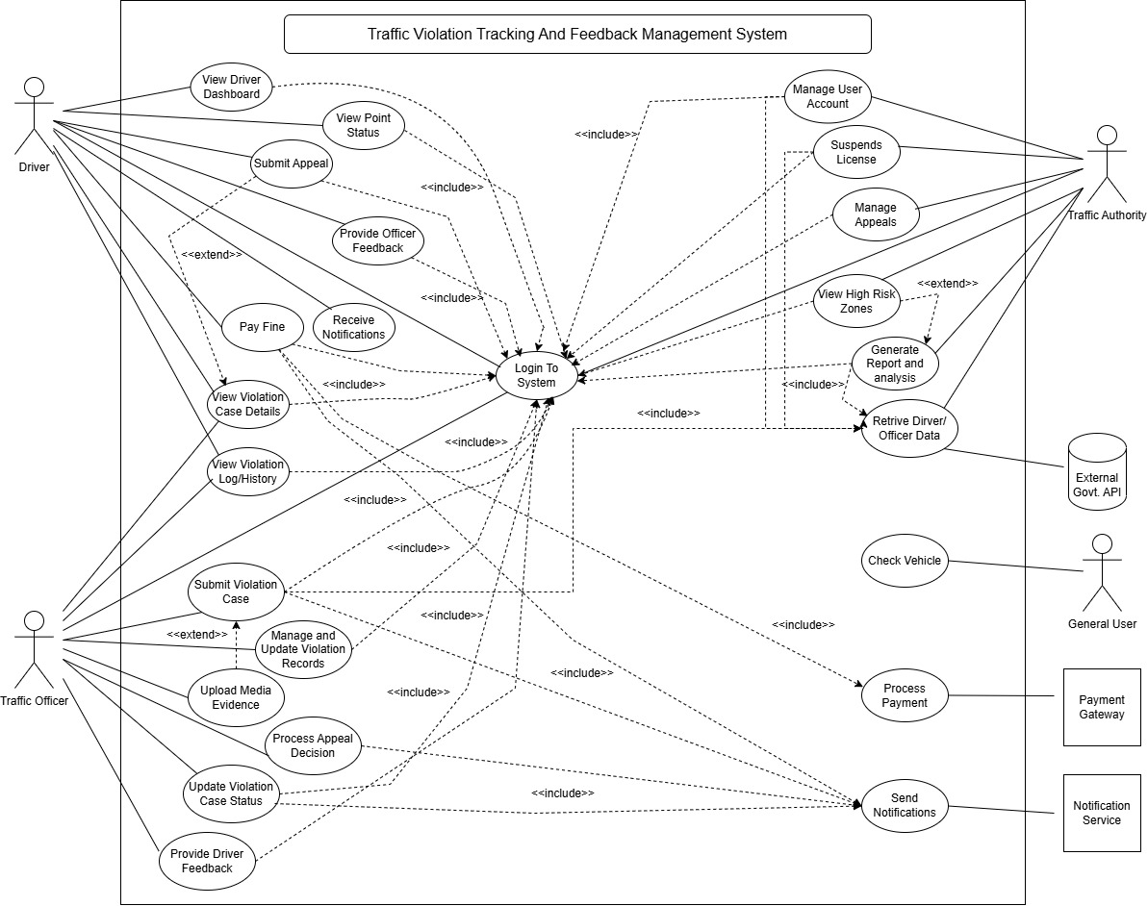

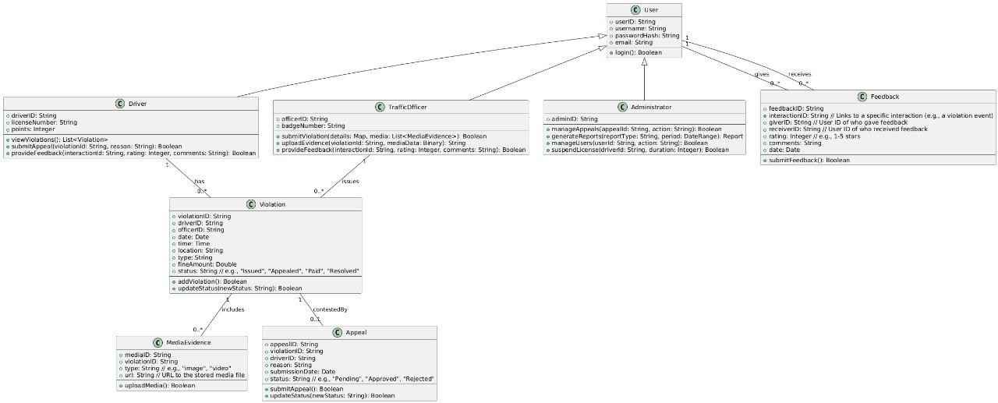
Class Diagram

Activity Diagram
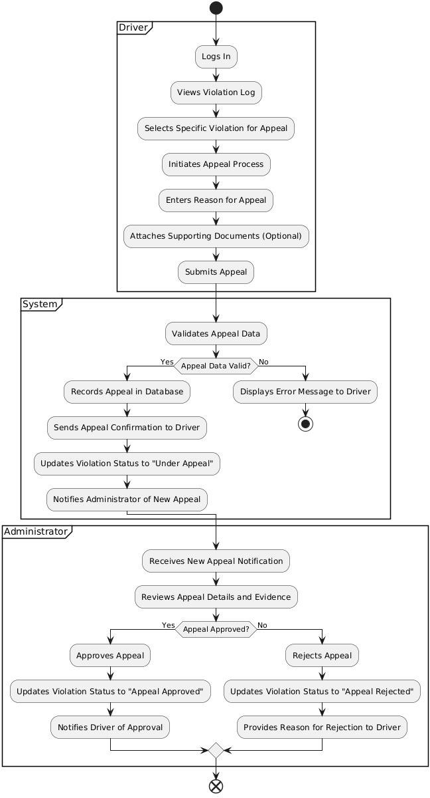

Wireframe Design
