Traffic Violation Tracking and Feedback Management System

INTRODUCTION
The Traffic Violation Tracking and Feedback Management System is a project designed to address the growing challenges in managing traffic violations, focusing on improving transparency, fairness, and communication between drivers and traffic officers. In many cities, traffic violations are typically handled in a one-sided manner. Drivers are fined for various infractions, often without a clear understanding of what they did wrong, while officers are sometimes accused of misconduct without any way to defend their actions. This lack of transparency creates confusion, frustration, and a breakdown of trust between the public and traffic authorities.
To resolve these issues, this project proposes a web-based system that ensures both drivers and officers have access to clear, detailed, and fair information about traffic violations. With this system, drivers can log in to view a complete record of their violations, which will include details such as the date, time, location, type of violation, and any available photographic or video evidence. This way, drivers can understand exactly why they were fined and avoid the frustration of unclear penalties. If a driver believes a violation is unjust, they can appeal directly through the system, making the process faster, simpler, and more transparent compared to traditional court hearings.
Additionally, the system will include a feedback mechanism, allowing both drivers and officers to rate their interactions. This feedback will help ensure accountability and promote respectful, professional behavior from both sides. To further encourage responsible behavior, the system will implement a points-based system. Drivers will earn points for following traffic laws and lose points for violations. If a driver accumulates too many violations, their license may be temporarily suspended. Officers will also be rated based on their conduct and professionalism, with the points system helping to maintain fairness and transparency in their interactions with drivers.
This project also explores key principles of software engineering, using development models like Agile, Waterfall, and Incremental to ensure that the system is developed efficiently and meets all the project’s requirements. The Software Development Life Cycle (SDLC), including phases like planning, modeling, construction, and maintenance, will guide the project from start to finish, ensuring that the system evolves to meet the needs of users and stakeholders. Agile methodologies, in particular, will help the development team adapt to changes, incorporate feedback, and deliver working software incrementally, ensuring that the final product is both functional and user-friendly.

Background to the Problem
Traffic violations are a common issue in urban areas, causing disruptions in road safety and traffic enforcement. However, existing methods of managing traffic violations are often inefficient, lacking transparency, and fail to provide effective communication between drivers and law enforcement.
Current Issues:
- Lack of Transparency: Drivers often receive fines without understanding the reason or seeing evidence, leading to frustration and disputes.
- Inefficient Appeal Process: The process for contesting fines is outdated, involving lengthy and complicated procedures that discourage drivers from appealing.
- Communication Gaps: There is little opportunity for drivers to provide feedback or communicate with traffic officers, which can lead to dissatisfaction and mistrust.
- Manual and Disconnected Systems: Many systems still rely on manual records, leading to errors and difficulty integrating with other systems (e.g., payment platforms, government databases).
The Need for a Solution:
The Traffic Violation Tracking and Feedback Management System aims to address these issues by providing a transparent, efficient, and user-friendly platform. The system will allow drivers to track violations, contest fines, pay fees easily, and provide feedback. Officers will benefit from a streamlined enforcement process, reducing errors and improving accountability. By automating and integrating these processes, the system will enhance the overall efficiency of traffic violation management, promoting fairness and improving public trust in traffic enforcement.

Selection of Process Model
For our project Traffic Violation Tracking and Feedback Management System, we think scrum method of agile software development is most suitable.
Process Model of Scrum: Agile Scrum is an iterative and incremental process model, which works particularly well for complex and evolving projects. This model is based on continuous feedback and quick adaptations, which is crucial for projects that require flexibility and constant user involvement—like the Traffic Violation Tracking and Feedback Management System.
Pre-game Phase
This phase is all about setting the foundation for the project. It includes two main sub-phases: Planning and Architecture.
- Planning:
  - Product Backlog Creation: This is where all the requirements and features for the project are gathered. The Product Backlog is essentially a list of everything that needs to be done for the project. For example, in your project (Traffic Violation Tracking System), items might include violation tracking, appeal submission, feedback mechanisms, and payment processing.
  - Prioritization: Once all the features are identified, they are prioritized based on business value. The most critical features will be at the top of the list, and these are tackled first in the development cycle.
  - Effort Estimation: The effort required to implement each feature is estimated, so the team knows how long each item will take.
  - The Product Backlog is constantly updated throughout the project as new features are added, or priorities change.
- Architecture:
  - At this stage, the team plans the high-level design of the system based on the Product Backlog. This includes deciding how the system will be structured and how different parts of it will interact.
  - If this is an enhancement to an existing system, the team identifies what changes are necessary and what potential issues may arise.
2. Game Phase (Development Phase)
Once the groundwork is laid in the Pre-game phase, the Game Phase focuses on the actual development of the system, and this is where Sprints come into play.
- Sprints:
  - Sprint Duration: A Sprint is an iteration in Scrum, lasting from 1 to 4 weeks (but typically around 2 weeks). Each Sprint is focused on delivering a working product increment, meaning that at the end of each Sprint, the system will have a feature or functionality that works.
  - During the Sprint, the team follows the traditional software development phases:
    - Requirements gathering
    - Analysis
    - Design
    - Development (coding)
    - Testing
    - Delivery (deployment)
  - The team works through these phases iteratively within the Sprint to complete the items in the Sprint Backlog (a subset of the Product Backlog).
- Daily Scrum:
  - Every day, the team holds a Daily Scrum or stand-up meeting to discuss what they worked on, what they plan to work on, and whether they are facing any obstacles. This keeps everyone aligned and ensures quick problem-solving if something is slowing down progress.
3. Post-game Phase
After the system is developed through a series of Sprints, the Post-game phase comes into play. This phase focuses on finalizing the project and preparing it for release.
- Completion of Requirements:
  - Once the requirements in the Product Backlog are completed, no more items or issues are introduced. The system is now considered ready for release.
- System Testing and Integration:
  - In this phase, the entire system undergoes final testing to ensure that all parts of the system work together smoothly. This could include integration testing and ensuring all features function as expected.
- Documentation:
  - The final documentation is completed, which might include user manuals, technical documentation, and anything else necessary to ensure the system can be properly maintained and used by the end-users.
- Release:
  - Once all the testing is done and the documentation is in place, the system is officially released for use.
Roles and Responsibilities in Scrum
- Scrum Master:
  - Ensures the team follows Scrum practices and removes any obstacles that could impede progress. The Scrum Master also ensures that communication flows smoothly between the team, stakeholders, and management.
- Product Owner:
  - Manages the Product Backlog. The Product Owner is responsible for setting priorities, ensuring that the team works on the most valuable features first, and making final decisions on product features.
- Scrum Team:
  - The Scrum Team is composed of developers, designers, and testers. They are self-organizing and collaborate to achieve the goals set in the Sprint Backlog. The team is also involved in effort estimation and reviewing the Product Backlog.
- Customer/Stakeholders:
  - These are the people who provide feedback and ensure the system meets user’s needs. In this case, they could be the drivers, traffic officers, or traffic authorities.
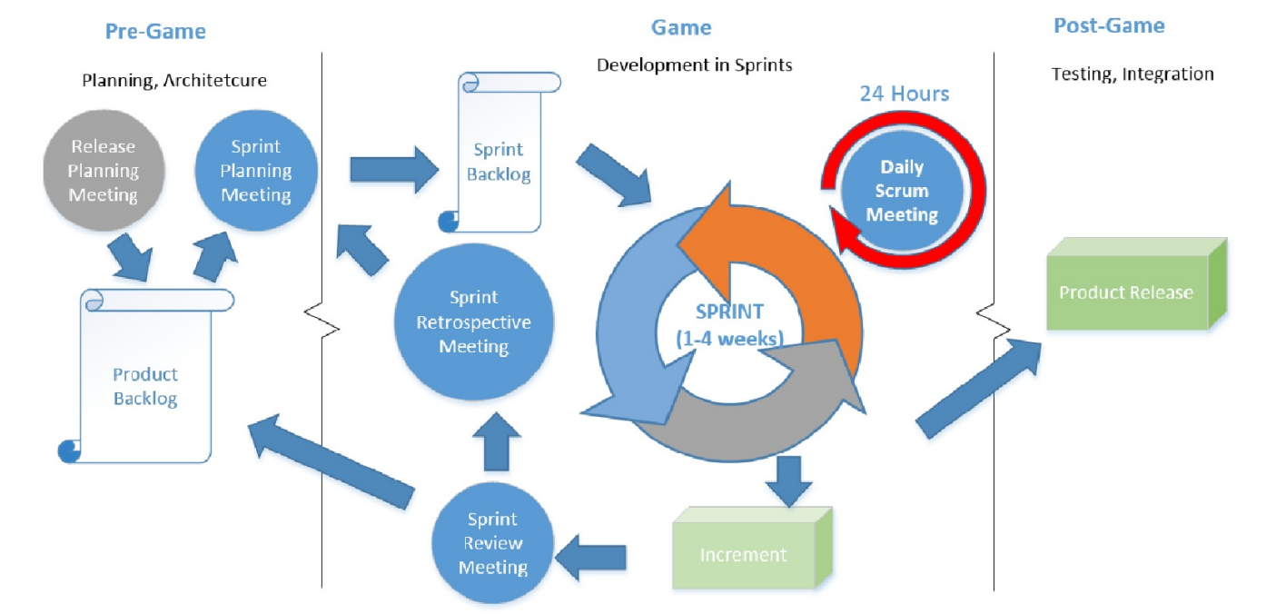
Reasons for choosing this model:
1. Pre-game Phase: Planning and Architecture
- Planning: The Product Backlog is created, listing all features like violation tracking, appeal submission, payment systems, and real-time violation tracking. These features are prioritized based on business value, and effort estimates are made. The backlog evolves with continuous feedback from stakeholders (drivers, officers, authorities), ensuring the system meets user needs.
- Architecture: The system’s high-level design is planned to ensure scalability and smooth integration with external systems (e.g., government databases, payment gateways).
2. Game Phase: Development in Sprints
- Development is done in Sprints (1 to 4 weeks), where specific features are built incrementally. For example:
  - Sprint 1: Focus on creating the login system and basic violation tracking.
  - Sprint 2: Integrate the appeal system and feedback mechanisms.
  - Sprint 3: Develop the payment system and real-time violation tracking.
- Scrum's iterative approach ensures we can test and deliver features quickly, gathering feedback to adjust and refine as needed. This is especially useful as user needs may evolve throughout development.
3. Post-game Phase: Completion and Release
- After several Sprints, the system undergoes final integration testing to ensure all components (violation tracking, appeal submission, payment systems) work seamlessly. Scrum ensures early and continuous testing, reducing the risk of issues at the end of the project.
4. Scrum Roles and Responsibilities
- Scrum Master: Ensures Scrum practices are followed, removes blockers, and helps keep the team on track.
- Product Owner: Manages the Product Backlog, prioritizes features based on business needs (e.g., violation tracking), and makes final decisions on feature inclusion.
- Scrum Team: Develops, tests, and designs the system, focusing on delivering the prioritized tasks in each Sprint.
- Stakeholders: Provide feedback during Sprint Reviews to ensure the system meets user needs.
5. Scrum Practices: Prioritization, Estimation, and Continuous Delivery
- Product Backlog & Sprint Backlog: Features are prioritized and refined based on feedback. During Sprint Planning, the team aligns on goals, ensuring the most important features are developed first.
- Daily Scrum Meetings: These keep the team aligned and focused on their tasks, ensuring timely progress.
- Sprint Review & Retrospective: Stakeholders provide feedback during Sprint Reviews, and the team reflects on process improvements during Sprint Retrospectives.
6. Transparency and Visibility
- Scrum ensures transparency through the Product Backlog, Sprint Backlog, and regular Sprint Reviews, providing visibility to all stakeholders (drivers, officers, authorities) and ensuring the system evolves based on feedback.
The Scrum Process Model is ideal for the Traffic Violation Tracking and Feedback Management System because it offers flexibility, incremental delivery, and a focus on continuous feedback. It allows the system to evolve with the changing needs of stakeholders while delivering a working product at the end of every Sprint, ensuring the project stays aligned with user expectations.

