ARTI 502
Deep Learning: 1st Assignment
Training-Testing Neural Net with MNIST Dataset using Pytorch
Year 2026 Term 1
Group # 1
Group Members:
# | Member Name | Member Academic ID
1 | Khalid Waleed Alhilal (Group Leader) | 2230000788
2 | Ali Khalid Albinali | 2230003813
3 | Mishary Waleed AlAwadh | 2230006217
4 | Nawaf Alsabr | 2230004159
5 | Yasir Saleh Alghamdi | 2230004157
6 | Ibrahim Alkuwaiz | 2230002878
7 | Meshal Alrubaie | 2230005991
GitHub repository: https://github.com/KhalidExe/ARTI502-Assignment1

Overview
In this assignment, you will perform Training Neural Net on the MNIST Dataset dataset using Pytorch. The goal is to explore the Basic Neural Network, understand its structure, and identify important issues such as architecture, learning rate, momentum and other parameters. You will also analyze relationships between number of layers and number of neurons for each layers to the overall Neural Network performance through their tuning hyperparameters.

Objective
Explore the dataset using PyTorch to understand:
- Simple Neural Networks structure
- How to do Training-Testing Neural Networks
- How to evaluate the performance
- How to determine learning rate, momentum and model hyperparameters

Summary of our results
All numbers below come from the executed notebook Assigment-1 DL.ipynb (NVIDIA GeForce RTX 5070 Ti, fixed seed 42). Hyper-parameters were chosen on a validation split only; the test set was used only for reporting.
Model | Val acc | Test loss | Test acc | Test errors
Task 6 – baseline MLP 784-512-10 (lr 0.01, momentum 0.9) | 97.92 % | 0.0603 | 98.26 % | 174
Task 8 – tuned MLP 1×512 (lr 0.1, momentum 0.5) | 98.26 % | 0.0682 | 98.55 % | 145
Extra – CNN + BatchNorm + Dropout + augmentation | 99.67 % | 0.0087 | 99.65 % | 35

Source code: https://github.com/KhalidExe/ARTI502-Assignment1
Environment: Windows 11, Python 3.14.4, PyTorch 2.14.0+cu130 (CUDA 13.0), VS Code; AMD Ryzen 9 9950X, NVIDIA GeForce RTX 5070 Ti 16 GB, 64 GB DDR5.

Tasks (with PyTorch)

Task 1: Install PyTorch
Instructions:
- Install PyTorch and load it to your python code and save it as ‘Assigment-1 DL’
- Screenshoot how your load PyTorch to your python source code.
Our Work & Results
PyTorch was installed in a project virtual environment (.venv, Python 3.14.4) from the official PyTorch wheel index. The RTX 50-series (Blackwell) GPU needs a CUDA 12.8-or-newer build; the latest stable release, PyTorch 2.14.0, is published for CUDA 13.0 (torch==2.14.0+cu130, https://download.pytorch.org/whl/cu130). The source code is saved as Assigment-1 DL.ipynb (plus a plain-Python export Assigment-1 DL.py).
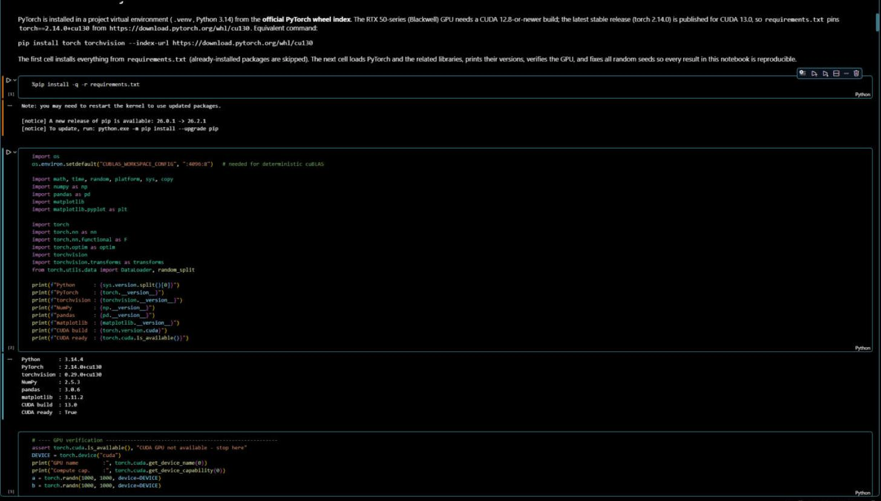
Figure 1: Loading PyTorch and the related libraries in Assigment-1 DL.ipynb (VS Code) – versions and CUDA availability
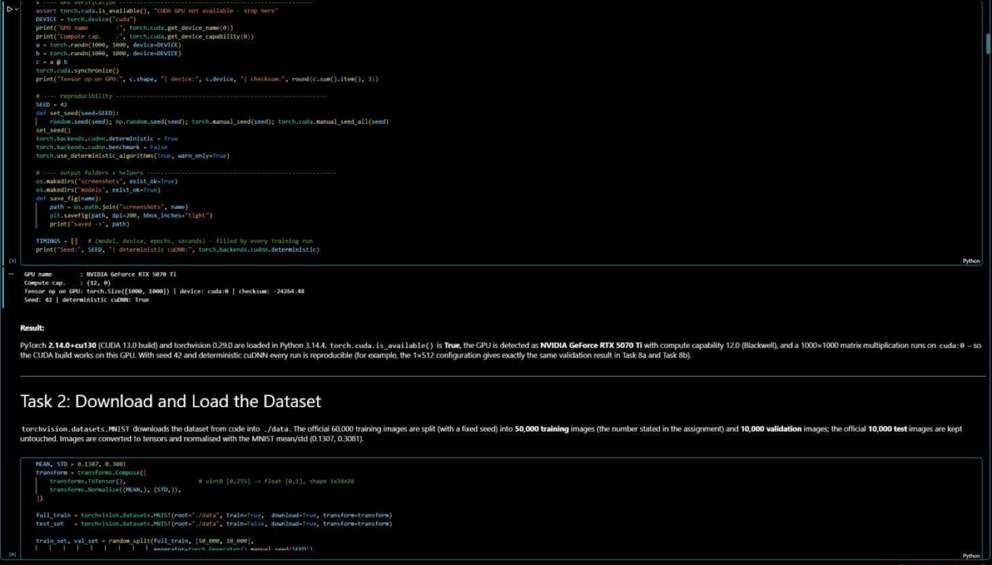
Figure 2: GPU verification and reproducibility settings
Result: PyTorch 2.14.0+cu130 and torchvision 0.29.0 are loaded, torch.cuda.is_available() returns True, the GPU is detected as NVIDIA GeForce RTX 5070 Ti (compute capability 12.0) and a 1000×1000 matrix multiplication runs on cuda:0. All random seeds (Python, NumPy, PyTorch) are fixed to 42 with deterministic cuDNN, so every result in this report is reproducible – the notebook was run twice and gave identical accuracy and loss values.

Task 2: Download and Load the Dataset
Instructions:
- PyTorch has some built tools for downloading and loading common datasets. You will be playing around with MNIST in this assignment. It is a dataset of 28x28 grayscale handwritten digits 0-9. There are 50,000 images in the training set and 10,000 in the test set.
- Download the dataset directly from your python code then load it into the the workspace.
Deliverable:
- Screenshot showing the dataset loaded successfully.
Our Work & Results
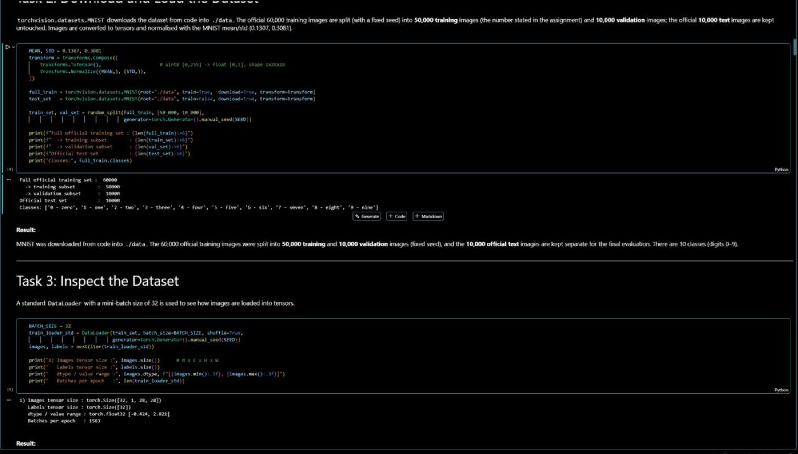
Figure 3: MNIST downloaded from code with torchvision and split into 50,000 / 10,000 / 10,000
Result: torchvision.datasets.MNIST(download=True) downloads the dataset into ./data. The official 60,000 training images are split (fixed seed) into 50,000 training images – the number given in the assignment – and 10,000 validation images used for tuning in Task 8. The official 10,000 test images are kept separate for testing. Images are converted to tensors and normalised with the MNIST mean/std (0.1307, 0.3081).

Task 3: Inspect the Dataset
Instructions:
- It's worthwhile to check out how the dataloader loads the images into tensors. You can print out the size of the loaded data in the images tensors. Also you can use matplotlib to see the visualization of the images data
Deliverable:
- Provide screenshots how to find:
- Images tensor size
- Data images vizualization using matplotlib
Our Work & Results
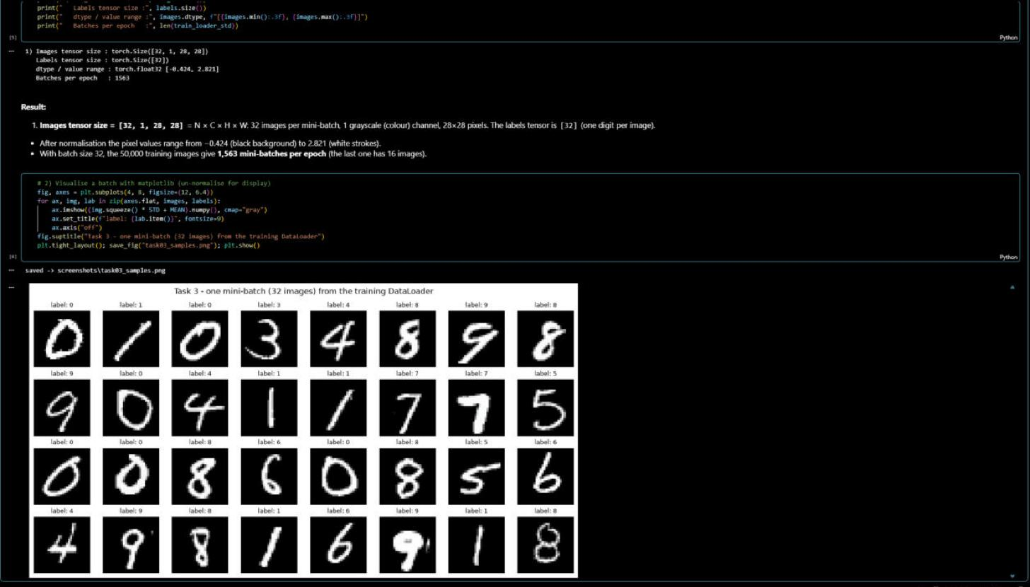
Figure 4: (1) images tensor size from the DataLoader and (2) visualisation of a mini-batch with matplotlib
1. Images tensor size = [32, 1, 28, 28] = N × C × H × W: 32 images per mini-batch, 1 grayscale (colour) channel, 28 × 28 pixels; the labels tensor is [32]. After normalisation the pixel values range from −0.424 (background) to 2.821 (strokes). With batch size 32 the 50,000 training images give 1,563 mini-batches per epoch.
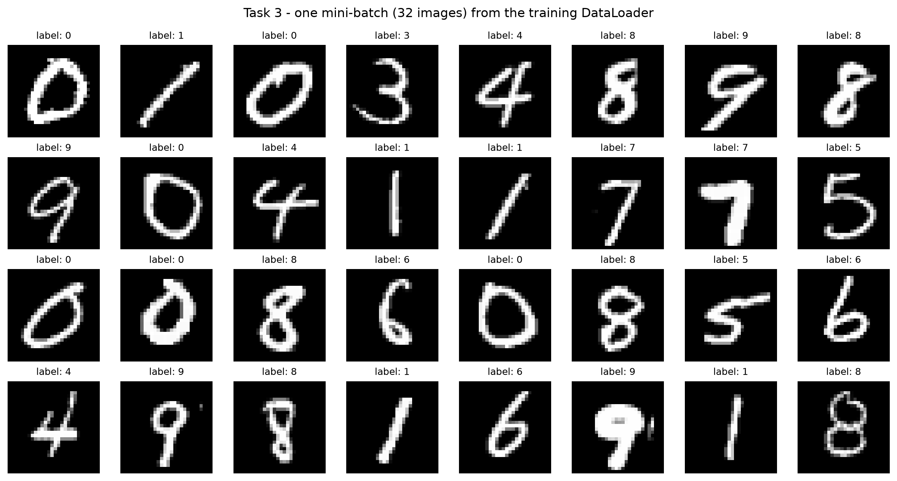
Figure 5: Task 3 – one mini-batch (32 images) from the training DataLoader with their labels
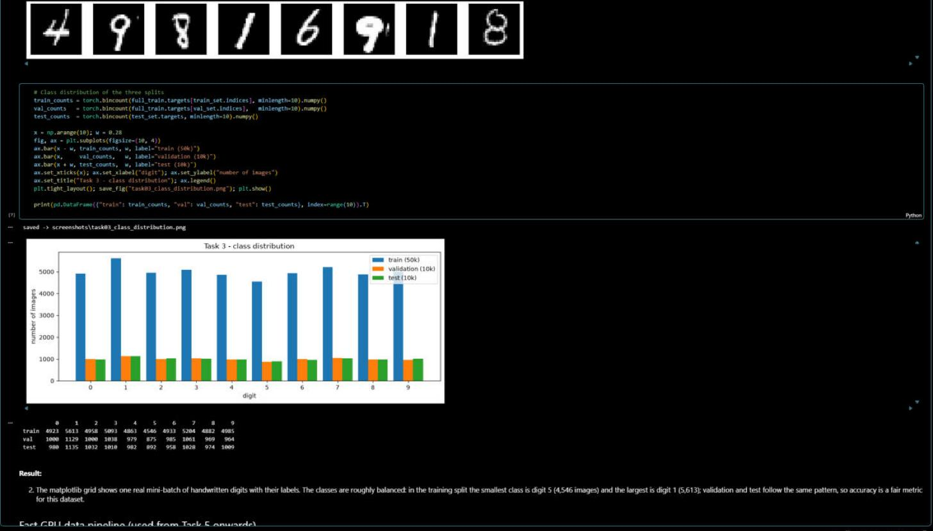
Figure 6: Class distribution of the training, validation and test splits
2. Visualisation: the matplotlib grid shows real handwritten digits with their labels. The class distribution shows the dataset is roughly balanced (training split: smallest class digit 5 with 4,546 images, largest digit 1 with 5,613), so accuracy is a fair metric. For training, all splits are then kept on the GPU once (same data and normalisation) to avoid per-batch copies.

Task 4: Creating A Simple Network
Instructions:
- Write your Python code to setup the following simple network architecture:
First you 'll build a very basic neural network with a single hidden layer of neurons. This means one fully connected layer of weights connects the input to the hidden neurons and one fully connected layer connects the hidden neurons to the output. Use the RELU activation function on the hidden neuron values as our nonlinearity.
These fully connected (or nn.Linear) layers expect a 2D input tensor where that is N x I where N is the number of data points in a mini batch and I is the number of inputs. However, our data is formatted in (N x C x H x W) right now so we need to tell PyTorch to rearrange it using torch.flatten. C, H and W are refer to Color, Height and Width respectively.
After being flattened our data goes from (32 x 1 x 28 x 28) to being (32 x 784)
Deliverables:
- Screenshot of source code
- Verify your code with above requirement.
Our Work & Results
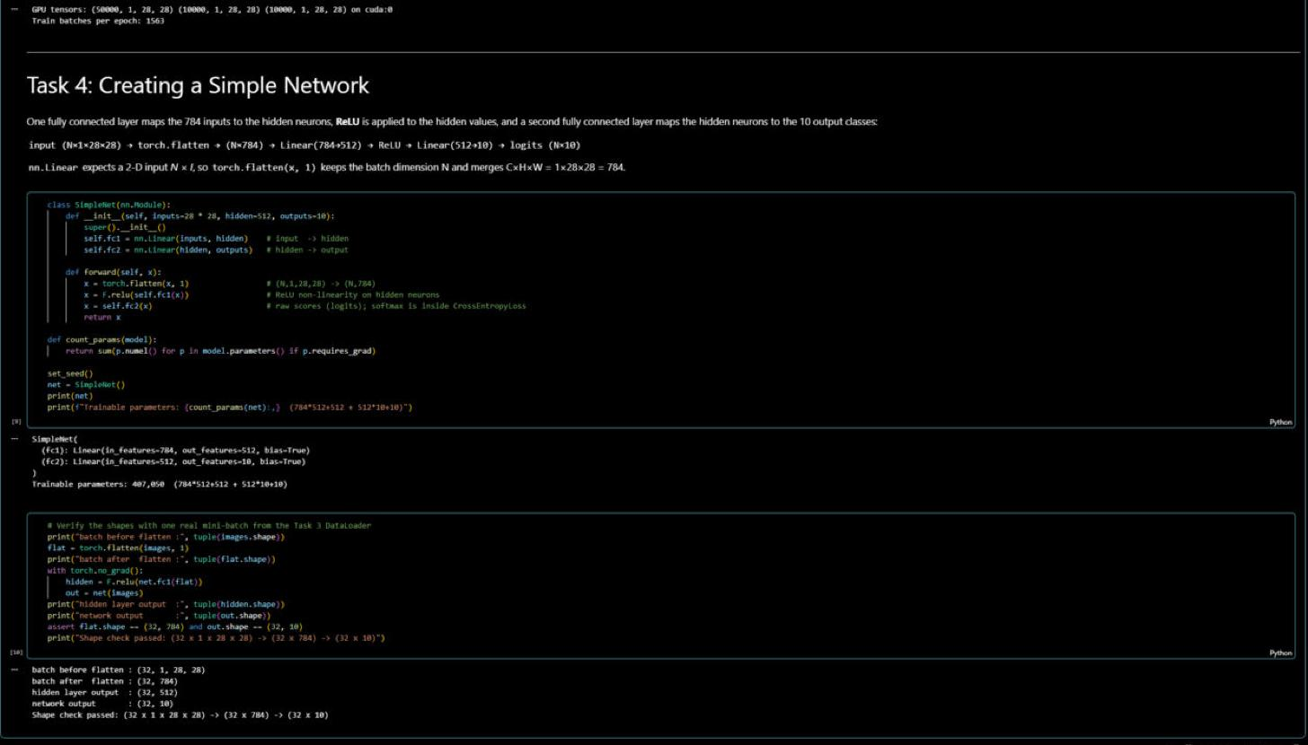
Figure 7: SimpleNet source code (Linear 784→512, ReLU, Linear 512→10 with torch.flatten) and shape verification
Architecture: input (N×1×28×28) → torch.flatten(x, 1) → (N×784) → Linear(784→512) → ReLU → Linear(512→10) → logits (N×10). The network has 407,050 trainable parameters (784·512 + 512 = 401,920 and 512·10 + 10 = 5,130).
Verification: running one real mini-batch through the network prints (32, 1, 28, 28) before flattening, (32, 784) after torch.flatten, (32, 512) after the hidden layer and (32, 10) at the output – exactly the required (32 × 1 × 28 × 28) → (32 × 784) transformation, with one score per class for every image.

Task 5: Training Function
Instructions:
- Now for training the network. Your train function takes as input the net to train and the dataloader for the training data. It also takes some optional parameters to control training.
- For your network you will be using PyTorch's built in nn.CrossEntropyLoss. This will apply a softmax to our network's output, calculate the log-probability assigned to each class, then try to minimize the negative log likelihood of our data (AKA maximize the likelihood)
- For your optimizer you are using stochastic gradient descent with learning rate and momentum
Deliverables:
- Screenshot of your python source code that contains your traing function with above requirements
Our Work & Results
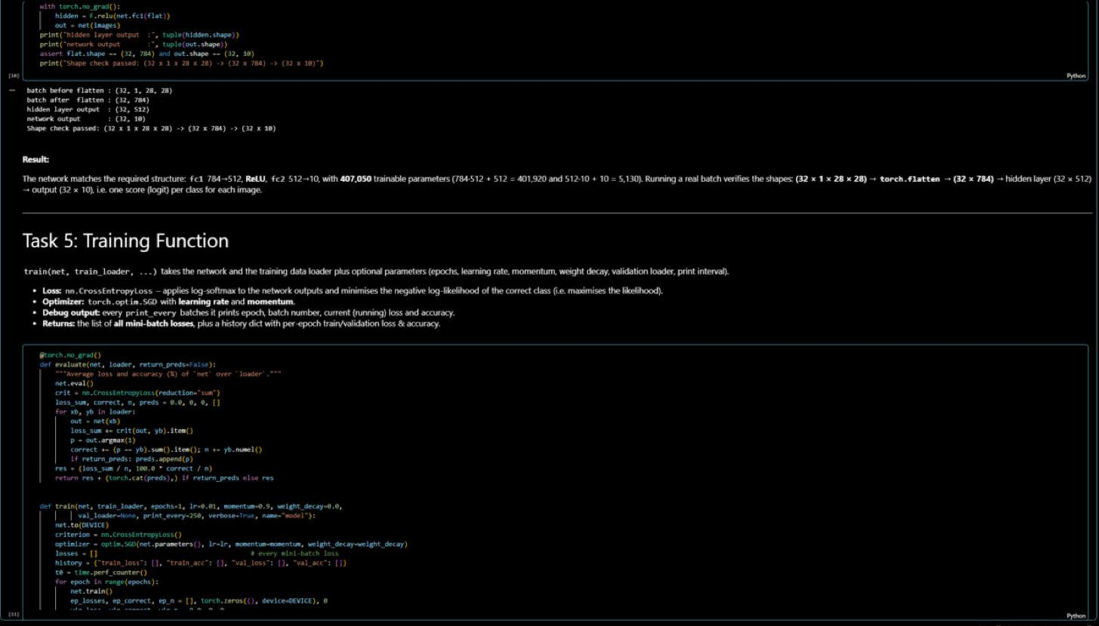
Figure 8: evaluate() and the start of train(net, train_loader, epochs, lr, momentum, …) – nn.CrossEntropyLoss and optim.SGD(lr, momentum)
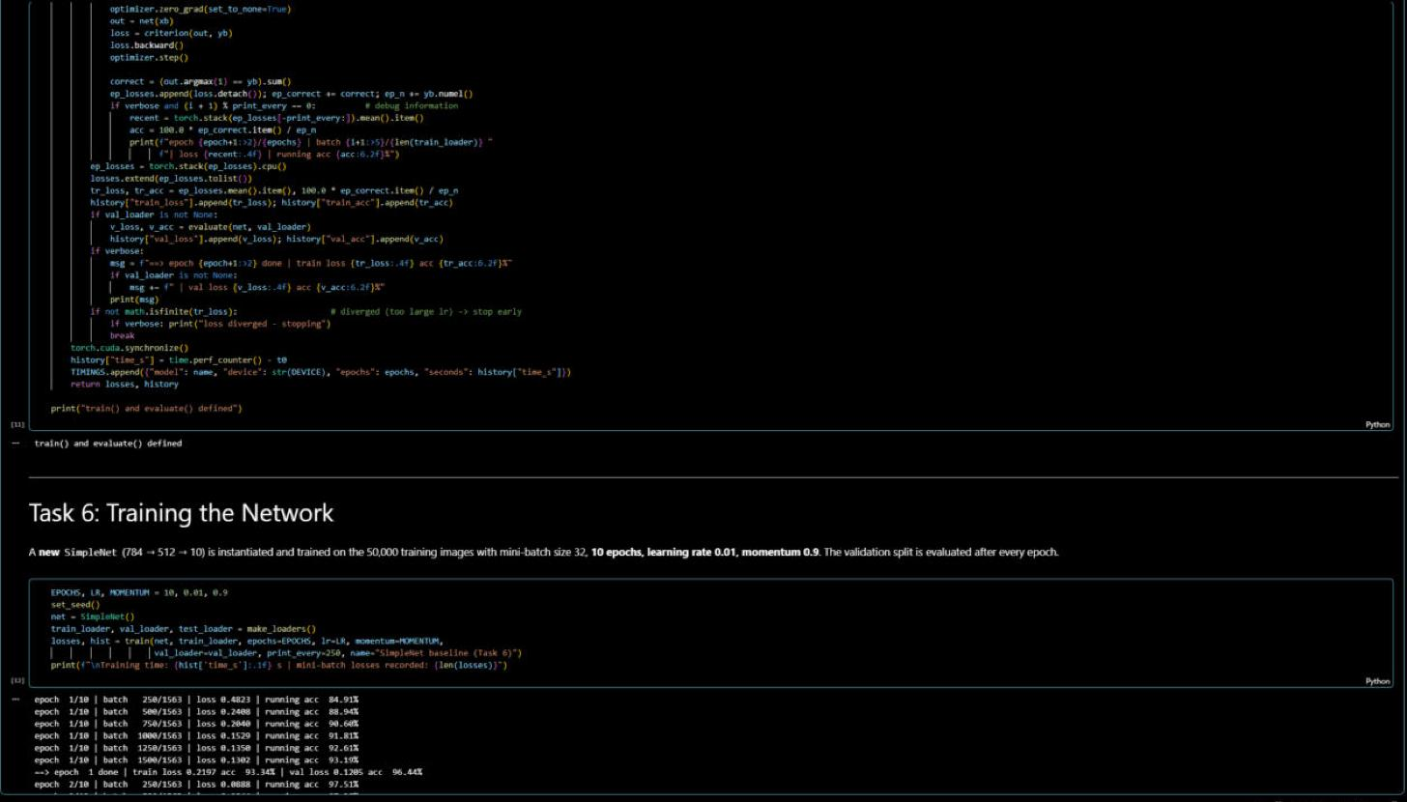
Figure 9: Rest of the training loop – debug printing, per-epoch validation and return values
train(net, train_loader, epochs, lr, momentum, weight_decay, val_loader, print_every, …) takes the network and the training data loader plus optional parameters. It uses nn.CrossEntropyLoss (log-softmax + negative log-likelihood) and torch.optim.SGD with learning rate and momentum. Each step does zero_grad → forward → loss → backward → optimizer.step. Every print_every batches it prints the epoch, batch number, current loss and running accuracy; after each epoch it evaluates the validation set. It returns the list of all mini-batch losses and a history of per-epoch train/validation loss and accuracy.

Task 6: Training Network
Instructions:
- You will instantiate a new network and train it on your training data.
- Your training function prints out some debug information about the epoch, batch number, and current loss and accuracy values. It also returns a list of all the losses on your mini-batches so you can plot them all once training has finished.
Deliverables:
- Screenshot of instantiate training source code
- Screenshot of training debug which include epoch, batch number and current loss, accuracy values and graph for overall processes ( loss and accuracy for each epoch).
Our Work & Results
A new SimpleNet is instantiated and trained on the 50,000 training images with mini-batch size 32, 10 epochs, learning rate 0.01, momentum 0.9 (instantiation code at the bottom of Figure 9).
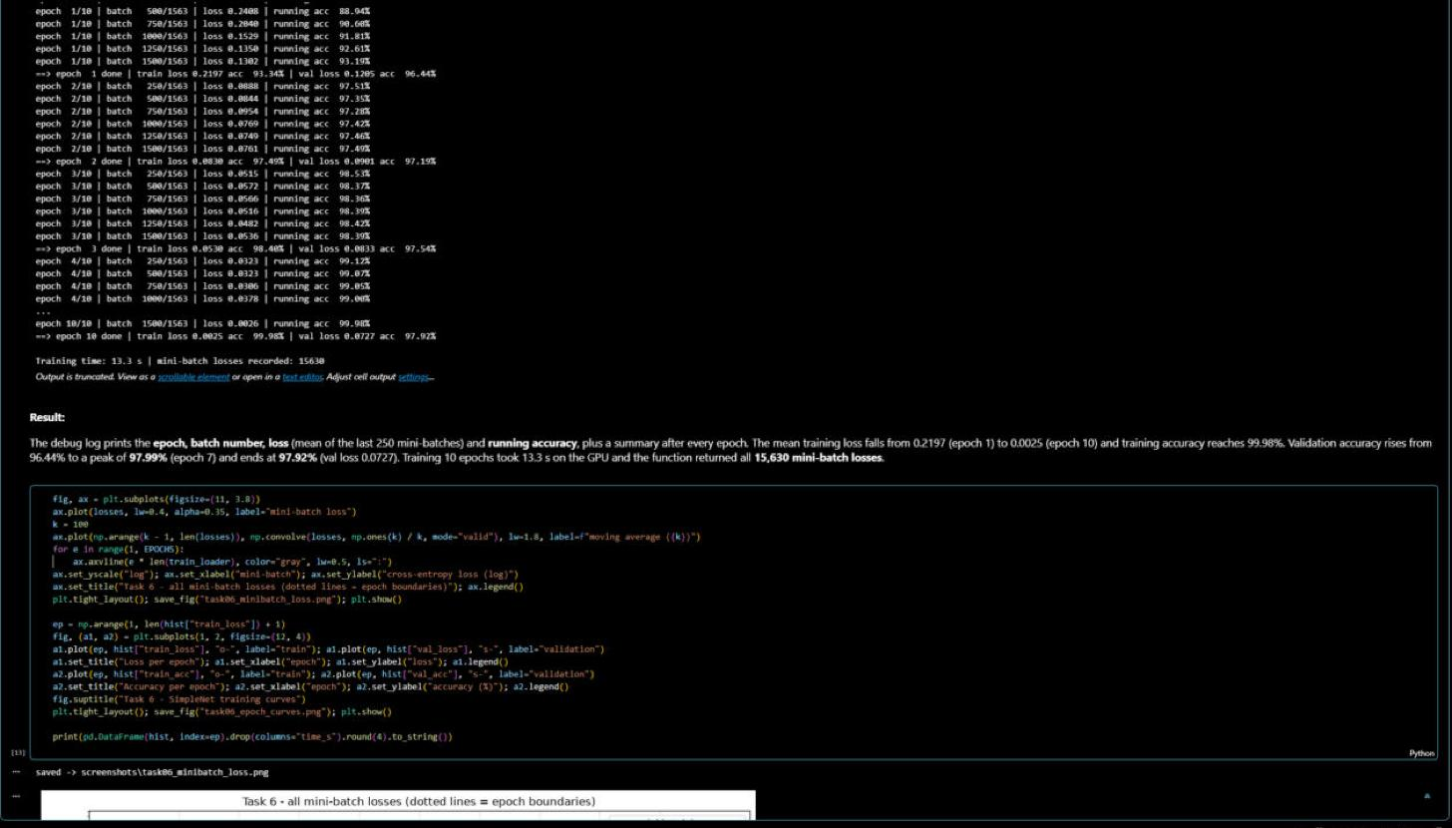
Figure 10: Training debug output – epoch, batch number, current loss and running accuracy, and per-epoch summary
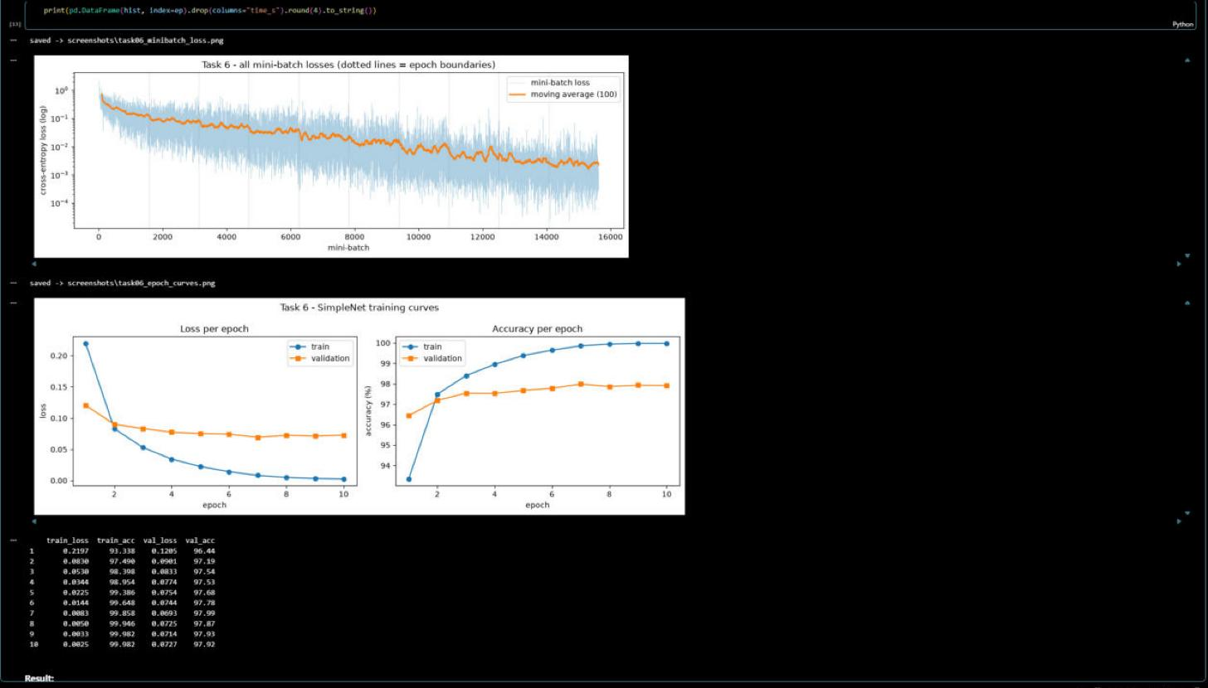
Figure 11: Graphs of all mini-batch losses and of loss / accuracy for each epoch
Epoch | Train loss | Train acc | Val loss | Val acc
1 | 0.2197 | 93.34 % | 0.1205 | 96.44 %
2 | 0.0830 | 97.49 % | 0.0901 | 97.19 %
3 | 0.0530 | 98.40 % | 0.0833 | 97.54 %
4 | 0.0344 | 98.95 % | 0.0774 | 97.53 %
5 | 0.0225 | 99.39 % | 0.0754 | 97.68 %
6 | 0.0144 | 99.65 % | 0.0744 | 97.78 %
7 | 0.0083 | 99.86 % | 0.0693 | 97.99 %
8 | 0.0050 | 99.95 % | 0.0725 | 97.87 %
9 | 0.0033 | 99.98 % | 0.0714 | 97.93 %
10 | 0.0025 | 99.98 % | 0.0727 | 97.92 %

Result: the debug log shows the epoch, batch number (out of 1,563), current loss and accuracy every 250 batches. The mean training loss falls from 0.2197 to 0.0025 and training accuracy reaches 99.98 %. Validation accuracy rises from 96.44 % to a peak of 97.99 % at epoch 7 and ends at 97.92 % (val loss 0.0727). The function returned all 15,630 mini-batch losses (10 × 1,563); training took 13.3 s on the GPU.
The mini-batch loss curve decreases steadily (log scale) with noise because every point is a single batch of 32 images. The per-epoch curves show that after about 7 epochs the validation loss stops improving while the training loss keeps going to zero – the ≈2-point gap between training (99.98 %) and validation (97.92 %) accuracy is the beginning of overfitting.

Task 7: Testing Network
Instructions:
- You can test your network on a few of your test images from task 2 and see what happens.
Deliverables:
- Screenshot your network testing source code
- Screenshot the results of the network testing
Our Work & Results
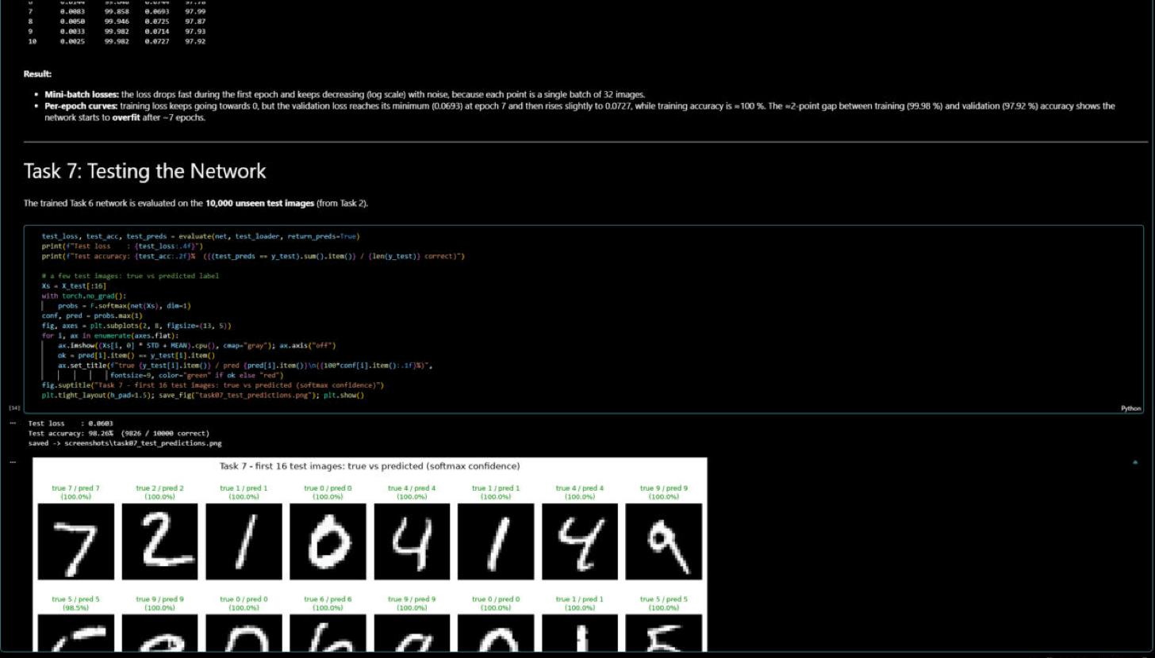
Figure 12: Network testing source code and results on the 10,000 test images
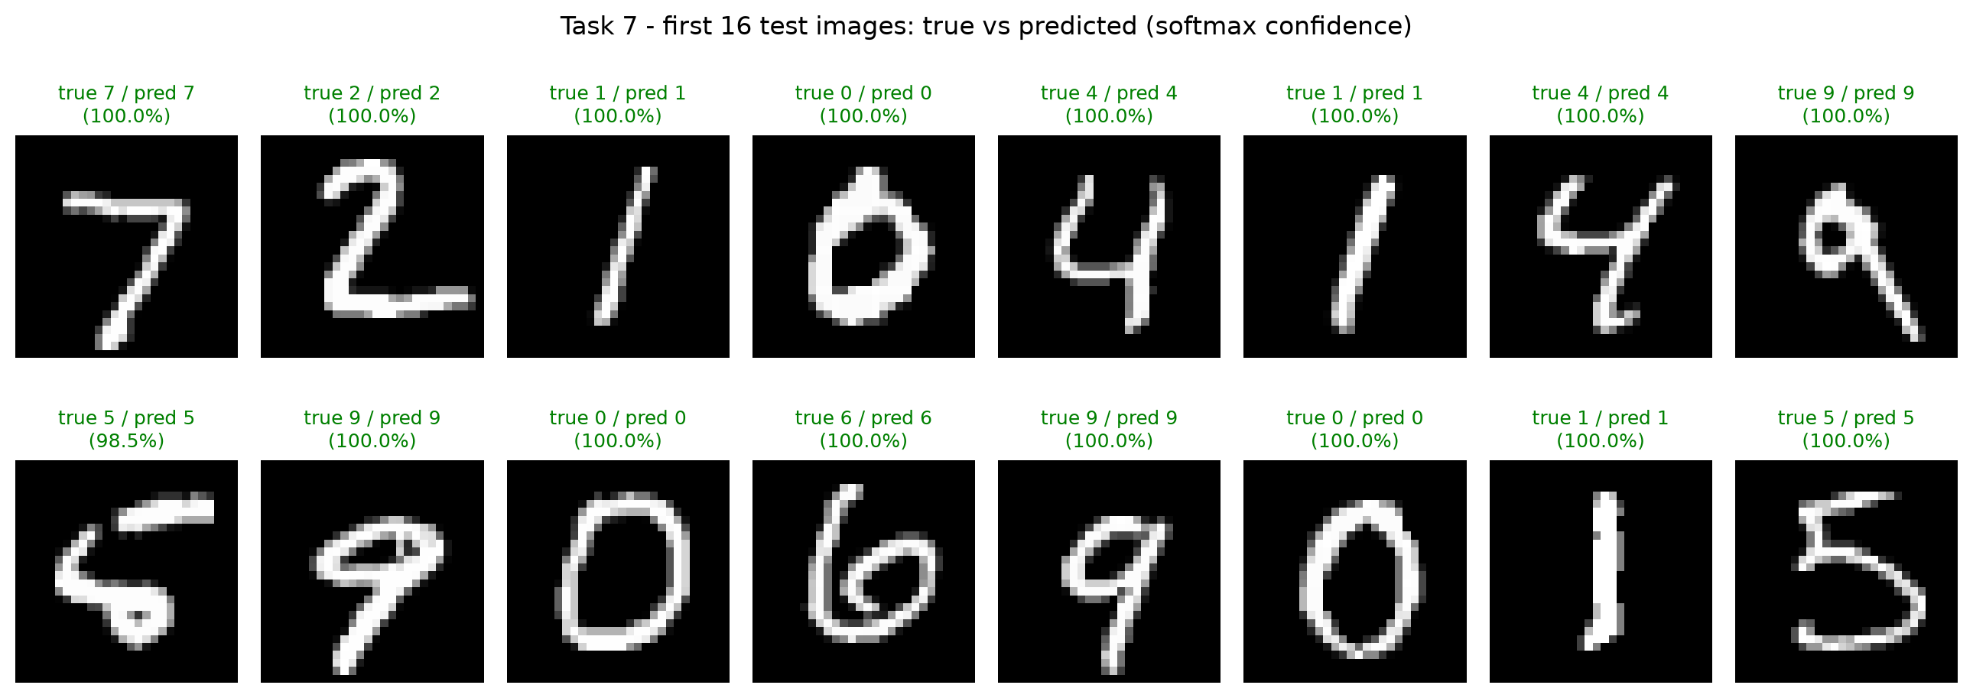
Figure 13: First 16 test images – true vs predicted label (softmax confidence)
Result: on the 10,000 unseen test images the Task 6 network reaches test loss 0.0603 and test accuracy 98.26 % (9,826 correct). All 16 test images shown are predicted correctly; 15 with ≈100 % confidence and the slanted “5” with 98.5 %.
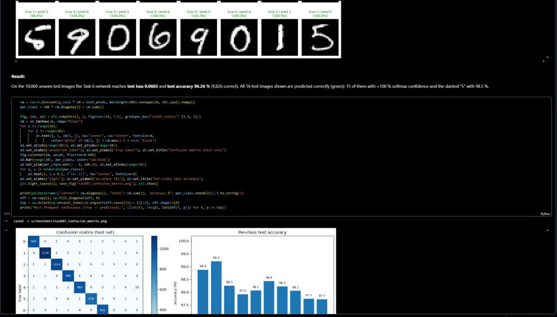
Figure 14: Confusion matrix and per-class accuracy – source code and output
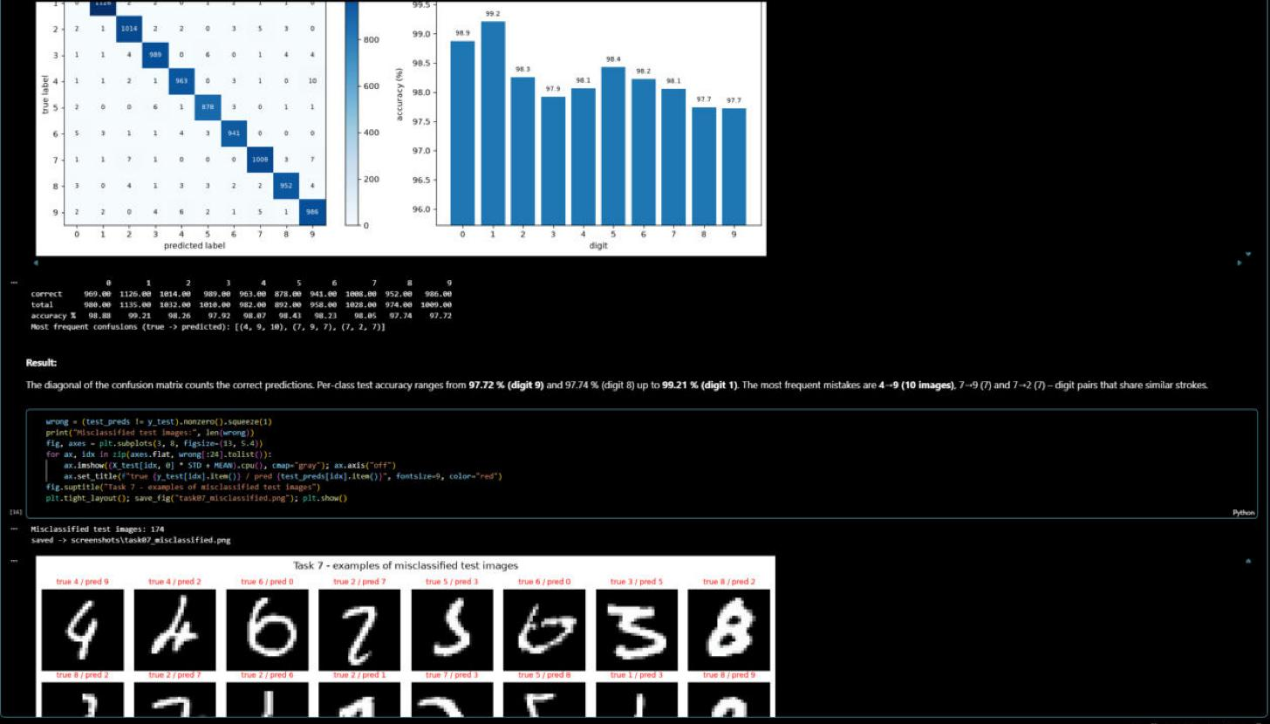
Figure 15: Per-class accuracy table, most frequent confusions and misclassified examples
Per-class test accuracy ranges from 97.72 % (digit 9) and 97.74 % (digit 8) to 99.21 % (digit 1). The most frequent mistakes are 4 → 9 (10 images), 7 → 9 (7) and 7 → 2 (7) – digits with similar strokes. In total 174 test images (1.74 %) are misclassified; most of them are unusual or badly written digits that are hard even for a human.
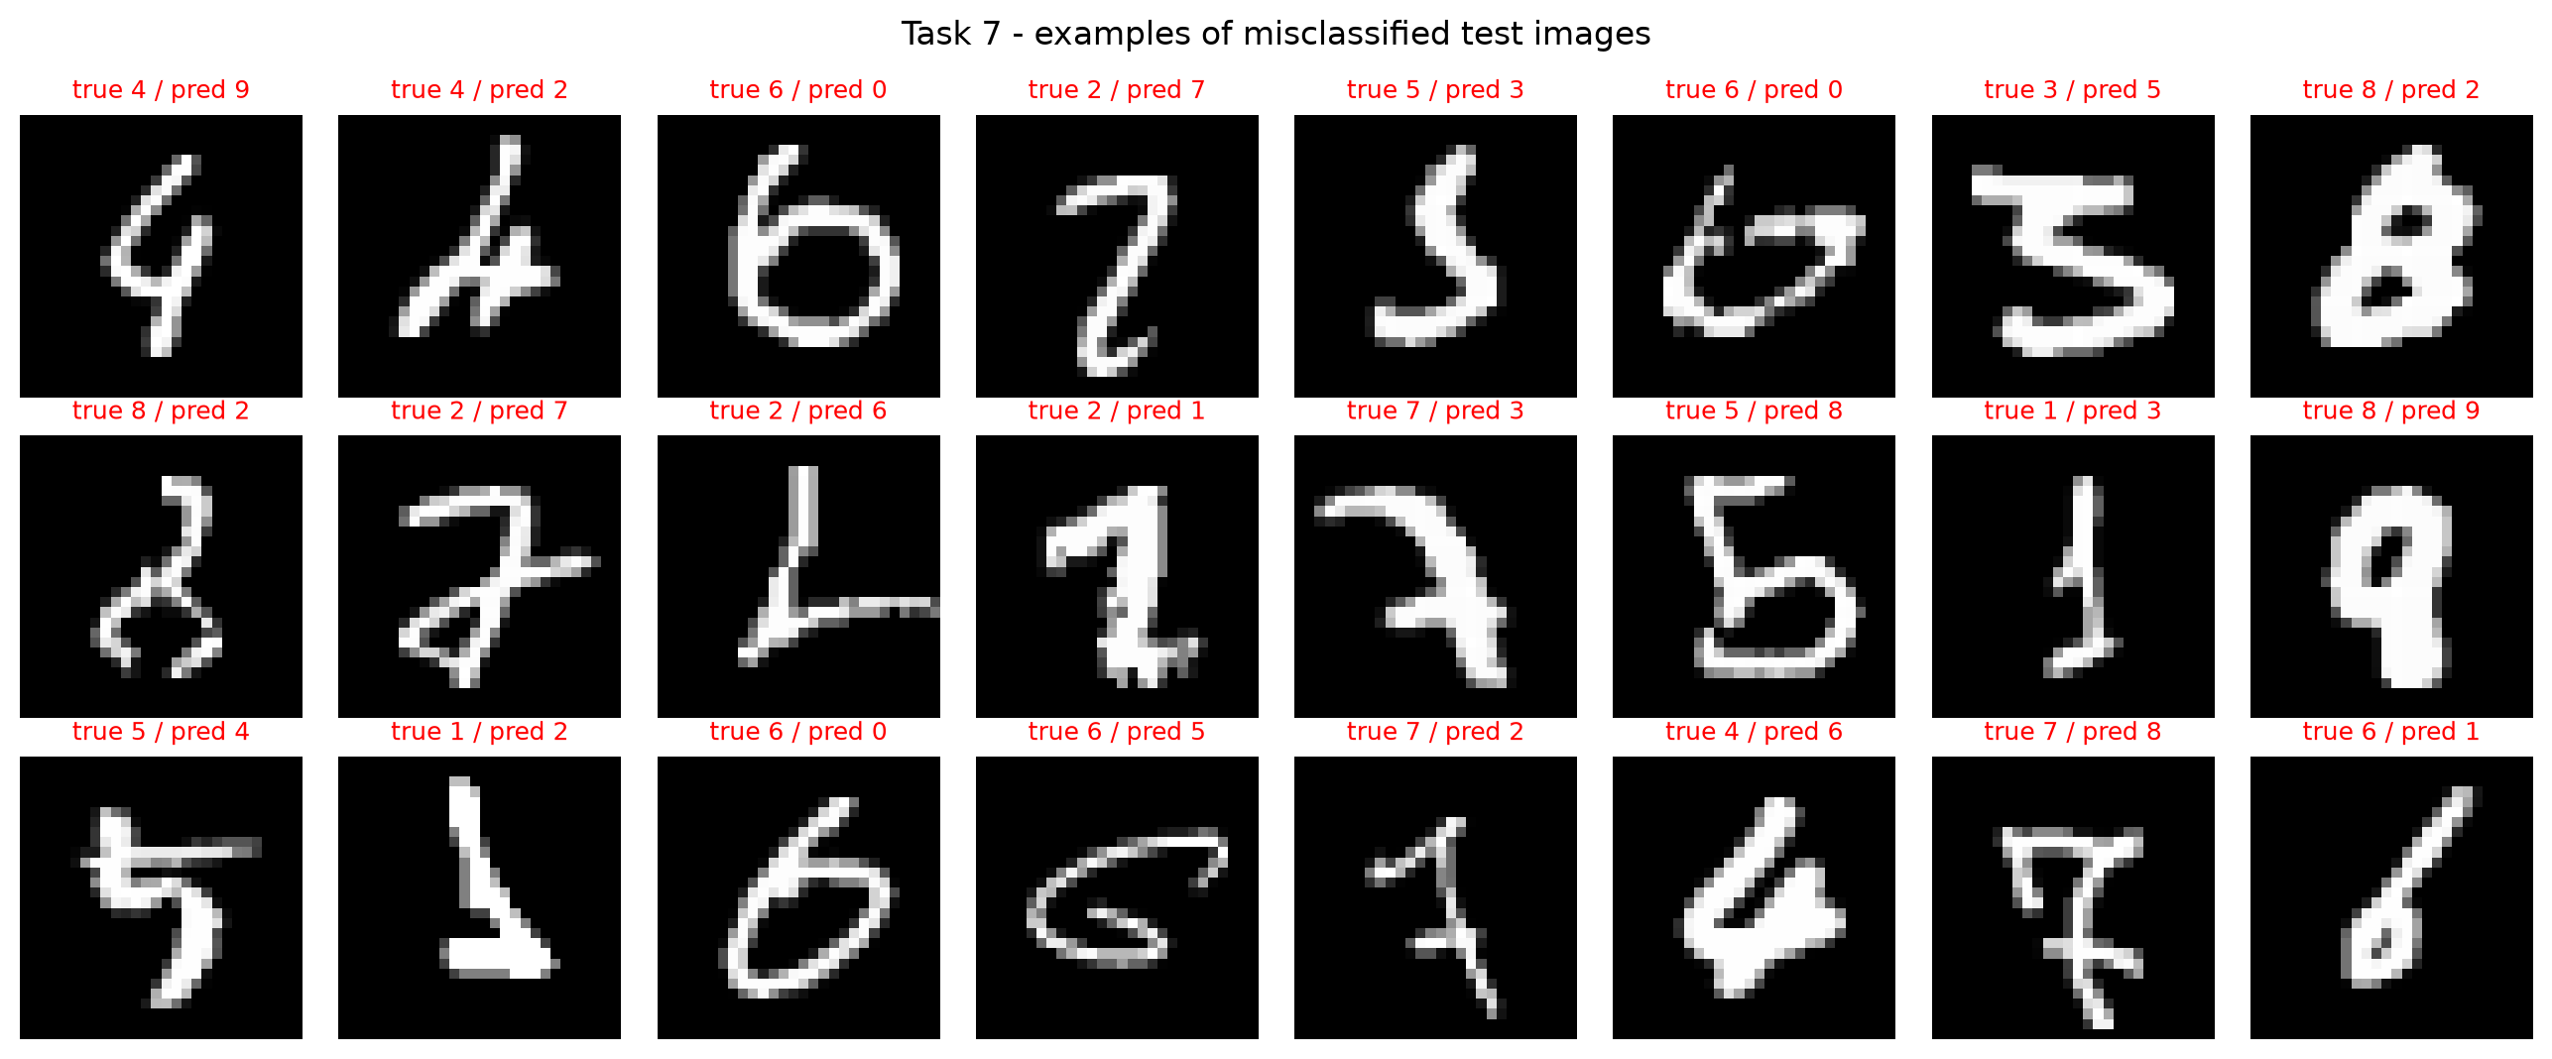
Figure 16: Examples of misclassified test images (true / predicted)

Task 8: Tuning the parameters and model archirecture
Instructions:
- Tune the parameters with different values of learning rate and momentum and write your best results ( lowest loss and highest accuracy).
- Tune the architecture model with different values of number of layer and number of neuron and write your best results ( lowest loss and highest accuracy).
Deliverables:
- Screen your source python code with the best results.
Our Work & Results
Protocol: every configuration is trained on the 50,000 training images for 8 epochs with the same seed and compared on the validation set (highest validation accuracy, ties broken by lowest validation loss). The test set is not used for any choice; it is evaluated only once for the final model.
8a) Learning rate × momentum (SimpleNet 784-512-10)
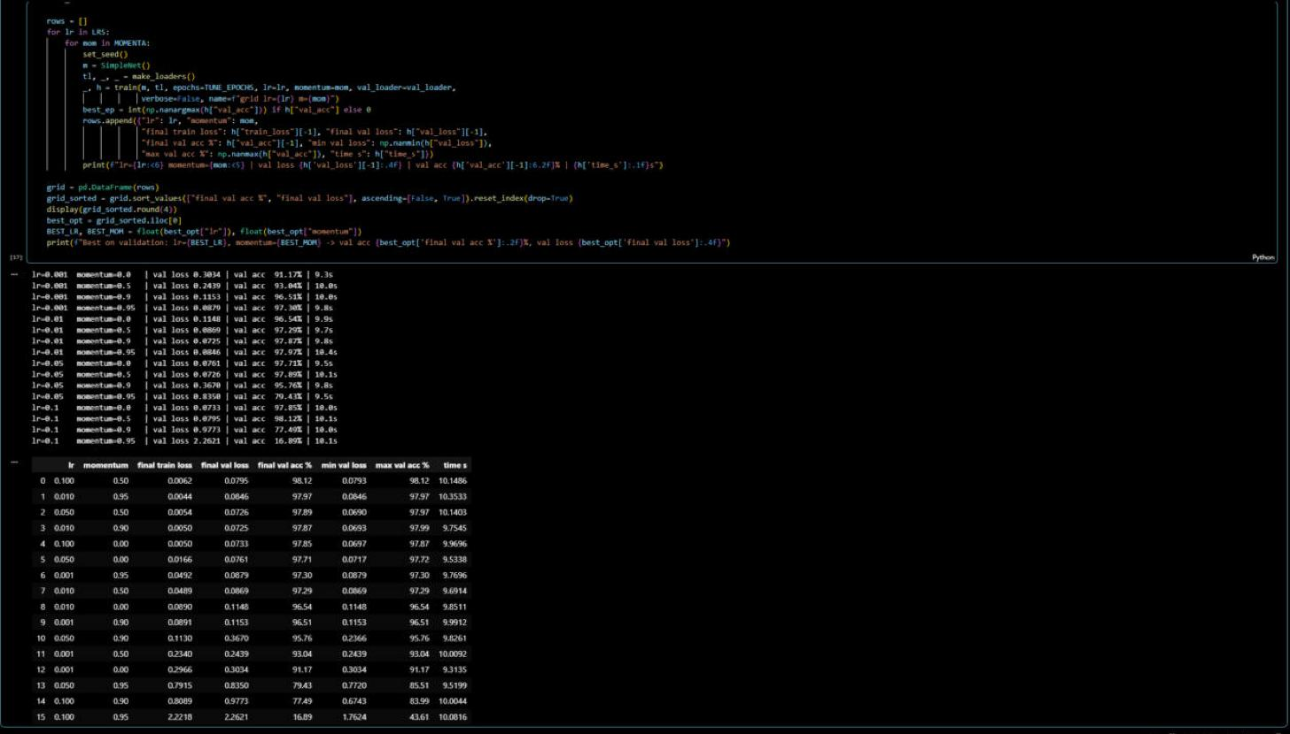
Figure 17: Grid search over learning rate {0.001, 0.01, 0.05, 0.1} × momentum {0, 0.5, 0.9, 0.95} – source code and results
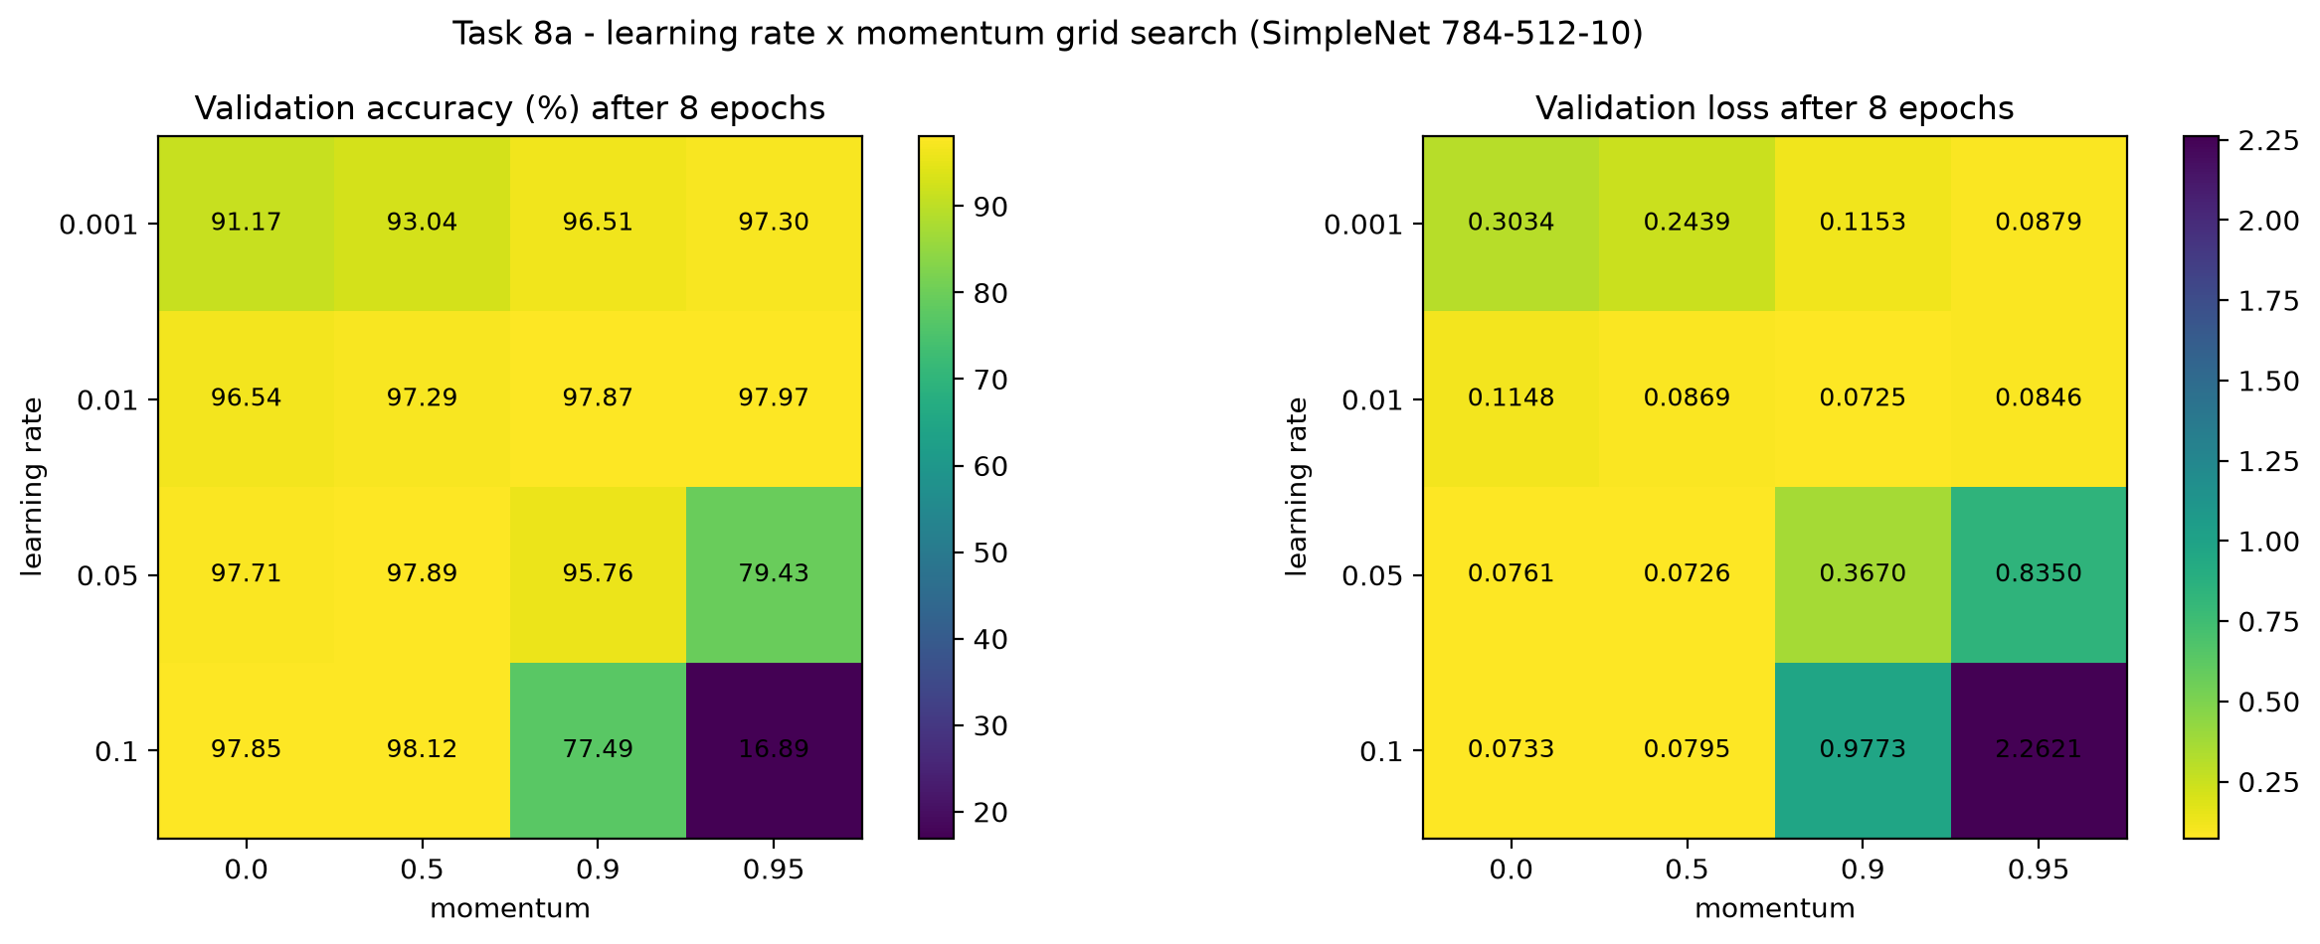
Figure 18: Validation accuracy and loss for every learning rate / momentum pair
Best result (validation) | Learning rate | Momentum | Val accuracy | Val loss
Highest accuracy | 0.1 | 0.5 | 98.12 % | 0.0795
Lowest loss | 0.01 | 0.9 | 97.87 % | 0.0725

- A too small learning rate learns slowly: lr 0.001 without momentum reaches only 91.17 % in 8 epochs; momentum helps a lot (97.30 % with 0.95).
- A too large step makes SGD unstable: lr 0.1 + momentum 0.95 collapses to 16.89 % and lr 0.05 + 0.95 to 79.43 %.
- Learning rate and momentum interact through the effective step ≈ lr / (1 − momentum). The best runs have an effective step of about 0.1–0.2 (0.1/0.5, 0.01/0.95, 0.01/0.9); effective steps of 0.5 or more became unstable.
8b) Number of hidden layers × neurons per layer (lr 0.1, momentum 0.5)
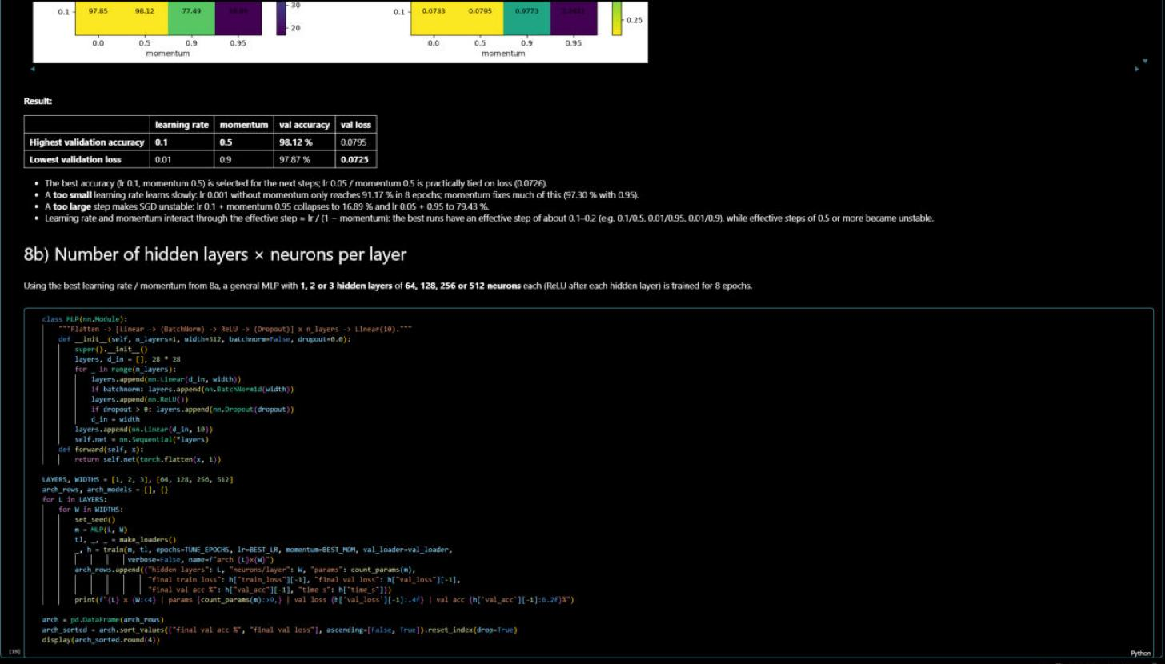
Figure 19: General MLP with 1–3 hidden layers and 64–512 neurons – source code
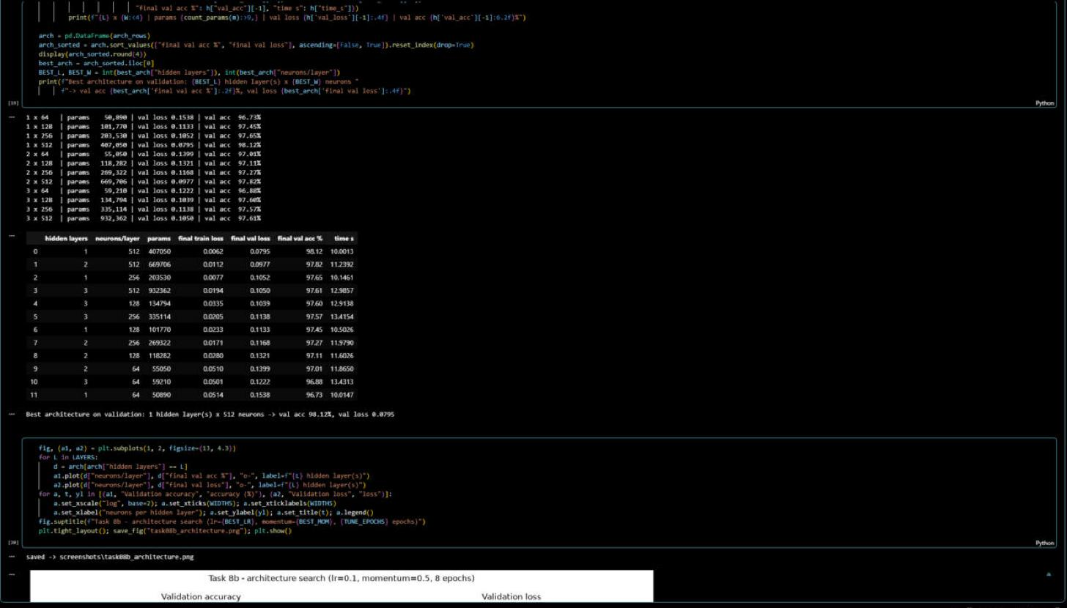
Figure 20: Architecture search results (sorted by validation accuracy)
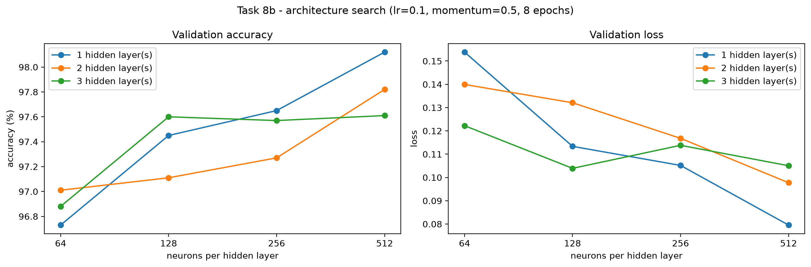
Figure 21: Validation accuracy and loss vs. neurons per hidden layer for 1, 2 and 3 hidden layers
Hidden layers × neurons | Params | Val accuracy | Val loss
1 × 512 (best: highest accuracy and lowest loss) | 407,050 | 98.12 % | 0.0795
2 × 512 | 669,706 | 97.82 % | 0.0977
1 × 256 | 203,530 | 97.65 % | 0.1052
3 × 512 | 932,362 | 97.61 % | 0.1050
1 × 64 (worst) | 50,890 | 96.73 % | 0.1538

- More neurons help at every depth (1 hidden layer: 96.73 % with 64 → 98.12 % with 512 neurons).
- More layers did not help here: 3 × 512 reaches 97.61 % with 2.3× the parameters. With 8 epochs and a learning rate tuned for the one-layer network, deeper MLPs are harder to optimise, and MNIST is simple enough for one wide hidden layer.
8c) Final model with the best settings
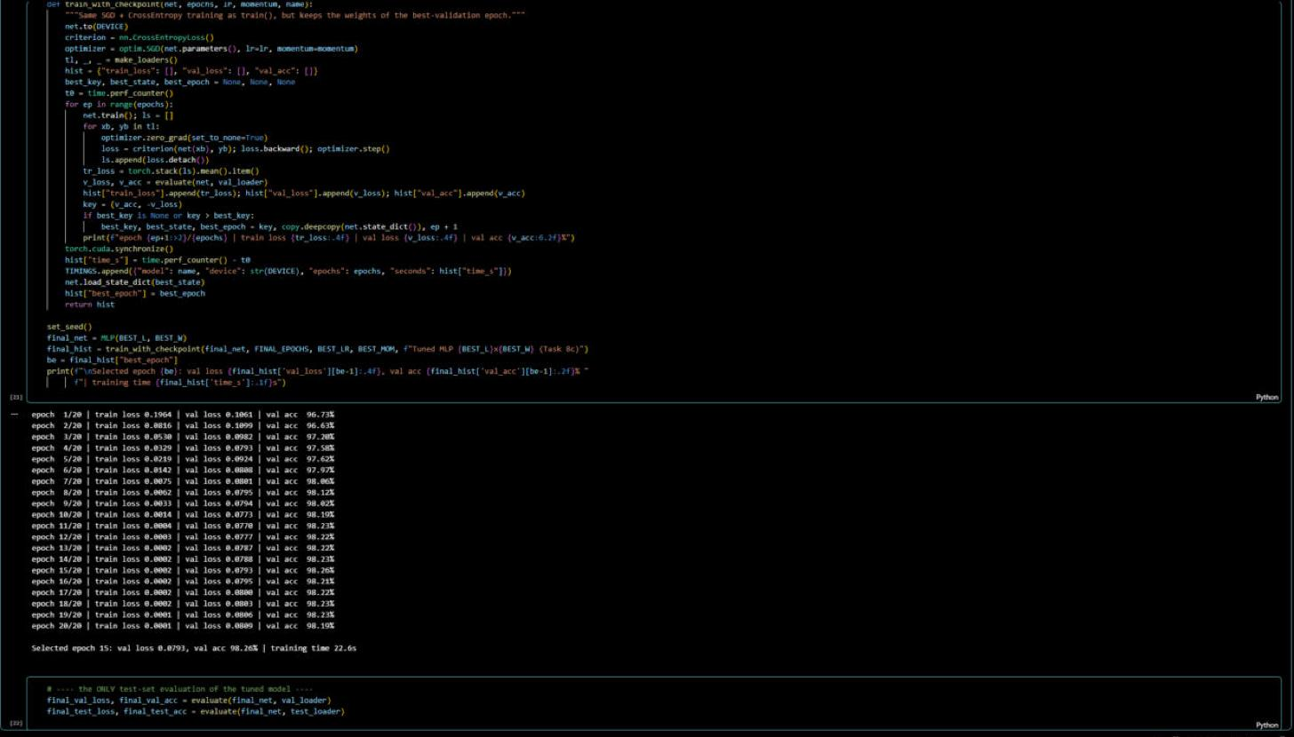
Figure 22: Final model 1 × 512, lr 0.1, momentum 0.5 trained for 20 epochs – best-validation epoch kept
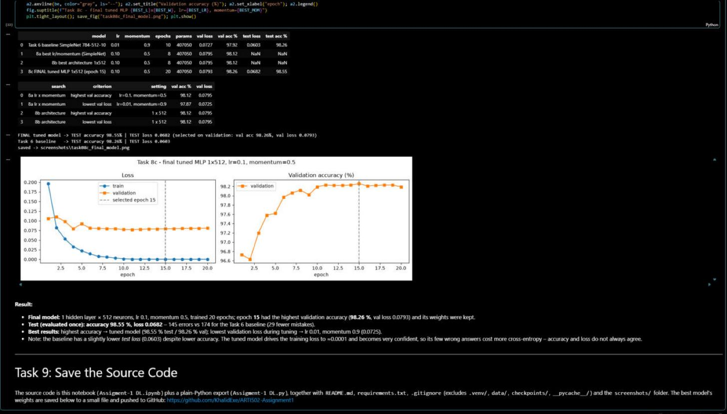
Figure 23: Source code output with the best results: summary tables and the single test evaluation
Model | Val loss | Val acc | Test loss | Test acc
Task 6 baseline (lr 0.01, momentum 0.9, 10 epochs) | 0.0727 | 97.92 % | 0.0603 | 98.26 %
Tuned MLP 1×512 (lr 0.1, momentum 0.5, epoch 15 of 20) | 0.0793 | 98.26 % | 0.0682 | 98.55 %

Result: epoch 15 had the highest validation accuracy (98.26 %, val loss 0.0793) and its weights were kept. On the test set this tuned model reaches 98.55 % accuracy (loss 0.0682) – 145 errors instead of 174 for the baseline, with the same number of parameters. Best results: highest accuracy → tuned model (98.55 % test / 98.26 % validation); lowest validation loss during tuning → lr 0.01 with momentum 0.9 (0.0725). The baseline has a slightly lower test loss (0.0603) despite its lower accuracy: the tuned model drives its training loss to ≈0.0001 and becomes very confident, so its few wrong answers cost more cross-entropy – accuracy and loss do not always agree.

Task 9: Save your source code
Instructions:
- Save your python source code
Deliverable:
- Submit your Github link of your source code along with this document, which includes all screenshots via Blackboard.
Our Work & Results
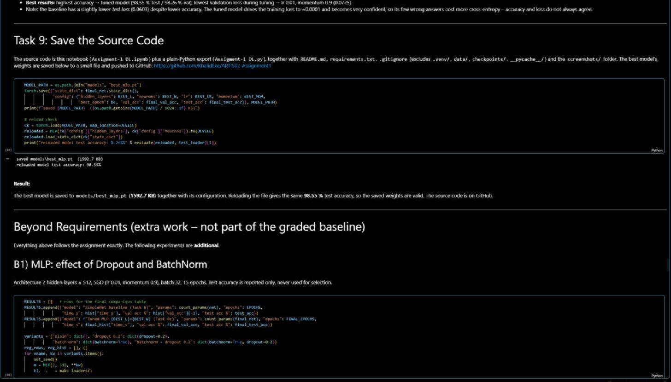
Figure 24: Saving the best model weights and reloading them
The best model is saved to models/best_mlp.pt (1,592.7 KB) together with its configuration; reloading the file gives the same 98.55 % test accuracy. The complete source code is saved and pushed to GitHub:
https://github.com/KhalidExe/ARTI502-Assignment1
File / folder | Content
Assigment-1 DL.ipynb | Main notebook – all tasks, executed with outputs
Assigment-1 DL.py | Plain-Python export of the notebook
screenshots/ + INDEX.md | All figures and VS Code screenshots, mapped to the task deliverables
models/best_mlp.pt | Weights of the best tuned MLP (Task 8c)
README.md, requirements.txt, .gitignore | Description and results, dependencies, ignored files (.venv, data, checkpoints, __pycache__)
report/ | This document (PDF and Word)

Beyond Requirements (extra work)
Everything above follows the assignment exactly. The experiments in this section are additional and were not used to change any required result.

B1) Effect of Dropout and BatchNorm on the MLP
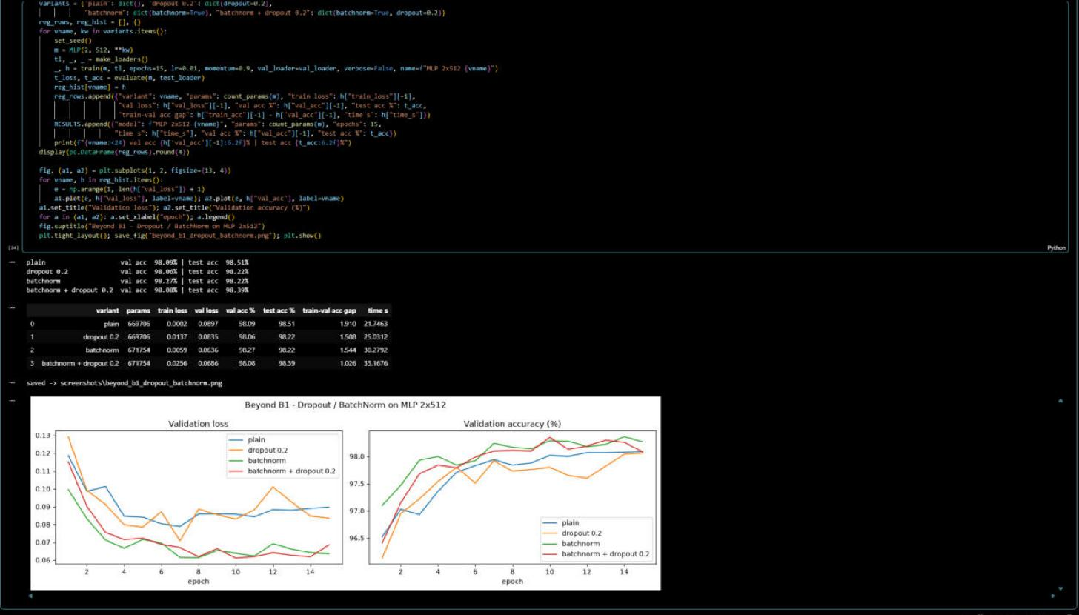
Figure 25: MLP 2 × 512 with and without Dropout / BatchNorm (15 epochs)
All four variants reach ≈98.1–98.3 % validation accuracy. BatchNorm gives the lowest validation loss (0.0636 vs 0.0897 without) and the highest validation accuracy (98.27 %). Dropout reduces overfitting: the train–validation accuracy gap shrinks from 1.91 (plain) to 1.51 (dropout) and 1.03 (BatchNorm + dropout). Test accuracy differences are small (98.22–98.51 %).

B2) CNN with BatchNorm, Dropout, data augmentation, LR scheduler and early stopping
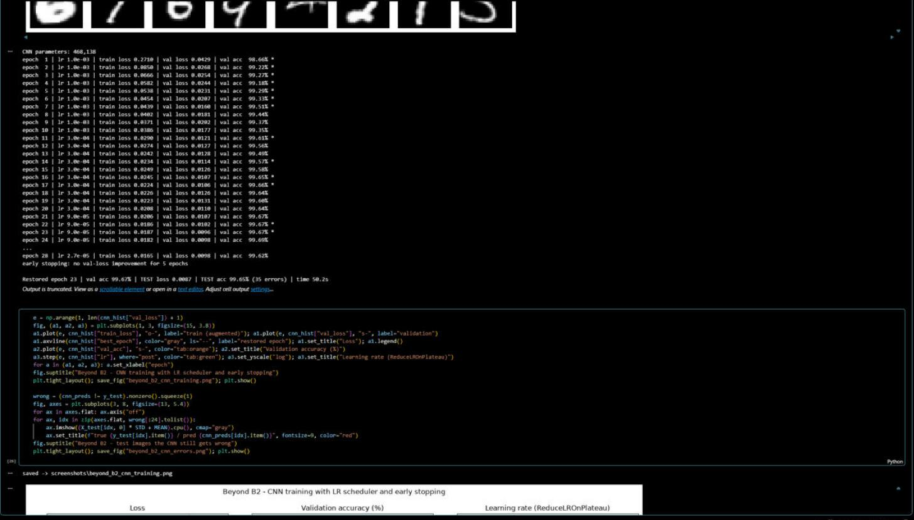
Figure 26: CNN training log – ReduceLROnPlateau and early stopping on validation loss
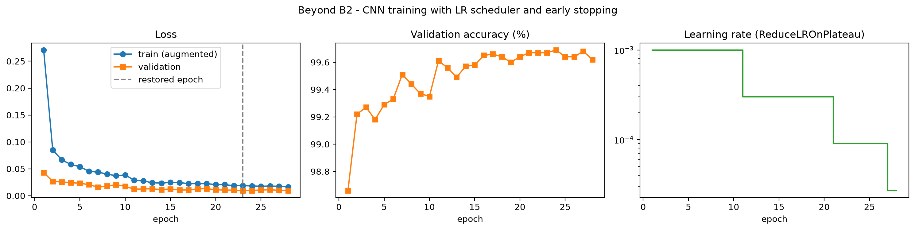
Figure 27: CNN loss, validation accuracy and learning-rate schedule
The CNN (4 conv layers with BatchNorm, 2 max-pool stages, Dropout; 468,138 parameters) is trained with light augmentation (rotation ±10°, shift ±2 px, scale 0.9–1.1) and Adam. ReduceLROnPlateau lowered the learning rate 1e-3 → 3e-4 → 9e-5 → 2.7e-5 and early stopping ended training after epoch 28; the weights of epoch 23 (lowest validation loss) were restored. Result: validation 99.67 %, test accuracy 99.65 % (test loss 0.0087) – only 35 errors out of 10,000.

B3) CPU vs GPU training time
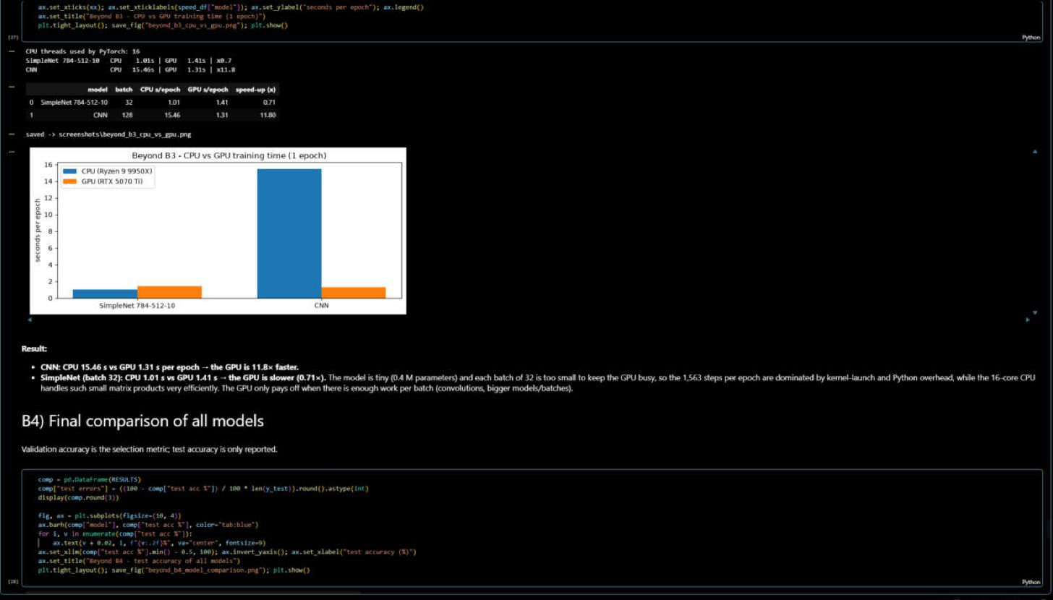
Figure 28: One training epoch on the CPU (Ryzen 9 9950X) and on the GPU (RTX 5070 Ti)
For the CNN the GPU is 11.8× faster (15.46 s vs 1.31 s per epoch). For the small SimpleNet with batch 32 the GPU is actually slower (1.41 s vs 1.01 s): each batch is too small to keep the GPU busy, so kernel-launch and Python overhead dominate, while the 16-core CPU handles such small matrix products efficiently.

B4) Comparison of all models
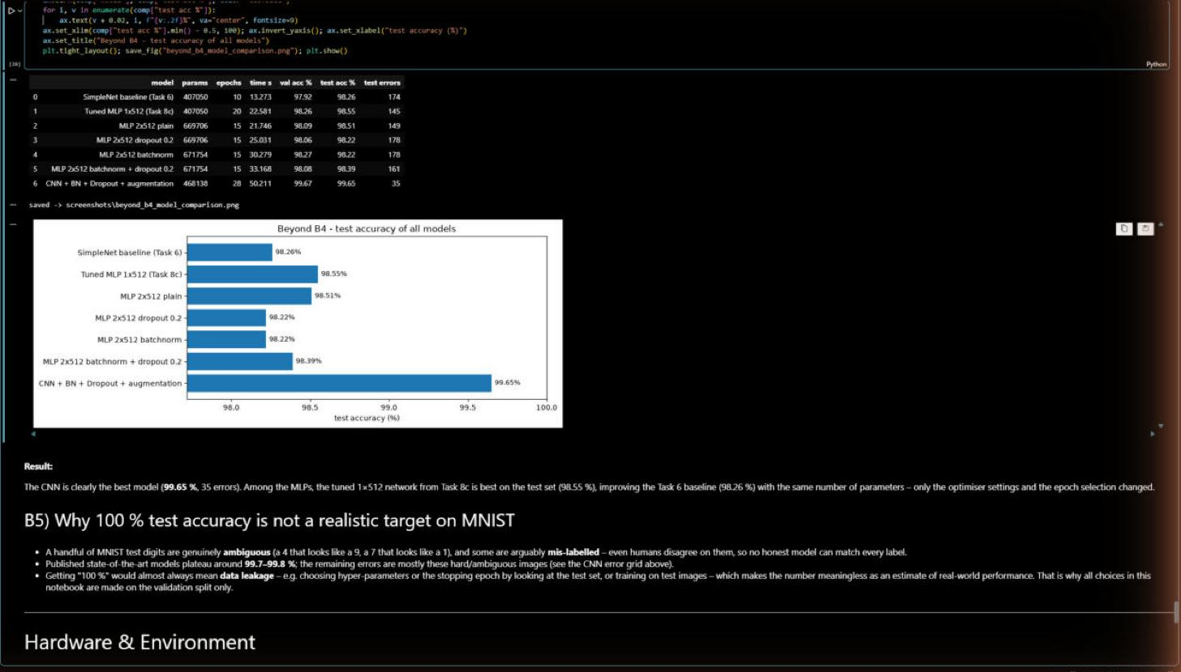
Figure 29: Final comparison of all models and why 100 % is not a realistic target
Model | Params | Epochs | Time (s) | Val acc | Test acc
Task 6 baseline MLP | 407,050 | 10 | 13.3 | 97.92 % | 98.26 %
Task 8c tuned MLP 1×512 | 407,050 | 20 | 22.6 | 98.26 % | 98.55 %
MLP 2×512 plain | 669,706 | 15 | 21.7 | 98.09 % | 98.51 %
MLP 2×512 + dropout 0.2 | 669,706 | 15 | 25.0 | 98.06 % | 98.22 %
MLP 2×512 + BatchNorm | 671,754 | 15 | 30.3 | 98.27 % | 98.22 %
MLP 2×512 + BatchNorm + dropout | 671,754 | 15 | 33.2 | 98.08 % | 98.39 %
CNN + BN + Dropout + augmentation | 468,138 | 28 | 50.2 | 99.67 % | 99.65 %

Why not 100 %? A few MNIST test digits are genuinely ambiguous (a 4 that looks like a 9, a 6 that looks like a 0) and some are arguably mislabelled, so even humans disagree on them. The best published models stop around 99.7–99.8 %. A “100 %” result would almost always mean data leakage – e.g. choosing hyper-parameters or the stopping epoch by looking at the test set – which is why all choices here were made on the validation set only.

Hardware & Environment
Component | Specification
CPU | AMD Ryzen 9 9950X (16 cores / 32 threads)
GPU | NVIDIA GeForce RTX 5070 Ti (Blackwell, 16 GB, compute capability 12.0)
RAM | 64 GB DDR5 (61.7 GB usable)
OS / software | Windows 11, Python 3.14.4, PyTorch 2.14.0+cu130, CUDA 13.0, cuDNN 9.24, VS Code

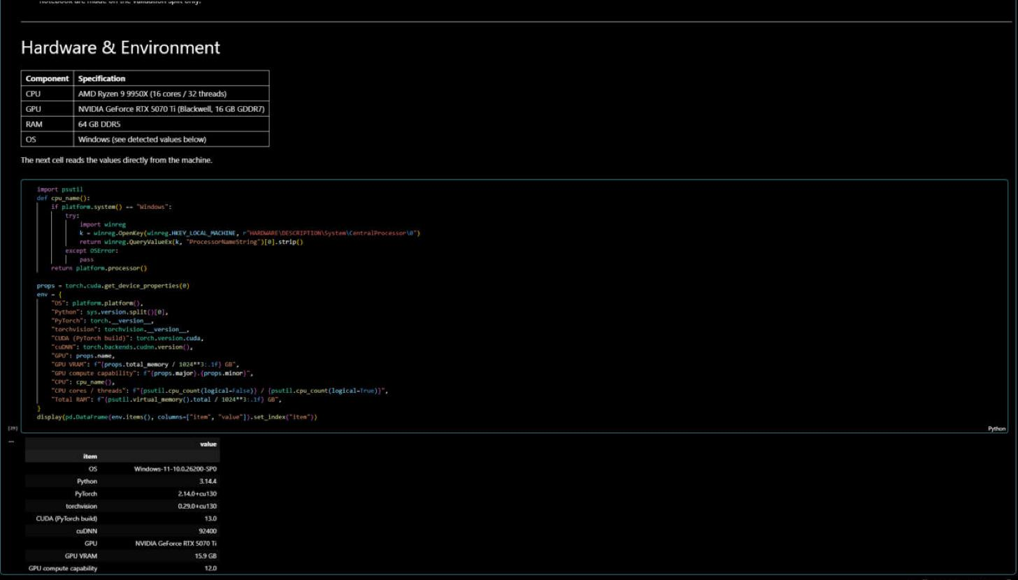
Figure 30: Hardware and software detected automatically by the notebook
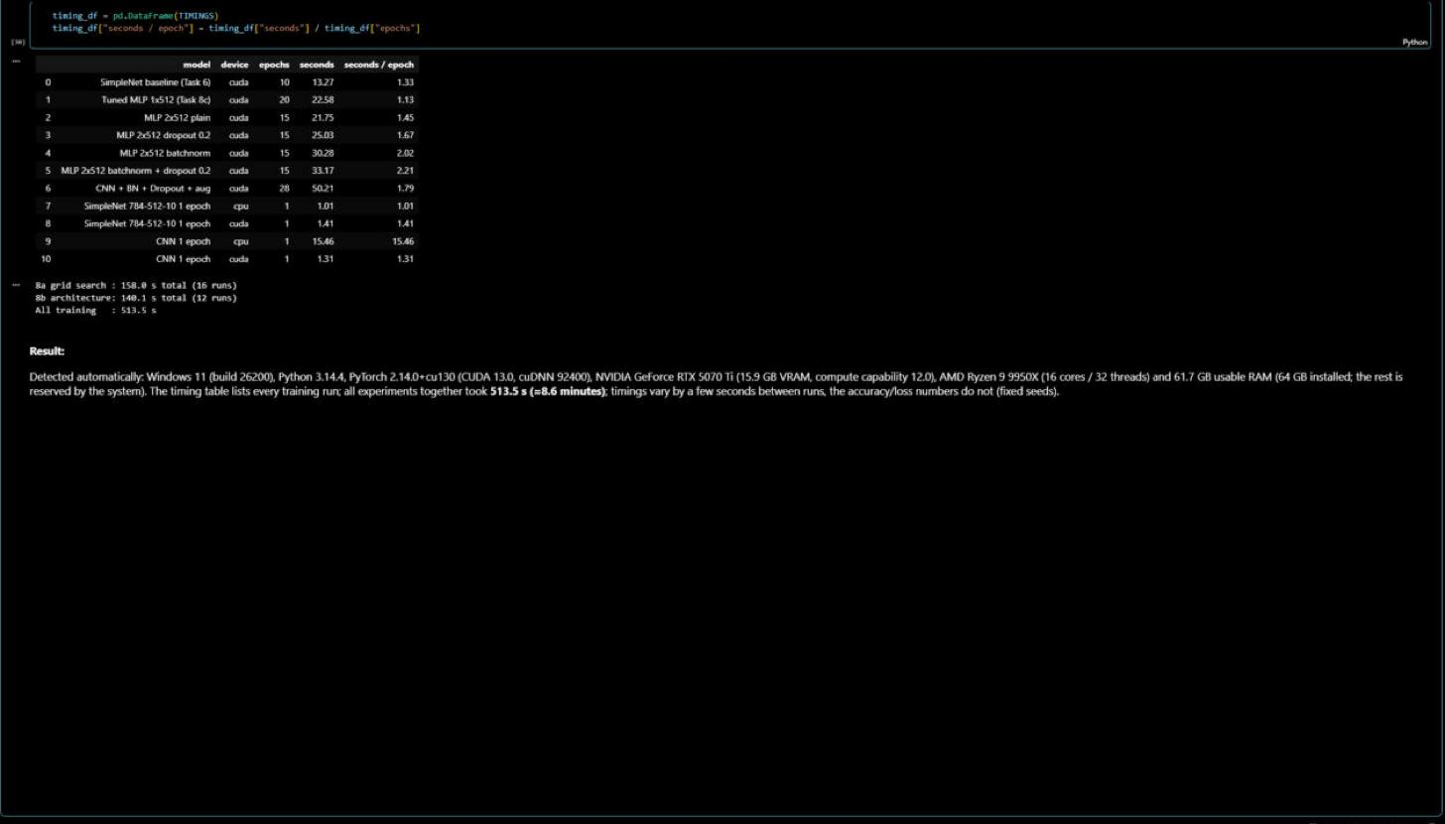
Figure 31: Training time of every model
All training runs together took 513.5 s (≈8.6 min): 158.0 s for the 16 learning-rate/momentum runs and 140.1 s for the 12 architecture runs. Times vary by a few seconds between runs; accuracy and loss values do not (fixed seeds).

- End of Assignment -
Grading Rubric
Criterion | Excellent | Good | Developing | Poor | Marks
Task 1: Install PyTorch | PyTorch installed successfully and PyTorch loaded correctly with clear structure | Installed and PyTorch loaded with minor issues | pyTorch exists but unclear or incomplete | Not completed / missing | 0.5
Task 2: Download and Load the Dataset | Dataset loaded correctly with clear screenshot showing successful execution | Loaded correctly but screenshot is unclear | Dataset loaded with issues or incomplete evidence | Not loaded / missing screenshot | 0.5
Task 3: Inspect the Dataset | All clear screenshots | Minor mistakes or missing small details | Several missing description or unclear screenshots | Not answered / incorrect / missing evidence | 0.5
Task 4: Creating A Simple Network | A simple network correctly craeted, screenshot included | Minor reporting issues | Node used but missing result explanation or screenshot | Not done | 2
Task 6: Training Function | Training function configured correctly with clear screenshots of output | Minor reporting issues | Training Function used but missing result explanation or screenshot | Not done | 1
Task 7: Testing Network | Correct Testing network created, screenshot included. | Testing network correct but result description is weak | Testing network exists but unclear results description | Not done | 1
Task 8: Tuning the parameters and model archirecture | Tuning parameters and model architecture created, screenshot included, and reults description explained accurately | Tuning Parameters and model architecture correct but results description is weak | Tuning Parameters and model architecture corect but incorrect results description | Not done | 1.5
Task 9: Save your source code | Source code save succefully | Source code save succefully done but minor missing item | Source code save incomplete or file format incorrect | Not submitted / missing | 0.5
Total |  |  |  |  | 7.5

