Clinical Study Report
TFL Shell Template

Tables, Figures, and Listings
ICH E3 Sections 14.1 / 14.2 / 14.3 / 14.4 / 16.2
Automatic Word TOC | Three-Line Table Format (三线表)
Embedded Clinical Figures | Dataset Traceability

Version: 2.1.0
Date: 27 April 2026
Classification: CONFIDENTIAL

Applicable to: Oncology and Non-Oncology Clinical Studies
Template Type: Master Shell — No Patient Data

Table of Contents

[To update: right-click the Table of Contents above and select 'Update Field', then 'Update entire table']

1.0 Introduction and Usage Notes
This document is the master TFL (Tables, Figures, and Listings) shell template for clinical study reports covering CSR Sections 14.1, 14.2, 14.3, 14.4, and 16.2. Each shell includes a sponsor/protocol header block, descriptive title, analysis population, shell-first table/listing structure or simulated figure, and traceability footnotes. No actual study results are included in this template.

1.1 Table and Listing Shell Conventions
All tables and listings use shell-first structure. The first column preserves the example row labels, categories, or subject-structure identifiers needed to show the intended layout. Non-structural cells use style-appropriate shell placeholders such as XX, xx (xx.x), x.xxx, or CI-style formats rather than mock numeric or subject-level results. Expandable treatment/group columns may be shown with ellipsis (...) and a Total column. Tables use the standard three-line table format (三线表).

1.2 How to Use This Template
1. Select applicable TFLs using the companion XLSX catalog workbook.
2. Replace bracketed metadata placeholders such as sponsor and protocol details.
3. Keep oncology-only shells only when applicable to the study.
4. Verify titles, headers, and footnotes against the protocol, SAP, and mock shell standards.
5. In Word, update the Table of Contents field to populate headings.
6. Use the shells as governance-ready templates for downstream programming and review.

1.3 Figure Shells
Figures retain simulated illustrations generated by matplotlib so the output shows expected visual layout for Kaplan-Meier curves, waterfall plots, spider plots, swimmer plots, forest plots, box plots, and longitudinal plots. These images are for shell illustration only and must be replaced with study-specific outputs in production.

14.1 Demographics and Baseline Characteristics

Table 14.1.1 Summary of Demographic Characteristics
Sponsor: [Sponsor Name]
Protocol: [Protocol Number] Page of
[Study Title / Compound Name]
Table 14.1.1
Summary of Demographic Characteristics
Analysis Set: Intent-to-Treat (ITT) Population
Demographic Variable  Category / Statistic | Treatment Group 1  (N=xx) | Treatment Group 2  (N=xx) | ...  ...  Total  (N=xx)
Age (years) | XX | XX | XX
n | XX | XX | XX
Mean (SD) | XX | XX | XX
Sex | XX | XX | XX
Race | XX | XX | XX
Weight (kg) | XX | XX | XX
XX | XX | XX | XX
Footnotes:
[1] Percentages based on number of subjects in each treatment group.
[2] Age calculated relative to date of informed consent.
[3] Dataset lineage: Source: ADSL. Program: t_demog_summary.sas.
[4] Note: Continuous: n, Mean, SD, Median, Min, Max. Categorical: n (%).

Table 14.1.2 Summary of Baseline Disease Characteristics
Sponsor: [Sponsor Name]
Protocol: [Protocol Number] Page of
[Study Title / Compound Name]
Table 14.1.2
Summary of Baseline Disease Characteristics
Analysis Set: Intent-to-Treat (ITT) Population
Characteristic  Category / Statistic | Treatment Group 1  (N=xx) | Treatment Group 2  (N=xx) | ...  ...  Total  (N=xx)
ECOG Performance Status | XX | XX | XX
Primary Tumor Type | XX | XX | XX
Disease Stage | XX | XX | XX
Time Since Initial Diagnosis (months) | XX | XX | XX
Disease Duration (mo) | XX | XX | XX
XX | XX | XX | XX
Footnotes:
[1] ECOG: 0=Fully active, 1=Restricted, 2=Ambulatory but unable to work, 3=Limited self-care, 4=Completely disabled.
[2] Baseline = last non-missing assessment on/before first dose.
[3] Dataset lineage: Source: ADSL, ADRS. Program: t_baseline_chars.sas.

Table 14.1.3 Summary of Medical History by System Organ Class and Preferred Term
Sponsor: [Sponsor Name]
Protocol: [Protocol Number] Page of
[Study Title / Compound Name]
Table 14.1.3
Summary of Medical History by System Organ Class and Preferred Term
Analysis Set: Safety Population
System Organ Class  Preferred Term | Treatment Group 1  (N=xx) n (%) | Treatment Group 2  (N=xx) n (%) | ...  ...  Total  (N=xx) n (%)
Vascular disorders | XX | XX | XX
Hypertension | XX | XX | XX
Hypotension | XX | XX | XX
Metabolism and nutrition disorders | XX | XX | XX
Diabetes mellitus | XX | XX | XX
Hyperlipidemia | XX | XX | XX
XX | XX | XX | XX
Footnotes:
[1] MedDRA version 26.0 used for coding medical history terms.
[2] Dataset lineage: Source: ADMH. Program: t_mh_soc_pt.sas.
[3] Coding dictionary versions: MedDRA 26.0.

Table 14.1.4 Summary of Prior Medications by ATC Class and Preferred Name
Sponsor: [Sponsor Name]
Protocol: [Protocol Number] Page of
[Study Title / Compound Name]
Table 14.1.4
Summary of Prior Medications by ATC Class and Preferred Name
Analysis Set: Safety Population
ATC Class Level 2  Preferred Name | Treatment Group 1  (N=xx) n (%) | Treatment Group 2  (N=xx) n (%) | ...  ...  Total  (N=xx) n (%)
Drugs for acid-related disorders | XX | XX | XX
Omeprazole | XX | XX | XX
Pantoprazole | XX | XX | XX
Antibacterials for systemic use | XX | XX | XX
Amoxicillin | XX | XX | XX
XX | XX | XX | XX
Footnotes:
[1] WHO Drug Dictionary Global 2024Q1 used for medication coding.
[2] Dataset lineage: Source: ADCM. Program: t_prior_meds.sas.
[3] Coding dictionary versions: WHO-DD 2024Q1.

Table 14.1.5 Subject Disposition
Sponsor: [Sponsor Name]
Protocol: [Protocol Number] Page of
[Study Title / Compound Name]
Table 14.1.5
Subject Disposition
Analysis Set: All Randomized Subjects
Disposition Category | Treatment Group 1  n (%) | Treatment Group 2  n (%) | Total  n (%)
Treated (>=1 dose) | XX | XX | XX
Completed Treatment | XX | XX | XX
Discontinued Treatment | XX | XX | XX
Disease Progression | XX | XX | XX
Adverse Event | XX | XX | XX
Withdrawal by Subject | XX | XX | XX
Other | XX | XX | XX
Footnotes:
[1] Percentages for discontinued: N=treated per arm.
[2] Primary reason for discontinuation per CRF EOT page.
[3] Dataset lineage: Source: ADSL. Program: t_disposition.sas.

Table 14.1.6 Major Protocol Deviations
Sponsor: [Sponsor Name]
Protocol: [Protocol Number] Page of
[Study Title / Compound Name]
Table 14.1.6
Major Protocol Deviations
Analysis Set: All Randomized Subjects
Deviation Category /  Description | Treatment Group 1  n (%) | Treatment Group 2  n (%) | Total  n (%)
Inclusion/Exclusion Criteria Not Met | XX | XX | XX
Received Wrong Treatment/Incorrect Dose | XX | XX | XX
Missed >=2 Consecutive Efficacy Assessments | XX | XX | XX
Concomitant Prohibited Medication | XX | XX | XX
XX | XX | XX | XX
Footnotes:
[1] Major PDs defined per Protocol Deviation Plan, determined prior to unblinding.
[2] Dataset lineage: Source: ADSL, DV. Program: t_prot_dev.sas.

Table 14.1.7 Analysis Populations
Sponsor: [Sponsor Name]
Protocol: [Protocol Number] Page of
[Study Title / Compound Name]
Table 14.1.7
Analysis Populations
Analysis Set: All Subjects
Analysis Population | Treatment Group 1  n (%) | Treatment Group 2  n (%) | Total  n (%)
Randomized | XX | XX | XX
Intent-to-Treat (ITT) | XX | XX | XX
Safety Population | XX | XX | XX
Per-Protocol (PP) | XX | XX | XX
PK Population | XX | XX | XX
Footnotes:
[1] ITT: All randomized subjects who received >=1 dose of study treatment.
[2] Safety: All subjects who received >=1 dose of study treatment.
[3] Dataset lineage: Source: ADSL. Program: t_populations.sas.

Table 14.1.8 Medical History by SOC/PT — Incidence >=2% in Any Arm
Sponsor: [Sponsor Name]
Protocol: [Protocol Number] Page of
[Study Title / Compound Name]
Table 14.1.8
Medical History by SOC/PT — Incidence >=2% in Any Arm
Analysis Set: Safety Population
SOC /  Preferred Term | Treatment Group 1  (N=xx) n (%) | Treatment Group 2  (N=xx) n (%)
Gastroesophageal reflux disease | XX | XX
Hiatus hernia | XX | XX
Musculoskeletal disorders | XX | XX
Back pain | XX | XX
Osteoarthritis | XX | XX
XX | XX | XX
Footnotes:
[1] MedDRA 26.0. Only PTs with >=2% incidence in any arm displayed.
[2] Dataset lineage: Source: ADMH. Program: t_mh_2pct.sas.
[3] Coding dictionary versions: MedDRA 26.0.

Table 14.1.9 Prior and Concomitant Medications by ATC Level 2 and Preferred Name
Sponsor: [Sponsor Name]
Protocol: [Protocol Number] Page of
[Study Title / Compound Name]
Table 14.1.9
Prior and Concomitant Medications by ATC Level 2 and Preferred Name
Analysis Set: Safety Population
ATC Level 2 /  Preferred Name | Treatment Group 1  (N=xx) n (%) | Treatment Group 2  (N=xx) n (%)
Concomitant Medications — Any | XX | XX
Drugs for acid-related disorders | XX | XX
Analgesics | XX | XX
Antihypertensives | XX | XX
XX | XX | XX
Footnotes:
[1] WHO Drug Dictionary 2024Q1. Concomitant: any medication after first dose or within 30 days prior and continuing.
[2] Dataset lineage: Source: ADCM. Program: t_conmed_atc.sas.
[3] Coding dictionary versions: WHO-DD 2024Q1.

Table 14.1.10 COVID-19 Medical History, Vaccination, and Testing Status
Sponsor: [Sponsor Name]
Protocol: [Protocol Number] Page of
[Study Title / Compound Name]
Table 14.1.10
COVID-19 Medical History, Vaccination, and Testing Status
Analysis Set: Safety Population
COVID-19 Parameter | Category | Treatment Group 1  (N=xx) n (%) | Treatment Group 2  (N=xx) n (%)
COVID-19 Vaccinated | XX | XX | XX
Baseline COVID-19 Test | XX | XX | XX
XX | XX | XX | XX
Footnotes:
[1] Dataset lineage: Source: ADSL, ADMH. Program: t_covid19_status.sas.

Table 14.1.11 Summary of Study Drug Exposure
Sponsor: [Sponsor Name]
Protocol: [Protocol Number] Page of
[Study Title / Compound Name]
Table 14.1.11
Summary of Study Drug Exposure
Analysis Set: Safety Population
Exposure Parameter | Statistic | Treatment Group 1  (N=xx) | Treatment Group 2  (N=xx)
Duration of Exposure (days) | XX | XX | XX
Number of cycles started | XX | XX | XX
Cumulative dose (mg) | XX | XX | XX
Dose intensity (mg/day) | XX | XX | XX
XX | XX | XX | XX
Footnotes:
[1] Dataset lineage: Source: ADEX. Program: t_exposure_summary.sas.

Table 14.1.12 Summary of Genomic/Biomarker Baseline Characteristics
Sponsor: [Sponsor Name]
Protocol: [Protocol Number] Page of
[Study Title / Compound Name]
Table 14.1.12
Summary of Genomic/Biomarker Baseline Characteristics
[ONCOLOGY ONLY]
Analysis Set: ITT Population with Biomarker Data
Biomarker | Category /  Statistic | Treatment A  (N=xx) | Treatment B  (N=xx)
PD-L1 Expression | XX | XX | XX
Tumor Mutation Burden | XX | XX | XX
EGFR Mutation | XX | XX | XX
XX | XX | XX | XX
Footnotes:
[1] Dataset lineage: Source: ADSL, ADBM. Program: t_biomarker_baseline.sas.

14.2 Efficacy Analysis

Table 14.2.1 Primary Efficacy Endpoint — Primary Analysis
Sponsor: [Sponsor Name]
Protocol: [Protocol Number] Page of
[Study Title / Compound Name]
Table 14.2.1
Primary Efficacy Endpoint — Primary Analysis
Analysis Set: Intent-to-Treat (ITT) Population
Parameter | Treatment Group 1  (N=xx) | Treatment Group 2  (N=xx) | Difference | 95% CI | p-value
Least Squares Mean (SE) | XX | XX | XX | XX | XX
ANCOVA Model: treatment + baseline + stratification factors | XX | XX | XX | XX | XX
XX | XX | XX | XX | XX | XX
Footnotes:
[1] ANCOVA with baseline value as covariate and treatment, stratification as fixed effects.
[2] Missing data handled by MMRM under MAR assumption.
[3] Two-sided 95% CI and p-value reported.
[4] Dataset lineage: Source: ADSL, ADEFF. Program: t_primary_eff.sas.

Table 14.2.2 Secondary Efficacy Endpoints — Summary
Sponsor: [Sponsor Name]
Protocol: [Protocol Number] Page of
[Study Title / Compound Name]
Table 14.2.2
Secondary Efficacy Endpoints — Summary
Analysis Set: Intent-to-Treat (ITT) Population
Endpoint | Statistic | Treatment Group 1  (N=xx) | Treatment Group 2  (N=xx) | Difference | 95% CI | p-value
Secondary Endpoint 2 — Response Rate | XX | XX | XX | XX | XX | XX
XX | XX | XX | XX | XX | XX | XX
Footnotes:
[1] Hierarchical testing per SAP; nominal p-values shown.
[2] Multiplicity-adjusted p-values for the primary family.
[3] Dataset lineage: Source: ADSL, ADEFF. Program: t_secondary_eff.sas.

Table 14.2.3 Subgroup Analysis of Primary Endpoint
Sponsor: [Sponsor Name]
Protocol: [Protocol Number] Page of
[Study Title / Compound Name]
Table 14.2.3
Subgroup Analysis of Primary Endpoint
Analysis Set: Intent-to-Treat (ITT) Population
Subgroup | Level | Treatment Group 1  n/N [stat] | Treatment Group 2  n/N [stat] | Effect [95% CI] | Interaction p
Age | XX | XX | XX | XX | XX
 | XX | XX | XX | XX | XX
Sex | XX | XX | XX | XX | XX
 | XX | XX | XX | XX | XX
XX | XX | XX | XX | XX | XX
Footnotes:
[1] Subgroup analyses are exploratory.
[2] Interaction p-value from model with treatment-by-subgroup term.
[3] Dataset lineage: Source: ADSL, ADEFF. Program: t_subgroup_primary.sas.

Table 14.2.4 Sensitivity Analysis of Primary Endpoint
Sponsor: [Sponsor Name]
Protocol: [Protocol Number] Page of
[Study Title / Compound Name]
Table 14.2.4
Sensitivity Analysis of Primary Endpoint
Analysis Set: ITT and Per-Protocol (PP) Populations
Analysis | Population | Missing Data | Treatment Group 1  LS Mean | Treatment Group 2  LS Mean | Difference | 95% CI
PP Analysis | XX | XX | XX | XX | XX | XX
Multiple Imputation | XX | XX | XX | XX | XX | XX
Tipping Point (δ=1.0) | XX | XX | XX | XX | XX | XX
XX | XX | XX | XX | XX | XX | XX
Footnotes:
[1] Sensitivity analyses assess robustness to MAR deviations.
[2] Dataset lineage: Source: ADSL, ADEFF. Program: t_sensitivity_eff.sas.

Table 14.2.5 Non-Inferiority Analysis of Primary Endpoint
Sponsor: [Sponsor Name]
Protocol: [Protocol Number] Page of
[Study Title / Compound Name]
Table 14.2.5
Non-Inferiority Analysis of Primary Endpoint
Analysis Set: Per-Protocol (PP) Population
Parameter | Treatment Group 1  (N=xx) | Control Group  (N=xx) | Difference | 95% CI | NI Margin | NI Met?
XX | XX | XX | XX | XX | XX | XX
Footnotes:
[1] NI margin = [X] per regulatory agreement.
[2] NI demonstrated if upper bound of 95% CI < NI margin.
[3] Dataset lineage: Source: ADSL, ADEFF. Program: t_ni_analysis.sas.

Table 14.2.6 Tipping Point Analysis for Primary Endpoint
Sponsor: [Sponsor Name]
Protocol: [Protocol Number] Page of
[Study Title / Compound Name]
Table 14.2.6
Tipping Point Analysis for Primary Endpoint
Analysis Set: ITT Population
Tipping Point Parameter | Shift Value | p-value | Conclusion
 | XX | XX | XX
 | XX | XX | XX
 | XX | XX | XX
XX | XX | XX | XX
Footnotes:
[1] Tipping point analysis per ICH E9(R1). Assesses departures from MAR.
[2] Dataset lineage: Source: ADSL, ADEFF. Program: t_tipping_point.sas.

Table 14.2.7 Sensitivity Analysis by Estimand Strategy
Sponsor: [Sponsor Name]
Protocol: [Protocol Number] Page of
[Study Title / Compound Name]
Table 14.2.7
Sensitivity Analysis by Estimand Strategy
Analysis Set: ITT Population
Estimand Strategy | Intercurrent Event Handling | Difference | 95% CI | p-value
Composite | XX | XX | XX | XX
Hypothetical | XX | XX | XX | XX
XX | XX | XX | XX | XX
Footnotes:
[1] Estimand strategies per ICH E9(R1).
[2] Dataset lineage: Source: ADSL, ADEFF. Program: t_estimand_sens.sas.

Table 14.2.8 Time to Deterioration (TTD) — Quality of Life
Sponsor: [Sponsor Name]
Protocol: [Protocol Number] Page of
[Study Title / Compound Name]
Table 14.2.8
Time to Deterioration (TTD) — Quality of Life
Analysis Set: ITT Population with PRO Data
Parameter | Treatment Group 1  (N=xx) | Treatment Group 2  (N=xx) | HR [95% CI] | p-value
Events / N | XX | XX | XX | XX
XX | XX | XX | XX | XX
Footnotes:
[1] TTD: time to first >=10-point decrease in EORTC QLQ-C30 GHS, confirmed at next visit, or death.
[2] Dataset lineage: Source: ADSL, ADPRO. Program: t_ttd_qol.sas.

Figure 14.2.1 Forest Plot — Primary Endpoint by Subgroup
Sponsor: [Sponsor Name]
Protocol: [Protocol Number] Page of
[Study Title / Compound Name]
Figure 14.2.1
Forest Plot — Primary Endpoint by Subgroup
Analysis Set: Intent-to-Treat (ITT) Population
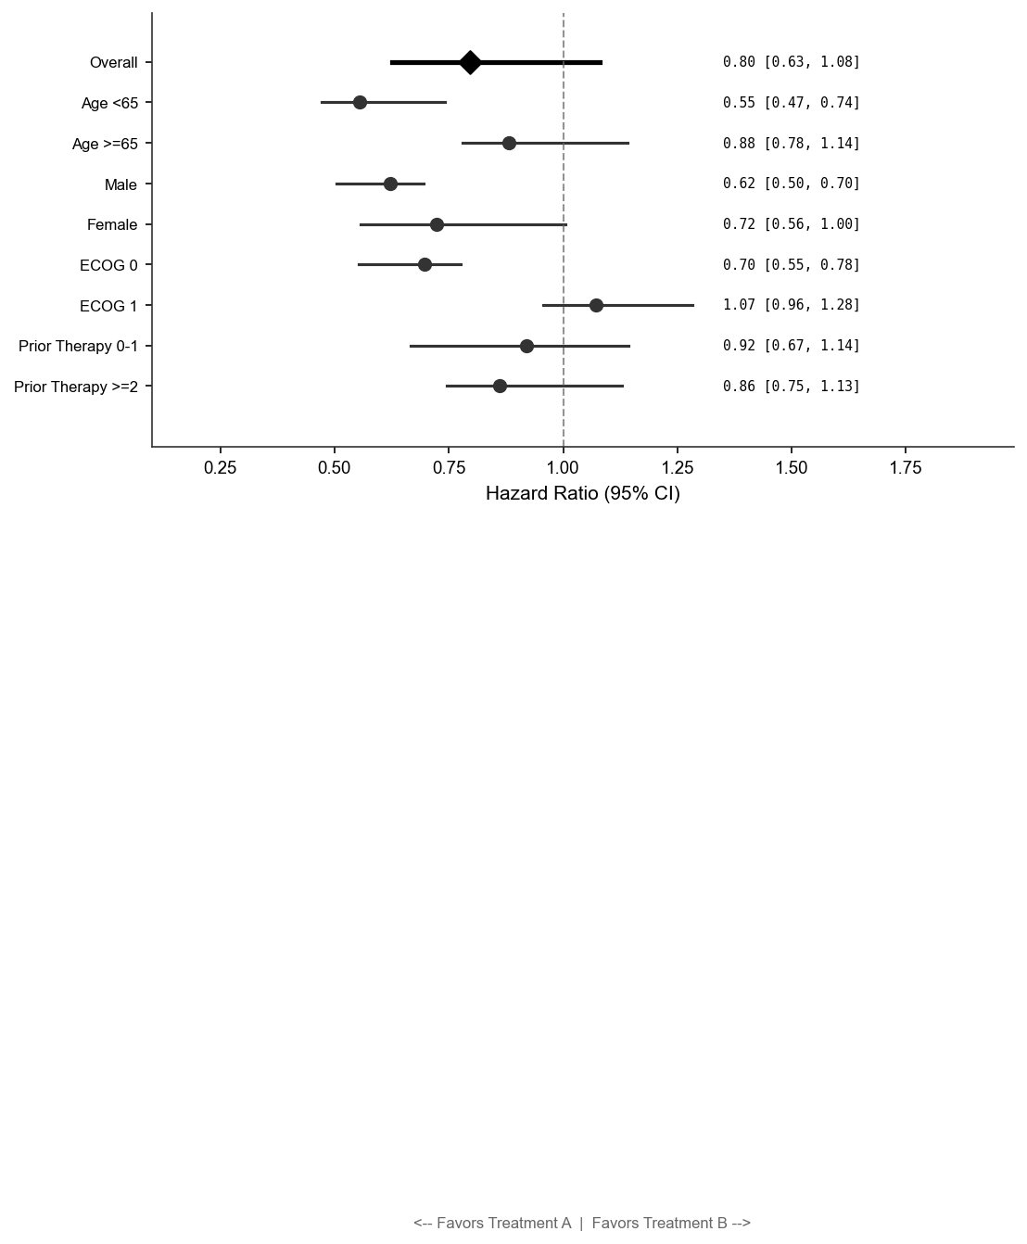
[Figure 14.2.1: Forest plot: treatment effect [95% CI] per subgroup, overall diamond.]
Footnotes:
[1] Dataset lineage: Source: ADSL, ADEFF. Program: f_forest_primary.sas.

Figure 14.2.2 Longitudinal Plot — Primary Endpoint Over Time
Sponsor: [Sponsor Name]
Protocol: [Protocol Number] Page of
[Study Title / Compound Name]
Figure 14.2.2
Longitudinal Plot — Primary Endpoint Over Time
Analysis Set: Intent-to-Treat (ITT) Population
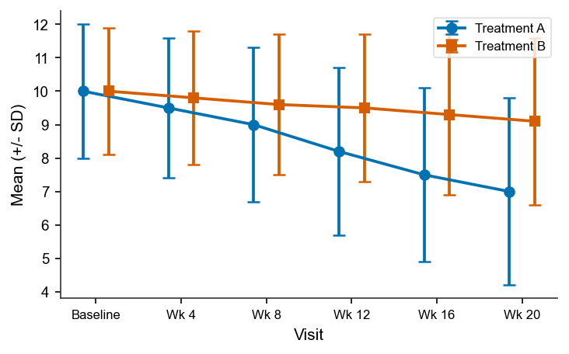
[Figure 14.2.2: Line plot: Mean (±SE) primary endpoint by visit, two arms.]
Footnotes:
[1] Dataset lineage: Source: ADSL, ADEFF. Program: f_longitudinal_eff.sas.

Figure 14.2.3 Cumulative Distribution Function Plot
Sponsor: [Sponsor Name]
Protocol: [Protocol Number] Page of
[Study Title / Compound Name]
Figure 14.2.3
Cumulative Distribution Function Plot
Analysis Set: Intent-to-Treat (ITT) Population

[Figure 14.2.3: CDF plot: X=Change from Baseline, Y=Cumulative Proportion.]
Footnotes:
[1] Dataset lineage: Source: ADSL, ADEFF. Program: f_cdf_eff.sas.

Table 14.2.9 Tumor Response — Best Overall Response (BOR)
Sponsor: [Sponsor Name]
Protocol: [Protocol Number] Page of
[Study Title / Compound Name]
Table 14.2.9
Tumor Response — Best Overall Response (BOR)
[ONCOLOGY ONLY]
Analysis Set: Intent-to-Treat (ITT) Population
Best Overall Response | Treatment Group 1  (N=xx) n (%) | Treatment Group 2  (N=xx) n (%)
Complete Response (CR) | XX | XX
Partial Response (PR) | XX | XX
Stable Disease (SD) | XX | XX
Progressive Disease (PD) | XX | XX
Not Evaluable (NE) | XX | XX
Footnotes:
[1] RECIST v1.1 by Independent Central Review (ICR). Confirmed responses only.
[2] Dataset lineage: Source: ADSL, ADRS. Program: t_bor.sas.

Table 14.2.10 Tumor Response — Objective Response Rate (ORR)
Sponsor: [Sponsor Name]
Protocol: [Protocol Number] Page of
[Study Title / Compound Name]
Table 14.2.10
Tumor Response — Objective Response Rate (ORR)
[ONCOLOGY ONLY]
Analysis Set: Intent-to-Treat (ITT) Population
Parameter | Treatment Group 1  (N=xx) | Treatment Group 2  (N=xx) | Odds Ratio [95% CI] | p-value
95% CI | XX | XX | XX | XX
Stratified CMH Test | XX | XX | XX | XX
Footnotes:
[1] 95% CI via Clopper-Pearson exact method.
[2] OR from stratified logistic regression.
[3] Dataset lineage: Source: ADSL, ADRS. Program: t_orr.sas.

Table 14.2.11 Tumor Response — Disease Control Rate (DCR)
Sponsor: [Sponsor Name]
Protocol: [Protocol Number] Page of
[Study Title / Compound Name]
Table 14.2.11
Tumor Response — Disease Control Rate (DCR)
[ONCOLOGY ONLY]
Analysis Set: Intent-to-Treat (ITT) Population
Parameter | Treatment Group 1  (N=xx) | Treatment Group 2  (N=xx)
95% CI | XX | XX
Footnotes:
[1] SD must be maintained for >=6 weeks from first dose.
[2] Dataset lineage: Source: ADSL, ADRS. Program: t_dcr.sas.

Table 14.2.12 Tumor Response — Duration of Response (DOR)
Sponsor: [Sponsor Name]
Protocol: [Protocol Number] Page of
[Study Title / Compound Name]
Table 14.2.12
Tumor Response — Duration of Response (DOR)
[ONCOLOGY ONLY]
Analysis Set: Responders (Confirmed CR or PR)
Parameter | Treatment Group 1  (N=xx) | Treatment Group 2  (N=xx)
Median DOR (months) | XX | XX
95% CI | XX | XX
KM rate at 12 months | XX | XX
Footnotes:
[1] KM method; median via Brookmeyer-Crowley. Censored at last adequate tumor assessment for alive+progression-free responders.
[2] Dataset lineage: Source: ADSL, ADRS, ADTTE. Program: t_dor.sas.

Table 14.2.13 Tumor Response — Time to Response (TTR)
Sponsor: [Sponsor Name]
Protocol: [Protocol Number] Page of
[Study Title / Compound Name]
Table 14.2.13
Tumor Response — Time to Response (TTR)
[ONCOLOGY ONLY]
Analysis Set: Responders (Confirmed CR or PR)
Parameter | Treatment Group 1  (N=xx) | Treatment Group 2  (N=xx)
Median (Min, Max) | XX | XX
Footnotes:
[1] Dataset lineage: Source: ADSL, ADRS. Program: t_ttr.sas.

Table 14.2.14 Progression-Free Survival (PFS) — Primary Analysis
Sponsor: [Sponsor Name]
Protocol: [Protocol Number] Page of
[Study Title / Compound Name]
Table 14.2.14
Progression-Free Survival (PFS) — Primary Analysis
[ONCOLOGY ONLY]
Analysis Set: Intent-to-Treat (ITT) Population
Parameter | Treatment Group 1  (N=xx) | Treatment Group 2  (N=xx)
Median PFS (months) | XX | XX
95% CI | XX | XX
Hazard Ratio (95% CI) | XX | XX
p-value (stratified log-rank) | XX | XX
Footnotes:
[1] PFS: time from randomization to PD (RECIST 1.1, ICR) or death.
[2] Stratified Cox model and log-rank test by baseline stratification factors.
[3] Dataset lineage: Source: ADSL, ADTTE. Program: t_pfs_primary.sas.

Table 14.2.15 Overall Survival (OS) — Primary Analysis
Sponsor: [Sponsor Name]
Protocol: [Protocol Number] Page of
[Study Title / Compound Name]
Table 14.2.15
Overall Survival (OS) — Primary Analysis
[ONCOLOGY ONLY]
Analysis Set: Intent-to-Treat (ITT) Population
Parameter | Treatment Group 1  (N=xx) | Treatment Group 2  (N=xx)
Median OS (months) | XX | XX
95% CI | XX | XX
Hazard Ratio (95% CI) | XX | XX
p-value (stratified log-rank) | XX | XX
Footnotes:
[1] OS: time from randomization to death from any cause. NR=Not Reached.
[2] Dataset lineage: Source: ADSL, ADTTE. Program: t_os_primary.sas.

Table 14.2.16 PFS — Sensitivity Analysis
Sponsor: [Sponsor Name]
Protocol: [Protocol Number] Page of
[Study Title / Compound Name]
Table 14.2.16
PFS — Sensitivity Analysis
[ONCOLOGY ONLY]
Analysis Set: Intent-to-Treat (ITT) Population
Analysis | Med PFS A  (mo) | Med PFS B  (mo) | HR [95% CI] | p-value
Investigator Assessment | XX | XX | XX | XX
PP Population | XX | XX | XX | XX
Footnotes:
[1] Dataset lineage: Source: ADSL, ADTTE. Program: t_pfs_sensitivity.sas.

Table 14.2.17 PFS — Subgroup Analysis
Sponsor: [Sponsor Name]
Protocol: [Protocol Number] Page of
[Study Title / Compound Name]
Table 14.2.17
PFS — Subgroup Analysis
[ONCOLOGY ONLY]
Analysis Set: Intent-to-Treat (ITT) Population
Subgroup | Level | Treatment A  n/N, Med PFS | Treatment B  n/N, Med PFS | HR [95% CI] | Interaction p
PD-L1 TPS | XX | XX | XX | XX | XX
 | XX | XX | XX | XX | XX
 | XX | XX | XX | XX | XX
XX | XX | XX | XX | XX | XX
Footnotes:
[1] Dataset lineage: Source: ADSL, ADTTE. Program: t_pfs_subgroup.sas.

Table 14.2.18 OS — Subgroup Analysis
Sponsor: [Sponsor Name]
Protocol: [Protocol Number] Page of
[Study Title / Compound Name]
Table 14.2.18
OS — Subgroup Analysis
[ONCOLOGY ONLY]
Analysis Set: Intent-to-Treat (ITT) Population
Subgroup | Level | Treatment A  n/N, Med OS | Treatment B  n/N, Med OS | HR [95% CI] | Interaction p
Age <65 | XX | XX | XX | XX | XX
Male | XX | XX | XX | XX | XX
XX | XX | XX | XX | XX | XX
Footnotes:
[1] Dataset lineage: Source: ADSL, ADTTE. Program: t_os_subgroup.sas.

Table 14.2.19 Summary of Target Lesion Changes from Baseline
Sponsor: [Sponsor Name]
Protocol: [Protocol Number] Page of
[Study Title / Compound Name]
Table 14.2.19
Summary of Target Lesion Changes from Baseline
[ONCOLOGY ONLY]
Analysis Set: ITT with Measurable Disease and Post-Baseline Assessment
Parameter | Treatment A  (N=145) | Treatment B  (N=145)
Median (Range) | XX | XX
Footnotes:
[1] Dataset lineage: Source: ADSL, ADRS. Program: t_target_lesion.sas.

Figure 14.2.4 Waterfall Plot — Best Percentage Change in Target Lesions
Sponsor: [Sponsor Name]
Protocol: [Protocol Number] Page of
[Study Title / Compound Name]
Figure 14.2.4
Waterfall Plot — Best Percentage Change in Target Lesions
[ONCOLOGY ONLY]
Analysis Set: ITT with Measurable Disease and Post-Baseline Assessment
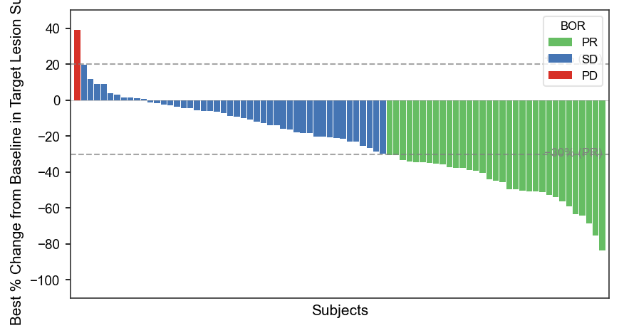
[Figure 14.2.4: Waterfall: best % change per subject, BOR-colored, ref lines at +20%/-30%.]
Footnotes:
[1] Dataset lineage: Source: ADSL, ADRS. Program: f_waterfall.sas.

Figure 14.2.5 Spider Plot — Percentage Change in Tumor Burden Over Time
Sponsor: [Sponsor Name]
Protocol: [Protocol Number] Page of
[Study Title / Compound Name]
Figure 14.2.5
Spider Plot — Percentage Change in Tumor Burden Over Time
[ONCOLOGY ONLY]
Analysis Set: ITT with Measurable Disease
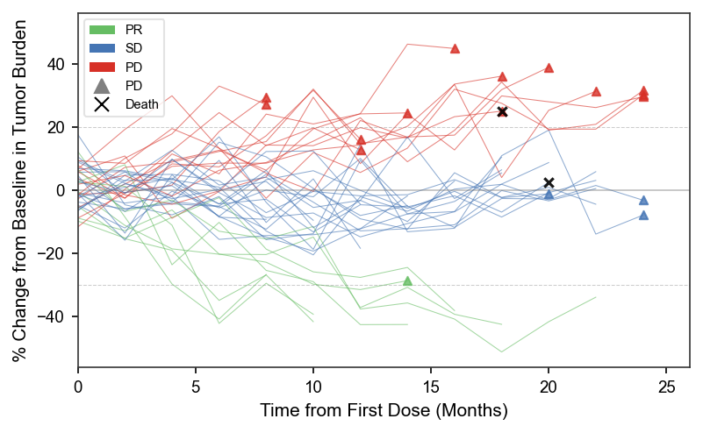
[Figure 14.2.5: Spider plot: % change trajectories, BOR-colored, PD/death markers.]
Footnotes:
[1] Dataset lineage: Source: ADSL, ADRS. Program: f_spider.sas.

Figure 14.2.6 Swimmer Plot — Duration of Treatment and Response
Sponsor: [Sponsor Name]
Protocol: [Protocol Number] Page of
[Study Title / Compound Name]
Figure 14.2.6
Swimmer Plot — Duration of Treatment and Response
[ONCOLOGY ONLY]
Analysis Set: Safety Population
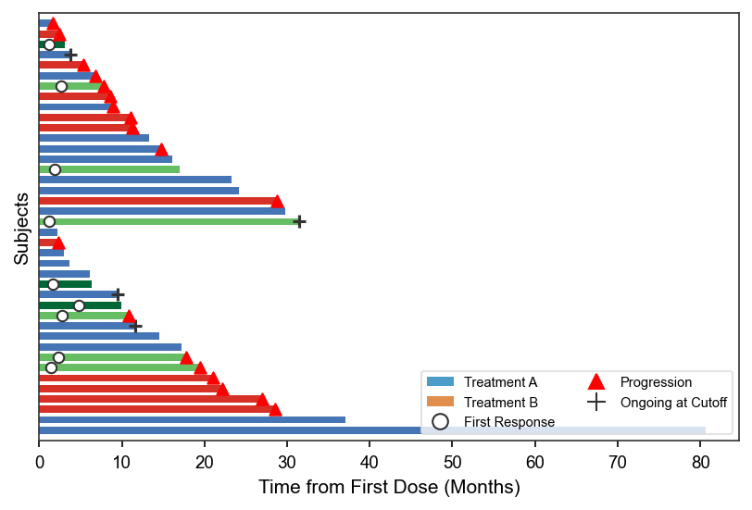
[Figure 14.2.6: Swimmer: treatment duration bars, response/progression/ongoing markers.]
Footnotes:
[1] Dataset lineage: Source: ADSL, ADEX, ADRS. Program: f_swimmer.sas.

Figure 14.2.7 Kaplan-Meier Plot — Progression-Free Survival
Sponsor: [Sponsor Name]
Protocol: [Protocol Number] Page of
[Study Title / Compound Name]
Figure 14.2.7
Kaplan-Meier Plot — Progression-Free Survival
[ONCOLOGY ONLY]
Analysis Set: Intent-to-Treat (ITT) Population
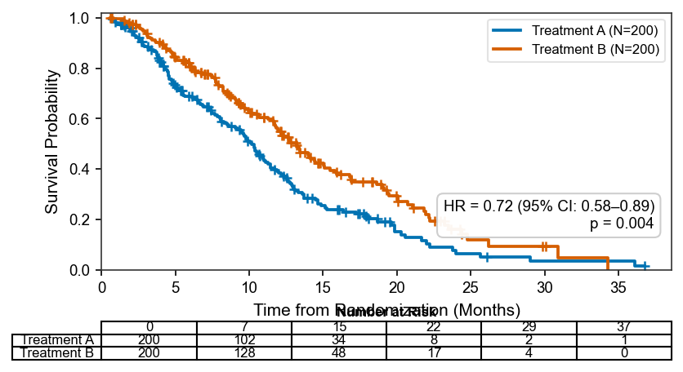
[Figure 14.2.7: KM PFS: step-function curves, + censoring, number-at-risk table, HR annotation.]
Footnotes:
[1] Dataset lineage: Source: ADSL, ADTTE. Program: f_km_pfs.sas.

Figure 14.2.8 Kaplan-Meier Plot — Overall Survival
Sponsor: [Sponsor Name]
Protocol: [Protocol Number] Page of
[Study Title / Compound Name]
Figure 14.2.8
Kaplan-Meier Plot — Overall Survival
[ONCOLOGY ONLY]
Analysis Set: Intent-to-Treat (ITT) Population

[Figure 14.2.8: KM OS: step-function curves, + censoring, number-at-risk table, HR annotation.]
Footnotes:
[1] Dataset lineage: Source: ADSL, ADTTE. Program: f_km_os.sas.

Figure 14.2.9 Forest Plot — PFS by Subgroup
Sponsor: [Sponsor Name]
Protocol: [Protocol Number] Page of
[Study Title / Compound Name]
Figure 14.2.9
Forest Plot — PFS by Subgroup
[ONCOLOGY ONLY]
Analysis Set: Intent-to-Treat (ITT) Population

[Figure 14.2.9: Forest PFS: HR [95% CI] per subgroup, overall diamond.]
Footnotes:
[1] Dataset lineage: Source: ADSL, ADTTE. Program: f_forest_pfs.sas.

Figure 14.2.10 Forest Plot — OS by Subgroup
Sponsor: [Sponsor Name]
Protocol: [Protocol Number] Page of
[Study Title / Compound Name]
Figure 14.2.10
Forest Plot — OS by Subgroup
[ONCOLOGY ONLY]
Analysis Set: Intent-to-Treat (ITT) Population

[Figure 14.2.10: Forest OS: HR [95% CI] per subgroup, overall diamond.]
Footnotes:
[1] Dataset lineage: Source: ADSL, ADTTE. Program: f_forest_os.sas.

Table 14.2.20 Landmark Analysis of OS by 6-Month PFS Status
Sponsor: [Sponsor Name]
Protocol: [Protocol Number] Page of
[Study Title / Compound Name]
Table 14.2.20
Landmark Analysis of OS by 6-Month PFS Status
[ONCOLOGY ONLY]
Analysis Set: ITT Alive and On-Study at 6 Months
PFS Status at 6M | Treatment A  n/N, Med OS | Treatment B  n/N, Med OS | HR [95% CI]
Progression-Free at 6M | XX | XX | XX
Progressed by 6M | XX | XX | XX
Footnotes:
[1] Dataset lineage: Source: ADSL, ADTTE. Program: t_landmark_os.sas.

Table 14.2.21 PK/PD Exposure-Response Correlation
Sponsor: [Sponsor Name]
Protocol: [Protocol Number] Page of
[Study Title / Compound Name]
Table 14.2.21
PK/PD Exposure-Response Correlation
Analysis Set: PK/PD Evaluable Population
PK Parameter | Quartile | N | Response Rate (%) | 95% CI
 | XX | XX | XX | XX
 | XX | XX | XX | XX
 | XX | XX | XX | XX
Footnotes:
[1] Dataset lineage: Source: ADSL, ADPK, ADEFF. Program: t_pkpd_corr.sas.

Table 14.2.22 Time to First Subsequent Therapy (TFST)
Sponsor: [Sponsor Name]
Protocol: [Protocol Number] Page of
[Study Title / Compound Name]
Table 14.2.22
Time to First Subsequent Therapy (TFST)
[ONCOLOGY ONLY]
Analysis Set: ITT Population
Parameter | Treatment Group 1  (N=xx) | Treatment Group 2  (N=xx) | HR [95% CI] | p-value
Median TFST (months) | XX | XX | XX | XX
Footnotes:
[1] Dataset lineage: Source: ADSL, ADTTE, ADCM. Program: t_tfst.sas.

14.3 Safety Analysis

Table 14.3.1 Overall Summary of Treatment-Emergent Adverse Events
Sponsor: [Sponsor Name]
Protocol: [Protocol Number] Page of
[Study Title / Compound Name]
Table 14.3.1
Overall Summary of Treatment-Emergent Adverse Events
Analysis Set: Safety Population
Adverse Event Category | Treatment Group 1  (N=xx) n (%) [E] | Treatment Group 2  (N=xx) n (%) [E]
Any TEAE | XX | XX
Drug-Related TEAE | XX | XX
CTCAE Grade >=3 TEAE | XX | XX
Serious TEAE (SAE) | XX | XX
TEAE Leading to Discontinuation | XX | XX
TEAE Leading to Dose Reduction/Interruption | XX | XX
Fatal TEAE (Grade 5) | XX | XX
Footnotes:
[1] TEAE: AE with onset on/after first dose through 30 days after last dose.
[2] CTCAE v5.0. MedDRA 26.0.
[3] Dataset lineage: Source: ADSL, ADAE. Program: t_ae_overview.sas.
[4] Coding dictionary versions: MedDRA 26.0, CTCAE 5.0.

Table 14.3.2 TEAEs by System Organ Class and Preferred Term (>=5% in Any Arm)
Sponsor: [Sponsor Name]
Protocol: [Protocol Number] Page of
[Study Title / Compound Name]
Table 14.3.2
TEAEs by System Organ Class and Preferred Term (>=5% in Any Arm)
Analysis Set: Safety Population
System Organ Class  Preferred Term | Treatment Group 1  (N=xx) n (%)  [Events] | Treatment Group 2  (N=xx) n (%)  [Events]
Any TEAE | XX | XX
Gastrointestinal disorders | XX | XX
Nausea | XX | XX
Diarrhea | XX | XX
Vomiting | XX | XX
Constipation | XX | XX
General disorders | XX | XX
Fatigue | XX | XX
Asthenia | XX | XX
XX | XX | XX
Footnotes:
[1] Sorted alphabetically by SOC; PTs by descending frequency in Treatment A.
[2] [E]=total events. MedDRA 26.0. CTCAE v5.0.
[3] Dataset lineage: Source: ADSL, ADAE. Program: t_ae_soc_pt.sas.
[4] Coding dictionary versions: MedDRA 26.0, CTCAE 5.0.

Table 14.3.3 TEAEs by SOC, PT, and Maximum CTCAE Grade (Treatment A)
Sponsor: [Sponsor Name]
Protocol: [Protocol Number] Page of
[Study Title / Compound Name]
Table 14.3.3
TEAEs by SOC, PT, and Maximum CTCAE Grade (Treatment A)
Analysis Set: Safety Population
System Organ Class  Preferred Term | Grade 1  n (%) | Grade 2  n (%) | Grade 3  n (%) | Grade 4  n (%) | Grade 5  n (%) | Any Grade  n (%)
Any TEAE (N=xx) | XX | XX | XX | XX | XX | XX
Gastrointestinal disorders | XX | XX | XX | XX | XX | XX
Nausea | XX | XX | XX | XX | XX | XX
Diarrhea | XX | XX | XX | XX | XX | XX
Vomiting | XX | XX | XX | XX | XX | XX
XX | XX | XX | XX | XX | XX | XX
Footnotes:
[1] CTCAE v5.0. Each subject counted once per PT at highest grade experienced.
[2] Table repeated for Treatment B.
[3] Dataset lineage: Source: ADSL, ADAE. Program: t_ae_grade.sas.
[4] Coding dictionary versions: MedDRA 26.0, CTCAE 5.0.

Table 14.3.4 Drug-Related TEAEs by SOC, PT, and Relationship
Sponsor: [Sponsor Name]
Protocol: [Protocol Number] Page of
[Study Title / Compound Name]
Table 14.3.4
Drug-Related TEAEs by SOC, PT, and Relationship
Analysis Set: Safety Population
System Organ Class  Preferred Term | Treatment Group 1  (N=xx) n (%) | Treatment Group 2  (N=xx) n (%)
Gastrointestinal disorders | XX | XX
Nausea | XX | XX
Diarrhea | XX | XX
Vomiting | XX | XX
General disorders | XX | XX
Fatigue | XX | XX
XX | XX | XX
Footnotes:
[1] Drug-related = investigator-assessed 'Related' or 'Reasonably Possible'.
[2] Dataset lineage: Source: ADSL, ADAE. Program: t_ae_related.sas.
[3] Coding dictionary versions: MedDRA 26.0.

Table 14.3.5 Serious Adverse Events by SOC and PT
Sponsor: [Sponsor Name]
Protocol: [Protocol Number] Page of
[Study Title / Compound Name]
Table 14.3.5
Serious Adverse Events by SOC and PT
Analysis Set: Safety Population
System Organ Class  Preferred Term | Treatment Group 1  (N=xx) n (%) [E] | Treatment Group 2  (N=xx) n (%) [E]
Any SAE | XX | XX
Infections and infestations | XX | XX
Pneumonia | XX | XX
Sepsis | XX | XX
Respiratory disorders | XX | XX
XX | XX | XX
Footnotes:
[1] SAE defined per ICH E2A criteria. [E]=total events.
[2] Dataset lineage: Source: ADSL, ADAE. Program: t_sae_soc_pt.sas.
[3] Coding dictionary versions: MedDRA 26.0.

Table 14.3.6 TEAEs Leading to Treatment Discontinuation by SOC and PT
Sponsor: [Sponsor Name]
Protocol: [Protocol Number] Page of
[Study Title / Compound Name]
Table 14.3.6
TEAEs Leading to Treatment Discontinuation by SOC and PT
Analysis Set: Safety Population
System Organ Class  Preferred Term | Treatment Group 1  (N=xx) n (%) | Treatment Group 2  (N=xx) n (%)
Gastrointestinal disorders | XX | XX
Nausea | XX | XX
Diarrhea | XX | XX
Skin disorders | XX | XX
Rash | XX | XX
XX | XX | XX
Footnotes:
[1] Dataset lineage: Source: ADSL, ADAE. Program: t_ae_disc.sas.
[2] Coding dictionary versions: MedDRA 26.0.

Table 14.3.7 TEAEs Leading to Dose Reduction or Interruption by SOC and PT
Sponsor: [Sponsor Name]
Protocol: [Protocol Number] Page of
[Study Title / Compound Name]
Table 14.3.7
TEAEs Leading to Dose Reduction or Interruption by SOC and PT
Analysis Set: Safety Population
System Organ Class  Preferred Term | Treatment Group 1  (N=xx) n (%) | Treatment Group 2  (N=xx) n (%)
Gastrointestinal disorders | XX | XX
Diarrhea | XX | XX
Nausea | XX | XX
General disorders | XX | XX
Fatigue | XX | XX
XX | XX | XX
Footnotes:
[1] Dataset lineage: Source: ADSL, ADAE. Program: t_ae_dose_mod.sas.
[2] Coding dictionary versions: MedDRA 26.0.

Table 14.3.8 TEAEs Leading to Death (Grade 5)
Sponsor: [Sponsor Name]
Protocol: [Protocol Number] Page of
[Study Title / Compound Name]
Table 14.3.8
TEAEs Leading to Death (Grade 5)
Analysis Set: Safety Population
Subject ID | Arm | Preferred Term  (Cause of Death) | Days from  First Dose | Relationship  to Study Drug
02005 | XX | XX | XX | XX
01015 | XX | XX | XX | XX
02012 | XX | XX | XX | XX
XX | XX | XX | XX | XX
Footnotes:
[1] All Grade 5 TEAEs. Relationship assessed by investigator.
[2] Dataset lineage: Source: ADSL, ADAE. Program: l_ae_death.sas.
[3] Coding dictionary versions: MedDRA 26.0, CTCAE 5.0.

Table 14.3.9 TEAEs Occurring in >=5% of Subjects by PT
Sponsor: [Sponsor Name]
Protocol: [Protocol Number] Page of
[Study Title / Compound Name]
Table 14.3.9
TEAEs Occurring in >=5% of Subjects by PT
Analysis Set: Safety Population
Preferred Term | Treatment Group 1  (N=xx) n (%) | Treatment Group 2  (N=xx) n (%)
Nausea | XX | XX
Diarrhea | XX | XX
Asthenia | XX | XX
Vomiting | XX | XX
Rash | XX | XX
Headache | XX | XX
Constipation | XX | XX
XX | XX | XX
Footnotes:
[1] Sorted by descending frequency in Treatment A. MedDRA 26.0.
[2] Dataset lineage: Source: ADSL, ADAE. Program: t_ae_5pct.sas.
[3] Coding dictionary versions: MedDRA 26.0.

Table 14.3.10 TEAEs by Cycle / Treatment Period
Sponsor: [Sponsor Name]
Protocol: [Protocol Number] Page of
[Study Title / Compound Name]
Table 14.3.10
TEAEs by Cycle / Treatment Period
Analysis Set: Safety Population
Cycle | N at Risk  (A / B) | Treatment A  >=1 TEAE n (%) | Treatment B  >=1 TEAE n (%)
Cycle 2 | XX | XX | XX
Cycle 3 | XX | XX | XX
Cycle 4 | XX | XX | XX
Cycle 5 | XX | XX | XX
Cycle 6+ | XX | XX | XX
Footnotes:
[1] Dataset lineage: Source: ADSL, ADAE, ADEX. Program: t_ae_by_cycle.sas.
[2] Coding dictionary versions: MedDRA 26.0, CTCAE 5.0.

Table 14.3.11 Exposure-Adjusted TEAE Incidence Rates (per 100 Patient-Years)
Sponsor: [Sponsor Name]
Protocol: [Protocol Number] Page of
[Study Title / Compound Name]
Table 14.3.11
Exposure-Adjusted TEAE Incidence Rates (per 100 Patient-Years)
Analysis Set: Safety Population
Preferred Term | Treatment A  Rate [95% CI] | Treatment B  Rate [95% CI]
Fatigue | XX | XX
Nausea | XX | XX
Diarrhea | XX | XX
XX | XX | XX
Footnotes:
[1] Exposure-adjusted rate = (n subjects with event / total PY exposure) × 100.
[2] 95% CI via exact method based on Poisson distribution.
[3] Dataset lineage: Source: ADSL, ADAE, ADEX. Program: t_ae_adj_rate.sas.
[4] Coding dictionary versions: MedDRA 26.0.

Table 14.3.12 TEAEs by Age Group Subgroup (>=5% in Any Arm)
Sponsor: [Sponsor Name]
Protocol: [Protocol Number] Page of
[Study Title / Compound Name]
Table 14.3.12
TEAEs by Age Group Subgroup (>=5% in Any Arm)
Analysis Set: Safety Population
Preferred Term | Age <65  (N=xx) n (%) | Age >=65  (N=xx) n (%) | Age >=75  (N=xx) n (%)
Nausea | XX | XX | XX
Diarrhea | XX | XX | XX
XX | XX | XX | XX
Footnotes:
[1] Dataset lineage: Source: ADSL, ADAE. Program: t_ae_age.sas.
[2] Coding dictionary versions: MedDRA 26.0.

Table 14.3.13 TEAEs by Sex Subgroup (>=5% in Any Arm)
Sponsor: [Sponsor Name]
Protocol: [Protocol Number] Page of
[Study Title / Compound Name]
Table 14.3.13
TEAEs by Sex Subgroup (>=5% in Any Arm)
Analysis Set: Safety Population
Preferred Term | Male  (N=xx) n (%) | Female  (N=xx) n (%)
Nausea | XX | XX
XX | XX | XX
Footnotes:
[1] Dataset lineage: Source: ADSL, ADAE. Program: t_ae_sex.sas.
[2] Coding dictionary versions: MedDRA 26.0.

Table 14.3.14 Listing of All Deaths with Narrative Reference
Sponsor: [Sponsor Name]
Protocol: [Protocol Number] Page of
[Study Title / Compound Name]
Table 14.3.14
Listing of All Deaths with Narrative Reference
Analysis Set: All Randomized Subjects
Subject | Arm | Date of  Death | Days from  First Dose | Days from  Last Dose | Primary Cause  of Death | Narrative  ID
02005 | XX | XX | XX | XX | XX | XX
01015 | XX | XX | XX | XX | XX | XX
XX | XX | XX | XX | XX | XX | XX
Footnotes:
[1] All deaths regardless of causality. Narrative cross-references Section 12.2.
[2] Dataset lineage: Source: ADSL, ADAE, ADTTE. Program: l_deaths.sas.

Table 14.3.15 Hy's Law Cases — Liver Chemistry Screening
Sponsor: [Sponsor Name]
Protocol: [Protocol Number] Page of
[Study Title / Compound Name]
Table 14.3.15
Hy's Law Cases — Liver Chemistry Screening
Analysis Set: Safety Population with Baseline and Post-Baseline Labs
Subject | Arm | ALT  (xULN) | AST  (xULN) | TBL  (xULN) | ALP  (xULN) | Hy's Law  Met?
02015 | XX | XX | XX | XX | XX | XX
XX | XX | XX | XX | XX | XX | XX
Footnotes:
[1] Hy's Law: ALT/AST >=3xULN, TBL >=2xULN, ALP <2xULN, no alternative cause.
[2] Dataset lineage: Source: ADSL, ADLB. Program: t_hys_law.sas.

Table 14.3.16 Laboratory Parameters — Shift Table (Baseline to Worst Post-Baseline)
Sponsor: [Sponsor Name]
Protocol: [Protocol Number] Page of
[Study Title / Compound Name]
Table 14.3.16
Laboratory Parameters — Shift Table (Baseline to Worst Post-Baseline)
Analysis Set: Safety Population
Parameter  (Unit) | Baseline  Grade | Worst Post-BL  Grade | Treatment Group 1  n (%) | Treatment Group 2  n (%)
 | XX | XX | XX | XX
 | XX | XX | XX | XX
ALT (U/L) | XX | XX | XX | XX
 | XX | XX | XX | XX
 | XX | XX | XX | XX
XX | XX | XX | XX | XX
Footnotes:
[1] CTCAE v5.0 grading. Baseline = last value on/before first dose.
[2] Worst post-baseline = furthest from normal range.
[3] Dataset lineage: Source: ADSL, ADLB. Program: t_lab_shift.sas.
[4] Coding dictionary versions: CTCAE 5.0.

Table 14.3.17 Hematology Parameters — Summary Statistics by Visit
Sponsor: [Sponsor Name]
Protocol: [Protocol Number] Page of
[Study Title / Compound Name]
Table 14.3.17
Hematology Parameters — Summary Statistics by Visit
Analysis Set: Safety Population
Parameter  Visit | Statistic | Treatment Group 1  (N=xx) | Treatment Group 2  (N=xx)
Baseline | XX | XX | XX
 | XX | XX | XX
Week 4 | XX | XX | XX
 | XX | XX | XX
Platelets (×10⁹/L) | XX | XX | XX
Baseline | XX | XX | XX
Week 4 | XX | XX | XX
XX | XX | XX | XX
Footnotes:
[1] Dataset lineage: Source: ADSL, ADLB. Program: t_heme_by_visit.sas.

Table 14.3.18 Clinical Chemistry Parameters — Summary Statistics by Visit
Sponsor: [Sponsor Name]
Protocol: [Protocol Number] Page of
[Study Title / Compound Name]
Table 14.3.18
Clinical Chemistry Parameters — Summary Statistics by Visit
Analysis Set: Safety Population
Parameter  Visit | Statistic | Treatment Group 1  (N=xx) | Treatment Group 2  (N=xx)
Baseline | XX | XX | XX
Week 4 | XX | XX | XX
AST (U/L) | XX | XX | XX
Baseline | XX | XX | XX
Week 4 | XX | XX | XX
Total Bilirubin (mg/dL) | XX | XX | XX
Baseline | XX | XX | XX
Creatinine (mg/dL) | XX | XX | XX
Baseline | XX | XX | XX
XX | XX | XX | XX
Footnotes:
[1] Dataset lineage: Source: ADSL, ADLB. Program: t_chem_by_visit.sas.

Table 14.3.19 Laboratory Abnormalities — Grade >=3 Listing
Sponsor: [Sponsor Name]
Protocol: [Protocol Number] Page of
[Study Title / Compound Name]
Table 14.3.19
Laboratory Abnormalities — Grade >=3 Listing
Analysis Set: Safety Population
Subject | Arm | Visit | Parameter | Result | Unit | ULN | CTCAE  Grade
01012 | XX | XX | XX | XX | XX | XX | XX
02005 | XX | XX | XX | XX | XX | XX | XX
XX | XX | XX | XX | XX | XX | XX | XX
Footnotes:
[1] Dataset lineage: Source: ADSL, ADLB. Program: l_lab_grade3.sas.
[2] Coding dictionary versions: CTCAE 5.0.

Table 14.3.20 Laboratory Toxicity Grade Shift Over Time (by Cycle)
Sponsor: [Sponsor Name]
Protocol: [Protocol Number] Page of
[Study Title / Compound Name]
Table 14.3.20
Laboratory Toxicity Grade Shift Over Time (by Cycle)
Analysis Set: Safety Population
Parameter | Cycle | Baseline  Grade | Max Post-BL  Grade | Treatment A  n/N (%) | Treatment B  n/N (%)
 | XX | XX | XX | XX | XX
ALT | XX | XX | XX | XX | XX
XX | XX | XX | XX | XX | XX
Footnotes:
[1] Dataset lineage: Source: ADSL, ADLB. Program: t_lab_shift_cycle.sas.
[2] Coding dictionary versions: CTCAE 5.0.

Figure 14.3.1 Mean (+/- SD) Change in Laboratory Parameters Over Time
Sponsor: [Sponsor Name]
Protocol: [Protocol Number] Page of
[Study Title / Compound Name]
Figure 14.3.1
Mean (+/- SD) Change in Laboratory Parameters Over Time
Analysis Set: Safety Population
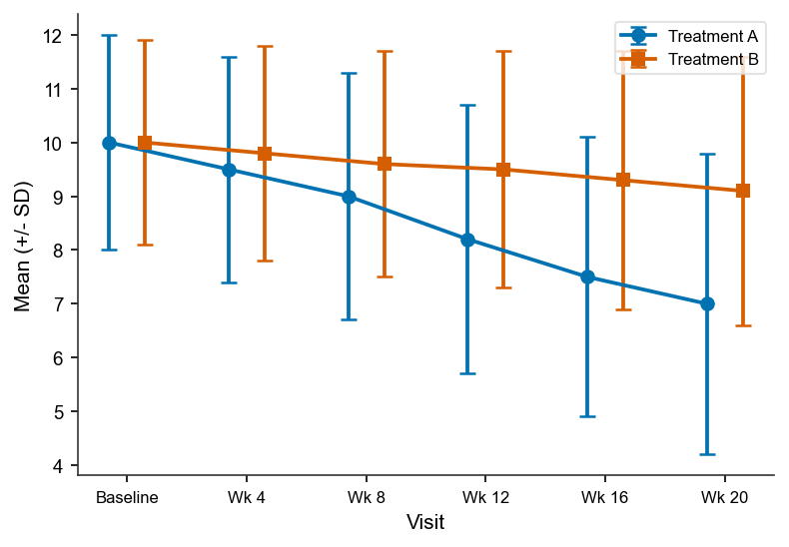
[Figure 14.3.1: Multi-panel line plot: mean ± SD change in Hgb, Plt, ANC, ALT, AST, Creatinine.]
Footnotes:
[1] Dataset lineage: Source: ADSL, ADLB. Program: f_lab_longitudinal.sas.

Figure 14.3.2 Box Plot — Liver Function Tests by Visit
Sponsor: [Sponsor Name]
Protocol: [Protocol Number] Page of
[Study Title / Compound Name]
Figure 14.3.2
Box Plot — Liver Function Tests by Visit
Analysis Set: Safety Population
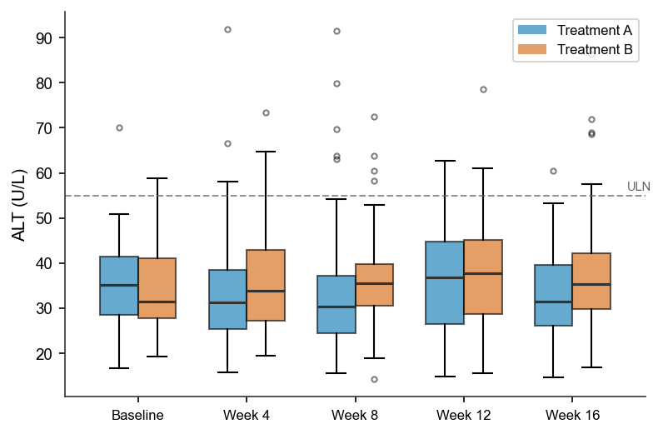
[Figure 14.3.2: Box plots: ALT, AST, ALP, TBL by visit, side-by-side arms, ULN reference.]
Footnotes:
[1] Dataset lineage: Source: ADSL, ADLB. Program: f_lft_box.sas.

Table 14.3.21 Vital Signs — Summary Statistics by Visit
Sponsor: [Sponsor Name]
Protocol: [Protocol Number] Page of
[Study Title / Compound Name]
Table 14.3.21
Vital Signs — Summary Statistics by Visit
Analysis Set: Safety Population
Parameter  Visit | Statistic | Treatment Group 1  (N=xx) | Treatment Group 2  (N=xx)
Systolic BP (mmHg) | XX | XX | XX
Baseline | XX | XX | XX
Week 4 | XX | XX | XX
Diastolic BP (mmHg) | XX | XX | XX
Baseline | XX | XX | XX
Heart Rate (bpm) | XX | XX | XX
Baseline | XX | XX | XX
Temperature (°C) | XX | XX | XX
Baseline | XX | XX | XX
XX | XX | XX | XX
Footnotes:
[1] Dataset lineage: Source: ADSL, ADVS. Program: t_vs_by_visit.sas.

Table 14.3.22 Vital Signs — Clinically Notable Abnormalities by Visit
Sponsor: [Sponsor Name]
Protocol: [Protocol Number] Page of
[Study Title / Compound Name]
Table 14.3.22
Vital Signs — Clinically Notable Abnormalities by Visit
Analysis Set: Safety Population
Parameter | Criterion | Visit | Treatment Group 1  n (%) | Treatment Group 2  n (%)
SBP | XX | XX | XX | XX
DBP | XX | XX | XX | XX
HR | XX | XX | XX | XX
XX | XX | XX | XX | XX
Footnotes:
[1] Dataset lineage: Source: ADSL, ADVS. Program: t_vs_notable.sas.

Figure 14.3.3 Mean (+/- SD) Vital Signs Over Time
Sponsor: [Sponsor Name]
Protocol: [Protocol Number] Page of
[Study Title / Compound Name]
Figure 14.3.3
Mean (+/- SD) Vital Signs Over Time
Analysis Set: Safety Population

[Figure 14.3.3: Multi-panel: mean ± SD of SBP, DBP, HR, Weight over visits.]
Footnotes:
[1] Dataset lineage: Source: ADSL, ADVS. Program: f_vs_longitudinal.sas.

Figure 14.3.4 Liver Function Panel — Mean Over Time with ULN Reference
Sponsor: [Sponsor Name]
Protocol: [Protocol Number] Page of
[Study Title / Compound Name]
Figure 14.3.4
Liver Function Panel — Mean Over Time with ULN Reference
Analysis Set: Safety Population
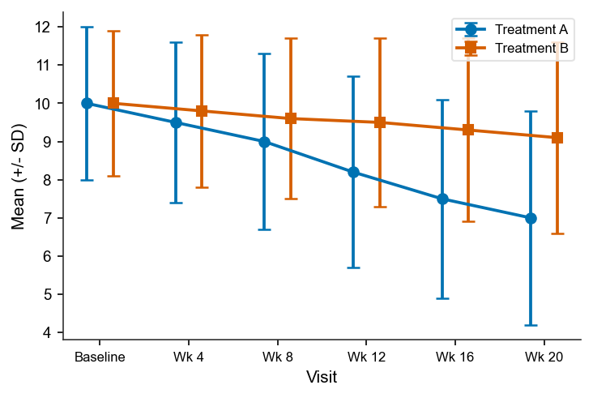
[Figure 14.3.4: Line plot: ALT, AST, ALP, TBL means over visits with ULN lines.]
Footnotes:
[1] Dataset lineage: Source: ADSL, ADLB. Program: f_lft_uln.sas.

Table 14.3.23 ECG Parameters — Summary Statistics by Visit
Sponsor: [Sponsor Name]
Protocol: [Protocol Number] Page of
[Study Title / Compound Name]
Table 14.3.23
ECG Parameters — Summary Statistics by Visit
Analysis Set: Safety Population with ECG Data
Parameter  Visit | Statistic | Treatment Group 1  (N=xx) | Treatment Group 2  (N=xx)
QTcF (ms) | XX | XX | XX
Baseline | XX | XX | XX
Week 4 | XX | XX | XX
 | XX | XX | XX
QRS Duration (ms) | XX | XX | XX
Baseline | XX | XX | XX
XX | XX | XX | XX
Footnotes:
[1] QTcF = Fridericia correction. Triplicate ECGs at each visit; mean analyzed.
[2] Dataset lineage: Source: ADSL, ADEG. Program: t_ecg_by_visit.sas.

Table 14.3.24 ECG QTcF Categorical Analysis
Sponsor: [Sponsor Name]
Protocol: [Protocol Number] Page of
[Study Title / Compound Name]
Table 14.3.24
ECG QTcF Categorical Analysis
Analysis Set: Safety Population with ECG Data
QTcF Category | Treatment Group 1  (N=xx) n (%) | Treatment Group 2  (N=xx) n (%)
<=450 ms | XX | XX
>450-480 ms | XX | XX
>480-500 ms | XX | XX
>500 ms | XX | XX
Change from Baseline | XX | XX
<=30 ms increase | XX | XX
>30-60 ms increase | XX | XX
>60 ms increase | XX | XX
Footnotes:
[1] Dataset lineage: Source: ADSL, ADEG. Program: t_qtcf_cat.sas.

Table 14.3.25 ECG Qualitative Assessment — Shift Table
Sponsor: [Sponsor Name]
Protocol: [Protocol Number] Page of
[Study Title / Compound Name]
Table 14.3.25
ECG Qualitative Assessment — Shift Table
Analysis Set: Safety Population with ECG Data
Baseline | Worst  Post-Baseline | Treatment Group 1  n (%) | Treatment Group 2  n (%)
Normal | XX | XX | XX
Normal | XX | XX | XX
Abnormal NCS | XX | XX | XX
XX | XX | XX | XX
Footnotes:
[1] NCS = Not Clinically Significant. CS = Clinically Significant.
[2] Dataset lineage: Source: ADSL, ADEG. Program: t_ecg_shift.sas.

Table 14.3.26 Infusion-Related Reactions by Preferred Term
Sponsor: [Sponsor Name]
Protocol: [Protocol Number] Page of
[Study Title / Compound Name]
Table 14.3.26
Infusion-Related Reactions by Preferred Term
Analysis Set: Safety Population
Preferred Term | Treatment Group 1  (N=xx) n (%) | Treatment Group 2  (N=xx) n (%)
Pyrexia | XX | XX
Chills | XX | XX
Flushing | XX | XX
XX | XX | XX
Footnotes:
[1] Dataset lineage: Source: ADSL, ADAE, ADEX. Program: t_irr.sas.
[2] Coding dictionary versions: MedDRA 26.0, CTCAE 5.0.

14.4 Special Assessments

Table 14.4.1 Summary of Pharmacokinetic Concentrations by Timepoint
Sponsor: [Sponsor Name]
Protocol: [Protocol Number] Page of
[Study Title / Compound Name]
Table 14.4.1
Summary of Pharmacokinetic Concentrations by Timepoint
Analysis Set: PK Population
Timepoint  (h) | Statistic | Treatment A  (N=30) | Treatment B  (N=32)
Cmax (2h) | XX | XX | XX
Cmin (24h) | XX | XX | XX
XX | XX | XX | XX
Footnotes:
[1] Dataset lineage: Source: ADSL, ADPC. Program: t_pk_conc.sas.

Table 14.4.2 Summary of PK Parameters by Subject
Sponsor: [Sponsor Name]
Protocol: [Protocol Number] Page of
[Study Title / Compound Name]
Table 14.4.2
Summary of PK Parameters by Subject
Analysis Set: PK Population
PK Parameter | Statistic | Treatment A  (N=30) | Treatment B  (N=32)
AUC0-tau (ng·h/mL) | XX | XX | XX
AUC0-inf | XX | XX | XX
Tmax (h) | XX | XX | XX
t1/2 (h) | XX | XX | XX
CL/F (L/h) | XX | XX | XX
Footnotes:
[1] Dataset lineage: Source: ADSL, ADPP. Program: t_pk_params.sas.

Listing 14.4.1 Listing of Pharmacokinetic Concentrations by Subject and Timepoint
Sponsor: [Sponsor Name]
Protocol: [Protocol Number] Page of
[Study Title / Compound Name]
Listing 14.4.1
Listing of Pharmacokinetic Concentrations by Subject and Timepoint
Analysis Set: PK Population
Note: Sorted by site/subject ID.
Subject | Arm | Cycle  Day | Nominal  Time (h) | Actual  Time (h) | Conc  (ng/mL) | BQL
01001 | XX | XX | XX | XX | XX | XX
01001 | XX | XX | XX | XX | XX | XX
XX | XX | XX | XX | XX | XX | XX
Footnotes:
[1] Dataset lineage: Source: ADSL, ADPC. Program: l_pk_conc.sas.

Table 14.4.3 Immunogenicity Summary — Anti-Drug Antibody (ADA) Incidence
Sponsor: [Sponsor Name]
Protocol: [Protocol Number] Page of
[Study Title / Compound Name]
Table 14.4.3
Immunogenicity Summary — Anti-Drug Antibody (ADA) Incidence
Analysis Set: Safety Population with ADA Samples
ADA Parameter | Treatment Group 1  (N=xx) n (%) | Treatment Group 2  (N=xx) n (%)
ADA Positive at Baseline | XX | XX
ADA Positive Post-Baseline | XX | XX
Treatment-Emergent ADA Positive | XX | XX
Neutralizing Antibody Positive | XX | XX
Footnotes:
[1] Dataset lineage: Source: ADSL, ADIS. Program: t_ada_incidence.sas.

Listing 14.4.2 Listing of Immunogenicity Results by Subject and Visit
Sponsor: [Sponsor Name]
Protocol: [Protocol Number] Page of
[Study Title / Compound Name]
Listing 14.4.2
Listing of Immunogenicity Results by Subject and Visit
Analysis Set: Safety Population with ADA Samples
Note: Sorted by site/subject ID.
Subject | Arm | Visit | ADA  Result | ADA  Titer | Nab  Result | TE-ADA?
01005 | XX | XX | XX | XX | XX | XX
01005 | XX | XX | XX | XX | XX | XX
XX | XX | XX | XX | XX | XX | XX
Footnotes:
[1] Dataset lineage: Source: ADSL, ADIS. Program: l_immuno.sas.

Table 14.4.4 Summary of Biomarker Results by Visit
Sponsor: [Sponsor Name]
Protocol: [Protocol Number] Page of
[Study Title / Compound Name]
Table 14.4.4
Summary of Biomarker Results by Visit
Analysis Set: ITT Population with Biomarker Data
Biomarker | Visit | Statistic | Treatment A  (N=xx) | Treatment B  (N=xx)
 | XX | XX | XX | XX
 | XX | XX | XX | XX
XX | XX | XX | XX | XX
Footnotes:
[1] Dataset lineage: Source: ADSL, ADBM. Program: t_biomarker_visit.sas.

Listing 14.4.3 Listing of Biomarker Results by Subject and Visit
Sponsor: [Sponsor Name]
Protocol: [Protocol Number] Page of
[Study Title / Compound Name]
Listing 14.4.3
Listing of Biomarker Results by Subject and Visit
Analysis Set: ITT with Biomarker Data
Note: Sorted by site/subject ID.
Subject | Arm | Visit | Biomarker | Result | Unit | Method
01001 | XX | XX | XX | XX | XX | XX
XX | XX | XX | XX | XX | XX | XX
Footnotes:
[1] Dataset lineage: Source: ADSL, ADBM. Program: l_biomarker.sas.

Table 14.4.5 Summary of Patient-Reported Outcomes by Visit
Sponsor: [Sponsor Name]
Protocol: [Protocol Number] Page of
[Study Title / Compound Name]
Table 14.4.5
Summary of Patient-Reported Outcomes by Visit
Analysis Set: ITT Population with PRO Data
PRO Scale | Visit | Statistic | Treatment Group 1  (N=xx) | Treatment Group 2  (N=xx)
 | XX | XX | XX | XX
 | XX | XX | XX | XX
EORTC QLQ-C30 PF | XX | XX | XX | XX
 | XX | XX | XX | XX
XX | XX | XX | XX | XX
Footnotes:
[1] Dataset lineage: Source: ADSL, ADPRO. Program: t_pro_summary.sas.

Listing 14.4.4 Listing of Patient-Reported Outcomes by Subject and Visit
Sponsor: [Sponsor Name]
Protocol: [Protocol Number] Page of
[Study Title / Compound Name]
Listing 14.4.4
Listing of Patient-Reported Outcomes by Subject and Visit
Analysis Set: ITT with PRO Data
Note: Sorted by site/subject ID.
Subject | Arm | Visit | GHS | PF | RF | EF | CF | SF
01001 | XX | XX | XX | XX | XX | XX | XX | XX
XX | XX | XX | XX | XX | XX | XX | XX | XX
Footnotes:
[1] Dataset lineage: Source: ADSL, ADPRO. Program: l_pro.sas.

16.2 Patient Data Listings

Listing 16.2.1 Listing of Subject Disposition
Sponsor: [Sponsor Name]
Protocol: [Protocol Number] Page of
[Study Title / Compound Name]
Listing 16.2.1
Listing of Subject Disposition
Analysis Set: All Randomized Subjects
Note: Sorted by site/subject ID.
Site/  Subject | Arm | Date  Randomized | Date of  First Dose | Date of  Last Dose | Completed  Treatment? | Reason for  Discontinuation | Completed  Study?
01/002 | XX | XX | XX | XX | XX | XX | XX
XX | XX | XX | XX | XX | XX | XX | XX
Footnotes:
[1] Dataset lineage: Source: ADSL. Program: l_disposition.sas.

Listing 16.2.2 Listing of Demographic Data
Sponsor: [Sponsor Name]
Protocol: [Protocol Number] Page of
[Study Title / Compound Name]
Listing 16.2.2
Listing of Demographic Data
Analysis Set: All Randomized Subjects
Note: Sorted by site/subject ID.
Site/  Subject | Arm | Age  (yrs) | Sex | Race | Ethnicity | Height  (cm) | Weight  (kg) | BMI
01/002 | XX | XX | XX | XX | XX | XX | XX | XX
XX | XX | XX | XX | XX | XX | XX | XX | XX
Footnotes:
[1] Dataset lineage: Source: ADSL. Program: l_demog.sas.

Listing 16.2.3 Listing of Protocol Deviations
Sponsor: [Sponsor Name]
Protocol: [Protocol Number] Page of
[Study Title / Compound Name]
Listing 16.2.3
Listing of Protocol Deviations
Analysis Set: All Randomized Subjects
Note: Sorted by site/subject ID.
Site/  Subject | Arm | Deviation  Category | Deviation Description | Date of  Deviation | Major/  Minor
02/015 | XX | XX | XX | XX | XX
XX | XX | XX | XX | XX | XX
Footnotes:
[1] Dataset lineage: Source: ADSL, DV. Program: l_protdev.sas.

Listing 16.2.4 Listing of Adverse Events
Sponsor: [Sponsor Name]
Protocol: [Protocol Number] Page of
[Study Title / Compound Name]
Listing 16.2.4
Listing of Adverse Events
Analysis Set: Safety Population
Note: Sorted by site/subject ID.
Site/  Subject | Arm | SOC | Preferred  Term | Start  Date | End  Date | Grade | Rel | SAE? | Action | Outcome
01/001 | XX | XX | XX | XX | XX | XX | XX | XX | XX | XX
XX | XX | XX | XX | XX | XX | XX | XX | XX | XX | XX
Footnotes:
[1] Dataset lineage: Source: ADSL, ADAE. Program: l_ae.sas.
[2] Coding dictionary versions: MedDRA 26.0, CTCAE 5.0.

Listing 16.2.5 Listing of Serious Adverse Events
Sponsor: [Sponsor Name]
Protocol: [Protocol Number] Page of
[Study Title / Compound Name]
Listing 16.2.5
Listing of Serious Adverse Events
Analysis Set: Safety Population
Note: Sorted by site/subject ID.
Site/  Subject | Arm | Preferred  Term | SAE  Criteria | Start  Date | End  Date | Grade | Rel | Outcome | Narrative  Ref
02/012 | XX | XX | XX | XX | XX | XX | XX | XX | XX
XX | XX | XX | XX | XX | XX | XX | XX | XX | XX
Footnotes:
[1] Dataset lineage: Source: ADSL, ADAE. Program: l_sae.sas.
[2] Coding dictionary versions: MedDRA 26.0, CTCAE 5.0.

Listing 16.2.6 Listing of Concomitant Medications
Sponsor: [Sponsor Name]
Protocol: [Protocol Number] Page of
[Study Title / Compound Name]
Listing 16.2.6
Listing of Concomitant Medications
Analysis Set: Safety Population
Note: Sorted by site/subject ID.
Site/  Subject | Arm | ATC  Class | Preferred  Name | Indication | Dose / Route /  Frequency | Start  Date | End  Date
01/003 | XX | XX | XX | XX | XX | XX | XX
XX | XX | XX | XX | XX | XX | XX | XX
Footnotes:
[1] Dataset lineage: Source: ADSL, ADCM. Program: l_conmed.sas.
[2] Coding dictionary versions: WHO-DD 2024Q1.

Listing 16.2.7 Listing of Laboratory Data — Hematology and Chemistry
Sponsor: [Sponsor Name]
Protocol: [Protocol Number] Page of
[Study Title / Compound Name]
Listing 16.2.7
Listing of Laboratory Data — Hematology and Chemistry
Analysis Set: Safety Population
Note: Sorted by site/subject ID.
Site/  Subject | Arm | Visit | Parameter | Result | Unit | Normal  Range | Flag
01/001 | XX | XX | XX | XX | XX | XX | XX
01/001 | XX | XX | XX | XX | XX | XX | XX
XX | XX | XX | XX | XX | XX | XX | XX
Footnotes:
[1] Dataset lineage: Source: ADSL, ADLB. Program: l_lab.sas.

Listing 16.2.8 Listing of Vital Signs
Sponsor: [Sponsor Name]
Protocol: [Protocol Number] Page of
[Study Title / Compound Name]
Listing 16.2.8
Listing of Vital Signs
Analysis Set: Safety Population
Note: Sorted by site/subject ID.
Site/  Subject | Arm | Visit | Date | SBP  (mmHg) | DBP  (mmHg) | HR  (bpm) | Resp  Rate | Temp  (°C) | Weight  (kg)
01/001 | XX | XX | XX | XX | XX | XX | XX | XX | XX
XX | XX | XX | XX | XX | XX | XX | XX | XX | XX
Footnotes:
[1] Dataset lineage: Source: ADSL, ADVS. Program: l_vitalsigns.sas.

Listing 16.2.9 Listing of ECG Data
Sponsor: [Sponsor Name]
Protocol: [Protocol Number] Page of
[Study Title / Compound Name]
Listing 16.2.9
Listing of ECG Data
Analysis Set: Safety Population with ECG Data
Note: Sorted by site/subject ID.
Site/  Subject | Arm | Visit | Date/  Time | HR  (bpm) | PR  (ms) | QRS  (ms) | QT  (ms) | QTcF  (ms) | Interpretation
01/001 | XX | XX | XX | XX | XX | XX | XX | XX | XX
XX | XX | XX | XX | XX | XX | XX | XX | XX | XX
Footnotes:
[1] Dataset lineage: Source: ADSL, ADEG. Program: l_ecg.sas.

Listing 16.2.10 Listing of Tumor Response Data
Sponsor: [Sponsor Name]
Protocol: [Protocol Number] Page of
[Study Title / Compound Name]
Listing 16.2.10
Listing of Tumor Response Data
[ONCOLOGY ONLY]
Analysis Set: ITT Population
Note: Sorted by site/subject ID.
Site/  Subject | Arm | Visit | Assessment  Date | Target Sum  (mm) | % Change  from BL | Non-Target  Status | New  Lesions? | Overall  Response | BOR
01/001 | XX | XX | XX | XX | XX | XX | XX | XX | XX
01/001 | XX | XX | XX | XX | XX | XX | XX | XX | XX
XX | XX | XX | XX | XX | XX | XX | XX | XX | XX
Footnotes:
[1] Dataset lineage: Source: ADSL, ADRS. Program: l_tumor_response.sas.

Listing 16.2.11 Listing of Survival Data
Sponsor: [Sponsor Name]
Protocol: [Protocol Number] Page of
[Study Title / Compound Name]
Listing 16.2.11
Listing of Survival Data
[ONCOLOGY ONLY]
Analysis Set: ITT Population
Note: Sorted by site/subject ID.
Site/  Subject | Arm | Last  Contact | Vital  Status | Death  Date | Primary Cause  of Death | PFS Event  Date | PFS  Censor
01/005 | XX | XX | XX | XX | XX | XX | XX
XX | XX | XX | XX | XX | XX | XX | XX
Footnotes:
[1] Dataset lineage: Source: ADSL, ADTTE. Program: l_survival.sas.

Listing 16.2.12 Listing of Study Drug Exposure and Dose Modifications
Sponsor: [Sponsor Name]
Protocol: [Protocol Number] Page of
[Study Title / Compound Name]
Listing 16.2.12
Listing of Study Drug Exposure and Dose Modifications
Analysis Set: Safety Population
Note: Sorted by site/subject ID.
Site/  Subject | Arm | Cycle/  Day | Planned  Dose | Actual  Dose | Modification  Reason
01/001 | XX | XX | XX | XX | XX
XX | XX | XX | XX | XX | XX
Footnotes:
[1] Dataset lineage: Source: ADSL, ADEX. Program: l_exposure.sas.

Listing 16.2.13 Listing of Medical History Verbatim vs. Coded Terms
Sponsor: [Sponsor Name]
Protocol: [Protocol Number] Page of
[Study Title / Compound Name]
Listing 16.2.13
Listing of Medical History Verbatim vs. Coded Terms
Analysis Set: Safety Population
Note: Sorted by site/subject ID.
Site/  Subject | Arm | SOC | Preferred  Term | Verbatim  Term | Start  Date | End  Date | Ongoing?
01/003 | XX | XX | XX | XX | XX | XX | XX
XX | XX | XX | XX | XX | XX | XX | XX
Footnotes:
[1] Dataset lineage: Source: ADSL, ADMH. Program: l_mh_coded.sas.
[2] Coding dictionary versions: MedDRA 26.0.

Listing 16.2.14 Listing of PK Parameters by Subject
Sponsor: [Sponsor Name]
Protocol: [Protocol Number] Page of
[Study Title / Compound Name]
Listing 16.2.14
Listing of PK Parameters by Subject
Analysis Set: PK Population
Note: Sorted by site/subject ID.
Site/  Subject | Arm | Cycle | Cmax  (ng/mL) | AUC0-tau  (ng·h/mL) | Tmax  (h) | t1/2  (h) | CL/F  (L/h)
02/020 | XX | XX | XX | XX | XX | XX | XX
XX | XX | XX | XX | XX | XX | XX | XX
Footnotes:
[1] Dataset lineage: Source: ADSL, ADPP. Program: l_pk_params.sas.

Listing 16.2.15 Listing of ADA and Neutralizing Antibody Results
Sponsor: [Sponsor Name]
Protocol: [Protocol Number] Page of
[Study Title / Compound Name]
Listing 16.2.15
Listing of ADA and Neutralizing Antibody Results
Analysis Set: Safety Population with ADA Samples
Note: Sorted by site/subject ID.
Site/  Subject | Arm | Visit  (Day) | ADA  Result | ADA  Titer | Nab  Result
01/005 | XX | XX | XX | XX | XX
01/005 | XX | XX | XX | XX | XX
XX | XX | XX | XX | XX | XX
Footnotes:
[1] Dataset lineage: Source: ADSL, ADIS. Program: l_ada.sas.

Listing 16.2.16 Listing of Subsequent Anti-Cancer Therapies
Sponsor: [Sponsor Name]
Protocol: [Protocol Number] Page of
[Study Title / Compound Name]
Listing 16.2.16
Listing of Subsequent Anti-Cancer Therapies
[ONCOLOGY ONLY]
Analysis Set: ITT Population
Note: Sorted by site/subject ID.
Site/  Subject | Arm | Therapy  Name | Therapy  Class | Start  Date | End  Date | Best Response  to Subsequent Therapy
02/010 | XX | XX | XX | XX | XX | XX
XX | XX | XX | XX | XX | XX | XX
Footnotes:
[1] Dataset lineage: Source: ADSL, ADCM. Program: l_subsequent_therapy.sas.

Listing 16.2.17 Listing of PRO Assessments by Subject and Visit
Sponsor: [Sponsor Name]
Protocol: [Protocol Number] Page of
[Study Title / Compound Name]
Listing 16.2.17
Listing of PRO Assessments by Subject and Visit
Analysis Set: ITT with PRO Data
Note: Sorted by site/subject ID.
Site/  Subject | Arm | Visit | GHS | PF | RF | EF | CF | SF
01/001 | XX | XX | XX | XX | XX | XX | XX | XX
XX | XX | XX | XX | XX | XX | XX | XX | XX
Footnotes:
[1] Dataset lineage: Source: ADSL, ADPRO. Program: l_pro.sas.

