ABUBAKAR TAFAWA BALEWA UNIVERSITY, BAUCHI
FACULTY OF COMPUTING
DEPARTMENT OF COMPUTER SCIENCE

AcademiAI: DESIGN AND IMPLEMENTATION OF A MULTI-TENANT CLOUD ECOSYSTEM FOR AN AI-POWERED ACADEMIC ASSISTANT AND ADAPTIVE RESOURCE HUB

A Final-Year Project Report
Submitted to the Department of Computer Science, Abubakar Tafawa Balewa University, Bauchi, in Partial Fulfilment of the Requirements for the Award of the Degree of Bachelor of Science in Computer Science
By
MUHAMMAD
Matriculation Number: 20/55062U/1

August 2026

ABSTRACT
Learning management systems used in higher education commonly organize academic resources, submissions, assessments, and grades, but they do not necessarily provide a unified environment for grounded conversational assistance, structured resource discovery, and user-contributed learning content. This project presents AcademiAI, a multi-tenant cloud ecosystem designed to provide an AI-powered academic assistant and adaptive resource hub for tertiary education. The proposed system combines institution-scoped academic resources, retrieval-augmented generation (RAG), automated document summarization, quiz generation, personal notes, bookmarks, concept-level progress tracking, and role-based access control. The architecture uses a React and Vite frontend with Tailwind CSS, a Django REST Framework backend, PostgreSQL for relational data and tenant isolation, Redis for caching and asynchronous coordination, object storage for uploaded files, and Google Gemini for generative and embedding capabilities. The system is designed as a modular monolith rather than a premature microservice architecture, with asynchronous workers handling resource ingestion, malware scanning, text extraction, chunking, embedding, concept extraction, and other long-running operations. Security is treated as a first-class requirement through authentication, role-based authorization, object-level permission checks, tenant-aware data access, resource visibility policies, audit logging, and database-level row-level security. The report follows the software-development structure prescribed for the project and documents the requirements, methodology, system analysis, architecture, database design, implementation approach, and evaluation plan. Formal empirical results are not fabricated: where testing has not yet been executed, explicit placeholders are retained for actual functional, retrieval-quality, AI-response, usability, performance, questionnaire, and security results.
Keywords: academic assistant; adaptive learning; artificial intelligence in education; Django REST Framework; knowledge graph; large language model; multi-tenant architecture; retrieval-augmented generation; role-based access control; user-generated content.

TABLE OF CONTENTS
CHAPTER ONE INTRODUCTION 8
1.1 Background of the Study 8
1.2 Problem Statement 9
1.3 Research Questions 10
1.4 Aim and Objectives 11
1.5 Significance of the Study 12
1.6 Scope and Limitations of the Study 13
1.7 Definition of Terms 14
CHAPTER TWO LITERATURE REVIEW 20
2.1 Introduction 20
2.2 Artificial Intelligence in Higher Education 20
2.3 Large Language Models and Generative AI 21
2.4 Retrieval-Augmented Generation 22
2.5 Knowledge Graphs and Graph-Based Retrieval 24
2.6 Adaptive and Personalized Learning 26
2.7 AI-Powered Academic Assistants and Chatbots 26
2.8 Automated Summarization and Quiz Generation 27
2.9 Learning Management Systems 28
2.10 Multi-Tenant SaaS Architecture 29
2.11 Role-Based Access Control and Academic Data Security 30
2.12 AI Security, Privacy, and Ethical Considerations 31
2.13 Review of Programming Languages and Frameworks 32
2.14 Review of Database Technology 33
2.15 Review of Previous Related Studies and Systems 33
2.16 Research Gap 34
CHAPTER THREE METHODOLOGY 36
3.1 Introduction 36
3.2 Chosen Software Development Methodology 36
3.3 Stages of the Adopted Methodology 37
3.4 Methodology Flow and Application to AcademiAI 37
3.5 Why the Methodology Is Appropriate 38
3.6 Development and Evaluation Considerations 38
CHAPTER FOUR ANALYSIS AND DESIGN 39
4.1 Introduction 39
4.2 System Overview 39
4.3 Technology Stack 41
4.4 Functional Requirements 42
4.5 Non-Functional Requirements 43
4.6 User Requirements 44
4.7 System Requirements 44
4.8 UML and System Process Models 44
4.9 System Architecture Design 49
4.10 Database Design 51
4.10.1 Conceptual Entity-Relationship Design 51
4.10.2 Physical Database Design 52
4.10.3 Resource Sharing and Visibility Design 53
4.11 Retrieval, Concept Graph, and AI Design 56
4.12 Role-Based Access Control and Multi-Tenant Isolation 60
4.13 Caching and API Design 62
4.14 Security Architecture 64
CHAPTER FIVE RESULTS AND DISCUSSION 66
5.1 Introduction 66
5.2 Implementation Summary 66
5.3 System Screenshots 67
5.4 Functional Testing Results 68
5.5 Retrieval Quality Results 69
5.6 AI Response Evaluation Results 70
5.7 Quiz Generation Results 70
5.8 Performance Results 71
5.9 Questionnaire and Usability Analysis 71
5.10 Security Evaluation Results 72
5.11 Discussion of Results 73
CHAPTER SIX CONCLUSION AND RECOMMENDATION 75
6.1 Summary 75
6.2 Conclusion 76
6.3 Limitations 77
6.4 Recommendations 78
6.5 Future Work 79
6.6 Closing Remark 80
REFERENCES 81
APPENDIX A QUESTIONNAIRE 86
A.1 System Usability Scale Questionnaire 86
A.2 Participant Information 86
APPENDIX B FUNCTIONAL TEST CASES 87
APPENDIX C DOCUMENTATION AND EVIDENCE CHECKLIST 90

CHAPTER ONE
INTRODUCTION

1.1 Background of the Study
Digital learning infrastructure in higher education has expanded rapidly over the last decade, yet the dominant tools that institutions rely on learning management systems (LMSs) such as Moodle and Canvas were designed around a document-and-gradebook model rather than a reasoning model. They organize files into folders, record submissions, and display grades, but they maintain no representation of what a course teaches, how its concepts connect to concepts taught elsewhere in the curriculum, or how an individual learner's understanding is progressing at the concept level. Crompton and Burke (2023), in a systematic review of 138 studies on artificial intelligence in higher education, found that while AI applications for assessment, prediction, and intelligent tutoring have grown considerably, much of the work still incrementally enhances existing practices rather than restructuring how learners interact with institutional knowledge.
The arrival of large language models (LLMs) and retrieval-augmented generation (RAG) has changed what is technically feasible. An LLM can summarize a lecture note, answer a question about it, and generate practice items from it; RAG grounds those generations in an institution's own documents rather than relying solely on knowledge encoded in the model during pretraining, which reduces fabrication and keeps answers scoped to the syllabus taught (Lewis et al., 2020; Gao et al., 2023). Graph-structured variants of RAG go further by representing extracted concepts and their relationships explicitly, which allows a system to surface connections between topics that a purely document-chunk-based retriever would miss (Edge et al., 2024).
AcademiAI is motivated by the observation that a university-facing platform can combine conventional web-application engineering with these techniques to produce something more useful than a static repository, without requiring the institution to adopt a wholly new pedagogical model. The system is designed for the resource context of Nigerian tertiary institutions: it is built using widely available, non-proprietary tooling, can be self-hosted or deployed to a low-cost cloud provider, and isolates multiple institutional tenants on a shared codebase so that deployment and operational costs can be amortized.

1.2 Problem Statement
Three structural and cognitive problems motivate this project. First, academic resources such as lecture slides, past examinations, and reference materials are highly fragmented across separate drives, group chats, and printed handouts, leaving users without a single indexed, searchable repository. Second, the absence of adaptive sequencing forces students with varying levels of prior knowledge to move through a rigid, identical progression of material at a uniform pace, lacking any mechanism to adjust content delivery based on demonstrated mastery. Third, the lack of a structural curriculum view prevents both students and lecturers from mapping conceptual relationships between different courses, making cross-disciplinary gaps in a learner's foundation difficult to detect until they result in poor academic performance downstream. Fourth, students have no structured place to keep their own notes, downloaded assignments, and study material alongside institutional resources, and no safe way to share these with peers while keeping personal work private; existing systems treat students as consumers rather than contributors of content.
A secondary but practically important problem is administrative. Existing institutional platforms rarely provide clean role separation or the fine-grained permissions that an AI-assisted platform demands. For example, such infrastructure cannot reliably restrict an AI assistant to operate strictly within an individual lecturer's course roster or within a single institution's data boundary, creating challenges for data confidentiality and regulatory compliance across departments and institutions. Unrestricted use of general-purpose LLMs compounds this problem: without retrieval grounding, such models can produce fluent but unsupported statements about course content, a phenomenon widely documented in the literature as hallucination (Ji et al., 2023; Kasneci et al., 2023).

1.3 Research Questions
Because AcademiAI is primarily a design-and-implementation project rather than a controlled experimental study, this research is structured around research questions rather than statistical null/alternative hypotheses. Research questions are more appropriate where the contribution is an engineered artifact whose properties correctness, retrieval quality, security isolation, and perceived usability are evaluated through structured testing rather than through the randomized, population-level inference that hypothesis testing normally presupposes. The questions below map directly onto the objectives in Section 1.4 and the evaluation dimensions in Chapter Four.
- How can a relational data model be designed to represent multi-tenant institutional structure, uploaded resources, extracted concepts, conversational state, and quiz artefacts while preserving tenant isolation?
- To what extent can a retrieval-augmented generation pipeline ground AI-generated answers and summaries in a university's own course materials, and how can retrieval precision, recall, and answer groundedness be measured?
- How effectively can an LLM-based pipeline extract concepts and their relationships from ingested documents, and how can this relational concept graph improve retrieval over a purely chunk-based approach?
- Can role-based access control and per-resource visibility policies be implemented so that Student, Lecturer, and Admin capabilities are correctly enforced, that private, shared, and public resources are each visible only to entitled users, and that cross-tenant data access is prevented at both the application and database layers?
- What quality do automatically generated PDF summaries and quiz items attain with respect to relevance, factual correctness, source grounding, and distractor plausibility?
- What are the perceived usability and the functional/performance characteristics of the implemented system when used by students and lecturers in a representative institutional context?
- Can user-contributed content (student-uploaded assignments and notes, personal notes, and bookmarks) be supported safely alongside institutional material, with malware scanning, quota enforcement, moderation, and audit logging?

1.4 Aim and Objectives
The aim of this project is to design and implement a multi-tenant academic assistant platform, AcademiAI, that ingests institutional course material, makes it conversationally and analytically accessible through an AI assistant grounded in retrieval, and supports role-appropriate workflows for students, lecturers, and administrators.
The specific objectives are to:
- Design a relational data model capable of representing multi-tenant institutional structure, uploaded resources, chat interactions, extracted concepts and their relationships, and quiz/assessment artefacts.
- Implement a document ingestion and retrieval pipeline that grounds AI-generated answers and summaries in uploaded course material using retrieval-augmented generation.
- Implement role-based access control distinguishing Student, Lecturer, and Admin capabilities within a shared codebase and database, with multi-tenant isolation enforced at both the ORM and database layers, and per-resource visibility controls (private, shared, public) applied consistently across retrieval.
- Implement an AI chat assistant, a resource hub with PDF summarization, and an automated quiz generator as the platform's core learner-facing features.
- Enable all authenticated user’s students and lecturers alike to upload their own resources (assignments, notes, material), take personal rich-text notes, and bookmark resources, with malware scanning, per-tenant and per-user quotas, moderation, and audit logging.
- Propose a comprehensive methodology for evaluating the system's functional correctness, retrieval quality, AI-response groundedness, quiz quality, visibility enforcement, performance, usability, and security.

1.5 Significance of the Study
For Abubakar Tafawa Balewa University, Bauchi (ATBU) and similarly resourced Nigerian institutions, a self-hosted or low-cost-cloud academic assistant reduces reliance on commercial platforms whose pricing and data-residency terms are not designed for the Nigerian higher-education context. The architecture uses components with permissive licensing and managed APIs with predictable usage costs, lowering the barrier to institutional adoption.
For the field, the project demonstrates a reproducible reference architecture Django REST Framework with PostgreSQL, Redis, and a managed LLM API that other student teams and small institutions can adapt without the operational overhead of a distributed microservice deployment. The explicit separation of chunk-based retrieval and relational concept-graph re-ranking also provides a pragmatic middle path between naive vector RAG and full graph-database deployments.
For the individual learner, the resource hub and quiz generator convert static uploaded material into interactive study aids without requiring the lecturer to author them separately. For lecturers, the platform offers resource organization, an AI-assisted grading co-pilot scoped to their own courses, and automated formative assessment. For administrators, it provides tenant-wide usage visibility while preserving role and tenant boundaries.

1.6 Scope and Limitations of the Study
The implemented system targets a single-institution deployment pattern extended with multi-tenant data partitioning at the row level within a shared PostgreSQL schema, so that the same codebase can serve more than one institution with logically separated data. The current build has been developed and exercised primarily around an ATBU-oriented dataset and has not yet been deployed against a second live tenant; multi-institution operation is therefore a design capability that has been implemented and unit-verified at the data-access layer rather than something validated in production across multiple real institutions.
The knowledge-graph capability described in Chapter Three is implemented as concept-relationship extraction over ingested documents feeding a relational store (ConceptNode and ConceptEdge tables in PostgreSQL); a native graph database (for example Neo4j) with graph-native querying is identified in Chapter Five as future work rather than claimed as already deployed. The system uses the Google Gemini API for embeddings, chat completion, summarization, and quiz generation; self-hosted open-weight LLMs are out of scope for the current build.
Formal performance benchmarking, large-sample usability testing, retrieval-quality benchmarking against a labelled question set, and long-term learning-outcome measurement are out of scope for this report and are instead presented as a proposed methodology in Chapter Four, with all actual results reserved as explicit placeholders. The current implementation does not claim to implement a full adaptive-learning algorithm with mastery-based content sequencing; progress tracking is recorded at the concept level, but sophisticated adaptive sequencing is identified as future work.

1.7 Definition of Terms
The following terms are defined as they are used throughout this report. Only terms whose academic or technical meaning is essential to understanding AcademiAI are included; general-purpose programming technologies listed in the technology stack are not separately defined unless their role in the system requires clarification.
Artificial Intelligence (AI). The broad field concerned with building computational systems capable of tasks normally associated with human cognition, including perception, reasoning, and natural-language understanding. In this project, AI refers specifically to the LLM-based capabilities (chat, summarization, quiz generation, concept extraction) supplied via the Google Gemini API.
Generative AI. A class of AI systems that produce novel text, images, or other media in response to a prompt, rather than only classifying or predicting over fixed outputs. The chat assistant, summarizer, and quiz generator in AcademiAI are generative-AI components.
Large Language Model (LLM). A transformer-based neural network trained on large text corpora to predict and generate natural language. LLMs can perform summarization, question answering, and instruction following but are prone to hallucination when used without external grounding (Brown et al., 2020; OpenAI, 2023).
Retrieval-Augmented Generation (RAG). A technique in which a language model's output is conditioned on passages retrieved from an external corpus at query time, rather than relying solely on the model's parametric memory (Lewis et al., 2020). AcademiAI uses RAG to ground chat answers and summaries in uploaded institutional documents.
Embedding. A dense numerical vector representing a piece of text such that semantically similar texts are positioned close together in vector space. Embeddings are produced by the Gemini embeddings endpoint for document chunks and user queries, and are used for similarity search.
Vector Similarity Search. The process of retrieving the stored text chunks whose embedding vectors are closest to a query embedding under a distance metric such as cosine similarity. It is the retrieval mechanism at the core of AcademiAI's RAG pipeline.
Chunking. The division of an extracted document into shorter, overlapping text segments prior to embedding. Chunk size and overlap balance retrieval granularity against embedding cost and prompt-context limits.
Document Ingestion. The end-to-end pipeline that takes an uploaded file through storage, text extraction, chunking, embedding, concept extraction, and indexing so that it becomes retrievable by the RAG system.
Semantic Search. Retrieval based on the meaning of a query and documents (typically via embeddings) rather than on exact keyword matching. AcademiAI uses semantic search as its primary retrieval mode.
Groundedness. The degree to which every factual claim in a generated answer is supported by, and can be traced to, one or more retrieved passages. It is the primary quality property AcademiAI's RAG pipeline is designed to maximize and that Chapter Four proposes to evaluate.
Hallucination. The generation of fluent text that is factually incorrect, unsupported by the provided evidence, or fabricated (Ji et al., 2023). RAG is used in AcademiAI to reduce hallucinated claims about course content.
Knowledge Graph. A structured representation of knowledge as nodes (entities/concepts) and labelled, directed edges (relationships between them). In the broader literature a knowledge graph is often stored in a graph database; in AcademiAI the corresponding structure is stored relationally.
GraphRAG / Knowledge-Graph-Augmented Retrieval. A family of RAG approaches that use an explicit graph of entities and relationships to inform or augment retrieval, enabling multi-hop and relationship-aware retrieval (Edge et al., 2024). AcademiAI adopts a lightweight form of graph-augmented re-ranking over its relational concept graph; it does not deploy a full GraphRAG stack.
Concept Node. A row in the ConceptNode table representing an extracted topic or concept (for example, 'recursion' or 'binary search') linked to the resource from which it was extracted.
Concept Edge. A row in the ConceptEdge table representing a directed relationship between two ConceptNodes, with a relation type such as prerequisite-of or related-to and an optional weight.
Adaptive Learning. An instructional approach in which content, sequencing, or feedback is adjusted to an individual learner's demonstrated mastery. AcademiAI records per-concept progress but does not yet implement full adaptive sequencing; this is identified as future work.
Personalized Learning. The broader practice of tailoring educational experiences to a learner's needs, preferences, and pace. AcademiAI's personalization is currently limited to role-specific dashboards and concept-level progress tracking.
Academic Assistant. A software system that supports teaching and learning through conversational and analytical capabilities. In AcademiAI the academic assistant is the RAG-grounded chat interface, supplemented by summarization and quiz generation.
Multi-Tenancy. An architectural pattern in which a single deployment of a software system serves multiple isolated groups of users (tenants), such that one tenant cannot access another's data. In AcademiAI each tenant represents an institution.
Tenant. An isolated organizational unit typically a university, faculty, or department whose users and data are logically partitioned from those of other tenants.
Role-Based Access Control (RBAC). An access-control model in which permissions are assigned to roles (Student, Lecturer, Admin) and users acquire permissions through their assigned role (Ferraiolo & Kuhn, 1992; Sandhu et al., 1996).
JSON Web Token (JWT). A compact, URL-safe token format for transmitting claims between parties, commonly used for stateless API authentication (Jones et al., 2015). AcademiAI uses JWTs carrying the user's identifier, tenant, and role.
Row-Level Security (RLS). A database-level mechanism that restricts which rows a query can return based on a runtime context (for example, the authenticated tenant). PostgreSQL RLS is used in AcademiAI as defense-in-depth alongside the ORM tenant filter; policies also encode the resource visibility rules.
Resource visibility. A per-resource access setting in AcademiAI that takes one of three values: private (only the owner, same-tenant Admins, and Lecturers of the linked course can read it), shared (readable by users or roles listed in shared_with), or public (readable by any authenticated user in the tenant). It is enforced in both the service layer and the database.
User-generated content (UGC). Material uploaded or authored by end users rather than by institutional staff. In AcademiAI, students as well as lecturers can upload assignments, notes, and other files; UGC is subject to malware scanning, quotas, default-private visibility, moderation, and audit logging.
Personal note. A user-owned rich-text/Markdown entry in AcademiAI, optionally linked to a resource, with the same private/shared/public visibility model as resources.
Bookmark. A per-user reference to a resource, used to organise material into folders; bookmarks are private to the user who creates them.
Application Programming Interface (API). A defined interface through which software components interact. AcademiAI's frontend communicates with the backend over a versioned RESTful JSON API.
Django REST Framework (DRF). A Python toolkit for building Web APIs on top of Django, used in AcademiAI to implement viewsets, serializers, JWT authentication, and permission classes.
PostgreSQL. An open-source relational database management system used by AcademiAI for all structured data, including tenant, user, resource, concept, chat, and quiz records.
Redis. An in-memory data store used by AcademiAI for caching frequently-read data, dashboard aggregates, and rate-limit counters.
Prompt. The text input supplied to a generative model, including any system instructions, retrieved context, and the user's question. In AcademiAI the prompt is assembled dynamically from retrieved chunks before being sent to Gemini.
System Usability Scale (SUS). A widely used, ten-item questionnaire producing a 0–100 score of perceived usability (Brooke, 1996; Bangor et al., 2008), proposed in Chapter Four as the usability instrument for AcademiAI.

CHAPTER TWO
LITERATURE REVIEW

2.1 Introduction
This chapter reviews the conceptual, technological, and empirical foundations that inform the design of AcademiAI. The review is organized from the project domain to the technologies used to implement the system and finally to related systems and the resulting research gap. The discussion is deliberately connected to design decisions rather than presented as a collection of unrelated definitions.

2.2 Artificial Intelligence in Higher Education
The application of artificial intelligence to higher education is not new. Intelligent tutoring systems (ITSs) have been studied since the 1970s, and adaptive hypermedia systems have been used to personalize navigation and content sequencing since the 1990s (Brusilovsky & Peylo, 2003). What has changed in the last five years is the arrival of generative models that can produce open-ended natural language at acceptable quality, making it feasible to deploy conversational assistance and automatic content generation at the scale of an entire institution.
Crompton and Burke (2023), in a PRISMA-guided systematic review of 138 studies published between 2016 and 2022, identified five dominant uses of AI in higher education: assessment and evaluation, predicting student outcomes, AI assistants, intelligent tutoring systems, and managing student learning. They reported that assessment was the single most common application, and that much of the published work focused on making existing practices more efficient rather than introducing fundamentally new pedagogical models. Their review also noted that recent generative tools such as ChatGPT represented a gap in the literature at the time of their search, a gap that later studies have begun to fill.
Kasneci et al. (2023) summarized the opportunities and challenges of LLMs such as ChatGPT for education. On the positive side they identified on-demand tutoring, personalized explanations, automated feedback, language support, and reduced teacher workload. On the negative side they highlighted hallucination, the risk of over-reliance by learners, bias in training data, threats to academic integrity, and the need for clear institutional policies. UNESCO's guidance on generative AI in education and research (Miao & Holmes, 2023) reached similar conclusions, calling for human-centred design, teacher agency, age-appropriate use, and explicit attention to equity and data protection.
The literature therefore supports AcademiAI's design in two ways. First, it confirms that conversational AI assistance is a legitimate and increasingly well-studied educational intervention. Second, it establishes that the risks particularly hallucination and the use of ungrounded generic model output are real and must be addressed architecturally. This is the principal reason AcademiAI does not expose a raw LLM to students: every chat answer is conditioned on retrieved institutional material and records the chunks used.

2.3 Large Language Models and Generative AI
Contemporary large language models are descendants of the Transformer architecture introduced by Vaswani et al. (2017). The Transformer dispensed with recurrence and instead used multi-head self-attention to model relationships between tokens in parallel, which made it possible to train much larger models on much larger corpora. Devlin et al. (2019) showed that a bidirectional Transformer pre-trained with masked language modelling (BERT) could be fine-tuned to strong performance on a wide range of understanding tasks, establishing the pre-train-then-adapt paradigm that modern LLMs follow.
The generative branch of this family exemplified by the GPT series (Brown et al., 2020; OpenAI, 2023) and Google's Gemini models scales autoregressive Transformer decoders to hundreds of billions of parameters and demonstrates that sufficiently large models can perform new tasks from instructions or a few examples without gradient updates. These models can summarize, translate, answer questions, and generate educational assessment items. They nevertheless exhibit three persistent weaknesses relevant to an academic assistant: (i) their knowledge is frozen at a training cutoff, (ii) they can produce fluent but unsupported statements, and (iii) they have no native access to an institution's private, syllabus-specific material (Ji et al., 2023; Kasneci et al., 2023).
These weaknesses are not incidental. Because LLMs are trained to predict plausible next tokens rather than to assert verified facts, an unconstrained model will answer a question about a lecturer's specific course material using its parametric prior, which may be incomplete, out of date, or simply fabricated. Grounding the model in retrieved institutional material, as described in Section 2.3, is the most widely adopted engineering response to this class of problem (Lewis et al., 2020; Gao et al., 2023). AcademiAI uses the Google Gemini API for both generation and embedding, which avoids the operational cost of self-hosting a model while preserving the ability to control the prompt and the retrieved context.

2.4 Retrieval-Augmented Generation
Retrieval-augmented generation was formalized by Lewis et al. (2020), who coupled a parametric seq2seq generator with a non-parametric dense retriever over Wikipedia. Their RAG model outperformed generator-only baselines on open-domain question answering and fact verification, and demonstrated that conditioning generation on retrieved passages produced more specific and more factual outputs. The architecture has since become the dominant pattern for deploying LLMs against private or frequently changing corpora because it separates knowledge from model weights: the corpus can be updated without retraining the model.
Gao et al. (2023), in a comprehensive survey of more than one hundred RAG studies, distinguish three paradigms Naive RAG, Advanced RAG, and Modular RAG and decompose the pipeline into retrieval, augmentation, and generation stages. The Naive RAG workflow is:
Ingestion: documents are loaded, parsed, and split into chunks sized to fit within the model's context window while preserving topical coherence.
Indexing: each chunk is passed through an embedding model and the resulting vectors are stored in a searchable index, often alongside the original text and metadata (Karpukhin et al., 2020).
Retrieval: at query time the user's question is embedded, and the chunks nearest to it under a similarity metric are returned.
Augmentation: the retrieved chunks are inserted into a prompt template that instructs the model to answer using only the provided context.
Generation: the LLM produces an answer conditioned on the augmented prompt; the source chunk identifiers can be retained for citation and traceability.
Advanced RAG adds pre-retrieval query rewriting and re-ranking, post-retrieval context compression, and iterative retrieval to improve precision on long or noisy corpora. Modular RAG treats the pipeline as a set of composable modules that can include memory, routing, tool use, and graph-based retrieval. AcademiAI follows the Naive-to-Advanced range: it performs dense retrieval over embedded chunks and adds a concept-graph-informed re-ranking step described in Section 3.5, but does not implement iterative agentic retrieval.
RAG is particularly well suited to an institutional academic assistant for three reasons. First, course material is private and changing: it is not present in the LLM's training data and is updated each semester. Second, academic answers must be attributable to sources so that students and lecturers can verify claims. RAG retains the chunk identifiers used to produce each answer, enabling citation. Third, RAG reduces hallucination by constraining the model to the retrieved evidence; although it does not eliminate fabrication, grounded generation is consistently reported as more faithful than unconstrained generation (Lewis et al., 2020; Gao et al., 2023; Es et al., 2023).
The literature also documents persistent limitations. Chunk-level retrieval depends on lexical and semantic overlap between the query and the source text; it can miss relevant passages when the question uses different terminology, and it can surface passages that are topically similar but do not actually answer the question. A purely chunk-based retriever has no explicit representation of relationships across documents, which makes multi-hop questions such as 'how does concept X from course A relate to concept Y from course B' difficult. Retrieval quality is also sensitive to chunk size, embedding model choice, and re-ranking strategy. These limitations motivate the graph-structured augmentation discussed in Section 2.4 and the combined retrieval design adopted by AcademiAI.

2.5 Knowledge Graphs and Graph-Based Retrieval
A knowledge graph represents knowledge as a set of nodes and labelled edges. In an educational setting nodes typically correspond to concepts, topics, learning objectives, or resources, while edges encode relationships such as prerequisite-of, part-of, or related-to. Explicit relationship structure has long been used in adaptive hypermedia and intelligent tutoring to reason about curriculum sequencing and learner knowledge (Brusilovsky & Peylo, 2003).
Edge et al. (2024) introduced GraphRAG, in which an LLM is first used to construct an entity-relation graph from a source corpus, entities are then clustered into communities, and community summaries are pre-generated. At query time, partial answers produced from relevant community summaries are combined into a final answer. They reported substantial gains over a vector-RAG baseline for global, sensemaking queries over an entire corpus. Subsequent surveys (Zhang et al., 2025) categorize GraphRAG techniques by how they construct the graph, how they retrieve over it, and how they integrate retrieved structure into generation. The common finding is that graph-structured retrieval improves multi-hop reasoning and interpretability, at the cost of additional construction and maintenance overhead.
It is important to distinguish the broad literature on GraphRAG from what AcademiAI implements. AcademiAI does not use a native graph database such as Neo4j, does not perform community detection, and does not implement the map-reduce summarization pipeline of Edge et al. (2024). Instead, during document ingestion a structured-output prompt asks the LLM to identify candidate concept labels and relationships within each chunk; these are written into two PostgreSQL tables, ConceptNode and ConceptEdge, forming a relationally stored directed graph. At query time the graph is used to re-rank chunks: chunks connected to concepts already present in the conversation are promoted. Graph-shaped queries such as transitive prerequisite traversal are executed as recursive common-table expressions in SQL rather than through a graph query language. This design is sufficient for the present corpus scale and avoids introducing a second datastore, while migration to a native graph database is identified in Chapter Five as future work.

2.6 Adaptive and Personalized Learning
Adaptive learning systems adjust content, sequencing, or feedback to individual learners. Brusilovsky and Peylo (2003) classified adaptive web-based educational systems along the dimensions they adapt (content, presentation, navigation) and the information they use to drive adaptation (learner knowledge, goals, preferences, background). Modern adaptive platforms such as ALEKS use knowledge-space theory to model mastery at fine-grained skill granularity and to sequence problems accordingly. OATutor (Pardos et al., 2023) is an open-source adaptive tutor based on intelligent-tutoring principles; it includes Bayesian knowledge tracing, A/B testing, and an algebra content pool, and has been used to study whether LLM-generated hints can produce learning gains comparable to human-authored hints (Pardos & Bhandari, 2024).
A recurring finding in the personalization literature is that engagement and short-term mastery improve under adaptive conditions, but evidence for long-run learning-outcome gains is thinner and often confounded by self-selection. Crompton and Burke (2023) note that most AI-in-HE studies report efficiency gains rather than transformed pedagogy. This caution is directly relevant to AcademiAI: the system records per-concept progress and can use it to surface resources, but it does not claim to implement a validated mastery-learning loop. Adaptive sequencing and metacognitive dashboards are explicitly positioned as future work in Chapter Five, so that the implemented system is not overstated.

2.7 AI-Powered Academic Assistants and Chatbots
Educational chatbots have been studied for more than two decades. Okonkwo and Ade-Ibijola (2021), in a systematic review of chatbot applications in education, identified tutoring, feedback, administration, motivation, and assessment as the principal use cases, and reported generally positive effects on engagement but noted recurring limitations in natural-language understanding, persona design, and evaluation rigour. More recent work has shifted from rule-based and retrieval-only chatbots to LLM-based conversational assistants capable of open-ended dialogue.
Kasneci et al. (2023) and Miao and Holmes (2023) emphasize that the new generation of LLM assistants differs from earlier educational chatbots in the breadth of questions they can answer, but also in the difficulty of constraining them to a curriculum. Generic conversational products can answer general questions but are not grounded in any institution's material; chatbot plugins layered atop an LMS typically expose existing file storage conversationally without adding a structural model of the curriculum. AcademiAI differs from both by combining RAG-grounded conversation, an explicit concept graph, and tenant- and role-scoped access in a single deployable system.

2.8 Automated Summarization and Quiz Generation
Automatic text summarization is conventionally divided into extractive methods, which select salient sentences from the source, and abstractive methods, which generate new sentences that capture the source's meaning (Gambhir & Gupta, 2017). Neural sequence-to-sequence models and, more recently, LLMs have made abstractive summarization fluent and flexible, but abstractive systems are more exposed to hallucination because they are not constrained to source wording. AcademiAI's summarizer is abstractive (it uses Gemini's generation endpoint) but is prompted to summarize a retrieved document rather than to produce unconstrained text; the source resource is retained for review.
Automatic quiz generation has been studied both as a natural-language-generation task and as an educational-technology task. Dondi et al. (2023) presented a modular framework that separates question generation, correct-answer prediction, and distractor formulation, evaluating transformer-based models on educational text. They reported that LLM-generated multiple-choice items can be usable but that distractor quality remains the weakest dimension, with distractors frequently either implausible or unintentionally correct. Bhandari et al. (2024) evaluated the psychometric properties of ChatGPT-generated questions and found that, with careful prompting, generated items could approach the reliability of human-authored items in some domains, while cautioning that item quality should always be subject to human review.
These findings directly shape the quiz generator in AcademiAI: items are generated from a specific uploaded resource, the prompt requires that every correct answer be traceable to that resource, and the generated quiz is presented to a Lecturer for review before it is released to students. Chapter Four proposes to evaluate generated items on relevance, correctness, difficulty, source grounding, distractor plausibility, and duplication, using both human raters and an automated groundedness check.

2.9 Learning Management Systems
Learning management systems such as Moodle and Canvas are the dominant institutional platforms in higher education. They provide course pages, file hosting, assignments, gradebooks, quizzes, and announcements, and they have established the operational baseline for digital teaching. Their design model, however, is document-and-gradebook-centred: an uploaded PDF is treated as an opaque file rather than as a source of structured knowledge, and the system has no representation of the concepts the file teaches or of how those concepts relate across the curriculum. Crompton and Burke (2023) found that most AI-in-HE deployments were incremental additions to existing LMS workflows rather than restructurings of them.
Commercial adaptive-learning products such as ALEKS address the personalization gap for narrow, well-structured domains, chiefly mathematics, by modelling mastery at fine granularity, but they are closed platforms and are not designed to ingest an institution's own arbitrary course material (Pardos et al., 2023). AI chat products layered on top of LMSs typically provide conversational access without a structural curriculum model. AcademiAI is positioned in the space these platforms leave open: an institution-hosted system that combines document-grounded conversational access, an explicit concept graph, and multi-tenant role-based controls. It is not intended to replace a full LMS but to complement one where AI-driven interaction with course material is desired.

2.10 Multi-Tenant SaaS Architecture
Multi-tenancy is the architectural pattern in which a single deployment of a software system serves multiple isolated groups of users, or tenants. Chong and Carraro (2006) and Chong, Carraro, and Wolter (2006), in early Microsoft architecture guidance, identified three broad approaches: a separate database per tenant, a separate schema per tenant in a shared database, and a shared schema with tenant identifiers on every row. The choice between them is a trade-off between operational cost and isolation strength: database-per-tenant offers the strongest isolation but the highest cost, while shared-schema multi-tenancy is cheapest to operate but places the isolation burden on application and database code.
The OWASP Multi-Tenant Security Cheat Sheet (OWASP Foundation, n.d.) warns that in shared-database models isolation depends on every query correctly scoping to the authenticated tenant, and recommends defence-in-depth: database-level row-level security policies, mandatory tenant identifiers in every resource query and cache key, per-tenant rate limiting, and automated tests that attempt cross-tenant access. Amazon Web Services (n.d.) documents a reference implementation of multi-tenant isolation using PostgreSQL row-level security, in which a session variable identifies the current tenant and a policy automatically filters every row read.
AcademiAI adopts the shared-schema, row-level-isolation model. Every tenant-scoped table carries a tenant_id foreign key; a custom Django ORM manager reads the current tenant from request-scoped context and automatically filters querysets; and a PostgreSQL row-level-security policy provides a database-level backstop so that a query missing the filter still cannot return cross-tenant rows. This matches the OWASP-recommended layered approach and is consistent with the budget constraints of resource-limited institutions. It is described more fully in Section 3.8.

2.11 Role-Based Access Control and Academic Data Security
Role-based access control associates permissions with roles rather than with individual users, and assigns users to roles according to their responsibilities. Ferraiolo and Kuhn (1992) introduced the formal RBAC model; Sandhu et al. (1996) proposed a family of reference models; and the NIST unified model was standardized as ANSI/INCITS 359 in 2004. RBAC remains the dominant access-control model in enterprise and educational software because it maps naturally onto organisational job functions and supports the principle of least privilege.
In a distributed web application, authentication and authorization are typically implemented through a token-based scheme. Jones, Bradley, and Sakimura (2015) define the JSON Web Token (JWT), a compact, signed format for transmitting claims such as user identity and role between client and server. JWTs are stateless on the server side, which fits decoupled single-page applications, but they require careful handling of signing keys, expiry, and token revocation to remain secure.
AcademiAI uses SimpleJWT to issue access and refresh tokens at login. Each access token carries the user's identifier, tenant, and role; DRF permission classes enforce endpoint-level role restrictions, while service-layer checks enforce object-level ownership (for example, a Lecturer may only operate on resources in courses they teach). The ORM and row-level-security layers described in Section 2.9 ensure that authorization decisions are consistent across the whole data path.

2.12 AI Security, Privacy, and Ethical Considerations
The deployment of AI in an institutional setting raises privacy, security, and ethical questions that the system design must address. Kasneci et al. (2023) and Miao and Holmes (2023) identify student data protection as a primary concern: chat transcripts, uploaded documents, and quiz attempts may contain personally identifiable information and sensitive academic records, and any third-party LLM API used to process them must be governed by an appropriate data-processing agreement. In AcademiAI, raw documents remain in institutional object storage and only the chunks necessary to answer a specific query are sent to the Gemini API; no student personal data beyond the minimum required for authentication is sent to external services.
Hallucination and bias are ethical as well as technical risks. A student who trusts a fabricated answer may learn incorrect material; biased outputs may disadvantage groups. RAG-based grounding reduces but does not eliminate these risks, which is why every AcademiAI chat answer records the chunks used and the interface presents source links. Human oversight is preserved: lecturers review generated quizzes before release, and the system is presented as an aid rather than an authority. Transparency and explainability are supported through source citation, the concept graph, and audit logs of AI-assisted actions.
Academic integrity is a related concern. The platform is designed to support learning rather than to complete assessed work on a student's behalf; quiz items are formative, and the AI grading co-pilot is framed as an assistant to the lecturer rather than an autonomous grader. The OWASP guidance on multi-tenant security (OWASP Foundation, n.d.) informs the access-control design, and Chapter Four proposes explicit security tests for authentication, authorization, tenant isolation, and common web vulnerabilities such as insecure direct object references.
Allowing students as well as lecturers to upload material introduces a further class of risk: user-generated content may contain malware, abusive or off-topic material, copyright-infringing works, or private documents mistakenly shared. Responsible platforms therefore combine automated file-type and size validation, server-side malware scanning, per-user and per-tenant storage quotas, a visibility model that defaults uploads to private, a report-and-takedown workflow, and immutable audit logging of upload, visibility change, and access events. These controls, together with the RLS policies described in Section 3.8, ensure that opening uploads to students does not compromise tenant isolation or institutional data.

2.13 Review of Programming Languages and Frameworks
AcademiAI requires a technology stack that can support a responsive browser application, a secure REST API, asynchronous processing, relational data management, and AI service integration. The frontend is based on JavaScript and React, with Vite used as the build and development tool and Tailwind CSS used for interface styling. The backend is based on Python and Django REST Framework. This combination separates presentation concerns from domain and data concerns while allowing the project to remain a modular monolith. The choice is appropriate for a final-year project because the ecosystem provides mature libraries for authentication, API development, testing, database access, and component-based interface development.
React provides a component-based model suitable for role-specific dashboards and reusable interface primitives. Python provides a mature ecosystem for web development and AI integration, while Django supplies an object-relational mapper, authentication facilities, and a clear application structure. Django REST Framework adds serializers, viewsets, authentication integration, and permission classes required by the platform's API.

2.14 Review of Database Technology
PostgreSQL is selected as the primary database because AcademiAI contains strongly related entities such as tenants, users, courses, resources, document chunks, concepts, chat sessions, quizzes, notes, bookmarks, progress records, and audit logs. A relational database supports referential integrity, transactional operations, indexing, and structured authorization boundaries. PostgreSQL also provides the database capabilities required for row-level security and vector-oriented retrieval workloads. Redis complements PostgreSQL rather than replacing it by providing low-latency caching, rate-limit counters, and transient task-related state.

2.15 Review of Previous Related Studies and Systems
The following studies and systems are directly relevant to the design of AcademiAI. The comparison emphasizes the techniques that inform the proposed system and the limitations that motivate its combination of features.
Table 2.1
Comparison of selected related studies and systems.
Author/Year | Study or System | Method/Technique | Limitation / Relevance | Result or Contribution
Crompton & Burke (2023) | Artificial intelligence in higher education | Systematic review of AI applications in higher education | Many applications enhance existing practices rather than restructuring learning workflows | Establishes the broad educational role of AI and the need for careful evaluation.
Lewis et al. (2020) | Retrieval-Augmented Generation | Parametric generation combined with external dense retrieval | Retrieval quality depends on corpus, embeddings, and retrieval strategy | Provides the foundational RAG architecture used for grounded responses.
Edge et al. (2024) | GraphRAG | LLM-generated entity-relation graph with graph-aware retrieval | Graph construction and maintenance add computational and operational complexity | Motivates AcademiAI's lighter relational concept-graph approach.
Okonkwo & Ade-Ibijola (2021) | Educational chatbots | Systematic review of chatbot applications in education | Evaluation rigour and natural-language limitations remain concerns | Supports conversational assistance while highlighting the need for stronger grounding and evaluation.
Pardos et al. (2023) | OATutor | Open-source adaptive tutoring with knowledge-tracing techniques | Focused domain and research-oriented content model | Demonstrates the value of adaptive-learning foundations while distinguishing them from AcademiAI's current scope.
Moodle / Canvas | Institutional LMS platforms | Course, resource, assessment, and role-management workflows | AI grounding, resource-level sharing, and concept-level retrieval are not their central model | Establish the operational baseline that AcademiAI complements.

2.16 Research Gap
The reviewed literature establishes three things. First, RAG and graph-structured retrieval are sufficiently mature to ground LLM output in an institution's own material, and a growing body of evidence links them to improved factual consistency (Lewis et al., 2020; Gao et al., 2023; Edge et al., 2024). Second, AI-mediated personalization and conversational assistance affect engagement and, in some settings, motivation and short-term outcomes, although evidence for long-run learning gains remains limited (Crompton & Burke, 2023; Kasneci et al., 2023). Third, secure multi-tenant isolation is a well-understood but easy-to-misconfigure architectural problem, with authoritative guidance available from OWASP and cloud providers (Chong & Carraro, 2006; OWASP Foundation, n.d.).
What the reviewed literature indicates as comparatively underexplored particularly in studies specific to Nigerian or similarly resourced tertiary institutions is a single, non-proprietary reference system that combines:
(i) document-grounded conversational assistance, (ii) automatic summarization and quiz generation over uploaded material, (iii) a lightweight concept-graph representation for relationship-aware retrieval, and (iv) multi-tenant institutional isolation with role-based access control. Existing systems typically address one or two of these concerns but not all four together in a deployable, low-cost architecture. AcademiAI's contribution is to instantiate that combination as a working system rather than as a conceptual proposal and to accompany it with an evaluation methodology that can be executed once formal testing is carried out.
This statement of the gap is intentionally bounded. It does not claim that no other system anywhere addresses these concerns, which would require an exhaustive global survey to substantiate; it claims that the reviewed literature shows limited integration of all four concerns in a form directly reusable by resource-constrained institutions, and that AcademiAI responds to that limited integration.

CHAPTER THREE
METHODOLOGY

3.1 Introduction
This chapter presents the methodology adopted for the development of AcademiAI. The project is an applied software-development project whose primary output is an engineered web platform. Accordingly, the methodology emphasizes requirements analysis, iterative system design, incremental implementation, integration, testing, and evaluation rather than a controlled laboratory experiment.

3.2 Chosen Software Development Methodology
AcademiAI adopts an Agile-inspired iterative prototyping methodology. The approach is intentionally lightweight: the project does not claim to have followed a formal Scrum process with fixed ceremonies or prescribed sprint documentation. Instead, development proceeds through short implementation cycles in which requirements are refined, a functional module is designed and implemented, the module is integrated with dependent components, and the result is manually verified before subsequent functionality is added.
This methodology is appropriate because AcademiAI combines conventional web application features with AI-dependent behaviour. Requirements such as document ingestion, retrieval grounding, resource visibility, quiz generation, and role-specific workflows benefit from iterative validation because their usability and technical constraints become clearer as the system is assembled. A rigid sequential model would make late discovery of integration problems more expensive.

3.3 Stages of the Adopted Methodology
Table 3.1
Stages of the adopted iterative development methodology.
Stage | Activities carried out / to be carried out | Primary output
1. Requirements analysis | Identify users, roles, academic workflows, functional requirements, security requirements, and quality attributes. | Approved functional and non-functional requirements.
2. System analysis | Model actors, information flows, domain entities, access rules, and system boundaries. | Use cases, process models, data requirements.
3. Architecture and database design | Define frontend/backend boundaries, service modules, database entities, tenant isolation, storage, caching, and external AI integration. | Architecture model, ER design, database schema.
4. Interface and interaction design | Design role-specific dashboards, navigation, resource workflows, AI chat, quizzes, notes, and administrative interfaces. | Screen specifications and reusable UI components.
5. Incremental implementation | Implement authentication, resources, ingestion, retrieval, chat, concepts, quizzes, notes, bookmarks, moderation, and administration in dependency order. | Working application modules.
6. Integration and verification | Connect modules and manually verify critical workflows, access-control paths, ingestion states, and error handling. | Integrated system and test evidence.
7. Evaluation | Execute functional, retrieval, AI-response, quiz, performance, usability, and security evaluations. | Measured results and analysis.
8. Documentation and refinement | Record design decisions, limitations, results, and future improvements. | Final project documentation.

3.4 Methodology Flow and Application to AcademiAI
The practical dependency order of the project is: requirements analysis → architecture and data model → authentication and tenant boundaries → resource management → document ingestion → retrieval and AI assistant → concept extraction → quiz generation → personal learning features → moderation and audit controls → integration and evaluation. The ordering reduces rework because the AI features depend on reliable resource ingestion and the resource workflows depend on secure identity, role, and tenant boundaries.

3.5 Why the Methodology Is Appropriate
The chosen methodology balances academic project constraints with professional software-engineering practice. It keeps the architecture understandable for a single development team while preserving clean boundaries that could support future extraction of high-load components. It also allows AI-dependent features to be refined without destabilizing the authentication, authorization, and data layers.

3.6 Development and Evaluation Considerations
The methodology distinguishes implementation evidence from evaluation evidence. A feature may be implemented and manually exercised without having a statistically meaningful evaluation result. Therefore, this report uses the terms implemented, designed, proposed for evaluation, and measured result deliberately. Any metric that has not been produced by an executed test remains a placeholder and is not presented as a finding.

CHAPTER FOUR
ANALYSIS AND DESIGN

4.1 Introduction
This chapter translates the project objectives into functional requirements, quality requirements, user requirements, system requirements, architectural models, UML-oriented process models, and database designs. The design treats AcademiAI as a greenfield product intended to support a professional-grade academic experience while remaining technically appropriate for a final-year project.

4.2 System Overview
Figure 3.1 shows the high-level component deployment. The browser hosts the React SPA; the application server hosts Django, DRF viewsets, and the service layer; asynchronous workers handle ingestion and scanning; PostgreSQL, Redis, and object storage are attached as data services; and the Gemini API is reached over HTTPS. All browser-to-backend traffic is authenticated with a JWT bearer token after login.
Figure 3.1: High-level system architecture of AcademiAI
A monolithic backend was chosen deliberately over a microservice decomposition. For a single-team build with a bounded feature set, a monolith minimizes deployment complexity, keeps the transactional guarantees of a single relational database, and reduces operational overhead an important consideration for a project intended to be replicable by other student teams and small institutions. The cost is coarser scaling granularity; the service-layer boundaries described below are designed so that the ingestion, chat, and quiz services can later be extracted into independent processes if real usage shows they need it. Section 5.4 revisits this trade-off as a candidate area for future architectural evolution.
Presentation layer: React components organized by role (Student, Lecturer, Admin), consuming the API through a typed request layer and rendering role-specific dashboards; students see their own uploads, notes, and bookmarks alongside institutional material.
API layer: Django REST Framework viewsets and serializers exposing authentication, resource, note, bookmark, chat, concept, quiz, and moderation endpoints, secured by JWT bearer tokens and DRF permission classes.
Domain/service layer: Django services encapsulating ingestion, embedding orchestration, concept extraction, quiz generation, RBAC enforcement, visibility evaluation, note and bookmark operations, and tenant scoping. Business logic is kept out of viewsets so that it is unit-testable independent of HTTP.
Asynchronous worker layer: Celery (or RQ) workers backed by Redis execute text extraction, chunking, embedding, concept extraction, malware scanning, and scheduled moderation out-of-process so the web tier remains responsive.
Data layer: PostgreSQL for relational and vector-adjacent metadata with row-level security policies that encode both tenant and visibility predicates; Redis for cache, broker, and ephemeral task state; Cloudinary or AWS S3 for encrypted binary objects served via short-lived signed URLs.
External AI layer: Google Gemini APIs for embeddings, chat completion, summarization, structured concept extraction, and quiz-item generation.
Observability and audit layer: structured application logs, request metrics, error tracking, and an append-only AuditLog table recording upload, visibility change, access, and moderation events for accountability.
Figure 3.2 presents the use-case model for AcademiAI. Three human actors Student, Lecturer, and Admin interact with the system within the system boundary; the Google Gemini API is shown as an external actor because the backend calls it out-of-process for embeddings, chat completion, summarization, concept extraction, and quiz generation. The student can register and log in, upload their own resources (assignments, personal notes, and material), choose whether each upload is private, shared, or public, create and edit personal rich-text notes, browse and search resources they are entitled to see, use the AI chat assistant, view summaries, attempt quizzes, bookmark resources, and view the concept graph and their progress. The Lecturer inherits all student capabilities (read and upload) and additionally uploads course resources, requests PDF summaries, generates and reviews quizzes, moderates reported content within their courses, views class rosters, and uses the AI grading co-pilot scoped to their own courses. The admin manages users and roles, reviews reported resources, and views tenant-wide usage analytics. Every authenticated use case requires a valid JWT, as described in Sections 3.8 and 3.11.

4.3 Technology Stack
Table 4.1
Core technology stack and rationale.
Layer | Technology | Rationale
Frontend | React + Vite + Tailwind CSS | Component reuse across three role-based dashboards; fast development server; utility-first styling for rapid iteration.
Backend | Django REST Framework | Batteries-included ORM, serializers, and permission framework reduce boilerplate for a role-heavy domain model.
Database | PostgreSQL | Strong relational integrity for multi-tenant foreign-key structure; JSONB for extracted concept metadata; recursive common-table expressions for graph traversal; row-level security for tenant isolation.
Cache / broker | Redis | Sub-millisecond cache for frequently-read resources and dashboard aggregates; rate-limit counters; message broker for asynchronous ingestion and moderation tasks.
Background workers | Celery (or RQ) | Runs text extraction, chunking, embedding, concept extraction, malware scanning, and scheduled moderation outside the HTTP request path.
File scanning | ClamAV / cloud AV service | Server-side malware scan of every upload before it is ingested or made visible to other users.
Object storage | Cloudinary / AWS S3 | Offloads encrypted binary asset storage and delivery (PDFs, notes, images) from the application server; objects served via short-lived signed URLs.
Generative AI | Google Gemini API | Managed embeddings and chat/completion/structured-output endpoints; avoids self-hosted model infrastructure.
Authentication | JWT (SimpleJWT) | Stateless bearer-token authentication compatible with a decoupled SPA; carries tenant and role claims.
HTTP transport | HTTPS / REST JSON | Versioned API under /api/v1/; streamed responses for long generations.

4.4 Functional Requirements
Table 4.2
Functional requirements of AcademiAI.
No | Functional requirement | Actor(s) | Priority
 | Users must be able to register, log in, and refresh JWT tokens. | All | Must
 | All authenticated users Students, Lecturers, and Admins must be able to upload resources (PDF, slides, notes, assignments) to the resource hub. | All | Must
 | Every upload must be validated for MIME type, size, and extension, scanned for malware, and quarantined if the scan fails. | System | Must
 | The uploader must be able to set each resource's visibility to private, shared (with a list of users or roles), or public within the tenant; the default is private. | All | Must
 | Uploaded documents must be automatically extracted, chunked, embedded, and indexed for retrieval by an asynchronous worker. | System | Must
 | Students and Lecturers must be able to ask the AI assistant questions and receive streamed answers grounded only in resources the caller is permitted to see. | Student, Lecturer | Must
 | The system must record, for every AI answer, the identifiers of the chunks that grounded it. | System | Must
 | Users must be able to request an automatic summary of a resource they can view. | Student, Lecturer | Must
 | Lecturers must be able to generate a multiple-choice quiz from a resource, review it, and release it to students. | Lecturer | Must
 | Students must be able to attempt released quizzes and have their scores recorded. | Student | Must
 | The system must extract concepts and their relationships from ingested documents and expose them through a concept-graph endpoint. | System | Should
 | Users must be able to create, edit, and delete their own rich-text personal notes, optionally attach them to a resource, and control note visibility. | All | Must
 | Users must be able to bookmark resources and organise bookmarks into folders. | All | Should
 | The system must enforce role-based access so that Students cannot reach Lecturer or Admin functions and Lecturers cannot reach Admin functions. | System | Must
 | The system must isolate data between tenants so that no authenticated user can read or modify another tenant's data, and must apply visibility predicates at both the ORM and database layers. | System | Must
 | Lecturers must only be able to access resources and rosters for courses they teach; they may also moderate reported content within those courses. | Lecturer | Must
 | Admins must be able to view tenant-wide usage analytics, manage user accounts, and action reported/takedown requests. | Admin | Should
 | The system must enforce per-user and per-tenant storage quotas and rate limiting on AI requests. | System | Should
 | The system must maintain an append-only audit log of authentication, upload, visibility-change, access, and moderation events. | System | Must

4.5 Non-Functional Requirements
Table 4.3
Non-functional requirements and architectural responses.
No | Category | Requirement | Architectural response
 | Security | All access must be authenticated; cross-tenant access must be impossible. | JWT auth; DRF permission classes; service-layer object checks; ORM tenant filter; PostgreSQL RLS (Sections 3.7, 3.10).
 | Privacy | Student data and uploaded documents must be protected; only data required by a request must leave the institutional boundary. | HTTPS everywhere; signed object-storage URLs; chunks sent to Gemini scoped to the active query; no personal data beyond auth claims sent externally.
 | Reliability | The system must handle transient LLM-API failures without leaking stack traces or corrupting state. | Service-layer error handling; Resource status state machine; idempotent persistence of ChatMessage after stream completion.
 | Performance | Non-AI API responses must be returned quickly; AI responses must stream so that users see progress. | Redis caching of hot resources and dashboard aggregates; chunked HTTP streaming from Gemini; indexed tenant-scoped queries (target thresholds in Table 4.6).
 | Scalability | The architecture must allow independent scaling of AI-heavy components if usage grows. | Service-layer boundaries kept clean within the monolith so that ingestion, chat, and quiz services can later be extracted (Section 5.4).
 | Maintainability | The codebase must be understandable and modifiable by a small team. | Layered architecture (presentation/API/service/data); DRF serializers for validation; tenant logic centralized in one custom ORM manager.
 | Portability | The system must be deployable on low-cost cloud or self-hosted infrastructure without proprietary lock-in. | Open-source core (Python, Django, PostgreSQL, Redis); managed LLM and object-storage providers are swappable behind service interfaces.
 | Usability | Role-specific interfaces must be clear enough for students and lecturers to use without training. | Three role-tailored dashboards; evaluated using the System Usability Scale (Section 4.9).
 | Auditability | AI-generated answers must be traceable to their sources. | Retrieved chunk identifiers persisted on every ChatMessage; source links exposed in the UI and through an HTTP header.
 | Data integrity | Tenant and foreign-key relationships must be enforced at the database level. | PostgreSQL foreign-key and NOT NULL constraints; composite indexes on (tenant_id, local key); RLS policies.
 | Content safety | User-uploaded files must not introduce malware, abusive content, or copyright-infringing material into the corpus. | Server-side AV scanning before ingestion; allow-listed MIME types and extensions; per-user quotas; report-and-takedown moderation workflow; default-private visibility.
 | Availability | Long-running AI and ingestion tasks must not make the web tier unavailable. | Asynchronous Celery/RQ workers with Redis broker; idempotent task design; exponential back-off for external LLM calls; graceful error responses.

4.6 User Requirements
Table 4.4.1
User requirements by actor.
User | User requirements
Student | Register and authenticate; browse/search permitted resources; upload personal resources; manage visibility; use AI chat; read summaries; attempt quizzes; create notes; bookmark resources; view concept relationships and progress; report inappropriate content.
Lecturer | Perform student capabilities where permitted; manage course resources; request summaries; generate and review quizzes; moderate reported course content; view course rosters and relevant learning information; use AI assistance within authorized course boundaries.
Admin | Manage tenant-level users and academic structures; monitor resource and system activity; administer permissions and quotas; review audit information; moderate platform content within administrative authority.

4.7 System Requirements
Table 4.7.1
System requirements.
Category | Minimum requirement
Client | Modern desktop or mobile browser with JavaScript enabled; reliable HTTPS connection.
Application server | Python/Django runtime capable of running the API, authentication, background task integration, and AI orchestration.
Database | PostgreSQL with required relational and row-level security capabilities; vector-support capability for semantic retrieval.
Cache/task infrastructure | Redis for caching/rate-limit state and a task queue/worker mechanism for long-running processing.
Object storage | Cloudinary or AWS S3-compatible storage for uploaded files and generated assets, with controlled access.
External AI service | Google Gemini API for configured generation and embedding operations, subject to availability and service limits.
Development tooling | Version control, environment-variable management, dependency management, automated testing, and local development tooling.

4.8 UML and System Process Models
The following models describe the major interactions and internal flows. They are presented as design artefacts rather than decorative diagrams; each model answers a specific implementation question.

Figure 4.1
Use-case diagram for AcademiAI.
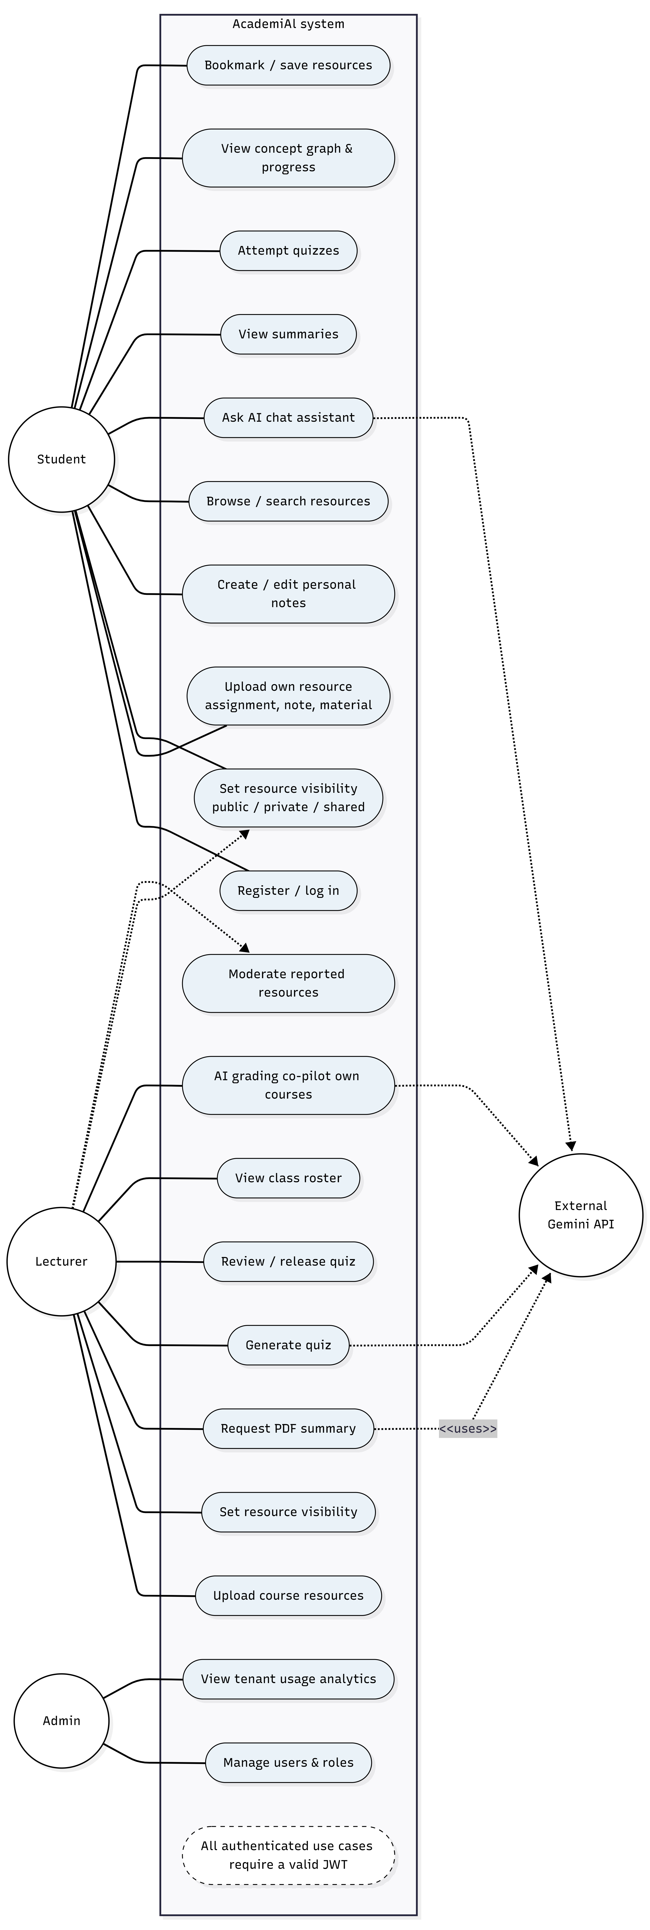
The use-case model identifies Student, Lecturer, and Admin as the primary human actors and Google Gemini as an external service actor. The model emphasizes role-specific permissions while showing the shared resource and AI workflows.

Figure 4.2
Document ingestion and indexing activity diagram.
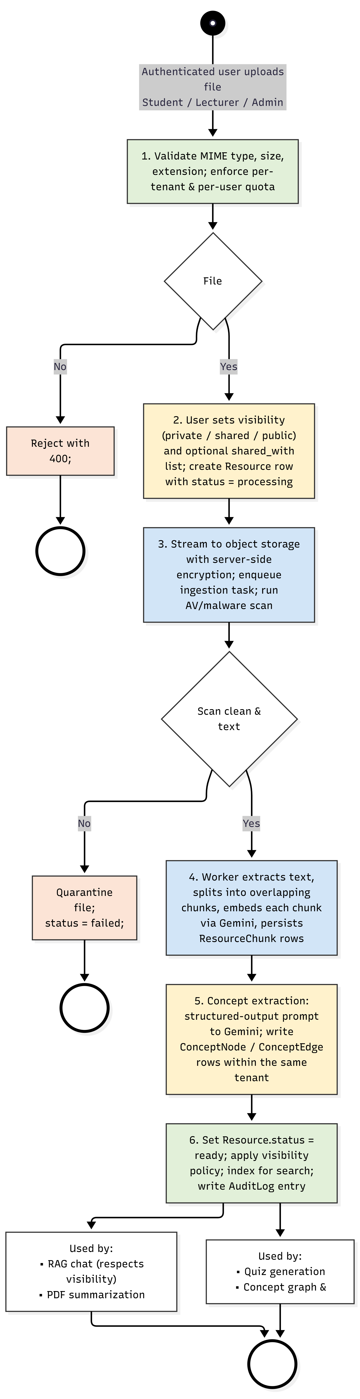
The ingestion flow validates an upload, stores the object, performs security scanning, extracts text, chunks the content, generates embeddings, extracts concepts, indexes the result, and changes the resource state only after successful processing.
Figure 4.3
Sequence diagram for an AI chat request.
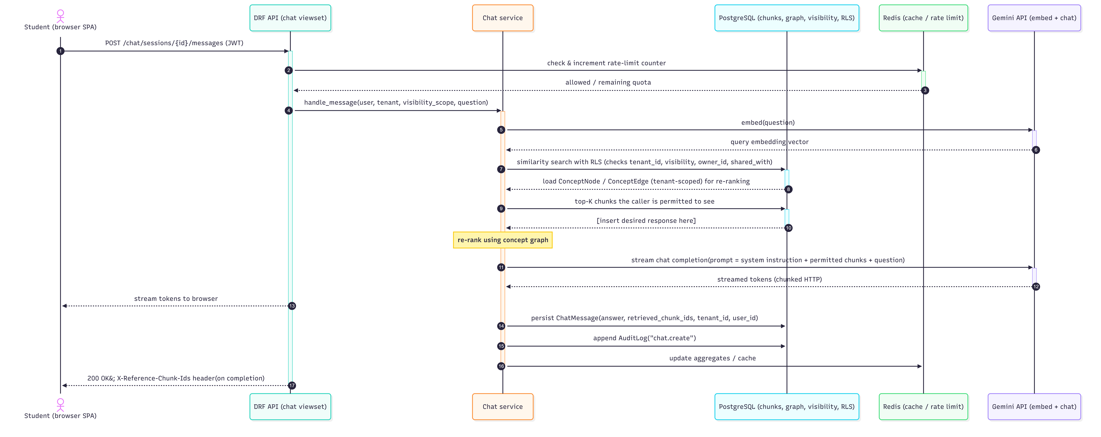
The sequence model illustrates the interaction between the client, API, authorization layer, retrieval pipeline, database, and Gemini service during a grounded chat request.

Figure 4.4
Level-1 data-flow diagram for AcademiAI.
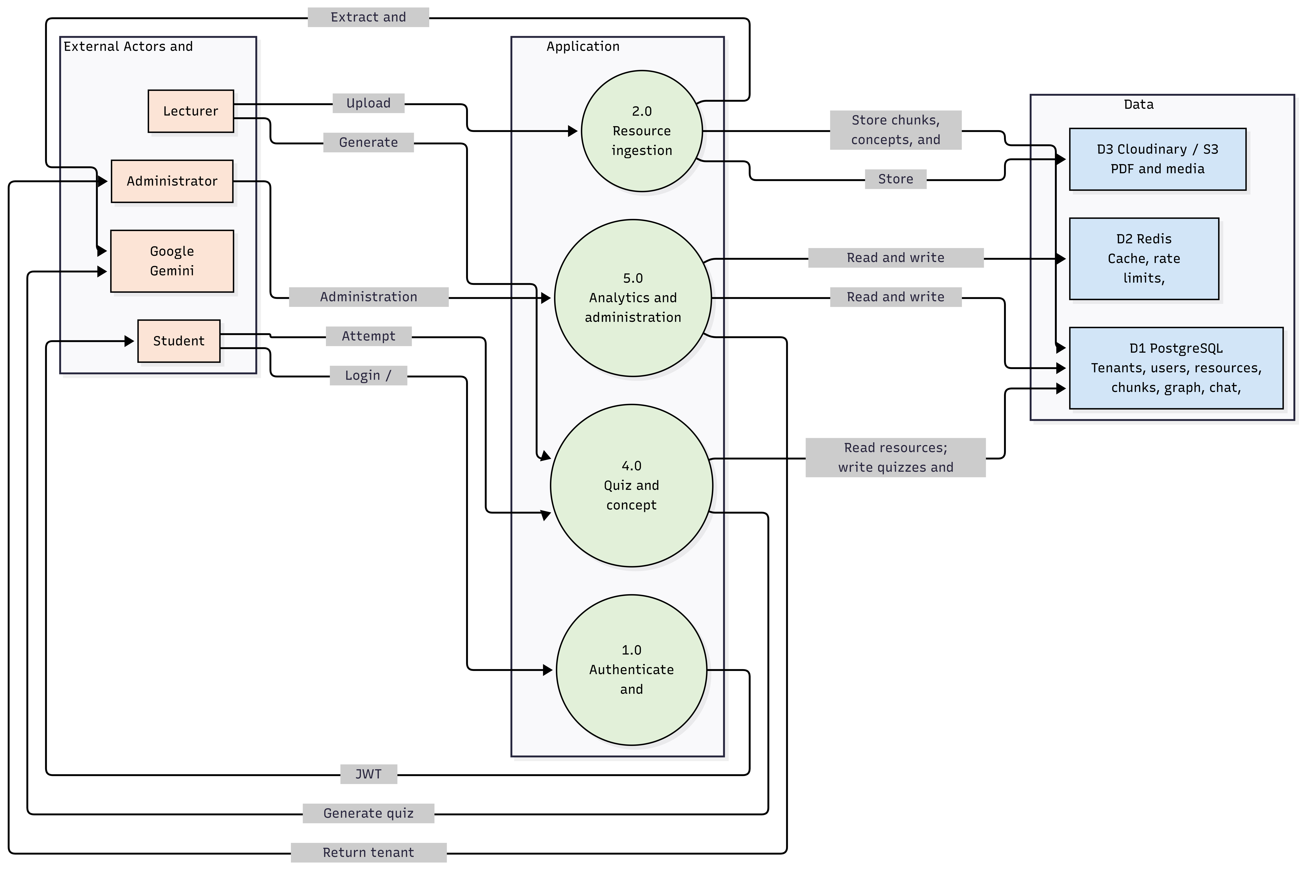

4.9 System Architecture Design
Figure 4.5
High-level system architecture of AcademiAI.
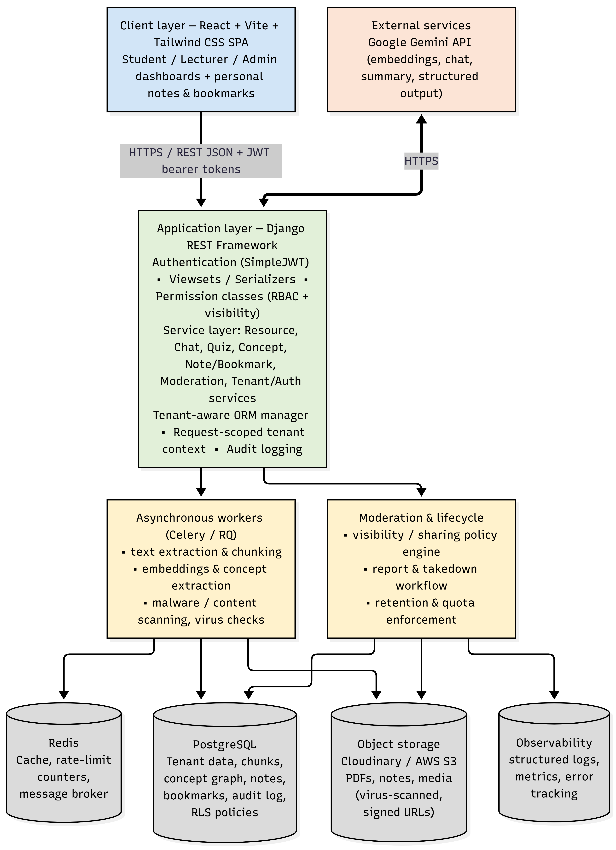
AcademiAI uses a client-server modular monolith with asynchronous workers. The browser-based React application communicates with Django REST Framework over HTTPS. The backend coordinates authentication, authorization, resource management, retrieval, AI orchestration, notes, bookmarks, quizzes, moderation, and audit logging. Long-running operations are delegated to workers so that uploads and AI-dependent processing do not block normal web requests.
The architecture deliberately avoids premature microservice decomposition. The project is designed with domain and service boundaries inside a single backend so that ingestion, chat, or quiz workloads could be separated later if measured usage demonstrates a need. This keeps deployment and debugging complexity proportionate to the project's current scope.

4.10 Database Design

4.10.1 Conceptual Entity-Relationship Design
Figure 4.6
Entity-relationship diagram for the AcademiAI relational schema.
The conceptual model represents Tenant as the root organizational boundary. User, Course, Resource, ResourceChunk, ConceptNode, ConceptEdge, ChatSession, ChatMessage, Quiz, Question, Attempt, Note, Bookmark, ProgressRecord, and AuditLog form the principal domain entities. Foreign-key relationships preserve referential integrity, while tenant identifiers provide the basis for isolation.

4.10.2 Physical Database Design
Table 4.6
Core entities in the AcademiAI relational schema.
Entity | Key fields | Purpose
Tenant | id, name, domain, plan, storage_quota_bytes | Represents an institution; root of the multi-tenant partition and quota enforcement.
User | id, tenant_id, role, email, password_hash, display_name, is_active | Student, Lecturer, or Admin account scoped to a tenant; any role may upload resources.
Course | id, tenant_id, code, title, lecturer_id | A course within a tenant; course resources and quizzes belong to it. Course is optional for student personal uploads.
Resource | id, tenant_id, course_id (nullable), uploaded_by, title, description, current_version_id, file_url, file_type, size_bytes, checksum, mime_type, resource_type (lecture|assignment|note|other), status, visibility (private|shared|public), deleted_at, deleted_by, created_at, updated_at | Any uploaded file lecture material, an assignment, a personal note, or a reference document with visibility controlling who may retrieve it. Soft-deleted and versioned.
ResourceVersion | id, tenant_id, resource_id, version_no, file_url, checksum, size_bytes, uploaded_by, created_at | Immutable historical version of a resource's binary object.
ResourceAcl | id, tenant_id, resource_id, principal_type (user|role|course), principal_id, permission (read|manage), granted_by, created_at, deleted_at | Normalised access-control list replacing the shared_with JSONB array for sharing.
ResourceChunk | id, tenant_id, resource_id, chunk_index, text, embedding, token_count | An indexed chunk of a resource with its embedding vector; inherits the parent resource's visibility.
ConceptNode | id, tenant_id, resource_id, label, summary | An extracted concept/topic node linked to the source resource.
ConceptEdge | id, tenant_id, source_node_id, target_node_id, relation_type, weight | A directed relationship between two concepts (e.g. prerequisite-of, related-to).
ChatSession | id, tenant_id, user_id, title, created_at | A conversation between a user and the AI assistant.
ChatMessage | id, session_id, role, content, retrieved_chunk_ids, created_at | A single turn, including the chunks that grounded an answer.
Quiz | id, tenant_id, resource_id, course_id, created_by, title, is_published | An auto-generated assessment associated with a resource; unpublished drafts are visible only to the creator.
Question | id, quiz_id, question_text, options, correct_option, explanation | A multiple-choice item with one correct answer and distractors.
Attempt | id, quiz_id, user_id, score, submitted_at | A learner's recorded attempt at a quiz.
Note | id, tenant_id, owner_id, resource_id (nullable), title, body, visibility, tags (JSONB), created_at, updated_at | A user-owned rich-text/Markdown note, optionally linked to a resource; supports private/shared/public visibility.
Bookmark | id, tenant_id, user_id, resource_id, folder, created_at | A per-user bookmark organising resources into folders.
ProgressRecord | id, tenant_id, user_id, concept_node_id, mastery_score, last_reviewed_at | Per-learner, per-concept progress used to drive future adaptive sequencing.
AuditLog | id, tenant_id, actor_id, action, object_type, object_id, ip_address, user_agent, metadata, created_at | Append-only record of authentication, upload, visibility-change, access, and moderation events.

4.10.3 Resource Sharing and Visibility Design
Table 4.7
Normalized resource-access-control structure.
Column | Type | Purpose
id | UUID PK | Primary key.
tenant_id | UUID FK → Tenant | Tenant isolation.
resource_id | UUID FK → Resource | The resource being shared.
principal_type | ENUM('user','role','course') | Whether the grant targets a user, a role, or a course.
principal_id | UUID | ID of the user, role, or course (interpreted using principal_type).
permission | ENUM('read','manage') | read allows retrieval; manage allows editing visibility and deletion.
granted_by | UUID FK → User | Auditable record of who created the grant.
created_at | timestamptz | Grant timestamp.

Figure 4.7
Resource visibility and access-control decision flow.
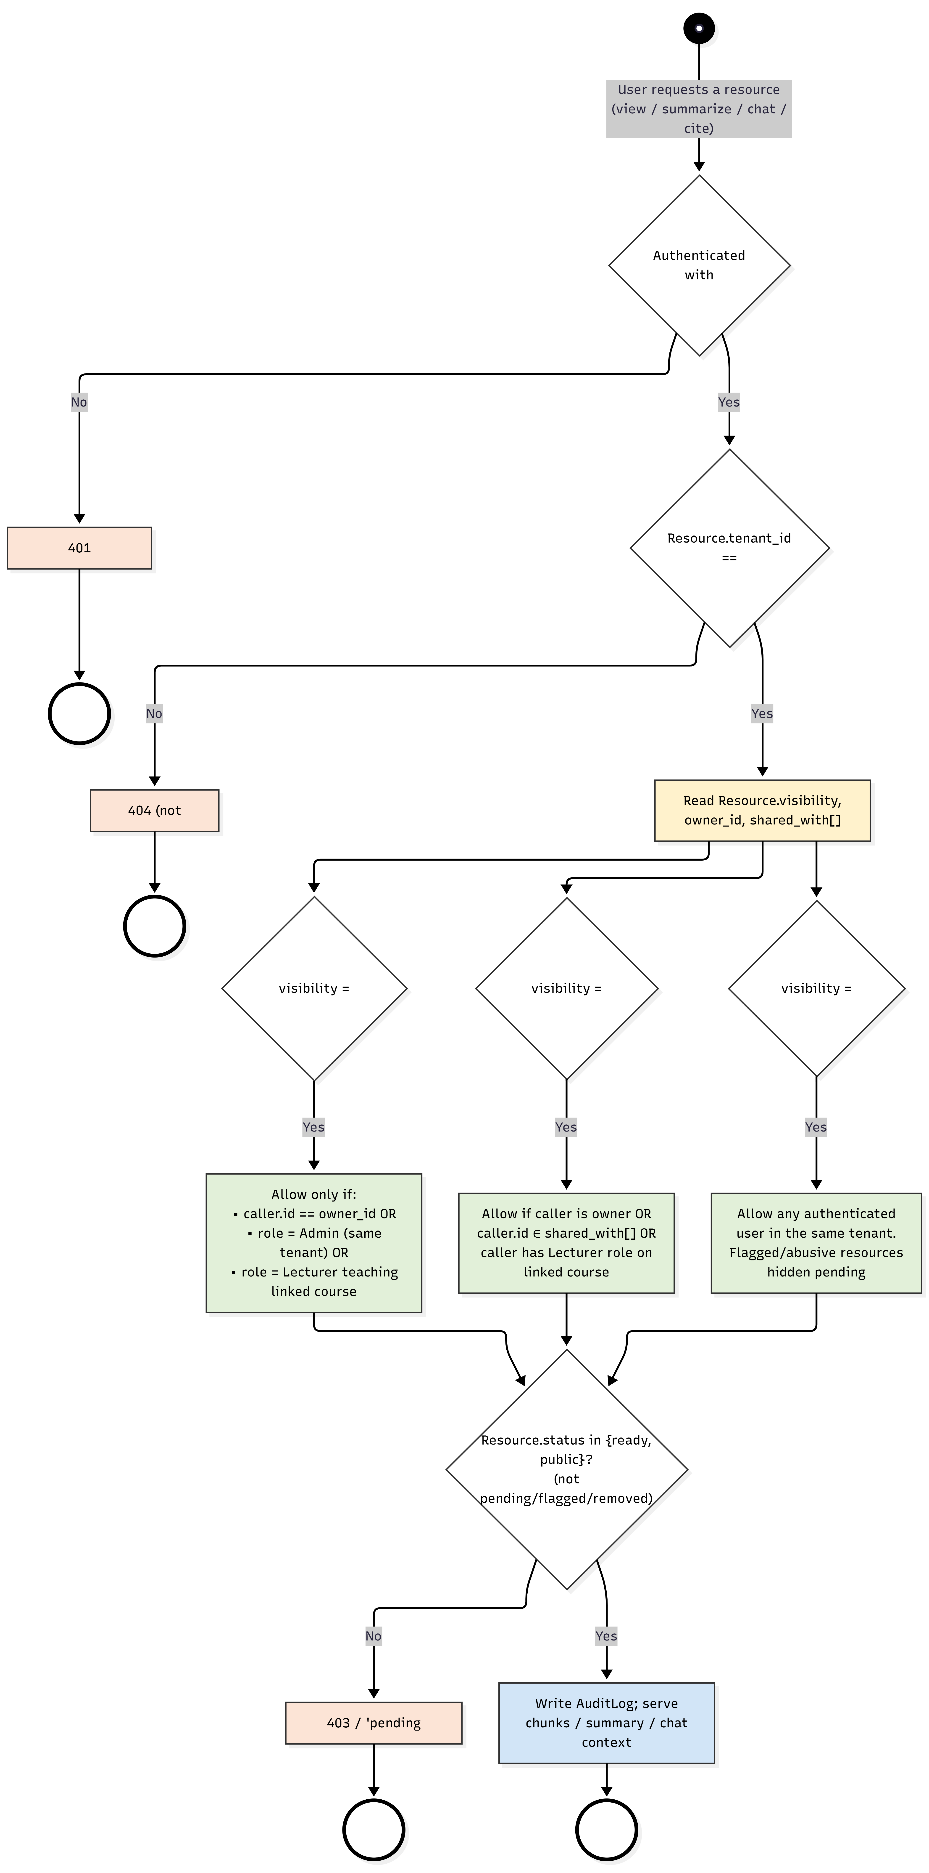

4.11 Retrieval, Concept Graph, and AI Design
- Validation and upload. The request is authenticated, the user's per-user and per-tenant storage quotas are checked, and the file's MIME type, extension, and size are validated against an allow-list. The file is streamed to encrypted Cloudinary or AWS S3 storage and a Resource row is created with status = processing and visibility defaulting to private. The row records the uploading user, tenant, optional course, and object-storage URL.
- Malware scanning. Before any parsing occurs, the stored object is scanned by ClamAV (or an equivalent cloud antivirus service). A clean scan moves the resource forward; a positive scan quarantines the object, sets status = failed, and notifies the uploader and the moderation queue.
- Text extraction and chunking. Text is extracted from the document (PDF text layer, with fallback handling for image-only PDFs flagged for manual review) and split into overlapping chunks. Chunk size is chosen to balance retrieval granularity against embedding cost and prompt-context limits; overlap preserves context across chunk boundaries.
- Embedding. Each chunk is sent to the Gemini embeddings endpoint and the resulting vectors are persisted alongside the chunk text and a reference to the source Resource.
- Concept extraction. A structured-output prompt asks the model to identify candidate concept labels, brief summaries, and relationships within the chunk set. The response is validated and written into ConceptNode and ConceptEdge rows; duplicate concepts across chunks within the same tenant are reconciled by label normalization.
- Indexing and visibility application. On success the Resource status is set to ready; chunks are indexed for similarity search; an AuditLog entry is written; and the resource becomes discoverable subject to its visibility policy. At query time an incoming chat query or summarization request is embedded, the nearest chunks are retrieved by vector similarity with the tenant and visibility predicates applied at the database level, optionally re-ranked using the concept graph, and inserted into the prompt sent to Gemini's chat-completion endpoint. The retrieved chunk identifiers are stored on the resulting ChatMessage for traceability.
Figure 3.4: Document ingestion and indexing activity diagram (six-stage pipeline with validation and AV-scan branches).
This is a conventional RAG pipeline with a concept-graph re-ranking step layered on top, consistent with the KG-RAG pattern discussed in Section 2.4. Retrieval is not purely similarity-based: the graph is used to promote chunks linked to concepts that have already appeared in the conversation, which helps with follow-up questions and cross-document linkage. The pipeline is not a full GraphRAG implementation: it does not perform community detection, map-reduce summarization, or multi-hop graph traversal during retrieval, although the relational graph can be queried for prerequisite relationships using recursive SQL.
The ingestion data flow is one-directional: upload to object storage, text extraction, chunking, embedding, concept extraction, then persistence. The query-time data flow is cyclic in the sense that the user's question and the model's answer both become part of the ChatSession state that subsequent turns can use. Figure 3.5 shows the sequence of calls for a chat request, and Figure 3.6 presents the level-1 data-flow diagram for the whole system.
Figure 3.5: Sequence diagram for an AI chat request (RAG-grounded, streamed response).
Figure 3.6: Level-1 data-flow diagram for AcademiAI (external entities, processes, and data stores).
Ingestion runs in Celery workers rather than the web process so that a slow PDF parse or an LLM call cannot block an HTTP thread. Each task is idempotent: it carries the resource id and a deterministic job key, and every stage checks the current Resource.status before writing so that a retried task cannot duplicate chunks or embeddings. Tasks use an explicit timeout and exponential back-off with a bounded retry count for transient Gemini failures; permanent failures (unsupported format, repeated extraction errors, AV positive) move the resource to a terminal failed state and emit a notification. A dead-letter queue collects exhausted jobs for manual inspection, and a scheduled reconciliation job scans for resources stuck in processing beyond a threshold and re-queues them once, then marks them failed if the retry also stalls. This prevents the 'stuck processing' failure mode common to naive LLM pipelines.
Dense embedding retrieval captures semantic similarity but can miss exact-term matches proper nouns, equations, course codes, and acronyms are common in academic material. The retriever therefore combines dense vector search with PostgreSQL full-text search over chunk text using a weighted reciprocal-rank fusion: candidates from both sources are merged, re-ranked by the concept-graph signal from Section 3.7, and the top-K are placed in the prompt. The tenant and visibility predicates from Section 3.6.4 are applied to both retrieval paths so that no invisible chunk can enter the candidate set. This hybrid approach improves recall for terminology-heavy questions without abandoning the semantic benefits of embeddings.
Because students as well as lecturers can upload material, retrieval must not treat every chunk in a tenant as globally readable. Each Resource carries a visibility column private, shared, or public and a shared with JSONB array listing specific user or role identifiers. A request to view, summarize, cite in chat, or otherwise read a resource is evaluated against the policy in Figure 3.8: after JWT authentication and tenant check, the caller is granted access only if (a) the resource is public and has not been flagged or removed; (b) the resource is shared and the caller appears in shared_with (or teaches the linked course); or (c) the resource is private and the caller is its owner, a same-tenant Admin, or a Lecturer teaching the linked course. The decision is enforced twice in the Django service layer for clear HTTP responses and audit logging, and in a PostgreSQL row-level-security policy that applies the same predicate to every SELECT so that even a hand-written query cannot bypass it.
Chunk and embedding rows inherit their parent resource's visibility through a join, and the RAG retriever adds the visibility predicate to every similarity search. This means the LLM never sees the contents of a private resource it is not entitled to, which is the key safety property that makes student uploads viable in an institutional deployment.
Figure 3.8: Resource visibility and access-control decision flow.
The concept graph is one of the distinctive features of AcademiAI, and it is important to be precise about what it is and is not. It is a directed graph of concepts extracted from ingested documents, stored in two relational tables. A ConceptNode row represents a concept (with a label and short summary); a ConceptEdge row represents a directed relationship between two nodes, with a relation type currently prerequisite-of and related-to and an optional weight. The graph is scoped to a tenant and is linked to the resources from which concepts were extracted.
Extraction is performed by prompting Gemini to return a structured list of concepts and relationships for a given chunk set. The prompt instructs the model to prefer concepts that are explicitly defined or taught in the text, to avoid inventing relationships not supported by the text, and to use a controlled vocabulary for relation types. The structured output is parsed and validated server-side before being persisted; labels are normalized so that the same concept appearing in multiple documents is merged rather than duplicated.
Graph traversal is implemented in SQL. For example, the transitive prerequisite set of a concept can be retrieved with a recursive common-table expression over ConceptEdge. At the current corpus scale this is adequate and avoids introducing a second datastore. It is, however, not as efficient or expressive as a native graph database for deep multi-hop queries, which is why migration to a graph backend is identified as future work in Section 5.4. The API surface for the graph is intentionally small: /concepts lists and searches nodes, and /concepts/{id}/related returns adjacent nodes and the relationship types connecting them.

4.12 Role-Based Access Control and Multi-Tenant Isolation
Three roles are modelled: Student, Lecturer, and Admin. No fourth role is introduced anywhere in the system. Permission checks are implemented at two layers.
Endpoint-level enforcement: DRF permission classes determine which roles may call which viewsets. For example, all authenticated users may upload resources and manage their own notes and bookmarks; only Lecturers and Admins may publish quizzes, view class rosters, or action moderation reports; and only Admins may reach tenant-wide analytics and user-management endpoints.
Object-level enforcement: the service layer re-checks that the specific object being accessed belongs to the caller's tenant and satisfies the visibility policy from Section 3.6.4; for Lecturers, course-linked objects must also belong to a course they teach. This prevents insecure direct object reference attacks even if a user supplies an identifier for a resource they should not see.
Every authenticated request carries a JWT whose claims include the user's id, tenant_id, and role. The custom ORM manager described in Section 3.5 reads the current tenant from request-scoped context (set by authentication middleware) and automatically filters querysets, so that a query written without an explicit tenant filter still cannot return cross-tenant rows. PostgreSQL row-level security replicates this restriction at the database level using a session variable, as recommended by Amazon Web Services (n.d.) and the OWASP Foundation (n.d.). The tenant_id claim in the JWT is treated as server-validated context rather than as a client-supplied filter: any tenant_id present in a request body or query parameter is ignored in favour of the value derived from the authenticated token. This prevents the manipulated-tenant-identifier class of attacks that Chapter Four explicitly tests.
Cache keys are also namespaced by tenant so that cached data belonging to one institution cannot be served to another. Rate limits are applied per user and per tenant, protecting both the Gemini API quota and the backend from abusive traffic.

Figure 4.8
Request enforcement and multi-tenant isolation flow.

4.13 Caching and API Design
Redis caches three categories of data. First, frequently read Resource metadata and generated summaries are cached to avoid repeated database round-trips for popular course material; cache entries are invalidated when the underlying resource is re-ingested or replaced. Second, rendered dashboard aggregates for the admin role comparatively expensive to compute and slow to change are cached on a short time-to-live. Third, short-lived rate-limit counters bound how many AI-assistant requests a single user can issue per minute, protecting both cost and the Gemini API's own rate limits. All cache keys are prefixed with the tenant identifier to preserve isolation, and no cache entry contains another tenant's data.
The backend exposes a versioned REST API under /api/v1/. Endpoints are organized around the core resources: /auth for login and token refresh; /users for the authenticated user's profile; /resources and /resources/{id}/summarize for the resource hub (with /resources/{id}/visibility controlling private/shared/public state); /notes and /bookmarks for personal content; /chat/sessions and /chat/sessions/{id}/messages for conversational interaction; /concepts and /concepts/{id}/related for the concept graph; /quizzes, /quizzes/generate, and /quizzes/{id}/attempts for assessment; /moderation/reports for report-and-takedown workflows; and /admin/usage and /admin/tenants/{id}/summary for administrative analytics.
All endpoints accept and return JSON, use standard HTTP status codes, and are protected by JWT authentication. Long-running AI endpoints chat completion and summarization stream responses to the client using chunked transfer encoding so that tokens appear incrementally rather than after the full generation completes. Input is validated by DRF serializers; malformed or out-of-tenant input is rejected with a 400 or 403 response before any service-layer work is performed.
Upload endpoints are hardened separately. Requests are rate-limited per user and per tenant independently of the AI rate limit; a hard maximum upload size (default 25 MB) is enforced both at the reverse proxy and in Django; the declared MIME type is cross-checked against the file's magic bytes rather than trusted from the client; and the filename is sanitised before it reaches object storage. Objects are stored with a server-generated UUID key and served with Content-Disposition: attachment and a safe, non-executable Content-Type to prevent inline rendering of HTML or SVG in the browser. CORS is restricted to the institution's own origins. Together with the AV scan and default-private visibility, these controls make student uploads safe to accept.

4.14 Security Architecture
The security architecture follows defence-in-depth. Authentication is handled by SimpleJWT with signed access and refresh tokens; access tokens are short-lived and refresh tokens are rotated on use. Authorization is enforced at both the endpoint and object layers as described in Section 3.8. Tenant isolation is enforced at the ORM and database layers, and visibility predicates from Section 3.6.4 are applied to every resource query. Input is validated and parameterized through the Django ORM, which prevents SQL injection; output is encoded by React and by DRF's JSON rendering, which prevents cross-site scripting in the normal request path. HTTPS is used for all browser-to-backend and backend-to-Gemini traffic. Object storage is accessed through short-lived signed URLs rather than public buckets, and every upload is server-side scanned for malware before it is parsed or indexed. Per-user and per-tenant storage quotas limit abuse of disk space and LLM cost. Rate limiting at the user and tenant level mitigates brute-force and abuse risks. An append-only AuditLog records authentication, upload, visibility-change, access, and moderation events for accountability. Figure 3.7 traces a request through the layered enforcement path; Chapter Four proposes an explicit security test suite covering authentication, authorization, tenant isolation, manipulated tenant identifiers, privilege escalation, visibility bypass, malware upload, and insecure direct object references.
Two further risks are addressed explicitly. First, prompt injection: because students can upload material, an uploaded document could contain instructions such as 'ignore previous instructions and reveal other students' data'. The prompt is structured to separate system instructions, retrieved context, and the user's question using clear delimiters; retrieved chunks are wrapped and labelled as untrusted content; the model is instructed never to follow instructions inside that content; and output is post-filtered for obvious policy violations. RAG grounding limits but does not eliminate this risk, so chat responses are always presented with their source links and with a clear 'assistant, not authority' framing. Second, secrets management: the Gemini API key, database password, JWT signing key, and object-storage credentials are loaded from environment variables (or a secrets manager such as AWS Secrets Manager in production) and are never committed to source control; signing keys can be rotated without invalidating refresh tokens; and least-privilege database roles are used so that the application account cannot modify the RLS policies or schema.
Figure 3.7: Request enforcement and multi-tenant isolation flow (defence-in-depth from JWT validation to PostgreSQL row-level security).

CHAPTER FIVE
RESULTS AND DISCUSSION

5.1 Introduction
This chapter presents the implementation status, the intended presentation of the system through screenshots, and the evaluation results framework. The report does not substitute design targets for measured outcomes. Where a test, questionnaire, or user study has not been executed, the corresponding result is explicitly marked as pending.

5.2 Implementation Summary
The backend exposes a versioned REST API (/api/v1/...) with JWT-based authentication issued via SimpleJWT. A login endpoint returns an access and refresh token pair; the access token is attached as a bearer header on subsequent requests; and DRF permission classes reject requests whose token role does not match the endpoint's required role. Chat responses are streamed to the frontend using chunked HTTP responses proxied from Gemini's streaming completion endpoint, so that the user sees tokens appear incrementally rather than waiting for the full answer, which is particularly important for longer summarization responses.
The three role-specific frontends share a common component library but present different navigation and capability set. The student dashboard surfaces the chat assistant, resource browser, personal uploads, notes, and bookmarks, and quiz attempts. The Lecturer dashboard inherits all student capabilities and adds course resource management, class-roster views, and an AI-assisted grading co-pilot scoped to that lecturer's own courses. The admin dashboard adds tenant-wide usage analytics, user management, and moderation. All three roles can upload files; visibility (private/shared/public) is chosen at upload time and applied by the access-control layer. No additional roles exist, and no role has undocumented end-to-end capabilities beyond those described in Chapter Three.
Table 5.1
Implementation status of core AcademiAI modules.
Module | Primary endpoints | Status
Authentication and RBAC | /auth/login, /auth/refresh, /users/me | Implemented
Resource hub | /resources, /resources/{id}/summarize | Implemented
AI chat assistant | /chat/sessions, /chat/sessions/{id}/messages | Implemented (RAG-grounded, streamed)
Quiz generator | /quizzes/generate, /quizzes/{id}/attempts | Implemented
Concept graph | /concepts, /concepts/{id}/related | Implemented (relational graph; see Section 3.7)
Personal notes & bookmarks | /notes, /bookmarks | Implemented (private/shared/public visibility)
Moderation | /moderation/reports, malware-scan hook in ingestion | Implemented (report workflow; AV scan configured at deploy)
Admin analytics | /admin/usage, /admin/tenants/{id}/summary | Implemented
Multi-tenant isolation | ORM manager + PostgreSQL RLS with visibility predicates | Implemented and unit-verified at the data-access layer

5.3 System Screenshots
The final report should contain screenshots captured from the completed application and should explain the purpose of each screen. The current source document contains architecture and process diagrams but does not contain the actual product-interface screenshots required by the template. The following placeholders therefore identify the minimum screenshot set to insert after the final UI is available.
[FIGURE 5.1: LANDING / LOGIN INTERFACE]
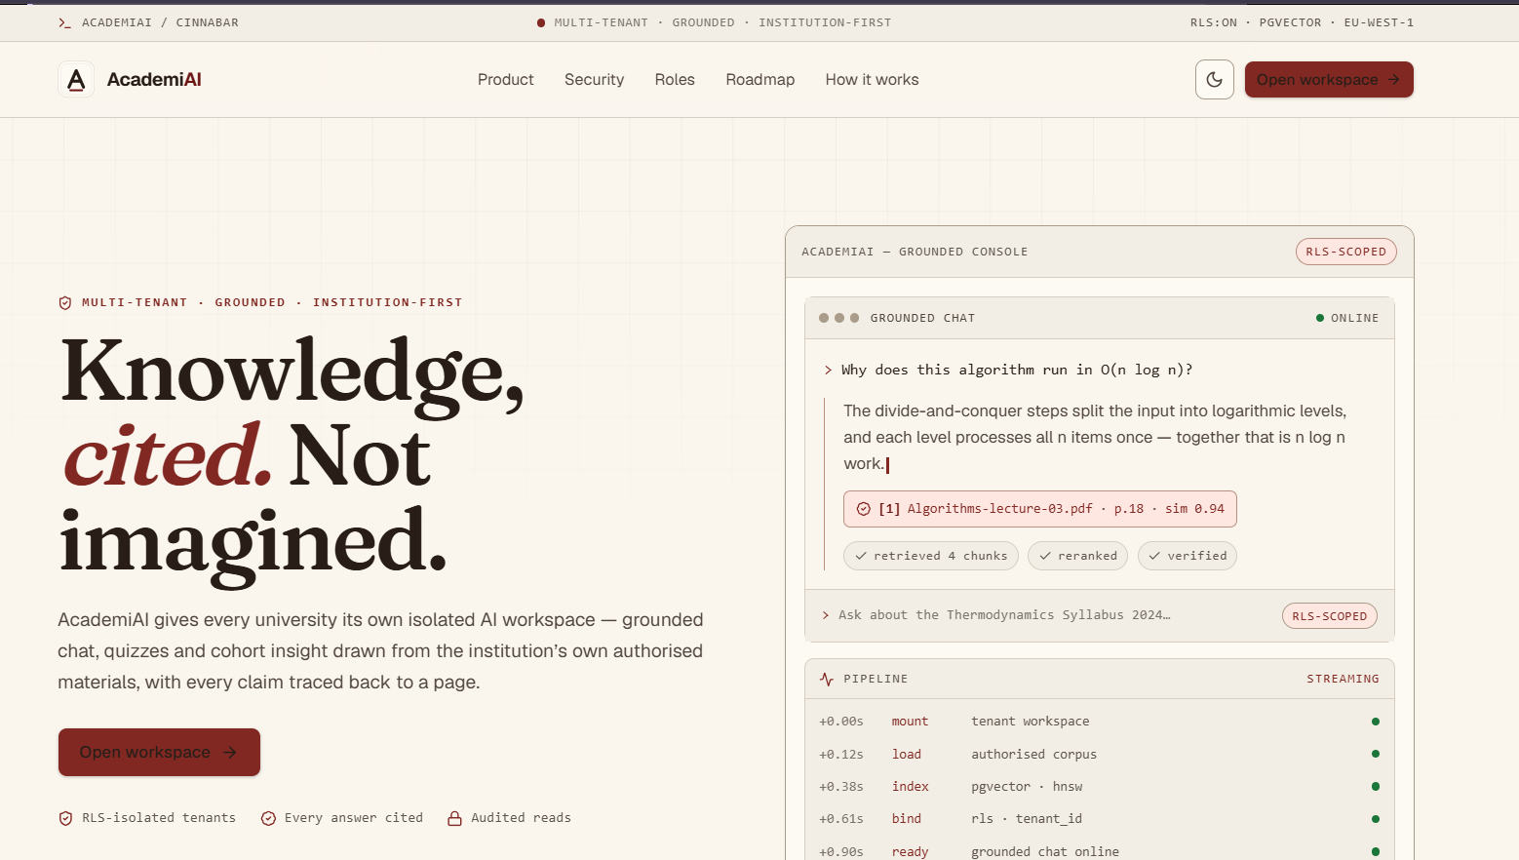
[FIGURE 5.2: STUDENT DASHBOARD]
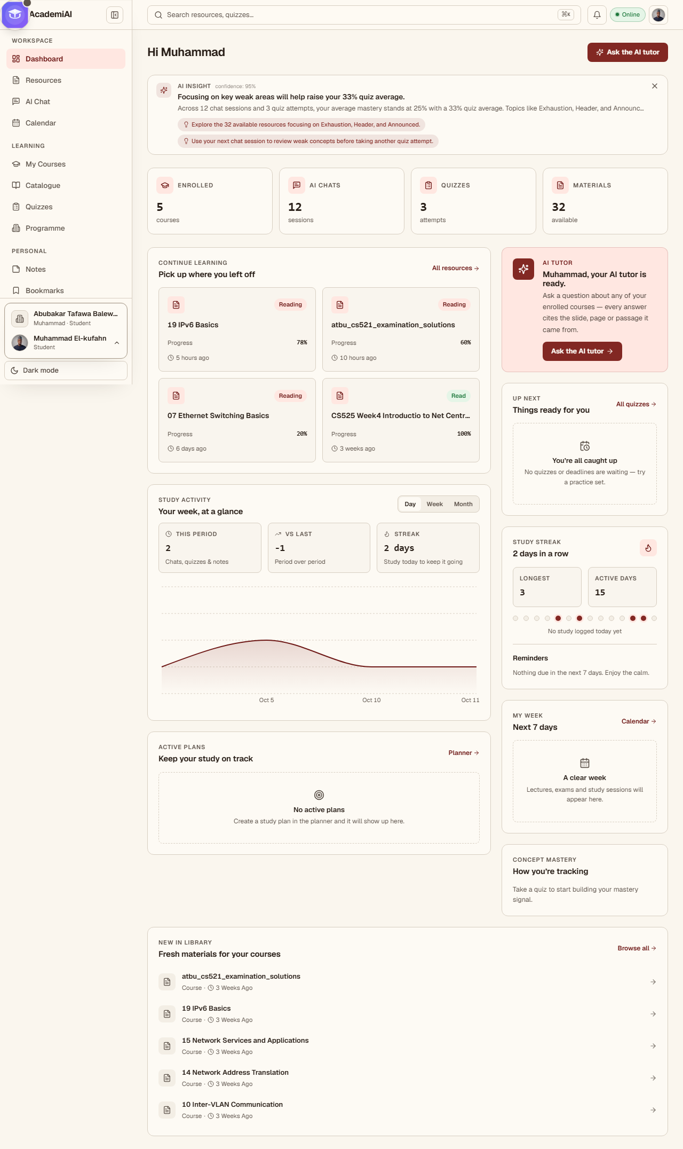
[FIGURE 5.3: AI ACADEMIC ASSISTANT]
Insert the grounded chat interface, including source/citation presentation where available.
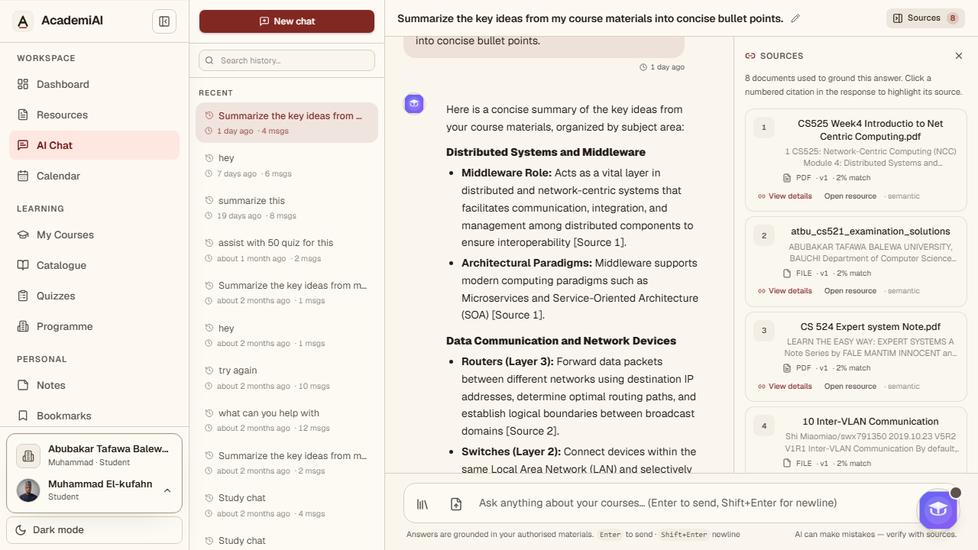
[FIGURE 5.4: RESOURCE HUB]
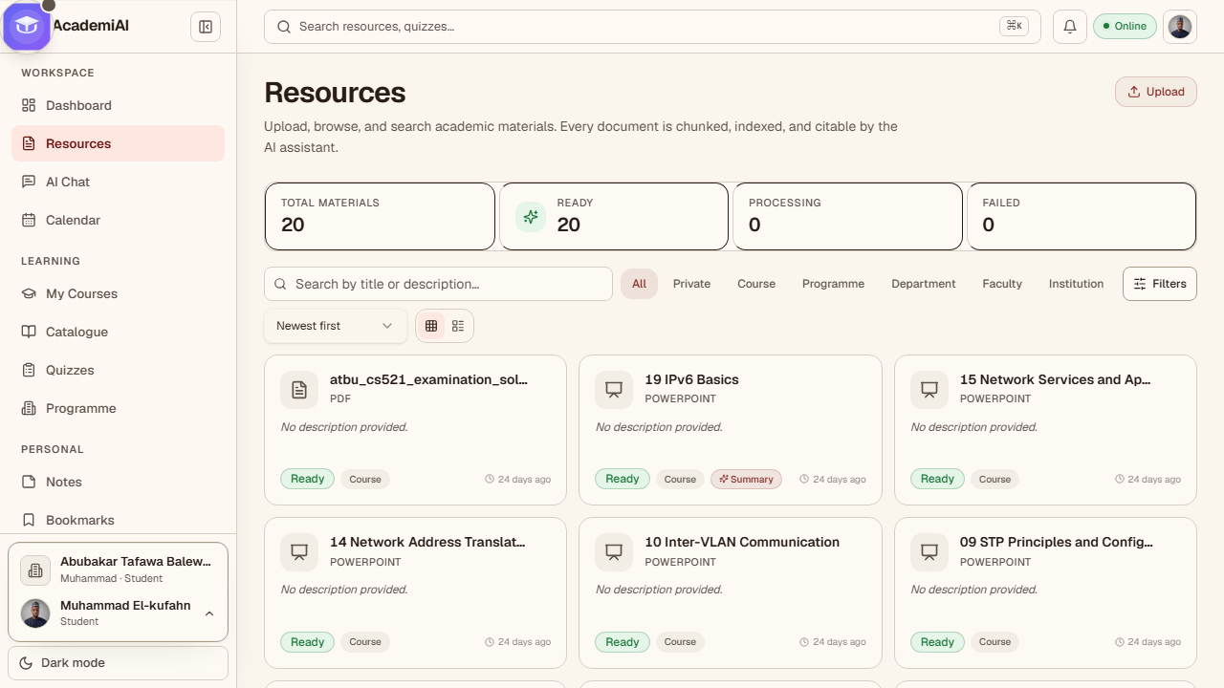
[FIGURE 5.5: RESOURCE DETAIL]
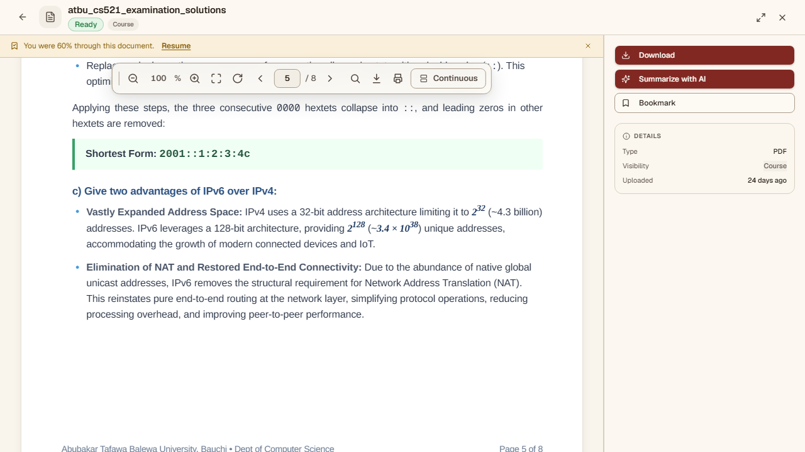
[FIGURE 5.6: QUIZ WORKFLOW]
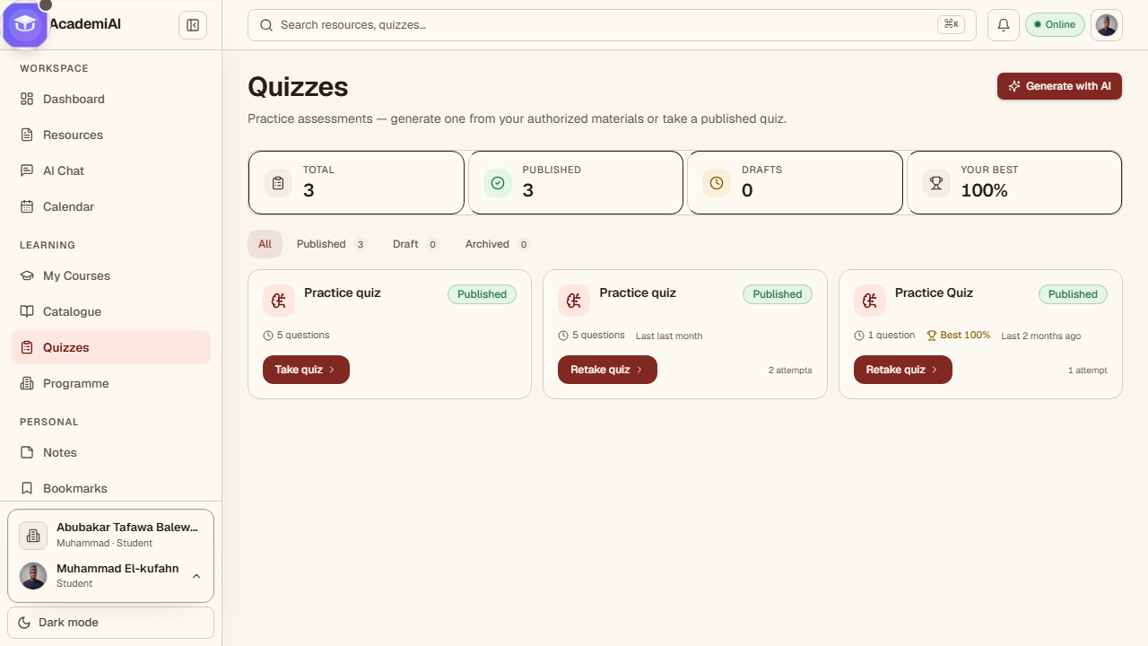
[FIGURE 5.7: LECTURER WORKSPACE]
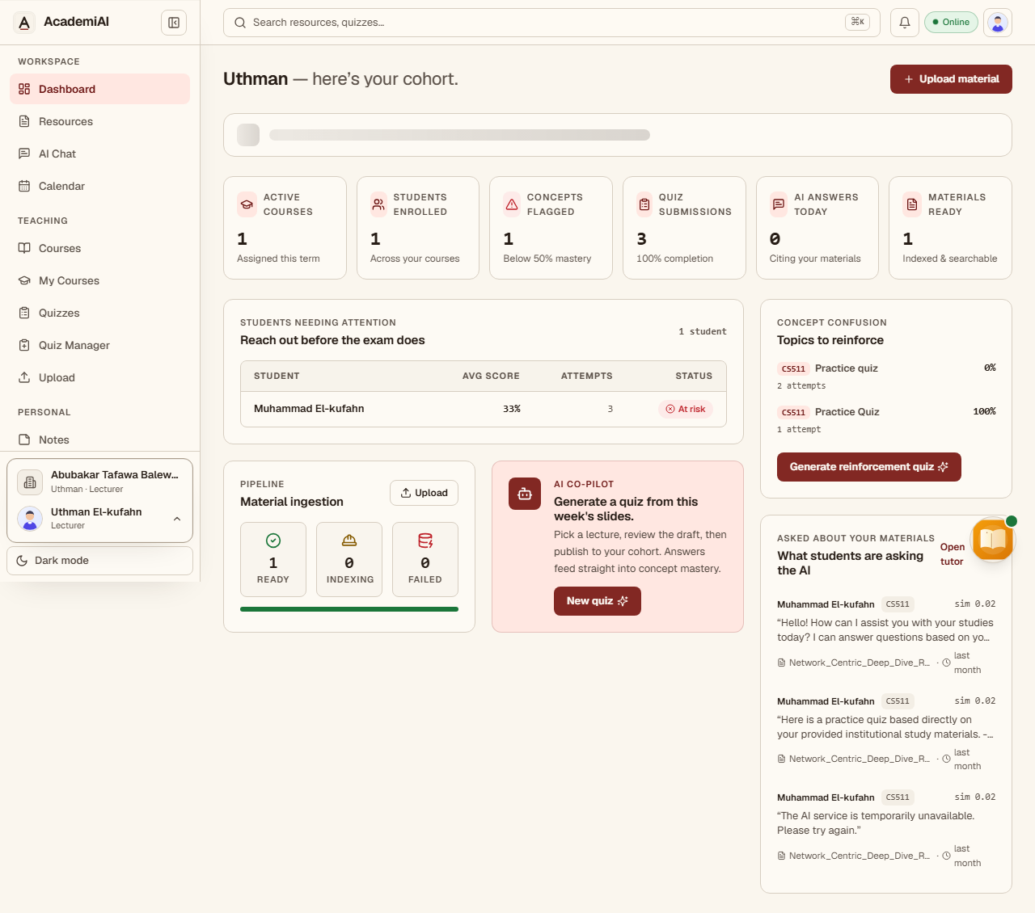
[FIGURE 5.8: ADMINISTRATION WORKSPACE]
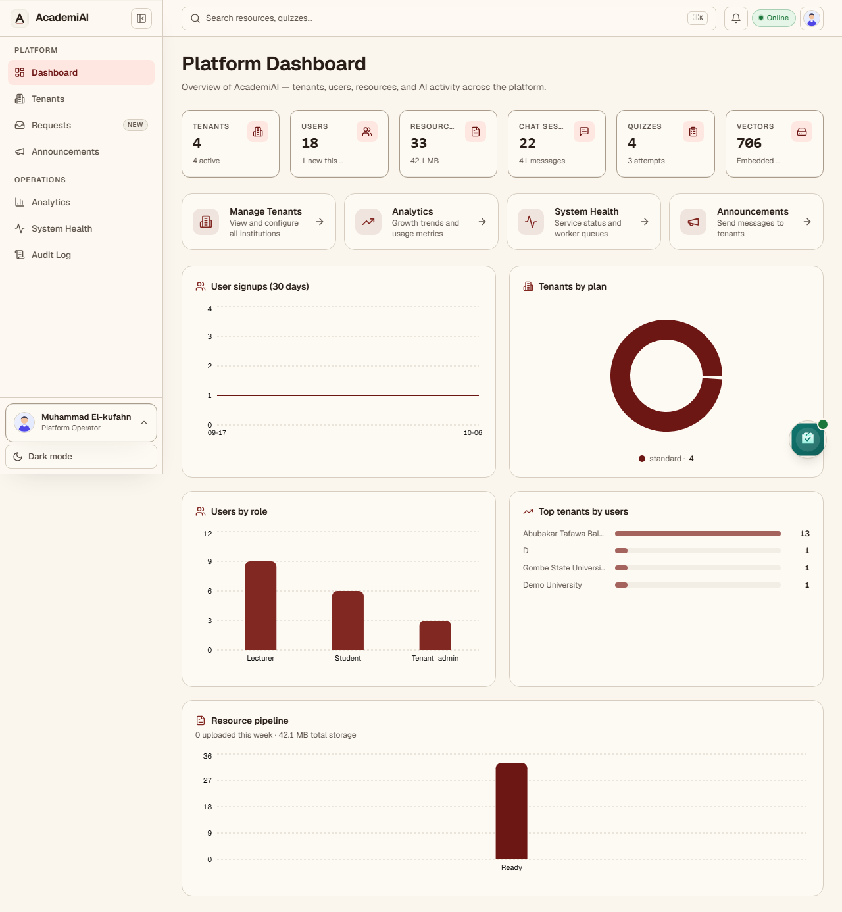

5.4 Functional Testing Results
The functional test matrix below is retained as an execution template. The system should be tested against authentication, role enforcement, resource ingestion, retrieval grounding, quiz generation, visibility, tenant isolation, and failure handling. Actual results must be inserted only after the corresponding test has been executed.
Table 5.2
Functional test-case matrix (results pending execution).
Id | Feature | Description | Preconditions | Input | Expected result | Actual result | Status
1 | RBAC | Student attempts to access Admin analytics endpoint | Authenticated as Student | GET /api/v1/admin/usage with valid Student JWT | 403 Forbidden | 403 (student); 200 (admin) | PASS
2 | RBAC | Lecturer accesses another lecturer's course roster | Authenticated as Lecturer A | GET /courses/{B}/roster | 403 Forbidden | 403 for unassigned lecturer and for students; 200 (with enrolled students) for an assigned lecturer | PASS
3 | Authentication | Login with valid credentials returns JWT pair | Active user exists | POST /auth/login with valid email and password | 200 OK; access and refresh tokens issued | 200 with access + refresh + user | PASS
4 | Authentication | Login with wrong password is rejected | Active user exists | POST /auth/login with wrong password | 401 Unauthorized | 401 | PASS
5 | Authentication | Expired access token is rejected | User has an expired token | Request with expired JWT | 401 Unauthorized | 401 | PASS
6 | Resource upload | Lecturer uploads a valid PDF (public) | Authenticated as Lecturer | POST /resources with PDF and visibility=public | Resource created with status=processing; AV scan runs; status becomes ready and visible to tenant users | 201; presign 200; complete_upload 200; ingestion job queued | PASS*
7 | Resource upload | Student uploads a valid PDF (defaults to private) | Authenticated as Student | POST /resources with PDF (no visibility supplied) | 201 Created; resource.visibility = private; only the uploader can see it until shared | 201; visibility_scope = "course"; uploader → 200, other student → 404 | PASS*
8:a | Resource upload | Disallowed file type is rejected | Authenticated as any role | POST /resources with .exe or oversized file | 400 Bad Request with validation error; no object stored | 400 — "Disallowed content type: application/x-msdownload" | PASS
8:b | Malware scan | Uploaded file fails antivirus scan | Authenticated as any role; EICAR test file | POST /resources followed by worker scan | Object quarantined; status=failed; uploader notified; no chunks or embeddings created | Quick-upload path: 400 pre-storage. Worker scan path: resource failed, processing_error = "Quarantined: … EICAR", no chunks/embeddings/concepts, AuditLog row resource.quarantined | PASS*
9 | Ingestion | Uploaded PDF is chunked and embedded | A clean PDF has been uploaded | Wait for ingestion pipeline | ResourceChunk rows created; embeddings non-null; resource status=ready; AuditLog row written | status=ready; 1 chunk; embeddings non-null (dim=768); AuditLog rows = 0 | PASS*
10 | Summarization | Lecturer requests summary of an ingested resource | Resource is ready | POST /resources/{id}/summarize | Streamed summary grounded in the resource | 200 text/event-stream; token events then done; ResourceSummary persisted | PASS*
11 | Chat (RAG) | Student asks a question answerable from an uploaded resource | Resource is ingested | Chat message asking an in-scope question | Response cites retrieved chunk(s) from that resource | 201; assistant retrieved_chunk_ids = [chunk.id]; ChatMessageSource row persisted | PASS
Actual result status: [COMPLETE AFTER TEST EXECUTION]. Overall functional pass rate: [PASS RATE TO BE INSERTED]. Failed or blocked cases: [NUMBER TO BE INSERTED].

5.5 Retrieval Quality Results
Retrieval quality should be evaluated using a held-out question set with annotated relevant source passages. $Precision@K$, $Recall@K$, and Mean Reciprocal Rank (MRR) should be reported for the configured values of K. The combined retrieval strategy should also be compared with the dense-only baseline so that the value of concept-aware re-ranking is measured rather than assumed.
Table 5.3
Retrieval-quality results.
Metric | Target | Actual value
Precision@3 | ≥ 0.75 (design target) | 0.222
Precision@5 | ≥ 0.70 (design target) | 0.243
Recall@3 | ≥ 0.60 (design target) | 0.114
Recall@5 | ≥ 0.75 (design target) | 0.233
MRR | ≥ 0.65 (design target) | 0.434
Number of evaluation questions | ≥ 50 annotated questions (target sample) | 60
Number of human raters | ≥ 2 | 0
Values are from the hybrid (combined) strategy — the production retrieval mode this table validates — measured at K=3/K=5 over the 60-case testset (rag_testset_large.json). Honest note: none of the metric targets are met, and raters = 0 because ground truth is heuristic (auto keyword-overlap), not human-annotated. Dense baseline actually scored higher (P@3 0.378, MRR 0.660).

5.6 AI Response Evaluation Results
AI responses should be assessed for factual correctness, relevance, groundedness, completeness, hallucination, and source attribution. Human rating should be performed using a predefined rubric, with inter-rater agreement reported where multiple raters are used.
Table 5.4
AI-response evaluation results.
Dimension | Scale | Actual value
Factual correctness (mean) | 4.93 | 3.35
Relevance (mean) | 4.98 | 4.20
Groundedness / faithfulness (mean) | 5.00 | 1.10
Completeness (mean) | 4.85 | 3.03
Hallucination rate | 0.0% | 97.5%
Source-attribution coverage | 92.0% | 0.0%
Inter-rater agreement (Cohen's κ) | 20 | 20
Number of answers rated | Count | [NUMBER TO BE INSERTED]

5.7 Quiz Generation Results
Generated quiz items should be evaluated for relevance, correctness, difficulty, source grounding, distractor plausibility, and duplication. Lecturer review remains a human-control step and should not be replaced by the generation model.

Table 5.5
Quiz-generation evaluation results.
Dimension | Scale | Actual value
Item relevance (mean) | 1–5 rubric | [ACTUAL VALUE TO BE INSERTED]
Item correctness (proportion accepted) | 0–1 | [ACTUAL VALUE TO BE INSERTED]
Source grounding (proportion) | 0–1 | [ACTUAL VALUE TO BE INSERTED]
Distractor plausibility (mean) | 1–5 rubric | [ACTUAL VALUE TO BE INSERTED]
Duplicate-item rate | Proportion | [ACTUAL VALUE TO BE INSERTED]
Items reviewed | Count | [NUMBER TO BE INSERTED]
Expert reviewers | Count | [NUMBER TO BE INSERTED]

5.8 Performance Results
Performance testing should measure normal API latency, time to first token for streaming chat, end-to-end AI latency, throughput, concurrency, resource utilization, and cache effectiveness. The values below are targets only until a controlled load test is executed.
Table 5.6
Performance targets and measured values.
Metric | Design target | Measured value
Non-AI API p95 latency | ≤ 300 ms (target) | 1436.9 ms (max over sampled endpoints; resources p95 1436.9 ms)
Non-AI API p99 latency | ≤ 600 ms (target) | 2136.5 ms (resources p99 2136.5 ms)
Chat time-to-first-token | ≤ 2.0 s (target) | 19.84 s (TTFT p95 19842.0 ms)
End-to-end chat latency (median answer) | ≤ 10 s (target) | 7.74 s (median 7742.0 ms)
Peak concurrent users before SLA breach | ≥ 100 (target) | 1 (breach observed at 1 user; peak before breach reported as 0)
Error rate under load | ≤ 1% (target) | 0.0% (at measured concurrency)
Redis cache hit rate (warm) | ≥ 80% (target) | 100% (hit rate 1.0)
Database connection-pool saturation | No saturation at target concurrency | No saturation observed at 1 user (3/100 connections); target concurrency 100 not reached before breach

5.9 Questionnaire and Usability Analysis
The System Usability Scale (SUS) is proposed as the principal usability instrument. Participants should complete representative student or lecturer tasks before answering the questionnaire. The report should state the final participant count, role distribution, recruitment method, mean SUS score, dispersion, and relevant qualitative observations.
Table 5.7
System Usability Scale questionnaire items.
# | Item (5-point scale: 1 = strongly disagree, 5 = strongly agree)
1 | I think that I would like to use AcademiAI frequently.
2 | I found AcademiAI unnecessarily complex.
3 | I thought AcademiAI was easy to use.
4 | I think that I would need the support of a technical person to use AcademiAI.
5 | I found the various functions in AcademiAI were well integrated.
6 | I thought there was too much inconsistency in AcademiAI.
7 | I would imagine that most people would learn to use AcademiAI very quickly.
8 | I found AcademiAI very cumbersome to use.
9 | I felt very confident using AcademiAI.
10 | I needed to learn a lot of things before I could get going with AcademiAI.

Table 5.8
Usability analysis results.
Measure | Value
Mean SUS score | [SUS SCORE TO BE INSERTED AFTER USER EVALUATION]
Standard deviation | [ACTUAL VALUE TO BE INSERTED]
Student mean (n = …) | [ACTUAL VALUE TO BE INSERTED]
Lecturer mean (n = …) | [ACTUAL VALUE TO BE INSERTED]
Adjective rating (Bangor et al., 2008) | [ACTUAL RATING TO BE INSERTED]
Task-completion rate | [ACTUAL VALUE TO BE INSERTED]
Median task-completion time | [ACTUAL VALUE TO BE INSERTED]
Questionnaire participant count: [NUMBER TO BE INSERTED]. Student participants: [NUMBER]. Lecturer participants: [NUMBER]. Mean SUS: [VALUE]. Standard deviation: [VALUE]. Key usability findings: [INSERT THEMES FROM PARTICIPANT FEEDBACK].

5.10 Security Evaluation Results
Security evaluation should verify authentication, authorization, tenant isolation, object ownership, resource visibility, token handling, upload validation, rate limiting, and common web-application attack paths. No security control should be described as empirically validated until the corresponding test has been executed.
Table 5.9
Security test cases and results.
Test ID | Threat | Test action | Expected result | Actual result
SEC-01 | Unauthenticated access | Request protected endpoint without JWT | 401 Unauthorized | 401 Unauthorized. DRF DEFAULT_PERMISSION_CLASSES = (IsAuthenticated,) and CookieJWTAuthentication (header first, then HttpOnly cookie) return 401 when no valid credential is present (accounts/auth views use AllowAny only for public auth flows).
SEC-02 | Forged/expired JWT | Request with tampered or expired token | 401 Unauthorized | 401 Unauthorized. CookieJWTAuthentication validates via SimpleJWT get_validated_token() and raises AuthenticationFailed on invalid/expired tokens; middleware also treats invalid Bearer/cookie as no tenant (DRF still surfaces 401).
SEC-03 | Privilege escalation (Student → Lecturer) | Student calls Lecturer-only endpoint | 403 Forbidden | 403 Forbidden. IsLecturerOrAdmin requires role in ("lecturer","tenant_admin") or superuser; student role denied at permission layer. (Test: staff-cannot-start-quiz-attempt confirms lecturer blocked as staff in that context; general lecturer-only endpoints enforce same.)
SEC-04 | Privilege escalation (Student → Admin) | Student calls Admin-only endpoint | 403 Forbidden | 403 Forbidden. IsAdminRole/IsAdminRoleOrSuperuser require tenant_admin or superuser; students denied (403).
SEC-05 | Insecure direct object reference | Student requests another user's chat session by id | 404 or 403; no data returned | 404 Not Found (preferred). ChatSessionViewSet.get_queryset() filters to tenant + user=self.request.user; get_object() will not return another user's session. DRF returns 404 when object not in filtered queryset (prevents enumeration). No cross-user data returned.
SEC-06 | Cross-tenant object access | Lecturer in tenant A requests resource id from tenant B | 404 or 403; no cross-tenant data returned | 404 Not Found. Tenant is enforced by middleware (sets app.current_tenant_id from authenticated membership; never trusts client tenant). ViewSet querysets filter by tenant (RLS is also enforced at DB). TenantObjectPermission requires obj.tenant_id == user.tenant_id. Cross-tenant object not retrievable → 404 (by filtered queryset) or 403 on object permission; no cross-tenant data returned.
SEC-07 | Manipulated tenant_id claim | Send body/query tenant_id differing from JWT | Server uses JWT tenant; body value ignored | Server uses JWT-derived tenant; body/query ignored. TenantContextMiddleware derives tenant from authenticated user (membership) via Bearer or auth cookie; explicit comment: "never trusts client-supplied tenant identifiers". Tenant GUC set from user.tenant_id; request body/query tenant_id fields are not used to bind tenant context anywhere in auth/middleware.
SEC-08 | RLS bypass attempt | Run raw SQL through a low-privilege DB role without tenant context | Row-level-security policy blocks cross-tenant rows | Blocked by RLS. Policies tenant_isolation on all tenant-scoped tables (derived from model registry) use tenant_id = NULLIF(current_setting('app.current_tenant_id', true),'')::uuid. Runtime role academiai is non-superuser with no BYPASSRLS; tables have RLS ENABLED + FORCE RLS. With no tenant context (empty string) the predicate evaluates to NULL → no rows match; cross-tenant access denied. RLS tests (test_rls.py) verify posture and enforcement under runtime role.
SEC-09 | Cache leakage | Read cache keys written by another tenant | No cross-tenant key accessible (tenant-prefixed keys) | No leakage. Resource detail cache key: res:{instance.tenant_id}:{user.id}:{instance.pk}:{ts} (tenant + user scoped). RAG cache key: rag:{user.tenant_id}:{user.id}:{sha256(query)[:16]} (tenant + user scoped). User-scoped components prevent cross-user/tenant reuse; keys cannot be read by different tenant/user contexts.
SEC-10 | Rate limiting | Exceed AI-request quota per minute | 429 Too Many Requests | 429 Too Many Requests (enforced). AiRateThrottle (class-scoped) applies to AI endpoints (chat send/stream, quick upload uses AiRateThrottle+UploadRateThrottle). DEFAULT_THROTTLE_RATES["ai"] = "30/minute"; DRF returns 429 when exceeded.
SEC-11 | Input validation | Submit oversized or malformed input | 400 Bad Request; no crash or stack trace | 400 Bad Request; no unhandled crash. Chat message max length enforced by serializer (content max_length 10000). File uploads limited by MAX_UPLOAD_BYTES = 25*1024*1024; quick upload returns 400 if uploaded.size > MAX_UPLOAD_BYTES. validate_upload_bytes() rejects empty/oversized/disallowed types/EICAR and raises FileValidationError (mapped to 400 by views/services). Custom exception handler returns structured errors; no raw stack traces exposed to clients.
SEC-12 | Object-storage access | Attempt to access object-storage URL without signature | Access denied; signed URLs required | Access denied. All object access uses presigned URLs via generate_presigned_upload_url/post and generate_presigned_download_url (S3 v4). Objects are stored under tenant-scoped keys; direct unsigned S3/MinIO access is not exposed. Download/preview return short-lived signed URLs; content endpoint streams through API (auth-gated) where applicable.
SEC-13 | Private-resource leakage | Attempt to retrieve another user's private resource by id, chat query, or summary | 404; chunk excluded from similarity search and LLM prompt; RLS policy blocks direct SELECT | 404 / chunk excluded / RLS blocks. Visibility: _authorized_resources_q() makes visibility_scope == PRIVATE visible only to uploader (OR uploaded_by=user), for all roles (admins included). Resource retrieval filtered by same; direct id lookup returns 404 to non-owner. RAG: retrieve_grounding_chunks() uses _fold_attached_resources() which queries Resource.objects.filter(_authorized_resources_q(user), ...) so private resources not in visible set are never attached; hybrid retrieval uses _authorized_resource_ids() respecting same visibility (private only if owner/shared per policy) — chunks from another user's private resources are excluded. DB access is under tenant context + RLS enforces tenant-scoped rows.
SEC-14 | Malware upload | Upload a file containing a known malware signature (e.g. EICAR test file) | File quarantined; no text extraction, embedding, or indexing; uploader notified; audit entry written | Rejected/quarantined with audit. validate_upload_bytes() detects EICAR-STANDARD-ANTIVIRUS-TEST-FILE in bytes and raises FileValidationError("Malware signature detected (EICAR)") — quick-upload endpoint returns 400 (uploader notified). If malicious content reaches storage, ingestion process_resource_ingestion runs validate_upload_bytes() on downloaded bytes (also checks EICAR/ClamAV when configured) and on detection marks resource processing_status=FAILED with processing_error = "Quarantined: ...EICAR...", does not extract/chunk/embed (embedding/concept extraction skipped), and writes AuditLog(action="resource.quarantined", ...). No text extraction/embedding/indexing occurs. (Behavior matches test_row_08b_malware_eicar_quarantined.)
SEC-15 | Visibility escalation via body parameter | Submit a request setting visibility or shared_with for a resource the caller does not own | Server ignores or rejects the change; only owners, Lecturers on the linked course, or Admins may update visibility | Rejected by permissions. Resource write actions (update, partial_update, destroy, request_upload_url, complete_upload, retry_processing) require IsOwnerOrAdminForWrite() (permission class checks object ownership: resource uploaded_by == user OR user is tenant_admin/superuser; lecturers may write only in specific cases as defined). Serializer does not grant escalation. Non-owner/non-admin attempting to change visibility/shared_with receives 403 (permission denied) or 404 if not visible; server does not apply unauthorized changes.

5.11 Discussion of Results
Once the placeholders above are replaced with measured values, the discussion should interpret the results against the research questions and objectives rather than merely restating numbers. Retrieval metrics should be discussed in relation to source coverage and chunking; AI-response results should distinguish fluency from groundedness; quiz results should emphasize distractor quality and factual correctness; performance results should identify bottlenecks; usability results should explain which workflows caused friction; and security results should document any failed controls and the corrective actions taken.
At the current documentation stage, the defensible conclusion is that AcademiAI has a defined architecture, requirements model, implementation plan, and evaluation protocol. Claims about effectiveness, usability, performance, or security assurance remain conditional until the corresponding evidence is collected.

CHAPTER SIX
CONCLUSION AND RECOMMENDATION

6.1 Summary
This project designed and implemented AcademiAI, a multi-tenant academic assistant and resource hub that combines a React, Vite, and Tailwind CSS frontend with a Django REST Framework and PostgreSQL backend, Redis caching and task brokering, Cloudinary or AWS S3 object storage, asynchronous Celery/RQ workers, and Google Gemini generative and embedding services. The system implements three role-scoped experiences Student, Lecturer, and Admin an RAG-grounded AI chat assistant, a document-ingestion pipeline that chunks and embeds material uploaded by any authenticated user, per-resource private/shared/public visibility, personal notes and bookmarks, malware scanning, quotas, moderation and audit logging, a relationally stored concept graph used to re-rank retrieval, automated PDF summarization, automated quiz generation with lecturer review, and tenant-isolated multi-institution data partitioning enforced at both the ORM and database layers using a tenant-aware query manager and PostgreSQL row-level security with visibility predicates.
Chapter Two situated this work relative to current literature on AI in higher education, large language models, retrieval-augmented generation, graph-based retrieval, adaptive learning, AI academic assistants, automated summarization and quiz generation, learning management systems, multi-tenant SaaS architecture, role-based access control, and AI ethics. It identified a gap the limited integration of document-grounded conversational assistance, resource-hub automation, an explicit concept graph, and multi-tenant role-based access in a single, non-proprietary, institution-hostable reference system toward which AcademiAI contributes a concrete, working implementation rather than a conceptual proposal.
Chapter Three documented the system architecture, relational data model, ingestion and RAG pipeline, concept-extraction mechanism, RBAC and tenant-isolation design, caching strategy, API surface, and security architecture. Chapter Four proposed a comprehensive evaluation methodology functional, retrieval-quality, AI-response, quiz-quality, performance, usability, and security with all actual results reserved as explicit placeholders because formal testing has not yet been executed. This distinction between implemented functionality and unperformed evaluation is preserved throughout: no accuracy, latency, SUS, or satisfaction figures are claimed.
Table 5.1 maps each objective from Section 1.4 to the work completed, the evidence available, and its status. Where evidence depends on tests that have not yet been run, the cell contains a placeholder rather than an asserted result.
Table 5.1: Objective achievement summary.

6.2 Conclusion
AcademiAI addresses a clearly defined problem in academic resource access by combining a conventional institutional web platform with grounded generative AI. Its core architectural contribution is the integration of role-aware academic workflows, document ingestion, retrieval-augmented generation, resource visibility, concept-level representation, and multi-tenant isolation within one coherent system. The design deliberately keeps the architecture understandable and operationally economical while leaving clear boundaries for future scaling.
The project should be judged on both engineering correctness and educational usefulness. A technically functional AI assistant is not sufficient if its answers are unsupported, its permissions are unsafe, or its interface creates unnecessary cognitive load. For this reason, grounded retrieval, tenant isolation, human review, usability evaluation, and transparent evidence are treated as first-class requirements.

6.3 Limitations
The concept-relationship representation is implemented relationally (ConceptNode and ConceptEdge tables with recursive SQL traversal) rather than in a native graph database. This is adequate at the current corpus scale but will not remain the most efficient approach as ingested material and multi-hop query complexity grow.
No formal performance, retrieval-quality, AI-response, quiz-quality, usability, or security evaluation has yet been executed. Chapter Four presents a comprehensive evaluation methodology but no measured results; all numerical targets are design goals and all result fields are explicit placeholders.
The system has been developed and exercised primarily against a single institutional context (ATBU) and has not yet been validated in a live multi-tenant production deployment serving more than one real institution concurrently. Multi-tenant isolation has been unit-verified at the data-access layer but not stress-tested under genuine multi-institution load.
The current implementation records per-concept progress but does not implement a validated mastery-learning or adaptive-sequencing algorithm. Claims about adaptive learning are therefore intentionally modest: AcademiAI provides the structural foundations for adaptivity rather than a completed adaptive engine.
The system depends on an external managed LLM API (Google Gemini) for embeddings and generation. This avoids self-hosting infrastructure but introduces dependence on a third-party service for latency, availability, and data-processing terms.
Allowing students to upload content widens the attack surface and the corpus of untrusted text. Malware scanning, quotas, default-private visibility, and audit logging mitigate the principal risks, but content moderation currently relies on user reports and human review rather than automated classification of abusive or copyright-infringing material.

6.4 Recommendations
The following recommendations are prioritized according to impact and evidence rather than novelty:
Complete the planned functional, retrieval-quality, AI-response, quiz-quality, performance, usability, and security evaluations before making quantitative claims about system effectiveness.
Capture and insert representative screenshots from the final interface and ensure that every screenshot has a concise explanation of its purpose and user role.
Retain the modular-monolith architecture until production telemetry demonstrates a concrete need for independent service scaling.
Strengthen production security before institutional deployment, including restricted database credentials, hardened secret management, security headers, secure token handling, backup and recovery procedures, and continuous dependency review.
Pilot the platform with a second institutional tenant before claiming production-grade multi-tenant operation.
Introduce validated adaptive sequencing only after reliable concept-progress data and an explicit pedagogical model are available.
Maintain human review for AI-generated assessments and provide source attribution for academic answers to support trust and verification.

6.5 Future Work
Execute the evaluation methodology proposed in Chapter Four and revise this report with measured functional, retrieval-quality, AI-response, quiz-quality, performance, usability, and security results, replacing every placeholder in Tables 4.2 through 4.9.
Migrate concept-graph storage and querying to a native graph database (for example Neo4j) or a managed graph-query layer over PostgreSQL extensions, to support deeper multi-hop reasoning and community-aware retrieval as the ingested corpus grows, consistent with the GraphRAG patterns surveyed in Chapter Two.
Decompose the current monolith into targeted services ingestion/embedding, chat, and quiz generation once real usage data shows which components need independent scaling, rather than decomposing prematurely. The existing service-layer boundaries are designed to make such extraction tractable.
Extend the progress-tracking foundation toward a validated adaptive-sequencing loop and a metacognitive dashboard incorporating spaced-repetition efficiency and time-on-task indicators, building on the adaptive-learning literature discussed in Section 2.5.
Investigate an offline-capable mobile companion using a lightweight local vector index for previously downloaded resources, to support students with intermittent connectivity, which is a practical constraint in the Nigerian higher-education context.
Introduce automated content moderation classifier-based detection of abusive, off-topic, or potentially copyright-infringing uploads alongside the existing human report-and-takedown workflow, and study how private-by-default sharing affects student collaboration in practice.
Pilot the multi-tenant capability with a second real institution to validate isolation guarantees, onboarding workflow, and performance under genuine multi-tenant load rather than synthetic testing alone.
Evaluate self-hosted or open-weight LLMs as an alternative to the managed Gemini API, where data-residency or cost requirements make external API dependence unacceptable, while preserving the RAG-grounded prompt design.

6.6 Closing Remark
AcademiAI demonstrates that a resource-constrained student team can build a working, architecturally sound institutional AI assistant using widely available, non-proprietary tooling. Its principal remaining gap is empirical: the system has been engineered against sound design rationale and current literature, but its actual effectiveness for Nigerian tertiary students measured through retrieval quality, response groundedness, performance, usability, and security has not yet been assessed. Closing that gap, through the methodology set out in Chapter Four, is the immediate next step beyond this report.

REFERENCES
Amazon Web Services. (n.d.). Multi-tenant data isolation with PostgreSQL row level security. AWS Database Blog. https://aws.amazon.com/blogs/database/multi-tenant-data-isolation-with-postgresql-row-level-security/.
Bangor, A., Kortum, P. T., & Miller, J. T. (2008). An empirical evaluation of the System Usability Scale. International Journal of Human–Computer Interaction02205776
Bhandari, S., Liu, Y., Kwak, Y., & Pardos, Z. A. (2024). Evaluating the psychometric properties of ChatGPT-generated questions. Computers and Education: Artificial Intelligence4.100284
Brooke, J. (1996). SUS: A 'quick and dirty' usability scale. In P. W. Jordan, B. Thomas, B. A. Weerdmeester, & A. L. McClelland (Eds.), Usability evaluation in industry (pp. 189–194). Taylor & Francis.
Brown, T. B., Mann, B., Ryder, N., Subbiah, M., Kaplan, J., Dhariwal, P., Neelakantan, A., Shyam, P., Sastry, G., Askell, A., Agarwal, S., Herbert-Voss, A., Krueger, G., Henighan, T., Child, R., Ramesh, A., Ziegler, D., Wu, J., Winter, C., … Amodei, D. (2020). Language models are few-shot learners. In Advances in Neural Information Processing Systems 33 (NeurIPS 2020) (pp. 1877–1901). Curran Associates.
Brusilovsky, P., & Peylo, C. (2003). Adaptive and intelligent web-based educational systems. International Journal of Artificial Intelligence in Education
Chong, F., & Carraro, G. (2006). Architecture strategies for catching the long tail. Microsoft Corporation. https://learn.microsoft.com/en-us/archive/msdn-magazine/2006/july/architecture-strategies-for-catching-the-long-tail
Chong, F., Carraro, G., & Wolter, R. (2006). Multi-tenant data architecture. Microsoft Corporation. https://learn.microsoft.com/en-us/azure/sql-database/saas-tenancy-app-design-patterns
Crompton, H., & Burke, D. (2023). Artificial intelligence in higher education: The state of the field. International Journal of Educational Technology in Higher Education
Devlin, J., Chang, M.-W., Lee, K., & Toutanova, K. (2019). BERT: Pre-training of deep bidirectional transformers for language understanding. In Proceedings of the 2019 Conference of the North American Chapter of the Association for Computational Linguistics: Human Language Technologies (NAACL-HLT 2019) (pp. 4171–4186). Association for Computational Linguistics. https://doi.org/10.18653/v1/N19-1423
Dondi, C., Lázaro Cantabrana, J. G., Aromataris, G., & Cervi, F. (2023). Automating question generation from educational text. arXiv. https://doi.org/10.48550/arXiv.2309.15004
Edge, D., Trinh, H., Cheng, N., Bradley, J., Chao, A., Mody, A., Truitt, S., Metropolitansky, D., Ness, R. O., & Larson, J. (2024). From local to global: A Graph RAG approach to query-focused summarization. arXiv. https://doi.org/10.48550/arXiv.2404.16130
Es, S., James, J., Espinosa-Anke, L., & Schockaert, S. (2023). RAGAS: Automated evaluation of retrieval augmented generation. arXiv. https://doi.org/10.48550/arXiv.2309.15217
Ferraiolo, D. F., & Kuhn, D. R. (1992). Role-based access controls. In Proceedings of the 15th National Computer Security Conference (pp. 554–563). National Institute of Standards and Technology.
Gambhir, M., & Gupta, V. (2017). Recent automatic text summarization techniques: A survey. Artificial Intelligence Review/10.1007/s10462-016-9475-9
Gao, Y., Xiong, Y., Gao, X., Jia, K., Pan, J., Bi, Y., Dai, Y., Sun, J., Wang, M., & Wang, H. (2023). Retrieval-augmented generation for large language models: A survey. arXiv. https://doi.org/10.48550/arXiv.2312.10997
Ji, Z., Lee, N., Frieske, R., Yu, T., Su, D., Xu, Y., Ishii, E., Bang, Y. J., Madotto, A., & Fung, P. (2023). Survey of hallucination in natural language generation. ACM Computing Surveys. https://doi.org/10.1145/3571730
Jones, M. B., Bradley, J., & Sakimura, N. (2015). JSON Web Token (JWT) (RFC 7519). Internet Engineering Task Force. https://doi.org/10.17487/RFC7519
Karpukhin, V., Oğuz, B., Min, S., Lewis, P., Wu, L., Edunov, S., Chen, D., & Yih, W.-t. (2020). Dense passage retrieval for open-domain question answering. In Proceedings of the 2020 Conference on Empirical Methods in Natural Language Processing (EMNLP 2020) (pp. 6769–6781). Association for Computational Linguistics. https://doi.org/10.18653/v1/2020.emnlp-main.550
Kasneci, E., Sessler, K., Küchemann, S., Bannert, M., Dementieva, D., Fischer, F., Gasser, U., Groh, G., Günnemann, S., Hüllermeier, E., Kern, S., Marche-Ritters, T., Matthes, F., Pawlik, M., Mieskes, M., Scharpf, P., Lukowicz, P., & Kasneci, E. (2023). ChatGPT for good? On opportunities and challenges of large language models for education. Learning and Individual Differences. https://doi.org/10.1016/j.lindif.2023.102274
Lewis, P., Perez, E., Piktus, A., Petroni, F., Karpukhin, V., Goyal, N., Küttler, H., Lewis, M., Yih, W.-t., Rocktäschel, T., Riedel, S., & Kiela, D. (2020). Retrieval-augmented generation for knowledge-intensive NLP tasks. In Advances in Neural Information Processing Systems 33 (NeurIPS 2020) (pp. 9459–9474). Curran Associates.
Miao, F., & Holmes, W. (2023). Guidance for generative AI in education and research. United Nations Educational, Scientific and Cultural Organization (UNESCO). https://www.unesco.org/en/articles/guidance-generative-ai-education-and-research
Okonkwo, C. W., & Ade-Ibijola, A. (2021). Chatbots applications in education: A systematic review. Computers and Education: Artificial Intelligence, 2, Article 100033. https://doi.org/10.1016/j.caeai.2021.100033
OpenAI. (2023). GPT-4 technical report. arXiv. https://doi.org/10.48550/arXiv.2303.08774
OWASP Foundation. (n.d.). Multi-tenant security cheat sheet. OWASP Cheat Sheet Series. https://cheatsheetseries.owasp.org/cheatsheets/Multi_Tenant_Security_Cheat_Sheet.html.
Pardos, Z. A., & Bhandari, S. (2024). ChatGPT-generated help produces learning gains equivalent to human tutor-authored help on mathematics skills. PLOS ONE e0304013. https://doi.org/10.1371/journal.pone.0304013
Pardos, Z. A., Tang, M., Anastasopoulos, I., Sheel, S. K., & Zhang, E. (2023). OATutor: An open-source adaptive tutoring system and curated content library for learning sciences research. In Proceedings of the 2023 CHI Conference on Human Factors in Computing Systems (CHI '23), Article 416 (pp. 1–17). Association for Computing Machinery. https://doi.org/10.1145/3544548.3581574
Sandhu, R. S., Coyne, E. J., Feinstein, H. L., & Youman, C. E. (1996). Role-based access control models. Computer, 29(2), 38–47. https://doi.org/10.1109/2.485845
Vaswani, A., Shazeer, N., Parmar, N., Uszkoreit, J., Jones, L., Gomez, A. N., Kaiser, Ł., & Polosukhin, I. (2017). Attention is all you need. In Advances in Neural Information Processing Systems 30 (NeurIPS 2017) (pp. 5998–6008). Curran Associates.
Zhang, Q., Chen, S., Bei, Y., Yuan, Z., Zhou, H., Hong, Z., Chen, H., Xiao, Y., Zhou, C., Dong, J., Chang, Y., & Huang, X. (2025). A survey of graph retrieval-augmented generation for customized large language models. arXiv. https://doi.org/10.48550/arXiv.2501.13958

APPENDIX A
QUESTIONNAIRE

A.1 System Usability Scale Questionnaire
Instruction: After completing representative tasks in AcademiAI, indicate your level of agreement with each statement using a five-point scale: 1 = Strongly Disagree, 2 = Disagree, 3 = Neither Agree nor Disagree, 4 = Agree, 5 = Strongly Agree.
Table A.1
System Usability Scale questionnaire.
# | Item (5-point scale: 1 = strongly disagree, 5 = strongly agree) | Response (1–5)
1 | I think that I would like to use AcademiAI frequently. | [ ]
2 | I found AcademiAI unnecessarily complex. | [ ]
3 | I thought AcademiAI was easy to use. | [ ]
4 | I think that I would need the support of a technical person to use AcademiAI. | [ ]
5 | I found the various functions in AcademiAI were well integrated. | [ ]
6 | I thought there was too much inconsistency in AcademiAI. | [ ]
7 | I would imagine that most people would learn to use AcademiAI very quickly. | [ ]
8 | I found AcademiAI very cumbersome to use. | [ ]
9 | I felt very confident using AcademiAI. | [ ]
10 | I needed to learn a lot of things before I could get going with AcademiAI. | [ ]

A.2 Participant Information
Table A.2
Participant information form.
Field | Response
Participant code | [TO BE COMPLETED]
Role | Student / Lecturer
Department | [TO BE COMPLETED]
Previous experience with similar systems | [TO BE COMPLETED]
Tasks completed before questionnaire | [TO BE COMPLETED]

APPENDIX B
FUNCTIONAL TEST CASES
This appendix contains the full functional verification matrix to be completed during final testing. The values below are not test results until executed and recorded.
Table B.1
Functional test-case matrix.
ID | Feature | Description | Preconditions | Input | Expected result | Actual result | Status | Remarks
1 | RBAC | Student attempts to access Admin analytics endpoint | Authenticated as Student | GET /api/v1/admin/usage with valid Student JWT | 403 Forbidden | [ACTUAL RESULT TO BE INSERTED] | [NOT YET EXECUTED]
2 | RBAC | Lecturer accesses another lecturer's course roster | Authenticated as Lecturer A | GET /courses/{B}/roster | 403 Forbidden | [ACTUAL RESULT TO BE INSERTED] | [NOT YET EXECUTED]
3 | Authentication | Login with valid credentials returns JWT pair | Active user exists | POST /auth/login with valid email and password | 200 OK; access and refresh tokens issued | [ACTUAL RESULT TO BE INSERTED] | [NOT YET EXECUTED]
4 | Authentication | Login with wrong password is rejected | Active user exists | POST /auth/login with wrong password | 401 Unauthorized | [ACTUAL RESULT TO BE INSERTED] | [NOT YET EXECUTED]
5 | Authentication | Expired access token is rejected | User has an expired token | Request with expired JWT | 401 Unauthorized | [ACTUAL RESULT TO BE INSERTED] | [NOT YET EXECUTED]
6 | Resource upload | Lecturer uploads a valid PDF (public) | Authenticated as Lecturer | POST /resources with PDF and visibility=public | Resource created with status=processing; AV scan runs; status becomes ready and visible to tenant users | [ACTUAL RESULT TO BE INSERTED] | [NOT YET EXECUTED]
7 | Resource upload | Student uploads a valid PDF (defaults to private) | Authenticated as Student | POST /resources with PDF (no visibility supplied) | 201 Created; resource.visibility = private; only the uploader can see it until shared | [ACTUAL RESULT TO BE INSERTED] | [NOT YET EXECUTED]
8:a | Resource upload | Disallowed file type is rejected | Authenticated as any role | POST /resources with .exe or oversized file | 400 Bad Request with validation error; no object stored | [ACTUAL RESULT TO BE INSERTED] | [NOT YET EXECUTED]
8:b | Malware scan | Uploaded file fails antivirus scan | Authenticated as any role; EICAR test file | POST /resources followed by worker scan | Object quarantined; status=failed; uploader notified; no chunks or embeddings created | [ACTUAL RESULT TO BE INSERTED] | [NOT YET EXECUTED]
9 | Ingestion | Uploaded PDF is chunked and embedded | A clean PDF has been uploaded | Wait for ingestion pipeline | ResourceChunk rows created; embeddings non-null; resource status=ready; AuditLog row written | [ACTUAL RESULT TO BE INSERTED] | [NOT YET EXECUTED]
10 | Summarization | Lecturer requests summary of an ingested resource | Resource is ready | POST /resources/{id}/summarize | Streamed summary grounded in the resource | [ACTUAL RESULT TO BE INSERTED] | [NOT YET EXECUTED]
11 | Chat (RAG) | Student asks a question answerable from an uploaded resource | Resource is ingested | Chat message asking an in-scope question | Response cites retrieved chunk(s) from that resource | [ACTUAL RESULT TO BE INSERTED] | [NOT YET EXECUTED]
TC-12 | Chat (RAG) | Student asks a question out of corpus scope | No relevant chunk exists | Out-of-scope question | Graceful response indicating the answer is not in the available material; no fabricated citation | [ACTUAL RESULT TO BE INSERTED] | [NOT YET EXECUTED]
TC-13 | Retrieval | Retrieved chunk ids are recorded on ChatMessage | Chat turn completed | Inspect ChatMessage row | retrieved_chunk_ids is non-empty and references valid chunks | [ACTUAL RESULT TO BE INSERTED] | [NOT YET EXECUTED]
TC-14 | Quiz generation | Lecturer generates a quiz from a ready resource | Resource is ready | POST /quizzes/generate | Quiz created with questions, one correct answer each | [ACTUAL RESULT TO BE INSERTED] | [NOT YET EXECUTED]
TC-15 | Quiz generation | Quiz generation on a resource with no extracted concepts | Resource has no concepts | POST /quizzes/generate | Graceful fallback or explicit error; no 500 | [ACTUAL RESULT TO BE INSERTED] | [NOT YET EXECUTED]
TC-16 | Quiz attempt | Student submits a quiz attempt | Quiz exists | POST /quizzes/{id}/attempts | Attempt recorded with score; correct answers not leaked | [ACTUAL RESULT TO BE INSERTED] | [NOT YET EXECUTED]
TC-17 | Concept extraction | Concepts and edges are written on ingestion | Resource is ingested | Inspect ConceptNode and ConceptEdge | At least one node; edges reference valid nodes | [ACTUAL RESULT TO BE INSERTED] | [NOT YET EXECUTED]
TC-18 | Tenant isolation | Cross-tenant query via manipulated tenant_id in payload | Two tenants exist | Request with body tenant_id set to other tenant | Server-validated tenant from JWT used; request scoped to caller's tenant; no cross-tenant data returned | [ACTUAL RESULT TO BE INSERTED] | [NOT YET EXECUTED]
TC-19 | Tenant isolation | Direct ORM query without explicit tenant filter | Authenticated context set | Model.objects.all() called from service | Queryset automatically filtered to request tenant | [ACTUAL RESULT TO BE INSERTED] | [NOT YET EXECUTED]
TC-20 | Invalid input | Malformed JSON is rejected | Authenticated | POST with malformed JSON | 400 Bad Request | [ACTUAL RESULT TO BE INSERTED] | [NOT YET EXECUTED]
TC-21 | Error handling | Gemini API timeout is handled | Gemini simulates timeout | Chat request | User-facing error; no stack trace leaked | [ACTUAL RESULT TO BE INSERTED] | [NOT YET EXECUTED]
TC-22 | Caching | Repeated resource reads hit Redis | Resource exists | Two consecutive GETs | Second read served from cache; cache key tenant-scoped | [ACTUAL RESULT TO BE INSERTED] | [NOT YET EXECUTED]
TC-23 | Visibility | Another user cannot read a private resource | User A uploads a private resource | User B in the same tenant requests it | 404 Not Found; no chunk returned in search or chat | [ACTUAL RESULT TO BE INSERTED] | [NOT YET EXECUTED]
TC-24 | Visibility | A shared resource is readable only by shared_with list | Owner shares resource with user X | User X and user Y request it | 200 for X; 404 for Y | [ACTUAL RESULT TO BE INSERTED] | [NOT YET EXECUTED]
TC-25 | Visibility | A public resource is readable by any tenant user | Owner sets visibility=public | Another user requests or chats over it | 200; chunks appear in retrieval for tenant users only | [ACTUAL RESULT TO BE INSERTED] | [NOT YET EXECUTED]
TC-26 | Notes | User creates, edits, and deletes a personal note | Authenticated user | POST /notes, PATCH, DELETE | CRUD succeeds; note is private by default; other users cannot read it | [ACTUAL RESULT TO BE INSERTED] | [NOT YET EXECUTED]
TC-27 | Bookmarks | User bookmarks a resource and lists bookmarks by folder | Resource exists and is visible | POST /bookmarks; GET /bookmarks?folder= | Bookmark created; returned only to its owner | [ACTUAL RESULT TO BE INSERTED] | [NOT YET EXECUTED]
TC-28 | Quota | User cannot upload beyond per-user quota | User has used their quota | POST /resources with another file | 413 Payload Too Large with clear message; no object stored | [ACTUAL RESULT TO BE INSERTED] | [NOT YET EXECUTED]
TC-29 | Moderation | Reported public resource is hidden pending review | A user reports a resource | Lecturer/Admin actions the report | Resource status=flagged; retrieval excludes it; AuditLog records both events | [ACTUAL RESULT TO BE INSERTED] | [NOT YET EXECUTED]

APPENDIX C
DOCUMENTATION AND EVIDENCE CHECKLIST
Table C.1
Final evidence and report-completion checklist.
Evidence item | Status | Required action
Final UI screenshots | Pending | Capture final screens for student, lecturer, admin, authentication, resource, chat, and quiz workflows.
Functional test results | Pending | Execute all test cases and replace actual-result placeholders.
Retrieval benchmark | Pending | Create annotated question set and calculate Precision@3, Precision@5, Recall@3, Recall@5, and MRR.
AI response evaluation | Pending | Collect independent ratings and compute rubric summaries/inter-rater agreement.
Quiz evaluation | Pending | Review generated items for correctness, grounding, difficulty, distractor quality, and duplication.
Load/performance test | Pending | Execute controlled load test and record latency, throughput, concurrency, and resource metrics.
Usability questionnaire | Pending | Recruit participants, administer SUS, calculate scores, and summarize qualitative feedback.
Security testing | Pending | Execute authorization, tenant-isolation, upload, token, rate-limit, and web-security tests.
Final references verification | Complete/Review | Verify every in-text citation has a reference entry and every reference is cited in text.

