Shanoir NG – Study card

Software Design Description

Table of content

1 Microservice context 2

1.1 Microservice presentation 2

1.2 Main functionalities 2

2 Functional architecture 2

2.1 Description 2

2.1.1 Study card 2

2.1.2 Study card rule 2

2.1.3 Study card condition 2

2.1.4 Study card assignment 3

2.2 Functionalities 3

2.2.1 List study cards 3

2.2.2 Create/update study card 3

2.2.3 Apply study card 4

2.2.4 Reapply study card 4

3 Software/technical Architecture 4

3.1 Model 4

3.1.1 Study card 4

3.1.2 Study card rule 5

3.1.3 Study card condition 5

3.1.4 Study card assignment 5

3.2 Database architecture 6

3.2.1 Study card metadata 6

3.2.2 Apply study card 6

3.2.3 Reapply study card 6

3.2.4 Class diagram 7

3.3 Interfaces 8

3.3.1 Communication with other microservices 8

3.3.2 Communication with Shanoir 8

3.4 Migration 8

4 Appendix 9

4.1 Assigning metadata 9

4.1.1 MR modality 9

4.2 Shanoir old code 12

4.2.1 Study card apply 12

# Microservice context

## Microservice presentation

This microservice is a part of the Shanoir-NG application and is responsible for study card management.

## Main functionalities

Shanoir NG main functionalities are:

* Managing study cards (list, create, delete, update)
* Applying study cards
* Reapplying study cards

Target population is:

* Shanoir administrators
* Shanoir users of any level

# Functional architecture

## Description

### Study card

A study card is used to fill metadata for datasets in function of conditions.

One study card is linked to:

* One study
* One center
* One acquisition equipment
* One NIfTI converter

It could be disabled and one study card has a list of rules.

### Study card rule

One rule has:

* a list of conditions that can be combined
* a list of assignments

If a dataset meets conditions of a rule, every assignments of the rule are applied to the dataset.

### Study card condition

Condition to apply study card rules. There are two types of condition:

* Always
* Depending on values found for DICOM tags
  + Tag X - condition - value
  + Condition: starts with, equals, ends with, contains, smaller than, bigger than.

### Study card assignment

One assignment fills or erases a dataset metadata with a predefined value.

Assigning metadata are described in appendix 4.1.

## Functionalities

### List study cards

A user could only access to its own study cards.

After clicking on the *Study cards* menu in Shanoir, the table with the list of study cards appears with the following columns:

* Name
* Research study
* Center
* Acquisition equipment
* NIfTI converter
* Enabled
* Edit
* Delete

It is possible to filter and sort the table. And for each study card, buttons “Edit” and “Delete” are displayed at the end of the row.

In the header there is a link to **create** a **new study card**.

### Create/update study card

When a user wants to create or update a study card, it enters some parameters:

* Name (mandatory)
* Research study (mandatory – to select in list of studies linked to the user)
* Center (mandatory – to select in list of centers linked to the study)
* Acquisition equipment (mandatory – to select in list of studies linked to the center)
* NIfTI converter (mandatory – to select in list of converters)
* Disable

Once parameters are filled, user can add rules. It can create a new rule or add existing one. If user creates a new rule, it selects one or more conditions. Then it fills some assignments.

Depending on acquisition equipment modality, rules assignments are different.

#### Conditions

Conditions are used to know if study card has to be applied to dataset during import process. A study card rule could be always applied or have many conditions. A condition checks if a DICOM tag resolves a predicates.

Predicates are composed of:

* One DICOM tag
* One condition (starts with, equals, ends with, contains, smaller than, bigger than)
* One value

#### Assignments

All metadata listed in appendix 4.1 could be defined as assignments. Metadata are modality dependent. They could be grouped in categories and are displayed one below another.

### Apply study card

During import process, system retrieves some metadata from DICOM files and saves them into database. These metadata are used by users to filter queries when they want to access to datasets.

Once these metadata are got, Shanoir allows users to fill or erase these metadata by applying a study card.

All this process is done during step “Study card”.

Study card apply is divided on three parts:

1. Metadata extraction
   1. Extract some data from dataset files and save them in database
2. Fill fields from the study card
   1. Fill or erase metadata in database
3. Check that the acquisition equipment for which is designed the study card is compatible with the metadata

### Reapply study card

Once metadata are extracted from dataset files and before applying the study card, metadata are duplicated in database as raw (unmodified) data. Then process continues and updated data are saved as dataset metadata. These updated data are displayed on dataset properties.

If a user wants to apply another study card on datasets, system erases erase updated metadata by raw data to reset first study card apply. Then the new study card is applied.

# Software/technical Architecture

## Model

### Study card

#### Name

May contain letters, numbers, whitespaces, special characters, accents. Minimum 2. Maximum: 200. Input. Mandatory.

#### Disabled

If study card is disabled: Boolean. Mandatory.

#### Study identifier

Identifier of object *Study* (see point 2.2 of *Shanoir-NG_Study.docx*). Facultative.

#### Acquisition equipment identifier

Identifier of object *AcquisitionEquipment* (see point 2.3 of *Shanoir-NG_Study.docx*). Facultative.

#### Center identifier

Identifier of object *Center* (see point 2.1 of *Shanoir-NG_Study.docx*). Mandatory.

#### List of study card rules

1 studycard has a list of rules**.**

Object StudyCardRule (see point 2.2). Facultative.

#### NIfTI converter

Object *NiftiConverter* (see ???). Mandatory.

### Study card rule

#### List of study card conditions

1 rule has a list of conditions that can be combined

Object StudyCardCondition (see point 2.3). Facultative.

#### List of study card assignments

Object StudyCardAssignment (see point 2.4). Facultative.

### Study card condition

Condition to apply study card rules.

Condition:

* Always
* Depends on values found for DICOM tags
  + Tag X - condition - value
  + Condition: contains, bigger than, smaller than, etc.

#### DICOM tag

DICOM tag. Mandatory.

#### DICOM value

DICOM value. Mandatory.

#### Comparison sign

The comparison sign for the value. Facultative. One of the following:

* STARTS_WITH
* EQUALS
* ENDS_WITH
* CONTAINS
* SMALLER_THAN
* BIGGER_THAN

### Study card assignment

#### Dataset SC metadata identifier

Identifier of object *DatasetSCMetadata* (same than point ??? of *Shanoir-NG_Dataset.docx*). Mandatory.

#### MR dataset SC metadata

Identifier of object *MrDatasetSCMetadata* (same than point ??? of *Shanoir-NG_Dataset.docx*). Mandatory.

#### MR protocol SC metadata

Identifier of object *MrProtocolSCMetadata* (same than point ??? of *Shanoir-NG_Dataset.docx*). Mandatory.

## Database architecture

### Study card metadata

For each study card metadata, two values are saved into database:

* Origin database
* Updated database

In MS dataset, classes which have these kinds of metadata are divided in two classes (two tables in database). One with metadata extracting from DICOM files alone. And one with metadata which could be erased by study card apply. This last class has two instances: one with original values and one with updated values.

As these tables only contain study card metadata, same schema could be used in MS study card to manage study card assignments

### Apply study card

During import, metadata are extracted and saved in database. For each tables which contains metadata, a row is created. System sets a tag “origin” to rows of tables containing updatable metadata.

Then microservice *dataset* (*import*) sends a request to microservice *study card* with origin values to apply study card on them. As assignments schema is the same than dataset schema, system maps data from row with tag “origin” with data from study card (it ignores null or empty data). System update data and sends them to microservice *dataset* (*import*). This microservice saves updated metadata without flag “origin” and displays on UI.

### Reapply study card

If a user wants to reapply a study card, microservice *dataset* (*import*) sends data with tag “origin” to microservice *study card*. System applies study card and sends updated data to microservice *dataset* (*import*). This microservice erase rows without flag “origin” with received data.

### Class diagram

#### MS study card

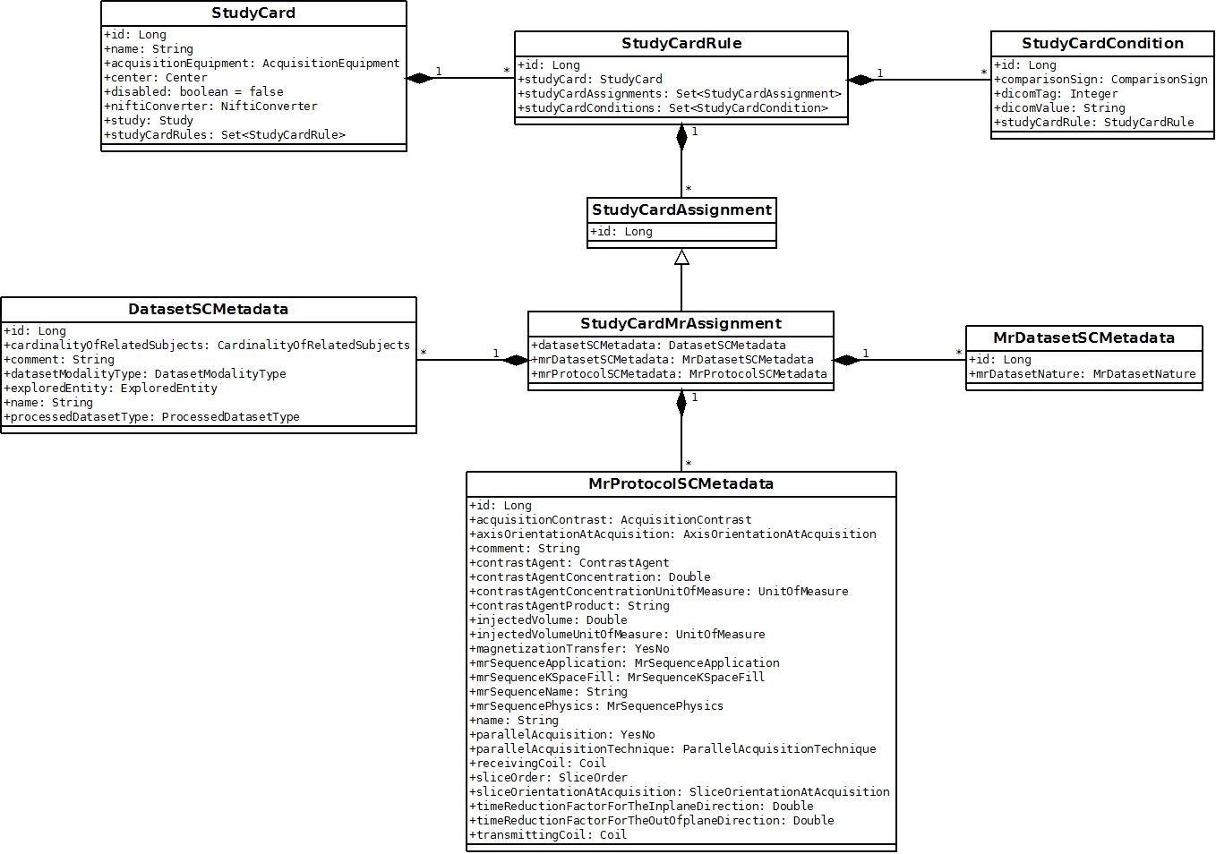

#### MS dataset

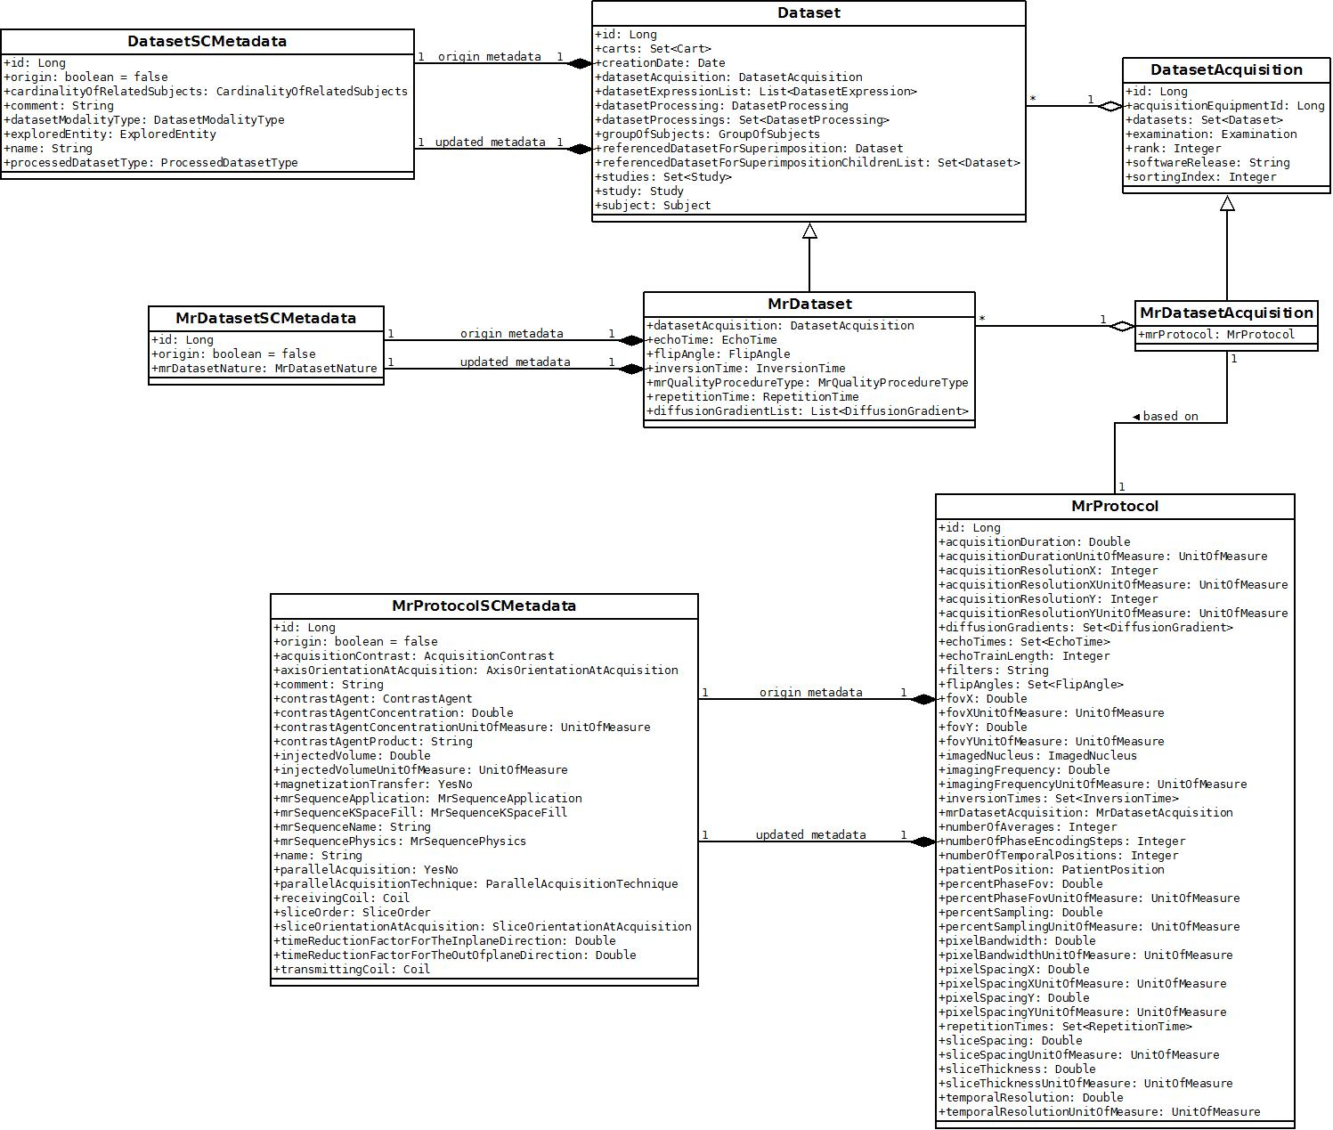

## Interfaces

### Communication with other microservices

Study card management microservice uses web services and message queues.

#### MS Studies

MS StudyCard sends messages to MS Study to:

* Get list of studies, centers, acquisition equipments, NIfTI converters for current user

#### MS Dataset

MS StudyCard sends messages to MS Dataset to:

* Apply study card during import process

### Communication with Shanoir

Every time a request is sent from Shanoir, it arrives via MQ to Shanoir-NG.

## Migration

Migrated metadata don’t have tag “origin”.

# Appendix

## Assigning metadata

Configurable metadata depend on acquisition equipment modality. In current version, one modality (MR) exists alone.

### MR modality

Configurable metadata for MR modality are divided in three groups:

* Protocol-dependent fields
* Protocol or Dataset-dependent fields
* Dataset-dependent fields

#### Protocol-dependent fields

* Dataset modality type
  + Drop-down list with these values:
    - CT dataset
    - EEG dataset
    - MEG dataset
    - MR dataset
    - PET dataset
    - SPECT dataset
* Cardinality of related subjects
  + Drop-down list with these values:
    - Multiple-subjects dataset
    - Single-subject dataset
* Protocol name
  + Input
* Protocol comment
  + Input

#### Protocol or Dataset-dependent fields

* Transmitting coil
  + Drop-down list of coils (see point 2.6 of *Shanoir-NG_Study.docx*)
* Receiving coil
  + Drop-down list of coils (see point 2.6 of *Shanoir-NG_Study.docx*). Coils could belong to:
    - Study card center
    - Other center
* Explored entity
  + Drop-down list with these values:
    - Anatomical dataset
    - Functional dataset
    - Hemodynamic dataset
    - Metabolic dataset

#### Dataset-dependent fields

* Acquisition contrast
  + Drop-down list with these values:
    - Spin density
    - T1
    - T2
    - T2START
* MR sequence application
  + Drop-down list with these values:
    - Angiography
    - BOLD
    - Calibration
    - Contrast agent angio
    - Diffusion
    - H1 chemical shift imaging spectroscopy
    - H1 single voxel spectroscopy
    - Morphometry
    - Perfusion
    - Spectroscopy
    - Time of flight angio
    - Velocity encoded angio
    - Non contrast agent angio
* MR dataset nature
  + Drop-down list with these values:
    - Contrast agent used angio MR dataset
    - Diffusion weighted MR dataset
    - Field map dataset long echo Time
    - Field map dataset short echo Time
    - H1 single voxel spectroscopy dataset
    - H1 spectroscopic imaging dataset
    - Proton density weighted MR dataset
    - Spin tagging perfusion MR dataset
    - T1 weighted DCE MR dataset
    - T1 weighted MR dataset
    - T2 star weighted DCE MR dataset
    - T2 star weighted MR dataset
    - T2 weighted DCE MR dataset
    - T2 weighted MR dataset
    - Time of flight MR dataset
    - Velocity encoded angio MR dataset
* MR sequence physics
  + Drop-down list with these values:
    - Hybrid gradient-echo and spin-echo sequence
    - Inversion recovery segmented spin-echo sequence
    - Inversion recovery single shot spin-echo sequence
    - Inversion recovery single-echo spin-echo sequence
    - Magnetization prepared GRE
    - Magnetization prepared segmented GRE EPI
    - Magnetization prepared single-shot GRE EPI
    - Magnetization prepared spoiled GRE
    - Multi-echo gradient-echo sequence
    - Multi-echo spin-echo sequence
    - Refocused GRE
    - Segmented GRE EPI
    - Segmented spin-echo sequence
    - Single shot spin-echo sequence
    - Single-echo gradient-echo sequence
    - Single-echo spin-echo sequence
    - Single-shot GRE EPI
    - Spin echo-echo planar imaging
    - Spoiled GRE
    - Standard segmented GRE EPI
    - Standard segmented spin-echo sequence
    - Standard single shot spin-echo sequence
    - Standard single-echo spin-echo sequence
    - Standard single-shot GRE EPI
    - Steady state FID-SE
    - Steady state GRE FID
    - Steady state GRE SE
* MR Sequence k-space fill
  + Drop-down list with these values:
    - Conventional Cartesian sequence
    - Non-conventional Cartesian sequence
    - Non-conventional non-Cartesian sequence
    - Non-conventional sequence
* Processed dataset type
  + Drop-down list with these values:
    - Non reconstructed dataset
    - Reconstructed dataset
* New name for the dataset
  + Input
* Dataset comment
  + Input
* MR sequence name
  + Input
* Contrast agent
  + Drop-down list with these values:
    - Gadolinium
    - USPIO
* Contrast agent (manufactured name)
  + If contrast agent selected
  + Input
* Contrast agent concentration
  + If contrast agent selected
  + Input
  + Drop-down list with these values:
    - mg/ml
* Injected volume
  + If contrast agent selected
  + Input
  + Drop-down list with these values:
    - ml
* Magnetization transfer
  + Drop-down list with these values:
    - No
    - Yes
* Parallel acquisition
  + Drop-down list with these values:
    - No
    - Yes
* Parallel acquisition technique
  + If parallel acquisition value is ‘Yes’
  + Drop-down list with these values:
    - GRAPPA
    - mSENSE
    - PILS
    - SENSE
    - SMASH
* Time reduction factor for the in-plane direction
  + If parallel acquisition value is ‘Yes’
  + Input
* Time reduction factor for the out-of-plane direction
  + If parallel acquisition value is ‘Yes’
  + Input
* Slice orientation at acquisition
  + Drop-down list with these values:
    - Coronal
    - Oblique
    - Sagittal
    - Transverse
* Axis orientation at acquisition
  + Drop-down list with these values:
    - AC PC line
    - Bi-callosal line
    - Central sulcus line
    - Lateral sulcus line
* Slice order
  + Drop-down list with these values:
    - Center in
    - Center out
    - Interlaced even acquired first
    - Interlaced odd acquired first
    - Non-interlaced

## Shanoir old code

### Study card apply

1) MrDatasetAcquisition creation

MrDatasetAcquisitionHome. createMrDatasetAcquisitionCommon()

1. Metadata extraction
   1. MrDatasetAcquisitionHome. createMrDatasetAcquisitionCommon()
      1. final IMetadataExtractor metadataExtractor = dicomImporter.getMetadataExtractor();
      2. final MrDatasetAcquisition mrDatasetAcquisition = metadataExtractor.extractMetadata(index);
         1. new MrDatasetAcquisition()
         2. setRank
         3. setSortingIndex
         4. setSoftwareRelease
         5. extractMetadataForMrProtocol(serieNumber, mrDatasetAcquisition, dcmObj);
         6. extractMetadataCompletingMrProtocol(serieNumber, mrDatasetAcquisition, dcmObj, privateDictionaryKey);
2. Fields set by the studyCard
   1. mrDatasetAcquisition - setFieldsByStudyCard(mrDatasetAcquisition, studyCard, tagMap)
   2. mrProtocol - setFieldsByStudyCard(mrDatasetAcquisition.getMrProtocol(), studyCard, tagMap);
3. Fields set by DICOM
   1. Software release
4. MR acquisition Equipment : set the equipment set in the studycard
5. Check that the acquisition equipment for which is designed the study card is compatible with the metadata