Random Taco Cookbook

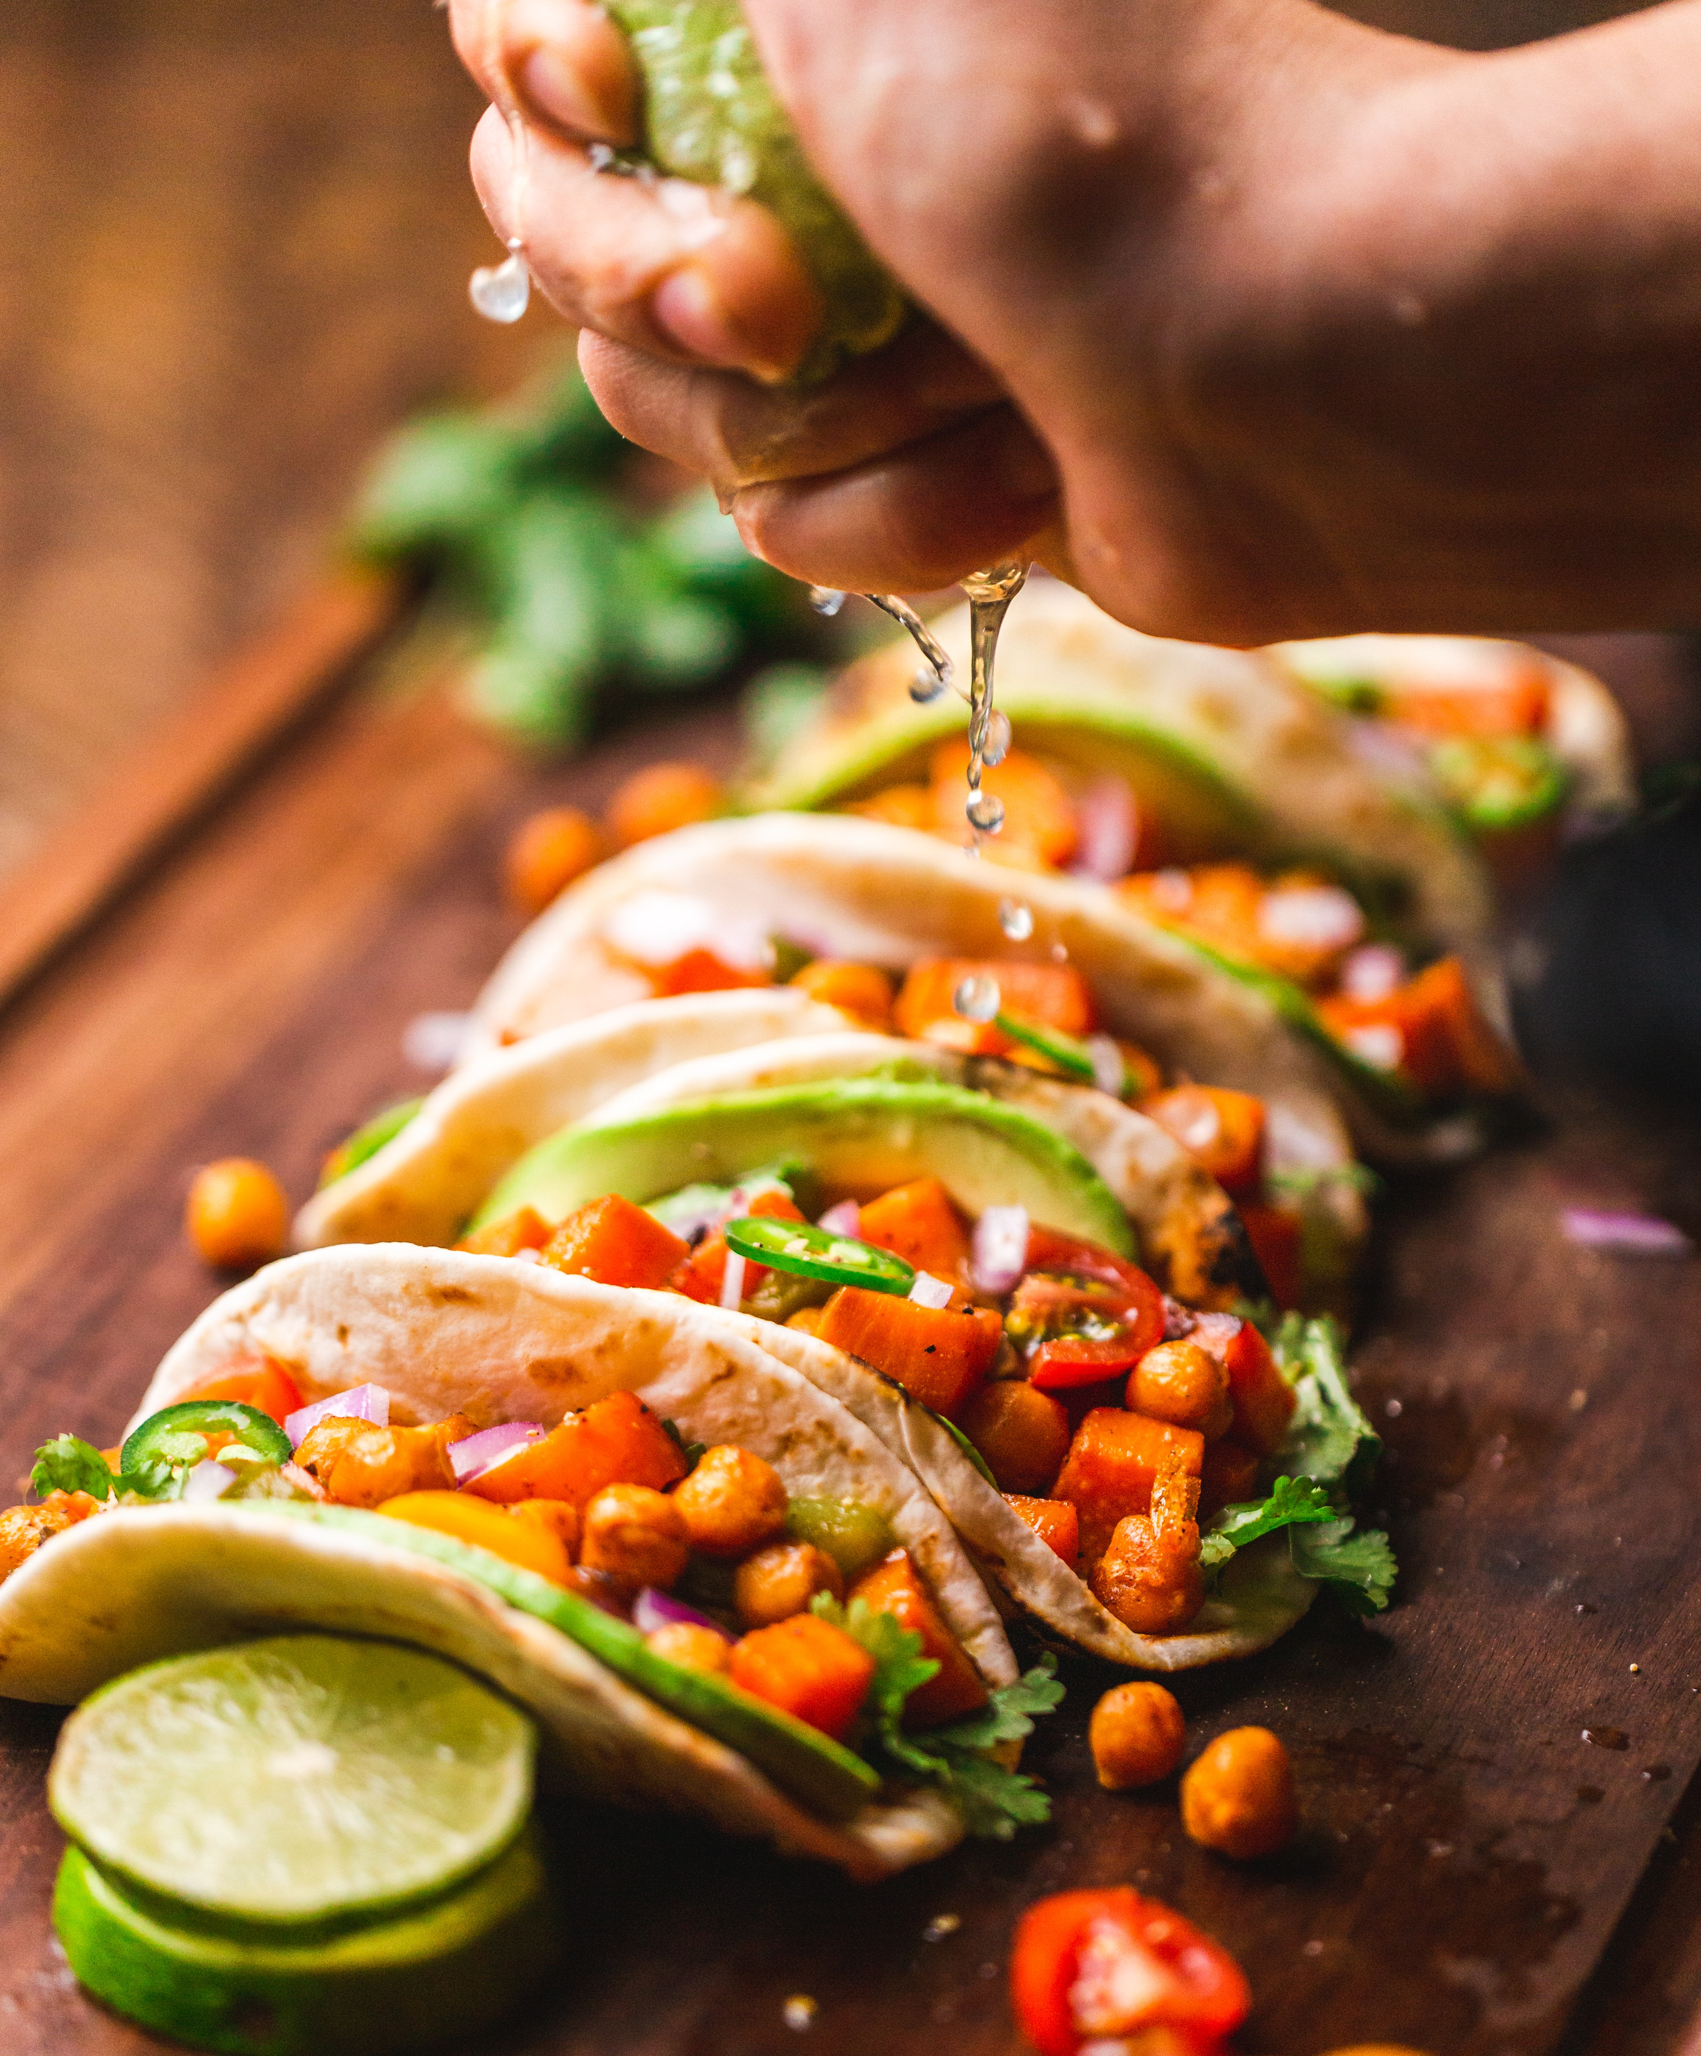

# Credits

* Taco image:
* Tacos from:
* Code by:

Packaged Seasonings, Roasted Tomatillo and Mushroom Sauce, Cheese (Traditional; US), Baja Beer Battered Fish, Fresh Corn Tortillas

# Packaged Seasonings

Packaged Seasonings  
==============  
  
Lest we be accused of snobbery, let's acknowledge that a taco is a taco, and taco night can be well-served by not having to think at all.  
  
Feel free to use the pre-packaged seasoning of your choice. When I'm in an old-school mood, I head straight for...  
  
* Old El Paso Taco Seasoning

# Roasted Tomatillo and Mushroom Sauce

Roasted Tomatillo and Mushroom Sauce  
====================================  
  
* 2 pounds tomatillos  
* 4 dried chipotle chiles  
* 2 pounds shiitake mushrooms  
* 1/4 cup olive oil  
* 1 cup water  
  
1. Remove husks from tomatillos and rinse them. Place them whole on your oven's broiler rack. Broil and turn them until they're browned on all sides.  
2. Boil the water. Drop in the dried chiles and bring the water down to a simmer. Keep them in until they are soft.   
3. Slice the shiitakes and cook them in a pan with the olive oil until they're tender.  
4. Take the chiles and tomatillos (once they're cooled off) and blend them in a food processor until they make a nice puree.  
5. Put the blended tomatillo-chile mixture in a saucepan and bring it to a boil. Add the cooked mushrooms and bring it back to a boil. Then bring the heat down until the mixture is simmering. Cook for about 10 minutes. Add salt to taste.  
  
---  
A friend gave me this recipe a while back, but I can't remember who it was. Sorry, friend.

# Cheese (Traditional; US)

Cheese (Traditional; US)  
======================  
  
A major flavor component of a traditional American taco, select a cheese that's firm and sharp.  
  
* Cheddar (shredded)  
* Jack/Pepper Jack (shredded)

# Baja Beer Battered Fish

Baja Beer Battered Fish  
========================  
  
This is the beer battered fish for [Baja fish tacos](../full_tacos/baja_fish_tacos.md).  
  
Batter  
-------  
  
* 1/2 c flour  
* 1/4 c baking powder  
* 1 egg  
* 1/2 c beer (Tecate!)  
* 1 tsp salt  
* 1 tsp chili powder (paprika, salt, garlic salt)  
* 2 tsp parsley  
  
Beat the eggs and fold all batter ingredients until smooth.  
Add flour to make it thicker or add beer to make it thinner.  
If you have time let the batter chill for a couple hours.  
  
Fish  
------  
  
* 1 lb. cod fillet, grouper, or similar white fish, the fresher the better  
  
* Cut fish into small chunks.  
* Fill a pan with oil and heat until approx. 375 F.  
* Fill a bowl with about a cup of flour and keep it next to the batter bowl.  
* Dip a fish piece into flour then into the batter.  
* Fry for 4-5 minutes, turning halfway through. Drain on a paper towel.

# Fresh Corn Tortillas

Fresh Corn Tortillas  
===================  
  
This is the only way to go. So worth it. Makes roughly 15 tortillas.  
  
* 1 3/4 cups masa harina  
* 1 1/8 cups water  
  
1. In a medium bowl, mix together masa harina and hot water until thoroughly combined. Turn dough onto a clean surface and knead until pliable and smooth. If dough is too sticky, add more masa harina; if it begins to dry out, sprinkle with water. Cover dough tightly with plastic wrap and allow to stand for 30 minutes.  
2. Preheat a cast iron skillet or griddle to medium-high.  
3. Divide dough into 15 equal-size balls. Using a tortilla press, a rolling pin, press each ball of dough flat between two sheets of wax paper.  
4. Place tortilla in preheated pan and allow to cook for approximately 30 seconds, or until browned and slightly puffy. Turn tortilla over to brown on second side for approximately 30 seconds more, then transfer to a plate. Repeat process with each ball of dough. Keep tortillas covered with a towel to stay warm and moist (or a low temp oven) until ready to serve.

Universal Taco Seasoning, Simple Salsa Verde, Green Chile Cabbage Salad, Better Than Powder Groundbeef, Hard Corn Shells (Traditional; US)

# Universal Taco Seasoning

Universal Taco Seasoning  
========================  
  
I got tired of buying packets of store-bought taco seasoning, so I experimented with various spices and ratios until I landed on this recipe. I keep a jar of it in the cupboard at all times.  
  
* 6 tbsp chili powder  
* 4 tbsp cumin  
* 4 tbsp corn starch  
* 3 tbsp onion powder  
* 1 tbsp salt  
* 1 tbsp garlic powder  
* 4 tsp oregano (Mexican oregano, if you've got it)  
* 2 tsp crushed red pepper  
  
Combine in Mason jar and shake well to combine.  
  
This mix works well for chicken, pork and beef, destined for the grill, oven, slow cooker or stovetop. You could tweak it a bit to target a specific meat, but I like to have a base, universal mix around. Makes it super easy to turn leftover anything into delicious taco filling: Just chop up whatever it is, toss it into a skillet, sprinkle generously with seasoning, then add a bit of water and simmer to impart flavor.

# Simple Salsa Verde

Simple Salsa Verde  
==================  
  
I got this base recipe from a vegan friend. If you can't find one of these peppers, swap in another one!  
  
* 6 Average-sized tomatillos  
* 1 Poblano pepper  
* 1 Serrano pepper  
* 1 Jalapeno pepper  
* 1 Sweet red pepper  
* Juice of 1 or 2 fresh-squeezed limes (to taste)  
* Pinch or two kosher salt (to taste)  
  
You're in charge of the heat here. For a milder salsa, remove all the ribs and seeds inside the peppers. For medium, leave in a few ribs, and for hot, go nuts. Rough chop the peppers and tomatillos, then throw into a blender or food processor with salt and lime juice. Pulse to desired consistency.  
  
As with most salsas, this will taste better if you let it sit in the fridge for a few hours before eating. It's great on chips or drizzled over steak or pork tacos.

# Green Chile Cabbage Salad

### Green Chile Cabbage Salad with Seared Corn  
This isn't a tradition, or even particularly traditional -- except in my apartment in Oakland, where I make this for myself ever time I make pork tacos.  
  
#### Ingredients  
* 1 green cabbage  
* 4 limes  
* 2 ears corn, or roughly two cups of corn kernels (adjust to desired corn-y-ness)  
* Dried, Powdered New Mexico Green Chile, to taste  
* Salt, to taste  
* Olive oil  
* Optional: some crumbled cotija or queso Oaxaqueno  
  
#### Directions  
1. If using ears of corn, strip the kernels from them with a sharp knife.  
2. Heat a few tablespoons of oil over high heat. I like to use a Dutch Oven for this, but the main cookware properties you want are heavy-bottomed and wide.  
3. Toss the corn kernels in to the oil, spread them evenly, salt very lightly and let them ride. I _highly_ recommend a splatter guard for this step, but **not** a lid. You want the corn to dry out just a little and get a good sear. It's done when it's starting to get dark, a little chewy, and probably is sticking to the pan.  
4. While the corn is going, core and chop the cabbage in to wide strips.  
5. How's the corn doing?  
6. Juice the limes.  
7. How's the corn doing? If it's not done yet, grab a beer and hang out 'til it is.  
8. The corn is done? Great. Toss it on top of the cabbage. Add a little salt, then a good hit of olive oil, then half-or-so of the lime juice. Toss in a good tablespoon or two of the green chile powder. Start stirring.  
9. You want everything coated nicely, but I don't like the salad too oily, so go easy on that. I add lime until the sour balances the sweet of the corn. I add green chile slowly -- it takes a second to rehydrate and get hot. I might add as much as a half cup of the stuff to a salad for myself or spicy food fans like me; I go easier on the spice-unenthused.  
10. Serve it! If you're in to tossing a little cheese on there, do it -- but I usually just eat it straight. Sometimes this goes on fish or chicken tacos; sometimes it's a side to richer pork tacos. It's always awesome.  
  
**Note on ingredients**: green chile is the gastronomical life blood of New Mexican cuisine, but it's little known in the other 49 states. I like a brand called [_Los Chileros de Nuevo Mexico_](http://www.loschileros.com/), which I can find sometimes in tiendas and other times at Whole Foods (go figure). The trick here is this: just don't accept substitutes. It's not the same. I've also had to accept that fresh chile is just not what this salad needs, so don't do that either (it doesn't distribute well enough across the cabbage). Do have this with cold, crisp beer.

# Better Than Powder Groundbeef

Did you grow up on Old El Paso ground beef taco seasonings?  
  
I'm sorry. So did I. They're terrible, right? Here's something better:  
  
Dice a half-onion, sautee and season liberally with salt, pepper, and ground cumin.  
  
Brown a pound of ground beef, seasoning liberally with ground cumin, salt, pepper. Add tabasco/other hot sauce if you like.  
  
When beef is browned, add a small jar of salsa (any kind! i like corn/black bean tomato salsa), and simmer for 5-10 minutes.  
  
Enjoy. Serve with crispy taco shells for nostalgia.

# Hard Corn Shells (Traditional; US)

Hard Corn Shells (Traditional; US)  
======================  
  
Mistakenly thought by many to be traditionally Mexican, hard shells were actually popularized in the US in the mid-20th century.  
  
While they can certainly be made at home (if you have access to a deep-fryer), the best method of obtaining hard taco shells is to head to the grocery store.

Quick and Dirty Spice Mix, Garlic Lime Sauce, Traditional Taco Mixins, Insane Garlic Ground Turkey, Fresh Corn Tortillas

# Quick and Dirty Spice Mix

Quick and Dirty Spice Mix  
=========================  
  
I’m not going to make a lot of big assumptions here. You own a skillet of some sort. You have some jars of jankity-ass spices from who-knows-when. You want to eat some tacos within the next, like, fifteen minutes. I got you covered, bachelor(ette).  
  
* 2 Tbsp all-purpose flour  
* 2 1/2 tsp. chili powder  
* 3/4 tsp. onion powder (or 1 1/2 tsp. minced yellow onion)  
* 1 1/4 tsp. salt  
* 1 tsp. paprika  
* 3/4 tsp beef bouillon powder  
* 1/4 tsp. granulated sugar  
* 1/4 tsp. cayenne pepper  
* 1/4 tsp. garlic powder  
* 1 tsp. cumin  
  
Put all this in something with a lid, add 3/4 cup of water, and shake it. Brown a pound of ground beef, then pour the whole situation in there. Stir. Cook it down until it looks like you only put in half a cup of water. You have tacos now.  
  
Vegetarians  
-----------  
  
I’ve made this with that soy protein “ground beef” and it does not _surprisingly_ taste like someone put spices on a stack of cheap bar coasters and ran it all through a blender. (Vegetable) oil the skillet when you’re dealing with that stuff, unless you’re looking for excuses to buy a new one.  
  
If you leave out the bouillon for the sake of doing things vegan-style you’ll probably want to nudge up the salt a little.

# Garlic Lime Sauce

Garlic Lime Sauce  
=====================  
  
This sauce packs a creamy, sour, garlicky punch and can cut the heat on a spicy salsa. It pairs well with Mango Lime Salsa for excellent fish tacos. This is a simplified version of the [lime sauce recipe](http://www.loveandoliveoil.com/2008/04/fish-tacos-with-mango-salsa.html) on Love and Oil.  
  
Combine in a bowl:  
* 1-2 tablespoons mayonnaise  
* 1/2 cup plain yogurt  
* 2 tablespoons fresh lime juice  
* 1-2 cloves minced garlic  
* salt to taste  
* (optional): chopped fresh cilantro garnish  
  
Whisk ingredients together in bowl.   
  
Serve on the side, or drizzle as a decorative layer onto prepared tacos. Optionally sprinkle with chopped cilantro as garnish.

# Traditional Taco Mixins

Traditional Taco Mixins  
(makes about 20 servings)  
  
- 1 (16 ounce) container sour cream  
- 1/4 head iceberg lettuce (rinsed, dried, shredded)  
- 1 cup shredded cheddar cheese  
- 3 diced tomatoes  
- 1 (2.25 ounce) can black olives, drained  
  
Add ingredients to tacos in layers.

# Insane Garlic Ground Turkey

Insane Garlic Ground Turkey  
=========================  
  
While not particularly fancy, the insane garlic ground turkey is a crowd pleaser.  
  
Ground Turkey  
-----------  
  
* 2 pounds of ground turkey (preferably thigh meat)  
* Four yellow onions  
* Store-bought Taco Seasoning  
* More garlic than you can imagine (4-5 cloves)  
* Olive Oil  
  
1. Chop several onions into slices.  
2. In a large pan heat olive oil in a saucepan over high heat  
3. Cook onions on high heat until they are almost caramelized. (10 minutes)  
4. Reduce heat to medium.  
5. Add ground turkey making sure to stir meat to ensure adequate turkey / onion mixture.  
6. Cover and let turkey cook for 8 minutes.  
7. Mix taco seasoning using one cup of water for each packet of seasoning  
8. Add several cloves or garlic to pan. When in doubt with garlic always err on the side of too much.  
9. Cook uncovered until taco seasoning is reduced.  
10. Warn guests of impending garlic.  
  
Total cooking time: 30-40 minutes

# Fresh Corn Tortillas

Fresh Corn Tortillas  
===================  
  
This is the only way to go. So worth it. Makes roughly 15 tortillas.  
  
* 1 3/4 cups masa harina  
* 1 1/8 cups water  
  
1. In a medium bowl, mix together masa harina and hot water until thoroughly combined. Turn dough onto a clean surface and knead until pliable and smooth. If dough is too sticky, add more masa harina; if it begins to dry out, sprinkle with water. Cover dough tightly with plastic wrap and allow to stand for 30 minutes.  
2. Preheat a cast iron skillet or griddle to medium-high.  
3. Divide dough into 15 equal-size balls. Using a tortilla press, a rolling pin, press each ball of dough flat between two sheets of wax paper.  
4. Place tortilla in preheated pan and allow to cook for approximately 30 seconds, or until browned and slightly puffy. Turn tortilla over to brown on second side for approximately 30 seconds more, then transfer to a plate. Repeat process with each ball of dough. Keep tortillas covered with a towel to stay warm and moist (or a low temp oven) until ready to serve.

Mahi Mahi Rub, Black Olives, Lettuce (Traditional; US), Asian Style Tofu or Pork Marinade, Hard Corn Shells (Traditional; US)

# Mahi Mahi Rub

Mahi Mahi Rub  
==============  
  
A rub for Mahi Mahi, if fish tacos be what you're fancying:  
  
* 1 Part spicy chili powder  
* 1 Part salt  
* 1 Part ground cumin  
* 1/2 Part chopped cilantro  
* 1/2 Part cayenne  
* 1/2 Part pepper  
* 1/2 Part oregano  
* 1/2 Part onion powder  
* 1/2 Part garlic powder  
  
You choose your measurements and enjoy!

# Black Olives

Black Olives  
==========  
  
Canned black olives add a sweet and cool meatiness to a traditional American taco.

# Lettuce (Traditional; US)

Lettuce (Traditional; US)  
======================  
  
In a traditional American taco, lettuce serves to add extra crunch and coolness. Favor the bulkier lettuces over leafier fare such as Bibb lettuces or mesclun.  
  
* Iceberg Lettuce (shredded)  
* Romaine Lettuce (shredded; maintain the stalks)

# Asian Style Tofu or Pork Marinade

Asian Style Tofu or Pork Marinade  
=================================  
  
For marinade mix:  
  
* quarter cup lime juice  
* quarter cup soy sauce  
* quarter cup toasted sesame oil  
* two cloves of garlic, chopped  
* 3 teaspoons cumin  
* 1 teaspoon paprika  
* Some chopped cilantro  
  
Mix with sliced tofu or pork, marinate for 30 minutes and quickly sauté.

# Hard Corn Shells (Traditional; US)

Hard Corn Shells (Traditional; US)  
======================  
  
Mistakenly thought by many to be traditionally Mexican, hard shells were actually popularized in the US in the mid-20th century.  
  
While they can certainly be made at home (if you have access to a deep-fryer), the best method of obtaining hard taco shells is to head to the grocery store.

Quick and Dirty Spice Mix, Roasted Tomatillo and Mushroom Sauce, Drunken Green Beans, Moroccan Lamb, Fresh Corn Tortillas

# Quick and Dirty Spice Mix

Quick and Dirty Spice Mix  
=========================  
  
I’m not going to make a lot of big assumptions here. You own a skillet of some sort. You have some jars of jankity-ass spices from who-knows-when. You want to eat some tacos within the next, like, fifteen minutes. I got you covered, bachelor(ette).  
  
* 2 Tbsp all-purpose flour  
* 2 1/2 tsp. chili powder  
* 3/4 tsp. onion powder (or 1 1/2 tsp. minced yellow onion)  
* 1 1/4 tsp. salt  
* 1 tsp. paprika  
* 3/4 tsp beef bouillon powder  
* 1/4 tsp. granulated sugar  
* 1/4 tsp. cayenne pepper  
* 1/4 tsp. garlic powder  
* 1 tsp. cumin  
  
Put all this in something with a lid, add 3/4 cup of water, and shake it. Brown a pound of ground beef, then pour the whole situation in there. Stir. Cook it down until it looks like you only put in half a cup of water. You have tacos now.  
  
Vegetarians  
-----------  
  
I’ve made this with that soy protein “ground beef” and it does not _surprisingly_ taste like someone put spices on a stack of cheap bar coasters and ran it all through a blender. (Vegetable) oil the skillet when you’re dealing with that stuff, unless you’re looking for excuses to buy a new one.  
  
If you leave out the bouillon for the sake of doing things vegan-style you’ll probably want to nudge up the salt a little.

# Roasted Tomatillo and Mushroom Sauce

Roasted Tomatillo and Mushroom Sauce  
====================================  
  
* 2 pounds tomatillos  
* 4 dried chipotle chiles  
* 2 pounds shiitake mushrooms  
* 1/4 cup olive oil  
* 1 cup water  
  
1. Remove husks from tomatillos and rinse them. Place them whole on your oven's broiler rack. Broil and turn them until they're browned on all sides.  
2. Boil the water. Drop in the dried chiles and bring the water down to a simmer. Keep them in until they are soft.   
3. Slice the shiitakes and cook them in a pan with the olive oil until they're tender.  
4. Take the chiles and tomatillos (once they're cooled off) and blend them in a food processor until they make a nice puree.  
5. Put the blended tomatillo-chile mixture in a saucepan and bring it to a boil. Add the cooked mushrooms and bring it back to a boil. Then bring the heat down until the mixture is simmering. Cook for about 10 minutes. Add salt to taste.  
  
---  
A friend gave me this recipe a while back, but I can't remember who it was. Sorry, friend.

# Drunken Green Beans

Drunken Green Beans  
===================  
  
Green beans are fine. Green beans cooked in beer are better. Maybe even the best.  
  
* 1 Surly fist full of green beans  
* half a beer  
* quarter cup vegetable broth  
* 2 cloves garlic  
* 1 Tbsp olive oil  
* some salt, whatever  
  
First peel and dice the garlic and sauté it in the olive oil. Before it gets all burned and ruined, add the beer and vegetable broth.   
   
As the liquid comes to a boil, cut the green beans up. Add the green beans and a pinch of salt and let them simmer for about five minutes. If you like your beans on the softer side you can let it go a little longer. But the trick is to pull them right after the color starts to turn and you've just made a delicious addition to any taco.

# Moroccan Lamb

Moroccan Lamb  
=============  
  
A Differently Spiced Meat Than Your Usual Taco  
----------------------------------------------  
  
* 500 g ground lamb  
* 20 g Ras al Hanout spice. My mix contains:  
 * Paprika  
 * Cinnamon  
 * Allspice  
 * Clove  
 * Toasted Mustard  
 * Cumin  
 * Caraway  
 * Black Pepper  
* 10 g fresh lemon zest or 10 g finely ground Black Lemon Omani (Moroccoan dried preserved lemon)  
  
Mix together and brown.

# Fresh Corn Tortillas

Fresh Corn Tortillas  
===================  
  
This is the only way to go. So worth it. Makes roughly 15 tortillas.  
  
* 1 3/4 cups masa harina  
* 1 1/8 cups water  
  
1. In a medium bowl, mix together masa harina and hot water until thoroughly combined. Turn dough onto a clean surface and knead until pliable and smooth. If dough is too sticky, add more masa harina; if it begins to dry out, sprinkle with water. Cover dough tightly with plastic wrap and allow to stand for 30 minutes.  
2. Preheat a cast iron skillet or griddle to medium-high.  
3. Divide dough into 15 equal-size balls. Using a tortilla press, a rolling pin, press each ball of dough flat between two sheets of wax paper.  
4. Place tortilla in preheated pan and allow to cook for approximately 30 seconds, or until browned and slightly puffy. Turn tortilla over to brown on second side for approximately 30 seconds more, then transfer to a plate. Repeat process with each ball of dough. Keep tortillas covered with a towel to stay warm and moist (or a low temp oven) until ready to serve.