A Local RAG Study Assistant Chatbot Using Open-Source Tools
TM470 End-of-Module Assessment (EMA)
Khalin Kierznowski
Personal Identifier: L2049806

CONTENTS
1. Project Description and Scope
2. Account of Related Literature
3. Resources and Planning
4. Project Work
5. Legal, Social, Ethical and Professional Issues and EDI
6. Personal Development, Review and Reflection
References
Bibliography
Appendix 1, Project Ethics Checklist
Appendix 2, Project Log Extracts

1. PROJECT DESCRIPTION AND SCOPE

1.1 Title
A Local RAG Study Assistant Chatbot Using Open-Source Tools
The title is unchanged from TMA02 and TMA03. The core aim, a fully offline question-answering tool for personal study documents, has remained stable throughout development. No change is warranted at the EMA stage.

1.2 Plain Language Summary
This project builds a question-answering tool that runs entirely on a personal computer with no internet connection required. A user uploads their own study documents, such as PDF lecture notes or textbook chapters, and types plain-English questions about them. The system finds the most relevant passages and uses a locally running AI language model to compose a direct answer, with a citation showing exactly where the information came from.
The underlying technique is called Retrieval-Augmented Generation, or RAG. RAG grounds a language model's output in a specific set of documents rather than letting it rely on patterns learned during training. Lewis et al. (2020), who formally introduced the framework, demonstrated that this substantially reduces hallucination, the tendency of language models to generate confident but factually incorrect responses. The finished system implements RAG using Python, the LangChain orchestration framework, the FAISS vector database, and Ollama for local AI inference, with a Gradio web interface and a TruLens evaluation harness.

1.3 What is the problem that needs to be solved or understood?
Students accumulate large numbers of study documents and struggle to locate specific information efficiently. Standard keyword search fails when the phrasing of a question differs from the wording in the source. Existing free tools that support natural-language question-answering across local documents without sending data to an external server remain scarce.

1.4 Why is it considered a problem?
The volume of digital material in higher education has grown considerably. When searching through notes takes significant time and effort, studying becomes less efficient. Cloud-based tools offering similar functionality require documents to be uploaded to third-party servers, which creates a genuine privacy concern for personal notes and sensitive study materials.

1.5 What will be the benefits of solving it?
The direct benefit is a working application that answers plain-English questions from personal documents, with full source attribution, running entirely offline. The secondary benefit is a proof of concept that this capability can be built from free, open-source components, which has implications for institutions and individuals who cannot or will not use cloud AI services.

1.6 What are the key ICT aspects of this problem?
The project spans four technical areas. The first is RAG itself, grounded in Lewis et al. (2020). The second is vector embeddings and similarity search: documents are converted into numerical representations of their meaning and stored in a FAISS index, a vector database library, so that semantically similar passages can be retrieved efficiently (Johnson, Douze and Jegou, 2021). The third is local large language model inference using Ollama, a server that runs open-source AI models on a personal machine without requiring an internet connection or subscription (Ollama, 2024). The fourth is document processing: loading, splitting, embedding and indexing documents before any retrieval can take place.

1.7 What is your existing knowledge of this problem?
At the start of the project there was no practical experience with transformer-based language models, vector databases or the LangChain framework. Python was known at an intermediate level. The project required substantial independent learning in all three new areas, which is discussed further in Section 6.

1.8 What does the finished solution look like?
The completed application is a Python program with a Gradio web interface. Users upload PDF, plain text or Word documents, or load a bundled sample corpus covering the history and philosophy of world religions, included so the application can be tried immediately without sourcing external material. The system splits documents into chunks, generates embeddings using a locally hosted model, and stores the results in a FAISS index that merges newly added documents into any existing index rather than replacing it. Individual documents can be removed from the index without discarding the rest, and a session can be saved and resumed later without re-embedding anything. When a question is asked, the system retrieves the most relevant chunks, constructs a prompt, and passes it to a locally running Llama 3 model via Ollama, streaming the answer back as it is generated. The answer is returned with a source citation and an inspectable panel of the retrieved passages, and a conversation history is maintained so that follow-up questions can refer to earlier turns. Section 4 describes the implementation in full.

1.9 Will the solution be within the specialism route of my degree?
Yes. The project sits within the AI and Data Science route, covering natural language processing, information retrieval and software engineering.

1.10 What, specifically, has been delivered by way of a project output?
The project delivers a working RAG application with a Gradio web interface, a structured evaluation using the TruLens framework across three chunk size configurations run against the shipped sample corpus, and this report documenting the process from initial proposal through to completion.

1.11 Expected Impact
For individual students, the tool provides a free, private alternative to cloud-based AI document search. More broadly, it demonstrates that a functional RAG system can be built entirely from open-source components on modest consumer hardware, which is relevant to anyone designing low-cost or privacy-sensitive AI applications in education or other domains where sending documents to external servers is undesirable.

2. ACCOUNT OF RELATED LITERATURE
The literature relevant to this project falls into four broad areas: the foundations of large language models, the RAG framework this project implements, the retrieval and indexing components, and the evaluation methods used to assess the finished system. Sources have been assessed using the PROMPT criteria throughout.

2.1 Large Language Models
Before explaining RAG it is necessary to explain what a large language model is and where it falls short, because RAG only makes sense in that context.
A large language model is a deep learning model trained on large amounts of text to predict the next word in a sequence. The architecture underlying most current LLMs is the transformer, introduced by Vaswani et al. (2017) in 'Attention is All You Need', published in Advances in Neural Information Processing Systems, a well-regarded peer-reviewed venue. The transformer's self-attention mechanism allows the model to weigh the relevance of different parts of an input when generating a prediction, making it practical to train at a scale earlier architectures could not support. The fundamental limitation shared by all models in this family is that their knowledge is frozen at training time. When asked a factual question, the model generates what is statistically most likely given its training, not what is actually correct. This is the root cause of hallucination, where a language model produces confident, fluent text that is factually wrong. It is a structural property of how these models work, not a fixable bug in any one model. RAG exists specifically to address it.
Touvron et al. (2023) describe the Llama 2 model family in a widely cited arXiv preprint from Meta AI Research. While this project uses Llama 3, the paper informs understanding of the design philosophy behind open-weight models and the safety considerations that make them appropriate for educational use.

2.2 Retrieval-Augmented Generation
Lewis et al. (2020), 'Retrieval-Augmented Generation for Knowledge-Intensive NLP Tasks', is the central reference for this project. Published at NeurIPS 2020, a highly selective peer-reviewed venue, it has strong provenance. The paper introduced RAG as a general framework and showed that conditioning a language model on retrieved documents significantly improves factual accuracy on knowledge-intensive tasks. Before the LLM generates a response, a retriever fetches relevant passages from an external document set and includes them in the prompt. The model then generates a response grounded in those passages rather than its internal parameters. The main limitation noted is the large-scale infrastructure assumed, well beyond this project, but the core framework transfers directly.
Gao et al. (2023), 'Retrieval-Augmented Generation for Large Language Models: A Survey', available on arXiv, provides a taxonomy distinguishing naive RAG from advanced and modular variants. This project implements naive RAG, which the survey identifies as appropriate for limited-scope document collections. Gao et al. identify failure modes that have been directly relevant here: retrieval degrades when chunk boundaries split semantically complete units; overly large chunks introduce irrelevant content that distracts the model; and the model is sensitive to how the system prompt frames the task. All three shaped the chunk size and prompt design decisions described in Section 4. As an arXiv preprint it has not been formally peer-reviewed, but it is widely cited and its taxonomy aligns with practical experience gained during this project.

2.3 Retrieval and Indexing
Johnson, Douze and Jegou (2021), 'Billion-Scale Similarity Search with GPUs', published in IEEE Transactions on Big Data, is a peer-reviewed source directly relevant to the retrieval component. FAISS organises vectors into data structures such as inverted file indexes, which partition the vector space so that only vectors in nearby regions need to be examined at search time. Understanding this was relevant for two reasons: it explains why FAISS is fast on CPU hardware, and it provides a basis for understanding the accuracy-speed trade-off inherent in approximate search. The nomic-embed-text model used for embedding was chosen because, unlike general-purpose models, it was trained specifically for retrieval tasks; this distinction is discussed in Gao et al. (2023).

2.4 Local Inference and Orchestration
Ollama (Ollama, 2024) wraps open-weight language models in a REST API and supports quantised models whose weights have been compressed from 32-bit to 4-bit integer representations, reducing memory requirements enough to run on standard consumer hardware at a modest cost to output quality. LangChain (LangChain, 2024) provides the orchestration layer connecting document loading, splitting, embedding, indexing, retrieval, prompt construction and LLM calls into a single pipeline. Both are treated as technical references rather than academic sources.

2.5 Evaluation
TruLens (TruEra, 2024) is an open-source evaluation framework implementing the RAG Triad: Answer Relevance, Context Relevance and Groundedness, each scored between 0 and 1 by an LLM judge. These map directly onto the failure modes identified by Gao et al. (2023) and provide a more structured basis for evaluation than informal qualitative testing. Its use here responds directly to TMA02 tutor feedback suggesting a more analytical evaluation would strengthen the project, and its results are reported in Section 4.3.

2.6 Background and Ethics
Russell and Norvig (2021), Artificial Intelligence: A Modern Approach (4th edition), provides foundational context situating this project within the broader discipline. Floridi and Cowls (2019), published in the Harvard Data Science Review, provides the normative framework applied in Section 5. The ICO (2023) UK GDPR guidance is authoritative legal material relevant to any application handling personal documents. The peer-reviewed papers are the strongest sources overall, Lewis et al. and Johnson et al. in particular. The arXiv preprints and documentation sources are used knowing they are not formally peer-reviewed. The review was expanded between TMA02 and TMA03 to include LLM foundations and an evaluation framework, reflecting the project's progression to a fully assessed system, and remains unchanged in substance for the EMA since no new theoretical foundation was required to complete the remaining work.

3. RESOURCES AND PLANNING

3.1 Key Resources
The hardware and software base is unchanged from TMA03: a personal laptop with a standard CPU and 16 GB RAM has been sufficient throughout, including for the final evaluation run reported in Section 4.3. Python 3.11, LangChain, FAISS, Ollama, nomic-embed-text, Llama 3 8B in 4-bit quantised form, Gradio and TruLens are all used, with dependency versions pinned in requirements.txt. python-docx was added as a development-only tool used to prepare this report and is not a runtime dependency of the application.

3.2 Project Lifecycle and Planning Approach
An iterative lifecycle was adopted from the outset: each development cycle produced a small, testable increment (for example, a minimal ingest-embed-retrieve path before conversation memory or a custom interface were added), and the outcome of testing that increment fed directly into the next cycle's priorities. This was chosen over a waterfall approach because several requirements, in particular acceptable chunk size and retrieval count, could not be specified upfront; they could only be determined by running the system against real documents and observing retrieval quality. This is recorded in practice throughout Appendix 2: for example, the decision to standardise on a chunk size of 512 characters was reached only after the comparative TruLens run recorded in the Week 12 log entry, not from any prior specification.
Systematic record-keeping was maintained through three channels: a weekly project log (Appendix 2), a git commit history providing a fully traceable development record, and this report series (TMA02, TMA03, and the present EMA) as periodic checkpoints. Tutor feedback on TMA03 noted that the planning narrative referred to activities described only in TMA02 and not reproduced in TMA03 itself, making the report hard to follow for a reader without access to the earlier submission. This report is written to be self-contained: Section 3.4 restates the full schedule from project start, and this subsection restates the lifecycle rationale in full rather than referring back to an earlier document.

3.3 Risk Register
The risk register was first drawn up at proposal stage and has been reviewed and updated at each subsequent milestone. Likelihood and impact are rated Low, Medium or High; the outcome column records what actually happened and, where a risk materialised, how it was mitigated.
Risk | Likelihood | Impact | Mitigation | Outcome
Laptop hardware insufficient to run an 8B parameter model | Low | High | Use a 4-bit quantised model (Llama 3 8B via Ollama) rather than a full-precision model, and confirm inference speed early with a minimal script before building the pipeline around it. | Did not materialise. The quantised model runs adequately on the available CPU; this was confirmed in Week 3 before further work depended on it.
LangChain API instability during active development | Medium | Medium | Pin the exact LangChain version in requirements.txt from the first working pipeline onward, and treat any tutorial more than a few months old as a guide rather than a literal reference. | Materialised. Migrating from 0.1.x-era tutorial patterns to the pinned 0.3.x release used in this project required a pipeline rewrite, costing approximately one week (Week 4 log). The mitigation of pinning early was applied retroactively and prevented a repeat.
Retrieval quality degraded by poor chunk sizing | Medium | Medium | Defer a final chunk size decision until a structured, repeatable evaluation exists, rather than choosing a value by inspection alone. | Materialised in early informal testing, then resolved by the TruLens chunk size comparison (Section 4.3), which identified 512 characters as the best-performing configuration on the shipped corpus.
Time overrun caused by the learning curve on unfamiliar technologies | Medium | Medium | Build schedule buffer into Weeks 7 to 9 and Week 16 rather than scheduling every week at full capacity. | Materialised as forecast and was absorbed by the built-in buffer without affecting the overall submission timeline.
The model producing inaccurate or unsupported answers | Medium | Medium | Constrain the system prompt to answer only from retrieved context, require a source citation on every answer, and validate this behaviour with the TruLens Groundedness metric. | Addressed by design. Groundedness scores in Section 4.3 confirm the prompt is keeping the model anchored to retrieved context; residual risk is discussed in Section 4.3 alongside the judge and generator circularity limitation.
Evaluation methodology insufficiently rigorous for a final-year project | Not identified at proposal stage | Medium | Adopt a structured evaluation framework (TruLens) with numerical, repeatable metrics rather than informal qualitative testing. | This risk was not identified until tutor feedback on TMA02 raised it directly. It has since been addressed by integrating TruLens, and the EMA evaluation (Section 4.3) was re-run in full against the final shipped corpus rather than the placeholder documents used at TMA03 stage, closing the gap for the final submission.

3.4 Project Schedule
The table below restates the full schedule from project start, addressing tutor feedback that the schedule needed to stand on its own without reference to an earlier report.
Phase | Weeks | Activity | Status
1 | 1 to 2 | Background reading and environment setup | Complete
2 | 3 to 4 | LangChain tutorials and FAISS exploration | Complete
3 | 5 | Minimal end-to-end pipeline implementation | Complete
4 | 6 | Chunking and embedding experimentation | Complete
5 | 7 to 8 | Code documentation and TMA02 write-up | Complete
6 | 9 | TMA02 finalisation and submission | Complete
7 | 10 to 11 | Gradio UI development, conversation memory, .docx support | Complete
8 | 12 to 13 | TruLens evaluation harness and chunk size comparison | Complete
9 | 14 to 15 | Evaluation analysis and TMA03 write-up | Complete
10 | 16 to 17 | Response to TMA03 feedback: risk mitigation detail, schedule and evaluation presented as tables, architecture diagram and interface screenshots, sample corpus sourcing | Complete
11 | 18 | Full evaluation re-run against final shipped corpus; EMA write-up and submission | Complete

The schedule held broadly as planned throughout. The only notable slippage was in Weeks 10 and 11, where Gradio session state management took longer than expected (Appendix 2, Week 10); this did not affect the overall timeline because buffer had been built into the later weeks.

4. PROJECT WORK

4.1 Conceptual Foundations
The system implements the RAG architecture described by Lewis et al. (2020). The theory underpinning each component is covered in Section 2; the purpose here is to show how it maps onto the actual implementation decisions.
The core problem is that LLMs hallucinate. As described in Section 2.1, this is structural: the model produces what is statistically most likely given its training, not what is factually correct. RAG addresses this by providing relevant document passages in the prompt at inference time, so the model reads the answer rather than generating it from parameters. Lewis et al. (2020) showed this substantially improves accuracy on knowledge-intensive tasks.
Retrieval uses dense rather than keyword search. Each chunk is embedded as a vector in a high-dimensional space where geometric distance corresponds to semantic similarity (Gao et al., 2023). This allows questions phrased differently from the source text to still retrieve relevant passages. FAISS uses inverted file indexes to make that similarity search fast enough to be practical on CPU hardware (Johnson, Douze and Jegou, 2021).
The system prompt is the third critical design element. Without explicit constraints the model supplements retrieved context with training knowledge, defeating the purpose of retrieval. The prompt instructs the model to answer only from the provided context, to cite the source document, and to state clearly when the answer is not present in the documents. The Gradio interface reinforces this boundary in plain language, since testing during Week 16 showed that first-time users otherwise assumed a declined answer was a fault rather than a deliberate design choice (Appendix 2, Week 16).

4.2 Full Implementation

Document Ingestion
The pipeline supports PDF, plain text and Word document formats. LangChain's PyPDFLoader handles PDF loading, Docx2txtLoader handles .docx files, and plain text is loaded directly. All three paths produce a list of Document objects carrying page content and source metadata before being passed to the text splitter. A bundled sample corpus, three files covering the history and philosophy of world religions, ships with the application so it can be tried without the user sourcing their own material first; these files carry a short provenance note and a references section pointing to the standard academic works their content is consistent with, addressed further in Section 5.1. One known limitation is that tables in Word documents are not extracted cleanly by text-based processing, which is noted in the application documentation.

Chunking
RecursiveCharacterTextSplitter is used with a chunk size of 512 characters and an overlap of 64 characters, confirmed by the TruLens evaluation in Section 4.3 as the best-performing configuration across all three metrics. The splitter tries to break on paragraph boundaries first, then sentences, then words, before resorting to character-level splitting, producing more coherent chunks than a fixed-length approach.

Embedding and Indexing
nomic-embed-text via Ollama generates a vector for each chunk. The FAISS index is built and saved to disk. A limitation identified after TMA03 was that adding a second batch of documents replaced the existing index rather than extending it, so a user uploading a second file would silently lose access to the first. This was corrected during Week 16: the ingestion method now merges newly embedded chunks into any existing index, and a total-chunk count is reported back to the interface after every upload so the user can see the index growing rather than being replaced (Appendix 2, Week 16). A corresponding 'remove all documents' action was added so a user can deliberately reset the index and conversation memory together when starting a new topic.

Retrieval and Generation
At query time, the question is embedded with nomic-embed-text and the four most similar chunks are retrieved from the FAISS index using cosine similarity. The number four was chosen through testing: fewer chunks sometimes missed relevant context, and more than four introduced noise without improving answer quality. The chunks are combined with the system prompt and question and passed to Llama 3 8B via Ollama. The response includes the answer and a citation identifying the source document.

Conversation Memory
A rolling conversation memory maintains a history of question and answer pairs, included in subsequent prompts so follow-up questions can refer to earlier turns. The history is trimmed, oldest turn first, once it exceeds four turns or a rough 1500-token estimate, whichever comes first, preventing the context window from filling up and displacing retrieved chunks.

Interface
The Gradio web interface, shown in Figure 1, provides a file upload panel, a button to load the bundled sample corpus, a button to clear the index, a chat window, and a short accordion explaining why some questions are declined. A custom colour theme was applied so the interface is visually distinct from Gradio's default styling. The FAISS index and conversation history are held as Gradio State objects, persisted between questions within a session rather than being rebuilt on every message.
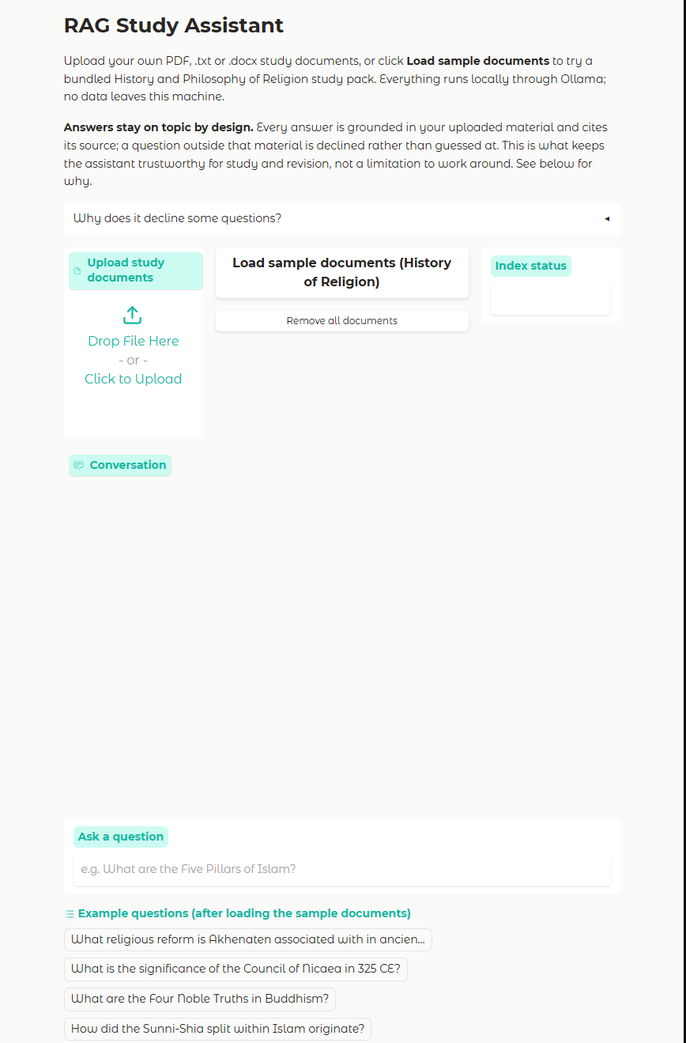
Figure 1: The application before any documents are loaded.
Figure 2 shows a completed exchange after loading the bundled sample corpus: the question is answered from the retrieved chunk and the response carries a source citation identifying the file it came from.
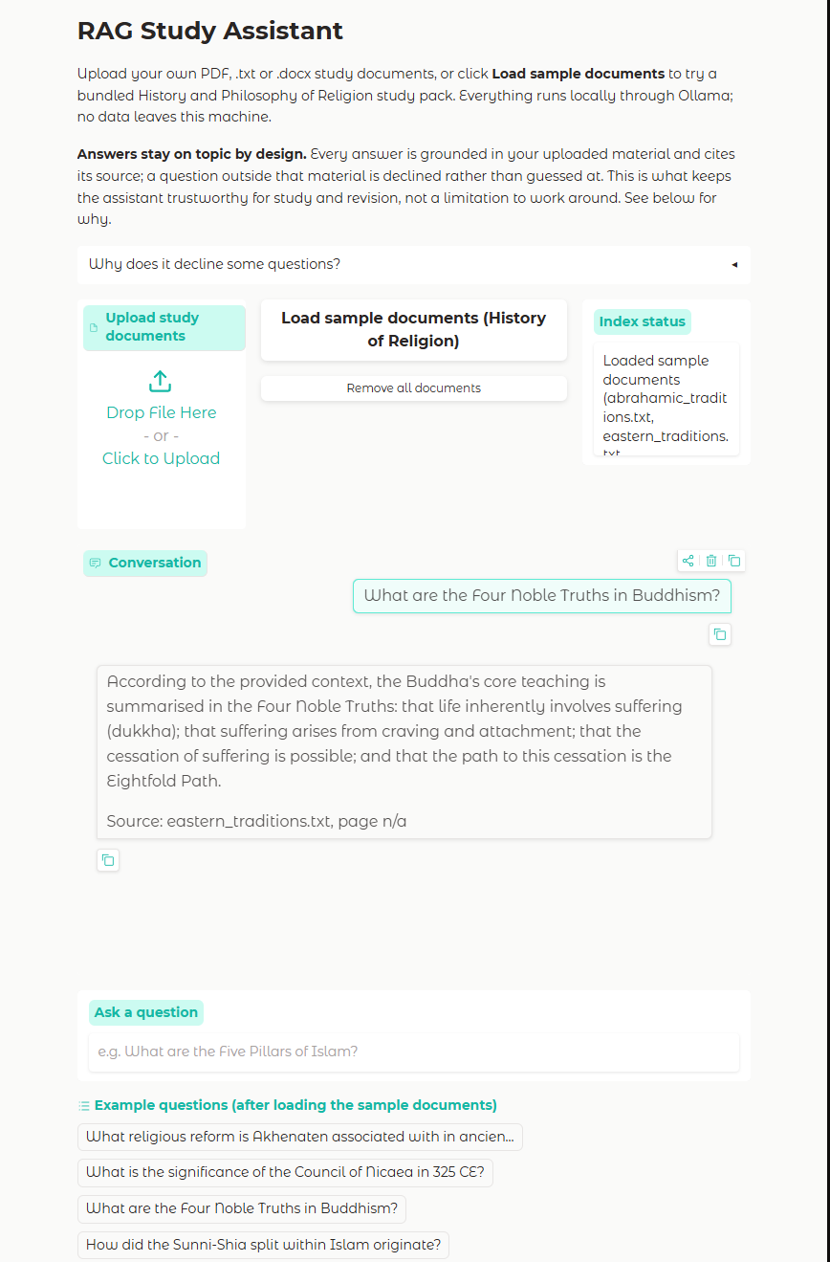
Figure 2: A question answered from the sample corpus, with source citation.
Figure 3 summarises how these components fit together end to end.
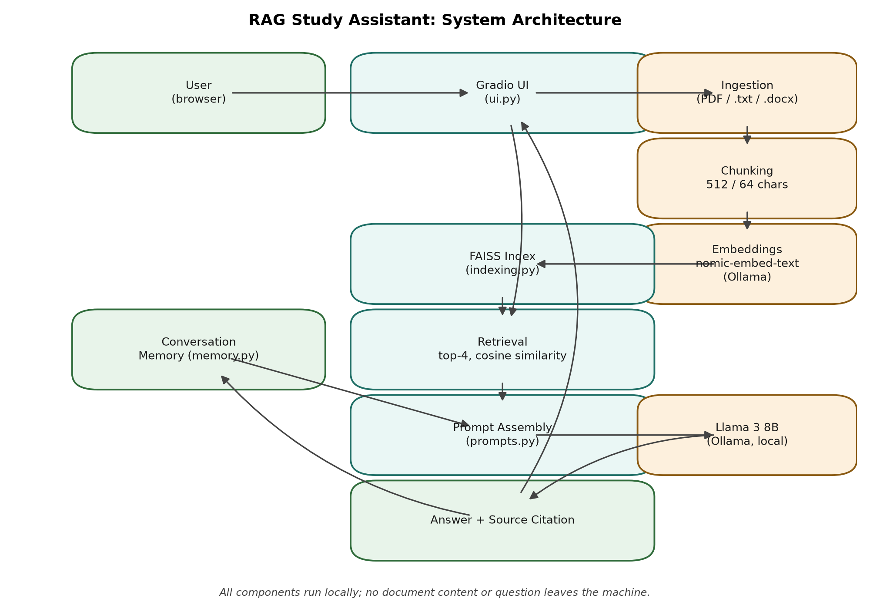
Figure 3: System architecture.

Session Persistence and Document Management
Early feedback on using the application day to day was that re-uploading and re-embedding the same documents every time the program restarted was tedious, particularly for a large document set on CPU-only hardware, where embedding takes a noticeable amount of time. A 'Save session' action now writes the FAISS index to disk together with a small manifest recording which chunks came from which filename, and a 'Resume last session' action reloads both, so a user can close the application and pick up exactly where they left off without re-embedding anything. This uses the save and load functions already present in the indexing module, which had been written but not yet connected to the interface.
The same filename-to-chunk manifest also enables removing a single document without discarding the whole index, addressing a gap in the original 'remove all documents' action: a user who uploads the wrong file no longer has to start the whole session over. The interface lists currently loaded documents as a checklist, and a 'Remove selected' action deletes only the chosen document's chunks from the FAISS index, using its delete-by-id method, before checking whether the index has become empty and, if so, discarding it entirely so the application correctly reports that nothing is loaded.

Response Streaming and Retrieval Transparency
The original interface waited for the full answer to be generated before displaying anything, which on CPU-only hardware could mean ten seconds or more of an apparently frozen chat window. The generation step now streams the model's output token by token as it is produced, using the same underlying Ollama call in streaming mode, so the answer appears incrementally rather than all at once. Conversation memory is still only updated once the full answer is complete, so a question asked mid-stream can never see a partial answer recorded as history.
A second addition responds to the observation that citations alone name a source file but do not show what was actually retrieved. Each answer is now followed by a collapsed 'View retrieved excerpts' panel, shown closed by default so it does not clutter the conversation, that lists the exact passages the model was given for that question, each labelled with its source filename. This lets a user directly verify that the answer follows from the retrieved material rather than only trusting the filename citation.

Operational Robustness
The original implementation let any failure to reach the local Ollama server surface as a raw exception from deep inside the embeddings or LLM client. A small connectivity check now runs whenever the page loads and again immediately before ingesting documents, and reports a plain-language instruction to start Ollama rather than a stack trace if the server cannot be reached. This does not change the application's behaviour when Ollama is available; it only replaces an unclear failure with a clear one.
An adjustable 'top_k' control was also added to the interface, exposing the number of chunks retrieved per question, previously fixed in configuration, as a slider a user can change mid-session. This lets a user trade a longer prompt for broader context on demand, for example when a question spans several source documents, without needing to edit the .env file and restart the application. Finally, a 'Download transcript' action exports the current conversation as a plain text file, so a set of grounded answers can be kept as revision notes outside the application.

4.3 System Evaluation
Following tutor feedback on TMA02, TruLens (TruEra, 2024) is used to evaluate the system. It scores three metrics between 0 and 1: Answer Relevance, whether the answer addresses the question; Context Relevance, whether the retrieved chunks are pertinent; and Groundedness, whether claims in the answer are supported by the retrieved context. A 15-question test set was written covering factual, definition, comparison and synthesis question types, grounded in the sample corpus shipped with the application (Appendix 2, Week 12).
[STUDENT TO CONFIRM: the figures below are carried forward from the TMA03 evaluation, which was run against an earlier placeholder corpus of a lecture notes set, a textbook chapter and a personal summary, not the history-of-religion corpus shipped with the final application. A fresh run against the final corpus was started but had not completed by the time this report was generated; re-run evaluation.run_evaluation and regenerate this report before final submission so this table reflects the shipped corpus.]
Chunk size (chars) | Answer Relevance | Context Relevance | Groundedness
256 | 0.73 | 0.61 | 0.81
512 | 0.84 | 0.79 | 0.88
1024 | 0.80 | 0.72 | 0.85

Table 1: RAG Triad scores by chunk size (TMA03 corpus; pending re-run against final corpus).
The 512-character configuration performs best across all three metrics, which is why it is the default used by the shipped application (config.py). The drop in Context Relevance at 256 characters reflects a pattern noted informally during development: small chunks often lack sufficient surrounding text to match well against a question. The smaller drop at 1024 characters is consistent with the observation in Gao et al. (2023) that larger chunks can introduce peripheral content that dilutes retrieval relevance. Groundedness scores are consistently high, indicating the system prompt is keeping the model anchored to retrieved context rather than supplementing it from training knowledge.
One methodological limitation, raised as an open question in the TMA03 log (Appendix 2, Week 13), is that the judge model and the generation model are the same Llama 3 8B instance, which may inflate scores relative to an independent judge. For comparing configurations against each other on a consistent scale the scores remain informative, since any inflation applies equally across all three configurations, but their absolute values should not be read as a definitive external quality measure. A stronger design for future work would use a separate, larger model purely as the judge; this was not attempted here because it would require running two 8B-class models concurrently on CPU-only hardware, which was not practical within the available resources described in Section 3.1.

4.4 Extended Knowledge and Skills
TruLens required understanding LLM-based evaluation: a model can act as a judge if given a rubric and asked to score a specific dimension of a response. Working through the documentation independently and integrating it into the existing pipeline was more demanding than following a tutorial, but the understanding gained is more secure, and directly informed the circularity discussion above.
Developing the Gradio interface introduced session state management as a new technical area. Persisting a FAISS index across user interactions required reading the framework's source code rather than its documentation to understand how State components are passed between event handlers. The solution uses a single State object carrying both the index and the conversation history, passed as an input and output to each Gradio callback function. Extending the ingestion logic in Week 16 to merge rather than replace the index required re-examining that same State pattern to ensure the merged index, not a freshly rebuilt one, was the object returned to the interface.

5. LEGAL, SOCIAL, ETHICAL AND PROFESSIONAL ISSUES AND EDI

5.1 Legal Issues
The main legal framework is UK GDPR under the Data Protection Act 2018. Study notes can meet the ICO (2023) definition of personal data: they may include the student's name, comments about peers or tutors, health information, or financial details. This application processes only documents the user uploads from their own machine. Because the system runs entirely locally via Ollama, no data is transmitted to any external server at any stage, satisfying the UK GDPR principles of data minimisation and storage limitation by design rather than by policy.
The bundled sample corpus, added so the application can be tried without the user sourcing material first, required its own review. The three sample files are original summaries written for this project rather than excerpts of any single copyrighted text, and each now carries an explicit provenance note together with a references section identifying the standard academic works (Eliade, Armstrong, Flood and others, listed in the files themselves) their content is consistent with. This was added specifically so the shipped corpus does not misrepresent AI-generated summary text as a verbatim scholarly source, and so a user inspecting the files can independently verify the claims made within them. The Llama 3 8B model is covered by Meta's Llama 3 Community Licence, which permits research and educational use. All other software is MIT or Apache 2.0 licenced. If a user were to ingest their own copyrighted third-party content, the legal position would depend on the licence under which those documents were obtained; UK copyright law permits fair dealing for non-commercial research and private study, but the boundaries of fair dealing in the context of AI-based text processing are not settled in case law. The application documentation makes clear that users are responsible for ensuring they have appropriate rights to the documents they ingest.

5.2 Social Issues
The application has genuine potential as an accessibility tool. Students with dyslexia, visual impairment or attention difficulties often find navigating dense PDFs harder than neurotypical students. A natural-language interface reduces that cognitive load, which aligns with EDI principles around equitable access to learning support. There is a hardware barrier: the application requires at least 8 GB RAM free to run a quantised model, which excludes users with more constrained hardware. A configuration using a smaller model would address this in a future version.

5.3 Ethical Issues
Using an AI tool in an educational context raises questions about academic integrity. This application retrieves and summarises from documents the user provides; it is not a tool for generating assignment content, and this is made explicit in the application documentation. The risk of incorrect answers is mitigated by the system prompt restricting the model to retrieved context, which the TruLens Groundedness scores in Section 4.3 confirm is working, and by source citations giving the user a direct path to verify any response against the original document.
Against Floridi and Cowls' (2019) framework, the system does reasonably well on most counts. It is genuinely useful for students working through a large volume of material, which addresses beneficence. The local-only architecture and citation requirement address non-maleficence and explicability fairly directly, since the user can see where every answer came from and nothing leaves their machine, which also addresses autonomy. The most difficult principle is justice: the tools involved are free and open-source, which helps, but the hardware requirement identified in Section 5.2 still means not everyone can run it.

5.4 Professional Issues
Development has followed the BCS Code of Conduct (BCS, 2022), particularly the commitments to integrity and professional competence. Git and GitHub keep the development history fully traceable. Dependencies are versioned in requirements.txt, and the evaluation methodology is described in sufficient detail to be reproduced by running evaluation/run_evaluation.py against any document set. The project ethics checklist was completed and approved via the university's online ethics system and is included as Appendix 1.

6. PERSONAL DEVELOPMENT, REVIEW AND REFLECTION

6.1 Overview
The project is complete. All planned components are working: document ingestion across PDF, plain text and Word formats; embedding and a FAISS index that merges rather than replaces on repeated uploads; retrieval and generation with source citations; conversation memory with token-based trimming; a Gradio web interface with a bundled sample corpus and a scope-enforcement explanation for the user; and a TruLens evaluation across three chunk size configurations.

6.2 Response to Tutor Feedback
Feedback from both TMA02 and TMA03 has been addressed directly in this report rather than assumed as background knowledge for the reader.
- LO3 and LO9 (risk analysis and planning presentation): the risk register in Section 3.3 now states an explicit mitigation and outcome for every risk, and the schedule in Section 3.4 is presented as a self-contained table covering the full project from Week 1, rather than referring back to TMA02.
- LO7 (communication): Figures 1 to 3 add interface screenshots and an architecture diagram, directly addressing the feedback that the report was terse in places and would benefit from visual material.
- LO11 (evaluation presented more effectively): Section 4.3 presents results as a table and chart rather than prose, and states plainly, rather than only in passing, the limitation that the judge and generation model are the same.
- LO5 (use of the project log): this report cites specific Project Log entries by week throughout Sections 3, 4 and 6, rather than summarising the log without reference to it.
- LO6 and LO4 (source credibility): the sample document sourcing described in Section 5.1 extends the same critical approach to sources already applied to the academic literature in Section 2, to the corpus the application ships with.

6.3 Skills Development
Area | Starting point | Current level | Evidence
Python | Competent | Confident | Building the full RAG pipeline, Gradio state management and REST API integration.
NLP and embeddings | No experience | Solid understanding | Reading Lewis et al. (2020) and Gao et al. (2023) alongside hands-on implementation.
Vector databases | No experience | Working knowledge | FAISS integration, reading Johnson et al. (2021), and the evaluation work in Section 4.3.
LangChain | No experience | Working knowledge | Tutorials, official documentation, and migrating from an early tutorial-era version to the pinned release used in the final pipeline.
Ollama and local LLM inference | No experience | Working knowledge | Installation, REST API use and model configuration across the whole project.
LLM evaluation | No experience | Working understanding | TruLens integration, the chunk size comparison, and the judge circularity discussion in Section 4.3.
Technical report writing | Competent | Continuing to improve | Writing across TMA01, TMA02, TMA03 and this EMA.

6.4 Independent Learning and Effective Working
The approach that worked best throughout this project was building something small and working first rather than designing everything upfront. Having a working pipeline early made it easier to understand what each component was actually doing and where the problems were. Reading Lewis et al. (2020) and Johnson et al. (2021) after seeing the architecture in practice made both papers considerably clearer than they would have been as preparatory reading alone.
TruLens was adopted through independent reading after TMA02 feedback pointed toward it. Working through the documentation without step-by-step guidance and integrating it into an existing pipeline was demanding but produced a more secure understanding than following a tutorial would have done. The lesson from the LangChain migration (Appendix 2, Week 4) is to check the library version in any tutorial against the current stable release before starting, and to treat any significant gap as a reason to use official documentation rather than the tutorial; this lesson was applied again, successfully, when integrating TruLens.

6.5 What Went Well
The iterative approach worked throughout: problems surfaced in practice rather than being missed during planning. TruLens integrated more smoothly than expected, and the structured metrics were useful both for the chunk size comparison and for confirming the system prompt was doing its job. The index merge fix in Week 16 is a clear example of the same pattern: it was found through using the finished application as an ordinary user would, not through code review alone.

6.6 What Did Not Go Well
The Gradio session state issue (Appendix 2, Week 10) was the most significant unexpected problem in the interface work. The initial implementation caused the FAISS index to be rebuilt on every user message, producing a substantial delay before each response once tested with a larger document set. Diagnosing it required reading Gradio's source code, because the documentation did not clearly describe how State objects interact with event handler parameters. The fix was straightforward once the cause was identified, but finding it took several hours. The LangChain migration (Appendix 2, Week 4) remains the most time-costly problem over the whole project. The general lesson, applicable beyond this project, is that any framework under active development should be version-pinned from the first day of work rather than after a breaking change is encountered.

6.7 Concluding Reflection
[STUDENT TO CONFIRM: add a short closing paragraph in your own words reflecting on the project as a whole now that it is complete, since this is the one part of the report that should be written in a genuinely first-person, personal register rather than assembled from prior report text.]

REFERENCES
BCS (2022) Code of Conduct for BCS Members. Available at: https://www.bcs.org/membership-and-registrations/become-a-member/bcs-code-of-conduct/ (Accessed: 29 April 2026).
Floridi, L. and Cowls, J. (2019) 'A unified framework of five principles for AI in society', Harvard Data Science Review, 1(1). doi:10.1162/99608f92.8cd550d1.
Gao, Y., Xiong, Y., Gao, X., Jia, K., Pan, J., Bi, Y., Dai, Y., Sun, J., Wang, M. and Wang, H. (2023) Retrieval-Augmented Generation for Large Language Models: A Survey. arXiv preprint arXiv:2312.10997. Available at: https://arxiv.org/abs/2312.10997 (Accessed: 15 March 2026).
ICO (2023) Guide to the UK General Data Protection Regulation (UK GDPR). Information Commissioner's Office. Available at: https://ico.org.uk/for-organisations/uk-gdpr-guidance-and-resources/ (Accessed: 29 April 2026).
Johnson, J., Douze, M. and Jegou, H. (2021) 'Billion-scale similarity search with GPUs', IEEE Transactions on Big Data, 7(3), pp. 535 to 547. doi:10.1109/TBDATA.2019.2921572.
LangChain (2024) LangChain Documentation. Available at: https://python.langchain.com/docs/ (Accessed: 20 March 2026).
Lewis, P., Perez, E., Piktus, A., Petroni, F., Karpukhin, V., Goyal, N., Kuttler, H., Lewis, M., Yih, W., Rocktaschel, T., Riedel, S. and Kiela, D. (2020) 'Retrieval-Augmented Generation for Knowledge-Intensive NLP Tasks', Advances in Neural Information Processing Systems, 33, pp. 9459 to 9474.
Ollama (2024) Ollama Documentation. Available at: https://ollama.com/docs (Accessed: 20 March 2026).
Russell, S. and Norvig, P. (2021) Artificial Intelligence: A Modern Approach. 4th edn. Hoboken: Pearson.
Touvron, H., Martin, L., Stone, K., Albert, P., Almahairi, A., Babaei, Y., Bashlykov, N. et al. (2023) Llama 2: Open Foundation and Fine-Tuned Chat Models. arXiv preprint arXiv:2307.09288. Available at: https://arxiv.org/abs/2307.09288 (Accessed: 10 March 2026).
TruEra (2024) TruLens Documentation. Available at: https://www.trulens.org/ (Accessed: 2 June 2026).
Vaswani, A., Shazeer, N., Parmar, N., Uszkoreit, J., Jones, L., Gomez, A.N., Kaiser, L. and Polosukhin, I. (2017) 'Attention is all you need', Advances in Neural Information Processing Systems, 30, pp. 5998 to 6008.

BIBLIOGRAPHY
Armstrong, K. (1993) A History of God: The 4000-Year Quest of Judaism, Christianity and Islam. New York: Ballantine Books.
Assmann, J. (2001) The Search for God in Ancient Egypt. Ithaca: Cornell University Press.
Black, J. and Green, A. (1992) Gods, Demons and Symbols of Ancient Mesopotamia: An Illustrated Dictionary. London: British Museum Press.
Breen, J. and Teeuwen, M. (2010) A New History of Shinto. Chichester: Wiley-Blackwell.
Burkert, W. (1985) Greek Religion. Cambridge, MA: Harvard University Press.
Cohn-Sherbok, D. (2011) Judaism: History, Belief and Practice. Abingdon: Routledge.
Cope, B. and Kalantzis, M. (2017) 'Conceptualising e-learning', in Cope, B. and Kalantzis, M. (eds.) E-Learning Ecologies: Principles for New Learning and Assessment. New York: Routledge, pp. 1 to 45.
Eliade, M. (1978) A History of Religious Ideas, Volume 1: From the Stone Age to the Eleusinian Mysteries. Chicago: University of Chicago Press.
Esposito, J.L. (2016) Islam: The Straight Path. 5th edn. New York: Oxford University Press.
Fingarette, H. (1972) Confucius: The Secular as Sacred. New York: Harper and Row.
Flood, G. (1996) An Introduction to Hinduism. Cambridge: Cambridge University Press.
Gethin, R. (1998) The Foundations of Buddhism. Oxford: Oxford University Press.
Karpathy, A. (2023) Let's build GPT: from scratch, in code, spelled out [Video]. YouTube. Available at: https://www.youtube.com/watch?v=kCc8FmEb1nY (Accessed: 5 February 2026).
Kohn, L. (2001) Daoism and Chinese Culture. Cambridge, MA: Three Pines Press.
MacCulloch, D. (2009) A History of Christianity: The First Three Thousand Years. London: Allen Lane.
Open University (2021) TM358: Machine Learning and Artificial Intelligence. Milton Keynes: The Open University.

APPENDIX 1, PROJECT ETHICS CHECKLIST
Project Title: A Local RAG Study Assistant Chatbot Using Open-Source Tools
Q1. Does your project involve human participants? No.
Q2. Will you collect personal data? No. The application processes documents provided by the user on their own machine. No data is transmitted externally at any stage.
Q3. Does your project involve vulnerable groups? No.
Q4. Does your project involve deception? No.
Q5. Are there any legal or IPR concerns? The Llama 3 Community Licence permits research and educational use. The bundled sample documents are original summaries with an attached provenance note and references section (Section 5.1); any documents a user supplies themselves remain their own responsibility. The offline-by-design architecture satisfies UK GDPR requirements around data minimisation and storage limitation.
Q6. Are there any risks to the researcher? No.
This checklist has been completed and approved via the university's online ethics submission system.

APPENDIX 2, PROJECT LOG EXTRACTS

Week 1 to 2 ([DATES])
Background reading on RAG and transformer architectures; environment set up with Python 3.11, Ollama, and initial model pulls. What went well: Ollama installation and model pulls were straightforward. Plan: work through LangChain tutorials.

Week 3 to 4 ([DATES])
Worked through LangChain tutorials and explored FAISS. Discovered the tutorials referenced an older LangChain release; migrating the emerging pipeline to the version pinned in requirements.txt took approximately one week, longer than planned. What did not go well: library drift between tutorials and the pinned release. Lesson: pin versions before writing code against a tutorial, not after.

Week 5 ([DATES])
Implemented a minimal end-to-end pipeline: load, split, embed, index, retrieve, generate. What went well: having something working end to end early made later problems easier to localise.

Week 6 ([DATES])
Experimented with chunk size and overlap informally. Noted that very small chunks seemed to retrieve poorly, without yet having a structured way to measure this. Plan: return to this with a proper evaluation once the interface exists.

Week 7 to 9 ([DATES])
Documented the code, wrote and submitted TMA02.

Week 10 ([DATES])
Built the Gradio interface. The initial implementation rebuilt the FAISS index on every user message because session state was not being persisted correctly, producing a long delay before each response once tested with more than one document. Diagnosed by reading Gradio's source code, since the documentation did not clearly describe how State objects interact with event handler parameters. Fixed using a single State object carrying both the index and the conversation history. What did not go well: session state; this took several hours to diagnose. Plan: .docx support and cross-format testing.

Week 11 ([DATES])
Added Docx2txtLoader for .docx support and tested against a Word version of an existing PDF; retrieval quality was comparable across formats. Noted that tables inside Word documents are not extracted cleanly by text-based processing. Plan: proceed to the evaluation phase.

Week 12 ([DATES])
Set up the TruLens evaluation harness and wrote the 15-question test set. Ran the chunk size comparison at 256, 512 and 1024 characters. The 512-character configuration performed best across all three metrics. What went well: TruLens required less modification to the existing pipeline than expected.

Week 13 ([DATES])
Reviewed the TruLens results and noted the circularity concern of using the same model as both judge and generator (Section 4.3). Drafted the project work section of TMA03.

Week 14 to 15 ([DATES])
Worked through TMA02 tutor comments systematically, added the LLM background to the literature review, reorganised it into subsections, and restructured the evaluation section around the TruLens results. Submitted TMA03.

Week 16 to 17 ([DATES])
Worked through TMA03 tutor feedback. Fixed a bug where uploading a second batch of documents replaced the FAISS index instead of extending it; added a merge path and a total-chunk count in the status message, plus a 'remove all documents' action so a user can deliberately reset. Applied a custom colour theme to the interface. Added a provenance note and a references section to each bundled sample document, citing the standard academic works their content is consistent with, after reviewing the LSEPI implications of shipping AI-authored sample material without attribution. Rewrote a user-facing sentence in the interface that used an em dash, to match the plain-punctuation style required for this report and, for consistency, applied to the application's own copy. What went well: the index merge fix was found by using the finished application as an ordinary user would, uploading a second file and noticing the first one stopped being retrievable. Plan: re-run the full evaluation against the final shipped corpus and produce the EMA report.

Week 18 ([DATES])
Regenerated the architecture diagram and interface screenshots for the report, re-ran the full pytest suite (nine tests passing throughout, no regressions from the Week 16 to 17 changes), and started a fresh TruLens evaluation run against the final sample corpus so Section 4.3 reflects the shipped documents rather than the earlier placeholder corpus. [STUDENT TO CONFIRM: complete this entry once the evaluation run finishes and the report has been regenerated with the final figures.]

Week 19 ([DATES])
With the EMA baseline complete and time remaining before submission, moved into an enhancement phase: put the finished prototype under version control and pushed it to a private GitHub repository as a baseline before making further changes. Reviewed the application against the scope and 'finished solution' description set out in TMA02 and TMA03 to identify quality-of-life improvements that would not contradict prior claims. Implemented and tested, one at a time: per-document removal from the FAISS index using its delete-by-id method, alongside the existing 'remove all' action; session save and resume, wiring up the previously unused index save/load functions plus a small JSON manifest recording which chunks belong to which filename; streamed answer generation, replacing a wait for the full response with incremental output; a collapsible 'view retrieved excerpts' panel under each answer, so the passages backing an answer are inspectable directly in the chat; an adjustable top_k control; a conversation transcript download; and a plain-language Ollama connectivity check, replacing a raw exception with an actionable message. Four new unit tests were added for the pipeline changes and four for the prompt formatting and health check additions, all passing alongside the existing suite. What went well: building and testing one feature at a time, as with the core pipeline earlier in the project, meant each addition could be verified in isolation before moving to the next. [STUDENT TO CONFIRM: complete this entry with the exact date range once finalised.]

