

KULLIYYAH OF INFORMATION AND COMMUNICATION TECHNOLOGY
DEPARTMENT OF COMPUTER SCIENCE

FINAL REPORT

PROJECT ID
17093D

PROJECT TITLE
Pelita: A Web-Based Teacher Support Platform with Automated RPH Generation

STUDENTS
- Muhammad Khalis Bin Mohd Zakaria (2318591)
- Anas Imran Bin Ismail (2317243)

SUPERVISOR
Asst. Prof. Dr. Siti Asma binti Mohammed

SEMESTER 2 2025/2026

FINAL YEAR PROGRESS REPORT

PROJECT ID
17093D

PROJECT TITLE
PELITA: A WEB-BASED TEACHER SUPPORT PLATFORM WITH AUTOMATED RPH GENERATION

PROJECT CATEGORY
SYSTEM DEVELOPMENT PROJECT

by
- MUHAMMAD KHALIS BIN MOHD ZAKARIA (2318591)
- ANAS IMRAN BIN ISMAIL (2317243)

SUPERVISED BY
ASST. PROF. DR. SITI ASMA BINTI MOHAMMED

In partial fulfillment of the requirement for the
Bachelor of Computer Science

Kuliyyah of Information and Communication Technology
International Islamic University Malaysia

ABSTRACT

The increasing use of digital platforms in education has changed the way in which the coordination of teaching and learning takes place. However, many of the current systems, such as WhatsApp and other learning management platforms, remain fragmented and force educators to multitask from different applications for managing the teaching materials, assigning tasks, announcements, and communication purposes. This approach causes an increase in the workload and decreases the efficiency in the management of educational materials.
In this regard, the present proposal contributes towards the development of Pelita, a web-based platform that supports teachers in managing their teaching activities in a centralized environment. The platform provides essential functionalities such as teaching material management, assignment handling, announcement administration, class management, and educational resource organization. In addition, the system incorporates an LLM-based feature specifically to assist teachers in generating a draft Rancangan Pengajaran Harian (RPH) from the selected subject, class and topic, which the teacher reviews and edits before saving. The interface is available in English and Bahasa Melayu. The goal of this feature is to save time and effort in lesson planning and to increase the efficiency and consistency of teaching preparation.
The expected result of this proposal is an efficient teaching support platform that helps teachers in improving their productivity and reducing the need for repetitive work.

TABLE OF CONTENTS

ABSTRACT 4
TABLE OF CONTENTS 5
LIST OF TABLES 5
LIST OF FIGURES 7
LIST OF APPENDICES 8
LIST OF ABBREVIATIONS 9
CHAPTER ONE 10
INTRODUCTION (System Development Project) 10
1.1 Background of the Study 10
1.2 Problem Description 11
1.3 Project Objectives 12
1.4 Scope of the Project 12
1.5 Constraints 13
1.6 Project Stages 14
1.7 Significance of the Project 15
1.8 Summary 16
CHAPTER TWO 17
REVIEW OF PREVIOUS WORK (System Development Project) 17
2.1 Introduction 17
2.2 Overview of Related Systems 18
2.3 Discussion 21
2.4 Summary 22
CHAPTER THREE 24
METHODOLOGY (System Development Project) 24
3.1 Introduction 24
3.2 Development Approach 24
3.3 Requirements Specification 27
3.4 Logical Design 34
3.5 Database Design 38
3.6 Prototype or Wireframes: 40
3.7 Summary 47
REFERENCES 49
APPENDICES (System Development Project) 51

LIST OF TABLES

TABLE NO. TITLE PAGE
1. Comparison of Each Website 17
2. Functional Requirement 28
3. Non-Functional Requirement 31

LIST OF FIGURES

FIGURE NO. TITLE PAGE NO.
1. Figure 3.4.1: Use Case Diagram 33
2. Figure 3.4.2: Data Flow Diagram 35
3. Figure 3.5.1: Entity Relationship Diagram 37
4. Figure 3.6.1: Pelita Login Page 39
5. Figure 3.6.2: Pelita Dashboard 40
6. Figure 3.6.3: Pelita Notification 40
7. Figure 3.6.4: Pelita Mini Profile 41
8. Figure 3.6.5: Pelita Announcement Page 42
9. Figure 3.6.6: Pelita Class Page 42
10. Figure 3.6.7: Pelita Assignment Page 43
11. Figure 3.6.8: Assignment Submission List 43
12. Figure 3.6.9: Add Assignment Feature 44
13. Figure 3.6.10: Pelita Schedule Page 45
14. Figure 3.6.11: Pelita AI RPH Generator Page 45
15. Figure 3.6.12: Pelita Profile Page 46

LIST OF APPENDICES

APPENDIX TITLE PAGE NO.
A Gantt Chart 50

LIST OF ABBREVIATIONS

CSS Cascading Style Sheets
AI Artificial Intelligence
API Application Programming Interface
DFD Data Flow Diagram
ERD Entity Relationship Diagram
HTML HyperText Markup Language
IIUM International Islamic University Malaysia
LLM Large Language Model
MIS Management Information System
MySQL My Structured Query Language
PDF Portable Document Format
RPH Rancangan Pengajaran Harian
SDLC Software Development Life Cycle
SMIS School Management Information System
UI User Interface
URL Uniform Resource Locator
UX User Experience
DBMS Database Management System
DELIMa Digital Educational Learning Initiative Malaysia

CHAPTER ONE

INTRODUCTION (System Development Project)

Background of the Study

The fast advancement of the information technology industry has significantly affected many sectors; one of the most prominent changes occurred in the education sphere, especially in teaching activity management. Today, numerous educational organizations heavily rely on online technologies to facilitate communication between members and exchange educational materials. Digital classrooms, cloud storage systems, and communication channels such as WhatsApp can be used to inform about important announcements and share materials with the learners.
Despite all the advantages of modern digital solutions, most of them lack specialization in the sphere of comprehensive teacher support during the process of managing learning materials and other educational aspects. Teachers often have to use multiple applications to organize materials, communicate, send assignments, and control academic resources. In this way, a significant part of the teachers' daily routine consists of switching between applications, which makes the work inefficient and disorganized.
One of the main tasks of teachers is the preparation of the materials for the lesson. It requires a lot of time, especially if an instructor needs to create the same types of materials for other lessons. The problem is that modern learning management systems do not have effective tools for generating educational materials. Furthermore, some educational platforms, like DELIMa, may include links to AI-related tools; however, they cannot be used in one application.
Additionally, the existing platforms may lack some features related to interface design and general friendliness. On the one hand, there are a variety of AI-powered solutions and services; on the other hand, these technologies are not used sufficiently to optimize the teachers' working process. The emergence of AI, in particular the development of large language models (LLM), opens up new possibilities for optimizing teachers’ work.
However, there are few AI-powered applications for creating, managing, and organizing educational materials for the lessons. Thus, it is important to develop a platform, which will combine all these elements in one application and facilitate the work of teachers. The proposed project is Pelita, a web-based service that will enable teachers to create educational content with the assistance of large language model technologies.

Problem Description

The main problems with current school management and learning environments can be divided into the “Teaching Productivity Problem” and the “System Integration Problem.” These issues collectively reduce the efficiency of teaching, learning, and communication within the school community.

- Teaching Productivity Problem: It is the duty of the educator to create the material needed for lectures. This task requires a lot of time and energy from their side. There is currently no such intelligent system to automate content creation and sorting out of the same. This makes teachers’ work heavy, leaving less time for them to improve on their teaching and engage with the students. Thus, automation is very much required in teaching support systems.

- System Integration Problem: Currently available solutions tend to focus on managing particular aspects of schools, including communication, educational content, or students' data, without combining those aspects in a single system. This means that a user will have to use multiple platforms, thereby wasting time on duplicated work. There is no single system that would combine the management of teaching activities and student performance monitoring with the added benefit of having smart capabilities like automatic content creation.

Project Objectives

The overall goal of the proposed system is to provide an integrated and intelligent learning environment that will increase teachers’ productivity and improve the management of pedagogical actions. Objectives are defined as follows:

- To develop a centralized teaching support system for handling teaching materials, assignments, and announcements in one platform.
- To implement an organized platform that allows teachers to create, upload, store, and manage educational resources more efficiently.
- To integrate an LLM-based feature that assists teachers in generating a draft Rancangan Pengajaran Harian (RPH) from the selected subject, class and topic, for the teacher to review and edit before saving.
- To evaluate the system's effectiveness and usability in reducing repetitive teaching preparation tasks and improving teaching workflow efficiency.

Scope of the Project
- Scope : The project focuses on the development of Pelita, a web-based platform designed to support teachers in managing teaching-related activities within a centralized environment. The system includes modules for teaching material management, assignment handling, announcement delivery, class management, and educational resource organization. Additionally, the system integrates a Large Language Model (LLM) feature specifically to assist teachers in generating a draft Rancangan Pengajaran Harian (RPH) from the selected subject, class and topic. The teacher reviews and edits each draft before it is saved, and the interface can be switched between English and Bahasa Melayu. The system also provides structured storage and organization of teaching materials according to subjects and topics to improve accessibility and workflow efficiency for teachers.

- Target Audience : School teachers who require efficient tools for preparing, organizing, and managing teaching materials and classroom activities. Schools seeking a centralized and user-friendly teaching support platform to improve teaching workflow management.

- Specific Platform: The system is developed as a web-based application which can be accessed through modern web browsers in both desktop and mobile devices.

Constraints

- Technology: The proposed system is heavily dependent on a stable internet connection to enable effective communication among the frontend interface, backend server, database system and external Large Language Model (LLM) API services. Since the system is web-based and integrates cloud-dependent AI functionalities, interruptions in internet connectivity may affect system responsiveness, data synchronization, and AI-generated content processing. Features such as AI-assisted RPH generation, announcements, and online assignment management may experience delays or limited functionality during network instability.
- System Complexity: The development of Pelita involves the integration of multiple interconnected modules, including teaching material management, assignment handling, class management, timetable management, announcement systems, student record management, and AI-assisted teaching support. Managing interactions between these modules increases the complexity of system architecture, database relationships, and backend processing. Therefore, extensive integration testing and careful system design are required to ensure all components function smoothly and consistently without data conflicts or processing errors.
- Resource Availability: The project is developed within an academic environment with limited development resources, infrastructure, and testing opportunities. Constraints in hardware resources, hosting services, API quotas, and development manpower may limit the implementation of more advanced functionalities, large-scale deployment, or high-performance optimization features.
- User Adaptability: The target users of the system include teachers with varying levels of digital literacy and technical experience. Some users, particularly senior or less technology-oriented educators, may face difficulties adapting to new digital systems if the interface becomes overly complex or overloaded with features. Therefore, the system design should be simple, accessible and easy to navigate so that users can understand and operate the platform effectively with minimal training.
- Time Constraint: The system must be developed within the allocated academic time frame, encompassing all phases such as requirement analysis, system design, prototyping, implementation, testing, documentation, and evaluation. Due to the limited development period, the project prioritizes core functionalities essential to the proposed system objectives, while certain advanced features or enhancements may be reserved for future development.

Project Stages

No | Task | Duration | MARCH |  |  |  | APRIL |  |  |  | MAY |  |  |  | JUNE
 | FINAL YEAR PROJECT 1 | Duration | W1 | W2 | W3 | W4 | W1 | W2 | W3 | W4 | W1 | W2 | W3 | W4 | W1 | W2 | W3 | W4
1 | Supervisor Consultation & Project setup | 3 weeks
 | Approach supervisor and discuss project direction
 | Refine title, problem statement, and objectives based on feedback
 | Milestone: Project title approved & group work finalized | 20/3/2026
2 | Introduction (Chapter 1) | 4 weeks
 | Draft Chapter 1 contents
 | Refine Chapter 1 contents and ensure alignment with project goals.
 | Consult and submit Chapter 1 to supervisor
 | Milestone: Draftr 1 Submission | 15/4/2026
3 | Literature Review (Chapter 2) | 3 weeks
 | Research related systems
 | Write Chapter 2 covering 3-5 related works
 | Refine and finalize Chapter 2 with comparison table
 | Consult and submit Chapter 2 to supervisor
 | Milestone: Draft 2 Submission | 30/4/2026
4 | Design & Development (Chapter 3) | 4 weeks
 | Report Writing Chapter 3
 | Sketch (Draft design)
 | User Interface Design (Figma)
 | Milestone : Draft 3 Submission | 20/5/2026
5 | Prototype Implementation & Testing | 5 weeks
 | Prototype Testing
 | User Acceptance Testing (UAT)
 | Milestone: Demonstrate Prototype Design & Functionality | TBD
6 | Documentation & Presentation | 2 weeks
 | Compile FYP Technical Report (Ch 1-3, poster, and Turnitin report
 | Final FYP 1 report submission | 1/6/2026
 | Milestone: Final Presentation at INNOVATEX | TBD

Significance of the Project
Its significance lies in:
- Improving Teaching Productivity: By incorporating AI-assisted RPH generation, the system cuts down on the time and effort teachers spend preparing their daily lesson plans. This frees up teachers to concentrate more on lesson delivery, student engagement and educational quality, rather than repetitive documentation tasks.
- Supporting Teaching Material Management: The system provides teachers with a centralized platform to create, store, organize, and retrieve teaching materials efficiently. This reduces dependency on multiple platforms and improves the management of educational resources across different subjects and classes.
- Enhancing Content Quality and Consistency: The AI-assisted RPH generation feature helps teachers produce structured lesson plans based on selected subjects, topics, and learning objectives. This supports consistency in lesson planning while reducing the administrative burden associated with preparing teaching documentation.
- Promoting Efficient Use of Educational Technology: The project illustrates the use of artificial intelligence in a teacher-centered platform to support teaching preparation activities. The platform combines teaching management tools and AI-assisted lesson planning into one system, helping schools to use educational technology more effectively and practically.

Summary
This proposal outlines the development of Pelita, a centralized teaching support platform designed to address key challenges faced by teachers, including fragmented management of teaching materials, repetitive administrative tasks, and the time required to prepare lesson plans and educational resources. The proposed system provides a teacher-focused environment that enables users to manage teaching materials, assignments, announcements, and class information within a single platform. In addition, the system integrates an LLM-based feature to assist teachers in generating Rancangan Pengajaran Harian (RPH) automatically, reducing the effort required for lesson planning and improving teaching productivity. Through the implementation of a structured system development methodology, the project seeks to achieve the delivery of a user-friendly and efficient platform that will facilitate teaching activities, optimize the organization of resources, and foster the effective utilization of educational technology in schools.

CHAPTER TWO

REVIEW OF PREVIOUS WORK (System Development Project)

Introduction

The advancement in digital technology has led to the change of how teaching and learning activities are conducted in educational institutions. Most educational institutions now use digital mediums like WhatsApp, Google Classroom, and other similar platforms to conduct their activities, including communication, material distribution, and conducting classes.
Even though the use of such platforms is convenient for both teachers and students, most platforms lack integration. The process of using these mediums requires teachers to switch from one application to another when preparing teaching materials, assigning homework, communicating, or conducting classes.
At the same time, the field of education has seen some new possibilities due to recent developments in the realm of artificial intelligence, especially large language models. Solutions based on AI can make the life of teachers easier, they will be able to prepare materials and lessons easier.
Therefore, this chapter aims to examine educational systems and teaching platforms available at present to see their advantages, drawbacks, and gaps in research in terms of usability and workflow optimization.

Overview of Related Systems
Table 1 Comparison of Developed System
No | System | Overview | Methods | Limitation
1 | Digital Educational Learning Initiative Malaysia (DELIMa) | DELIMa (Digital Educational Learning Initiative Malaysia) is a platform for online learning that was introduced by the Ministry of Education Malaysia to assist the digital educational activities in schools. The platform gives teachers and students access to a wide range of educational tools, learning resources, cloud storage and online collaboration services. | - Centralized Learning Access  - AI Tool Accessibility | - Limited Integration of AI Features  - User Interface and Usability Issues  - Fragmented Workflow
2 | iSAMS School Management Information System (MIS) | iSAMS is a cloud-based School Management Information System (MIS) designed to support academic, administrative, communication, and operational processes within schools. The platform provides a centralized system that integrates student information, academic records, attendance, reporting, communication, finance, and wellbeing management into a single environment. The system is widely used by independent and international schools and supports teachers, students, parents, and school administrators through dedicated portals and applications. iSAMS is built using a modular architecture, allowing schools to customize features according to their needs. | - Centralized Database System  - Modular System Architecture  - Third-Party Integration  - Cloud-Based Accessibility | - Complex System Structure  - Limited Direct AI Teaching Support  - User Familiarization
3 | PINTARR | PINTARR is an AI-powered educational platform developed to assist Malaysian school teachers in generating Rancangan Pengajaran Harian (RPH) more efficiently. The platform utilizes Artificial Intelligence (AI) technology to automate and simplify the preparation of lesson plans based on Malaysian educational requirements.  The system aims to reduce teachers’ workload by generating structured teaching plans automatically, helping educators save time in preparing daily teaching documentation. | - AI-Assisted RPH Generation  - Automated Content Structuring  - Web-Based Accessibility | - Limited Scope of Functionality  - Dependence on AI Accuracy
4 | Classter Teacher Portal | Classter Teacher Portal is a cloud-based education management platform that provides teachers with a centralized portal for classroom activities, assignments, attendance, grading, communication, and academic resources. The system is part of the broader Classter School Management System, which integrates portals for teachers, students, parents, and school administrators. | - Centralized Teacher Dashboard  - Assignment and Homework Management  - Attendance and Grading Management  - Mobile and Cloud Accessibility | - Complex System Structure  - User Familiarization Challenge  - Limited AI-Assisted Teaching Support

Discussion

Analyzing the existing educational platforms, one can note the tendency to develop centralized digital systems to facilitate the work of educational institutions and learning processes. However, all current solutions have some shortcomings that require the introduction of another platform designed to help teachers prepare their lessons.

For instance, DELIMa is a solution that allows teachers to use different educational tools and resources to facilitate online learning in Malaysian schools. It includes cloud educational services that allow learners and educators to communicate with each other and participate in digital education projects. Nevertheless, there are several issues related to this system, such as workflow fragmentation and insufficiently convenient user experience since teachers still have to log into many external applications to get AI assistance in preparing the lessons.

Alternatively iSAMS is a solution which brings together school management and academic administration in a centralised environment. The system has a centralized database and a modular architecture to support the communication and information management between teachers, students, parents and school administrators. But the platform's main focus is on institutional and administrative management, not on directly supporting teachers in preparing instructional materials or taking over repetitive educational tasks.

Moreover, the system’s structure and interface may appear complex to some users, especially to less tech-savvy teachers or those belonging to older age groups. The system has many modules, menus and functionalities integrated, so users may have problems to understand the system flow in the first use. This can affect its usability and more time is needed for users to get familiar and adapt before teachers can make efficient use of the platform.

Classter Teacher Portal has also been developed to help teachers manage classroom activities, such as grading, administration of assignments, attendance and communication with students. These functionalities provide organization and efficiency of workflow in educational settings. However, as with iSAMS, the platform has many built-in modules and features which can be daunting or difficult to use for those less experienced in technology. More guidance or training might be necessary for teachers to grasp the interface and to utilize the system. It also provides some AI-assisted help for automatically creating educational content and teaching materials.

On the contrary, other platforms are more likely to involve AI solutions to enhance the work of teachers. For instance, PINTARR aims to provide an automated RPH creation to lessen teachers’ routine works. So, teachers can benefit more from automating the process of lesson planning. Also, the platform is too specialized because it only provides RPH creation for teachers and cannot do other tasks relating to teaching management.

Thus, Pelita can be seen as an attempt to merge the useful features of the other platforms, while providing a better product in general. This system will have a simpler workflow and rely less on external platforms compared to DELIMa. And Pelita is more teachers and their needs oriented than Classter and iSAMS. Moreover, Pelita has more functionality than PINTARR, as it is related to the automated content generation, teaching-material management, homework assigning, etc.

As a result, Pelita is a centralized and intelligent teaching support platform to improve teaching productivity through improved usability and workflow.

Summary

In this chapter, we have analyzed some of the existing educational platforms and systems for digital learning, school management, and AI-assisted teaching support such as DELIMa, iSAMS, PINTARR, and Classter Teacher Portal. The analysis demonstrated the advantages and disadvantages of each platform in terms of centralised management, usability, workflow efficiency and AI-assisted educational support. The results indicate that although current systems have various teaching and management functionalities, many platforms still face challenges such as fragmented workflows, complex system architectures, low levels of AI adoption, and limited support for teacher-centric productivity. Currently, AI systems such as PINTARR are mainly focused on the generation of lesson plans, while the general management systems such as iSAMS and Classter are focused on school management and not on intelligent teaching support. These observations lead to the proposed Pelita which is designed to provide a more centralized, user-friendly interface and an AI assisted system specifically to help teachers in managing teaching materials, assignments, announcements and creation of educational content in a single platform. The analysis in this chapter supports the need for a simplified and intelligent teacher-support system that improves the workflow efficiency and reduces repetitive tasks of teaching preparation.

CHAPTER THREE

METHODOLOGY (System Development Project)

3.1 Introduction
This chapter explains the methodology implemented during the development of Pelita. The methodology offers a systematic framework to guide the planning, analysis, design, development and testing activities to be performed during the project life cycle.
Prototyping Model is taken as the system development approach which allows continuous interaction with prospective users and iterative feedback provides the means for system requirements refinement. This is where the proposed system fits in perfectly with multiple modules like teaching material management, assignment management, announcement management, class management, timetable management, student record management and AI assisted RPH generation.
The selected development methodology, requirements gathering, system analysis and design activities, database design and prototype development process are described in this chapter. It also describes the development of the system architecture, diagrams and user interface designs to guarantee that the system meets the identified user requirements and project goals.

3.2 Development Approach
This project adopts the Software Development Life Cycle (SDLC) using the Prototyping Model as the primary development methodology.
Justification of Prototyping Model
The Prototyping Model is selected because the system focuses heavily on user interface usability, workflow efficiency, and user requirements from teachers. The system is designed to support teachers with varying levels of technological experience, particularly users from older age groups, so it is important to have continuous user feedback to ensure the system is simple, understandable and user-friendly.
The prototyping approach allows an early version of the system to be developed quickly so that users can interact with the interface and provide feedback before the final system is fully implemented. This helps identify usability issues, workflow problems, and missing functionalities at an earlier stage of development.
The model is also suitable for this project because:
- User requirements may evolve after users interact with the prototype
- The project emphasizes interface simplicity and usability
- Early feedback helps improve user experience and workflow design
- Teachers can evaluate the practicality of AI-assisted features before final implementation
- The iterative process helps reduce misunderstanding between developer and users
Phases of Development
The development process is divided into the following stages:
1. Requirements Gathering & Analysis
During this phase, the requirements are collected through:
- Interviews
- Observation sessions
The goal is to identify:
- Current teaching workflow problems
- User expectations
- Required system functionalities
- Challenges in existing platforms
2. Quick Design
A preliminary system design is prepared based on the collected requirements. This includes:
- User interface sketches
- System architecture
- Use case diagrams
- Database structure
- Navigation flow
3. Prototype Development
A preliminary system prototype is created to illustrate:
- Teaching material management
- Assignment handling
- Announcement features
- AI-assisted RPH generation
Prior to full development, the prototype enables users to engage with the system and assess its features.
4. User Evaluation and Feedback
Teachers evaluate the prototype and provide feedback regarding the following:
- Interface usability
- Workflow organization
- Feature suitability
- Ease of navigation
- AI-assisted functionalities
The collected feedback is analyzed to identify areas for improvement.
5. Prototype Refinement
The prototype is improved and refined based on user feedback. Modifications may involve:
- Interface redesign
- Feature enhancement
- Workflow simplification
- Improvement of AI-assisted functions
This iterative process continues until the system meets user expectations and requirements.
6. Final Development and Testing
After the prototype is finalized, the complete system will be developed and tested. The system will be implemented using Laravel as the main full-stack web framework, where Laravel handles both backend logic and frontend interface development through Blade templates.
This phase includes:
- Backend development using Laravel
- Frontend development using Blade, Tailwind CSS, and JavaScript
- Database integration using SQLite through Laravel Eloquent, with MySQL as an option for deployment
- LLM API integration for AI-assisted RPH generation
- Functional testing
- Usability testing
The final system will then be evaluated to ensure that all modules, including login, dashboard, assignments, announcements, timetable, profile, and the AI RPH generator, operate correctly and efficiently.

3.3 Requirements Specification
During the requirements specification phase, the functional and non-functional requirements of the proposed system are identified and analyzed. This stage is necessary to ensure that the created system meets the real needs of users and solves the problems found in existing educational platforms.
Several requirement gathering methods were used in this project to collect information from potential users, particularly teachers. These methods include interviews and observation sessions.
1. Interview analysis
Teachers were interviewed to get detailed information about current teaching workflows, problems they face in managing teaching materials and their expectations from the proposed system.
The interview sessions focused on several aspects such as:
- Current platforms used for teaching and communication
- Difficulties in organizing teaching materials
- Challenges in preparing lesson content
- Repetitive administrative tasks
- Opinions on AI-assisted educational support
Finding 1: Teaching Materials Are Stored Across Multiple Platforms
Most teachers reported storing teaching materials in different locations such as personal computers, messaging applications, and external drives. This often makes it difficult to locate materials when needed.
Implication:
A centralized teaching material management module is required to enable teachers to upload, organize, and retrieve educational resources efficiently.
Finding 2: Assignment Management Is Time-Consuming
Teachers indicated that distributing assignments and tracking student submissions manually requires considerable effort, especially when handling multiple classes.
Implication:
The system should provide assignment management functions that simplify assignment creation and submission monitoring.
Finding 3: School Announcements Are Scattered Across Communication Channels
Teachers mentioned that school announcements are often distributed through messaging applications, causing important information to be overlooked.
Implication:
A dedicated announcement module is needed to centralize school information.
Finding 4: Difficulty Accessing Class Information
Teachers stated that information related to classes, student lists, and assigned subjects is sometimes difficult to access quickly.
Implication:
The system should provide centralized access to class-related information.
Finding 5: Timetable Information Needs Better Organization
Teachers highlighted the need for quick access to teaching schedules and timetable information.
Implication:
A timetable management module should be included.
Finding 6: Lesson Plan Preparation Requires Significant Time
Several teachers reported spending considerable time preparing Rancangan Pengajaran Harian (RPH), especially when creating similar plans repeatedly for different topics.
Implication:
An AI-assisted RPH generation feature could reduce preparation time and improve productivity.
Results from the interview show that teachers need a central platform to ease their teaching-related activities, improve the accessibility of educational resources and reduce their administrative burden. These results contribute directly to the development of the functional requirements and system modules proposed for Pelita, which include teaching material management, assignment management, announcement management, class management, timetable management, student record management, and AI-assisted RPH generation.
2. Observation
Observation was conducted to understand how teachers currently manage teaching activities and utilize existing educational platforms. This method helped identify workflow inefficiencies, interface usability issues, and repetitive tasks within current systems.
The observation findings showed that:
- Teaching materials are often scattered across multiple platforms
- Teachers repeatedly perform similar preparation tasks
- Existing systems may appear complex or difficult for less technologically experienced users
- AI tools are often accessed externally rather than directly integrated into the workflow
Functional Requirement
Module 1: Authentication & Access Module
Requirement ID | Requirement Statement
PL-F-0001 | The system shall enable teachers to log in using their six-digit staff ID and password.
PL-F-0002 | The system shall require user credentials for accessing the system.
PL-F-0003 | The system shall prevent unauthorized users from accessing protected modules.
PL-F-0004 | The system shall allow teachers to securely log out from the system.
PL-F-0005 | The system shall display the teacher dashboard after successful login.

Module 2: Dashboard Module
Requirement ID | Requirement Statement
PL-F-0006 | The system shall display a summary of the teacher’s teaching activities on the dashboard.
PL-F-0007 | The system shall display the total number of classes handled by the teacher.
PL-F-0008 | The system shall display the total number of students under the teacher’s classes.
PL-F-0009 | The system shall display active assignments and pending evaluations.
PL-F-0010 | The system shall display recent assignment submissions from students.
PL-F-0011 | The system shall display upcoming schedules and teaching activities.
PL-F-0012 | The system shall provide quick navigation shortcuts to major system modules

Module 3: Announcement Management Module
Requirement ID | Requirement Statement
PL-F-0013 | The system shall allow admins to create school or class announcements.
PL-F-0014 | The system shall allow admins to enter announcement titles, descriptions, and dates.
PL-F-0015 | The system shall allow admins to save an announcement as a draft and publish it to the selected audience.
PL-F-0016 | The system shall allow admins to edit existing announcements.
PL-F-0017 | The system shall allow admins to delete announcements.
PL-F-0018 | The system shall display announcements in chronological order.
PL-F-0019 | The system shall display notification alerts for important announcements

Module 4: Class Management Module
Requirement ID | Requirement Statement
PL-F-0020 | The system shall allow teachers to view all assigned classes.
PL-F-0021 | The system shall display the class detail.
PL-F-0022 | The system shall allow teachers to organize classes according to subjects and academic sessions.
PL-F-0023 | The system shall allow the admin to create new class records.
PL-F-0024 | The system shall allow teachers to upload teaching materials.
PL-F-0025 | The system shall allow teachers to organize materials according to subjects and classes.
PL-F-0026 | The system shall allow teachers to search and retrieve stored materials.

Module 5: Assignment Management Module
Requirement ID | Requirement Statement
PL-F-0027 | The system shall allow teachers to add new assignments.
PL-F-0028 | The system shall allow teachers to enter assignment details.
PL-F-0029 | The system shall allow teachers to attach supporting files to assignments.
PL-F-0030 | The system shall allow teachers to edit assignment information.
PL-F-0031 | The system shall allow teachers to remove assignments.
PL-F-0032 | The system shall display assignment submission progress for each class.
PL-F-0033 | The system shall allow teachers to view lists of submitted assignments.
PL-F-0034 | The system shall allow teachers to filter assignments according to class and subject.

Module 6: Teaching Schedule Module
Requirement ID | Requirement Statement
PL-F-0035 | The system shall display the teacher’s weekly teaching schedule.
PL-F-0036 | The system shall display class periods, subjects, classroom locations, and teaching times.
PL-F-0037 | The system shall display schedules according to weekdays.
PL-F-0038 | The system shall allow teachers to view upcoming teaching sessions.

Module 7: AI RPH Generator Module
Requirement ID | Requirement Statement
PL-F-0039 | The system shall allow teachers to enter the lesson details for an RPH, namely the subject, class, date, duration and topic.
PL-F-0040 | The system shall allow teachers to add optional details such as learning objectives, learning standards and additional instructions for the AI.
PL-F-0041 | The system shall allow teachers to generate a draft Rancangan Pengajaran Harian (RPH) using AI assistance, with the AI suggesting the learning objectives when none are given.
PL-F-0042 | The system shall allow teachers to choose Bahasa Melayu or English as the language of the generated RPH.
PL-F-0043 | The system shall structure the generated RPH according to the requirements of Surat Pekeliling Ikhtisas Bil. 3/1999.
PL-F-0044 | The system shall allow teachers to print a saved RPH or export it to Microsoft Word.
PL-F-0045 | The system shall allow teachers to review and edit AI-generated content before saving it.
PL-F-0046 | The system shall save an RPH only after the teacher confirms it, and shall list the saved RPH for searching, editing and deleting.
PL-F-0047 | The system shall display an error message if AI content generation fails.

Module 8: Profile Management Module
Requirement ID | Requirement Statement
PL-F-0048 | The system shall allow teachers to view their profile information.
PL-F-0049 | The system shall display teacher details including name, staff ID, department, email, phone number, and subjects taught.
PL-F-0050 | The system shall allow teachers to update selected profile information.

Non-Functional Requirement

Requirement ID | Requirement Statement
PL-NF-0001 | The system should be a user friendly system for teachers of various degrees of technological experience.
PL-NF-0002 | The system shall use simple and consistent navigation throughout the platform.
PL-NF-0003 | The system shall use readable typography and organized layouts to improve usability for elderly users.
PL-NF-0004 | The system shall be available via modern web browsers.
PL-NF-0005 | The system shall support responsive display for desktop, tablet, and mobile devices.
PL-NF-0006 | The system shall provide fast response time during normal usage.
PL-NF-0007 | The system shall securely store user authentication information.
PL-NF-0008 | The system shall restrict system access to authenticated users according to their role (teacher or administrator).
PL-NF-0009 | The system shall provide clear feedback and error messages during failed operations.
PL-NF-0010 | The system shall maintain data consistency during data creation, modification, and deletion processes.
PL-NF-0011 | The system shall provide reliable system performance during teaching management activities.
PL-NF-0012 | The system shall require internet connectivity for AI-assisted RPH generation features.
PL-NF-0013 | The system shall allow future expansion and integration of additional educational modules.
PL-NF-0014 | The system should allow for review of AI-generated content prior to use to ensure educational accuracy.
PL-NF-0015 | The system shall provide its interface in both English and Bahasa Melayu, and remember the language chosen by each user.

3.4 Logical Design
- Use Case Diagram
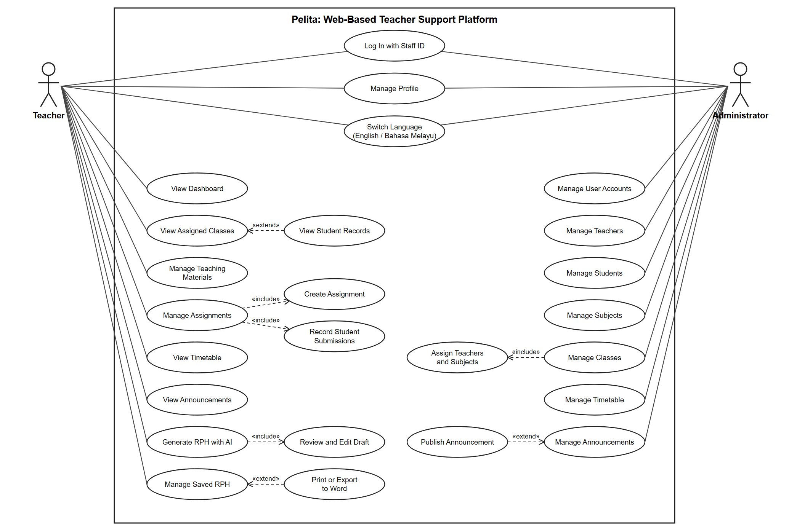
Figure 3.4.1: Use Case Diagram

The Use Case Diagram illustrates the interactions between the two primary actors of Pelita: Teacher and Administrator. The diagram represents the main functionalities available to each actor and how they interact with the system.
The Teacher is responsible for activities concerning teaching. Teachers log in with their staff ID and see the dashboard. They can view their assigned classes and the student records of those classes, manage teaching materials, manage assignments, view the teaching timetable, view school announcements and manage their profile. Managing assignments includes creating assignments and recording student submissions. Teachers can also generate an RPH with AI assistance, which always includes reviewing and editing the draft, and they can print a saved RPH or export it to Microsoft Word.
The Administrator shall be in charge of the overall operation of the system. Administrators manage user accounts, teachers, students, subjects, classes, the timetable and announcements. Managing classes includes assigning teachers and subjects to each class. Both actors can log in, manage their profile and switch the interface language between English and Bahasa Melayu.
The relationships depicted using <<include>> are sub-functions that are mandatory and part of a higher-level process. For instance, managing assignments includes creating assignments and recording student submissions, and generating an RPH includes reviewing and editing the draft. The <<extend>> relationships are optional or additional functions, for example viewing student records from an assigned class, printing or exporting a saved RPH, and publishing an announcement.
In summary, the use case diagram shows at a high level the interactions between teachers, administrators, and Pelita that assist the management of teaching, academic administration, and organization of educational resources on a centralized platform .

- Data Flow Diagram

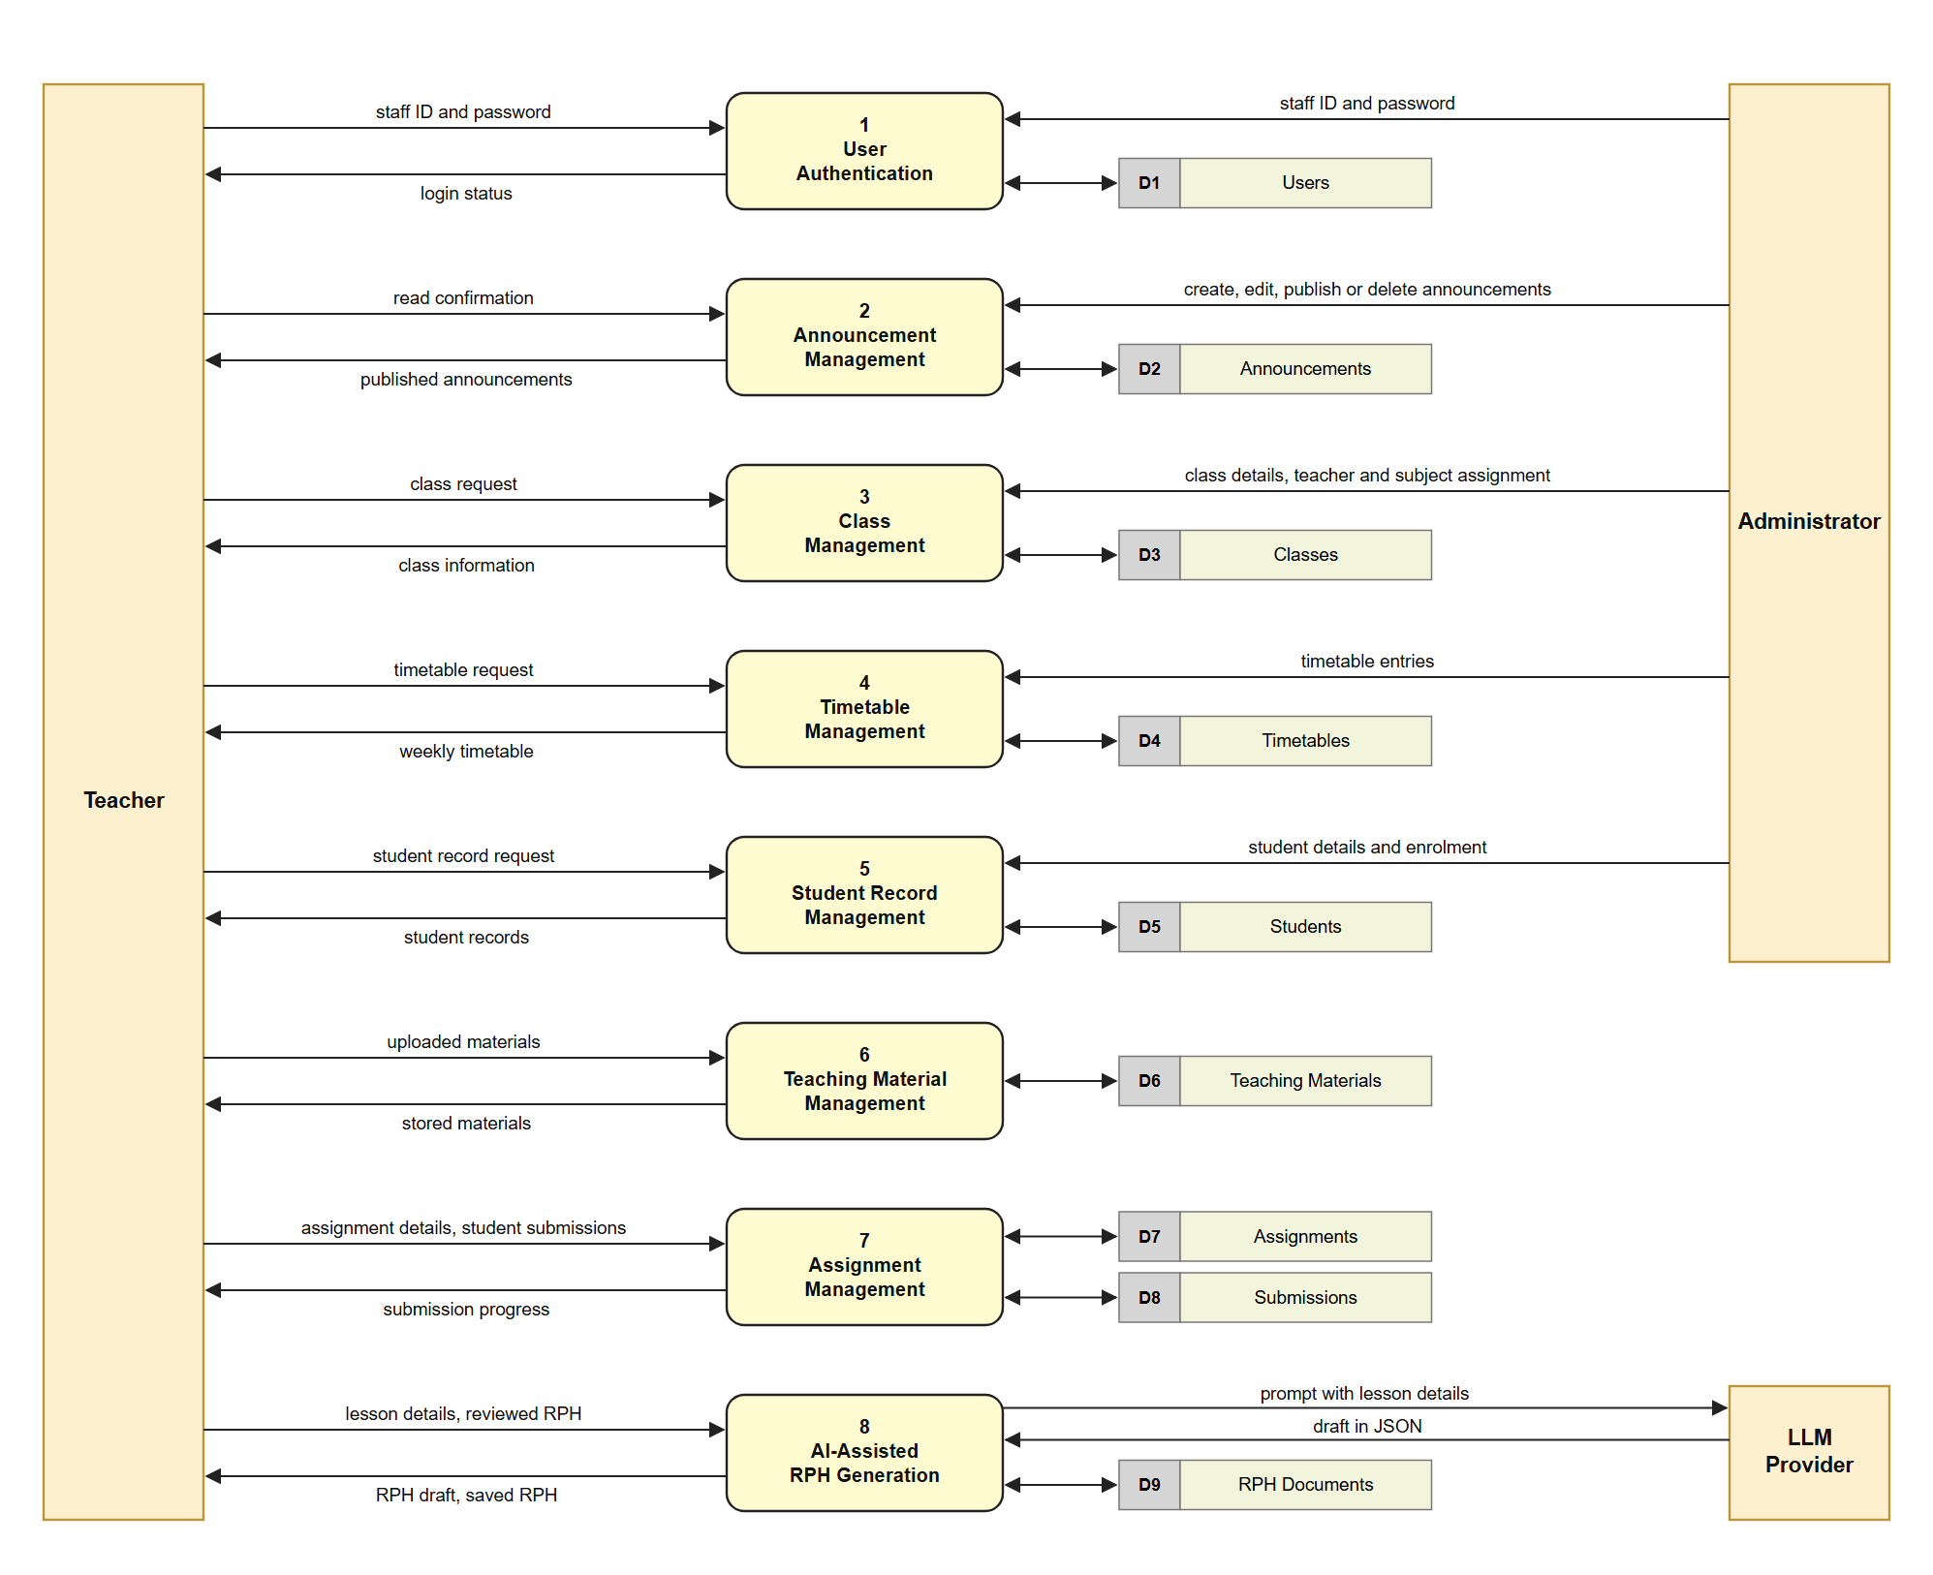
Figure 3.4.2: Data Flow Diagram

The Level 1 Data Flow Diagram illustrates the flow of data within Pelita between the external entities, which are the Teacher, the Administrator and the LLM provider, and the main system processes.
User Authentication checks the staff ID and password of teachers and administrators against the Users data store. Once authenticated, teachers are able to access the processes for Announcement Management, Class Management, Timetable Management, Student Record Management, Teaching Material Management, Assignment Management and AI-Assisted RPH Generation.
The Teaching Material Management process allows teachers to upload, retrieve and manage the educational resources stored in the Teaching Materials data store. The Assignment Management process allows teachers to create assignments and record student submissions, with assignment and submission data stored in their respective data stores.
Administrators create, edit, publish and delete school announcements through the Announcement Management process, and teachers view the published announcements. The AI-Assisted RPH Generation process takes the lesson details from the teacher, sends a prompt to the external LLM provider and receives a draft in JSON. The teacher reviews the draft, and only the reviewed RPH is stored in the RPH Documents data store.
Administrators use the Class Management, Timetable Management and Student Record Management processes to manage organizational information. These modules help in class assignments, timetable maintenance and student information management. Teachers can then see information about their teaching duties, for example classes, timetable details and student records.
Overall, the DFD shows that Pelita can integrate the administration of the teaching, academic administration and the management of the educational resources by interlinked processes and databases.

3.5 Database Design

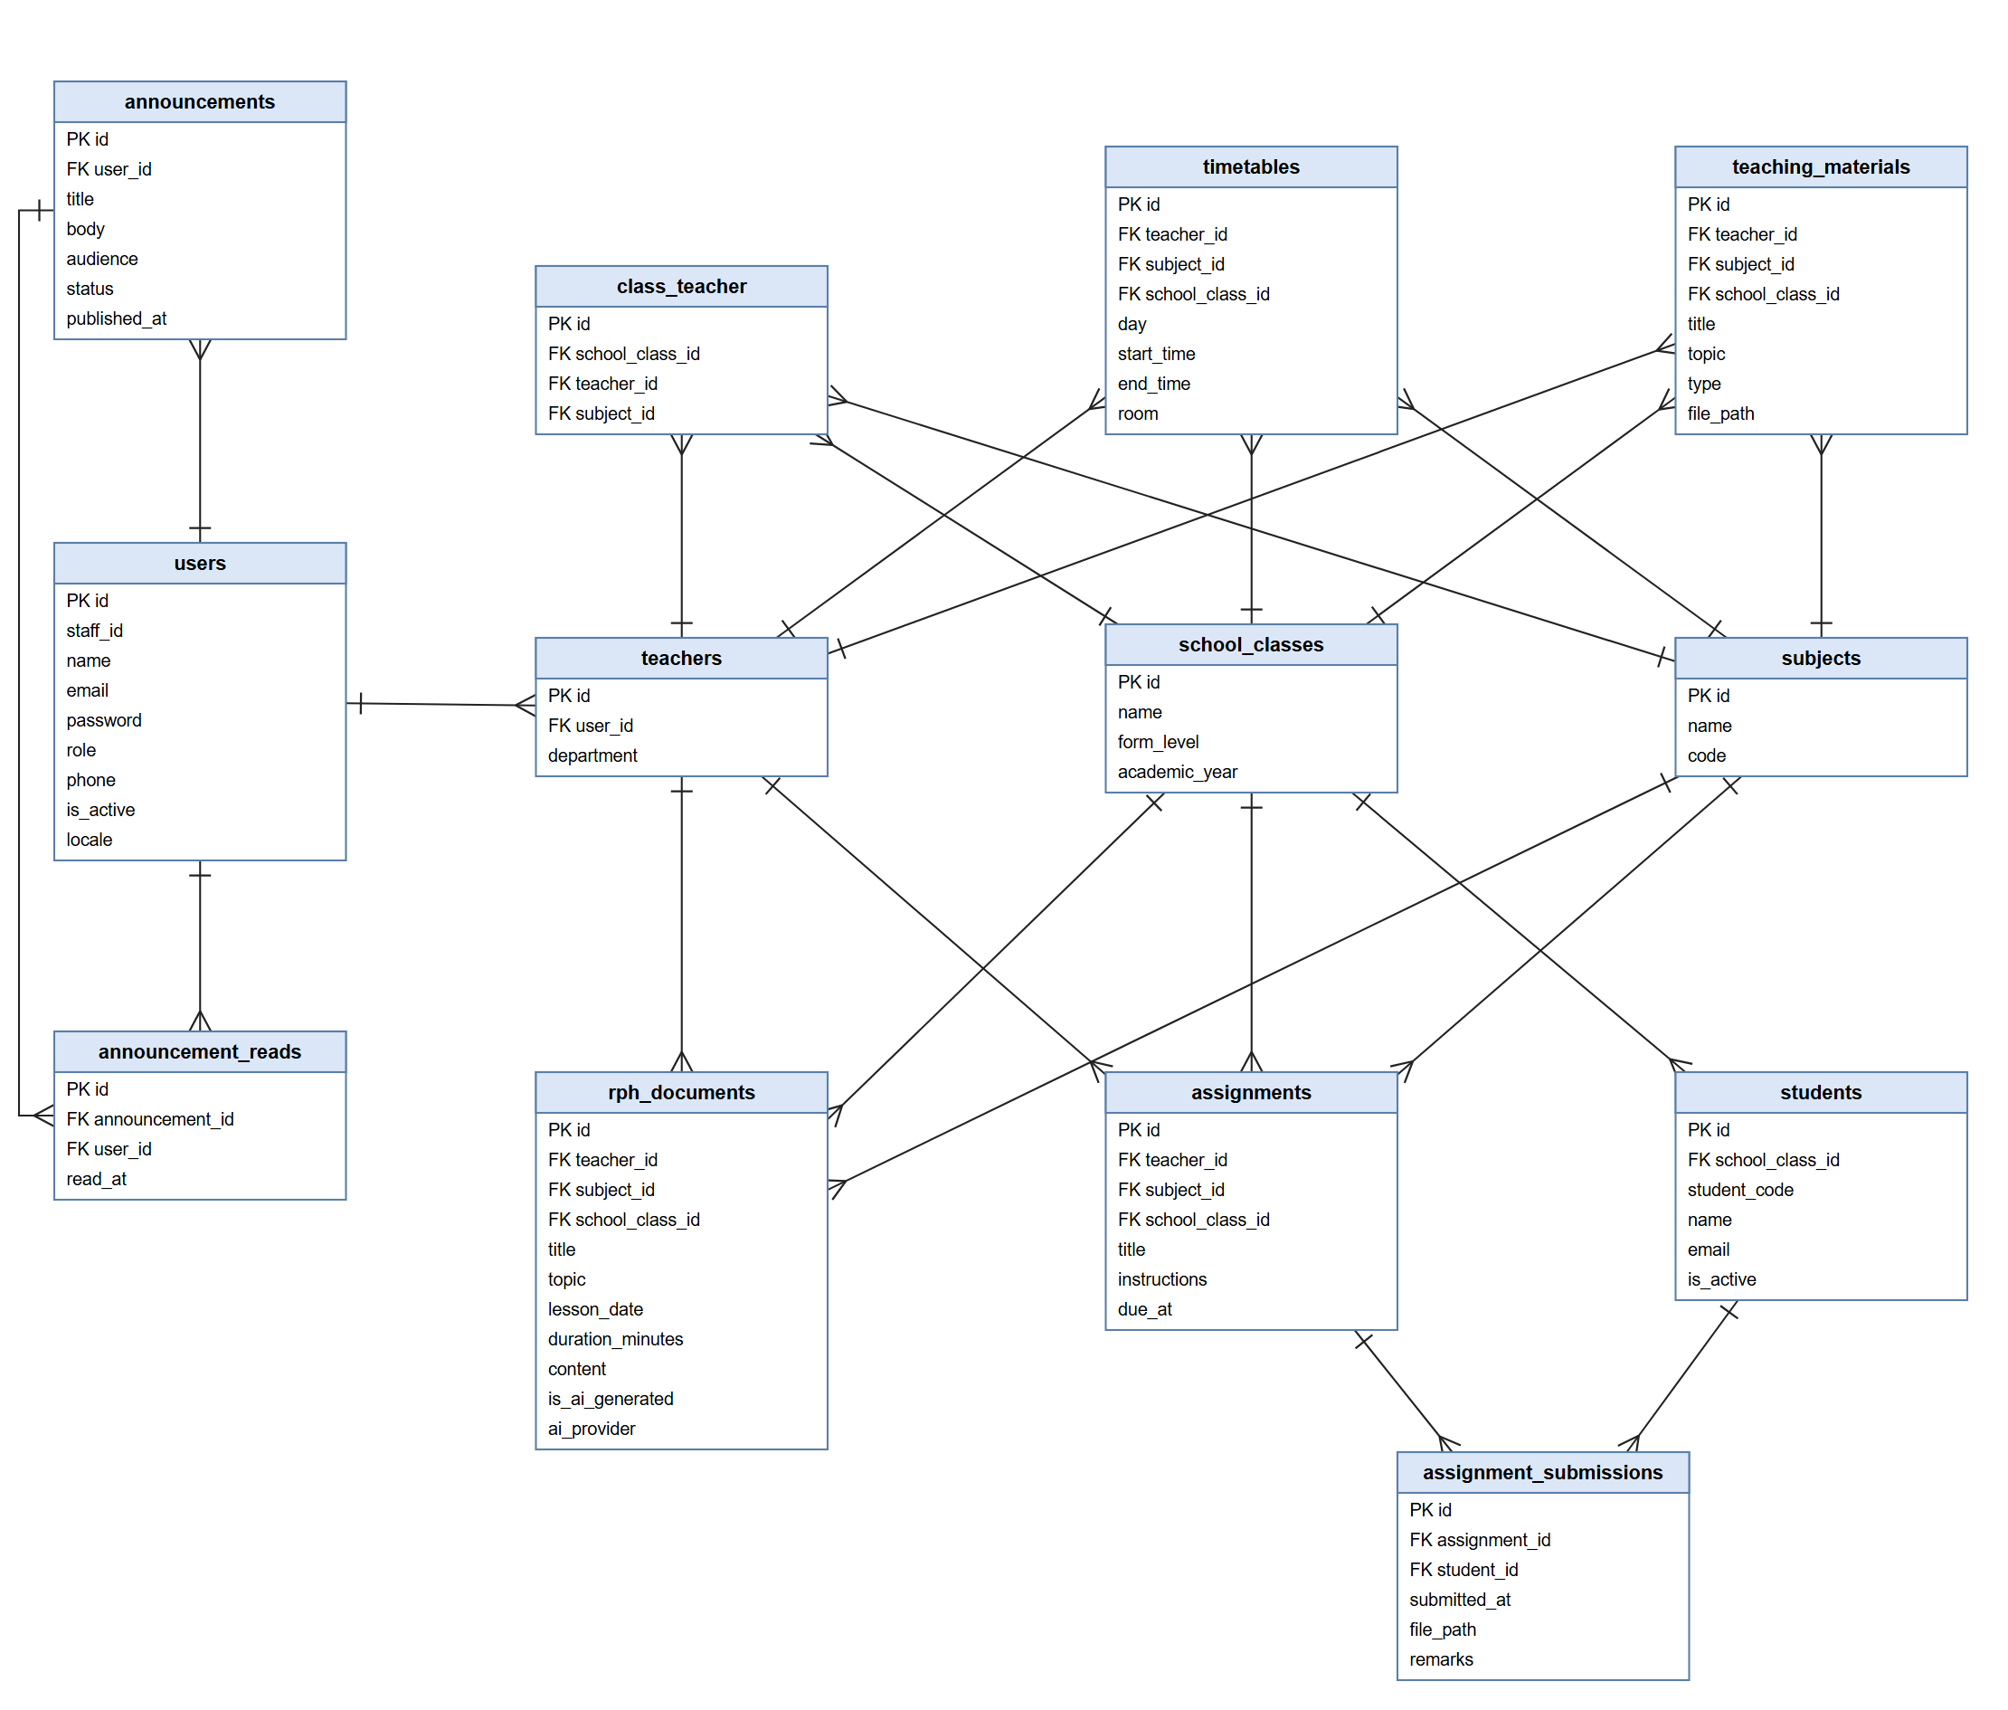
Figure 3.5.1: Entity Relationship Diagram

The Entity Relationship Diagram (ERD) of Pelita provides an overview of the structure of the database and the relations between the core entities of the system. It supports centralized teaching management, assignment handling, scheduling, announcement management and AI-assisted RPH generation.
The users entity is the main authentication entity. It holds the staff ID used for login, the name, email, password, role, phone number, active status and preferred language of each account. The role attribute separates administrators from teachers, so a separate admin entity is not needed.
Administrators are users with the administrator role. They create announcements, and each announcement is linked to the user who created it. The announcement_reads entity records which user has read which announcement.
The teachers entity extends a user account with the department of the teacher. Teachers are the core of the system and are associated with the class_teacher, timetables, teaching_materials, assignments and rph_documents entities.
The school_classes entity contains the class name, form level and academic year, and the subjects entity holds the subject name and code. The class_teacher entity links a class, a teacher and a subject, which records who teaches which subject to which class.
The students entity holds the student code, name, email and active status. Each student belongs to one class.
The assignments entity stores the assignments that teachers create, including the title, instructions and due date. Each assignment is associated with a teacher, a subject and a class.
The assignment_submissions entity stores the submission of a student for an assignment, including the submission date, file and remarks. It connects students and assignments.
The timetables entity contains the timetable information for teachers and classes, including the day, start time, end time and room. This helps the system to arrange the teaching schedules systematically.
The teaching_materials entity holds the educational resources uploaded by teachers, for example notes, slides and worksheets, with the title, topic, type and file location of each resource.
The rph_documents entity stores each saved RPH with its topic, lesson date, duration and content. It also records whether the RPH was generated with AI and which AI provider was used. An RPH is stored only after the teacher has reviewed the draft.
To conclude, the ERD shows the incorporation of the suggested system into one database system which includes administrative management, creating teaching procedures, assignments, scheduling, educational resource management, and AI-assisted RPH generation.

Prototype or Wireframes:

- Login Page
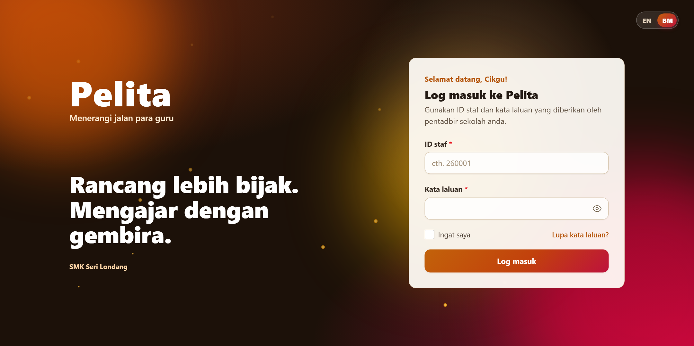
Figure 3.6.1: Pelita Login Page
The Pelita system starts with the login page. Users log in with their six-digit staff ID and password. The page shows the system name and a switch for changing the interface language between English and Bahasa Melayu.

- Dashboard Page
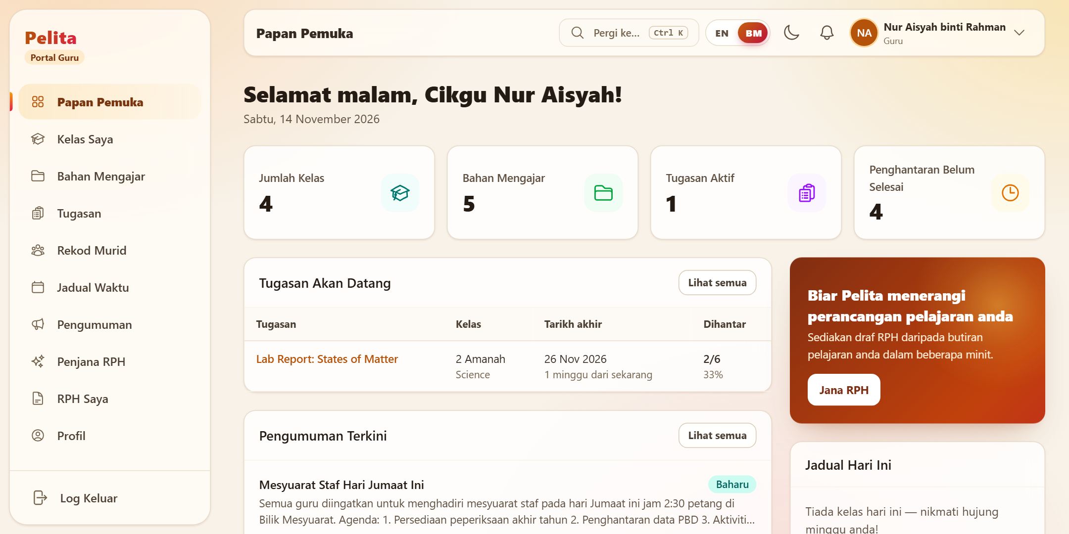
Figure 3.6.2: Pelita Dashboard

After login, the Dashboard is the main overview page. It greets the teacher and displays the number of classes, teaching materials, active assignments and pending submissions. The page also lists upcoming assignments, recent announcements and the timetable for the day, and gives quick access to the RPH generator.

- Notification

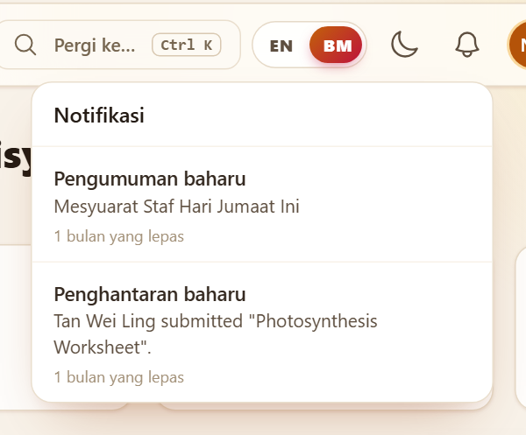
Figure 3.6.3: Pelita Notification
The Notification feature shows recent alerts in a dropdown from the bell icon in the top bar. Notifications include new announcements, new student submissions and assignments that are due soon.

- Mini profile
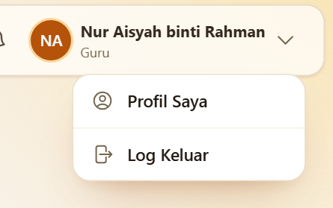
Figure 3.6.4: Pelita Mini Profile

The Mini Profile is a dropdown menu in the top bar that shows the name and role of the teacher. It gives fast access to the profile page and to the log out action.

- Announcement Page
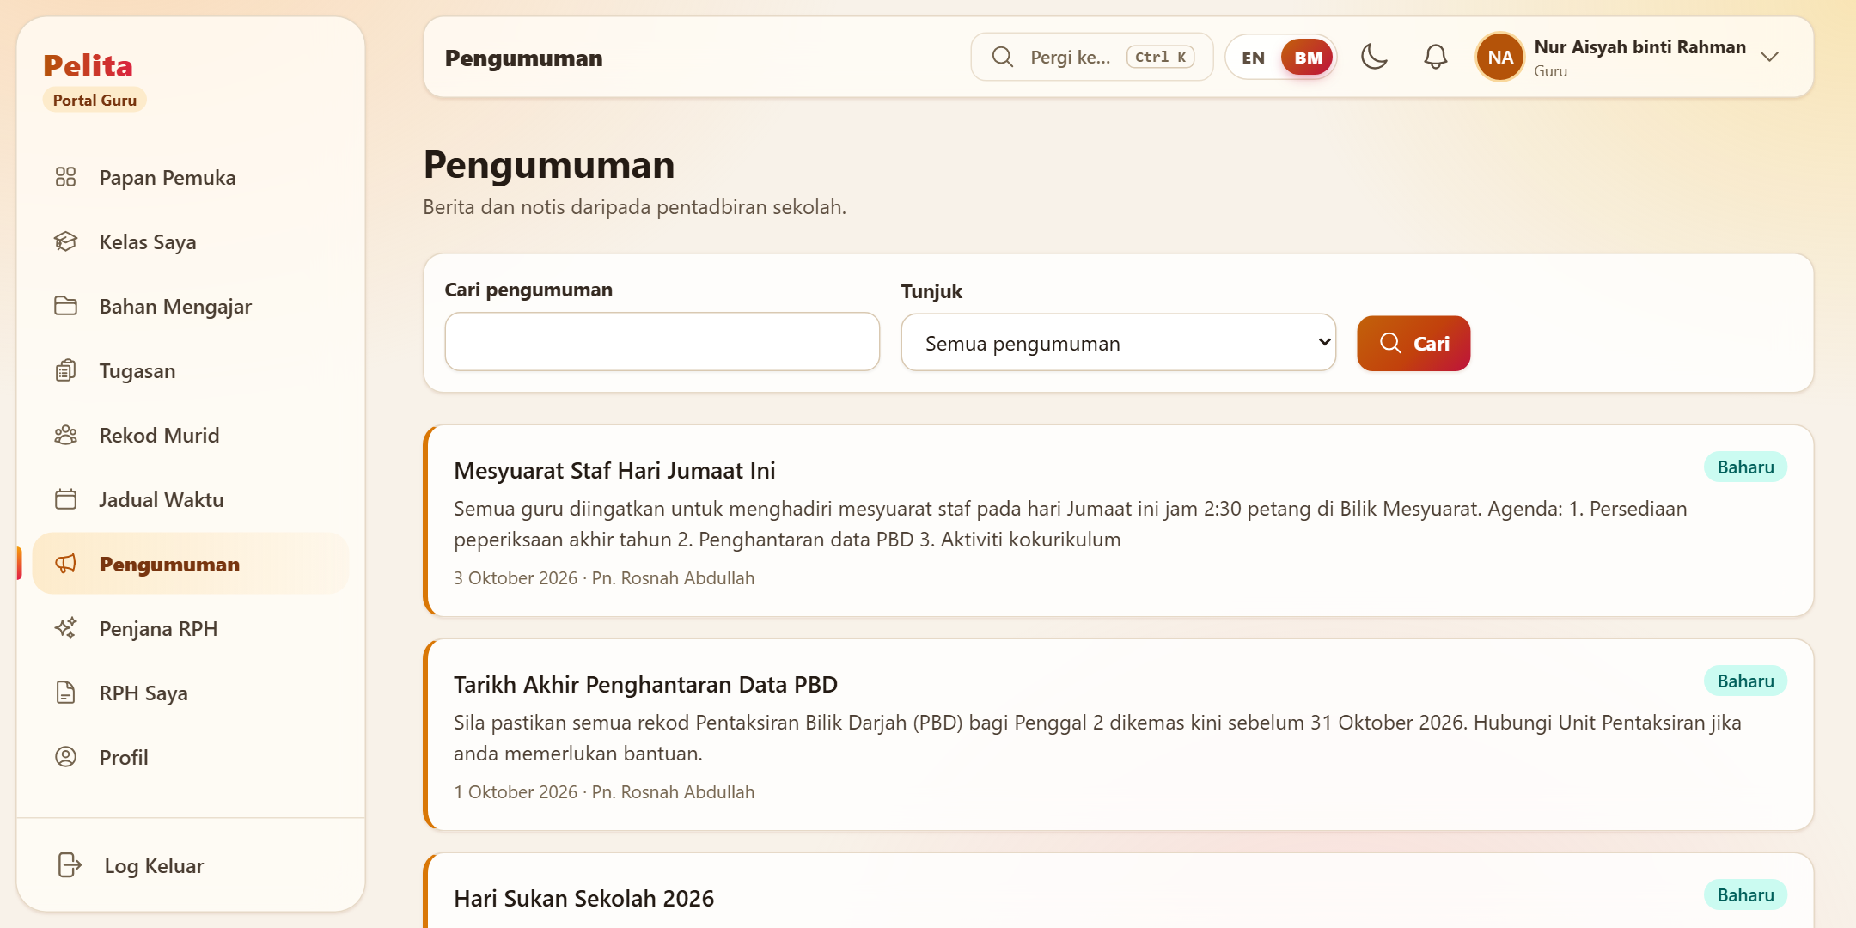
Figure 3.6.5: Pelita Announcement Page

The Announcement Page enables teachers to view official school announcements published by the administration. Teachers can search the announcements, new announcements are marked, and each announcement shows its date and the person who posted it.

- Class page
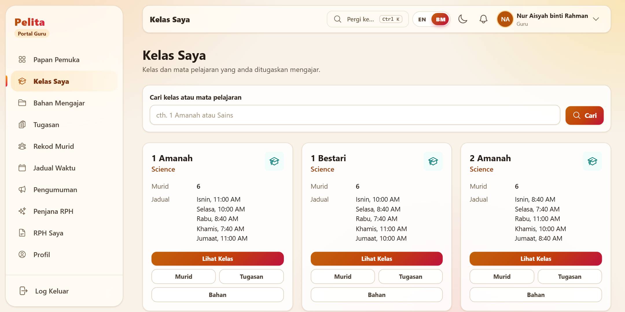
Figure 3.6.6: Pelita Class Page

The Class Page displays the list of classes assigned to the teacher. Each class card shows the class name, the subject taught, the number of students and the weekly schedule, with access to the student list, assignments and teaching materials of the class.

- Assignment Page
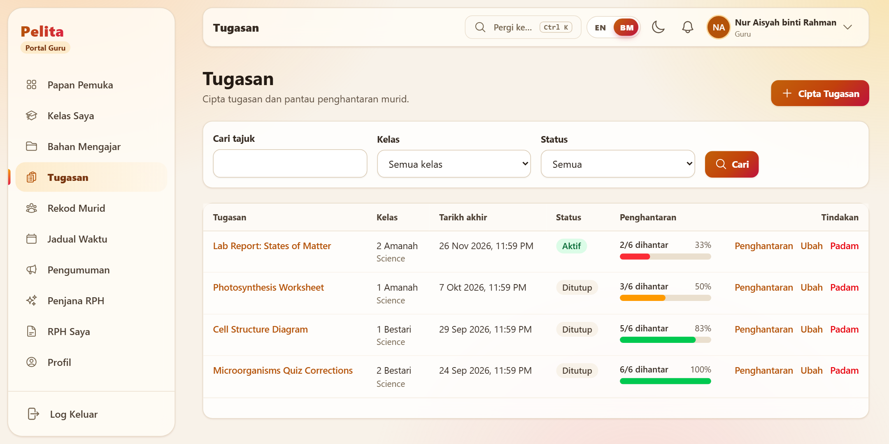
Figure 3.6.7: Pelita Assignment Page

The Assignment Page allows teachers to manage assignments for their classes. Teachers can create assignments, monitor submission progress, edit assignment details and filter the list by class and subject.

- Assignment submission list
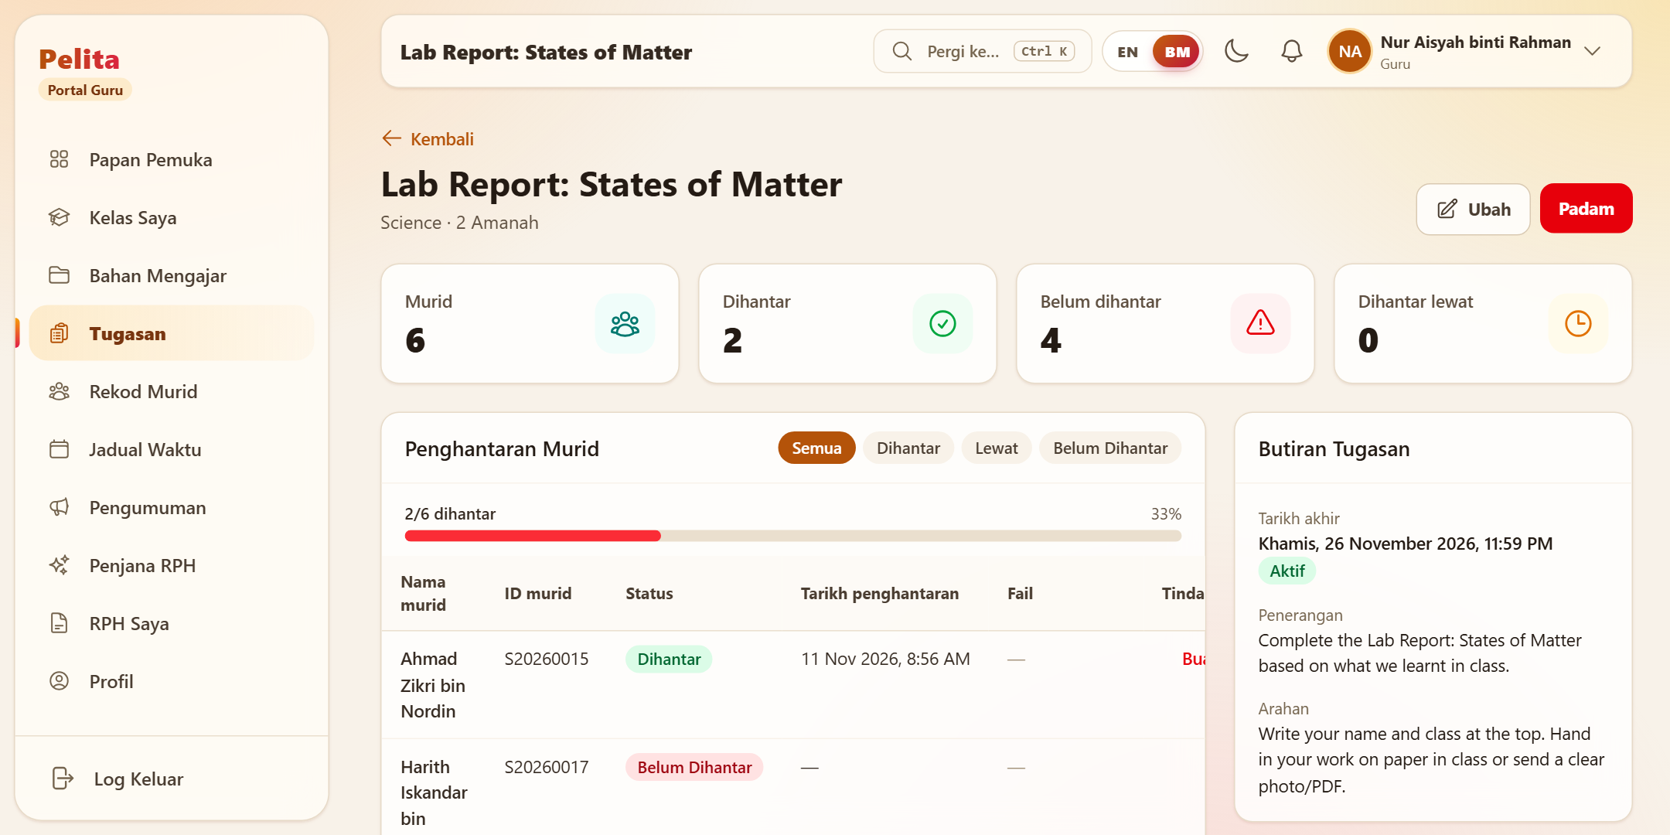
Figure 3.6.8: Assignment Submission List
The Assignment Submission List displays the submissions of the students for a selected assignment. Teachers can see who has submitted, who has not submitted and who submitted late, and can record a submission for a student.

- Add Assignment
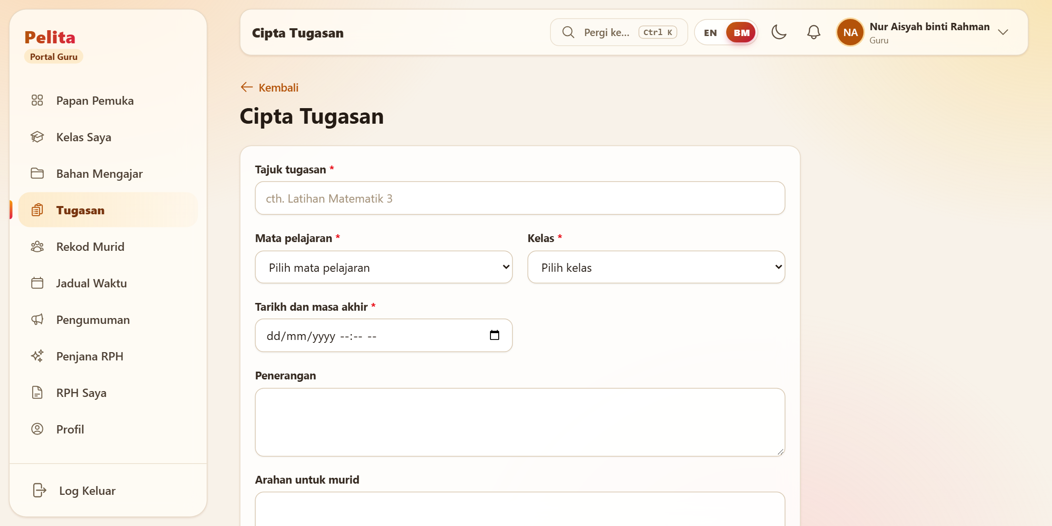
Figure 3.6.9: Add Assignment Feature

The Add Assignment module provides a form for teachers to create new assignments. Teachers enter the title, subject, class, due date, description and instructions, and can attach a supporting file.

- Schedule Page
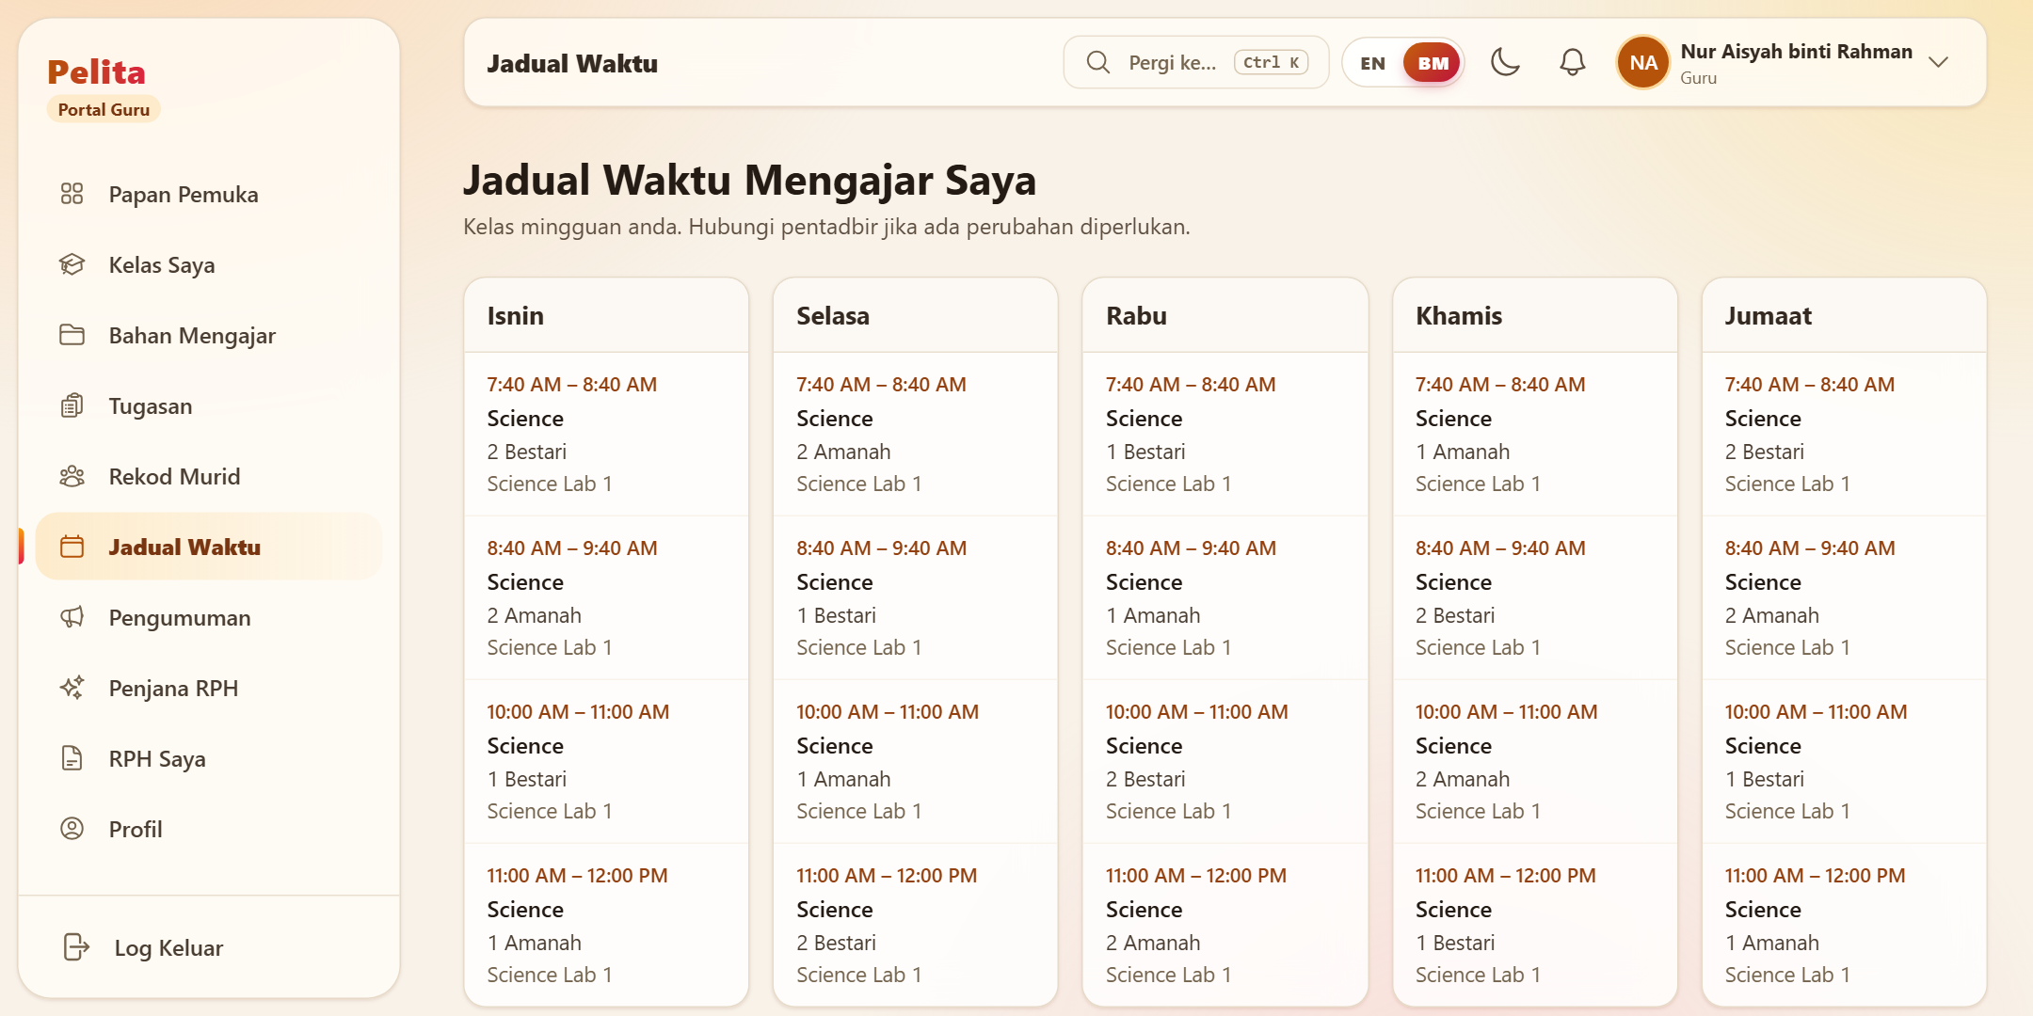
Figure 3.6.10: Pelita Schedule Page
The Schedule Page presents the weekly timetable of the teacher. It displays the teaching sessions for each weekday with the subject, class, time and room.

- AI RPH generator page

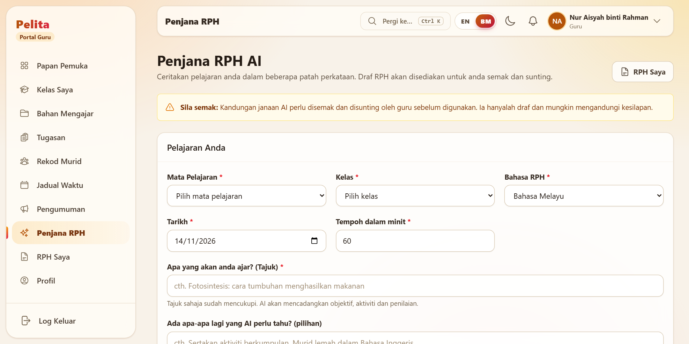
Figure 3.6.11: Pelita AI RPH Generator Page

The AI RPH Generator Page supports teachers in preparing the daily lesson plan. The teacher chooses the subject, class, language, date and duration and types the lesson topic. The AI then prepares a draft RPH with suggested objectives, activities and assessment, which the teacher reviews and edits before saving. A notice on the page reminds the teacher that AI-generated content must be checked.

- Profile Page

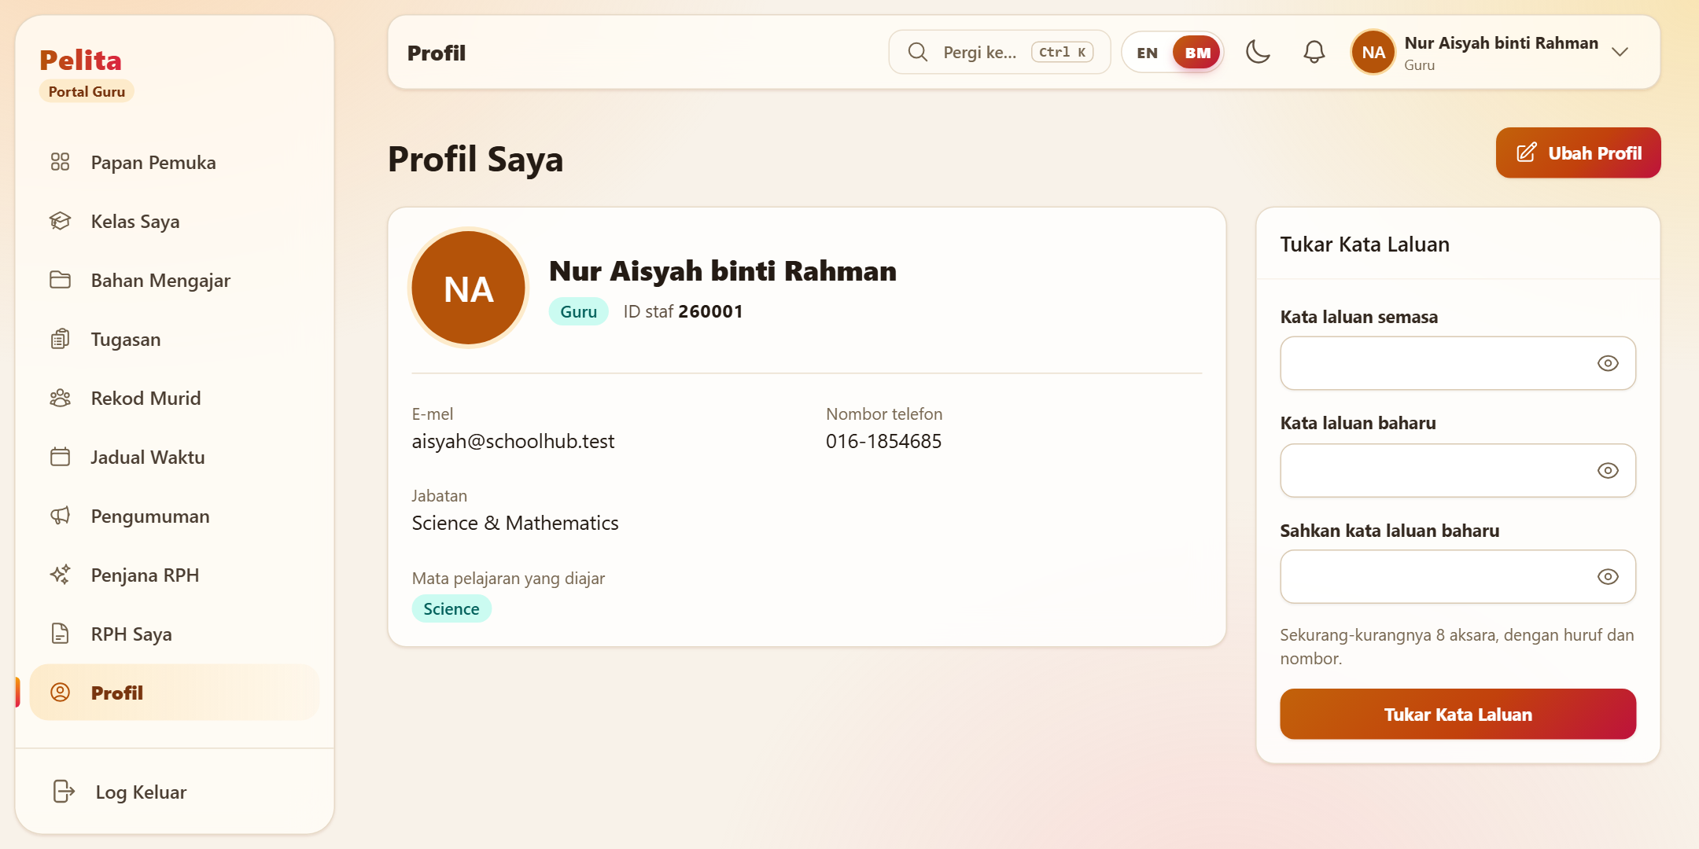
Figure 3.6.12: Pelita Profile Page

The Profile Page shows the personal and professional information of the teacher, including the name, staff ID, email, phone number, department and subjects taught. The teacher can edit the profile and change the password on this page.

Summary
In this chapter, a description of the methodology utilized in developing the proposed Pelita system will be provided. In particular, the project follows the Prototyping Model. Thus, the development process will consist of iterations, each one allowing for refinement of the system according to the results of evaluation and feedback from users. This approach works well to make sure that the system is as good as it can be in meeting the needs and expectations of teachers.

Moreover, in this chapter, the discussion concerning requirement specification and analysis is to be provided. Specifically, to specify what problems do teachers face in managing their teaching material, assigning tasks, making announcements, and providing other educational resources, interviews and observations will be conducted. Using this information, several design artifacts will be developed, including the Use Case Diagram, Data Flow Diagram (DFD), and Entity-Relationship Diagram (ERD).

Finally, to facilitate better understanding of the proposed system and its functionality, interface prototypes will be designed to illustrate how the application looks. The key features include the management of teaching material, assignments, schedules, and announcements, as well as teaching with the help of artificial intelligence. Thus, the design should consider not only usability but also simplicity, since different teachers can have various levels of computer literacy.

REFERENCES
- Wang, S., Yang, H., Li, W., & Zhao, Y. (2024). Artificial intelligence in education: A systematic literature review. Expert Systems with Applications, 252, 124167. https://doi.org/10.1016/j.eswa.2024.124167
- Garzón, J., Acevedo, J., & Baldiris, S. (2025). Systematic review of artificial intelligence in education. Applied System Innovation, 9(8), 84. https://www.mdpi.com/2414-4088/9/8/84
- Alfredo, R., Echeverria, V., Jin, Y., Yan, L., Swiecki, Z., Gašević, D., & Martinez-Maldonado, R. (2023). Human-centred learning analytics and AI in education: A systematic literature review. https://arxiv.org/abs/2312.12751
- Fitria, T. N. (2021). Artificial intelligence (AI) in education: Using AI tools for teaching and learning process. Prosiding Seminar Nasional. https://www.researchgate.net/publication/357447234_Artificial_Intelligence_AI_In_Education_Using_AI_Tools_for_Teaching_and_Learning_Process
- Demir, K. (2006). School management information systems in primary schools. The Turkish Online Journal of Educational Technology, 5(2), 32–45. https://files.eric.ed.gov/fulltext/EJ1102477.pdf
- Durnali, M. (2013). The contributions of E-School, a student information management system, to the data processes, environment, education and economy of Turkey. The Asian Conference on Technology in the Classroom 2013 Proceedings. https://papers.iafor.org/wp-content/uploads/papers/actc2013/ACTC2013_0233.pdf
- Forrester, V. V. (2019). School management information systems: Challenges to educational decision-making in the big data era. https://arxiv.org/abs/1904.08932
- U.S. Department of Education, Office of Educational Technology. (2023). Artificial intelligence and the future of teaching and learning. https://www.ed.gov/sites/ed/files/documents/ai-report/ai-report.pdf
- PINTARR. (2025). PINTARR: AI-powered lesson planning platform. Retrieved May 29, 2026, from https://pintarrph.com/
- Ministry of Education Malaysia. (2025). Digital Educational Learning Initiative Malaysia (DELIMa). Retrieved May 29, 2026, from https://delima.moe-dl.edu.my/
- iSAMS. (2025). School management information system (MIS). Retrieved May 29, 2026, from https://www.isams.com/platform/school-management-information-system-mis/
- RPH365. (2025). JanaRPH: AI-assisted lesson planning system. Retrieved May 29, 2026, from https://shop.rph365.com/janarph
- Google. (2025). Gemini API documentation. Retrieved May 29, 2026, from https://ai.google.dev/
- L. W. Xuan and N. B. M. Nasri, “Teachers’ Perceptions of DELIMa 2.0 in Teaching and Learning Process,” Int. J. Acad. Res. Progress. Educ. Dev., vol. 13, no. 4, Art. no. 4, Nov. 2024, doi: 10.6007/IJARPED/v13-i4/23164.

APPENDICES (System Development Project)
- GANTT CHART
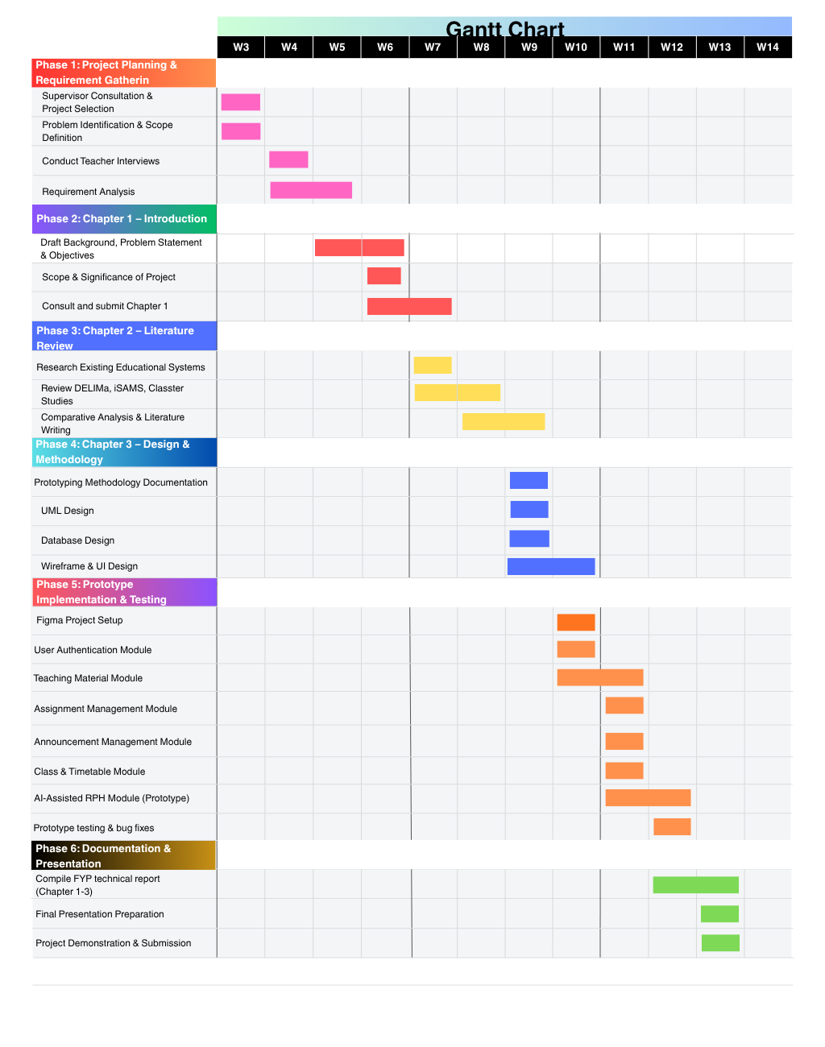

- DIVISION OF WORK (FOR GROUP PROJECTS).
Member 1: Muhammad Khalis Bin Mohd Zakaria
- Develop project idea and problem identification.
- Prepare Chapter 1 (Introduction), including background, problem description, objectives, scope, significance, and constraints.
- Conduct stakeholder interviews and requirement analysis.
- Prepare functional and non-functional requirements.
- Design Use Case Diagram and Data Flow Diagram (DFD).
- Design system prototype and user interface mockups.
- Prepare project poster and presentation materials.
Member 2: Anas Imran Bin Ismail
- Conduct literature review and collect related studies.
- Prepare Chapter 2 (Literature Review), including analysis of DELIMa, iSAMS, PINTARR, and Classter.
- Design Entity Relationship Diagram (ERD) and database structure.
- Prepare references, citations, and formatting according to APA style.
- Review and proofread the report for consistency and completeness.
Shared Responsibilities
- Prepare Chapter 3 (Methodology), including development approach, requirement specification, logical design, database design, and prototype documentation.
- Discussion and validation of project requirements.
- Review and refinement of diagrams and prototypes.
- Compilation and finalization of the complete report.
- Preparation for proposal presentation and Q&A session.

