 | Journal of Advanced Research in Social  and Behavioural Sciences  Journal homepage:  https://karyailham.com.my/index.php/jarsbs/index  ISSN: 2462-1951 | 

The Use of Generative AI to Support Teachers’ Lesson Planning Skills: Pelita, a Bilingual Web-Based Teaching Management System with a Human-in-the-Loop RPH Generator
Muhammad Khalis Bin Mohd Zakaria^{1,*}, Anas Imran Bin Ismail¹

¹ Department of Computer Science, Kulliyyah of Information and Communication Technology, International Islamic University Malaysia, Jalan Gombak, 53100 Kuala Lumpur, Malaysia

Given Name | Family Name | Email
1. Muhammad Khalis | 1. Bin Mohd Zakaria | 1. mkhaliszk@gmail.com
2. Anas Imran | 2. Bin Ismail | 2. anasimranismail.02@gmail.com

ARTICLE INFO | ABSTRACT
Article history:  Received  Received in revised form  Accepted  Available online  Keywords:  Daily lesson plan; generative artificial intelligence; teacher workload; human-in-the-loop; school management system | Teachers in Malaysian schools spend a considerable share of their working time on administrative tasks, including the daily lesson plan (Rancangan Pengajaran Harian, RPH) required by Surat Pekeliling Ikhtisas Bil. 3/1999. These plans are commonly prepared by hand or in scattered documents, which adds to teacher workload and leaves less time for instruction. Generative artificial intelligence (AI) can draft lesson plans quickly, but general-purpose chatbots do not follow the RPH format, are not linked to school data, and may produce inaccurate content that is used without review. This study aims to design and develop Pelita, a bilingual (English and Bahasa Melayu) web-based teaching management system that integrates an AI-assisted RPH generator in which the teacher remains responsible for the final plan. The system was developed through iterative prototyping on the Laravel framework, using a three-layer architecture, role-based access control for administrators and teachers, and a provider-independent large language model (LLM) interface that requests a structured draft aligned with the RPH requirements. Every generated draft is held for teacher review and is saved only after the teacher confirms it. Functional correctness was evaluated with an automated suite of 146 feature and unit tests containing 497 assertions, all of which passed. The implemented system supports the management of classes, students, timetables, announcements, teaching materials and assignments, and produces RPH documents that can be edited, printed and exported to Microsoft Word. The results show that a human-in-the-loop design can bring generative AI into routine teacher documentation without removing professional judgement. Future work will evaluate the usability and acceptance of the system with practising teachers.

1. Introduction

Teaching is widely recognised as a demanding profession. Beyond classroom instruction, teachers are expected to plan lessons, keep records, manage assessment and respond to administrative requests. Skaalvik and Skaalvik [1] found that time pressure is associated with emotional exhaustion and lower teacher self-efficacy, while Tuxford and Bradley [2] showed that emotional job demands contribute to emotional exhaustion among teachers. More recent work by Hu et al., [3] similarly links job demands to burnout, which suggests that reducing unnecessary administrative effort remains an important goal for school systems.
In Malaysia, one recurring documentation task is the daily lesson plan, known as Rancangan Pengajaran Harian (RPH). Surat Pekeliling Ikhtisas Bil. 3/1999 [4] requires teachers to record the learning objectives of each lesson, the activities used to achieve them, and how the teacher will judge the extent to which the objectives were achieved. Although the requirement is academically sound, preparing an RPH for every lesson is repetitive, and the plans are often written by hand or kept in separate documents that are not connected to other school information such as classes, subjects and timetables.
Artificial intelligence (AI) has been studied in education for many years. Reviews by Zawacki-Richter et al., [5] and Chen et al., [6] cover applications such as profiling, assessment and adaptive systems. Celik et al., [7] reviewed AI research specifically for teachers and noted that AI can support planning, implementation and assessment, while also raising concerns about teacher agency. The arrival of large language models (LLMs) such as ChatGPT has accelerated this interest. Kasneci et al., [8] described opportunities for LLMs to help teachers create teaching material, and reviews by Lo [9] and Rudolph et al., [10] reported both benefits and risks for teaching and assessment. Dwivedi et al., [11] further highlighted questions of accuracy, responsibility and ethics in the use of generative AI.
Lesson planning is one of the most direct uses of generative AI for teachers. van den Berg and du Plessis [12] discussed how ChatGPT can contribute to lesson planning and critical thinking in teacher education, and Appel et al., [13] provided experimental evidence on the effects of generative AI use and AI training on teachers’ lesson planning. Guan et al., [14] showed that teacher preparedness for AI-integrated education depends on perceptions and capabilities, not only on the availability of tools. At the same time, LLMs are known to produce fluent but incorrect content, a problem described as hallucination by Ji et al., [15]. For this reason, Holstein and Aleven [16] argue for designs in which AI complements rather than replaces educators, and Shneiderman [17] proposes human-centred AI that keeps people in control of consequential decisions.
Despite this interest, most reported uses of generative AI for lesson planning rely on general-purpose chatbots. These tools are not aware of the RPH structure required in Malaysian schools, are not linked to the teacher’s own classes and subjects, and do not enforce a review step before the content is used. There is therefore a gap for a school system that embeds AI-assisted RPH preparation within the teacher’s everyday work while keeping the teacher responsible for the final plan. Such a system is significant because it can reduce repetitive documentation effort, keep lesson plans consistent with school data, and support Bahasa Melayu as well as English. Accordingly, the objectives of this study are (i) to design a bilingual web-based teaching management system for administrators and teachers, (ii) to develop a human-in-the-loop AI-assisted RPH generator aligned with Surat Pekeliling Ikhtisas Bil. 3/1999, and (iii) to evaluate the functional correctness of the system through automated testing.

2. Methodology
2.1 System Development Approach

Pelita was developed using an iterative prototyping approach. Each iteration added one group of features, such as user management, teaching materials or the RPH generator, and was followed by automated tests for the new behaviour before the next iteration began. The system was implemented as a web application on the Laravel 13 framework with PHP 8.4, using Blade templates and Tailwind CSS for the interface and Vite for asset bundling. A relational database stores the school data; SQLite was used during development, and the schema is compatible with MySQL for deployment.
The overall architecture follows three layers, as shown in Figure 1. The presentation layer renders the pages for each user role in English or Bahasa Melayu. The application layer handles authentication, role checks, input validation and business logic, and the data layer stores records and uploaded files. The RPH generator communicates with an external LLM provider through an interface, so the provider can be changed without modifying the rest of the system.

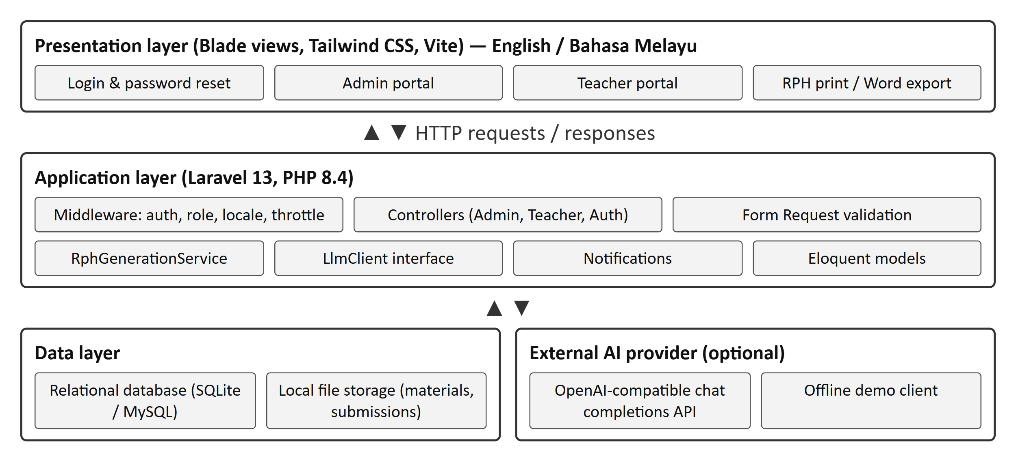
Fig. 1. Three-layer architecture of the Pelita system

2.2 User Roles and Functional Modules

Access to the system is controlled using role-based access control (RBAC), in which permissions are attached to roles rather than to individual users [18]. Pelita defines two roles, administrator and teacher, and every request passes through middleware that checks the user’s role before the controller is executed. Students do not log in; they are managed as records by administrators and teachers. The functional modules available to each role are summarised in Table 1.

Table 1
Functional modules by user role
Role | Modules
Administrator | Dashboard; user accounts (create, edit, activate or deactivate); teacher and student records; classes and class-teacher assignments; subjects; announcements (draft, publish, target audience); timetable
Teacher | Dashboard; assigned classes; teaching materials (upload, download); assignments and submissions; student records; timetable; announcements; RPH generator; saved RPH (edit, print, Word export)
All users | Login and password reset; profile and password change; notifications; English or Bahasa Melayu interface

2.3 AI-Assisted RPH Generation

The RPH generator follows the five-step workflow shown in Figure 2. The teacher first enters the lesson details: subject, class, topic, date, duration, learning objectives and output language, together with optional fields such as theme, unit, learning standards, teaching aids and prior knowledge. The input is validated, a teacher can only generate a plan for a class they teach, and generation requests are limited to ten per minute for each user to control cost and misuse.

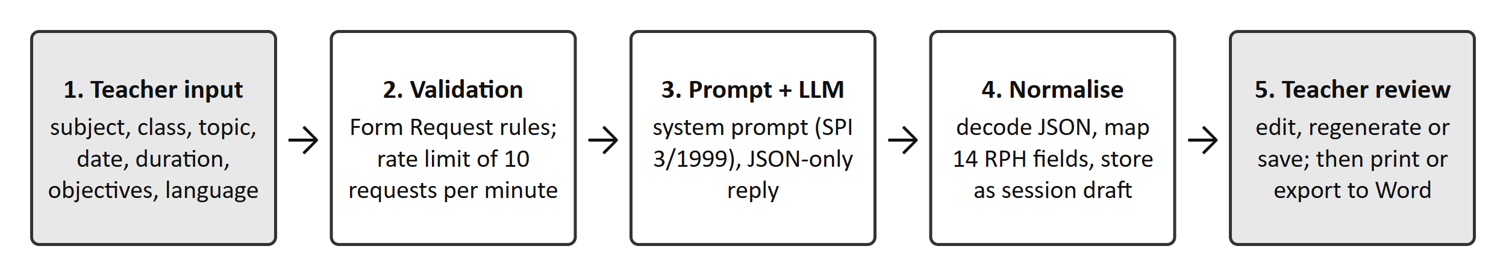
Fig. 2. Workflow of the human-in-the-loop RPH generator

The validated input is sent to the LLM together with a system prompt. The prompt instructs the model to generate a draft based only on the information provided, not to invent school-specific policies, and to align the objectives, activities and assessment. It also encodes the requirements of Surat Pekeliling Ikhtisas Bil. 3/1999 [4]: each learning objective must complete the phrase “Pada akhir pengajaran dan pembelajaran murid dapat:” using a measurable verb, and only learning standard codes supplied by the teacher may be used. The model must reply with a single JSON object containing 14 fixed fields, including learning objectives, learning standards, teaching aids, teacher activities, student activities, assessment and closure. The reflection field is deliberately left empty, because reflection can only be written by the teacher after the lesson.
The lesson stages in the generated plan must fit the lesson duration. If a lesson of duration T minutes is divided into k stages, such as set induction, development and closure, the stage durations t_{i} must satisfy Eq. (1).

$\sum_{i=1}^{k}{t_{i}}=T$ (1)

The reply is decoded, normalised into the RPH fields and stored as a temporary draft in the user’s session. Nothing is written to the database until the teacher reviews the draft and selects Save. The teacher can edit any field, regenerate the draft or change the lesson details. Each saved plan records whether it was AI-generated and which provider was used, and the interface shows a reminder that AI-generated content must be reviewed. This design keeps the teacher in control of the final plan, as recommended by Shneiderman [17] and by Holstein and Aleven [16], and reduces the risk of hallucinated content being used without checking [15].
The LLM client accepts any OpenAI-compatible chat completions endpoint, configured through environment variables. An offline demonstration client is also provided, which returns a fixed draft without a network connection or an API key. This allows the system to be demonstrated and tested without external dependencies.

2.4 Bilingual Interface

RPH documents in Malaysian schools are commonly written in Bahasa Melayu, while some subjects are taught in English. The interface therefore supports both languages. Each user’s language choice is stored in their profile and can be switched at any time from the page header. The output language of the RPH is chosen separately for each plan, and the generated document uses the standard Bahasa Melayu RPH headings, such as Mata Pelajaran, Kelas and Objektif Pembelajaran.

2.5 Testing Procedure

Functional correctness was evaluated using automated tests written with the Pest testing framework. Feature tests send HTTP requests to the application and check the responses, database records and access rules, while unit tests check individual components such as RPH content normalisation and translation. The tests run against an isolated in-memory SQLite database, and the RPH tests use the offline demonstration client or a simulated provider response, so the results do not depend on an external AI service. The pass rate, PR, was calculated using Eq. (2)

$PR=\frac{N_{pass}}{N_{total}}×100\%$ (2)

where N_{pass} is the number of passed tests and N_{total} is the total number of tests executed.

3. Results
3.1 Implemented System

The implemented system was run locally and populated with demonstration data for a secondary school, consisting of one administrator, four teachers, five subjects, and a set of classes and students. Figure 3 shows the login page and the teacher dashboard. After logging in, each user is directed to the dashboard for their role. The teacher dashboard summarises the number of classes, teaching materials, active assignments and pending submissions, and lists upcoming assignments, recent announcements and the day’s schedule.

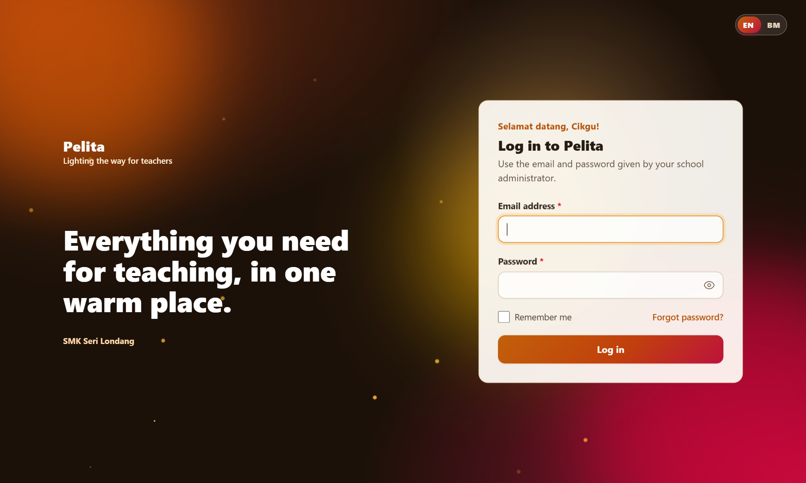  (a) | 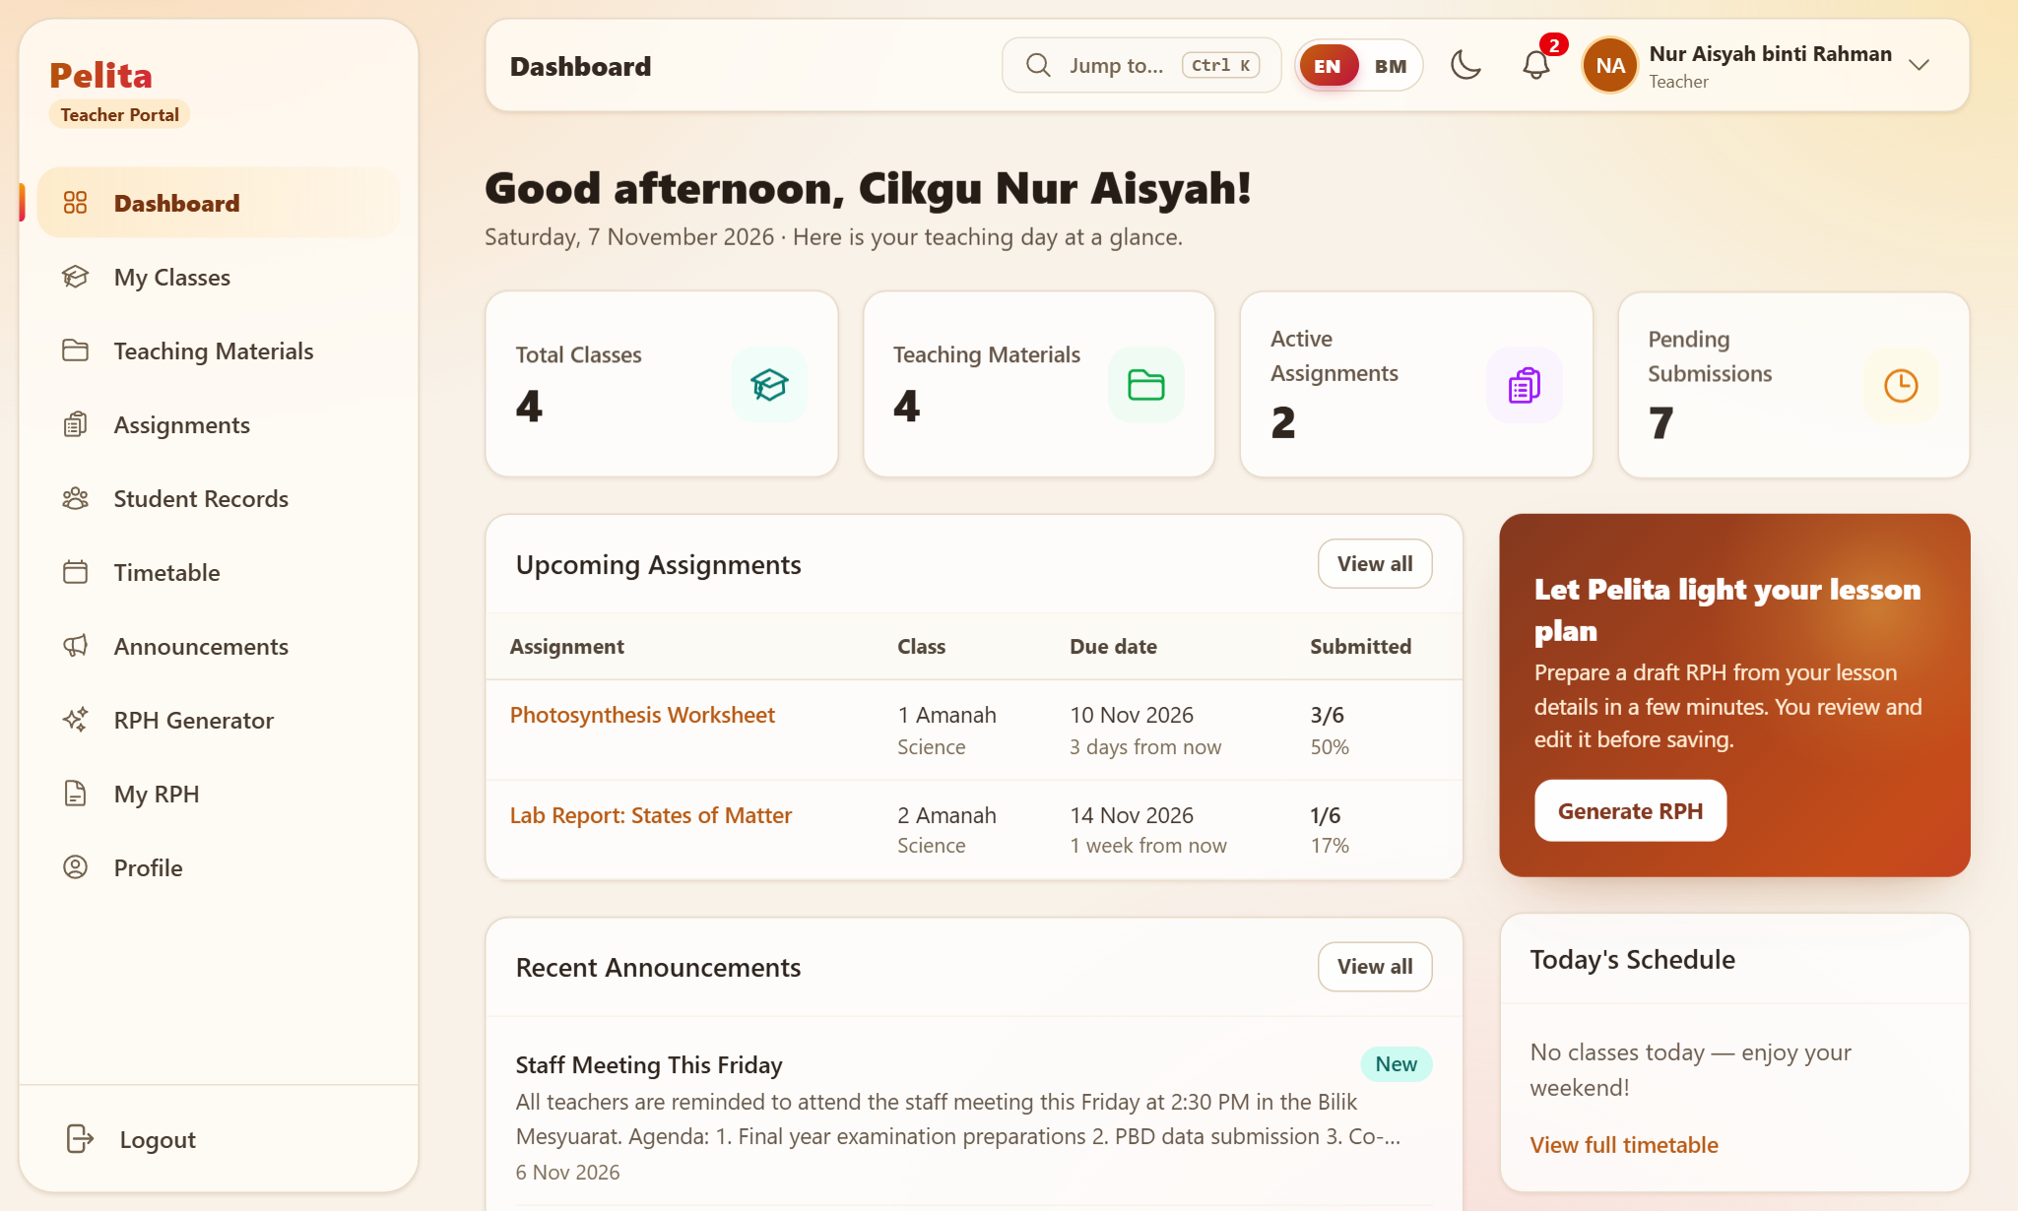  (b)
Fig. 3. Pelita user interface (a) Login page with the English and Bahasa Melayu language switch (b) Teacher dashboard

Figure 4 shows the RPH draft review page produced after a teacher requested a 60-minute Science lesson on photosynthesis for class 1 Amanah. The page states that nothing is saved until the teacher selects Save RPH and reminds the teacher that AI-generated content may contain mistakes. From this page the teacher can save the draft, regenerate it or return to change the lesson details.

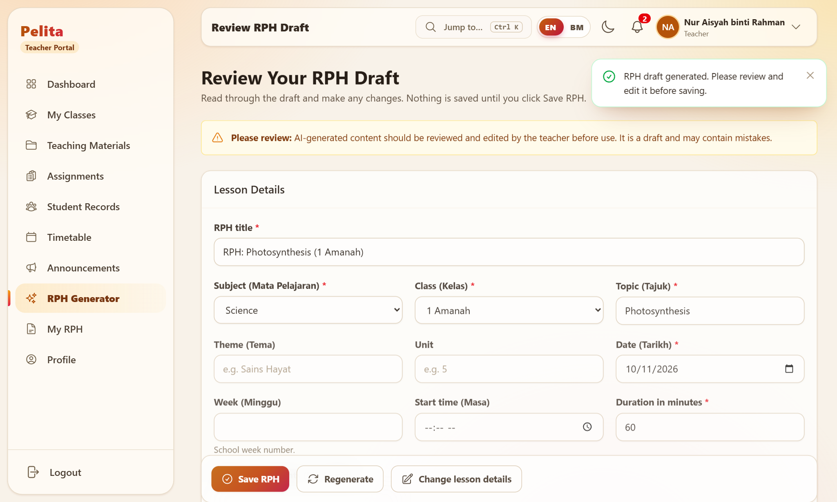
Fig. 4. RPH draft review page with the teacher review notice

Once saved, the RPH is presented in the standard Rancangan Pengajaran Harian layout shown in Figure 5. The header lists the subject, week, time, date, unit, class, theme, number of students, topic and teacher, followed by the learning standards and learning objectives. The same document can be printed or downloaded as a Microsoft Word file.

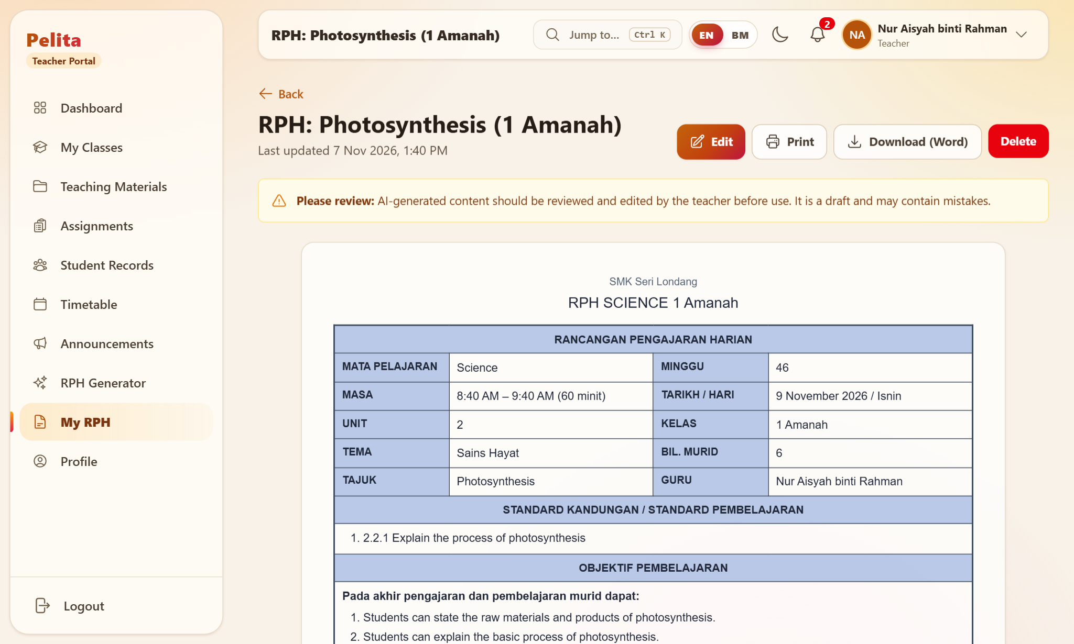
Fig. 5. Saved RPH document in the standard RPH layout

3.2 Functional Testing

The complete test suite was executed on PHP 8.4. Table 2 summarises the results by test suite. A total of 146 tests containing 497 assertions were executed in about 43 seconds, and all of them passed. Applying Eq. (2) gives a pass rate of 100%.

Table 2
Automated test results by test suite
Test suite | Area tested | Tests | Assertions
RphTest | RPH generation, review, saving, printing and export | 20 | 84
AdminManagementTest | Administrator management of users and school data | 23 | 56
LocaleTest | English and Bahasa Melayu switching and translations | 13 | 49
PageSmokeTest | All administrator and teacher pages render | 3 | 54
AuthenticationTest | Login, logout and password reset | 11 | 38
RoleAuthorizationTest | Role-based access control | 16 | 36
AssignmentTest | Assignments and submissions | 10 | 36
TeachingMaterialTest | Teaching materials | 9 | 33
AnnouncementTest | Announcements and target audiences | 8 | 32
TimetableTest | Timetable management | 8 | 24
BladeTranslatorTest (unit) | Interface translation | 12 | 17
ProfileTest | Profile and password change | 5 | 16
TeacherDashboardTest | Teacher dashboard | 4 | 12
RphContentTest (unit) | RPH content normalisation | 2 | 7
ExampleTest (feature, unit) | Framework examples | 2 | 3
Total |  | 146 | 497

The largest suite covers the RPH generator, with 20 tests and 84 assertions. These tests verify that a generated draft is stored in the session for review and not in the database, that invalid input is rejected, that a teacher cannot generate a plan for a class they do not teach, that a provider failure shows a clear error while keeping the form input, that replies which are not valid JSON are rejected, and that the printed plan follows the standard RPH layout. The role authorisation suite of 16 tests confirms that teachers cannot reach administrator pages, that administrators cannot reach teacher-only pages, and that a teacher cannot open classes, students or records belonging to other teachers, which is the behaviour expected of RBAC [18].

3.3 Discussion

The results show that AI-assisted lesson planning can be built into a school system rather than used through a separate chatbot. Compared with the general-purpose tools discussed by Kasneci et al., [8] and van den Berg and du Plessis [12], Pelita already knows the teacher’s subjects and classes, structures its output in the RPH format, and requires a review step before any content is stored. This addresses the concern raised by Ji et al., [15] that generated text may be fluent but wrong, because a teacher must read and confirm every draft. However, passing functional tests does not show that teachers find the system useful or easy to use. Acceptance of a new technology depends on perceived usefulness and perceived ease of use [19,20], and these factors have been confirmed for teachers in a meta-analysis by Scherer et al., [21]. A usability and acceptance study with teachers is therefore still needed.

4. Conclusions

This study designed and developed Pelita, a bilingual web-based teaching management system that integrates a human-in-the-loop AI-assisted RPH generator for Malaysian teachers. The first objective was met through a three-layer Laravel system with role-based modules for administrators and teachers. The second objective was met through an RPH generator that produces structured drafts aligned with Surat Pekeliling Ikhtisas Bil. 3/1999, holds each draft for teacher review, and lets the teacher print or export the final plan to Microsoft Word. The third objective was met through 146 automated tests with 497 assertions, all of which passed. This study is limited to functional evaluation with demonstration data, and the quality of the generated plans depends on the LLM provider selected. Future work will evaluate the system with practising teachers using the System Usability Scale [22] and a technology acceptance questionnaire [19], and will compare the time needed to prepare an RPH with and without the generator.

Acknowledgement
This research was not funded by any grant.

References
[1] Skaalvik, Einar M., and Sidsel Skaalvik. "Teacher self-efficacy and teacher burnout: A study of relations." Teaching and Teacher Education 26, no. 4 (2010): 1059-1069. https://doi.org/10.1016/j.tate.2009.11.001
[2] Tuxford, Linda M., and Graham L. Bradley. "Emotional job demands and emotional exhaustion in teachers." Educational Psychology 35, no. 8 (2014): 1006-1024. https://doi.org/10.1080/01443410.2014.912260
[3] Hu, Yingying, Gengxia He, and Wenjing Wang. "Profiles of Chinese teachers' emotional labor: Evolution and relations with job demands, resources, and burnout." Teaching and Teacher Education 132 (2023): 104230. https://doi.org/10.1016/j.tate.2023.104230
[4] Kementerian Pendidikan Malaysia. (1999). Surat Pekeliling Ikhtisas Bil. 3/1999: Penyediaan Rekod Pengajaran dan Pembelajaran. Kuala Lumpur: Kementerian Pendidikan Malaysia.
[5] Zawacki-Richter, Olaf, Victoria I. Marín, Melissa Bond, and Franziska Gouverneur. "Systematic review of research on artificial intelligence applications in higher education – where are the educators?" International Journal of Educational Technology in Higher Education 16, no. 1 (2019): 39. https://doi.org/10.1186/s41239-019-0171-0
[6] Chen, Lijia, Pingping Chen, and Zhijian Lin. "Artificial Intelligence in Education: A Review." IEEE Access 8 (2020): 75264-75278. https://doi.org/10.1109/access.2020.2988510
[7] Celik, Ismail, Muhterem Dindar, Hanni Muukkonen, and Sanna Järvelä. "The Promises and Challenges of Artificial Intelligence for Teachers: a Systematic Review of Research." TechTrends 66, no. 4 (2022): 616-630. https://doi.org/10.1007/s11528-022-00715-y
[8] Kasneci, Enkelejda, Kathrin Sessler, Stefan Küchemann, Maria Bannert, Daryna Dementieva, Frank Fischer, Urs Gasser, et al. "ChatGPT for good? On opportunities and challenges of large language models for education." Learning and Individual Differences 103 (2023): 102274. https://doi.org/10.1016/j.lindif.2023.102274
[9] Lo, Chung Kwan. "What Is the Impact of ChatGPT on Education? A Rapid Review of the Literature." Education Sciences 13, no. 4 (2023): 410. https://doi.org/10.3390/educsci13040410
[10] Rudolph, Jürgen, Samson Tan, and Shannon Tan. "ChatGPT: Bullshit spewer or the end of traditional assessments in higher education?" Journal of Applied Learning & Teaching 6, no. 1 (2023): 342-363. https://doi.org/10.37074/jalt.2023.6.1.9
[11] Dwivedi, Yogesh K., Nir Kshetri, Laurie Hughes, Emma Louise Slade, Anand Jeyaraj, Arpan Kumar Kar, Abdullah M. Baabdullah, et al. "Opinion Paper: 'So what if ChatGPT wrote it?' Multidisciplinary perspectives on opportunities, challenges and implications of generative conversational AI for research, practice and policy." International Journal of Information Management 71 (2023): 102642. https://doi.org/10.1016/j.ijinfomgt.2023.102642
[12] van den Berg, Geesje, and Elize du Plessis. "ChatGPT and Generative AI: Possibilities for Its Contribution to Lesson Planning, Critical Thinking and Openness in Teacher Education." Education Sciences 13, no. 10 (2023): 998. https://doi.org/10.3390/educsci13100998
[13] Appel, Philipp, Lukas Fervers, and Joachim G. Piepenburg. "Can AI help teachers? Experimental evidence on the effects of generative AI use and AI training on teachers’ lesson preparation." Computers and Education Open 11 (2026): 100427. https://doi.org/10.1016/j.caeo.2026.100427
[14] Guan, Lihang, Yue Zhang, and Mingyue Michelle Gu. "Pre-service teachers preparedness for AI-integrated education: An investigation from perceptions, capabilities, and teachers’ identity changes." Computers and Education: Artificial Intelligence 8 (2025): 100341. https://doi.org/10.1016/j.caeai.2024.100341
[15] Ji, Ziwei, Nayeon Lee, Rita Frieske, Tiezheng Yu, Dan Su, Yan Xu, Etsuko Ishii, Ye Jin Bang, Andrea Madotto, and Pascale Fung. "Survey of Hallucination in Natural Language Generation." ACM Computing Surveys 55, no. 12 (2023): 1-38. https://doi.org/10.1145/3571730
[16] Holstein, Kenneth, and Vincent Aleven. "Designing for human–AI complementarity in K‐12 education." AI Magazine 43, no. 2 (2022): 239-248. https://doi.org/10.1002/aaai.12058
[17] Shneiderman, Ben. "Human-Centered Artificial Intelligence: Reliable, Safe & Trustworthy." International Journal of Human–Computer Interaction 36, no. 6 (2020): 495-504. https://doi.org/10.1080/10447318.2020.1741118
[18] Sandhu, R.S., E.J. Coyne, H.L. Feinstein, and C.E. Youman. "Role-based access control models." Computer 29, no. 2 (1996): 38-47. https://doi.org/10.1109/2.485845
[19] Davis, Fred D. "Perceived Usefulness, Perceived Ease of Use, and User Acceptance of Information Technology." MIS Quarterly 13, no. 3 (1989): 319-340. https://doi.org/10.2307/249008
[20] Venkatesh, Viswanath, Michael G. Morris, Gordon B. Davis, and Fred D. Davis. "User Acceptance of Information Technology: Toward A Unified View." MIS Quarterly 27, no. 3 (2003): 425-478. https://doi.org/10.2307/30036540
[21] Scherer, Ronny, Fazilat Siddiq, and Jo Tondeur. "The technology acceptance model (TAM): A meta-analytic structural equation modeling approach to explaining teachers’ adoption of digital technology in education." Computers & Education 128 (2019): 13-35. https://doi.org/10.1016/j.compedu.2018.09.009
[22] Bangor, Aaron, Philip T. Kortum, and James T. Miller. "An Empirical Evaluation of the System Usability Scale." International Journal of Human–Computer Interaction 24, no. 6 (2008): 574-594. https://doi.org/10.1080/10447310802205776

