Determinants of Employment Status: Evidence from the European Social Survey
By : Khamidov Mirzakalonboy id : 474561

1. Hypotheses
In this research, I will investigate the socio-economic, demographic, and behavioral determinants that influence an individual's likelihood of being employed across Europe. This is a crucial economic problem with direct policy implications in labor market efficiency, education reform, and inequality reduction.
Main Research Question: What socio-demographic, economic, and attitudinal factors influence the employment status of individuals in Europe?
Main Hypothesis H1 : The probability of being employed is significantly affected by personal attributes such as education, age, gender, health, income, political trust, discrimination experience, and internet usage.
Sub-Hypotheses I am planning to use in my research :
- H1: Higher educational attainment ( years of schooling) increases employment probability.
- H2: Individuals with better self-reported health are more likely to be employed.
- H3: Females are less likely to be employed than males, controlling for other factors.
- H4: Those who experience discrimination have a lower chance of being employed.
- H5: Greater political and institutional trust correlates with a higher likelihood of employment.
- H6: Frequent internet use and social activity are positively associated with employment status.

2. Dataset and Descriptive Statistics
Data Source: European Social Survey (ESS) – Round 10 (202022022)
Source: ESS Data Portal
I will use from the European Social Survey (ESS), Round 10 (2020), which includes responses from over 30,000 individuals across Europe.
As dependent Variable I am going to choose : Employment status (pdwrk), treated as a binary variable—employed vs. not employed.
From the dataset, which contains over 600 variables, I have manually selected independent 50 variables based on theoretical significance and real-world evidence. These span the following categories:
- Demographics (agea, gndr, yrbrn, marsts, domicil)
- Education (eduyrs, edulvlb, eisced, edulvlpb)
- Economic status (hinctnta, hincfel, hincsrca)
- Health (health, hlthhmp)
- Social capital and connectivity (netusoft, netustm, sclmeet, sclact)
- Trust (trstprl, trstlgl, trstplc)
- Attitudes (loylead, ipmodst, happy, stflife)
- Discrimination (dscrgrp, dscrgnd)
- Household/partner variables (hhmmb, chldhhe, pdwrkp, mnactp)
- Employment-specific characteristics (wrkctra, emplrel, wkhtot, estsz, jbspv)
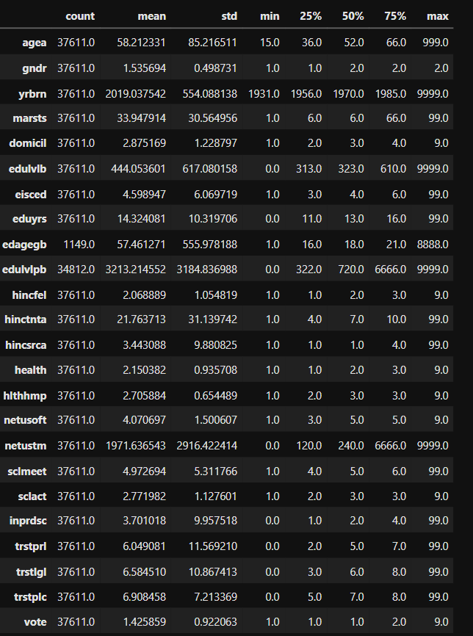
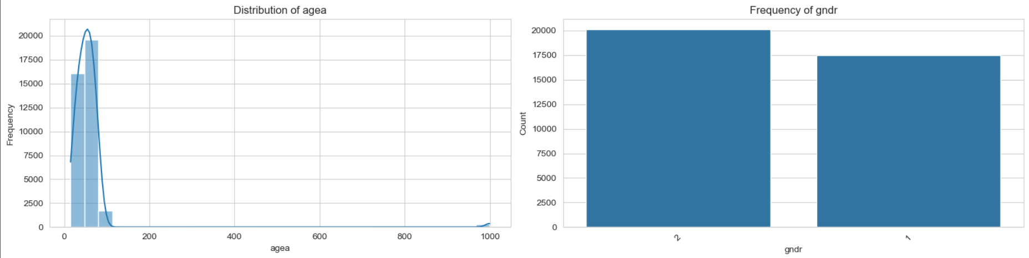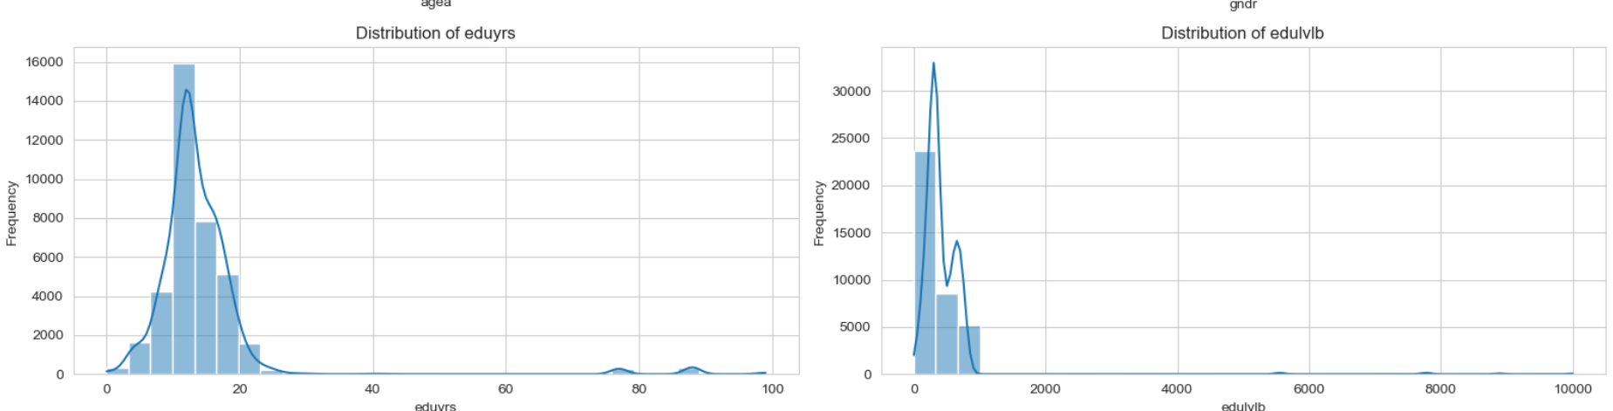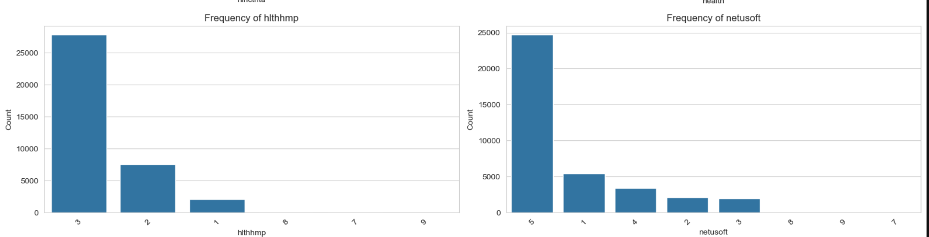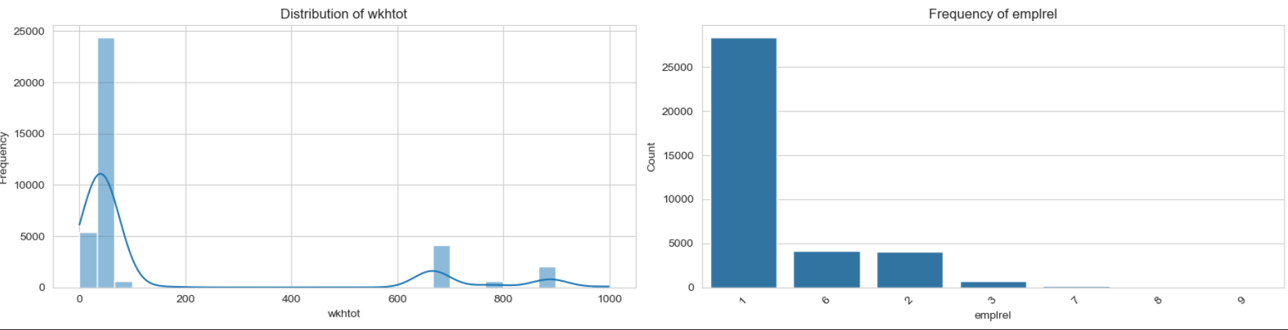
Here is the frequency of the main variable employment status (pdwrk)
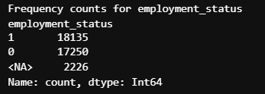

3. Econometric and Machine Learning Models
To test my hypotheses about the factors influencing employment status, I will use two main econometric models and one machine learning algorithm. These methods are suitable because my dependent variable is binary:
- 1 if the individual is employed
- 0 if the individual is not employed
All the independent variables I selected from the ESS dataset—such as education, age, gender, income, internet usage, and health—are either continuous or categorical, making these models well-suited for my analysis.

1. Binary Logistic Regression (Logit Model)
The first and primary model I will use is the binary logistic regression, also known as the logit model. This is a widely used econometric model for analyzing binary dependent variables. It estimates the probability that an individual is employed, based on a set of explanatory variables. The logit model is particularly useful for this research because it allows for straightforward interpretation of the effect of each variable on the odds of being employed. For example, it can tell us how much the odds of being employed increase with each additional year of education, or how those odds are affected by factors like gender or health status.
The logistic regression model equation:
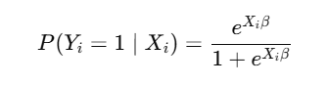
Y(i​) is the employment status of individual iii (1 if employed, 0 if not),
X(i) is a vector of explanatory variables for individual (i),
Β(beta) is a vector of coefficients that represent the estimated effect of each variable.
This model will be estimated using maximum likelihood estimation, and the results will allow me to directly test each of my hypotheses by examining the sign, size, and statistical significance of the coefficients.
2. Probit Regression Model
To ensure the robustness of my findings, I will also estimate a probit regression model, which is another popular approach for binary outcome analysis. The main difference between the probit and logit models lies in the underlying assumption about the distribution of the error terms. While the logit model assumes a logistic distribution, the probit model assumes a standard normal distribution. The probit model is useful in cases where the normality assumption may be more appropriate or where I want to compare the sensitivity of my results to different model specifications.
The probit model is defined as:
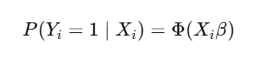
Φ(phi) represents here the cumulative distribution function (CDF) of the standard normal distribution.
X(i)​ and β are defined as above.
By comparing the results of the logit and probit models, I will be able to assess the consistency of my findings and validate the strength of the identified relationships.

3. XGBoost (Extreme Gradient Boosting) – Machine Learning Algorithm
In addition to the econometric models, I will apply XGBoost, a cutting-edge machine learning algorithm designed for high-performance classification tasks. XGBoost is based on the principle of gradient boosting, where multiple decision trees are trained sequentially. Each tree tries to correct the errors made by the previous one, allowing the algorithm to capture complex, nonlinear relationships between the features and the target variable. XGBoost is particularly well-suited for this research for several reasons: It automatically handles missing data, which is common in large survey datasets. It is highly accurate and efficient, especially with a large number of features (as in my dataset of 50 selected variables). It provides feature importance scores, helping identify which variables contribute most to predicting employment.
The model can be expressed in simplified form as:
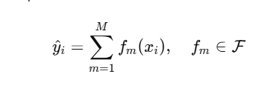
Unlike traditional models, XGBoost does not make assumptions about the functional form of the data. This flexibility allows me to identify intricate interactions and nonlinear effects that may be missed by econometric models.
In conclusion, the combination of logistic regression, probit regression, and XGBoost will allow me to statistically test my hypotheses (using Logit and Probit), interpret the relationships between variables and employment status, achieve high predictive accuracy and identify the most influential factors (using XGBoost). I am sure together, these models will answer to my main question of the research "What determines whether someone in Europe is employed or not?"

4. Literature I plan to explore for this Research
To build a strong theoretical foundation and guide the empirical analysis in my study on the determinants of employment status in Europe, I will explore a selection of key academic works. Each of these sources addresses a different dimension of labor market analysis—ranging from labor supply theory to poverty, education, and econometric methodology. Below is the list of literature I intend to review, along with the rationale for each:
1. Blundell, R., & MaCurdy, T. (1999)
Book/Chapter: Labor Supply: A Review of Alternative Approaches
Published in: Handbook of Labor Economics
Source : https://doi.org/10.1016/S1573-4463(99)03008-4
This foundational chapter provides an in-depth review of labor supply models and their empirical applications. It will help me understand how demographic and policy-related variables affect individuals' decisions to participate in the labor force—core to my hypotheses around employment status.

2. Nolan, B., & Whelan, C. T. (2011)
Book: Poverty and Deprivation in Europe
Publisher: Oxford University Press
Source : Link to Book
This book offers a comprehensive analysis of poverty, inequality, and social exclusion across European countries. It is particularly useful for interpreting variables related to income, living conditions, and social participation—all of which are linked to employment outcomes in my research.

3. Heckman, J. (1979)
Article: Sample Selection Bias as a Specification Error
Journal: Econometrica
This classic paper introduces the concept of sample selection bias and provides a correction method (Heckman selection model). I will use this to better understand potential biases in my dataset, especially since unemployed individuals may systematically differ from employed ones in unobserved ways.

4. DiPrete, T. A., & Eirich, G. M. (2006)
Article: Causal Inference with Panel Data
Journal: Annual Review of Sociology
Although my research is based on cross-sectional data, this paper will guide my understanding of causality and its challenges in labor market studies. It will help me reflect critically on the limitations of my findings and frame them within the broader literature on labor outcomes.

5. Goldin, C., & Katz, L. F. (2008)
Book: The Race Between Education and Technology
Publisher: Harvard University Press
This book examines the historical relationship between educational attainment and labor market performance. It directly supports my hypothesis that higher education increases employment chances, and will help contextualize the importance of education variables in my model.

