Exercise 1)

1. https://www.linkedin.com
2. 13.107.42.14:443
3. 6
4. 200 response
5. 2.6 mb
6. 496 ms

Exercise 2)

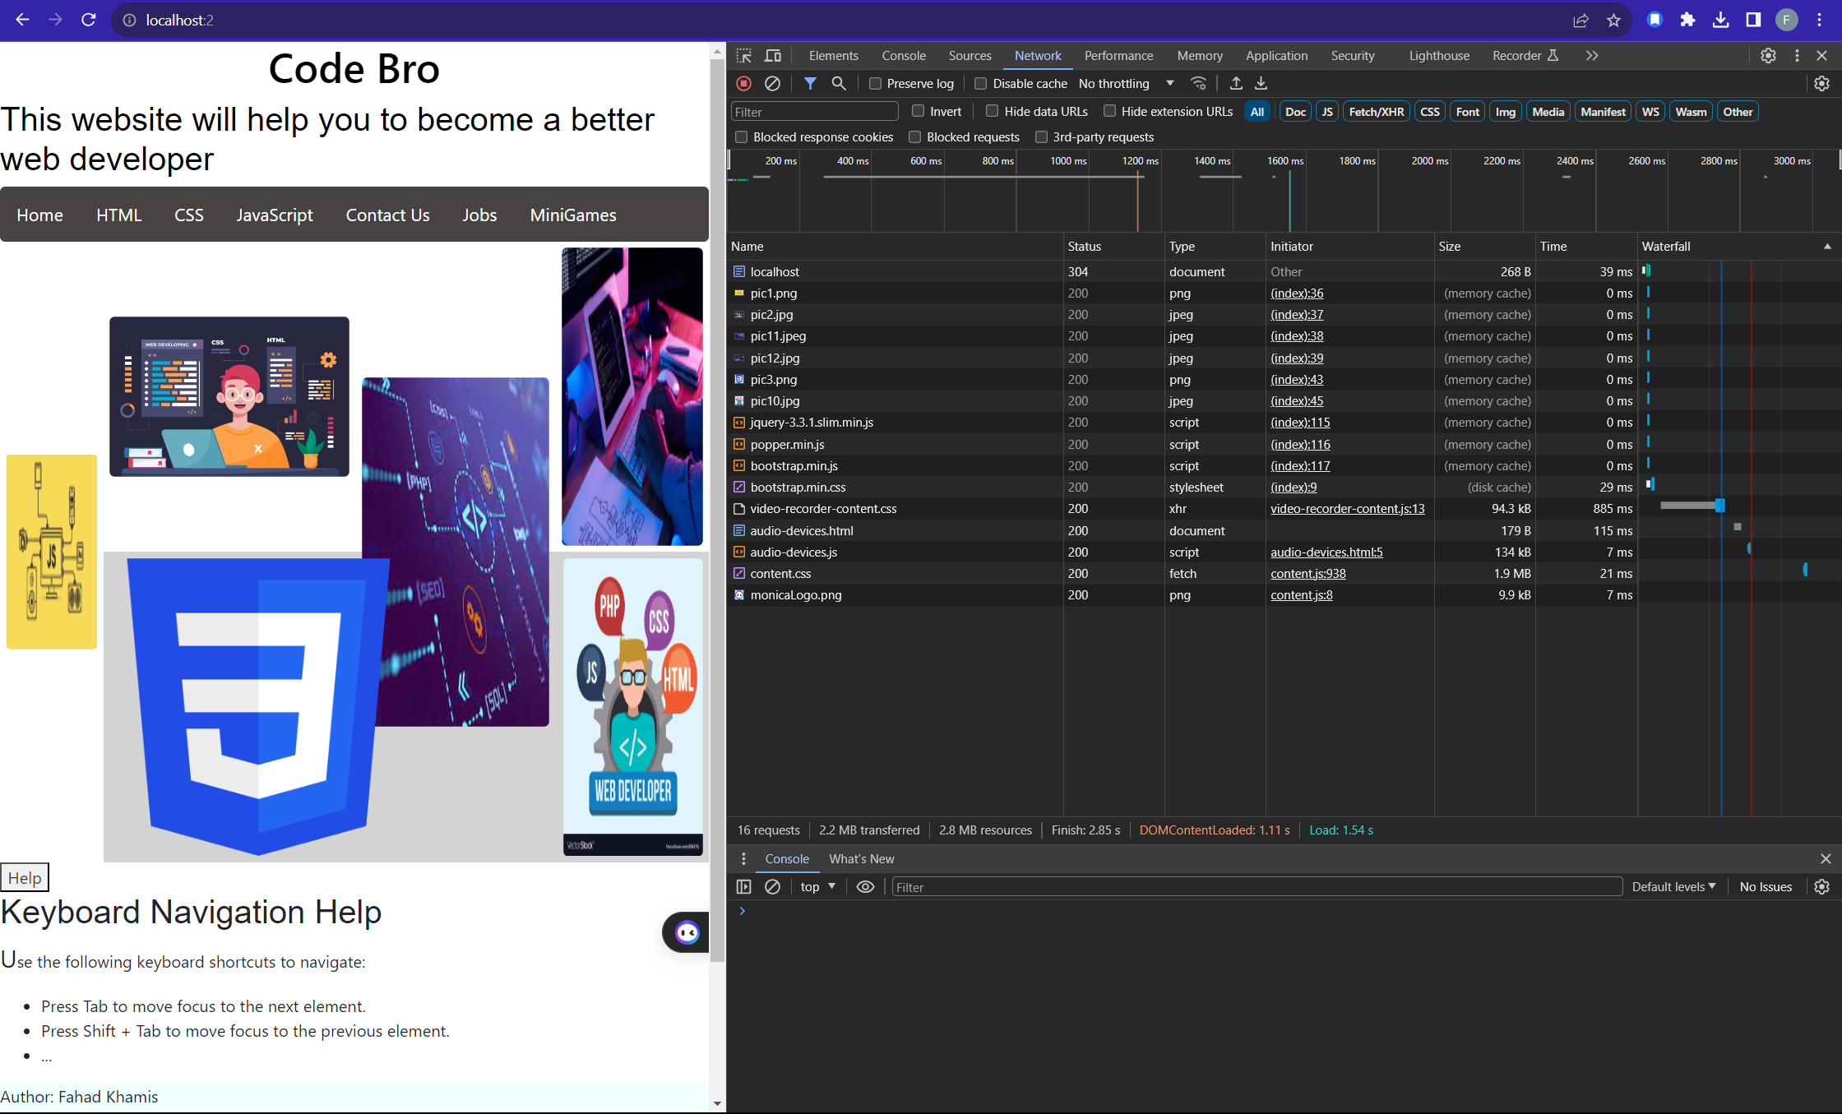

Exercise 3)

