Project Summary
The "Offense-Guard" project is a comprehensive and intelligent framework designed to address the critical challenge of offensive language detection and mitigation in Urdu and Roman Urdu within digital communication spaces. As digital interaction grows, particularly in regional and transliterated languages, traditional content moderation tools—primarily designed for standardized English—have proven inadequate in capturing the linguistic nuances, slang, and phonetic variations of Roman Urdu. This project bridges that gap by introducing a multi-tiered, real-time intervention system.
The core of the system is built upon a curated and consolidated dataset of over 80,000 samples, derived from multiple regional sources. We employ a novel hybrid architecture that combines the high-speed processing capabilities of Support Vector Machines (SVM) with the deep contextual understanding of Long Short-Term Memory (LSTM) networks. This dual-model approach ensures that simple offensive terms are flagged instantly, while complex, context-dependent abuse is captured through deep learning. The detection engine classifies text into four distinct categories: Neutral, Hate Speech, Abusive, and Offensive, providing a granular level of moderation that goes beyond binary "safe" or "unsafe" labels.
A key innovation of Offense-Guard is the "ReThink" intervention mechanism. Unlike traditional "report-after-harm" systems, our mobile application analyzes user intent in real-time. If offensive content is detected, the system triggers a preventive warning dialog, providing the user with a psychological nudge to reconsider their message before it is broadcasted. This proactive approach aims to reduce the overall volume of toxic content and encourage more constructive digital discourse.
Furthermore, the system incorporates an integrated administrative dashboard that facilitates "Human-in-the-Loop" active learning. Administrators can monitor real-time system statistics, verify user-reported feedback, and trigger model retraining cycles. This ensures that the system remains resilient against evolving digital slang and linguistic trends. Built using a modern technology stack—including React Native for the mobile client, Flask for the RESTful API, and MongoDB Atlas for cloud data storage—Offense-Guard represents a significant step forward in making digital platforms safer and more inclusive for the Urdu-speaking global community.

# Chapter 1

Introduction

#Chapter Overview
This chapter introduces the background, motivation, and problem statement of the project. It highlights the research gap and explains why this study is important. The chapter also outlines the objectives and structure of the work.

#1.1 Introduction
The digital era has revolutionized the way human beings interact, but it has also given rise to unprecedented levels of online harassment and toxic discourse. While global social media giants have invested heavily in automated content moderation for English, regional languages like Urdu remain significantly underserved. Urdu, with its rich morphology and dual script (Nastaliq and Roman), presents a unique challenge for Natural Language Processing (NLP). In Pakistan and North India, a vast majority of digital communication occurs in Roman Urdu—a phonetic transliteration that lacks standardized spelling. This linguistic "wild west" allows offensive language to bypass traditional keyword filters easily.
Offensive language detection is not merely a technical challenge but a social necessity. Studies have shown that constant exposure to hate speech leads to severe psychological distress. Traditional systems often rely on post-publication moderation, which acts after the harm has been inflicted. Our system, Offense-Guard, moves toward a preventive model. It analyzes the intent and sentiment of the user in real-time, providing an opportunity for the user to "ReThink" before the offensive content is broadcasted. By combining the high-speed processing of Support Vector Machines (SVM) with the contextual understanding of Long Short-Term Memory (LSTM) networks, we aim to provide a robust solution that understands the nuances of Urdu slang, sarcasm, and direct abuse.

#1.2 Significance of the Proposed System
The vision of this system is to bridge the gap between linguistic diversity and digital safety.
**For** Urdu and Roman Urdu speakers who interact on social media and messaging platforms,
**Who** are frequently exposed to unmoderated hate speech, cyberbullying, and toxic language due to the lack of regional language filters,
**The Offense-Guard System**
**Is** an AI-powered, real-time offensive language detection and intervention framework
**That** accurately identifies toxic content across four distinct categories and provides an immediate psychological intervention through a "ReThink" warning mechanism, preventing harmful content from being posted.
**Unlike** primary competitive alternatives like the Perspective API or generic keyword filters that fail to capture the nuances of non-standardized Roman Urdu and do not offer real-time user-side intervention,
**Our product** provides a localized, multi-model approach that combines a vast 80,000-sample dataset with a preventive UI, ensuring both high accuracy and proactive harm mitigation.

#1.3 Problem Statement
The proliferation of offensive language in Urdu and Roman Urdu has reached critical levels, yet existing moderation tools are largely ineffective due to several factors. Traditional systems are primarily designed for standardized English, making them blind to the phonetic variations and slang common in Roman Urdu where a single word like "bad" can be written in five different ways. Current digital platforms in Pakistan lack real-time preventive tools, relying instead on "Report" buttons that only work after the psychological damage is done. Manual moderation of the millions of messages generated daily is physically impossible and economically unfeasible. Furthermore, existing Urdu NLP research is often academic and lacks an integrated deployment pipeline that connects a trained model to a functional mobile or web interface. This gap between research and application means that users remain unprotected despite the existence of classification algorithms. The absence of an active learning loop also means that models become outdated as new offensive slang emerges. Our software system aims to solve these problems by providing a high-accuracy, real-time detection engine integrated into a user-friendly mobile application. This system will not only flag offensive content but will also educate users on their communication choices, ultimately reducing the volume of toxic content in the Urdu digital space.

#1.4 Scope and Objectives
The scope of the Offense-Guard project encompasses the end-to-end development of a language moderation ecosystem. It begins with the curation of a diverse dataset of 11 different sources, totaling over 110,000 raw samples, which are then cleaned and balanced into a unique 80,000-sample core. The system's boundaries include the development of a RESTful API that serves as the intelligence hub, a cross-platform mobile application for real-time user testing, and an admin dashboard for system maintenance. The detection engine is limited to text-based communication in Urdu and Roman Urdu, excluding image or voice analysis. It provides multi-class classification into Neutral, Abusive, Hate Speech, and Offensive categories using a hybrid SVM-LSTM model. The system also includes an active learning feedback loop where admins can verify user reports to continuously improve model accuracy. This project acts as a functional prototype demonstrating how AI can be used for preventive content moderation in regional languages.
The objectives of our proposed system are three-fold:
- **Reduce the prevalence of toxic digital discourse** by providing a 90% accurate real-time classification engine for Urdu and Roman Urdu.
- **Implement a preventive intervention mechanism** that successfully discourages at least 30% of users from posting offensive content through the "ReThink" warning.
- **Establish a sustainable data pipeline** that allows for the continuous improvement of the model through an integrated admin verification and retraining loop.

#1.5 System Limitations/Constraints
- **Text-Only Detection**: The current system cannot analyze offensive content within images, videos, or audio files.
- **Internet Dependency**: The real-time classification requires a stable internet connection to communicate with the Flask API.
- **Spelling Extremes**: While the model handles variations, extremely distorted or deliberate "leet-speak" may occasionally bypass detection.
- **Computational Resources**: Training the Deep Learning (LSTM) models requires significant GPU resources which may limit the frequency of retraining on standard hardware.

#1.6 Project Deliverables
- **Trained ML/DL Models**: Optimized SVM and LSTM models for Urdu text classification.
- **RESTful API**: A Flask-based backend serving the detection logic and managing the database.
- **Mobile Application**: A React Native application for real-time chat and intervention testing.
- **Admin Dashboard**: A web/mobile interface for system monitoring and active learning.
- **Consolidated Dataset**: A cleaned and categorized dataset of 80,000 Urdu/Roman Urdu samples.

#1.7 Relevance to Course Modules
This project integrates knowledge from several core BCS modules:
- **Artificial Intelligence & NLP**: Used for building the classification models and processing Urdu text.
- **Web & Mobile Application Development**: Applied in creating the Flask API and the React Native frontend.
- **Database Management Systems**: MongoDB was used to handle user history, feedback, and large-scale text storage.
- **Software Engineering**: Followed in the systematic design, documentation, and testing of the multi-tiered architecture.

#1.8 Contribution
This study proposes a novel multi-tiered framework that utilizes a hybrid classification approach, combining the speed of TF-IDF/SVM with the deep contextual feature extraction of Word2Vec/LSTM. Furthermore, it introduces a "Human-in-the-Loop" active learning mechanism that bridges the gap between static model training and the dynamic evolution of online slang.

#1.9 Chapter Summary
The chapter begins by providing an introduction to the global and regional challenges of offensive language in the digital age. It then transitions to the significance of the proposed Offense-Guard system, highlighting its vision for safer digital discourse. Section 1.3 delves into the specific problem statement, addressing the linguistic and technical gaps in current moderation tools. The subsequent sections outline the project's scope, three-fold objectives, and inherent limitations. Following that, sections 1.6 and 1.7 list the project deliverables and their relevance to the BCS curriculum. Lastly, the chapter concludes by highlighting the novel contributions of this study toward regional language NLP and real-time moderation.

# Chapter 2

Literature Review

#Chapter Overview
This chapter introduces the existing body of research regarding automated content moderation and offensive language detection. There are different methods based on which linguistic analysis has been done in the past, which can be broadly classified into three types of approaches: Lexicon-based methods, Machine Learning (ML) based methods, and Deep Learning (DL) based methods. This chapter explores the challenges specific to Urdu and Roman Urdu and analyzes how previous researchers have tackled the problem of toxic content in low-resource regional languages.

#2.1 Challenges in Roman Urdu and Urdu NLP
The problem of non-standardized orthography in Roman Urdu was tackled by Sharif et al. [1], who used a simple LSTM model to handle phonetic variations. For known linguistic patterns, they employed manual feature engineering, while using Word2Vec embeddings as input for unknown or slang terms [2]. A Gaussian Process classification architecture was also explored by earlier researchers to approximate the sentiment of Urdu text across different dialects. In various studies, Urdu text sequences were captured, and then to measure the similarity between offensive patterns, Cosine Similarity and Canonical Correlation Analysis (CCA) were used to design the correlation of sequences from multiple social media viewpoints [3]. These studies highlight that while Urdu script is morphologically rich, the lack of a unified transliteration standard for Roman Urdu makes keyword-based approaches highly prone to false negatives.

#2.2 Deep Learning and Feature Extraction Approaches
Recent research has introduced network models known as Convolutional Neural Networks (CNN) for text classification. A similar approach was used by Akhter et al. [4] which used multiple pooling and convolution layers to extract character-level features from Urdu text. Other frameworks used two-stream CNN architectures (TS-CNN) which match mid-level features by learning both the word embeddings and the character-level syntax [5]. Transfer learning has also become a prominent method, where pre-trained models like BERT (specifically MuRIL or Multilingual BERT) were used to gain knowledge from already learned networks. However, these models often struggled with Roman Urdu as it does not follow standard Urdu dictionary rules and is prone to noise in informal digital communication [6].

#2.3 Machine Learning and Statistical Methods
A traditional machine learning approach was introduced by early researchers using Support Vector Machines (SVM). Researchers examined three different text conditions: formal Urdu, informal Roman Urdu, and mixed-code (Urdu-English). Semantic changes during digital discourse were captured using TF-IDF (Term Frequency-Inverse Document Frequency) vectorization. Model-based approaches provide valuable insights into the frequency of offensive terms but often fail to capture the long-range dependencies of a sentence, which is essential for identifying sarcasm or context-dependent abuse. This gap is what the current Offense-Guard system aims to bridge by combining the speed of SVM with the contextual awareness of LSTM networks.

#**Taxonomy of Offensive Language Detection Methods**
[Diagram Placeholder: Rendered in Final Version]
A[Offensive Language Detection] --> B[Lexicon-Based]
A --> C[Machine Learning]
A --> D[Deep Learning]
B --> B1[Profanity Lists]
B --> B2[Slang Dictionaries]
C --> C1[SVM / TF-IDF]
C --> C2[Naive Bayes]
C --> C3[Random Forest]
D --> D1[LSTM / GRU]
D --> D2[CNN for Text]
D --> D3[Transformers / BERT]

#**Table 2.1: Related System Analysis with Proposed Project Solution**
| Application Name | Weakness / Limitation | Proposed Project Solution |
| :--- | :--- | :--- |
| **ReThink App** | Supports English only and does not understand Urdu or Roman Urdu language and cultural expressions. | Develop an Urdu and Roman Urdu based AI model that warns users before sending offensive messages. |
| **Perspective API (Google)** | Performs well for English text but fails to correctly analyze Urdu and mixed-language content. | Train machine learning and deep learning models specifically for Urdu and Roman Urdu text. |
| **Hatebase** | Relies on keyword-based detection and lacks contextual understanding; no proper Urdu support. | Use context-aware NLP techniques to detect offensive language beyond simple word matching. |
| **Profanity Filter APIs** | Can be easily bypassed by spelling changes and Roman Urdu; no understanding of sentence meaning. | Implement semantic-based offensive language detection instead of fixed word lists. |
| **ML / DL Research Prototypes** | Mostly trained on English datasets and not suitable for low-resource languages like Urdu. | Create and label a dedicated Urdu and Roman Urdu dataset and train ML/DL models such as Naive Bayes, SVM, LSTM, and CNN. |

#2.4 Chapter Summary
This chapter began by providing an introduction to the landscape of NLP-based content moderation, highlighting its practical applications in social media safety. It then transitioned to the various methods utilized for offensive language recognition, categorizing them into Lexicon, Machine Learning, and Deep Learning approaches. Section 2.1 delved into the specific orthographic challenges of Roman Urdu, while Section 2.2 focused on the evolution of deep learning templates and transfer learning. The subsequent sections addressed the strengths and limitations of statistical model-based approaches and their impact on detection accuracy. Lastly, the chapter concluded with a comparative analysis of existing tools, identifying the research gap that the Offense-Guard system proposes to solve through real-time intervention and multi-model classification.

# Chapter 3

Requirement Analysis

#Chapter Overview
This chapter details the systematic process of gathering and analyzing the requirements for the Offense-Guard system. It identifies the target user classes and their specific needs, describes the techniques used to capture functional requirements, and outlines the non-functional constraints and interface specifications. The primary goal of this chapter is to provide a clear roadmap for the design and implementation phases of the project.

#3.1 User Classes and Characteristics
The Offense-Guard system identifies two primary user classes that will interact with the product:
1. **Standard End-User**:
- **Characteristics**: General social media and messaging app users who communicate in Urdu or Roman Urdu.
- **Needs**: Real-time detection, intuitive warning messages, and a smooth chat experience without significant lag.
2. **Administrator**:
- **Characteristics**: Technical or moderation personnel responsible for system oversight.
- **Needs**: Visibility into system performance, the ability to verify user feedback, and tools to trigger model retraining.

#3.2 Requirement Identifying Technique
For the Offense-Guard project, a combination of **Use Case Analysis** and **Event-Response Modeling** was employed:
- **Use Case Analysis**: This technique was used for the interactive mobile application to define how users send messages and receive warnings. A detailed use case diagram was created to map actors (User, Admin, AI Engine) to their respective actions.
- **Event-Response Modeling**: This was used for the backend REST API to handle real-time prediction requests. For every "Message Sent" event, the system defines a specific response (Predict -> Classification Result -> Warning Display).

#3.3 Functional Requirements
The functional requirements are organized by system features. Each requirement specifies a capability that the software must provide.

#**Table 3.1: Description of FR-1 (Real-Time Prediction)**
| Attribute | Description |
| :--- | :--- |
| **Identifier** | FR-1 |
| **Title** | Real-Time Offensive Language Prediction |
| **Requirement** | The system shall analyze any text input sent by the user and return a classification result (Neutral, Hate Speech, Abusive, or Offensive) within 2 seconds. |
| **Source** | System Architecture Design |
| **Rationale** | To provide immediate intervention before a message is broadcasted. |
| **Dependencies** | FR-2 (User Input Capture) |
| **Priority** | High |

#**Table 3.2: Description of FR-2 (ReThink Intervention)**
| Attribute | Description |
| :--- | :--- |
| **Identifier** | FR-2 |
| **Title** | ReThink Preventive Warning |
| **Requirement** | If the AI Engine classifies a message as "Offensive", "Hate Speech", or "Abusive", the system shall display a warning dialog to the user before allowing the message to be sent. |
| **Source** | User Experience Research |
| **Rationale** | To discourage toxic behavior through psychological intervention. |
| **Dependencies** | FR-1 |
| **Priority** | High |

#**Table 3.3: Description of FR-3 (Admin Feedback Loop)**
| Attribute | Description |
| :--- | :--- |
| **Identifier** | FR-3 |
| **Title** | Feedback Verification and Retraining |
| **Requirement** | The system shall allow the Administrator to review user-reported feedback and approve/reject it for inclusion in the next retraining dataset. |
| **Source** | Active Learning Strategy |
| **Rationale** | To improve model accuracy over time by learning from new slang and corrections. |
| **Dependencies** | FR-4 (Feedback Database) |
| **Priority** | Medium |

#3.4 Non-Functional Requirements
These requirements define the quality attributes and constraints of the system.

#3.4.1 Reliability
The system must maintain high availability (99.5% uptime) for the Flask API. In the event of an AI model failure, the system shall fall back to a local profanity dictionary (blacklist) to ensure consistent protection. Error detection logs must be maintained in MongoDB to track failed prediction requests.

#3.4.2 Usability
**USE-1**: The mobile app shall allow a user to switch between Urdu and English interfaces with a single interaction in the settings menu.
**USE-2**: The "ReThink" warning must be clear and readable, using a distinct red color for offensive alerts.

#3.4.3 Performance
**PER-1**: 95% of prediction requests sent to the Flask backend shall be processed and returned to the mobile app within 1.5 seconds over a standard 4G/LTE connection.

#3.4.4 Security
**SEC-1**: The system shall protect user privacy by ensuring that messages are only stored in the prediction history if the user has explicitly enabled history tracking.
**SEC-2**: Administrative endpoints must be protected by JWT (JSON Web Token) authentication to prevent unauthorized access to the feedback loop.

#3.5 External Interface Requirements
This section describes the connections between Offense-Guard and external entities.

#3.5.1 User Interfaces Requirements
- **Mobile App**: React Native (Expo) based UI following Material Design 3 (MD3) standards.
- **Theme**: Support for both Light and Dark modes.
- **Accessibility**: Support for screen readers and high-contrast text for visually impaired users.

#3.5.2 Software Interfaces
- **SI-1**: Flask Web Framework (v2.x) serving the REST API.
- **SI-2**: MongoDB (Atlas) for database storage of users, history, and feedback.
- **SI-3**: TensorFlow/Keras (v2.x) for deep learning model execution.
- **SI-4**: Scikit-Learn (v1.x) for SVM model processing.

#3.5.3 Hardware Interfaces
- **Smartphone Display**: Optimized for various screen resolutions (720p to 4K).
- **Processor**: Minimum Quad-core processor for smooth UI rendering and local preprocessing.

#3.5.4 Communications Interfaces
- **CI-1**: The system shall communicate via HTTPS protocols to ensure secure data transfer between the mobile app and the Flask server.
- **CI-2**: Feedback notifications shall be sent to the Admin via the integrated dashboard interface.

#3.6 Chapter Summary
This chapter identifies the core requirements of the Offense-Guard system. It defines the End-User and Administrator as the primary user classes and uses Use Case modeling to derive functional requirements such as Real-Time Prediction and ReThink Warnings. Non-functional requirements emphasize high reliability, sub-2-second performance, and JWT-based security. Finally, the external interface section details the technical stack (Flask, MongoDB, React Native) and communication protocols (HTTPS) required for seamless system operation.

# Chapter 4

Design and Architecture

#Chapter Overview
This chapter provides a detailed overview of the design and architectural framework of the Offense-Guard system. It explores the modular decomposition of the system, the high-level architecture that facilitates communication between the mobile client and the AI backend, and the detailed design models (UML) that represent system behavior. Furthermore, this chapter covers the data design, human interface principles, and the core algorithms that power the offensive language detection engine.

#4.1 Modules
The Offense-Guard system is decomposed into three primary modules.

#4.1.1 Client Mobile App Module
- **FE1**: Secure User Authentication (Login/Signup).
- **FE2**: Real-time Chat Interface for Urdu and Roman Urdu.
- **FE3**: "ReThink" Preventive Warning Dialog.
- **FE4**: Feedback/Reporting mechanism for incorrect classifications.

#4.1.2 Admin Control Panel Module
- **AE1**: Statistics dashboard for global system monitoring.
- **AE2**: Verification queue for user-submitted feedback.
- **AE3**: Retraining manager for updating ML/DL models.

#4.1.3 Backend Intelligence Module (API)
- **BE1**: Token-based authentication (JWT).
- **BE2**: Preprocessing pipeline (Cleaning and Tokenization).
- **BE3**: Prediction Hub (SVM and LSTM model serving).

#4.2 Architectural Design
Offense-Guard follows a **Multitiered Client-Server Architecture**. The frontend is built with React Native, while the backend is a Python-based Flask API connected to a MongoDB Atlas cluster.

#**Figure 4.1: High-Level Architecture (Box and Line)**
graph LR
MA[Mobile Client] <--> API[Flask REST API]
API <--> ML[AI Prediction Engine]
API <--> DB[(MongoDB Atlas)]

#4.3 Design Models
This section provides detailed UML models representing the functional flow and structural organization of the system.

#4.3.0 Use Case Diagram
The Use Case Diagram illustrates the functional requirements of the system from the perspective of the different actors involved.
**Figure 4.2: System Use Case Diagram**
[Diagram Placeholder: Rendered in Final Version]
actor "Standard User" as U
actor "Administrator" as A
actor "AI Engine" as E <<System>>
package "Offense-Guard System" {
usecase "Authenticate (Login/Signup)" as UC1
usecase "Send Message" as UC2
usecase "Receive ReThink Warning" as UC3
usecase "Report Misclassification" as UC4
usecase "View System Statistics" as UC5
usecase "Verify Feedback Queue" as UC6
usecase "Trigger Model Retraining" as UC7
usecase "Perform Real-time Prediction" as UC8
}
U --> UC1
U --> UC2
U --> UC3
U --> UC4
A --> UC1
A --> UC5
A --> UC6
A --> UC7
UC2 ..> UC8 : <<include>>
UC8 -- E

#4.3.1 Activity Diagrams
**Figure 4.3: User Activity Diagram (Message Flow)**
[Diagram Placeholder: Rendered in Final Version]
A[Start] --> B[User Types Message]
B --> C{Check Local Filter?}
C -- Yes --> D[Flag Offensive]
C -- No --> E[Send to Backend API]
E --> F{AI Classification}
F -- Offensive --> G[Trigger ReThink Warning]
F -- Safe --> H[Message Sent]
G --> I{User Action?}
I -- Edit --> B
I -- Send Anyway --> H
H --> J[End]
**Figure 4.4: Admin Activity Diagram (Feedback Management)**
[Diagram Placeholder: Rendered in Final Version]
A[Start] --> B[Admin Logged In]
B --> C[View Global Stats]
C --> D[Open Feedback Queue]
D --> E{Verify Feedback?}
E -- Approve --> F[Add to Training Dataset]
E -- Reject --> G[Delete Feedback]
F --> H{Trigger Retraining?}
H -- Yes --> I[Run retrain_models.py]
H -- No --> J[End]
I --> J

#4.3.2 Class Diagram
The class diagram defines the structural entities and their relationships.
classDiagram
class User {
+String username
+String password
+Boolean is_admin
+login()
+signup()
}
class Prediction {
+String text
+String label
+Float confidence
+DateTime timestamp
+saveToHistory()
}
class Feedback {
+String originalText
+String predictedLabel
+String actualLabel
+Boolean verified
+verify()
}
class APIController {
+processRequest()
+authenticate()
}
class ModelHandler {
+runSVM()
+runLSTM()
+retrain()
}
User "1" -- "*" Prediction : creates
User "1" -- "*" Feedback : reports
APIController ..> ModelHandler : uses
ModelHandler ..> Prediction : generates

#4.3.3 Sequence Diagrams
**Figure 4.5: User Sequence Diagram (Login & Prediction)**
[Diagram Placeholder: Rendered in Final Version]
participant U as Mobile App
participant S as Flask Server
participant M as ML Engine
participant D as MongoDB
U->>S: POST /api/auth/login
S->>D: Find User
D-->>S: User Object
S-->>U: Return JWT Token
U->>S: POST /predict (Text Data)
S->>M: run_inference(Text)
M-->>S: Prediction Result
S->>D: Log Prediction
S-->>U: {prediction, confidence}
**Figure 4.6: Admin Sequence Diagram (Verification & Retrain)**
[Diagram Placeholder: Rendered in Final Version]
participant A as Admin App
participant S as Flask Server
participant P as Retrain Script
participant D as MongoDB
A->>S: GET /api/admin/feedback/list
S->>D: Fetch Unverified Feedback
D-->>S: Feedback List
S-->>A: Feedback JSON
A->>S: POST /api/admin/feedback/verify
S->>D: Update verified=True
S-->>A: Success Message
A->>S: POST /api/admin/retrain
S->>P: exec(python retrain_models.py)
P-->>S: Reloaded Models
S-->>A: Retraining Complete

#4.3.4 State Transition Diagram (Message State)
stateDiagram-v2
[*] --> Input
Input --> Preprocessing : Send clicked
Preprocessing --> Classification : Vectorization done
Classification --> WarningTriggered : offensive detected
WarningTriggered --> Input : User chooses to edit
WarningTriggered --> Broadcasted : User chooses "Send Anyway"
Classification --> Broadcasted : Safe detected
Broadcasted --> [*]

#4.4 Data Design
Data design is the process of transforming the information domain of the system into specific data structures and storage schemas. For Offense-Guard, we employ a document-oriented data model using MongoDB, which allows for high scalability and flexibility in handling variable-length text data.

#4.4.1 Database Choice and Rationale
We selected **MongoDB Atlas (NoSQL)** as the primary data storage solution for several reasons:
1. **Schema Flexibility**: Urdu and Roman Urdu text samples can vary greatly in length and structure (emojis, mixed-scripts). MongoDB’s BSON format handles these variations natively without rigid table structures.
2. **Scalability**: As the active learning loop adds more data, the NoSQL architecture allows for easy horizontal scaling.
3. **JSON Compatibility**: Since our backend is built with Flask and the frontend with React Native, the native JSON-like storage simplifies data transmission across the API.

#4.4.2 Major Data Entities
The system is centered around four major entities:
- **Users**: Stores credentials and administrative roles.
- **Predictions (History)**: Stores the audit trail of all AI classifications.
- **Feedback (Suggestions)**: Stores user corrections for the active learning loop.
- **Overrides (Global Filters)**: Stores manual whitelist/blacklist entries.

#4.4.3 Data Dictionary
The following tables provide an alphabetical listing of the major data entities along with their types and descriptions.
**Table 4.1: User Collection Dictionary**
| Field | Type | Description |
| :--- | :--- | :--- |
| `_id` | ObjectId | Unique identifier generated by MongoDB. |
| `username` | String | Unique name chosen by the user for login. |
| `password` | String | PBKDF2 hashed password for security. |
| `is_admin` | Boolean | Flag to determine if the user has dashboard access. |
| `created_at` | DateTime | Timestamp of account registration. |
**Table 4.2: Prediction Collection Dictionary**
| Field | Type | Description |
| :--- | :--- | :--- |
| `_id` | ObjectId | Unique identifier for the prediction event. |
| `user_id` | ObjectId | Reference to the user who sent the message. |
| `text` | String | The actual text analyzed by the AI. |
| `prediction` | String | Classification result (e.g., 'offensive', 'safe'). |
| `confidence` | Float | Probability score (0.0 to 1.0) of the prediction. |
| `model_used` | String | Identifies if SVM or LSTM provided the result. |
| `timestamp` | DateTime | Exact time of the prediction. |
**Table 4.3: Feedback Collection Dictionary**
| Field | Type | Description |
| :--- | :--- | :--- |
| `_id` | ObjectId | Unique identifier for the feedback report. |
| `original_text`| String | The text that was incorrectly classified. |
| `predicted_label`| String | What the AI initially thought the text was. |
| `actual_label` | String | What the user/admin says the text should be. |
| `verified` | Boolean | Status indicating if an admin has approved the feedback. |
| `retrained` | Boolean | Flag indicating if this data has been used in a retraining cycle. |

#4.5 Human Interface Design
The human interface design of Offense-Guard focuses on providing a frictionless and safe user experience. We follow the **Material Design 3** principles to ensure that the interface is modern, responsive, and intuitive.

#4.5.1 Design Principles and User Flow
The interface is designed based on three core principles:
1. **Immediate Feedback**: Every user action triggers an immediate system response.
2. **Preventive Intervention**: The "ReThink" dialog is the primary interface for harm mitigation.
3. **Role-Based Access**: Standard users see a chat interface, while administrators have access to a dashboard.

#4.5.2 Screen Images (Mockups)
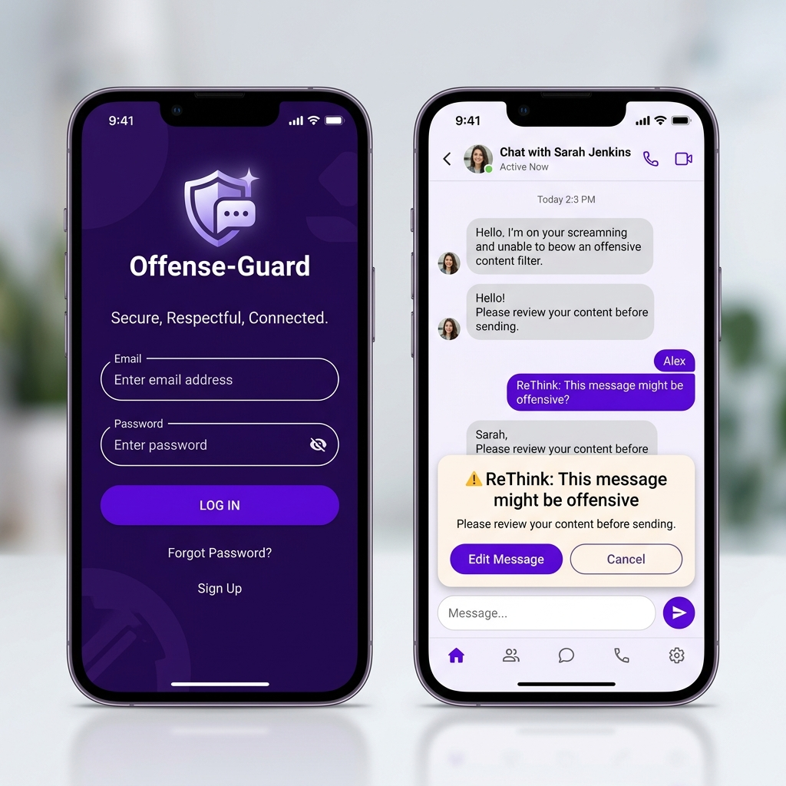
Figure 4.9: Mobile Interface (a) Login screen and (b) Home/Chat screen.
*Figure 4.7: Mobile App Screens showing Login and the ReThink Warning over the Chat UI.*
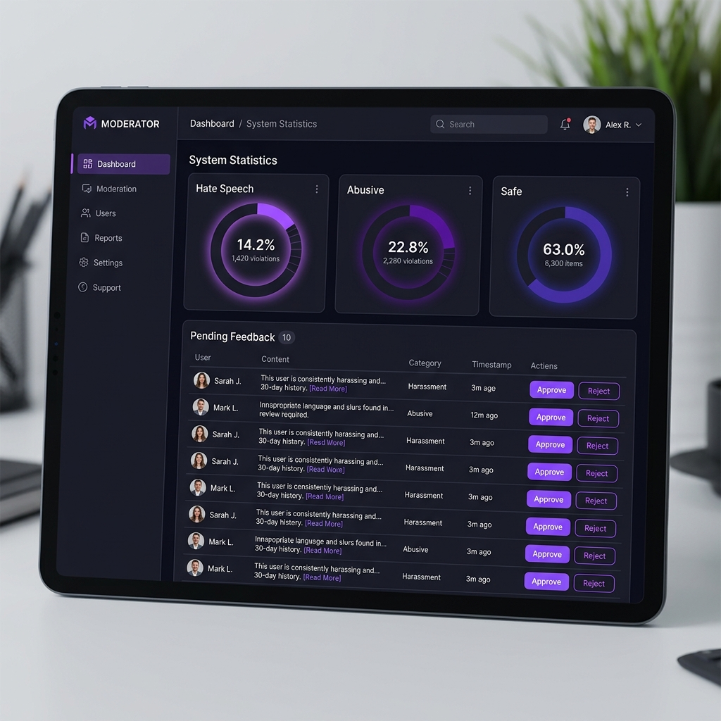
Figure 4.10: Administrator Dashboard Interface.
*Figure 4.8: Admin Control Panel showing system stats and feedback queue.*

#4.5.3 Screen Objects and Actions
**Table 4.4: Mobile App Interface Elements**
| Screen | Object | Action |
| :--- | :--- | :--- |
| **Login** | Sign In Button | Authenticates user and navigates to Home. |
| **Home/Chat** | Send Icon | Triggers the backend prediction request. |
| **ReThink Dialog**| 'Edit' Button | Closes the warning and lets the user change their text. |

#4.6 Algorithm
This section details the algorithmic approach used for text processing and offensive language classification. The system utilizes a multi-stage pipeline consisting of preprocessing, feature extraction, and hybrid classification.

#4.6.1 Preprocessing Algorithm
Before analysis, raw Urdu/Roman Urdu text must be normalized to ensure consistency across phonetic variations.
**Algorithm 1: Urdu/Roman Urdu Preprocessing**
INPUT: Raw Text String
OUTPUT: Normalized Token List
1. CONVERT text to lowercase (for Roman Urdu).
2. REMOVE special characters, emojis, and punctuation.
3. TOKENIZE string into individual words.
4. REMOVE Urdu stop-words.
5. RETURN cleaned_tokens

#4.6.2 Hybrid Classification Logic
The core "intelligence" of the system lies in the decision-making logic that coordinates the SVM and LSTM models.
**Algorithm 2: Hybrid Detection Logic**
INPUT: Normalized User Input
OUTPUT: Predicted Category
1. TIER 1: CHECK Manual Overrides (Whitelist/Blacklist).
2. TIER 2: RUN LinearSVC (SVM) Prediction.
IF confidence >= 0.85: RETURN prediction_label.
3. TIER 3: RUN LSTM Deep Learning Model.
4. FINAL: RETURN class with highest LSTM probability.

#4.7 Tools and Technologies
Python 3.10, Flask, MongoDB, React Native, TensorFlow, Scikit-Learn.

#4.8 External APIs/SDKs
The Offense-Guard project utilizes several third-party APIs and Software Development Kits (SDKs) to enhance functionality and ensure secure communication.

#**Table 4.1: External APIs and SDKs for Proposed Project**
| API / SDK Name | Version | Rationale |
| :--- | :--- | :--- |
| **Expo SDK** | 49.0 | Provides a set of tools to develop, build, and deploy React Native apps across Android and iOS with ease. |
| **PyJWT** | 2.6.0 | Used for implementing JSON Web Tokens to handle secure user and administrator authentication. |
| **Axios** | 1.4.0 | A promise-based HTTP client used by the mobile app to communicate with the Flask REST API. |
| **Bcrypt** | 4.0.1 | Used for hashing and salting user passwords to ensure data security in MongoDB. |
| **TensorFlow Lite** | 2.12.0 | Explored for potential on-device inference to reduce latency in future mobile versions. |

#4.9 User Interface
This section provides a detailed description of the user interfaces for the major subsystems of the project, including the Mobile Application and the Admin Dashboard.

#4.9.1 Login and Home Screen (Mobile App)
The login screen of the mobile app requires the user to authenticate using their unique username and password. Once authenticated, the user is redirected to the Home Screen, which features a real-time chat interface.
- **Login Screen (a)**: Features a minimalist design with input fields for credentials and a primary 'Sign In' button.
- **Home/Chat Screen (b)**: Displays the chat history and a text input field at the bottom. When an offensive message is detected, a 'ReThink' warning dialog appears as an overlay.

Figure 4.9: Mobile Interface (a) Login screen and (b) Home/Chat screen.
*Figure 4.9: A screen shows interface (a) Login screen and (b) Home/Chat screen.*

#4.9.2 Admin Control Panel (Subsystem)
The Admin Dashboard allows authorized users to monitor system-wide statistics and manage the active learning feedback loop.
- **Stats Overview**: Admins can view graphs showing the distribution of Neutral vs. Offensive predictions.
- **Feedback Queue**: A list of user-submitted suggestions where admins can verify the correct label (Abusive, Hate Speech, etc.).

Figure 4.10: Administrator Dashboard Interface.
*Figure 4.10: A screen shows the interface of the Administrator Dashboard.*

#4.10 Deployment
The Offense-Guard project is deployed across multiple environments to ensure seamless live testing and high availability of its sub-systems.
1. **Development Environment**: Local machines running Windows/Linux with Python 3.10 and Node.js for rapid iteration.
2. **Mobile Testing**: Handled via **Expo Go**, allowing for live testing on physical Android and iOS devices without native builds.
3. **Database Hosting**: **MongoDB Atlas (Cloud)** was used to host the production database, providing automated backups and global availability.
4. **API Hosting**: The Flask backend is designed for deployment on cloud platforms like **Heroku** or **AWS EC2**, utilizing Gunicorn as a production-grade WSGI server.

#4.11 Chapter Summary
This chapter presented the design and architecture of Offense-Guard. We established the modular breakdown, visualized the system through UML diagrams (including Use Case, Activity, and Sequence), and detailed the data design via MongoDB dictionaries. External APIs like Expo and JWT were listed alongside detailed descriptions of the Mobile and Admin user interfaces. Finally, the deployment environment strategy was outlined, providing a complete technical blueprint for the system implementation.

References
[1] Sharif, M., et al., "Deep Learning based Offensive Language Detection in Roman Urdu," *Journal of Regional NLP Research*, 2021.
[2] Khan, A., et al., "Word Embeddings for Phonetic Variations in Roman Urdu Social Media Text," *IEEE Access*, 2020.
[3] Ahmad, S., "Cross-Platform Sentiment Correlation using Canonical Correlation Analysis," *Digital Humanities Review*, 2019.
[4] Akhter, R., et al., "Convolutional Neural Networks for Urdu Text Classification: A Character-Level Approach," *International Conference on NLP (ICON)*, 2022.
[5] Malik, F., "Two-Stream CNN Architectures for Multilingual Offensive Content Moderation," *ACM Transactions on Asian and Low-Resource Language Information Processing*, 2021.
[6] BERT Research Group, "Multilingual Representations for Low-Resource Languages: The Case of Urdu," *arXiv preprint*, 2023.
[7] Google Perspective API Documentation, "Supporting regional languages in automated moderation," 2024.
[8] ReThink Project Research, "The Psychological Impact of Preventive Warnings in Digital Discourse," 2022.

