Dynamic Civic Issue Prioritization System

- Introduction:

Civic issues such as road damage, waste mismanagement, water supply disruptions, electricity failures, and sanitation problems are common across urban, semi-urban, and rural regions. With rapid population growth and urbanization, these issues are increasing in both frequency and severity.

Although several digital platforms allow citizens to report problems, they lack intelligent mechanisms to manage and prioritize them effectively. Most systems operate on a first-come-first-serve basis or depend heavily on manual intervention, resulting in delayed responses and inefficient use of resources.

The Dynamic Civic Issue Prioritization System is designed to overcome these limitations. It is a web-based platform that not only collects complaints but also intelligently analyzes and prioritizes them using multiple parameters such as severity, number of reports, location density, and user reliability.

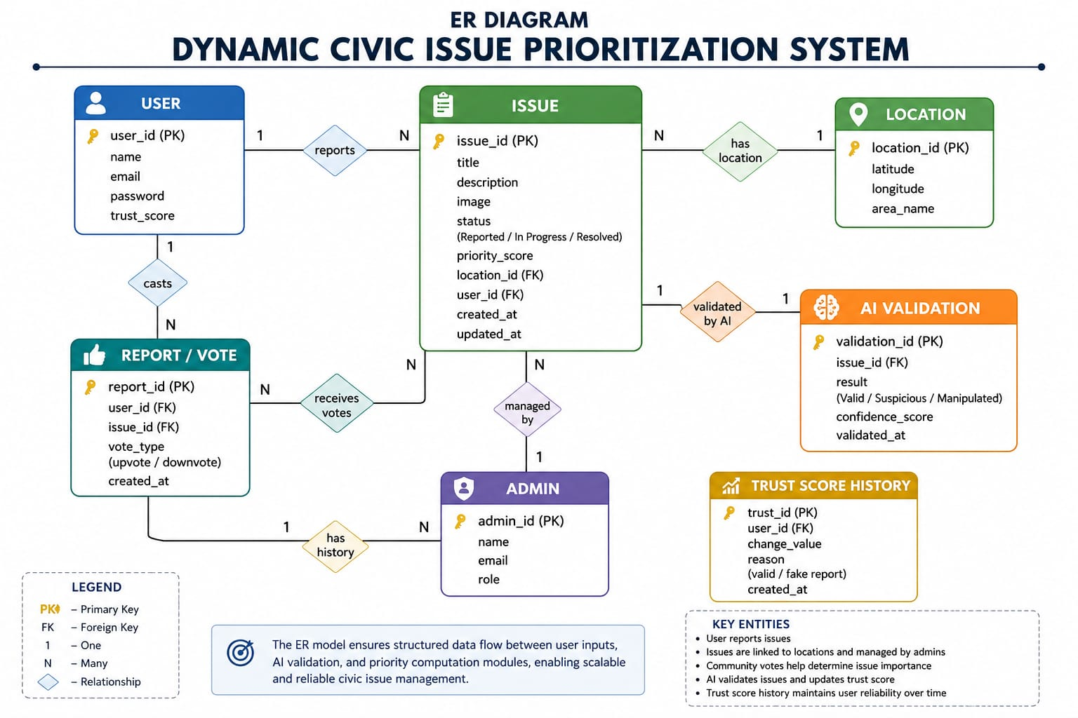

- Problem Statement:

There is no unified, intelligent system that can efficiently collect, analyze, and prioritize civic issues across different regions to ensure timely resolution.

Key Challenges:

- Lack of intelligent prioritization of complaints
- Duplicate reporting of the same issue
- Absence of data-driven insights for authorities
- Poor transparency in issue handling
- Presence of unreliable or false reports

- Objectives:

- To design a centralized platform for reporting civic issues
- To reduce duplicate complaints using clustering techniques
- To implement a dynamic priority scoring system
- To improve decision-making using data analytics
- To ensure data reliability using a trust score mechanism
- To enhance user experience through an AI assistant

- Proposed Solution:

The system is a web-based platform that allows users to report civic issues and enables authorities to manage them efficiently.

Working Process:

- Users submit issues with location and image proof
- System validates and processes data
- Duplicate issues are detected and merged
- Priority score is calculated dynamically
- Issues are visualized using heatmaps
- AI chatbot assists in validation and insights
- Admin reviews and takes action
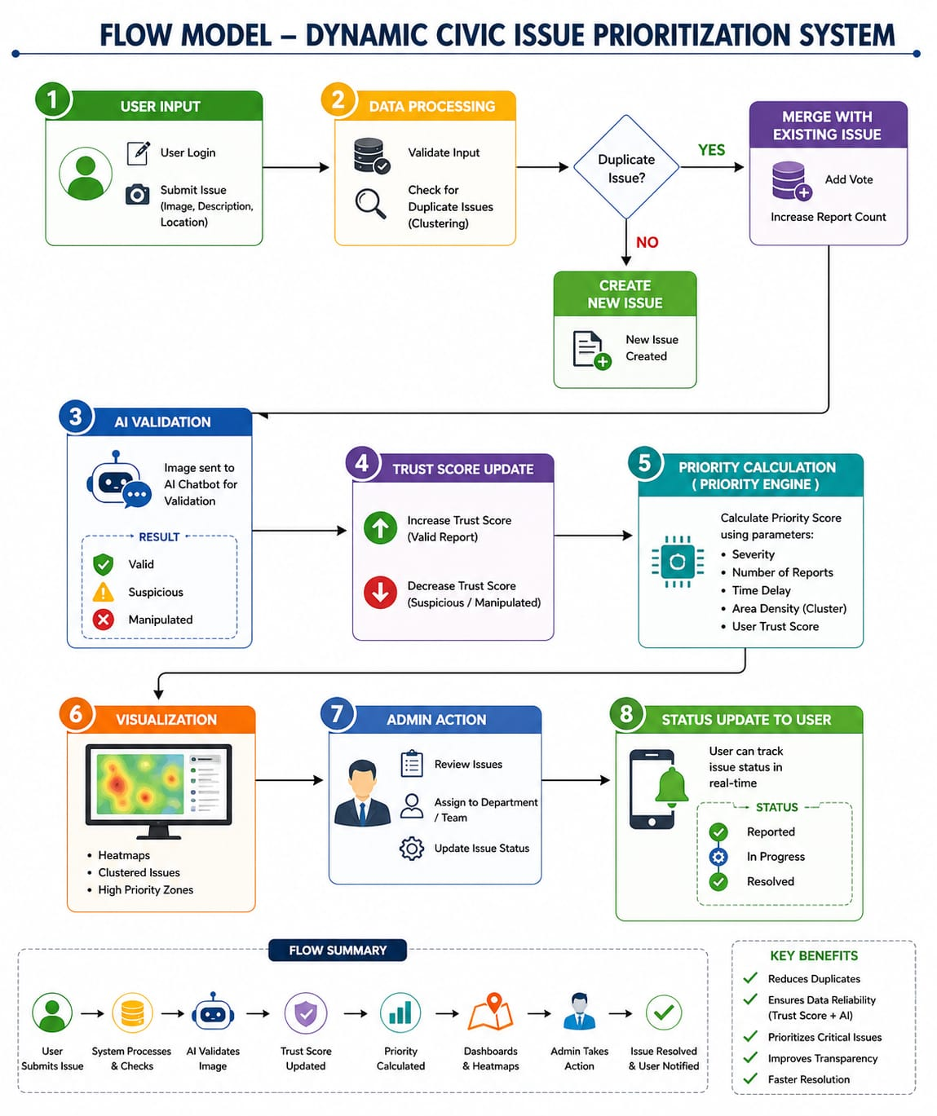

- System Architecture:

Frontend

- User and admin interface
- Issue reporting and tracking
- Map-based visualization

Backend

Handles:
- Business logic
- Priority calculation
- Clustering algorithms
- Trust score updates
- AI validation processing

Database

Stores:
- Users
- Issues
- Locations
- Votes
- Trust scores

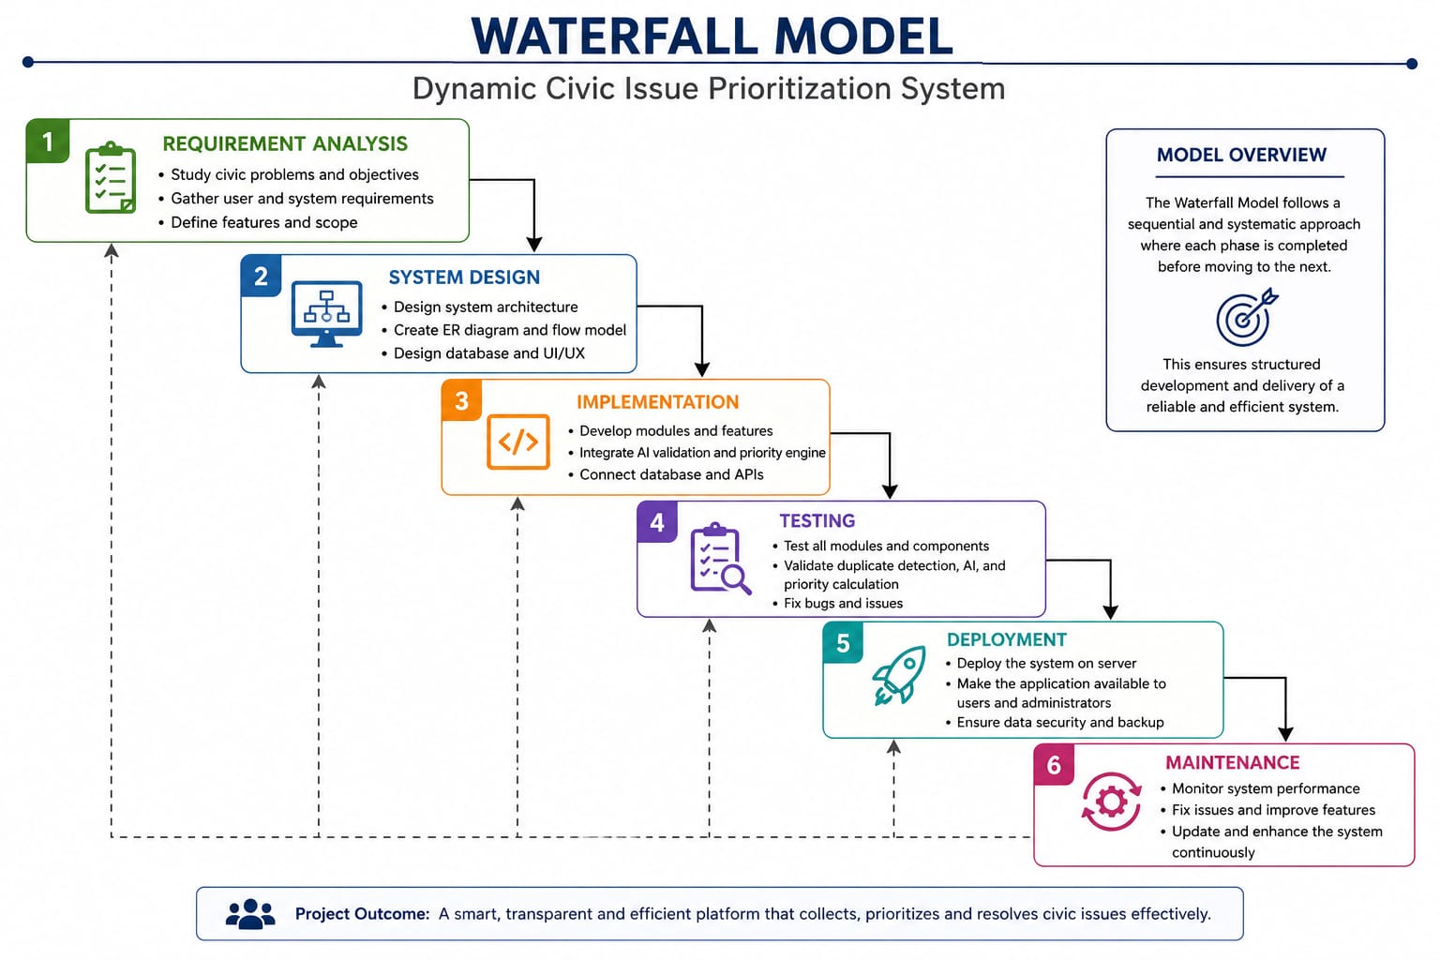
- Key Features:

6.1 User Module

- Registration and login
- Submit issues with images
- View nearby issues
- Track status

6.2 Admin Module

- View prioritized issues
- Assign tasks
- Update issue status
- Use AI chatbot for validation

6.3 Issue Management Module

- Handles issue lifecycle
- Performs clustering and updates

6.4 Priority Engine

- Calculates and updates priority scores dynamically

6.5 Trust Management Module

- Maintains user trust scores
- Updates scores based on AI validation results

6.6 AI Validation Module

- Processes uploaded images
- Performs morph detection
- Sends validation result to system
- Triggers trust score and priority updates

6.7 Visualization Module
- Displays heatmaps
- Shows clustered issues
6.8 Chatbot Module
- Handles user queries
- Assists admin in validation
- Provides system insights

- Key Features:

7.1 Smart Heatmap and Problem Clustering

- Displays issues based on geographical intensity
- Identifies high-risk zones
- Helps in efficient resource allocation

7.2 Dynamic Priority Scoring System
Issues are ranked based on:
- Severity level
- Number of reports
- Time delay
- Area impact
- User trust score
Ensures critical issues are handled first.
7.3 Trust Score System

Formula:
Trust Score = Verified Reports / Total Reports
Score Increases When:
- Reports are verified
- Valid evidence is provided

Score Decreases When:
- Reports are false
- Evidence is manipulated

7.4 AI Chatbot for Morph Detection
Working:
- Admin submits report images or files to the chatbot
- Chatbot performs image authenticity analysis (morph detection)
Classification:
- Valid
- Suspicious
- Manipulated

System Actions:
- If image is valid → Trust score increases
- If image is manipulated →
  - Trust score decreases
  - Issue priority score adjusted
  - Admin notified
Output:
- Verified result returned to admin
- Trust score and priority updated automatically
Benefits:
- Reduces fake or misleading reports
- Improves system reliability
- Enables automated validation

7.5 AI Chatbot Assistant

- Guides users during issue reporting
- Suggests existing issues
- Provides insights such as:
  - Critical areas
  - Common issues
7.6 Duplicate Issue Handling

- Detects similar complaints
- Groups them into one issue
- Uses voting mechanism

7.7 Real-Time Status Tracking
Users can track issue progress:
- Reported
- In Progress
- Resolved

- Priority Calculation:
Priority Score (P) =
(W1 × Severity) +
(W2 × Number of Reports) +
(W3 × Time Delay) +
(W4 × Cluster Density) +
(W5 × Trust Score)

Update with AI Validation
- If morph detected → Trust Score decreases
- Reduced trust lowers priority contribution
- Ensures unreliable issues are deprioritized

- Workflow

- User submits issue
- System checks for duplicates
- Issue created
- Priority calculated
- Admin reviews issue
- Admin sends image to AI chatbot
- Chatbot performs morph detection
- Trust score updated
- Priority recalculated
- Admin proceeds with action

- Advantages :

- Intelligent prioritization
- Reduced duplicate complaints
- Improved transparency
- Automated validation of evidence
- Higher data reliability
- Better decision-making

- Limitations:

- Requires internet connectivity
- AI validation may not be 100% accurate
- Depends on quality of uploaded images

- Future Scope:

- Advanced AI-based image forensics
- Real-time automated validation
- Mobile application integration
- Predictive analytics for issue forecasting
- Integration with smart city infrastructure

- Conclusion:

The system provides an intelligent and scalable solution for civic issue management by integrating prioritization, clustering, trust evaluation, and AI-based validation.

The addition of morph detection ensures that decisions are based on reliable and verified data, improving both efficiency and trust in the system.

