TASK 1: CUSTOMER CHURN CLASSIFICATION

Name: Saheen Khatoon

Artificial Intelligence Internship

1. Objective

The objective of this project is to predict customer churn using machine learning techniques. Customer churn prediction helps organizations identify customers who are likely to discontinue their services, allowing businesses to take proactive retention measures.

2. Dataset Description

The project uses a customer churn dataset containing customer demographic information, service usage details, account information, and churn labels. The dataset is used to train and evaluate machine learning models for predicting customer churn.

3. Environment Setup
Python Version: 3.
Required Libraries:
- pandas
- numpy
- matplotlib
- scikit-learn

Installation Command:
pip install pandas numpy matplotlib scikit-learn

4. Run Instructions

Using Jupyter Notebook:

jupyter notebook Customer_Churn_Classification.ipynb
Using Google Colab:
1. Open Google Colab.
2. Upload the notebook file.
3. Upload the dataset file if required.
4. Click Runtime → Run All.
5. Methodology
The project follows the following steps:
- Data Collection
- Data Preprocessing
- Feature Selection
- Train-Test Split
- Model Training
- Model Evaluation
- Result Analysis

6. Screenshots
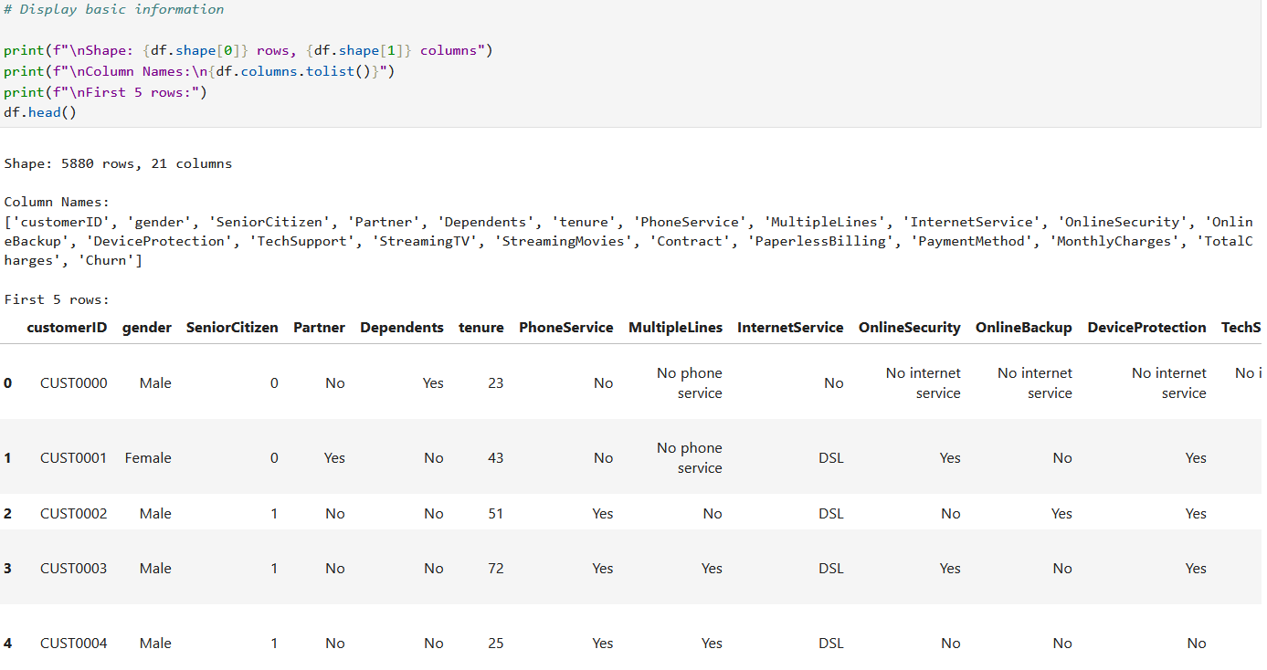
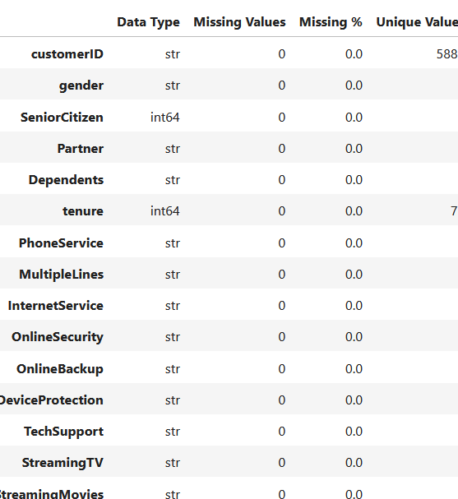
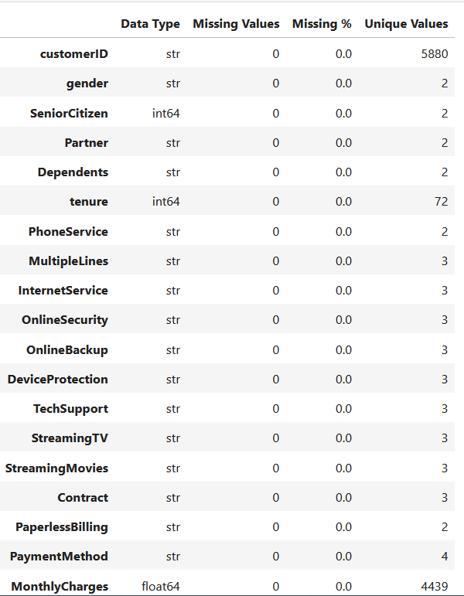
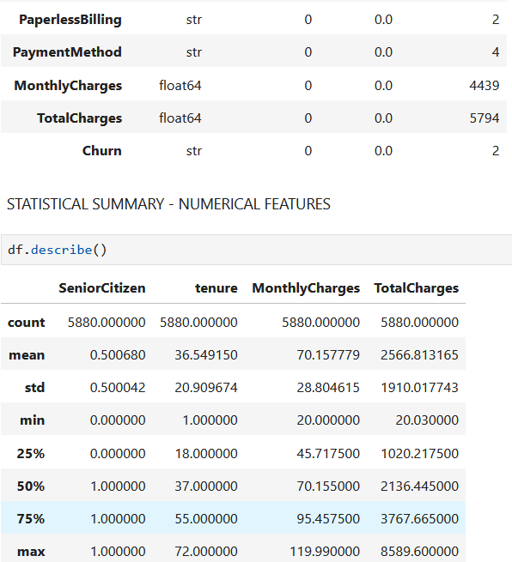
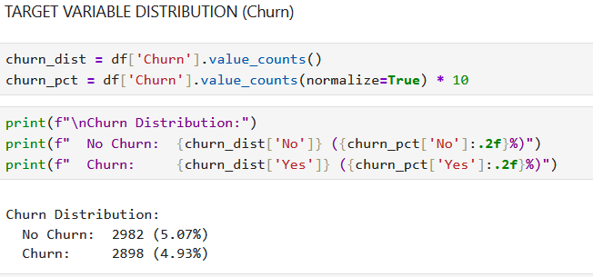
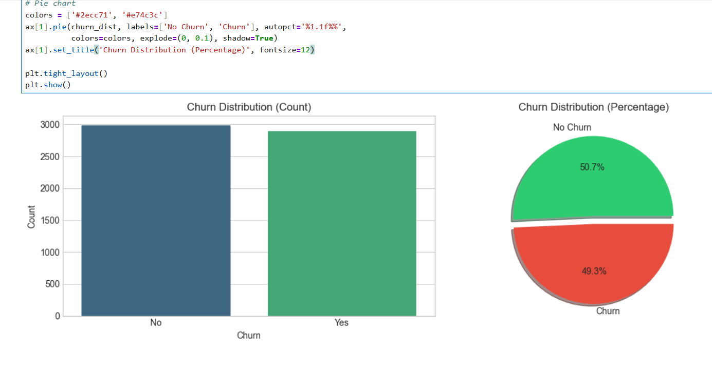
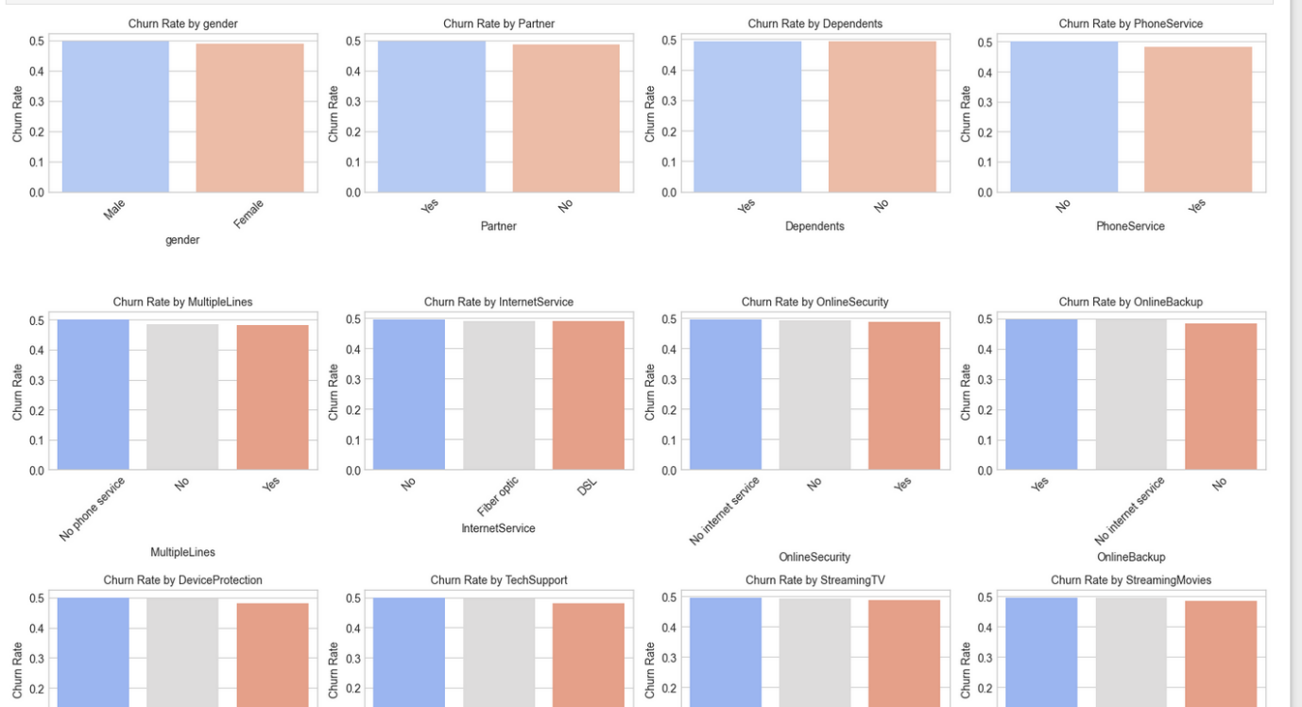
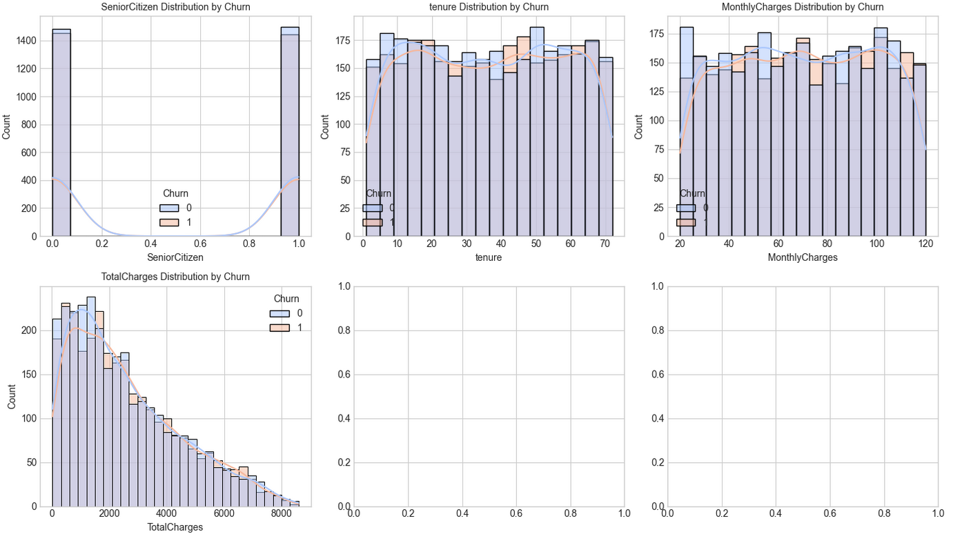
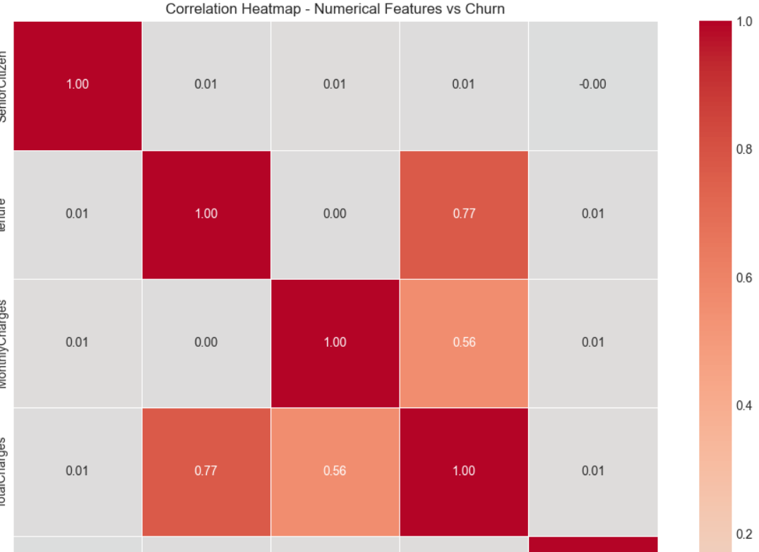
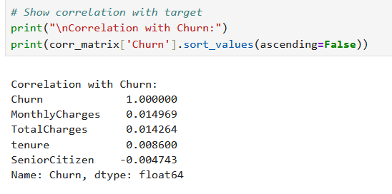7. Results

The machine learning model was successfully trained and evaluated on the customer churn dataset. The model generated predictions for customer churn and achieved satisfactory classification performance. The evaluation metrics and visualizations demonstrate the effectiveness of the trained model.

8. Conclusion

This project demonstrates the application of machine learning techniques for customer churn prediction. The trained model can help organizations identify customers at risk of leaving and support customer retention strategies. The project provided practical experience in data preprocessing, model training, evaluation, and predictive analytics.

9. GitHub Repository Link

GitHub Repository:
(To be added after repository creation)

