CS 4347.502- Semester Project - Part 2( Final)

Arafat Khan, Axk22019

1. **EER- Diagram**

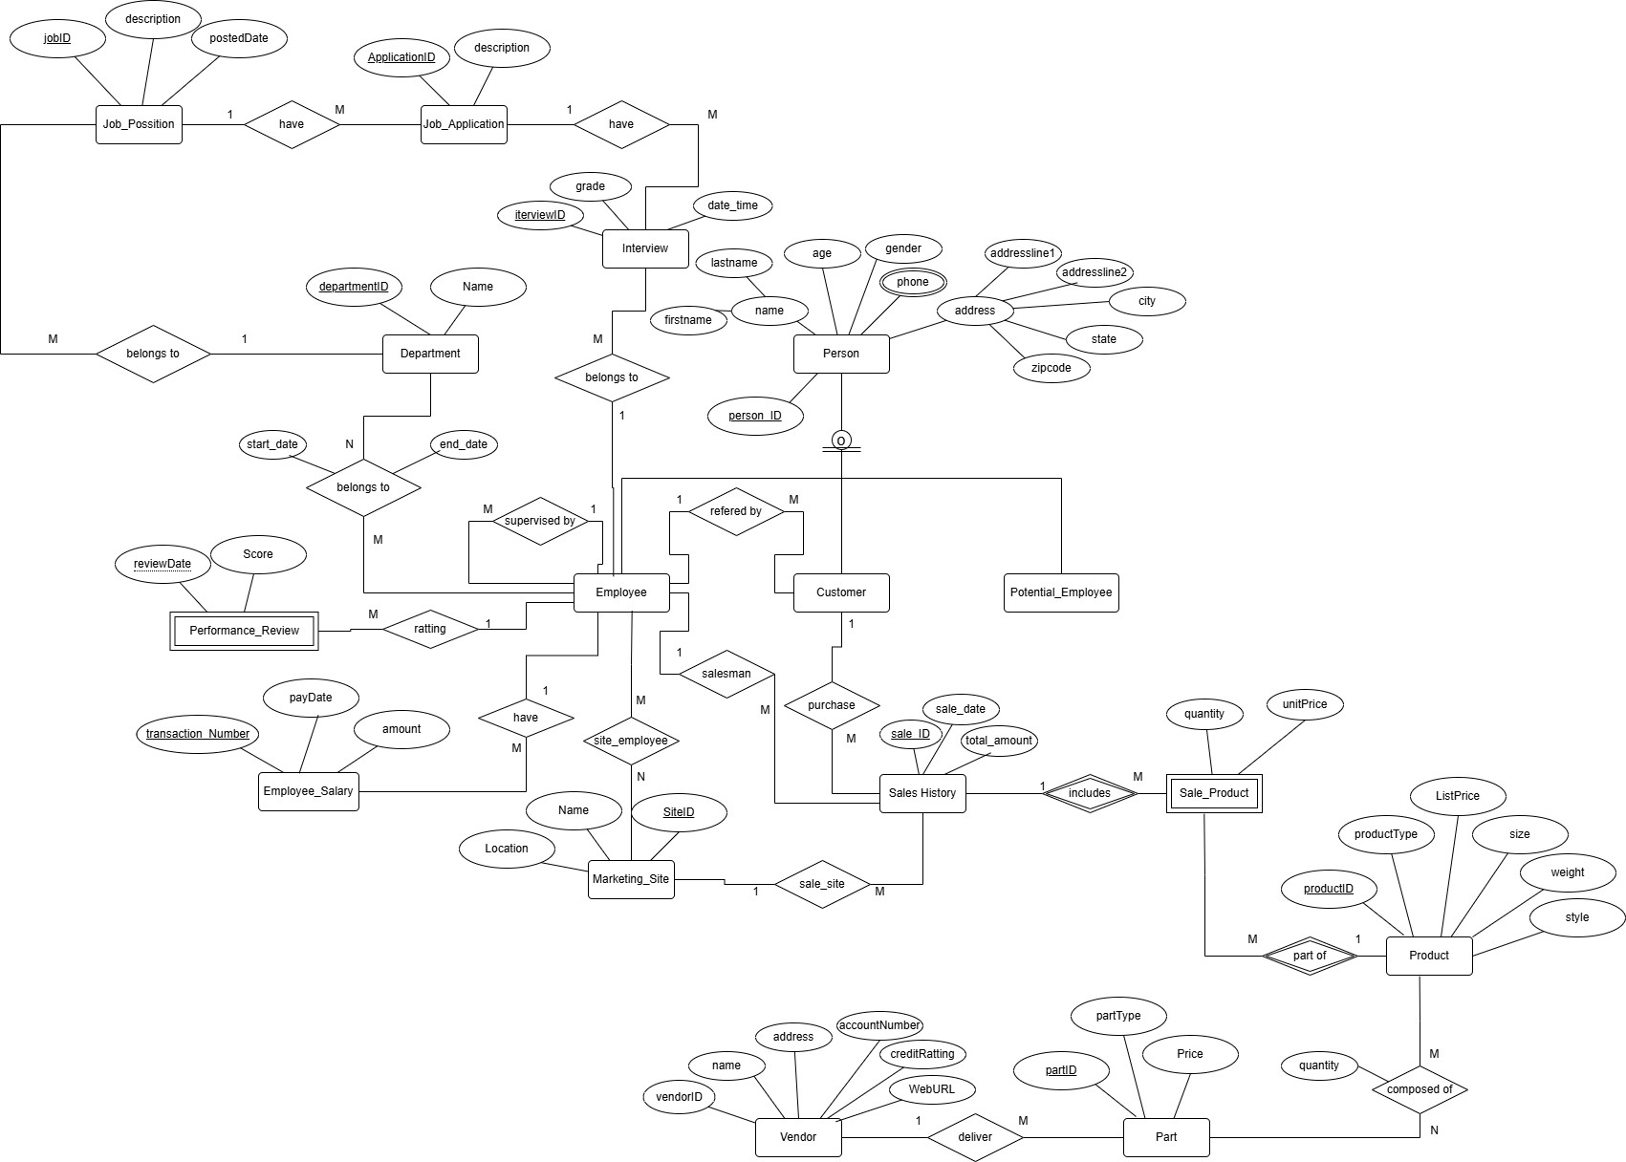

1. **Logical Design (with data types)**

**Assumptions:**

- I did not make any new table for address table.

- I used some my own created primary keys for weak entities. Like in Employee_performance table and other weak entities.

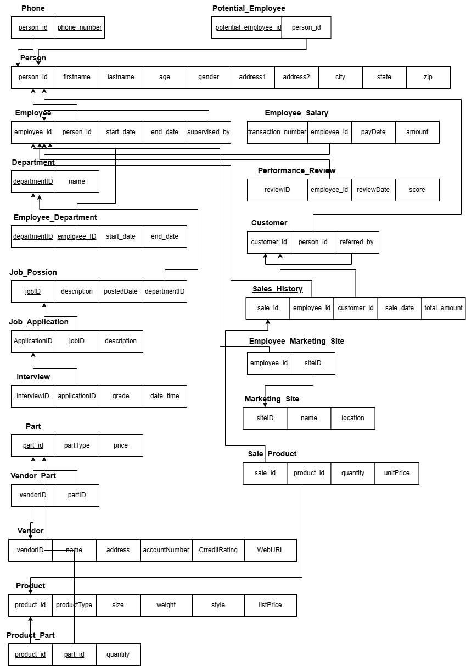

1. **Physical Design (data dictionary form)**

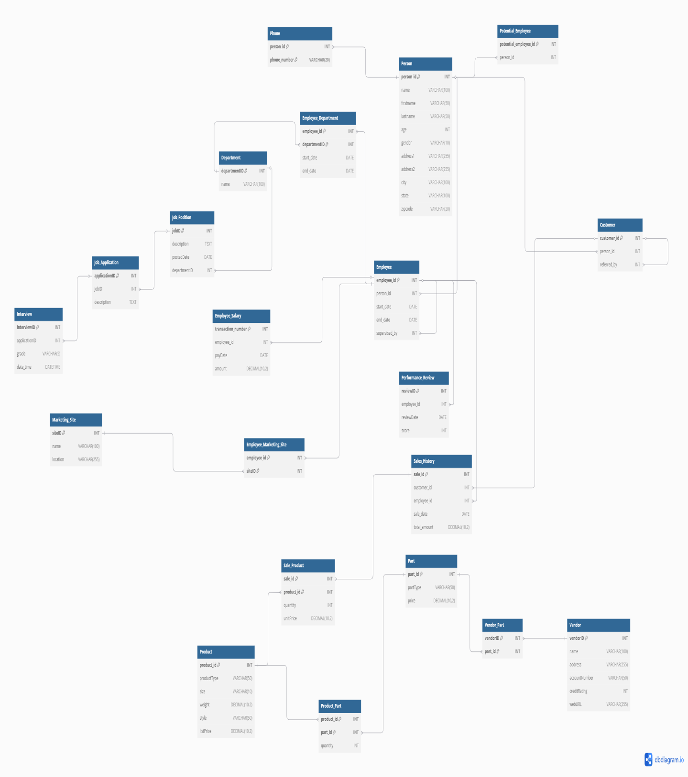

## Person Table

| **Attribute** | **Data Type** | **Size** | **Description** | **Constraints** |
| --- | --- | --- | --- | --- |
| person_id | INT | - | Unique identifier for a person | PRIMARY KEY |
| name | VARCHAR | 100 | Full name of the person | - |
| firstname | VARCHAR | 50 | First name of the person | - |
| lastname | VARCHAR | 50 | Last name of the person | - |
| age | INT | - | Age of the person | - |
| gender | VARCHAR | 10 | Gender of the person | - |
| address1 | VARCHAR | 255 | Primary address line | - |
| address2 | VARCHAR | 255 | Secondary address line | - |
| city | VARCHAR | 100 | City of residence | - |
| state | VARCHAR | 100 | State of residence | - |
| zipcode | VARCHAR | 20 | Postal/ZIP code | - |

## Phone Table

| **Attribute** | **Data Type** | **Size** | **Description** | **Constraints** |
| --- | --- | --- | --- | --- |
| person_id | INT | - | Reference to person | PRIMARY KEY, FOREIGN KEY references Person(person_id) |
| phone_number | VARCHAR | 20 | Phone number | PRIMARY KEY |

## Employee Table

| **Attribute** | **Data Type** | **Size** | **Description** | **Constraints** |
| --- | --- | --- | --- | --- |
| employee_id | INT | - | Unique employee identifier | PRIMARY KEY |
| person_id | INT | - | Reference to person | FOREIGN KEY references Person(person_id) |
| start_date | DATE | - | Employment start date | - |
| end_date | DATE | - | Employment end date | - |
| supervised_by | INT | - | Employee's supervisor | FOREIGN KEY references Employee(employee_id) |

## Customer Table

| **Attribute** | **Data Type** | **Size** | **Description** | **Constraints** |
| --- | --- | --- | --- | --- |
| customer_id | INT | - | Unique customer identifier | PRIMARY KEY |
| person_id | INT | - | Reference to person | FOREIGN KEY references Person(person_id) |
| referred_by | INT | - | Customer who referred this customer | FOREIGN KEY references Customer(customer_id) |

## Potential_Employee Table

| **Attribute** | **Data Type** | **Size** | **Description** | **Constraints** |
| --- | --- | --- | --- | --- |
| potential_employee_id | INT | - | Unique identifier | PRIMARY KEY |
| person_id | INT | - | Reference to person | FOREIGN KEY references Person(person_id) |

## Job_Position Table

| **Attribute** | **Data Type** | **Size** | **Description** | **Constraints** |
| --- | --- | --- | --- | --- |
| jobID | INT | - | Unique job identifier | PRIMARY KEY |
| description | TEXT | - | Job description | - |
| postedDate | DATE | - | Date job was posted | - |
| departmentiD | INT | - | Department ID | FOREIGN KEY references Department(departmentiD) |

## Job_Application Table

| **Attribute** | **Data Type** | **Size** | **Description** | **Constraints** |
| --- | --- | --- | --- | --- |
| applicationID | INT | - | Unique application identifier | PRIMARY KEY |
| jobID | INT | - | Reference to job position | FOREIGN KEY references Job_Position(jobID) |
| description | TEXT | - | Application details | - |

## Interview Table

| **Attribute** | **Data Type** | **Size** | **Description** | **Constraints** |
| --- | --- | --- | --- | --- |
| interviewID | INT | - | Unique interview identifier | PRIMARY KEY |
| applicationID | INT | - | Reference to job application | FOREIGN KEY references Job_Application(applicationID) |
| grade | VARCHAR | 5 | Interview grade/rating | - |
| date_time | DATETIME | - | Interview date and time | - |

## Department Table

| **Attribute** | **Data Type** | **Size** | **Description** | **Constraints** |
| --- | --- | --- | --- | --- |
| departmentID | INT | - | Unique department identifier | PRIMARY KEY |
| name | VARCHAR | 100 | Department name | - |

## Employee_Department Table

| **Attribute** | **Data Type** | **Size** | **Description** | **Constraints** |
| --- | --- | --- | --- | --- |
| employee_id | INT | - | Reference to employee | PRIMARY KEY, FOREIGN KEY references Employee(employee_id) |
| departmentID | INT | - | Reference to department | PRIMARY KEY, FOREIGN KEY references Department(departmentID) |
| start_date | DATE | - | Assignment start date | - |
| end_date | DATE | - | Assignment end date | - |

## Performance_Review Table

| **Attribute** | **Data Type** | **Size** | **Description** | **Constraints** |
| --- | --- | --- | --- | --- |
| reviewID | INT | - | Unique review identifier | PRIMARY KEY |
| employee_id | INT | - | Reference to employee | FOREIGN KEY references Employee(employee_id) |
| reviewDate | DATE | - | Review date | - |
| score | INT | - | Performance score | - |

## Employee_Salary Table

| **Attribute** | **Data Type** | **Size** | **Description** | **Constraints** |
| --- | --- | --- | --- | --- |
| transaction_number | INT | - | Unique transaction identifier | PRIMARY KEY |
| employee_id | INT | - | Reference to employee | FOREIGN KEY references Employee(employee_id) |
| payDate | DATE | - | Payment date | - |
| amount | DECIMAL | 10,2 | Payment amount | - |

## Marketing_Site Table

| **Attribute** | **Data Type** | **Size** | **Description** | **Constraints** |
| --- | --- | --- | --- | --- |
| siteID | INT | - | Unique site identifier | PRIMARY KEY |
| name | VARCHAR | 100 | Site name | - |
| location | VARCHAR | 255 | Site location | - |

## Employee_Marketing_Site Table

| **Attribute** | **Data Type** | **Size** | **Description** | **Constraints** |
| --- | --- | --- | --- | --- |
| employee_id | INT | - | Reference to employee | PRIMARY KEY, FOREIGN KEY references Employee(employee_id) |
| siteID | INT | - | Reference to marketing site | PRIMARY KEY, FOREIGN KEY references Marketing_Site(siteID) |

## Sales_History Table

| **Attribute** | **Data Type** | **Size** | **Description** | **Constraints** |
| --- | --- | --- | --- | --- |
| sale_id | INT | - | Unique sale identifier | PRIMARY KEY |
| customer_id | INT | - | Reference to customer | FOREIGN KEY references Customer(customer_id) |
| employee_id | INT | - | Reference to employee | FOREIGN KEY references Employee(employee_id) |
| sale_date | DATE | - | Sale date | - |
| total_amount | DECIMAL | 10,2 | Total sale amount | - |

## Sale_Product Table

| **Attribute** | **Data Type** | **Size** | **Description** | **Constraints** |
| --- | --- | --- | --- | --- |
| sale_id | INT | - | Reference to sale | PRIMARY KEY, FOREIGN KEY references Sales_History(sale_id) |
| product_id | INT | - | Reference to product | PRIMARY KEY, FOREIGN KEY references Product(product_id) |
| quantity | INT | - | Quantity sold | - |
| unitPrice | DECIMAL | 10,2 | Unit price at time of sale | - |

## Product Table

| **Attribute** | **Data Type** | **Size** | **Description** | **Constraints** |
| --- | --- | --- | --- | --- |
| product_id | INT | - | Unique product identifier | PRIMARY KEY |
| productType | VARCHAR | 50 | Type of product | - |
| size | VARCHAR | 10 | Product size | - |
| weight | DECIMAL | 10,2 | Product weight | - |
| style | VARCHAR | 50 | Product style | - |
| listPrice | DECIMAL | 10,2 | Standard list price | - |

## Product_Part Table

| **Attribute** | **Data Type** | **Size** | **Description** | **Constraints** |
| --- | --- | --- | --- | --- |
| product_id | INT | - | Reference to product | PRIMARY KEY, FOREIGN KEY references Product(product_id) |
| part_id | INT | - | Reference to part | PRIMARY KEY, FOREIGN KEY references Part(part_id) |
| quantity | INT | - | Quantity of part in product | - |

## Part Table

| **Attribute** | **Data Type** | **Size** | **Description** | **Constraints** |
| --- | --- | --- | --- | --- |
| part_id | INT | - | Unique part identifier | PRIMARY KEY |
| partType | VARCHAR | 50 | Type of part | - |
| price | DECIMAL | 10,2 | Part price | - |

## Vendor Table

| **Attribute** | **Data Type** | **Size** | **Description** | **Constraints** |
| --- | --- | --- | --- | --- |
| vendorID | INT | - | Unique vendor identifier | PRIMARY KEY |
| name | VARCHAR | 100 | Vendor name | - |
| address | VARCHAR | 255 | Vendor address | - |
| accountNumber | VARCHAR | 50 | Account number | - |
| creditRating | INT | - | Credit  rating | - |
| webURL | VARCHAR | 255 | Website URL | - |

## Vendor_Part Table

| **Attribute** | **Data Type** | **Size** | **Description** | **Constraints** |
| --- | --- | --- | --- | --- |
| vendorID | INT | - | Reference to vendor | PRIMARY KEY, FOREIGN KEY references Vendor(vendorID) |
| part_id | INT | - | Reference to part | PRIMARY KEY, FOREIGN KEY references Part(part_id) |

**Phase 03:**

**a) Normalization to 3NF**

You have already implemented most tables in 3NF as shown in your Phase 2. Below is a confirmation and rationale for why your tables are in 3NF

Example:

Employee Table

* 1NF: Atomic attributes only (e.g., start_date, end_date are atomic).
* 2NF: Every non-key attribute is fully functionally dependent on the primary key employee_id.
* 3NF: No transitive dependency exists (e.g., supervised_by is a foreign key, not a derived or transitive field).

Similar reasoning holds for:

* Person, Phone, Customer, Potential_Employee
* Department, Employee_Department, Job_Position, Job_Application, Interview
* Product, Sale_Product, Sales_History, Part, Vendor, Vendor_Part, etc.

### ****b) Dependency Diagrams****

Here are **sample dependency diagrams** for a few major tables. Each one shows **primary key → all other non-key attributes**.

**Employee Table**

employee_id → person_id, start_date, end_date, supervised_by

**Product Table**

product_id → productType, size, weight, style, listPrice

**Employee_Department Table**

(employee_id, departmentID) → start_date, end_date

**Interview Table**

interviewID → applicationID, grade, date_time

**Vendor_Part Table**

(vendorID, part_id) → (No non-key attributes)

**c) SQL Statements**

CREATE DATABASE IF NOT EXISTS phase3;

USE phase3;

-- Person Table (Core entity)

CREATE TABLE Person (

person_id INT PRIMARY KEY,

name VARCHAR(100),

firstname VARCHAR(50),

lastname VARCHAR(50),

age INT,

gender VARCHAR(10),

address1 VARCHAR(255),

address2 VARCHAR(255),

city VARCHAR(100),

state VARCHAR(100),

zipcode VARCHAR(20),

email VARCHAR(100)

);

-- Phone Numbers

CREATE TABLE Phone (

person_id INT,

phone_number VARCHAR(20),

PRIMARY KEY (person_id, phone_number),

FOREIGN KEY (person_id) REFERENCES Person(person_id)

);

-- Employees and Supervision Structure

CREATE TABLE Employee (

employee_id INT PRIMARY KEY,

person_id INT,

start_date DATE,

end_date DATE,

supervised_by INT,

FOREIGN KEY (person_id) REFERENCES Person(person_id),

FOREIGN KEY (supervised_by) REFERENCES Employee(employee_id)

);

-- Customers and Referrals

CREATE TABLE Customer (

customer_id INT PRIMARY KEY,

person_id INT,

referred_by INT,

FOREIGN KEY (person_id) REFERENCES Person(person_id),

FOREIGN KEY (referred_by) REFERENCES Customer(customer_id)

);

-- Potential Employees

CREATE TABLE Potential_Employee (

potential_employee_id INT PRIMARY KEY,

person_id INT,

FOREIGN KEY (person_id) REFERENCES Person(person_id)

);

-- Job Positions

CREATE TABLE Job_Position (

jobID INT PRIMARY KEY,

description TEXT,

postedDate DATE

);

-- Job Applications

CREATE TABLE Job_Application (

applicationID INT PRIMARY KEY,

jobID INT,

person_id INT,

description TEXT,

FOREIGN KEY (jobID) REFERENCES Job_Position(jobID),

FOREIGN KEY (person_id) REFERENCES Person(person_id)

);

-- Interviews

CREATE TABLE Interview (

interviewID INT PRIMARY KEY,

applicationID INT,

grade VARCHAR(5),

date_time DATETIME,

FOREIGN KEY (applicationID) REFERENCES Job_Application(applicationID)

);

-- Interviewers

CREATE TABLE Interviewer (

interviewer_id INT PRIMARY KEY,

employee_id INT,

FOREIGN KEY (employee_id) REFERENCES Employee(employee_id)

);

-- Mapping Interviewers to Interviews

CREATE TABLE Interview_Interviewer (

interview_id INT,

interviewer_id INT,

PRIMARY KEY (interview_id, interviewer_id),

FOREIGN KEY (interview_id) REFERENCES Interview(interviewID),

FOREIGN KEY (interviewer_id) REFERENCES Interviewer(interviewer_id)

);

-- Departments

CREATE TABLE Department (

departmentID INT PRIMARY KEY,

name VARCHAR(100)

);

-- Employee-Department Assignments

CREATE TABLE Employee_Department (

employee_id INT,

departmentID INT,

start_date DATE,

end_date DATE,

PRIMARY KEY (employee_id, departmentID),

FOREIGN KEY (employee_id) REFERENCES Employee(employee_id),

FOREIGN KEY (departmentID) REFERENCES Department(departmentID)

);

-- Performance Reviews

CREATE TABLE Performance_Review (

reviewID INT PRIMARY KEY,

employee_id INT,

reviewDate DATE,

score INT,

FOREIGN KEY (employee_id) REFERENCES Employee(employee_id)

);

-- Salaries

CREATE TABLE Employee_Salary (

transaction_number INT PRIMARY KEY,

employee_id INT,

payDate DATE,

amount DECIMAL(10, 2),

FOREIGN KEY (employee_id) REFERENCES Employee(employee_id)

);

-- Marketing Sites

CREATE TABLE Marketing_Site (

siteID INT PRIMARY KEY,

name VARCHAR(100),

location VARCHAR(255)

);

-- Employee assignments to sites

CREATE TABLE Employee_Marketing_Site (

employee_id INT,

siteID INT,

PRIMARY KEY (employee_id, siteID),

FOREIGN KEY (employee_id) REFERENCES Employee(employee_id),

FOREIGN KEY (siteID) REFERENCES Marketing_Site(siteID)

);

-- Products

CREATE TABLE Product (

product_id INT PRIMARY KEY,

productType VARCHAR(50),

size VARCHAR(10),

weight DECIMAL(10, 2),

style VARCHAR(50),

listPrice DECIMAL(10, 2)

);

-- Parts

CREATE TABLE Part (

part_id INT PRIMARY KEY,

partType VARCHAR(50),

price DECIMAL(10, 2)

);

-- Product-Part Mapping

CREATE TABLE Product_Part (

product_id INT,

part_id INT,

quantity INT,

PRIMARY KEY (product_id, part_id),

FOREIGN KEY (product_id) REFERENCES Product(product_id),

FOREIGN KEY (part_id) REFERENCES Part(part_id)

);

-- Vendors

CREATE TABLE Vendor (

vendorID INT PRIMARY KEY,

name VARCHAR(100),

address VARCHAR(255),

accountNumber VARCHAR(50),

creditRating INT,

webURL VARCHAR(255)

);

-- Vendor-Part Mapping

CREATE TABLE Vendor_Part (

vendorID INT,

part_id INT,

PRIMARY KEY (vendorID, part_id),

FOREIGN KEY (vendorID) REFERENCES Vendor(vendorID),

FOREIGN KEY (part_id) REFERENCES Part(part_id)

);

CREATE TABLE Sales_History (

sale_id INT PRIMARY KEY,

customer_id INT,

employee_id INT,

sale_date DATE,

total_amount DECIMAL(10, 2),

FOREIGN KEY (customer_id) REFERENCES Customer(customer_id),

FOREIGN KEY (employee_id) REFERENCES Employee(employee_id)

);

CREATE TABLE Sale_Product (

sale_id INT,

product_id INT,

quantity INT,

unitPrice DECIMAL(10, 2),

PRIMARY KEY (sale_id, product_id),

FOREIGN KEY (sale_id) REFERENCES Sales_History(sale_id),

FOREIGN KEY (product_id) REFERENCES Product(product_id)

);

INSERT INTO Person VALUES

(1, 'John Smith', 'John', 'Smith', 35, 'Male', '123 Main St', '', 'New York', 'NY', '10001', 'john.smith@example.com'),

(2, 'Alice Johnson', 'Alice', 'Johnson', 29, 'Female', '456 Oak Ave', '', 'Chicago', 'IL', '60616', 'alice.johnson@example.com'),

(3, 'Bob Williams', 'Bob', 'Williams', 40, 'Male', '789 Pine Rd', '', 'Dallas', 'TX', '75201', 'bob.williams@example.com'),

(4, 'Carol Davis', 'Carol', 'Davis', 33, 'Female', '321 Elm St', '', 'Miami', 'FL', '33101', 'carol.davis@example.com'),

(5, 'Ethan Brown', 'Ethan', 'Brown', 28, 'Male', '654 Cedar Blvd', '', 'Seattle', 'WA', '98101', 'ethan.brown@example.com'),

(6, 'Hellen Cole', 'Hellen', 'Cole', 30, 'Female', '789 Sunset Blvd', '', 'Los Angeles', 'CA', '90001', 'hellen.cole@example.com');

INSERT INTO Phone VALUES

(1, '555-1111'),

(2, '555-2222'),

(3, '555-3333'),

(4, '555-4444'),

(5, '555-5555');

INSERT INTO Employee VALUES

(101, 1, '2020-01-10', NULL, NULL),

(102, 2, '2021-03-15', NULL, 101),

(103, 3, '2019-06-20', NULL, 101),

(104, 4, '2022-09-05', NULL, 102),

(105, 5, '2023-07-12', NULL, 102),

(106, 6, '2023-01-01', NULL, NULL);

INSERT INTO Employee_Salary VALUES

(1001, 101, '2024-01-30', 5000.00),

(1002, 102, '2024-01-30', 4500.00),

(1003, 103, '2024-01-30', 4800.00),

(1004, 104, '2024-01-30', 4600.00),

(1005, 105, '2024-01-30', 4700.00);

INSERT INTO Customer VALUES

(201, 1, NULL),

(202, 2, 201),

(203, 3, 201),

(204, 4, 202),

(205, 5, 203);

INSERT INTO Potential_Employee VALUES

(301, 1),

(302, 2),

(303, 3),

(304, 4),

(305, 5);

INSERT INTO Job_Position VALUES

(401, 'Software Developer', '2024-12-01'),

(402, 'Sales Associate', '2024-12-05'),

(403, 'Marketing Analyst', '2024-12-10'),

(11111, 'Senior Designer', '2025-01-01'),

(403, 'Marketing Analyst', '2024-12-10'),

(11111, 'Senior Designer', '2025-01-01'),

(9999, 'Digital Marketer', '2011-01-15', 703),

(12345, 'Test Job', '2025-05-01', 701);

INSERT INTO Job_Application VALUES

(999, 12345, 1, 'Testing employee as applicant'),

(501, 401, 1, 'Applied via portal'),

(502, 401, 2, 'Referred by employee'),

(503, 402, 3, 'Walk-in interview'),

(504, 403, 4, 'University job fair'),

(601, 11111, 1, 'Applied for Senior Designer');

INSERT INTO Interview VALUES

(601, 501, 'A+', '2025-01-10 10:00:00'),

(602, 502, 'B', '2025-01-12 14:00:00'),

(603, 503, 'A', '2025-01-15 11:00:00'),

(604, 504, 'C', '2025-01-20 13:00:00'),

(701, 601, 'A', '2025-05-06 10:00:00');

INSERT INTO Department VALUES

(701, 'IT'),

(702, 'Sales'),

(703, 'Marketing');

INSERT INTO Employee_Department VALUES

(101, 701, '2020-01-10', NULL),

(102, 701, '2021-03-15', NULL),

(103, 702, '2019-06-20', NULL),

(104, 702, '2022-09-05', NULL),

(105, 703, '2023-07-12', NULL),

(101, 702, '2020-01-10', NULL),

(101, 703, '2020-01-10', NULL);

INSERT INTO Performance_Review VALUES

(801, 101, '2024-12-01', 90),

(802, 102, '2024-12-01', 85),

(803, 103, '2024-12-01', 88),

(804, 104, '2024-12-01', 75),

(805, 105, '2024-12-01', 80);

INSERT INTO Marketing_Site VALUES

(901, 'Site A', 'New York'),

(902, 'Site B', 'Chicago');

INSERT INTO Employee_Marketing_Site VALUES

(105, 901),

(104, 902);

INSERT INTO Product VALUES

(1001, 'Shirt', 'M', 0.5, 'Casual', 29.99),

(1002, 'Pants', 'L', 0.8, 'Formal', 49.99),

(1003, 'Jacket', 'XL', 1.2, 'Winter', 89.99);

INSERT INTO Part VALUES

(1101, 'Button', 0.10),

(1102, 'Zipper', 0.50),

(1103, 'Cloth Panel', 1.00),

(1201, 'Cup', 3.50);

INSERT INTO Product_Part VALUES

(1001, 1101, 5),

(1002, 1102, 1),

(1003, 1103, 3);

INSERT INTO Vendor VALUES

(1201, 'Best Parts Co.', '123 Supply Rd', 'ACC123', 5, 'http://bestparts.com'),

(1202, 'Zippers Inc.', '456 Fashion Ln', 'ACC456', 4, 'http://zippersinc.com');

INSERT INTO Vendor_Part VALUES

(1201, 1101),

(1202, 1102),

(1201, 1103),

(1204, 1201);

INSERT INTO Sales_History VALUES

(1301, 201, 101, '2025-01-25', 129.97),

(1302, 202, 102, '2025-01-26', 89.99);

INSERT INTO Sale_Product VALUES

(1301, 1001, 1, 29.99),

(1301, 1002, 1, 49.99),

(1301, 1003, 1, 49.99),

(1302, 1003, 1, 89.99);

INSERT INTO Interviewer VALUES

(6, 106);

INSERT INTO Interview_Interviewer VALUES

(701, 6);

(801, 601, 'A+', '2025-05-01 10:00:00'),

(802, 601, 'A', '2025-05-02 10:00:00'),

(803, 601, 'A', '2025-05-03 10:00:00'),

(804, 601, 'B', '2025-05-04 10:00:00'),

(805, 601, 'A+', '2025-05-05 10:00:00')

**d)View creation statements**

**View 1: Average salary each employee has earned monthly since joining**

CREATE VIEW View1 AS

SELECT

e.employee_id,

ROUND(AVG(s.amount), 2) AS avg_monthly_salary

FROM

Employee_Salary s

JOIN

Employee e ON e.employee_id = s.employee_id

GROUP BY

e.employee_id;

SELECT * FROM View1;

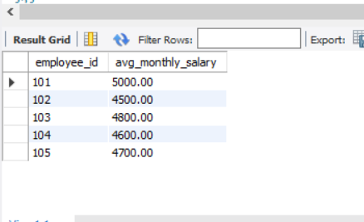

**View 2: Number of interview rounds each interviewee passes for each job**

CREATE OR REPLACE VIEW View2 AS

SELECT

ja.applicationID,

COUNT(*) AS passed_rounds

FROM

Interview i

JOIN

Job_Application ja ON ja.applicationID = i.applicationID

WHERE

i.grade > 60

GROUP BY

ja.applicationID;

SELECT * FROM View2;

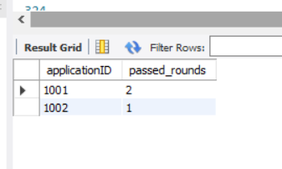

**View 3: Number of items of each product type sold**

CREATE VIEW View3 AS

SELECT

p.productType,

SUM(sp.quantity) AS total_items_sold

FROM

Sale_Product sp

JOIN

Product p ON p.product_id = sp.product_id

GROUP BY

p.productType;

SELECT * FROM View3;

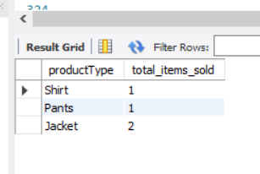

**View 4: Part purchase cost for each product**

CREATE VIEW View4 AS

SELECT

pp.product_id,

SUM(pp.quantity * pt.price) AS total_part_cost

FROM

Product_Part pp

JOIN

Part pt ON pt.part_id = pp.part_id

GROUP BY

pp.product_id;

SELECT * FROM View4;

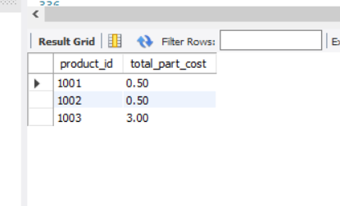

**SQL Queries**

**Q1: Interviewers for “Hellen Cole” and job “11111”**

SELECT e.employee_id, p.name

FROM Interview i

JOIN Interview_Interviewer ii ON i.interviewID = ii.interview_id

JOIN Interviewer ir ON ii.interviewer_id = ir.interviewer_id

JOIN Employee e ON ir.employee_id = e.employee_id

JOIN Person p ON e.person_id = p.person_id

JOIN Job_Application ja ON i.applicationID = ja.applicationID

JOIN Job_Position jp ON ja.jobID = jp.jobID

WHERE jp.jobID = 11111 AND p.name = 'Hellen Cole';

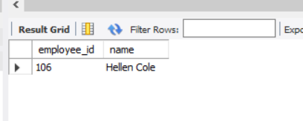

**Q2: Jobs posted by “Marketing” in Jan 2011**

SELECT jp.jobID

FROM Job_Position jp

JOIN Department d ON jp.departmentID = d.departmentID

WHERE d.name = 'Marketing'

AND MONTH(jp.postedDate) = 1

AND YEAR(jp.postedDate) = 2011;

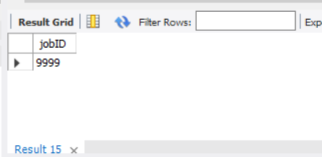

**Q3: Employees with no supervisees**

SELECT e1.employee_id, p.name

FROM Employee e1

JOIN Person p ON e1.person_id = p.person_id

WHERE e1.employee_id NOT IN (

SELECT e2.supervised_by FROM Employee e2 WHERE e2.supervised_by IS NOT NULL

);

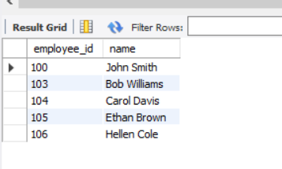

**Q4: Sites with no sales in March 2011**

SELECT ms.siteID, ms.location

FROM Marketing_Site ms

WHERE ms.siteID NOT IN (

SELECT DISTINCT siteID

FROM Sales_History

WHERE MONTH(sale_date) = 3 AND YEAR(sale_date) = 2011

);

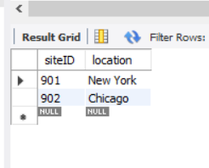

**Q5: Jobs with no hires one month after posting**

SELECT jp.jobID, jp.description

FROM Job_Position jp

WHERE jp.jobID NOT IN (

SELECT ja.jobID

FROM Job_Application ja

JOIN Interview i ON ja.applicationID = i.applicationID

GROUP BY ja.jobID

HAVING AVG(CAST(i.grade AS UNSIGNED)) > 70 AND COUNT(*) >= 5

)

AND jp.postedDate < DATE_SUB(CURDATE(), INTERVAL 1 MONTH);

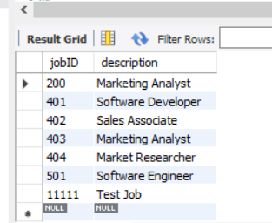\

**Q6: Salesmen who sold all product types > $200**

SELECT DISTINCT e.employee_id, p.name

FROM Employee e

JOIN Person p ON e.person_id = p.person_id

WHERE NOT EXISTS (

SELECT pt.productType

FROM Product pt

WHERE pt.listPrice > 200

AND NOT EXISTS (

SELECT p2.productType

FROM Sales_History sh

JOIN Sale_Product sp ON sh.sale_id = sp.sale_id

JOIN Product p2 ON sp.product_id = p2.product_id

WHERE sh.employee_id = e.employee_id AND p2.listPrice > 200

)

);

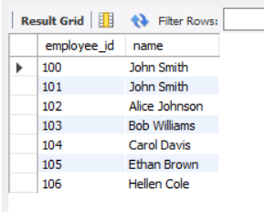

**Q7: Departments with no job posts in Jan–Feb 2011**

SELECT d.departmentID, d.name

FROM Department d

WHERE d.departmentID NOT IN (

SELECT departmentiD

FROM Job_Position

WHERE postedDate BETWEEN '2011-01-01' AND '2011-02-01'

);

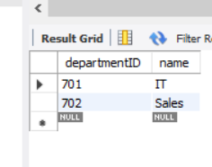

**Q8: Existing employees who applied for job “12345”**

SELECT DISTINCT p.name, e.employee_id, ed.departmentID

FROM Employee e

JOIN Person p ON e.person_id = p.person_id

JOIN Job_Application ja ON ja.person_id = p.person_id

JOIN Employee_Department ed ON e.employee_id = ed.employee_id

WHERE ja.jobID = 12345;

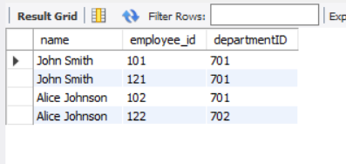

**Q9: Best selling product type (most items sold)**

SELECT productType

FROM View3

ORDER BY total_items_sold DESC

LIMIT 1;

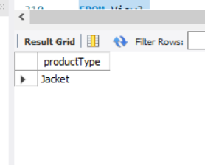

**Q10: Product type with highest profit**

SELECT

p.productType,

(SUM(sp.quantity * sp.unitPrice) - IFNULL(MAX(v.total_part_cost), 0)) AS profit

FROM Sale_Product sp

JOIN Product p ON sp.product_id = p.product_id

LEFT JOIN View4 v ON v.product_id = p.product_id

GROUP BY p.productType

ORDER BY profit DESC

LIMIT 1;

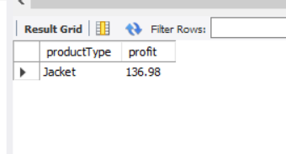

**Q11: Employees who worked in all departments**

SELECT e.employee_id, p.name

FROM Employee e

JOIN Person p ON e.person_id = p.person_id

WHERE NOT EXISTS (

SELECT 1

FROM Department d

LEFT JOIN Employee_Department ed ON ed.departmentID = d.departmentID AND ed.employee_id = e.employee_id

WHERE ed.employee_id IS NULL

);

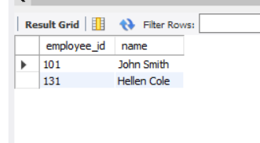

**Q12: Interviewees who are selected**

SELECT DISTINCT p.name, p.person_id

FROM Interview i

JOIN Job_Application ja ON i.applicationID = ja.applicationID

JOIN Person p ON ja.person_id = p.person_id

GROUP BY p.person_id

HAVING AVG(CAST(i.grade AS UNSIGNED)) > 70 AND COUNT(*) >= 5;

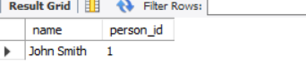

**Q 13. Query for: "name, phone number, email of selected interviewees for all jobs they applied for"**

SELECT

per.name,

ph.phone_number,

per.email

FROM Interview i

JOIN Job_Application ja ON i.applicationID = ja.applicationID

JOIN Person per ON ja.person_id = per.person_id

LEFT JOIN Phone ph ON per.person_id = ph.person_id

WHERE i.grade IN ('A', 'A+');

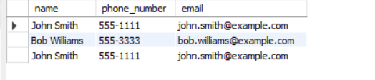

**Q14: Employee with highest average monthly salary**

SELECT e.employee_id, p.name, AVG(s.amount) AS avg_salary

FROM Employee_Salary s

JOIN Employee e ON s.employee_id = e.employee_id

JOIN Person p ON e.person_id = p.person_id

GROUP BY e.employee_id

ORDER BY avg_salary DESC

LIMIT 1;

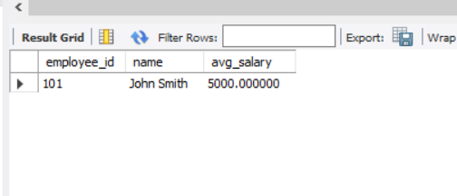

**Q15: Vendor who supplies “Cup” < 4 lbs at lowest price**

SELECT v.vendorID, v.name

FROM Vendor v

JOIN Vendor_Part vp ON v.vendorID = vp.vendorID

JOIN Part p ON vp.part_id = p.part_id

WHERE p.partType = 'Cup' AND p.price = (

SELECT MIN(p2.price)

FROM Part p2

WHERE p2.partType = 'Cup' AND p2.price < 4

);

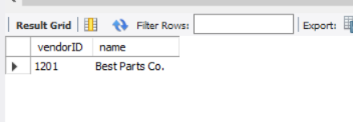

**Q16: 5 Likely Business Rules**

1. A person can be an employee, customer, or both.
2. Each interview must be conducted by at least one interviewer.
3. A job application must belong to an existing job position and person.
4. Every employee must belong to at least one department.
5. Products are made up of one or more parts sourced from vendors.

**Q17: Is subclass/superclass modeling important here?**

Yes. The Person entity is a clear superclass, while Employee, Customer, and Potential_Employee are subclasses. Using subclass/superclass (a.k.a. generalization/specialization) helps avoid redundancy and ensures integrity when different roles share common attributes (like name, address).

**Q18: Why is a relational DBMS like Oracle suitable?**

* Strong support for referential integrity via foreign keys.
* Complex queries using joins and views.
* Support for stored procedures and triggers to enforce business logic.
* Scalability and concurrency control for large enterprise use.
* Mature ecosystem with backup, security, and analytics tools.