Wideawake International
Ascension Ultra 2010 Edition
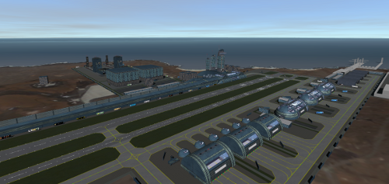

BETA DOCUMENTATION

Released under General Public Licence
This program is free software. You can redistribute it and/or modify it under the terms of the GNU General Public License, as published by the Free Software Foundation. Either version 2 of the License, or (at your option) any later version. This program is distributed in the hope that it will be useful, but without any warranty, without even the implied warranty of merchantability or fitness for particular purpose. See the GNU General Public License for more details.
Once finished, Wideawake International Ascension Ultra will be made completely open source. Dr Martin Schweiger has given us a wonderful gift with Orbiter Simulator, and it is in his spirit of honest giving for the benefit of all, that we create this addon.

Credits
All base meshes and textures (excluding the doppler radar) were created by Tom 'wehaveaproblem' Fisher. All related code has been witten by Friedrich 'face' Kastner-Masilko. The doppler radar mesh and texture were created by Greg "Loru" Lorens, and is included here with his permission, but is not included in with the GPL. Rising Fury has also contributed some code to the radar.


Beta Documentation Contents:
Introduction
Feature list
Beta Feedback Information
Base Components
Module and Base Option
MFD Operation

Introduction from the Developers
Welcome! Let me start with the obvious. This is a BETA, it is therefore work in progress (as is this manual). You are not just testing “WHAP's new WIN”, but perhaps more importantly you are testing the tools Face is developing, which provide the base's functionality. Ascension Ultra (AU) is the test bed for these tools. Ultimately AU will become the flagship base, not only being the most advanced Orbiter base to date, but showcasing the tools which will be made open source, so that others can use them to create their own bases.
Therefore I'm asking you to not only test the aesthetics and usability of AU as a spaceport, but also the coded functionality, to identify bugs and suggest improvements/features. This process will only work if you can provide us with constructive feedback and proper bug reports. If you want to just 'play' with AU, then I suggest you wait for the full release, once beta is complete. If you are willing to help us test it, then I give you my thanks in advance for your time and effort.
The beta test will take as long as it takes, and we plan to release a new version at least once a month, with each release having whatever new features and fixes have been developed since the last.

Thanks,
WHAP & Face

AIA development blog link
List of Changes in 0.4
Resolved/New/Fixes:
*[MFD] Ground Control: LFMC Launch wizard implemented
*[MFD] Air Traffic Control: Request Launch Clearance
*[MFD] Ground and ATC text chatter added for LFMC activity
[MODULE] VLC lights now move with animations
[MODULE] Recorder Save: Hangar Doors, Crane and Taxiway Beacon states now save
*[BASE] Abort Exit doors added to LFMC Launchway
*[BASE] Abort Exit added to end of LFMC Launchway
*[BASE] New Airport Mesh. Control Room and UMMU access added.
*[BASE] Port and Dockyard Facility added (static mesh)
*[BASE] Palm Trees added, sign textures added to hangar doors.
*[BASE] Site for possible Capitol Ship Facility removed.
*[FIX] Doppler radar now maintains its previous target when AU Vessel is the focus.
*[FIX] Doppler radar rotation speed now limited for realism. Thank you to Rising Fury.
*[DOCU] added LFMC Launch Wizard instructions

Issues not yet resolved:
*[MESH] Windowframe flicker on hangars.(experienced by some pcs).
*[MFD] Taxiway Guidance auto-off
*[MODULE] Vessel appears as a dot through the Earth when seen from great distance

Features in development
*[MODULE] Configuration Tool: Instant Reset
*[MODULE] Configuration Tool: Recorder Save
*[MFD] Ground Control: Cargo Management
*[MFD] Air Traffic Control: Request Bearing
*[MFD] Ground Control: VLC Launch wizard

Future planned features
*[INI] Base Option menu, inc LoD settings
*[MFD] Leasing of Hangars
*[BASE] Orbiter Racing League HQ

BETA FEEDBACK

As explained in the introduction, AU is far from finished, it is not yet ready to 'use' as a base per se. That said, we would like you to not only specifically test the features in isolation, but also try and use the base as you would intent to once it is released. This will help discover bugs that we cannot, because different people operate/think differently, as well as help educate us as to how to make using the base a more efficient, practical and enjoyable experience. At this stage please try to avoid using too many other mods or addons (vessels excluded), so that we can isolate AU bugs before working on any cross-mod compatibility issues, which will come later in the process.

Reporting Feedback
All feedback should be posted to the BETA Thread on the Orbiter Forum, found here:
http://orbiter-forum.com/showthread.php?t=28106

Bug Reports
This is the most important part of the beta test at the moment. Please try to be as detailed as possible with bug reports, with clear steps on how to recreate the bug. Please include information on addons installed, vessels and UMMUs used, the location of the action and any applicable MFD operations.

General Feedback
As important as bug fixing is, we are also keen to get general impressions, thoughts and feelings about AU as a whole. How does the look suit you? How well is the base designed? Is the MFD easily navigable? Generally speaking, what do you like and dislike?

Feature Requests
Please don't go mad on this front! There is a fairly comprehensive list of features yet to be added, or currently being worked on, but suggestions will of course be considered., especially if they improve on existing features or add something worthwhile to the base. We will consider suggestions for both aesthetic/base design elements and coded back-end/MFD features.

Source Code Repository
Starting with this version, development will be public. As such, you will have free pull access to the source code repository at Bitbucket: http://bitbucket.org/face/ascensionultra . Given a user account at Bitbucket, you are also free to add issues to the tracker or edit the Wiki pages. The later is also a great resource for background information to the code and configuration.
WIDEAWAKE INTERNATIONAL

Introduction
The Ascension Ultra version of Wideawake International is a complete redesign of the previous base. The base has been designed as a near-future tech spaceport capable of handling heavy traffic, both domestic and extra terrestrial, in the manner which a large airport might do today. It has been specifically designed to accommodate winged space vessels and vertical launch rocket stacks. Many issues of the original WIN have been addressed and a host of new features added. There has also been less concession made to low-end computer specs. Although every effort has been made to make the meshes as clean and efficient as possible, there are more meshes, the poly count is much higher for each mesh, the textures are higher resolution, and considerable transparency has been used. Therefore, some users may experience a low fps.
My rig has the following specs and runs the base at 1920x1080, with all bells and whistles turned to max, and gets 70+fps easily:
Intel(R) Core i5-2500k @ 3.6GHZ, 8GB RAM, GeForce GTX 580, Win7



Base Components
What follows is a brief description of each of the major base components and their features. Below is a map of the base layout, showing all the key locations.
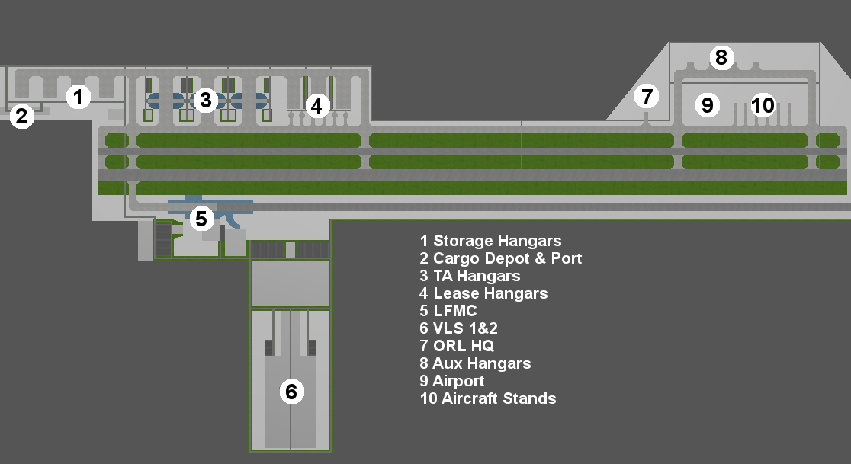
Taxiways and signage
The base includes taxiway markings and signage pretty much in accordance to those established on modern airports.
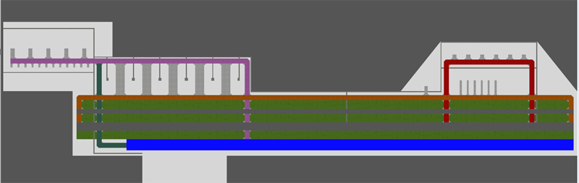
Taxiway Key: Purple - Taxiway A ; Red - Taxiway B ; Orange - Taxiway C ; Green - Taxiway D

Runways
There are 2 runways on AU, usable from either direction, although the run-off is greater for westerly approaches, as most space vessels will approach from this direction on direct reentry flight paths.

Runway | 13L | 13R | 31L | 31R
VOR | 113.00 | 113.00 | 113.00 | 113.00
ILS | 113.20 | 113.40 | 113.60 | 113.80
Width | 45m/148ft | 80m/282ft | 80m/262ft | 45m/148ft
TORA | 4270m/14009ft | 4270m/14009ft | 4270m/14009ft | 4270m/14009ft
TODA | 4725m/15502ft | 4725m/15502ft | 6755m/22162ft | 6755m/22162ft
ASDA | 4540m/14895ft | 4540m/14895ft | 4540m/14895ft | 4540m/14895ft
LDA | 4725m/15502ft | 4725m/15502ft | 4540m/14895ft | 4540m/14895ft

13L/31R: Classified for all domestic traffic and un-powered landings of light space vessels only.
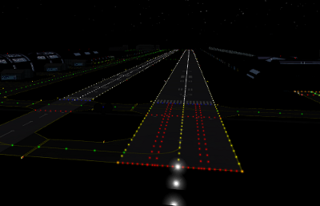
13R/31L: Classified for un-powered landings of all winged space vessels. Powered landings may be permitted on this runway in cases of extreme emergency.

Turn Around Hangars
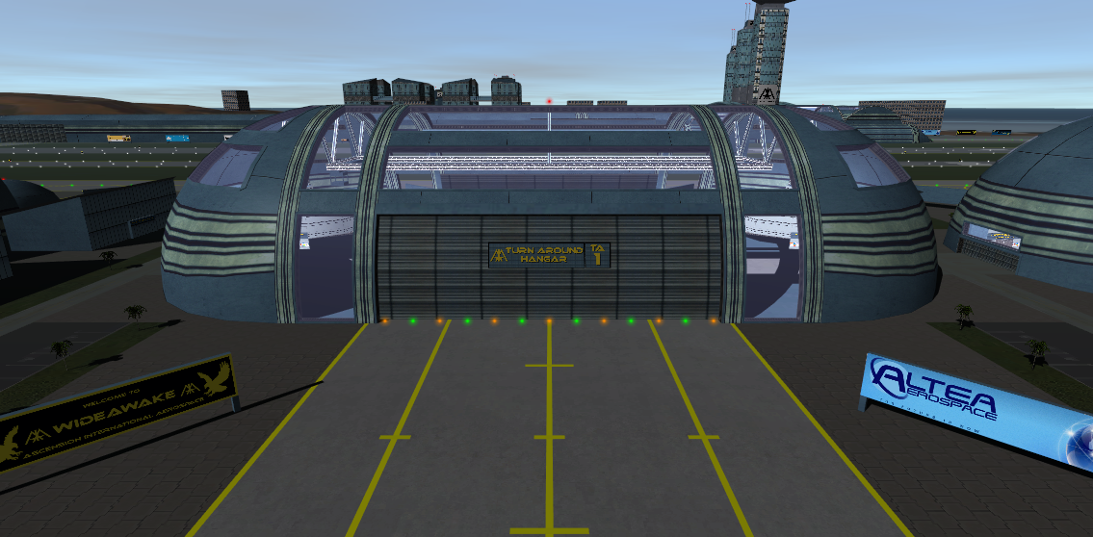
The TA hangars are designed for swift turn around of winged space vessels and can accommodate the giant XR-5 Vanguard. Hear vessels can load/unload cargo and receive the required routine maintenance before returning to the stars. These hangars belong to AIA and a re used by other companies on a per-flight schedule booked basis. They include a usable cargo crane, 2 control rooms, animated doors, and can ingress/egress UMMUs; all accessed via the MFD. Each Hangar also has 2 UMMU action areas. One is the Crew Lounge door which allows ingress into the hangar, the other is the control box on the left of each main door, which can be activated to operate the door manually.
Lease Hangars
As the name suggests, the Lease hangars are available for users to lease for their own private use. The Light hangars can accommodate XR1/XR/DG size vessels, whilst the larger ones can house XR-5 size vessels. Each has an animated door controlled through the MFD, or through the UMMU action area to the left of the door.
NB: The feature to actually lease hangars through the MFD is not implemented yet, only the animations work. However, you can replace the appropriate “Leasebillx.dds”(where x is the hangar number) texture in the Textures/AscensionUltra/Billboards folder with your own to 'privatise' a hangar in the meantime.
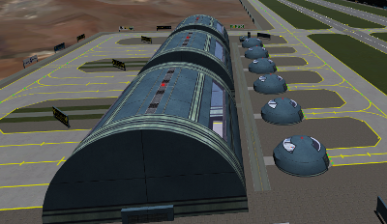

Launch Facility and Mission Control
This is where all winged space vessels take off from. Here vessels carry out their pre-flight checks, load passengers, load fuel, then launch. The shielded launchway has been designed to contain rocket exhaust and any catastrophic take-off accidents (plus it's a cool experience!). The LMFC has 2 control rooms, one in the pre-launch area, the other in the ATC Tower.
The Launchway: This is NOT a runway, and has been named accordingly. It is used explicitly for the take-off of space-bound vessels only.
TORA | 4010m/13156ft
TODA | 6000m/19685ft
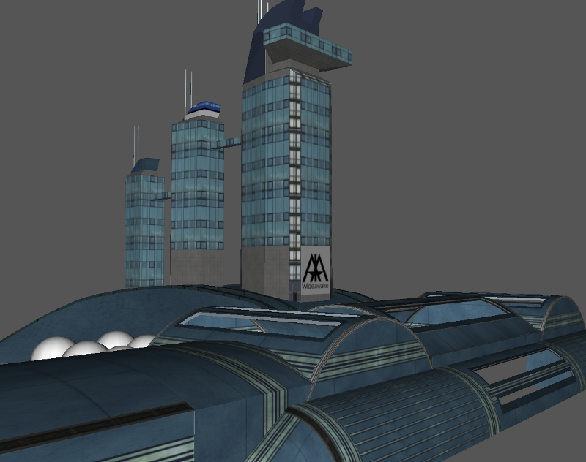
Vertical Launch Complex
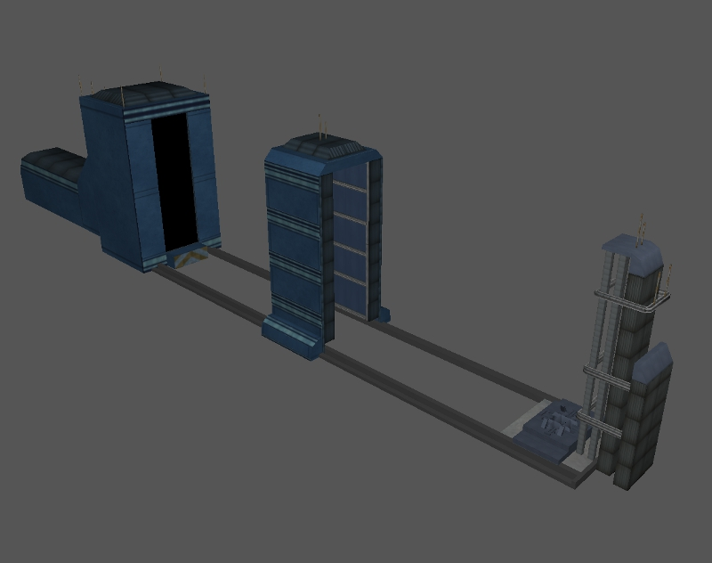
The complex consists of 2 VABs and pads capable of launching rocket stacks in excess of 100m height. The design is based on an up-scaled version of the Slick6 pad at Vandenberg, which uses a covered MLP for the roll-out. Loading rockets to the MLP and roll-out from VAB to Tower is controlled through the MFD.

Static Meshes
There are also many other static meshes around the base which currently have no interactive features. These include the Airport, The Storage Hangars, and all the other office buildings. The Airport does however have UMMU roster functionality and a control room.
In addition there are 2 doppler radar, which are animated, but all they do is follow the current active vessel, they have no interactive potential per se.
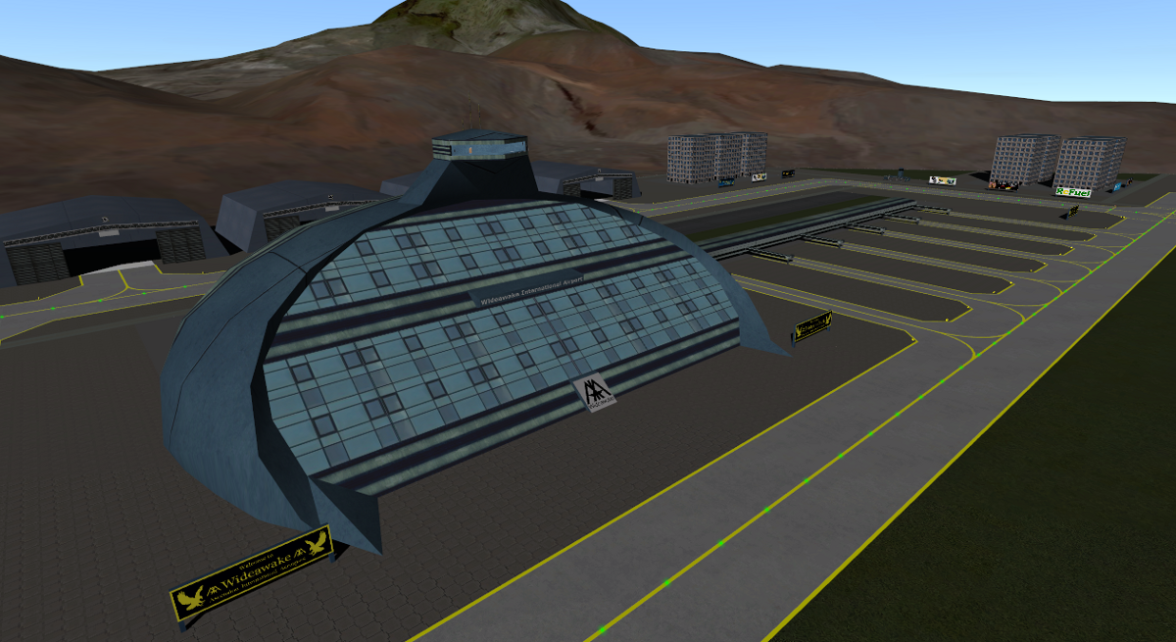

Lpads
There are currently 12 LPADS available for use through the scenario editor, to place vessels at key areas around the base. None have ILS, they are all invisible. These 12 are all that will ever be in the cfg file as standard, however the full release manual will include a comprehensive list of extra coordinates for all useful locations, should users wish to add more lpads themselves.
NB: The scn editor does not auto-rotate a vessel to the correct heading, so headings have been included below for ease of manual alteration.
Pad | Location | Heading
1 | Storage Hangar | 40
2 | Turn Around Hangar | 40
3 | Light Lease Hangar | 210
4 | Heavy lease Hangar | 40
5 | Auxiliary Hangar | 210
6 | LFMC Entrance | 130
7 | LFMC Launchway | 130
8 | Runway 13L | 130
9 | Runway 13R | 130
10 | Runway 31L | 310
11 | Runway 31R | 310
12 | Airport Aircraft Stand | 40

MODULE AND BASE OPTIONS

Base Configuration
The Base Configuration tool can be found in the Orbiter Extra tab. It allows the user to pre-set several option for the base, prior to loading a scenario. This is part of the base making toolbox, so different bases made with the tools will have separate settings entries. Double-click the 'Ascension Configuration' to see the options implemented so far.
NB: All options are checked 'ON' by default.

Auto-spawn
Regardless of which scenario the user starts, the system will scan for the presence of the base vessels and, if not found, will creates new vessels at the proper locations automatically. No more need for special scenarios!
NB: This will only work if scenario contains the Earth Gbody.

Instant Reset
As you will see, the MFD has the option to reset all base states back to default. This option will dictate whether the resets are animated(if applicable), or instantaneous.
NB: This function is not currently implemented.

Scenario Save
The system will automatically save all the animation and settings states (doors, crane, opening/closing etc.) into the scenario file on game save or exit.
NB: Un-checking this option will cause all base elements to be reset to default settings on game save or exit.

Recorder Save
Triggers whether any Recorder events should be saved.
NB: This function is WIP. Currently only door, crane and taxiway beacon settings are saved.
ASCENSION TOWER MFD

Introduction
The Ascension Tower MFD lies at the heart of Wideawake, bringing her to life. All base functionality can be accessed through the various multi-page wizards and menus. It has been designed with future bases in mind, and will become a key part of the open source tool set. All animations controlled by the MFD are Orbiter recorder compatible, so animation states will be loaded/saved from/to the scn file.

General Navigation
There are 4 main sections to the MFD: Ground Control, Air Traffic Control, Control Rooms, Roster. Each takes you to a list of relevant sub-options.
NB: There is also the dev option to reset all variables for all functions to default.
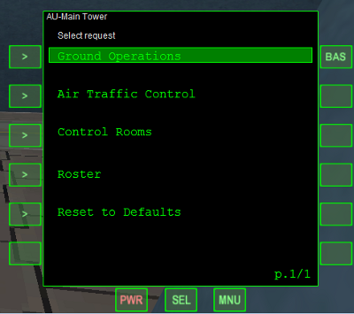
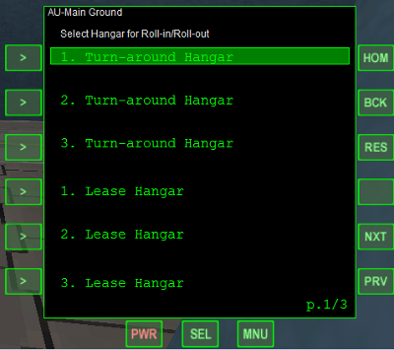
The top 3 buttons on the right hand side of every screen (except for main menu) are the same. HOM, will return you to the main menu. BCK, takes you to the previous menu screen. RES, resets the state of the current page (if anything can be changed). If there is more than one sub-menu, then there will be NXT and PRV buttons in the bottom right also, for scrolling between them. A sub-menu page count is displayed in the bottom right corner of the screen..

Ground Control Menu
Request Rollin/Roll Out: This opens the relevant doors for hangars. Select the hangar, then the door, then command to open/close.
NB: VLC: Currently the Cover and MLP are animated, but rocket attachment is not functional and beacons do not animate. So the ability to test the animation alone is added to this section at present.

Request Taxi: The Guided Taxi System is a visual navigation aid for pilots. Select your current location and your destination, and beacons will strobe out the appropriate route for you to follow.
NB: The ability to 1-click reset the taxi-guidance (RES) is currently not implemented.

Request Cargo Control: This grants access to the TA cargo cranes. The crane can be controlled through the MFD or via WASD once activated.
NB: The crane is currently only an animation, it's functionality for cargo transfer is not currently implemented.

Request Passenger Transfer: This option will only appear when inside a vessel that itself is inside either a TA Hangar or the passenger area of the LFMC. Activate the appropriate location and when you EVA a UMMU from that location it will transfer directly into the vessel.
NB: This option will still appear when inside a non-UMMU compatible vessel, however the functionality will be void as a result.

Request Launch: This option is for winged vessels. It will trigger the Launch Wizard for the LFMC. See LFMC Launch Wizard below for more details.

Air Traffic Control
Request Clearance to Land: Select the appropriate runway when on final approach and the appropriate landing guidance beacons will activate.

Request Launch Clearance: this function is used to request final launch clearance when positioned at the Launch Hold of the LFMC.

Control Rooms
There are a number of control rooms at key locations around the base, used as viewing and control platforms. Select the appropriate control room to be moved there.

Roster
Add UMMU: Create a new UMMU entry on the AU base roster. You can set their basic stats, then select their location to move them there.
UMMU roster list: Once a UMMU has been created or transferred to the base, they will appear on this screen. Click the required person to edit their details or use the EVA button to egress them from their current location.
LFMC Launch Wizard
The LFMC launch wizard is a function of the MFD and will guide you through winged vessel launches.

The LFMC is split into 4 areas. Pre-Flight Hold, Passenger Hold, Fuelling Hold and Launch Hold. Each area allows you to perform certain relevant actions. Follow the instructions on the MFD to be directed through each area in turn. When you approach each Hold, the available action options will be triggered and the MFD page will change. When this happens, stop your vessel and carry out appropriate activity. Once all activity has been completed, click the 'GO' button on the MFD to proceed to the next area.
Each Hold is marked by a dashed double line and coloured beacons on the ground, and a sign over-head.
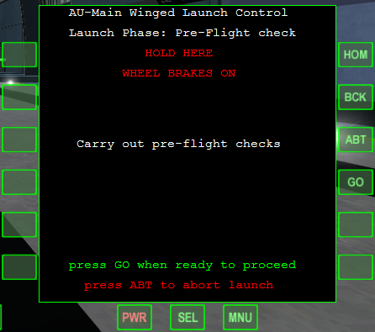
Example of Launch Wizard MFD Page

Initiate launch process:
On approach to the LFMC, select:
Ground > Request Launch > Winged Launch Facility.
You will be directed to the LF stop line outside the LFMC. Once there, you will be directed to Pre-flight.

Pre-Flight Hold:
This area is for final checks of a vessel's key systems. Complete whatever checklist you desire, make sure your vessel is space-worthy before continuing. The MFD page has no functionality for this process, you are responsible for your own checklists.
Once ready to proceed, click 'GO' button on MFD.

Passenger Hold:
This area is for loading passengers. The MFD will show any passengers currently in the terminal. You can also use the MFD Roster page (ROS button) to create/move passengers as required.
Once you have finished loading passengers, Press 'GO' to proceed to fuelling.

Fueling Hold:
This area is for loading fuel. The MFD will indicate current fuel levels and allow you to load fuel as required.
Once you are fully fuelled, press 'GO' button to proceed to Launch Tunnel.

Launch Hold:
Once you reach the Launch Hold you will be instructed to contact Wideawake Air Traffic Control for final launch clearance. Select:
Air Traffic Control > Request Launch Clearance.
Once given clearance, you are free to take off. Contact with ATC will continue until you clear Wideawake Airspace.

Aborting:
At any point during your passage through the LFMC, you may abort your launch for whatever reason. To do this, press “ABT” button on the MFD. You have one chance to confirm this abort before being directed to the Abort Exit. This is a door in the Launchway left wall that connects to taxiway A. Proceed through the LFMC and exit through this door. Alternatively the end of the Launchway is now connected to Taxiway C, should you need to abort the launch once already rolling down the Launchway.

Traffic stacking:
The LFMC can handle multiple vessels at one time. If the Hold you wish to advance into is occupied by another vessel, you will be instructed to maintain your hold until that vessel has been cleared.

Radio Chatter:
Although the MFD will give you all the instruction you need, we have also implemented voice-synth radio chatter to enhance your experience. These commands will echo those of the MFD, and will also be printed to screen, so sound is not necessary.
NB: There is currently no user interface to specify the screen positions of the radio chatter slots. You will have to edit the orbiter.cfg manually to set some to see the chatter as text, e.g. like so:
ATCAnnotationSlot0 = 0.200000, 0.100000, 0.800000, 0.200000

SOME THINGS TO BE AWARE OF WITH UMMU
These are UMMU coded issues we cannot resolve, so what follows are workarounds to avoid the problems caused.

TRANFERS: When transferring a UMMU between base/vessel an error can occur if the vessel name has a space in it. Therefore, when adding vessels to an AU scenario, you can avoid this using dashes or underscores. For example “DG 1” will cause an error “DG-1” or “DG_1” will not.
UMMU TITLE: When entering the title/role of a new UMMU, only the first 4 letters entered will be saved.

General note on Beacons in BETA:
Please be aware that some of the beacons you see in the above facilities are not yet functioning as intended. That is to say they do not animate and move as intended. Many have a purpose connected to an animation that has not yet been coded.

