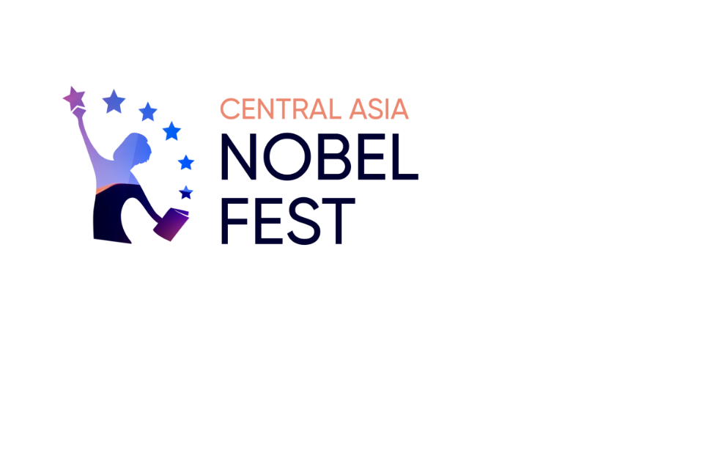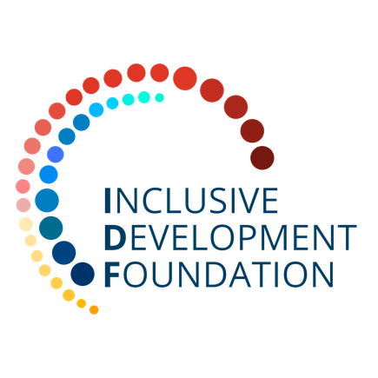

55/23, Mangilik El street, Office 250; Nur-Sultan, Kazakhstan, Z05T3F6

[https://nobel-fest.inpolicy.net](https://nobel-fest.inpolicy.net/)

**__________________________________________________________________________**

|  |  |
| --- | --- |
| Reg 029  07.06.2021  **Ahmed Abdallah**  **Senior Software Engineer**  **Codecademy** |  |

**Dear Mr Abdallah,**

Let us take this opportunity to express our high regards and invite you to participate as a key speaker in the **III** **Central Asia Nobel Fest**. This event will be held in a **hybrid format** from Nur-Sultan, Kazakhstan between **October 26-29, 2021.**

**Central Asia Nobel Fest** is a unique scientific and educational event that annually brings over 20,000 students and professors from 65 countries together with Nobel Prize winners, Breakthrough Prize laureates, world scientists, renowned industry experts and leaders of international organizations and major companies. The festival creates an inclusive environment that provides access to the exchange of scientific knowledge, unleashing endless opportunities for a new generation of researchers and innovators.

The III Nobel Fest entitled **"The Future Is Now"** is dedicated to the large-scale transformation of **technology and innovation** that we are witnessing today, addressing important issues like the growth of green technologies, development of smart cities, inclusive policies, economics of happiness, trends in online education, as well as longevity and human health.

We expect more than **20,000** participants, unique debates with **30** influential speakers, and tremendous opportunities to interact with the audience thanks to modern online solutions that we have developed specifically for conducting the Nobel Fest events.

Acknowledging your outstanding and unique expertise, we will be honored to have your presence at the **III Central Asia Nobel Fest**.

We believe that your involvement will inspire participants to new ideas and achievements, and eagerly look forward to your response.

**Sincerely,**

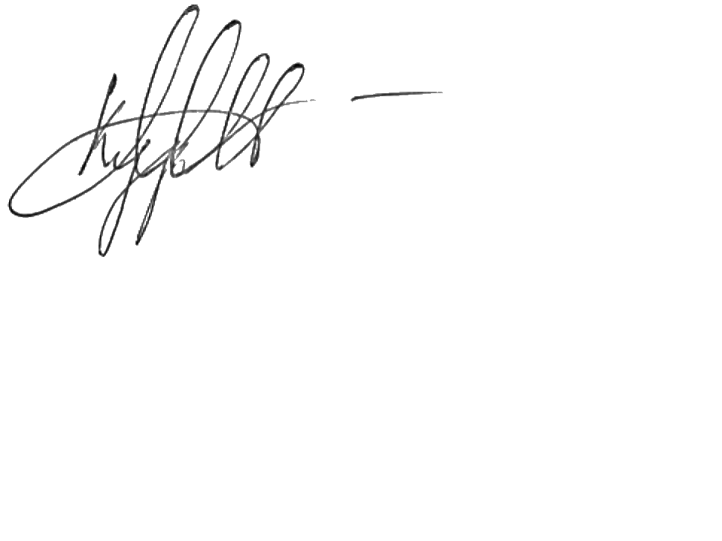**Maxat Kurbenov**

Managing Director,

Inclusive Development Foundation