Website documentation.

The Alliance Skin Care Center website, currently running on a local server, is designed to facilitate interaction between users and a machine learning model that predicts the type of skin cancer based on uploaded images. The primary objective of the website is to create a user-friendly interface for both doctors and patients, allowing them to upload images and receive predictions from the machine learning model. Additionally, the platform aims to establish a communication channel between doctors and patients for follow-up consultations and support. The target audience consists of medical professionals who need to analyze skin-related conditions and consult with patients, as well as individuals seeking medical advice and diagnosis for skin conditions, particularly skin cancer.

The Alliance Skin Care Center website consists of six primary pages, each designed to meet specific needs. The home page serves as the landing page, offering visitors an overview of the website's services and explaining how the platform operates. The "My Health" page allows users to interact with the machine learning model by uploading images to predict skin cancer. The "Near Me" page features an interactive map that shows nearby dermatologists, along with a list of well-known dermatologists and their contact details. The "About Us" page introduces the team behind the website, describing their objectives and providing background information.

Additionally, there is a "Book Appointment" page where users can schedule appointments with dermatologists. This page includes a form where users can select a date, time, and dermatologist, providing an easy way to arrange consultations. The "Invoice" page displays the details of scheduled appointments, such as appointment time, location, and any associated fees, allowing users to review their bookings and keep track of their appointments.

The design philosophy prioritizes simplicity and ease of use, ensuring that both medical professionals and patients can navigate the website with minimal effort. The front-end technology stack includes HTML, CSS, Bootstrap, and Font Awesome, creating an intuitive and visually appealing interface. The back-end utilizes Python, JavaScript, and Ajax, with MySQL for managing data, including appointment information. Email integration is used for sending appointment confirmations and other communications to users.

The technology stack for the Alliance Skin Care Center website is designed to ensure a seamless, user-friendly experience while providing robust functionality. On the front-end, HTML, CSS, Bootstrap, and Font Awesome are used to create a visually appealing interface that is both responsive and intuitive. HTML provides the basic structure of the website, while CSS is used for styling and layout. Bootstrap, a popular front-end framework, enables quick development of responsive designs, ensuring that the website looks and works well on various devices. Font Awesome is used to include scalable vector icons, adding visual elements that enhance user interaction.

On the back-end, Python serves as the primary programming language, with Flask as the web framework. Flask is lightweight and flexible, making it a popular choice for building web applications. It allows you to create server-side logic, handle HTTP requests, and manage routing with ease. The back-end also includes JavaScript and Ajax for dynamic interactions, allowing asynchronous communication with the server without reloading the entire page, which enhances user experience.

For database management, the website uses MySQL, a widely-used relational database system. MySQL provides reliable data storage and retrieval, allowing you to manage appointment information and other critical data. To connect Python to MySQL, an SQL connector is used to facilitate database interactions.

In addition, TensorFlow is utilized to run the machine learning model for predicting skin cancer. This powerful open-source library enables you to build and deploy machine learning models, providing the underlying technology for the "My Health" page's predictive functionality. For image processing, cv2 (OpenCV) is used, offering robust tools for image analysis and manipulation.

Lastly, email integration is achieved through the Flask-Mail extension, allowing you to send automated emails to users for appointment confirmations and other communications. This technology stack collectively provides a comprehensive framework for building and maintaining the website, ensuring reliability, scalability, and ease of use.

Homepage1

Homepage 2

Homepage 3

My health 1

My health 2

My health 3

Near me 1

Near me 2

About us 1

About us 2

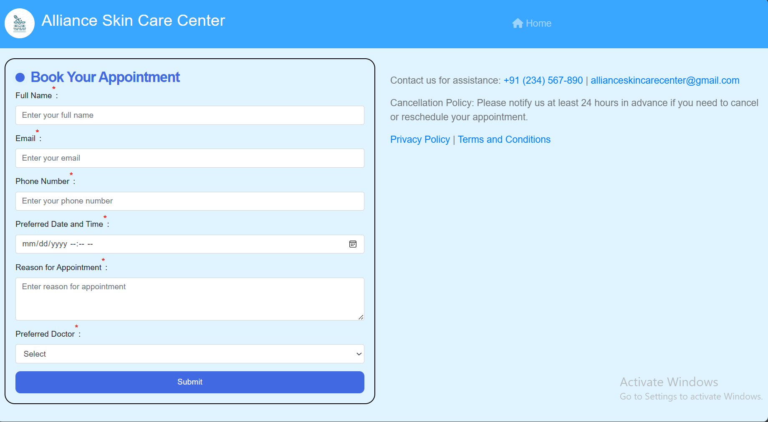

Form

conformationpage

Sent email

1. Home Page

Name: Home

Description: This page serves as the introduction to the Alliance Skin Care Center. It highlights the website's mission to empower users with early skin cancer detection through advanced technology. It includes navigation elements to explore other functionalities.

2. My Health Page

Name: My Health

Description: This page allows you to upload images of skin lesions and get predictions on potential skin cancer. It also provides educational resources about skin cancer and facilitates communication with the Alliance Skin Care Center for further consultation or appointments. Here's a breakdown of the functionalities:

Image Upload: You can upload an image of a skin lesion you want to analyze for potential cancer.

Skin Cancer Information: The page provides links to educational resources about skin cancer, allowing users to learn more about the disease.

Book Appointment: A button or link is likely available to navigate to the appointment booking page if you decide to seek a professional consultation after reviewing the analysis results.

Contact and Support: The page might also include contact information or a support section to connect with the Alliance Skin Care Center for further questions or concerns.

3. About Us Page

Name: About Us

Description: This page provides information about the Alliance Skin Care Center's team, mission, and vision. It showcases the team members' profiles with short biographies and highlights the organization's goals of providing accessible and accurate skin cancer detection tools.

4. Book Your Appointment Page

Name: Book Your Appointment

Description: This page allows you to schedule an appointment with a dermatologist at the Alliance Skin Care Center. It provides a form to enter your contact details, preferred date and time, reason for the appointment, and preferred doctor (if available). Upon submitting the form, you'll receive a confirmation email with the appointment details.

5. Confirmation Email

Name: Appointment Confirmation Email

Description: This is an email confirmation sent by the Alliance Skin Care Center after you book an appointment. It summarizes the appointment details you provided, including your name, contact information, preferred date and time, reason for the appointment, and chosen doctor (if applicable). It also includes the clinic's contact details and cancellation policy.