

**Project. Parts 0-6**

**Music Platform “Spotfy”**

**Students:** Yedil Alinur, Taldybayev Batkyrhan

**Tutor:** Kozina Lyudmila

# **Deploying the database on a server**

**Renting a server on hosting provider**

Before we start the project parts, we want to rent a server on which we will deploy the database, because it will be uncomfortable to work on a local database and send data and SQL queries to each other. So, I entered to billing.firstbyte.com to rent a server. The cheapest is good, and that’s why this hosting is good for it:

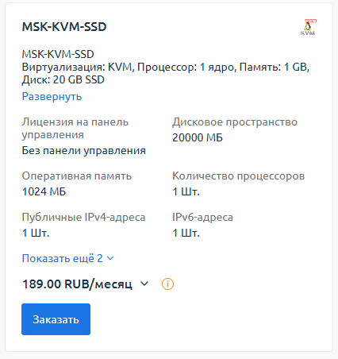

This server is not bad. For this cost we get 1 GB of RAM, 1 Core of CPU, IP-address and 20 GB of SSD.

The next step is to enter into the server using root credentials and setup it for logging by using public and private keys. At first it will solve the security problem, at second it’s easier to log in by using my own password and private key. Thanks to WSL on my system, I can log in to server without other programs like PuTTy, so I do this directly from Linux CLI. But at first, I need to create public and private keys:

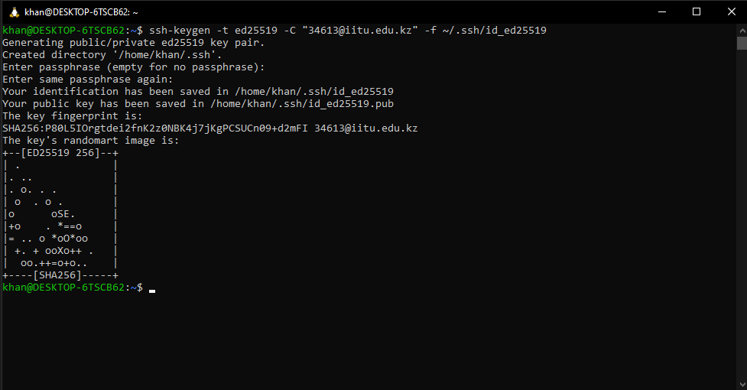

Keys were created successfully. Next step is to log in to the server, creating user for me and setup the keys:

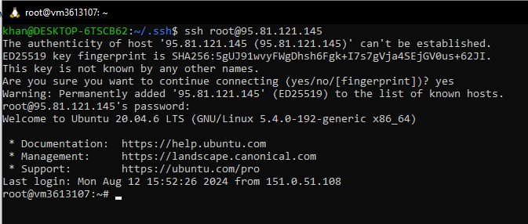

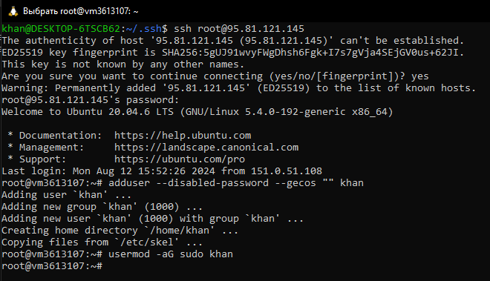

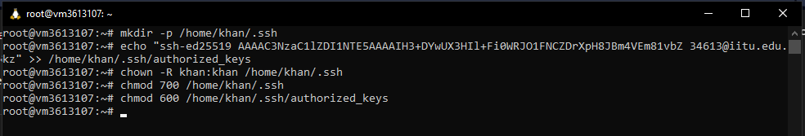

Public key is implemented to my user, so I can access to the server by using my private key:

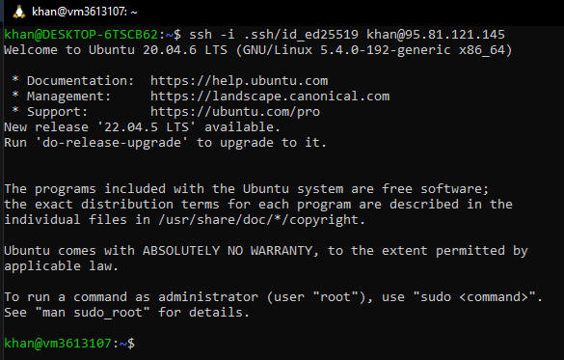

And it worked! So, the next step is to update packages and initialize PostgreSQL for work.

**Setup the PostgreSQL**

The commands I need to input are:

1. sudo apt update && apt upgrade -y
2. sudo apt install postgresql

That’s enough to work with it.

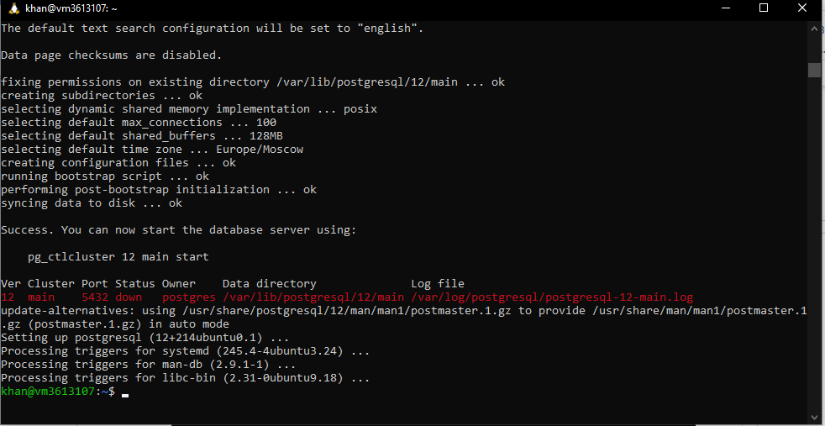

Screenshot says that PostgreSQL has been installed

But it’s already started, because I checked it by systemctl and enabled for auto-start:

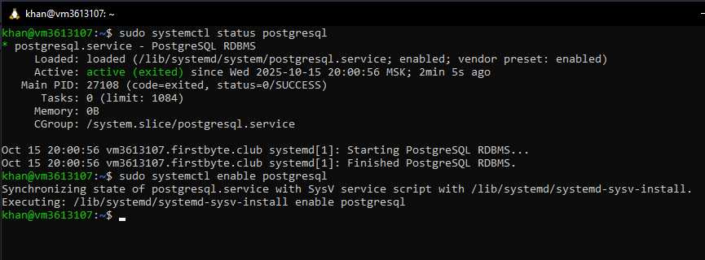

According to documentation, I need to enable all other computers to connect to database and then create a user.

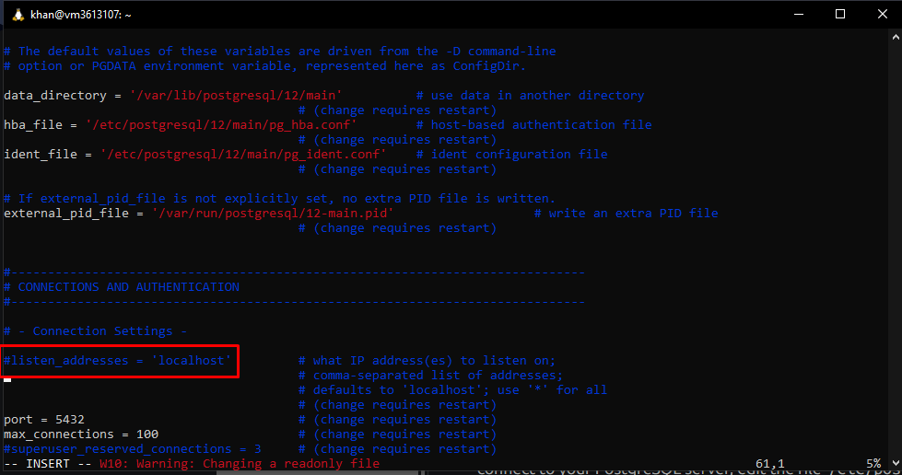

This line #listen_addresses = ‘localhost’ has to be changed to ‘*’, so me and Alinur can access to it from our computers.

After that, it’s time to create user:

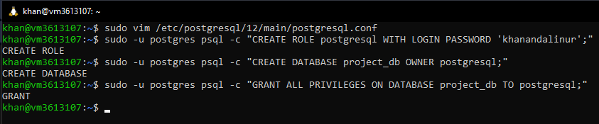

Thanks to -c I can directly in command write the unnecessary query: Created role postgresql with our custom password, created database named “project_db” for postgresql (our main user) and gave all privileges for postgresql to interact with database.

**Connecting to the database**

In pgAdmin I created new server “project” and entering credentials: 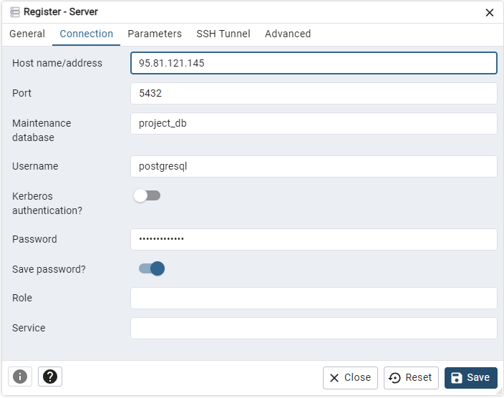

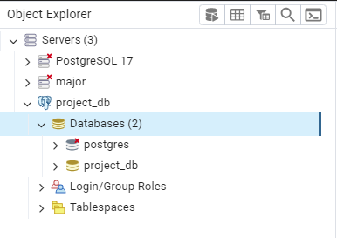

Perfect! Now I and Alinur can connect to the database from our computer via pgAdmin!

# **Part 0. PostgreSQL Database Implementation**

We chose the database for Music Platform. We tried to make similar to *Spotify* database. Of course, it’s not so similar and perfect like we didn’t use the UUID for IDs, there is no columns such as “danceability”, “energy”, “loudness”, “tempo” and so on, but the main idea exists.

There are tables:

1. Countries

|  |  |  |  |
| --- | --- | --- | --- |
| country_id | VARCHAR(50) | PK | Unique id of country |
| name | VARCHAR(100) |  | Name of the country |

1. Subscriptions

|  |  |  |  |
| --- | --- | --- | --- |
| subscription_id | VARCHAR(50) | PK | Unique id |
| name | VARCHAR(50) |  | The name of subscription |
| Price | DECIMAL(6,2) |  | The cost of subscription |

1. Users

|  |  |  |  |
| --- | --- | --- | --- |
| user_id | VARCHAR(50) | PK | Unique id |
| name | VARCHAR(100) |  | Name of the user |
| email | VARCHAR(100) |  | Email (unique) |
| password | VARCHAR(255) |  | Hash of the password |
| subscription_id | VARCHAR(50) | FK | Subscription of the user |
| country_id | VARCHAR(50) | FK | The country of the user |
| registration_date | TIMESTAMP |  | Registration date of the user |

1. Artists

|  |  |  |  |
| --- | --- | --- | --- |
| artist_id | VARCHAR(50) | PK | Unique id |
| name | VARCHAR(150) |  | The name of the artist |
| bio | TEXT |  | Bio of the artist |

1. Genres

|  |  |  |  |
| --- | --- | --- | --- |
| genre_id | VARCHAR(50) | PK | Unique id |
| name | VARCHAR(100) |  | The name of the genre |

1. Albums

|  |  |  |  |
| --- | --- | --- | --- |
| album_id | VARCHAR(50) | PK | Unique id |
| title | VARCHAR(100) |  | The name of the album |
| release_date | DATE |  | The release date of the album |
| artist_id | VARCHAR(50) | FK | Author of the album |

1. Tracks

|  |  |  |  |
| --- | --- | --- | --- |
| track_id | VARCHAR(50) | PK | Unique id |
| title | VARCHAR(200) |  | Name of track |
| duration | INTERVAL |  | Track duration |
| artist_id | VARCHAR(50) | FK | Author of track |
| album_id | VARCHAR(50) | FK | Album of track |
| genre_id | VARCHAR(50) | FK | Genre of track |

1. Playlists

|  |  |  |  |
| --- | --- | --- | --- |
| playlist_id | VARCHAR(50) | PK | Unique id |
| title | VARCHAR(200) |  | Name of playlist |
| user_id | VARCHAR(50) | FK | Creator of playlist |

1. Playlist_Track

|  |  |  |  |
| --- | --- | --- | --- |
| playlist_id | VARCHAR(50) | PK, FK | ID of playlist |
| track_id | VARCHAR(50) | PK, FK | ID of track |
| position | INTEGER |  | Track position in playlist |

1. Listening_Histories

|  |  |  |  |
| --- | --- | --- | --- |
| history_id | VARCHAR(50) | PK | ID of the listening record |
| user_id | VARCHAR(50) | FK | ID of user |
| track_id | VARCHAR(50) | FK | ID of listened track |
| play_date | TIMESTAMP |  | Date of listening |

1. Ratings

|  |  |  |  |
| --- | --- | --- | --- |
| user_id | VARCHAR(50) | PK, FK | ID of user |
| track_id | VARCHAR(50) | PK, FK | ID of track |
| rating | SMALLINT |  | The rating of track (1-5) |
| review | TEXT |  | Review |

1. Recommendations

|  |  |  |  |
| --- | --- | --- | --- |
| recommendation_id | VARCHAR(50) | PK | ID of recommendation |
| user_id | VARCHAR(50) | FK | ID of user |
| track_id | VARCHAR(50) | FK | ID of track that recommended |

1. Charts

|  |  |  |  |
| --- | --- | --- | --- |
| chart_id | VARCHAR(50) | PK | ID of Chart |
| name | VARCHAR(100) |  | Name of chart |
| country_id | VARCHAR(50) | FK | Country of chart |

1. ChartTrack

|  |  |  |  |
| --- | --- | --- | --- |
| chart_id | VARCHAR(50) | PK, FK | ID of chart |
| track_id | VARCHAR(50) | PK, FK | ID of track |
| position | INTEGER |  | Position in chart |

The queries are also represented in [**GitHub repository**](https://github.com/KhanWarden/advanced_database_theory)

The query of creating tables:

CREATE TABLE Countries (

    country_id VARCHAR(50) PRIMARY KEY,

    name VARCHAR(100) NOT NULL UNIQUE

);

CREATE TABLE Subscriptions (

    subscription_id VARCHAR(50) PRIMARY KEY,

    name VARCHAR(50) NOT NULL UNIQUE,

    price DECIMAL(6,2) NOT NULL

);

CREATE TABLE "users" (

    user_id VARCHAR(50) PRIMARY KEY,

    name VARCHAR(100) NOT NULL,

    email VARCHAR(100) NOT NULL UNIQUE,

    password VARCHAR(255) NOT NULL,

    subscription_id VARCHAR(50) REFERENCES Subscriptions(subscription_id),

    country_id VARCHAR(50) REFERENCES Countries(country_id),

    registration_date TIMESTAMP NOT NULL DEFAULT NOW()

);

CREATE TABLE Artists (

    artist_id VARCHAR(50) PRIMARY KEY,

    name VARCHAR(150) NOT NULL,

    bio TEXT

);

CREATE TABLE Genres (

    genre_id VARCHAR(50) PRIMARY KEY,

    name VARCHAR(100) NOT NULL UNIQUE

);

CREATE TABLE Albums (

    album_id VARCHAR(50) PRIMARY KEY,

    title VARCHAR(200) NOT NULL,

    release_date DATE,

    artist_id VARCHAR(50) NOT NULL REFERENCES Artists(artist_id)

);

CREATE TABLE Tracks (

    track_id VARCHAR(50) PRIMARY KEY,

    title VARCHAR(200) NOT NULL,

    duration INTERVAL MINUTE TO SECOND NOT NULL,

    artist_id VARCHAR(50) NOT NULL REFERENCES Artists(artist_id),

    album_id VARCHAR(50) REFERENCES Albums(album_id),

    genre_id VARCHAR(50) REFERENCES Genres(genre_id)

);

CREATE TABLE Playlists (

    playlist_id VARCHAR(50) PRIMARY KEY,

    title VARCHAR(200) NOT NULL,

    user_id VARCHAR(50) NOT NULL REFERENCES "users"(user_id)

);

CREATE TABLE Playlist_Track (

    playlist_id VARCHAR(50) NOT NULL,

    track_id VARCHAR(50) NOT NULL,

    position INT,

    PRIMARY KEY (playlist_id, track_id),

    FOREIGN KEY (playlist_id) REFERENCES Playlists(playlist_id),

    FOREIGN KEY (track_id) REFERENCES Tracks(track_id)

);

CREATE TABLE Listening_Histories (

    history_id VARCHAR(50) PRIMARY KEY,

    user_id VARCHAR(50) NOT NULL REFERENCES "users"(user_id),

    track_id VARCHAR(50) NOT NULL REFERENCES Tracks(track_id),

    play_date TIMESTAMP NOT NULL DEFAULT NOW()

);

CREATE TABLE Ratings (

    user_id VARCHAR(50) NOT NULL,

    track_id VARCHAR(50) NOT NULL,

    rating SMALLINT CHECK (rating BETWEEN 1 AND 5),

    review TEXT,

    PRIMARY KEY (user_id, track_id),

    FOREIGN KEY (user_id) REFERENCES "users"(user_id),

    FOREIGN KEY (track_id) REFERENCES Tracks(track_id)

);

CREATE TABLE Recommendations (

    recommendation_id VARCHAR(50) PRIMARY KEY,

    user_id VARCHAR(50) NOT NULL REFERENCES "users"(user_id),

    track_id VARCHAR(50) NOT NULL REFERENCES Tracks(track_id)

);

CREATE TABLE Charts (

    chart_id VARCHAR(50) PRIMARY KEY,

    name VARCHAR(100) NOT NULL,

    country_id VARCHAR(50) REFERENCES Countries(country_id)

);

CREATE TABLE ChartTrack (

    chart_id VARCHAR(50) NOT NULL,

    track_id VARCHAR(50) NOT NULL,

    position INT NOT NULL,

    PRIMARY KEY (chart_id, track_id),

    FOREIGN KEY (chart_id) REFERENCES Charts(chart_id),

    FOREIGN KEY (track_id) REFERENCES Tracks(track_id)

);

Now if I enter this query in our remote database: 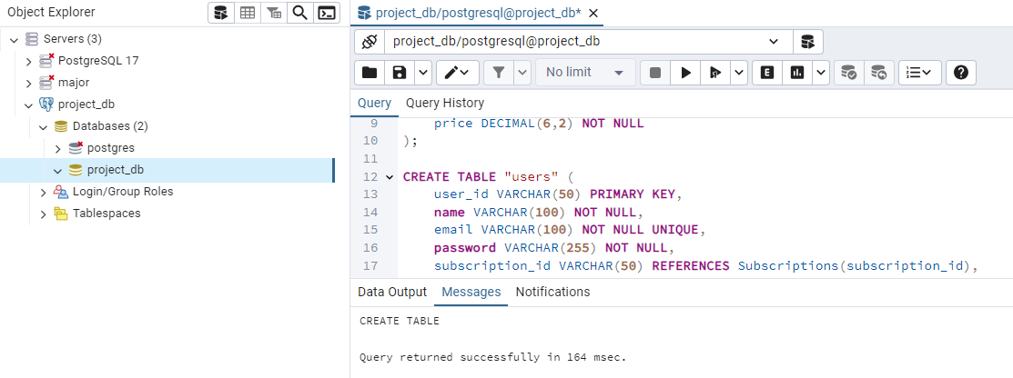

Successfully created tables. And inserting values:

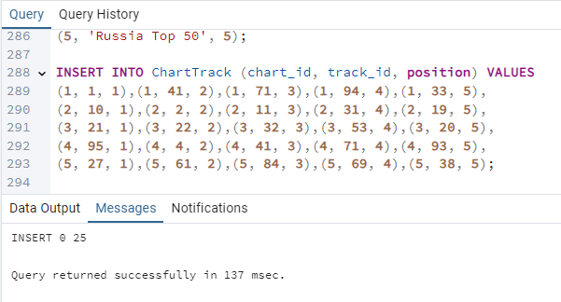

The full query:

INTO Countries (country_id, name) VALUES

(1, 'United Kingdom'),

(2, 'United States'),

(3, 'Canada'),

(4, 'Kazakhstan'),

(5, 'Russia'),

(6, 'Germany'),

(7, 'France'),

(8, 'Australia'),

(9, 'Brazil'),

(10, 'Japan');

INSERT INTO Subscriptions (subscription_id, name, price) VALUES

(1, 'Free', 0.00),

(2, 'Premium', 9.99),

(3, 'Family', 14.99);

INSERT INTO "users" (user_id, name, email, password, subscription_id, country_id, registration_date) VALUES

(1, 'Aidar Nurgaliyev', 'aidar.n@local.kz', 'hashed_pass_a1', 2, 4, '2025-01-10 09:12:00'),

(2, 'Gulnara Seitova', 'gulnara@example.kz', 'hashed_pass_a2', 1, 4, '2025-02-05 14:30:00'),

(3, 'John Miller', 'john.miller@example.com', 'hashed_pass_a3', 2, 2, '2024-11-20 08:00:00'),

(4, 'Maria Petrova', 'm.petrov@example.ru', 'hashed_pass_a4', 3, 5, '2023-05-12 18:45:00'),

(5, 'Emma Thompson', 'emma.t@example.uk', 'hashed_pass_a5', 2, 1, '2024-08-01 10:05:00'),

(6, 'Carlos Silva', 'c.silva@example.br', 'hashed_pass_a6', 1, 9, '2025-03-03 21:10:00'),

(7, 'Satoshi Yamamoto', 's.yama@example.jp', 'hashed_pass_a7', 2, 10, '2024-12-12 12:00:00'),

(8, 'Lena Müller', 'lena.mueller@example.de', 'hashed_pass_a8', 2, 6, '2025-06-15 11:23:00'),

(9, 'Olga Ivanova', 'olga.ivanova@example.ru', 'hashed_pass_a9', 1, 5, '2025-04-22 16:40:00'),

(10, 'Michael Johnson', 'm.johnson@example.com', 'hashed_pass_a10', 3, 2, '2022-10-30 09:00:00'),

(11, 'Daniela Rossi', 'd.rossi@example.it', 'hashed_pass_a11', 1, 7, '2025-07-01 13:18:00'),

(12, 'Alex Kim', 'alex.kim@example.ca', 'hashed_pass_a12', 2, 3, '2025-02-27 07:50:00');

INSERT INTO Artists (artist_id, name, bio) VALUES

(1, 'Queen', 'Legendary British rock band formed in 1970.'),

(2, 'Boney M', 'Disco group created by German record producer Frank Farian.'),

(3, 'Twenty One Pilots', 'American musical duo from Columbus, Ohio.'),

(4, 'Travis Scott', 'American rapper and record producer.'),

(5, 'Kendrick Lamar', 'American rapper and songwriter.'),

(6, 'Kanye West', 'American rapper, producer and fashion designer.'),

(7, 'Adele', 'English singer-songwriter.'),

(8, 'Drake', 'Canadian rapper, singer and actor.'),

(9, 'The Weeknd', 'Canadian singer, songwriter, and record producer.'),

(10, 'Imagine Dragons', 'American pop rock band.'),

(11, 'Coldplay', 'British rock band formed in London.'),

(12, 'Metallica', 'American heavy metal band.'),

(13, 'Billie Eilish', 'American singer-songwriter.'),

(14, 'Post Malone', 'American rapper, singer, songwriter and record producer.'),

(15, 'David Bowie', 'English singer-songwriter and actor.'),

(16, 'Arctic Monkeys', 'English rock band formed in Sheffield.'),

(17, 'Rihanna', 'Barbadian singer and businesswoman.'),

(18, 'Skrillex', 'American electronic music producer and DJ.'),

(19, 'Eminem', 'American rapper, songwriter and record producer.'),

(20, 'Shakira', 'Colombian singer and songwriter.');

INSERT INTO Genres (genre_id, name) VALUES

(1, 'Rock'),

(2, 'Disco'),

(3, 'Alternative'),

(4, 'Hip-Hop'),

(5, 'Pop'),

(6, 'R&B'),

(7, 'Electronic'),

(8, 'Metal'),

(9, 'Indie'),

(10, 'Latin');

INSERT INTO Albums (album_id, title, release_date, artist_id) VALUES

(1, 'A Night at the Opera', '1975-11-21', 1),

(2, 'The Miracle', '1989-05-22', 1),

(3, 'Bobby Farrell Hits', '1978-06-01', 2),

(4, 'Nightflight to Venus', '1978-05-01', 2),

(5, 'Blurryface', '2015-05-17', 3),

(6, 'Vessel', '2013-01-08', 3),

(7, 'Astroworld', '2018-08-03', 4),

(8, 'Rodeo', '2015-09-04', 4),

(9, 'DAMN.', '2017-04-14', 5),

(10, 'To Pimp a Butterfly', '2015-03-15', 5),

(11, 'My Beautiful Dark Twisted Fantasy', '2010-11-22', 6),

(12, 'Graduation', '2007-09-11', 6),

(13, '25', '2015-11-20', 7),

(14, '19', '2008-01-28', 7),

(15, 'Views', '2016-04-29', 8),

(16, 'Scorpion', '2018-06-29', 8),

(17, 'After Hours', '2020-03-20', 9),

(18, 'Beauty and the Beat', '2012-06-04', 9),

(19, 'Night Visions', '2012-09-04', 10),

(20, 'Evolve', '2017-06-23', 10),

(21, 'Parachutes', '2000-07-10', 11),

(22, 'A Rush of Blood to the Head', '2002-08-26', 11),

(23, 'Master of Puppets', '1986-03-03', 12),

(24, 'Ride the Lightning', '1984-07-27', 12),

(25, 'When We All Fall Asleep, Where Do We Go?', '2019-03-29', 13),

(26, 'Hollywood''s Bleeding', '2019-09-06', 14),

(27, 'Heroes', '1977-10-14', 15),

(28, 'Whatever People Say I Am, That''s What I''m Not', '2006-01-23', 16),

(29, 'Anti', '2016-01-28', 17),

(30, 'Recess', '2014-03-14', 18),

(31, 'The Marshall Mathers LP', '2000-05-23', 19),

(32, 'Laundry Service', '2001-11-13', 20),

(33, 'Greatest Hits Vol.1', '2020-01-01', 14),

(34, 'Late Registration', '2005-08-30', 6),

(35, 'King of the Road', '2021-01-01', 4),

(36, 'Selected Singles', '1999-01-01', 2);

INSERT INTO Tracks (track_id, title, duration, artist_id, album_id, genre_id) VALUES

(1, 'Bohemian Rhapsody', INTERVAL '00:05:55', 1, 1, 1),

(2, 'Love of My Life', INTERVAL '00:03:38', 1, 1, 1),

(3, 'Killer Queen', INTERVAL '00:03:01', 1, 2, 1),

(4, 'Rasputin', INTERVAL '00:04:25', 2, 4, 2),

(5, 'Daddy Cool', INTERVAL '00:03:26', 2, 3, 2),

(6, 'Hold the Line', INTERVAL '00:03:58', 2, 36, 2),

(7, 'Stressed Out', INTERVAL '00:03:22', 3, 5, 3),

(8, 'Heavydirtysoul', INTERVAL '00:03:05', 3, 6, 3),

(9, 'Ride', INTERVAL '00:03:45', 4, 8, 4),

(10, 'Sicko Mode', INTERVAL '00:05:13', 4, 7, 4),

(11, 'Goosebumps', INTERVAL '00:04:02', 14, 33, 4),

(12, 'HUMBLE.', INTERVAL '00:02:57', 5, 9, 4),

(13, 'DNA.', INTERVAL '00:03:05', 5, 9, 4),

(14, 'Alright', INTERVAL '00:03:39', 5, 10, 6),

(15, 'Power', INTERVAL '00:04:52', 6, 11, 4),

(16, 'Stronger', INTERVAL '00:05:10', 6, 12, 4),

(17, 'Hello', INTERVAL '00:04:55', 7, 13, 5),

(18, 'Someone Like You', INTERVAL '00:04:45', 7, 13, 5),

(19, 'Hotline Bling', INTERVAL '00:04:27', 8, 15, 6),

(20, 'God''s Plan', INTERVAL '00:03:19', 8, 15, 6),

(21, 'Blinding Lights', INTERVAL '00:03:20', 9, 17, 6),

(22, 'Save Your Tears', INTERVAL '00:03:35', 9, 17, 6),

(23, 'Radioactive', INTERVAL '00:03:08', 10, 19, 5),

(24, 'Demons', INTERVAL '00:02:57', 10, 19, 5),

(25, 'Yellow', INTERVAL '00:04:29', 11, 21, 1),

(26, 'Clocks', INTERVAL '00:05:07', 11, 22, 1),

(27, 'Enter Sandman', INTERVAL '00:05:32', 12, 23, 8),

(28, 'Nothing Else Matters', INTERVAL '00:06:28', 12, 23, 8),

(29, 'Bad Guy', INTERVAL '00:03:14', 13, 25, 5),

(30, 'bury a friend', INTERVAL '00:03:13', 13, 25, 7),

(31, 'Circles', INTERVAL '00:03:35', 14, 26, 5),

(32, 'Sunflower', INTERVAL '00:02:38', 14, 26, 5),

(33, 'Heroes', INTERVAL '00:06:07', 15, 27, 1),

(34, 'Do I Wanna Know?', INTERVAL '00:04:32', 16, 28, 9),

(35, 'Umbrella', INTERVAL '00:04:36', 17, 29, 5),

(36, 'Bangarang', INTERVAL '00:03:35', 18, 30, 7),

(37, 'The Real Slim Shady', INTERVAL '00:04:44', 19, 31, 4),

(38, 'Lose Yourself', INTERVAL '00:05:26', 19, 31, 4),

(39, 'Hips Don''t Lie', INTERVAL '00:03:38', 20, 32, 10),

(40, 'Whenever, Wherever', INTERVAL '00:03:16', 20, 32, 10),

(41, 'Somebody to Love', INTERVAL '00:04:56', 1, 1, 1),

(42, 'I Want to Break Free', INTERVAL '00:04:18', 1, 2, 1),

(43, 'Ma Baker', INTERVAL '00:04:37', 2, 4, 2),

(44, 'Blurryface (Intro)', INTERVAL '00:01:56', 3, 5, 3),

(45, 'Stargazing', INTERVAL '00:04:30', 4, 7, 4),

(46, '90210', INTERVAL '00:05:00', 4, 8, 4),

(47, 'Swimming Pools', INTERVAL '00:03:40', 5, 9, 4),

(48, 'Poetic Justice', INTERVAL '00:05:00', 5, 10, 6),

(49, 'Flashing Lights', INTERVAL '00:03:58', 6, 11, 4),

(50, 'Good Life', INTERVAL '00:03:27', 6, 12, 5),

(51, 'Rumour Has It', INTERVAL '00:03:43', 7, 14, 5),

(52, 'Set Fire to the Rain', INTERVAL '00:04:02', 7, 13, 5),

(53, 'In My Feelings', INTERVAL '00:03:38', 8, 15, 6),

(54, 'One Dance', INTERVAL '00:02:54', 8, 15, 6),

(55, 'Heartless', INTERVAL '00:03:53', 9, 18, 6),

(56, 'The Hills', INTERVAL '00:04:02', 9, 17, 6),

(57, 'On Top of the World', INTERVAL '00:03:12', 10, 19, 5),

(58, 'Believer', INTERVAL '00:03:24', 10, 20, 5),

(59, 'The Scientist', INTERVAL '00:05:09', 11, 22, 1),

(60, 'Fix You', INTERVAL '00:04:55', 11, 21, 1),

(61, 'Master of Puppets', INTERVAL '00:08:35', 12, 23, 8),

(62, 'Fade to Black', INTERVAL '00:06:57', 12, 24, 8),

(63, 'Everything I Wanted', INTERVAL '00:04:05', 13, 25, 5),

(64, 'Goodbyes', INTERVAL '00:02:53', 14, 26, 5),

(65, 'Life on Mars?', INTERVAL '00:03:55', 15, 27, 1),

(66, 'Do I Wanna Know? (Live)', INTERVAL '00:04:45', 16, 28, 9),

(67, 'We Found Love', INTERVAL '00:03:35', 17, 29, 5),

(68, 'Scary Monsters and Nice Sprites', INTERVAL '00:04:07', 18, 30, 7),

(69, 'Stan', INTERVAL '00:06:44', 19, 31, 4),

(70, 'Whenever, Wherever (Remix)', INTERVAL '00:03:50', 20, 32, 10),

(71, 'Another One Bites The Dust', INTERVAL '00:03:35', 1, 1, 1),

(72, 'Under Pressure', INTERVAL '00:04:08', 1, 2, 1),

(73, 'Sunshine of My Life', INTERVAL '00:04:00', 2, 36, 2),

(74, 'Chlorine', INTERVAL '00:05:30', 3, 6, 3),

(75, 'Goosebumps (Remix)', INTERVAL '00:04:20', 14, 33, 4),

(76, 'Antidote', INTERVAL '00:03:33', 4, 35, 4),

(77, 'ELEMENT.', INTERVAL '00:03:26', 5, 9, 4),

(78, 'Power (Live)', INTERVAL '00:05:02', 6, 34, 4),

(79, 'Rolling in the Deep', INTERVAL '00:03:49', 7, 13, 5),

(80, 'Hotline Bling (Acoustic)', INTERVAL '00:03:50', 8, 15, 6),

(81, 'Blinding Lights (Remix)', INTERVAL '00:03:40', 9, 17, 6),

(82, 'Thunder', INTERVAL '00:03:07', 10, 20, 5),

(83, 'Viva La Vida', INTERVAL '00:04:02', 11, 21, 1),

(84, 'Nothing Else Matters (Live)', INTERVAL '00:06:22', 12, 23, 8),

(85, 'when the party''s over', INTERVAL '00:04:53', 13, 25, 5),

(86, 'White Iverson', INTERVAL '00:04:18', 14, 33, 5),

(87, 'Space Oddity', INTERVAL '00:05:18', 15, 27, 1),

(88, 'R U Mine?', INTERVAL '00:03:22', 16, 28, 9),

(89, 'Diamonds', INTERVAL '00:03:45', 17, 29, 5),

(90, 'Breakn'' a Sweat', INTERVAL '00:04:02', 18, 30, 7),

(91, 'The Real Slim Shady (Live)', INTERVAL '00:05:10', 19, 31, 4),

(92, 'She Wolf', INTERVAL '00:03:06', 20, 32, 10),

(93, 'Somebody to Love (Live)', INTERVAL '00:05:03', 1, 1, 1),

(94, 'Bohemian Rhapsody (Live Aid)', INTERVAL '00:06:30', 1, 2, 1),

(95, 'Rivers of Babylon', INTERVAL '00:03:52', 2, 3, 2),

(96, 'Stressed Out (Live)', INTERVAL '00:03:50', 3, 5, 3),

(97, 'Astrothunder', INTERVAL '00:03:27', 4, 7, 4),

(98, 'LOVE.', INTERVAL '00:03:32', 5, 9, 6),

(99, 'Devil in a New Dress', INTERVAL '00:05:52', 6, 11, 4),

(100, 'La Tortura', INTERVAL '00:03:34', 20, 32, 10);

INSERT INTO Playlists (playlist_id, title, user_id) VALUES

(1, 'Aidar''s Mix', 1),

(2, 'Gulnara''s Favorites', 2),

(3, 'John''s Roadtrip', 3),

(4, 'Maria''s Chill', 4),

(5, 'Emma''s Hits', 5),

(6, 'Carlos Party', 6),

(7, 'Satoshi Selects', 7),

(8, 'Lena Workout', 8),

(9, 'Olga Study', 9),

(10, 'Michael Classics', 10),

(11, 'Daniela Dance', 11),

(12, 'Alex Top 40', 12),

(13, 'Shared: Party Mix', 1),

(14, 'Shared: Soft Hits', 3);

INSERT INTO Playlist_Track (playlist_id, track_id, position) VALUES

(1, 1, 1),(1, 41, 2),(1, 71, 3),(1, 94, 4),

(2, 4, 1),(2, 43, 2),(2, 95, 3),

(3, 10, 1),(3, 45, 2),(3, 76, 3),(3, 97, 4),

(4, 29, 1),(4, 30, 2),(4, 85, 3),

(5, 17, 1),(5, 79, 2),(5, 25, 3),

(6, 11, 1),(6, 31, 2),(6, 75, 3),

(7, 21, 1),(7, 22, 2),(7, 81, 3),

(8, 57, 1),(8, 58, 2),(8, 82, 3),

(9, 63, 1),(9, 64, 2),(9, 86, 3),

(10, 27, 1),(10, 61, 2),(10, 84, 3),

(11, 36, 1),(11, 68, 2),(11, 90, 3),

(12, 19, 1),(12, 20, 2),(12, 53, 3),

(13, 2, 1),(13, 3, 2),(13, 41, 3),(13, 71, 4),

(14, 59, 1),(14, 60, 2),(14, 69, 3);

INSERT INTO Listening_Histories (history_id, user_id, track_id, play_date) VALUES

(1, 1, 1, '2025-10-10 12:00:00'),

(2, 1, 41, '2025-10-10 12:05:00'),

(3, 2, 4, '2025-09-30 09:12:00'),

(4, 3, 10, '2025-10-01 18:22:00'),

(5, 4, 29, '2025-09-25 20:00:00'),

(6, 5, 17, '2025-10-08 14:33:00'),

(7, 6, 11, '2025-10-09 23:01:00'),

(8, 7, 21, '2025-10-07 07:44:00'),

(9, 8, 57, '2025-10-06 06:30:00'),

(10, 9, 63, '2025-10-05 11:11:00'),

(11, 10, 27, '2025-09-29 22:22:00'),

(12, 11, 31, '2025-10-03 16:16:00'),

(13, 12, 19, '2025-10-02 19:45:00'),

(14, 2, 95, '2025-09-20 13:10:00'),

(15, 3, 96, '2025-09-21 14:14:00');

INSERT INTO Ratings (user_id, track_id, rating, review) VALUES

(1, 1, 5, 'Epic song.'),

(2, 4, 4, 'Great disco vibes.'),

(3, 10, 5, 'Sick production.'),

(4, 29, 4, 'Beautiful melody.'),

(5, 17, 5, 'Powerful voice.'),

(6, 11, 4, 'Nice beat.'),

(7, 21, 5, 'Can''t stop listening.'),

(8, 57, 4, 'Good workout track.'),

(9, 63, 5, 'Very emotional.'),

(10, 27, 5, 'Metal classic.'),

(11, 31, 4, 'Catchy.'),

(12, 19, 3, 'Not my style.');

INSERT INTO Recommendations (recommendation_id, user_id, track_id) VALUES

(1, 1, 2),

(2, 1, 41),

(3, 2, 43),

(4, 3, 10),

(5, 4, 29),

(6, 5, 17),

(7, 6, 11),

(8, 7, 21),

(9, 8, 57),

(10, 9, 63);

INSERT INTO Charts (chart_id, name, country_id) VALUES

(1, 'UK Top Hits', 1),

(2, 'US Billboard', 2),

(3, 'Canada Hot 100', 3),

(4, 'Kazakhstan Top', 4),

(5, 'Russia Top 50', 5);

INSERT INTO ChartTrack (chart_id, track_id, position) VALUES

(1, 1, 1),(1, 41, 2),(1, 71, 3),(1, 94, 4),(1, 33, 5),

(2, 10, 1),(2, 2, 2),(2, 11, 3),(2, 31, 4),(2, 19, 5),

(3, 21, 1),(3, 22, 2),(3, 32, 3),(3, 53, 4),(3, 20, 5),

(4, 95, 1),(4, 4, 2),(4, 41, 3),(4, 71, 4),(4, 93, 5),

(5, 27, 1),(5, 61, 2),(5, 84, 3),(5, 69, 4),(5, 38, 5);

User group 1: Listeners (Usual users without subscription)

Access Rights:

|  |  |
| --- | --- |
| Tracks | Read-only |
| Artists | Read-only |
| Albums | Read-only |
| Genres | Read-only |
| Countries | Read-only |
| Subscriptions | Read-only |
| Playlists | Read-only |
| Playlist_Track | Read-only |
| Listening_Histories | Read-only |
| Ratings | Read-write |
| Recommendations | Read-only |

User group 2: Listeners with subscription

|  |  |
| --- | --- |
| Tracks | Read-only |
| Artists | Read-only |
| Albums | Read-only |
| Genres | Read-only |
| Countries | Read-only |
| Subscriptions | Read-only |
| Playlists | Read-write |
| Playlist_Track | Read-write |
| Listening_Histories | Read-write |
| Ratings | Read-write |
| Recommendations | Read-only |

User group 3: Content Managers

Access Rights:

|  |  |
| --- | --- |
| Artists | Read-write |
| Albums | Read-write |
| Tracks | Read-write |
| Genres | Read-write |
| Charts | Read-write |
| ChartTrack | Read-write |
| Countries | Read-only |
| Subscriptions | Read-only |
| Users | Read-only |
| Playlists | Read-only |
| Ratings | Read-only |
| Recommendations | Read-only |

User group 4: Artists

|  |  |
| --- | --- |
| Artists | Read-only |
| Albums | Read-write (Only on their profile) |
| Tracks | Read-write (Only on their profile) |
| Genres | Read-write (Only on their profile) |
| Charts | Read-only |
| ChartTrack | Read-only |
| Countries | Read-only |
| Subscriptions | Read-only |
| Users | Read-only |
| Playlists | Read-only |
| Ratings | Read-only |
| Recommendations | Read-only |

**Threats for the database:**

1. SQL Injection

**A:** A user is able to inject SQL query in input fields such as “Search bar” or “Login form”

**B:** Use only ORM like SQLAlchemy, validate input at application layer, use parameterized queries, prepared statements.

1. Illegal entry by hacker

**A:** A hacker can enter to our database due to the lack of an SSH tunnel for connection. So, hacker needs only login and password to connect to the database.

**B:** Use of SSH tunnel and connect to the database by using Public and Private keys.

# **Part 1. PostgreSQL with CSV format**

As I, Batyrkhan, love the Queen group, I want to write queries related to them. So, at first, I want to count how many tracks there are in the database. So, there is the SQL query and its result:

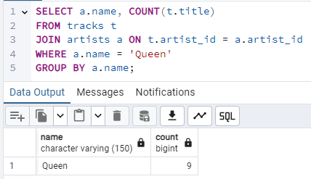

And what tracks?

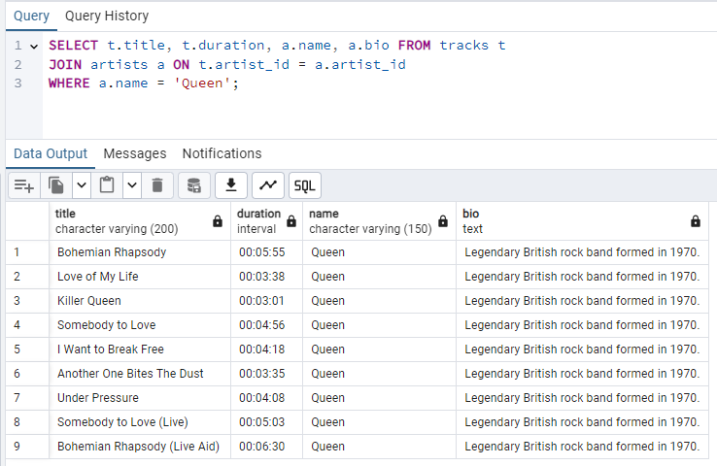

Trying to export and…

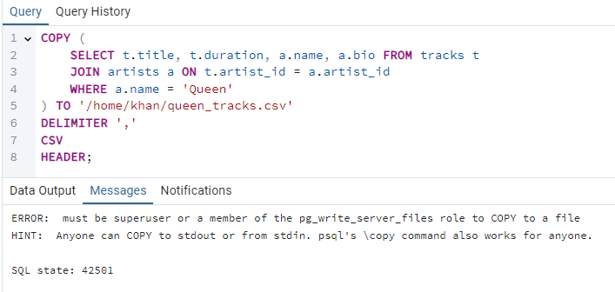

That’s the problem… I can’t export the data in to the server. But it can be fixed if I use \copy from terminal or give the permission to “postgresql” user to change server’s data:



Try again:

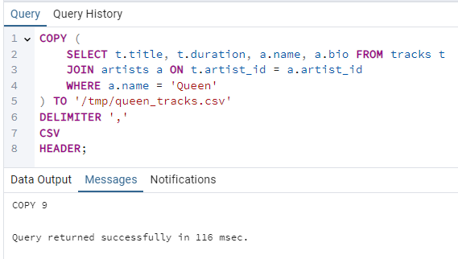

Imported to /tmp directory because khan is my user’s folder which can be accessed by my private key.

Anyway, it worked!

The next query is to count how many music in each genre and order it in descending order:

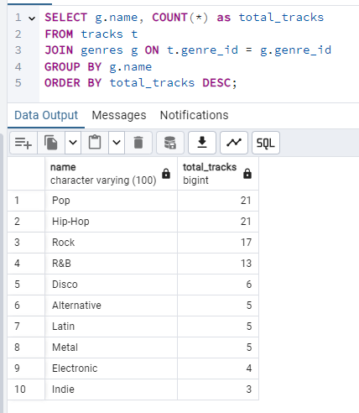

Exporting the data:

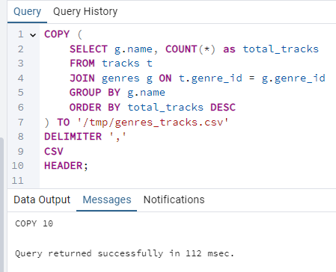

Now, let’s connect to the server via FTP and check the CSV files:

WinSCP is needed to enter to the server’s file system:

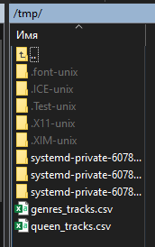

They are right here.

And if I open them:

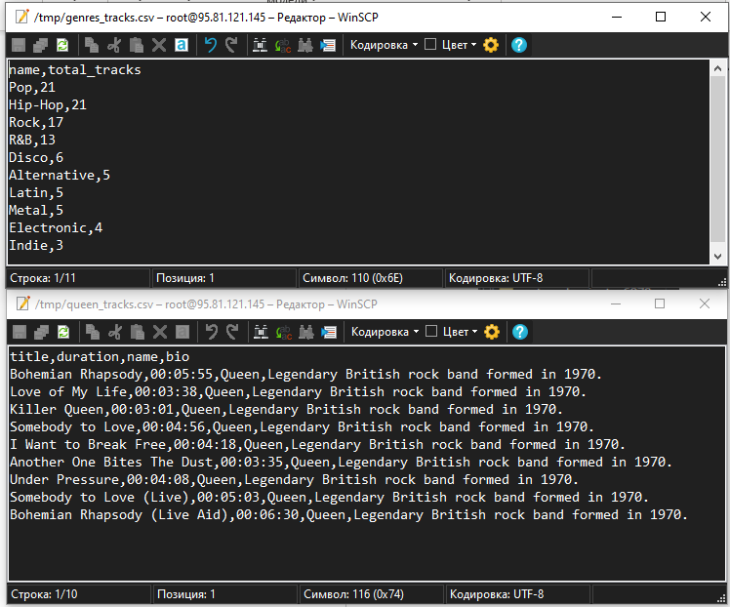

The CSVs were exported successfully. Great!

# **Part 2. PostgreSQL with JSON format**

The first query is to copy the tracks table to JSON. There is the query:

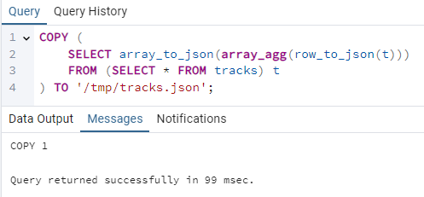

And the second query is to copy the artists table to JSON. And there is the query for this:

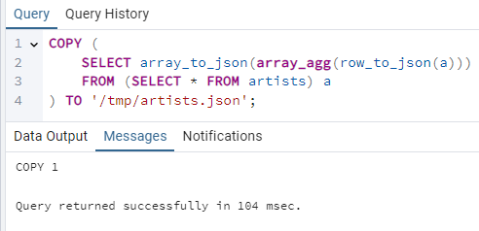

And if I look at the files via FTP:

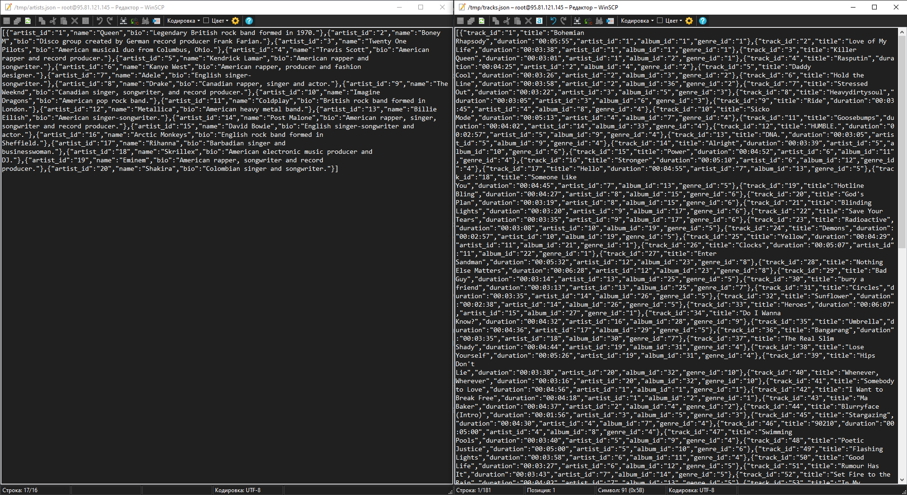

If I format it to normal JSON: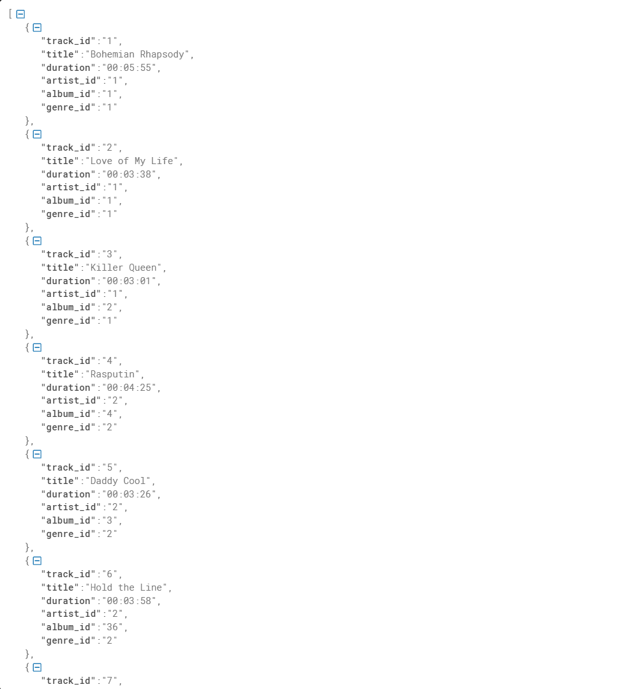

And for artists:

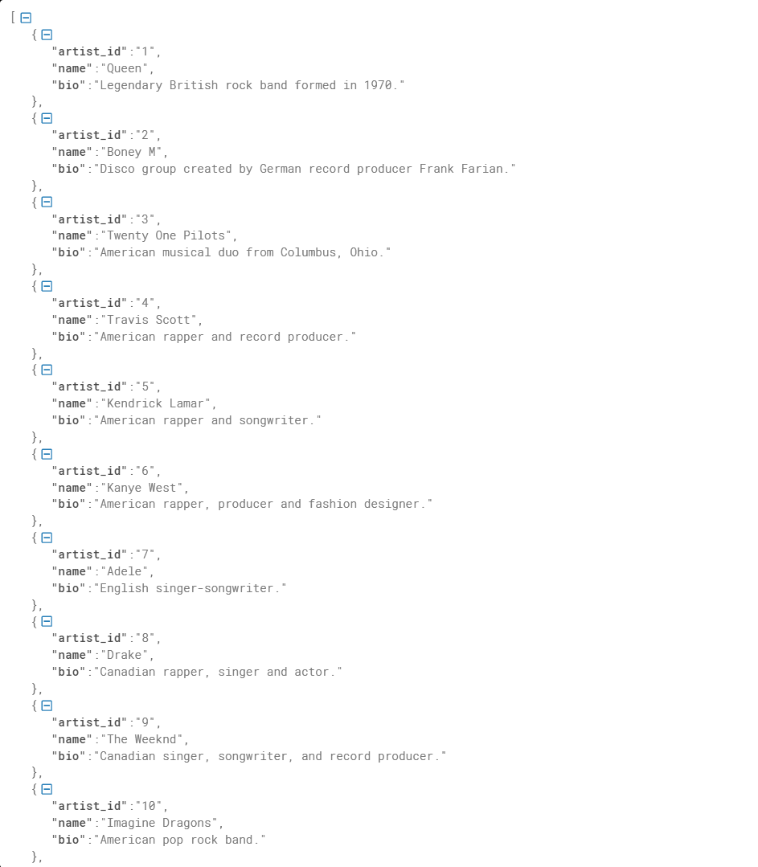

It worked! Great!

# **Part 3. Windows functions**

It’s time to use window functions.

1. The number of tracks of each artist:

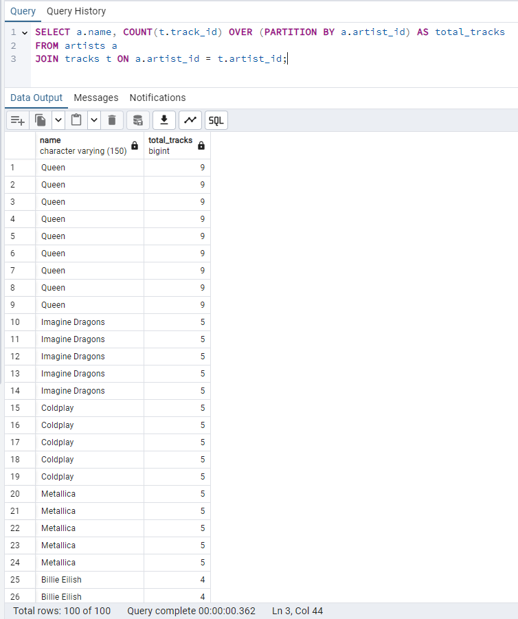

1. Average track duration by artist:

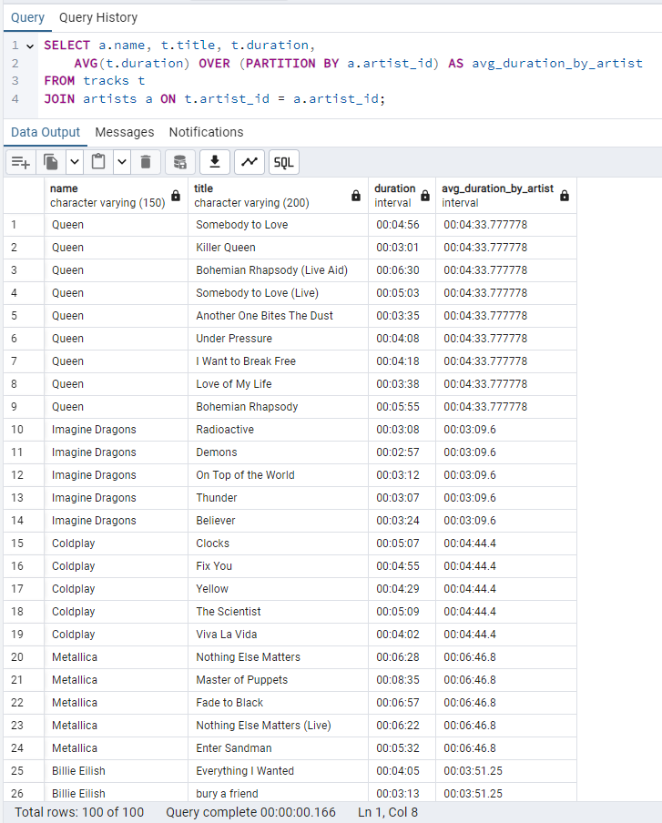

1. Rating of Queen tracks by duration:

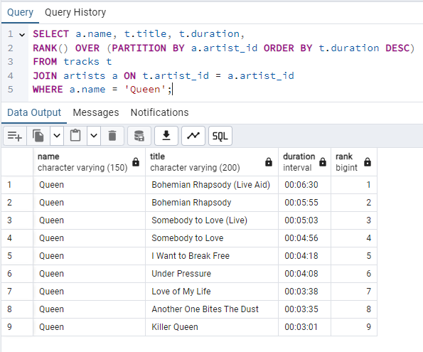

1. The user’s last played track:

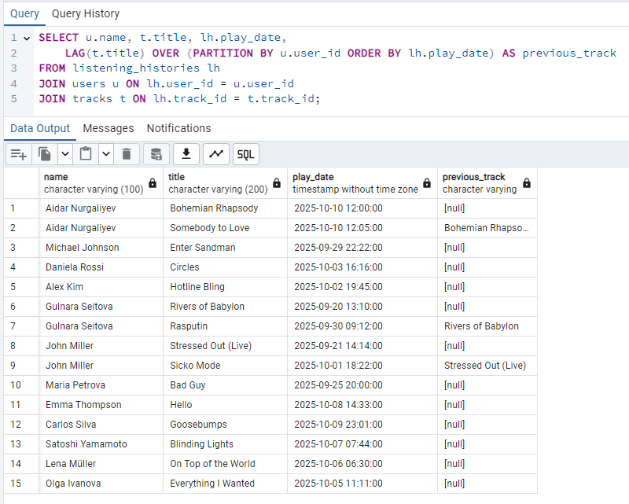

1. Track rating by popularity in the chart:

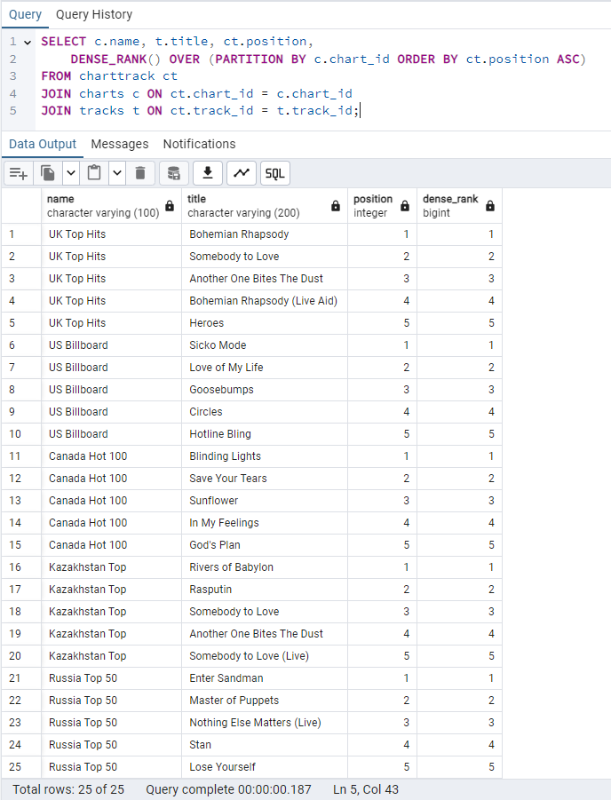

1. Track numbering by alphabetic ascending order within each artist

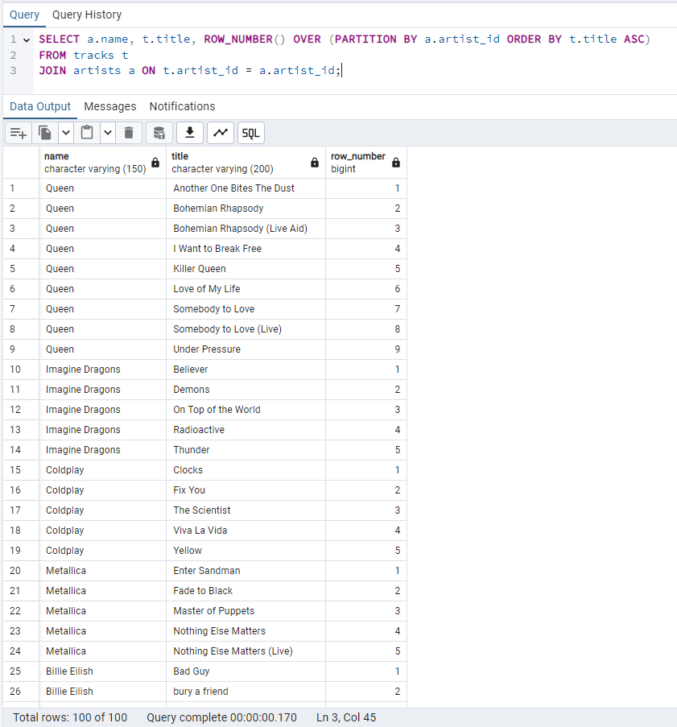

1. Splitting the tracks into 4 groups by duration:

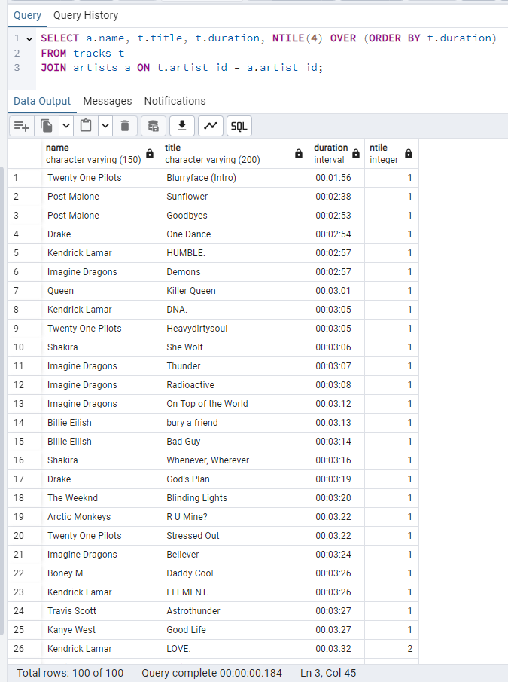

# **Part 4. Window Functions 2**

1. The track person listened and the previous track of the listened track:

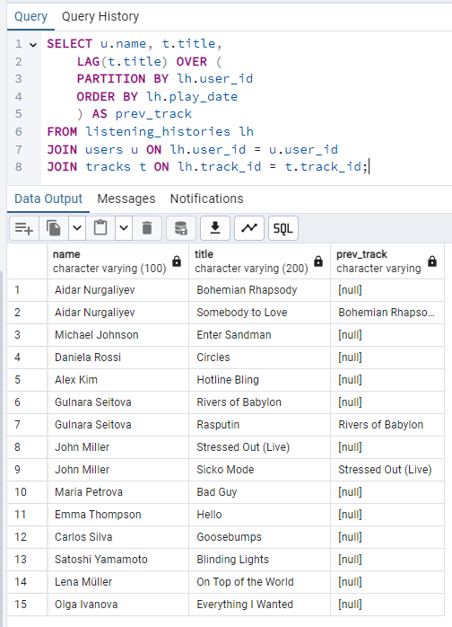

1. The same, but next track after listened track:

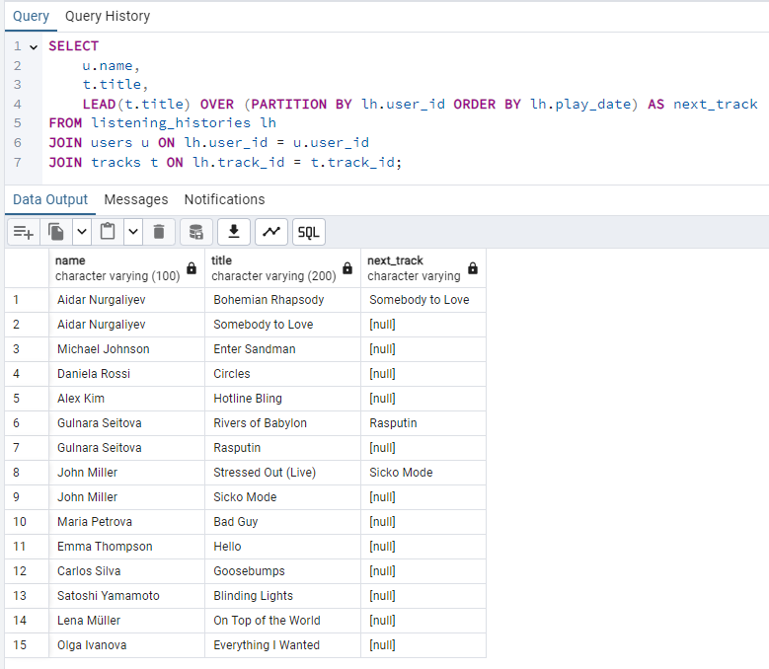

1. The artist’s the shortest track:

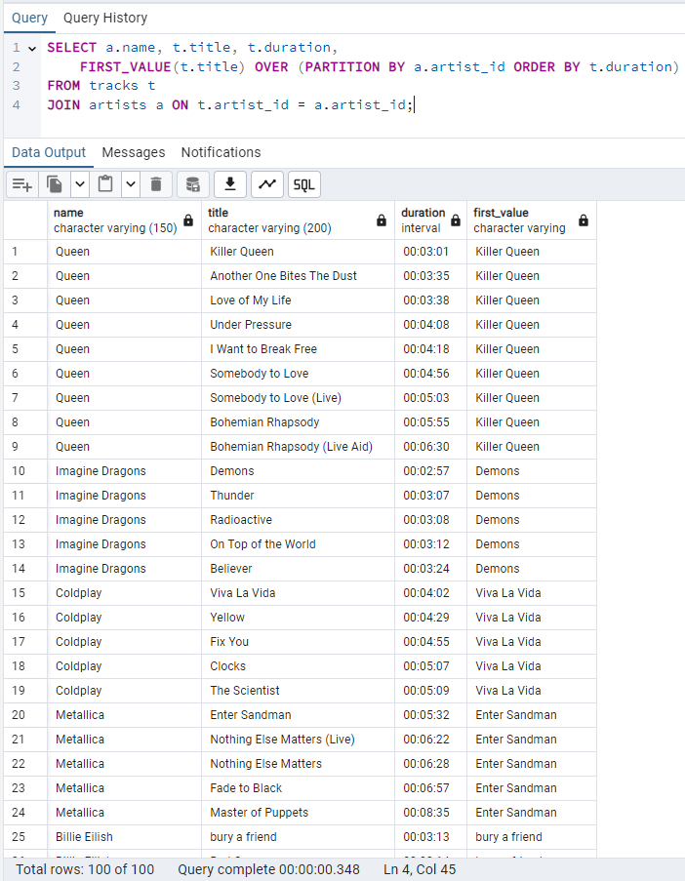

1. The artist’s the longest track:

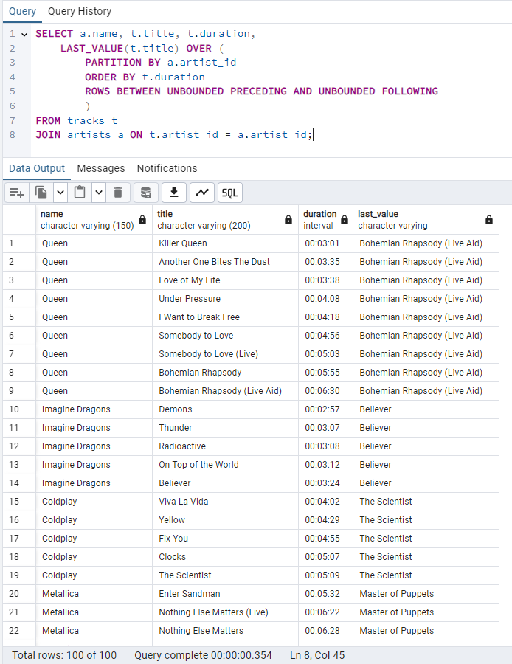

1. The artist’s 3rd the longest track

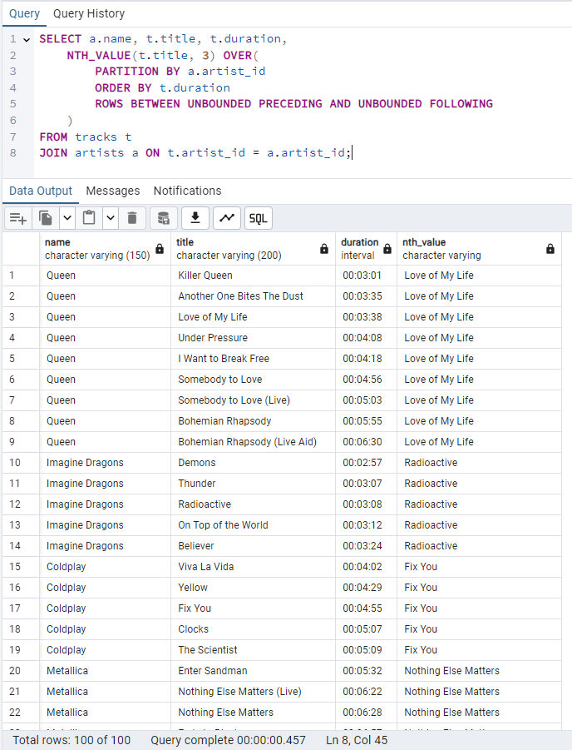

1. Artist’s track position by duration in descending order:

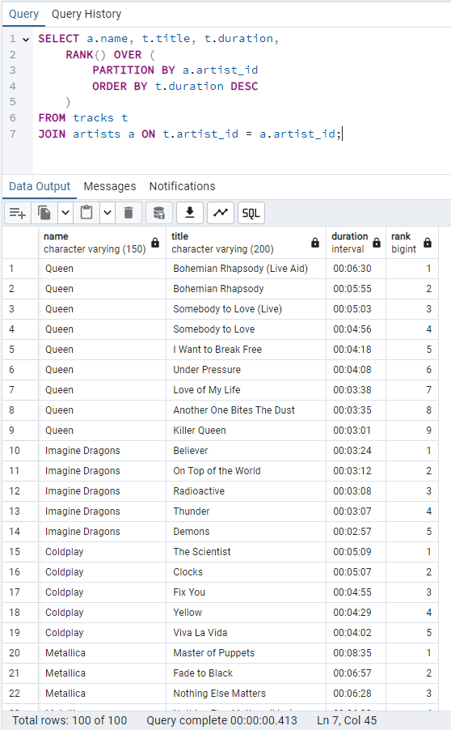

1. Amount of tracks that user listened since registration

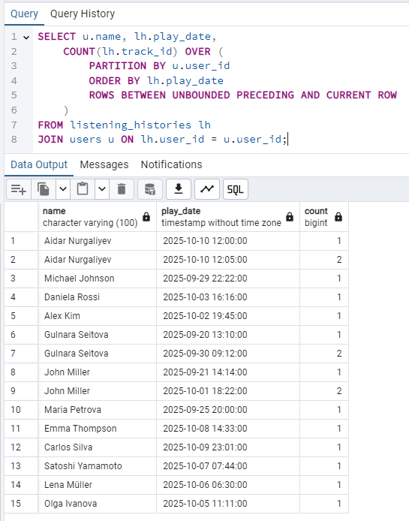

# **Part 5. Roles**

According to Part 0, we need to create user groups:

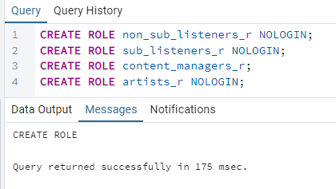

This query created 4 group roles, and there are:

1. Listeners without subscription
2. Listeners with subscription
3. Content Managers
4. Artists (who only can interact with their album, tracks)

P.S._r at the end means role

And the next step is to create 2 users for each group:

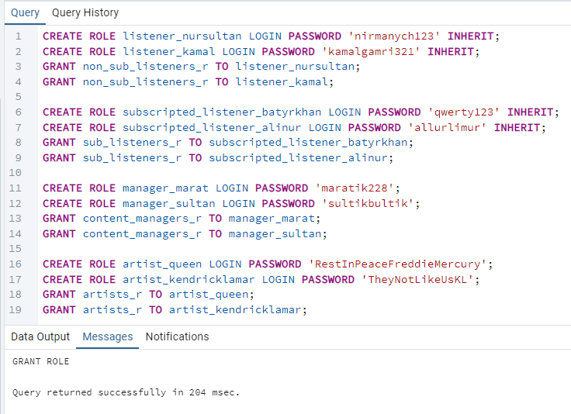

There are users that have been created are:

1. Nursultan, Kamal (non-subscribed listeners)
2. Batyrkhan, Alinur (subscribed listeners)
3. Marat, Sultan (content managers)
4. Queen, Kendrick Lamar (artists)

# **Part 6. Privileges**

At the previous part we created user groups and 2 users for each group. Now we need to set privileges for each group role such as it’s written in the descriptions in part 0:

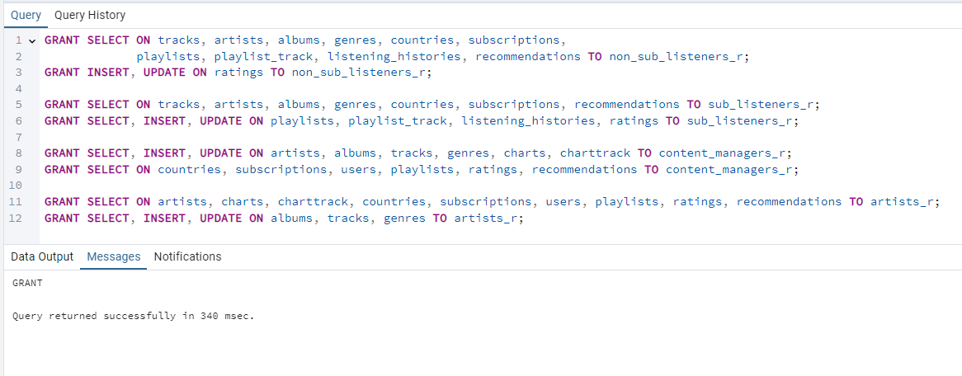

Now let’s check if everything is correct. Let’s start with the non-subscribed listeners. The only can insert or update ratings, but can’t change anything else:

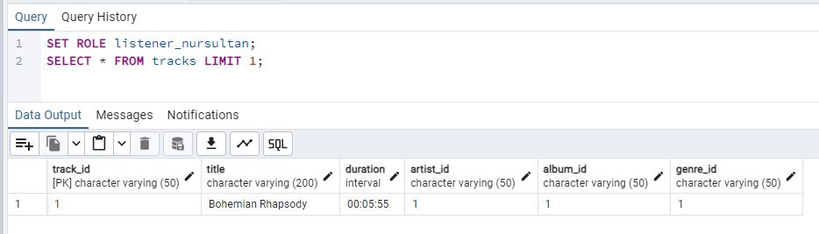

Select works!

Now rating insert rating:

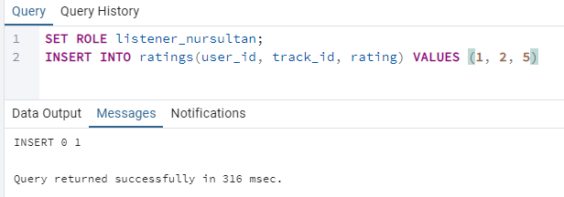

And what if I delete the rating?

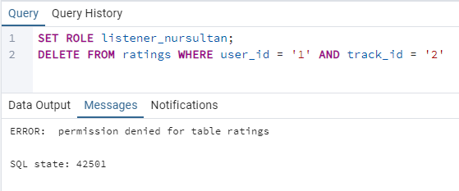

Permission denied. That’s right, I didn’t give DELETE permission for deleting rating. Only insert and update.

The next is subscribed listener and as subscribed listener I want to create my playlist and then try to create new track for artist in database (music platform):

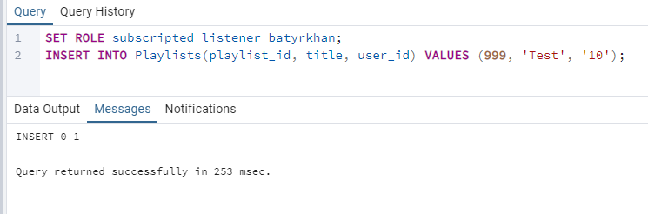

It works, now trying to create a track:

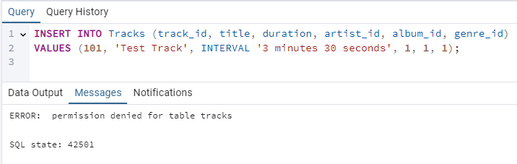

Works fine. Permission denied.

The next is content manager. Content manager can create artist, but not countries or users:

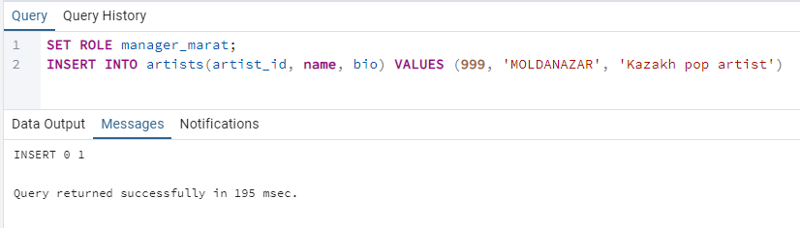

And trying to create country:

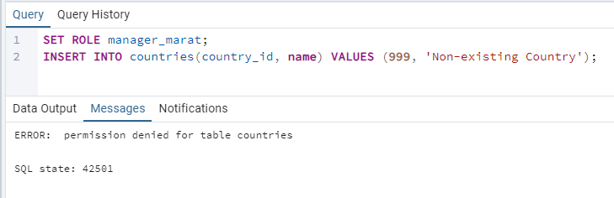

Great!

And the last one is artist. Artist can create track or album, but can’t interact with chart.

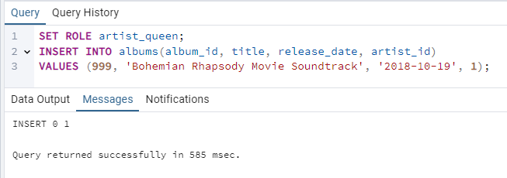

Album has been created. Now I need to create a track for this album, then what if I try to push it to chart?

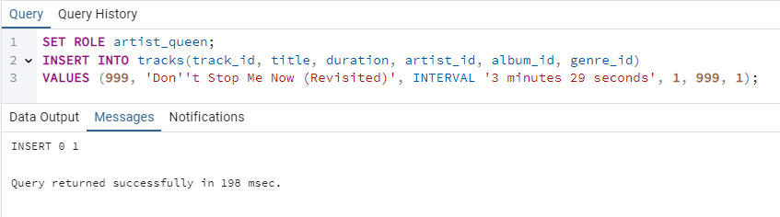

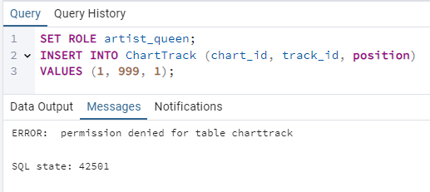

Error: Permission denied. Great! Everything works as expected!