ARSHAAN ALI KHAN 35304011

ICT 171 ASSIGNMENT 2: CLOUD SERVER

IP Address: 16.176.204.107 https://arshaanfitness.fitness

WEB SERVER DOCUMENTATION

INTRODUCTION

STEP 1) Launching AN INSTANCE

Create an Amazon Web Services Account.

For that visit https://aws.amazon.com/education/awseducate/ and create an account with

your credentials and log in.

Once you are logged in, Open EC2 from the services and create a server with launch instance.

Once you have launched the Instance, Name your instance and select the option Ubuntu from

the Quick start TAB.

Now continue with the default settings of instance type and create a new key pair

and put the name for the key pair.

NOTE: Save the key pair in a safe place as it can be used to log in for your server.

Now once the key pair is done, go to the network settings and allow HTTPS and HTTP traffic from the internet.

Then continue with the default settings and launch the instance.

STEP 2) ALLOCATING ELASTIC IP (Optional)

NOTE: We need elastic IP for the instance because everytime you will reboot your instance it

will change its IP, So for making it elastic we Allocate an elastic IP to the instance.

For the Elastic IP, you need to click Dashboard and then click Elastic IP. Now choose

your instance and click Actions and from the options there choose Associate Elastic IP.

Now choose your instance and proceed with the option associate.

STEP 3) CONNECTING TO UBUNTU ON EC2:

For this step, go to dashboard and select the Instance and Click on the Button Connect and then connect to the ubuntu virtual machine command line.

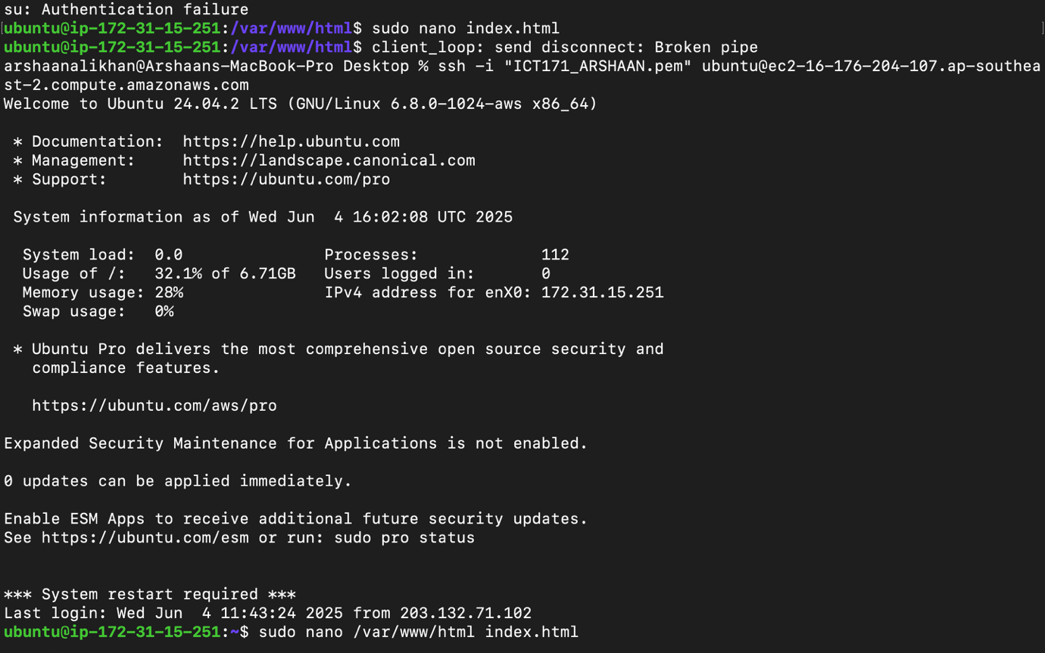

STEP 4) INSTALLING APACHE WEB SERVER:

Now, install apache2 server by running the command below

“Sudo apt install apache2”

It will ask you to install the packages and for it Type “y” and enter it.

Once entered, your apache web server will be uploaded and it will run when you run your IP address in the web browser.

STEP 5) Upload and deploy your website:

1. Save your HTML code as index.html.
2. Upload it from your Mac:

scp -i ~/Desktop/ICT171_ARSHAAN.pem ~/Desktop/index.html ubuntu@16.176.204.107:~

1. SSH into the server, then move the file:

sudo mv ~/index.html /var/www/html/index.html

sudo systemctl restart apache2

1. Visit your site at: http://arshaanfitness.fitness

STEP 6) DOMAIN NAME

Buy a domain using any domain registrars. I used Namecheap.com to buy my domain.

Once you have your name and go the DNS Management of your domain. Now we would like to add an A record. Find the option to add records and fill in the fields as given below.

**A Record for Root Domain**

* **Type**: A
* **Name/Host**: @
* **Value**: ‘Your IPv4 address’
* **TTL**: 3600

**A Record for 'www' Subdomain (This is optional but recommended)**

* **Type**: A
* **Name/Host**: www
* **Value**: ‘Your IPv4 address’
* **TTL**: 3600

After saving wait for some time as it might take a couple of minutes to update. To check if the domain is working just search up your website with the new domain on a browser your website should pop up.

STEP 7) SSL certification

Now we want our website to be secure for that we use SSL certificate. To get an SSL certificate follow the steps below.

1. Open your terminal and open your .pem file in read-only using this command:

chmod 400 ~/Desktop/ICT171_ARSHAAN.pem

1. Connect to Your EC2 Instance using this command:

ssh -i ~/Desktop/ICT171_ARSHAAN.pem [ubuntu@16.176.204.107](mailto:ubuntu@16.176.204.107)

1. Now we just need to update and install certbot and run it using this command below:

sudo certbot –apache

You can visit your secure website by using <https://arshaanfitness.fitness>

My GitHub repository: [Here](https://github.com/Khanarshaanali/ICT171_ass2/blob/main/README.md)

Video explainer: [Here](https://youtu.be/QT2U0fjOpdg)

References:

* <https://ubuntu.com/tutorials/install-and-configure-apache>
* https://certbot.eff.org
* Unit lab exercises
* <https://html5up.net>

Live Site:

[https://arshaanfitness.fitness](https://arshaanfitness.fitness/)