****************Experiment no:-06*****************

-----------------------------------------------------------------

Author:Saurabh Khandagale

Roll No:46

Date :28-March-2021

------------------------------------------------------------------

**AIM:-**

**To construct Component Diagram and Deployment Diagram to depict the structural view of the system.**

**Problem Statement:-**

**Component and Deployment Diagram for "ONLINE COURIER TRACKING (MANAGEMENT) SYSTEM”.**

**Component Diagram**A component diagram allows verification that a system's required functionality is acceptable. These diagrams are also used as a communication tool between the developer and stakeholders of the system. Programmers and developers use the diagrams to formalize a roadmap for the implementation, allowing for better decision-making about task assignment or needed skill improvements. System administrators can use component diagrams to plan ahead, using the view of the logical software components and their relationships on the system

**Deployment Diagram**

Deployment Diagram is a type of diagram that specifies the physical hardware on which the software system will execute. It also determines how the software is deployed on the underlying hardware. It maps software pieces of a system to the device that are going to execute it.

The deployment diagram maps the software architecture created in design to the physical system architecture that executes it. In distributed systems, it models the distribution of the software across the physical nodes.

The software systems are manifested using various **artifacts**, and then they are mapped to the execution environment that is going to execute the software such as **nodes**. Many nodes are involved in the deployment diagram; hence, the relation between them is represented using communication paths.

**Authentication**

Authentication, the system will check into database and ask user to either login or register. User may be customer or staff.

**Customer**

Customer have an option to check for status or check for bill information. After calculation of distance and item weight.

**Operating_Staff**

It will manages item to be dispatch , Bill_information , Item is valid or not. Then it also update the status of user .Next task is to send details to deliver staff where to send product.

**Delivery_Staff**

By considering the distance, time to deliver item the cost will be calculated and return to Dispatcher_Staff , Dispatcher_Staff return bill_information and update status.

**Component Diagram**

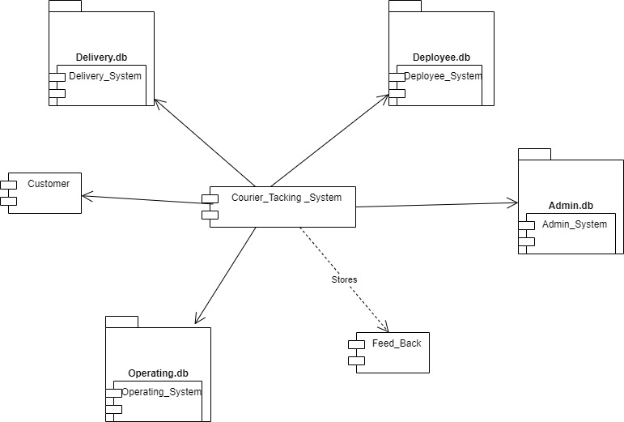

**Deployment Diagram**

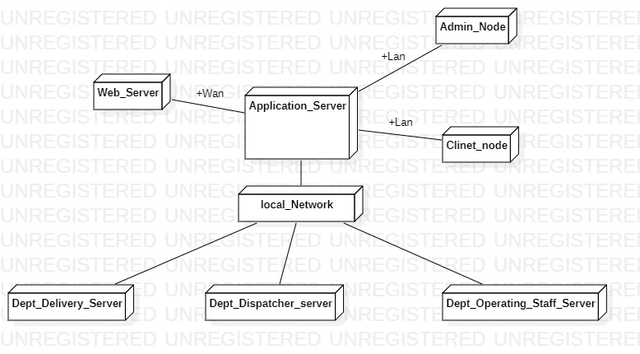

**Conclusion** : Hence learn about Component and Deployment diagram diagram.