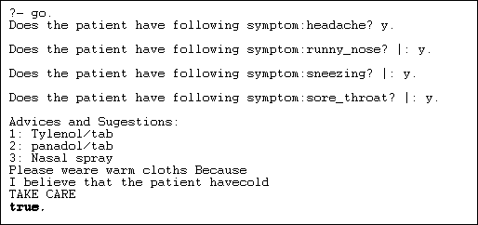

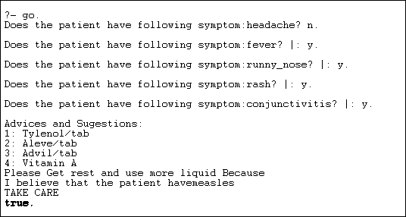

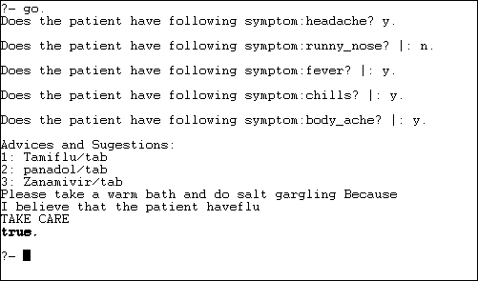

/*Source code of expert system*/

go:-

hypothesis(Disease),

write('I believe that the patient have'),

write(Disease),

nl,

write('TAKE CARE '),

undo.

/*Hypothesis that should be tested*/

hypothesis(cold) :- cold, !.

hypothesis(flu) :- flu, !.

hypothesis(typhoid) :- typhoid, !.

hypothesis(measles) :- measles, !.

hypothesis(malaria) :- malaria, !.

hypothesis(unknown). /* no diagnosis*/

/*Hypothesis Identification Rules*/

cold :-

verify(headache),

verify(runny_nose),

verify(sneezing),

verify(sore_throat),

write('Advices and Sugestions:'),

nl,

write('1: Tylenol/tab'),

nl,

write('2: panadol/tab'),

nl,

write('3: Nasal spray'),

nl,

write('Please weare warm cloths Because'),

nl.

flu :-

verify(fever),

verify(headache),

verify(chills),

verify(body_ache),

write('Advices and Sugestions:'),

nl,

write('1: Tamiflu/tab'),

nl,

write('2: panadol/tab'),

nl,

write('3: Zanamivir/tab'),

nl,

write('Please take a warm bath and do salt gargling Because'),

nl.

typhoid :-

verify(headache),

verify(abdominal_pain),

verify(poor_appetite),

verify(fever),

write('Advices and Sugestions:'),

nl,

write('1: Chloramphenicol/tab'),

nl,

write('2: Amoxicillin/tab'),

nl,

write('3: Ciprofloxacin/tab'),

nl,

write('4: Azithromycin/tab'),

nl,

write('Please do complete bed rest and take soft Diet Because'),

nl.

measles :-

verify(fever),

verify(runny_nose),

verify(rash),

verify(conjunctivitis),

write('Advices and Sugestions:'),

nl,

write('1: Tylenol/tab'),

nl,

write('2: Aleve/tab'),

nl,

write('3: Advil/tab'),

nl,

write('4: Vitamin A'),

nl,

write('Please Get rest and use more liquid Because'),

nl.

malaria :-

verify(fever),

verify(sweating),

verify(headache),

verify(nausea),

verify(vomiting),

verify(diarrhea),

write('Advices and Sugestions:'),

nl,

write('1: Aralen/tab'),

nl,

write('2: Qualaquin/tab'),

nl,

write('3: Plaquenil/tab'),

nl,

write('4: Mefloquine'),

nl,

write('Please do not sleep in open air and cover your full skin Because'),

nl.

/* how to ask questions */

ask(Question) :-

write('Does the patient have following symptom:'),

write(Question),

write('? '),

read(Response),

nl,

( (Response == yes ; Response == y)

->

assert(yes(Question)) ;

assert(no(Question)), fail).

:- dynamic yes/1,no/1.

/*How to verify something */

verify(S) :-

(yes(S)

->

true ;

(no(S)

->

fail ;

ask(S))).

/* undo all yes/no assertions*/

undo :- retract(yes(_)),fail.

undo :- retract(no(_)),fail.

undo.