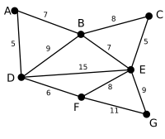 | This is our original graph. The numbers near the arcs indicate their weight. None of the arcs are highlighted.
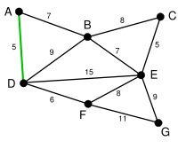 | AD and CE are the shortest arcs, with length 5, and AD has been arbitrarily chosen, so it is highlighted.
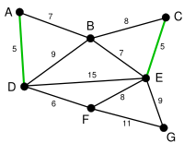 | CE is now the shortest arc that does not form a cycle, with length 5, so it is highlighted as the second arc.
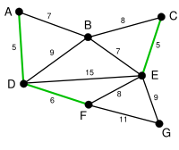 | The next arc, DF with length 6, is highlighted using much the same method.
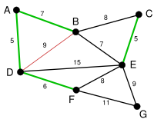 | The next-shortest arcs are AB and BE, both with length 7. AB is chosen arbitrarily, and is highlighted. The arc BD has been highlighted in red, because there already exists a path (in green) between B and D, so it would form a cycle (ABD) if it were chosen.
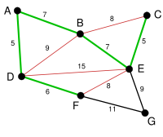 | The process continutes to highlight the next-smallest arc, BE with length 7. Many more arcs are highlighted in red at this stage: BC because it would form the loop BCE, DE because it would form the loop DEBA, and FE because it would form FEBAD.
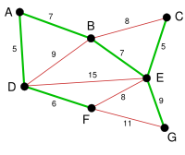 | Finally, the process finishes with the arc EG of length 9, and the minimum spanning tree is found.

The above method is Kruskal’s Method of finding Minimum spanning Tree whereas the following method is Prims Method

Image | Description | Not seen | Considerable  Vertices | selected
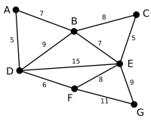 | This is our original weighted graph. This is not a tree because the definition of a tree requires that there are no cycles and this diagram contains cycles. A more correct name for this diagram would be a graph or a network. The numbers near the arcs indicate their weight. None of the arcs are highlighted, and vertex D has been arbitrarily chosen as a starting point. | C, G | A, B, E, F | D
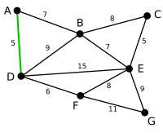 | The second chosen vertex is the vertex nearest to D: A is 5 away, B is 9, E is 15, and F is 6. Of these, 5 is the smallest, so we highlight the vertex A and the arc DA. | C, G | B, E, F | A, D
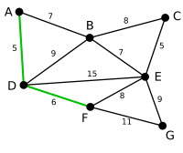 | The next vertex chosen is the vertex nearest to either D or A. B is 9 away from D and 7 away from A, E is 15, and F is 6. 6 is the smallest, so we highlight the vertex F and the arc DF. | C | B, E, G | A, D, F
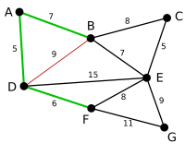 | The algorithm carries on as above. Vertex B, which is 7 away from A, is highlighted. Here, the arc DB is highlighted in red, because both vertex B and vertex D have been highlighted, so it cannot be used. | null | C, E, G | A, D, F, B
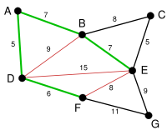 | In this case, we can choose between C, E, and G. C is 8 away from B, E is 7 away from B, and G is 11 away from F. E is nearest, so we highlight the vertex E and the arc EB. Two other arcs have been highlighted in red, as both their joining vertices have been used. | null | C, G | A, D, F, B, E
 | Here, the only vertices available are C and G. C is 5 away from E, and G is 9 away from E. C is chosen, so it is highlighted along with the arc EC. The arc BC is also highlighted in red. | null | G | A, D, F, B, E, C
 | Vertex G is the only remaining vertex. It is 11 away from F, and 9 away from E. E is nearer, so we highlight it and the arc EG. Now all the vertices have been highlighted, the minimum spanning tree is shown in green. In this case, it has weight 39. | null | null | A, D, F, B, E, C, G

