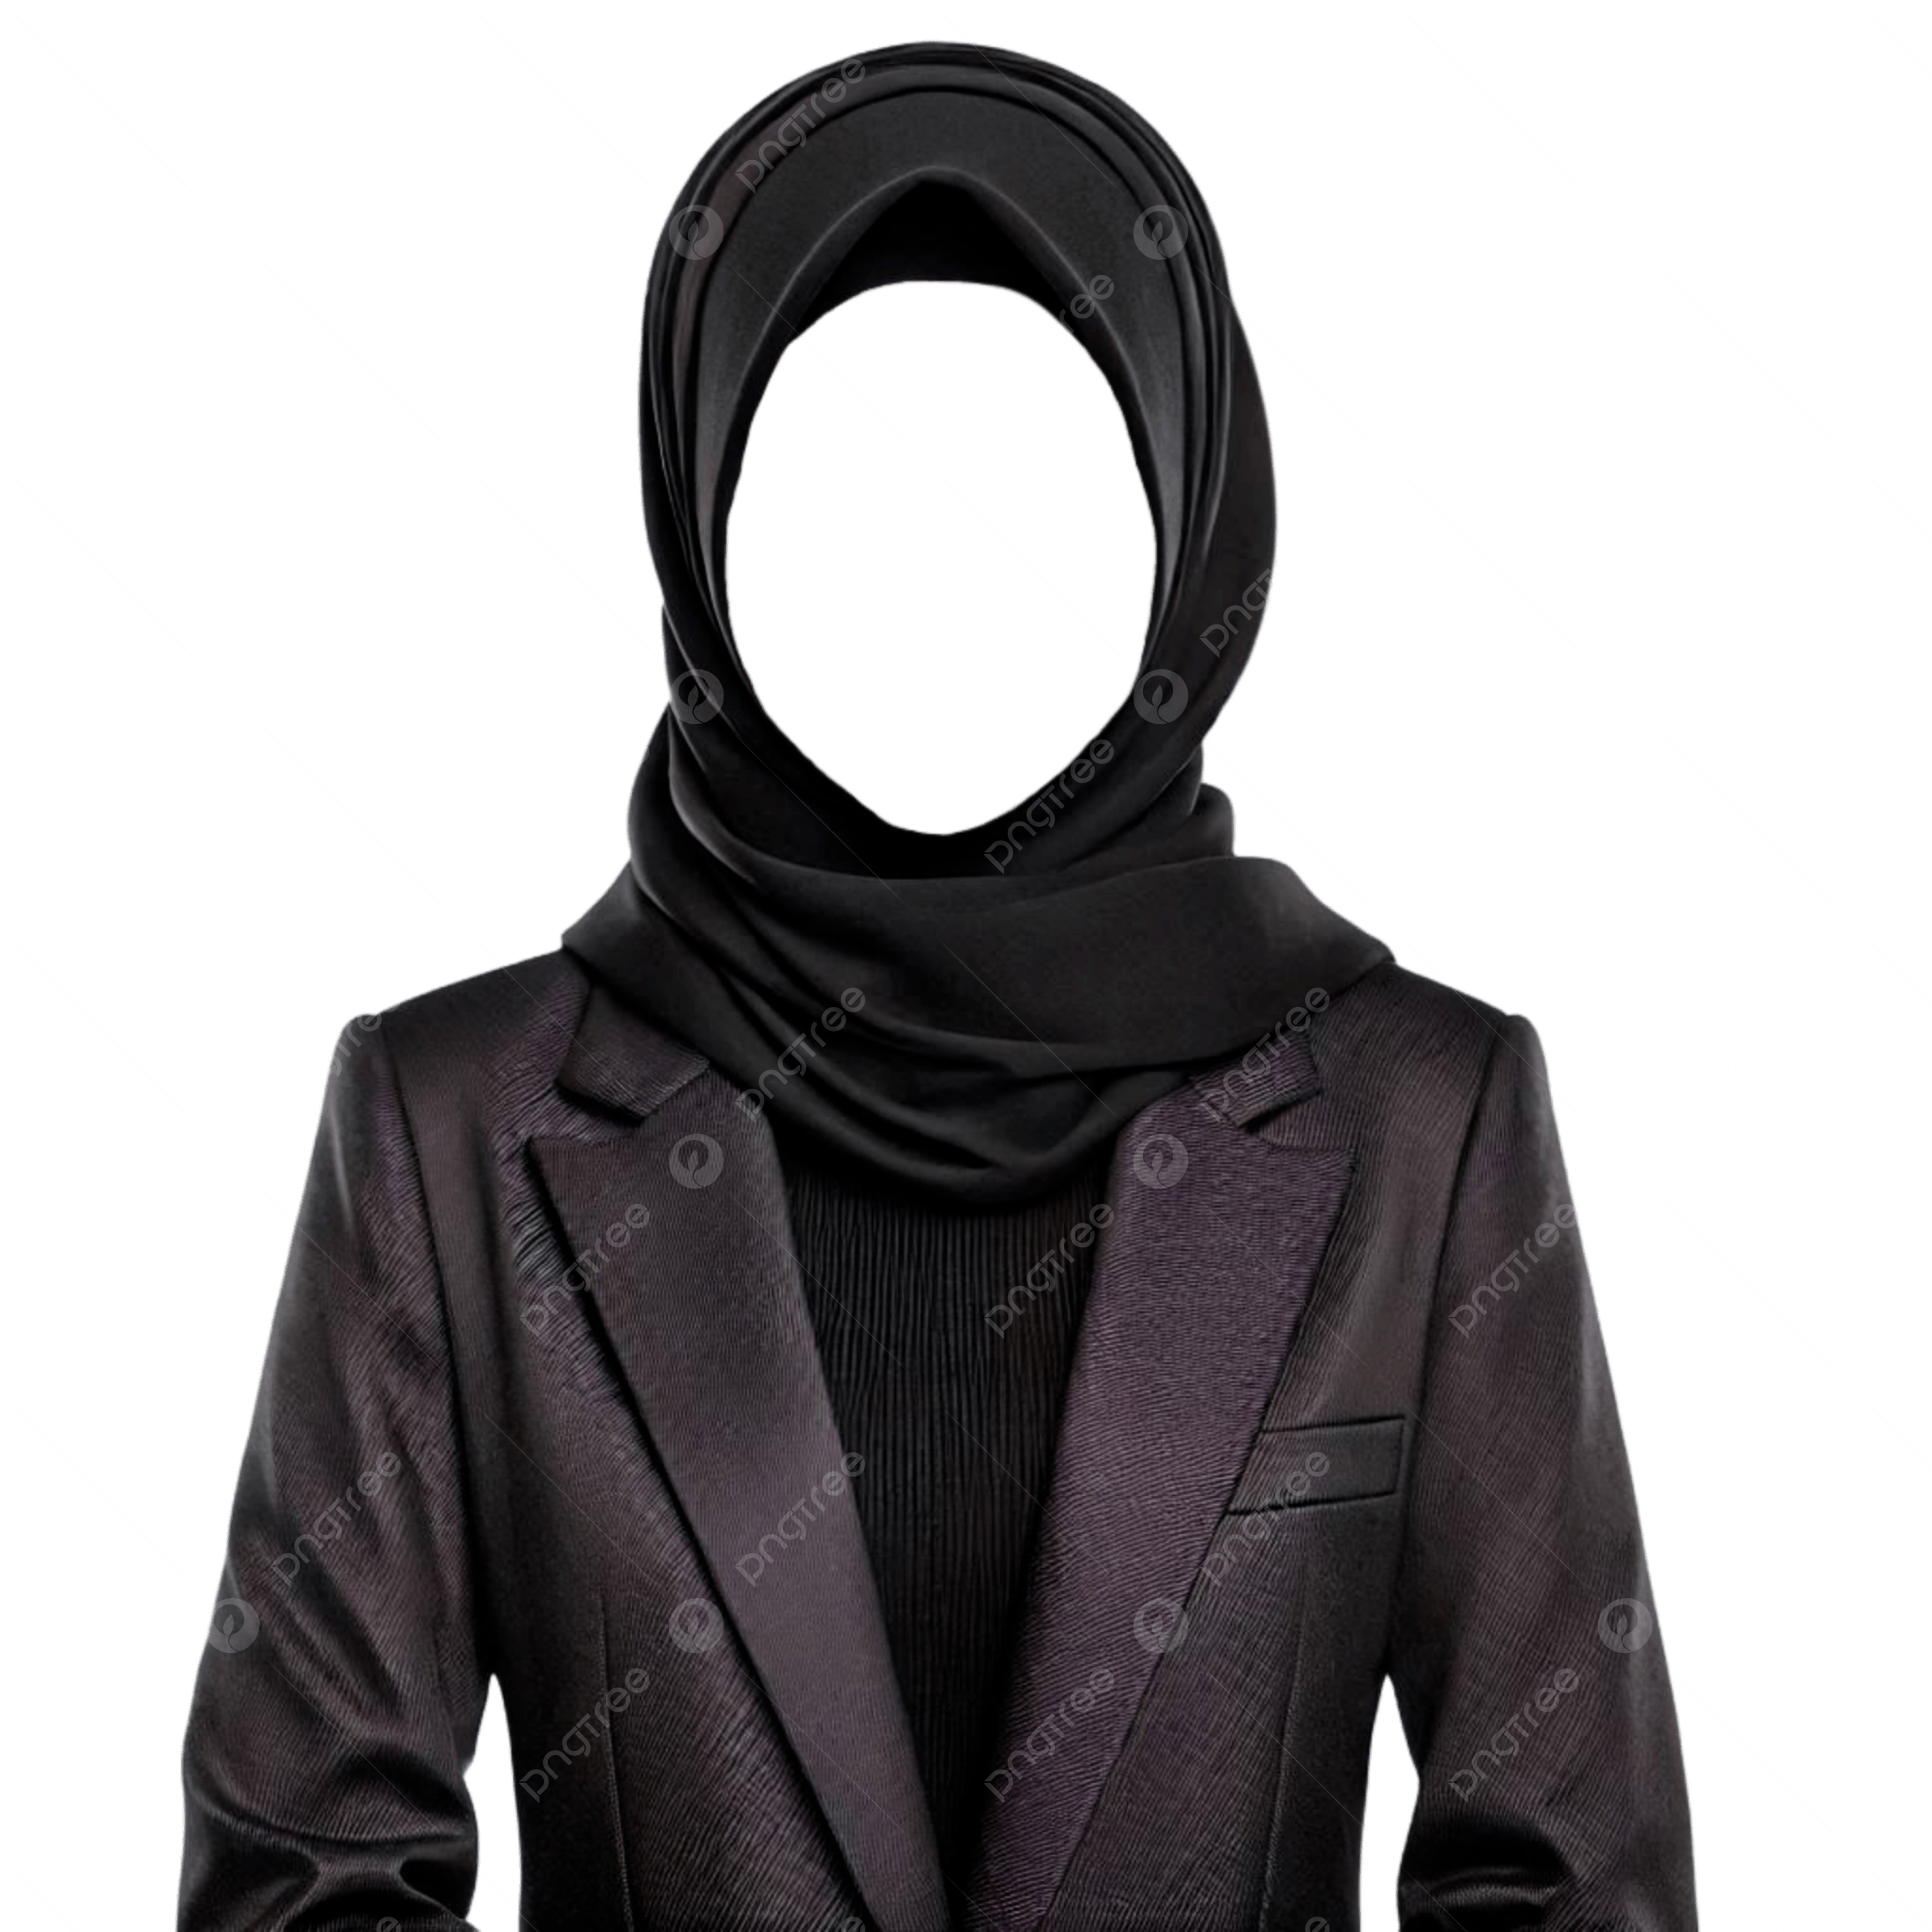
Designation: Managing Director
Mobile: 01756795652
E-mail: mouree@gmail.com

- Graphic Designer
CRR Technologies
2015-2019
- Senior Graphic Design
Gullible Enter
2000-2024
- Junior Graphic Designer
Emanuelle Fashion
2010-2015
Reference:
- UI/UX
- Graphic Design
- User Flows
- Process Flows
SKILLS
Course Studied
University/ College Details
2010-2012
EDUCATION
CONTACT ME
Phone: +880175689213
E-mail: abc1@gmail.com
Address: Kapasia, Gazipur,
Dhaka, Bangladesh.
Work Experience
Dani
Martinez
Graphic Designer

