Bangladesh Hajj Management System

*Database Website*

***CSE 311L Section: 03   
 Group Project Members:***Khandokar Shafkatuzzaman 1520697642

Md. Farhan Bin Shafiq 1411464042

23-Apr-18

Table of Contents

**Introduction2**

User Feature and Manual3-8

Requirement Analysis9-10

**Tools and Technology 10**

Important Codes11-15

**Table of Figures**

Figure 1 : Homepage 4

Figure 2 : Authorized Hajj Agencies 5

Figure 3 : Notices 5

Figure 4 : Contact Admin Members through sending messages 6

Figure 5 : Contact Numbers 7

Figure 6 : Navigation Bar 7

Figure 7 : Protected Admin Page 9

Figure 8 : Admin Login Page 9

Figure 9 : Generating Accident Query Report 12

Figure 10 : Insertion/Deletion of Hajji Information to/from the database by admin 12

Figure 11 : Generating Agency Staff Report (All Agency Staff’s info) 13

Figure 12 : Code for Admin Login 13

Figure 13 : Session 14

Figure 14 : Connection with Database 14

Figure 15 : JavaScript Code for Homepage Slideshow 15

Figure 16 : Getting Message from Users 15

Figure 17 : Generating Hajj Agency Report 16

Bangladesh Hajj Management System

Database Website

Introduction

Our motive was to build a website to serve the people who intend to perform Hajj/Umrah and people who would be performing Hajj/Umrah the following year, enlisted under Government (Admin).

The Database contains every information about a hajji, authorized hajj agencies, monazzems and guides (who help hajjis through the program) and the website generates relative queries and information to help anyone interested in performing hajj/umrah next and the relatives/family members of any hajji. Details of any registered hajji could be inserted through the website to the database by admin members (or Government authority/Officials). The website provides a list of authorized agencies and the guides with their contacts for people to differentiate between fake and original ones.

Every year thousands of Muslims from Bangladesh intend to perform Hajj or Umrah. Unfortunately a majority among them can’t get on to the plane because of numerous fake Hajj agencies and also travel agents who make good use of the illiteracy of the hajjis and deceive them. They take a huge amount of money as advance and get away, leaving them helpless.

We tried our best to meet the expectations of the hajjis, their concerned family members and other interested persons with the detailed information and report to help them with their queries.

User Features and Manual

We can think of three types of users for our website.

They are mentioned below:

# General User:

General User is any random person who came to visit the website, someone who needs Information/Contact numbers regarding Hajj or anyone interested to perform hajj. He/she doesn’t have any tracking Id/Hid or passport number of any hajji, or we can say the person have no access to any search key value.

## Features:

The person can:

* See the homepage and the scrolling news updates

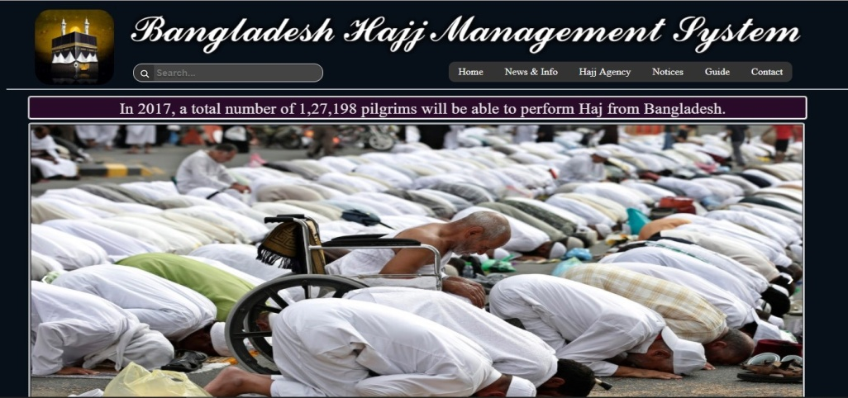

Figure 1 : Homepage

* See the developers/admin members of the website and their details (in the “About Us” section)
* Have information’s of Authorized Agencies and could contact them

(Click the button called “Hajj Agency” in the navigation bar)

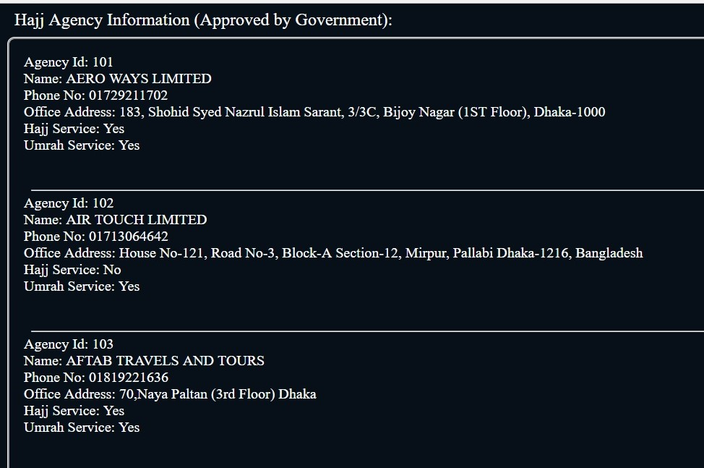

Figure 2 : Authorized Hajj Agencies

* Get information’s and contact numbers of the valid Guides

(Click “Guides” from the navigation bar)

* Go through notices (By clicking the “Notices” button in the navigation bar)

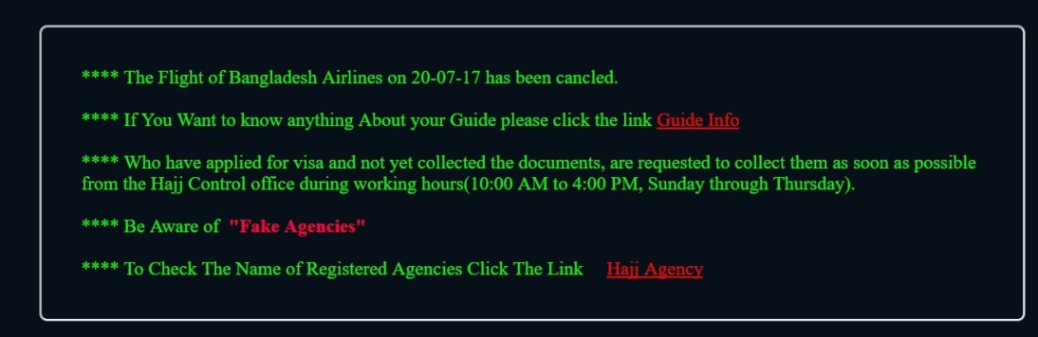

Figure 3 : Notices

* Send messages/Give feedbacks
* Ask for any query through sending message

(By clicking the “Contact” button in the navigation bar)

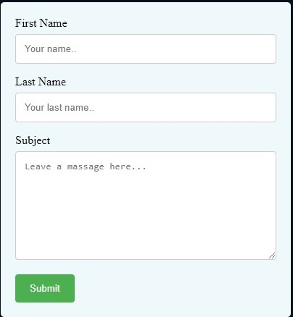

Figure 4 : Contact Admin Members through sending messages

* Get Important links, emails and contact numbers of ministries, Helpdesks and offices regarding Hajj (By clicking the Contact button in the navigation bar)

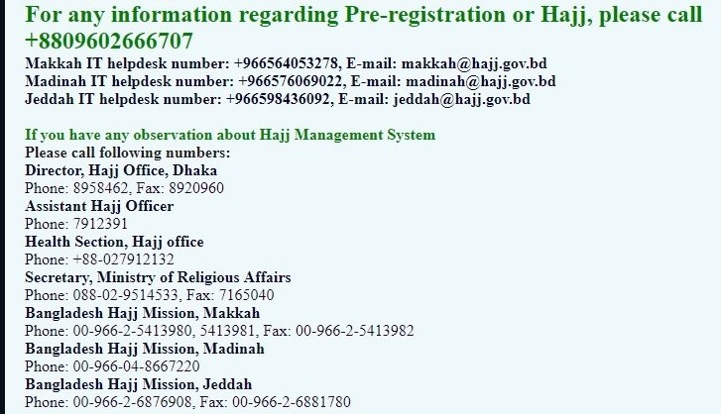

Figure 5 : Contact Numbers

# Hajji/Relatives of Hajji

This user can be Hajji himself/herself, who has previously performed hajj or will perform next and has his/her HID/Tracking Id or passport number to search for his/her information’s. Any family member or relative who have this search values (HID/Passport no) for a particular Hajji can see details of the Hajji.

## Features:

Along with the features of a general user, this user can also even see the information of any particular Hajji, whose HID is known to him/her.

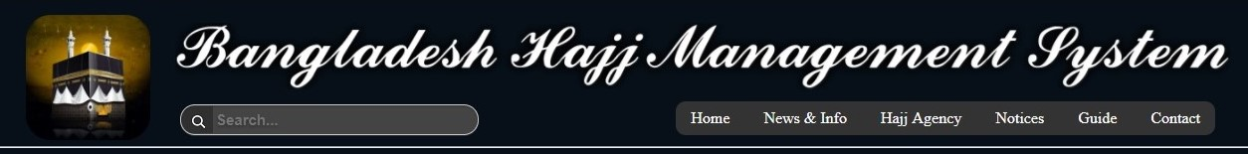

Figure 6 : Navigation Bar

This kind of user can make use of every element of the navigation bar including the search option.

# Admin Members

Each Admin Member has his/her own username and password to login into such a page which has:

* Detail Information’s of all Hajji’s, Hajj Agencies
* Death and Accident Reports
* Information’s of all Agency Staff’s including Monazzem
* Details of Hajj and Umrah packages provided by the Hajj Agencies
* User messages/feedbacks/Queries
* Information’s of the Hotels of Saudi Arab
* Information’s of all the Emergency Contact Persons
* Report regarding Physically Disable/unwell Hajji’s with their helper’s information

Along with all the above features, an admin member can insert or delete any hajji information into the database. So, Admin can be considered any Government official who

* manages the database
* register any Hajji (through inserting his information) ,which he can get from the authorized hajj agencies
* monitors all the reports and utilizes the information’s when necessary

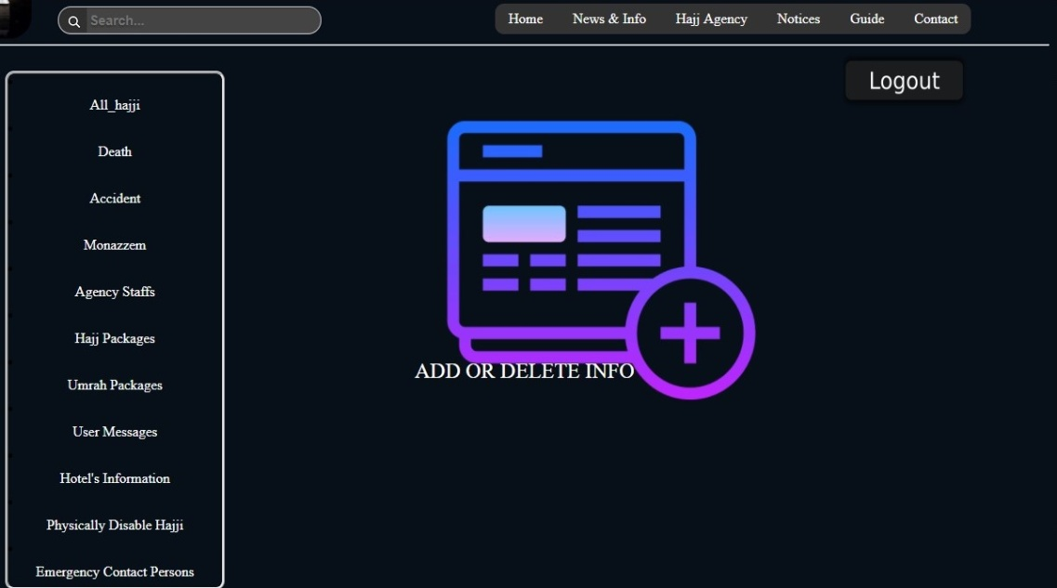

Figure 7 : Protected Admin Page

But, anyone trying to login as an admin cannot get to this confidential page without a valid username and password. Any login session with incorrect username and password redirects to a page saying “Your username/password is incorrect”, protecting the confidential admin page. Nobody except the admin members can go to this page, which is an important feature.

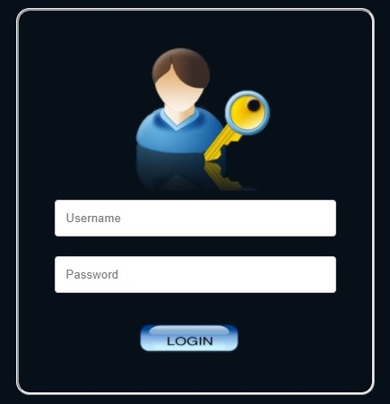

Figure 8 : Admin Login Page

Requirement Analysis

Starting with the AGENCIES, they have a unique Agency_ID , Name, Office_Address, Contact#, Email. Some of the agencies either provide with the hajj_service or umrah_service and some provide both. They have staffs functioning in different sectors with a Name, Sex, Age, Address, Contact#, Job_type and a Staff_Id , which is unique within a particular agency. Some specialized staffs works as GUIDES, MONAZZEM and HELPER. AGENCIES offer PACKAGES for hajj/umrah. Packages also have a distinct package_id under a specific agency, type(hajj/umrah), year and approximate_cost .

HAJJI’s , who are registered(through admin member/authority) and either going to perform hajj or have performed earlier have a unique HID, Name (First_name,Last_name), Age, Sex, unique Passport_no, Current_address, Permanent_address, Contact# and have an EMERGENCY_CONTACT_PERSON associated with them. One or more HAJJI’s can have a similar EMERGENCY_CONTACT_PERSON (in case of family members). EMERGENCY_CONTACT_PERSON’s have their own unique ECPID, Name, Address, Contact#.

HAJJI’s with PHYSICAL_DISABILITY or who are unwell, are listed together with the type of disability and linked with a HELPER. HAJJI’s who faced an ACCIDENT or DEATH has a record together with their EMERGENCY_CONTACT_PERSON information.

We kept record of the FLIGHT_SCHEDULE’s of the HAJJI’s, with a unique Flight ID, Airlines, Departure/Arrival date and time, specialized into FLIGHT_GO (flights leaving Bangladesh) and FLIGHT_BACK (flights arriving Bangladesh).

HAJJI’s live in HOTELS of Makkah/Madina. HOTELS have their unique Hotel_ID, Name, Address, Contact# and room capacity for HAJJI’s. AGENCIES reserve rooms in one or more HOTEL’s to accommodate the HAJJI’s for a specific day_limit and with allocated no_of_rooms and a reservation code (opt). Along with other preparations this work is done by the MONAZZEM’s, before HAJJI’s arrive in Saudi Arab.

Tools and Technology

# UsbWebServer v8

# PHPMyAdmin :

For creating the Database (Inserting Tables and columns)

## Local Host: Creates a local domain in the pc/laptop, connecting the website to the database

We modified the root folder of USBWebServer to implement our website replacing theirs.

* Sublime Text 3

For writing php, html, css and javascript codes

Important codes:

Some report generating sql queries and important codes are included below :

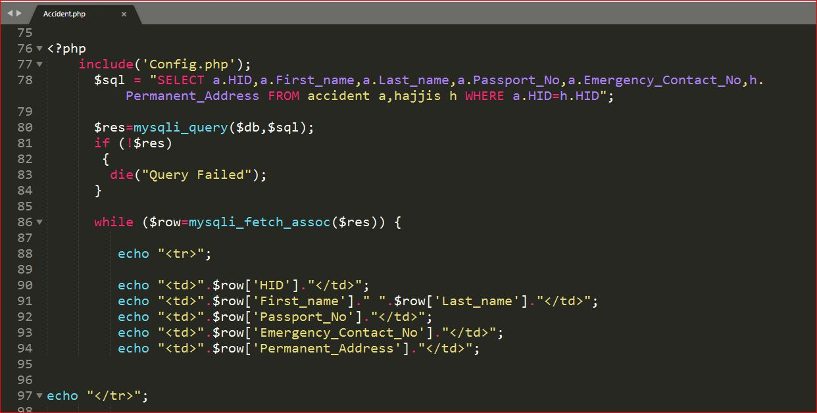

Figure 9 : Generating Accident Query Report

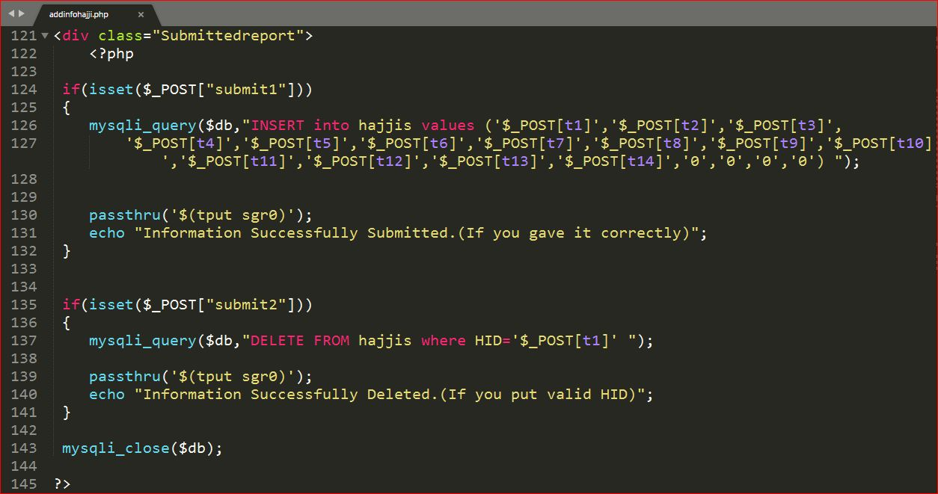

Figure 10 : Insertion/Deletion of Hajji Information to/from the database by admin

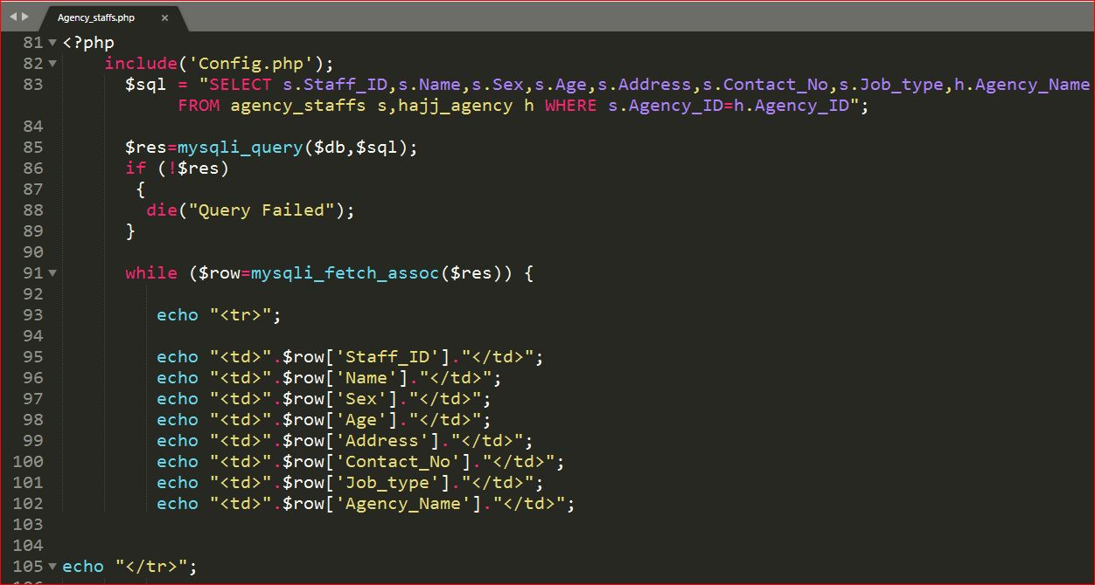

Figure 11 : Generating Agency Staff Report (All Agency Staff’s info)

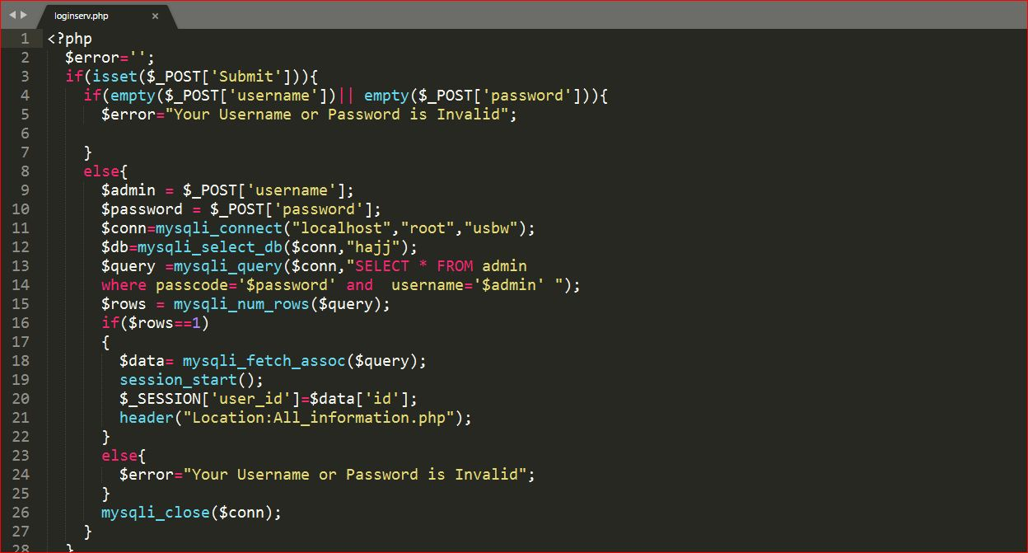

Figure 12 : Code for Admin Login

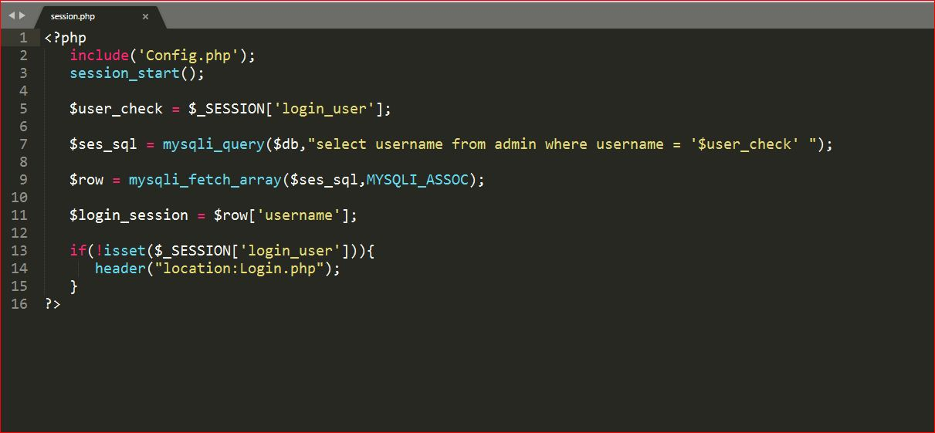

Figure 13 : Session

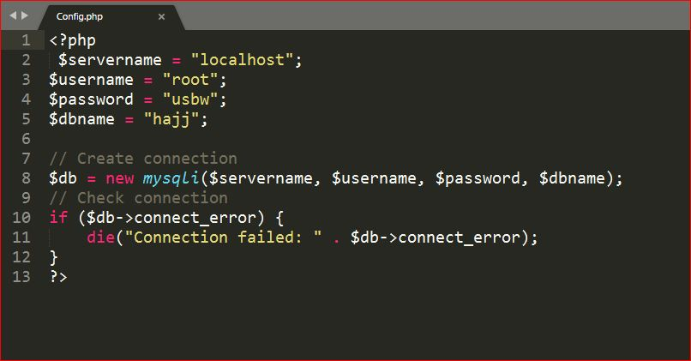

Figure 14 : Connection with Database

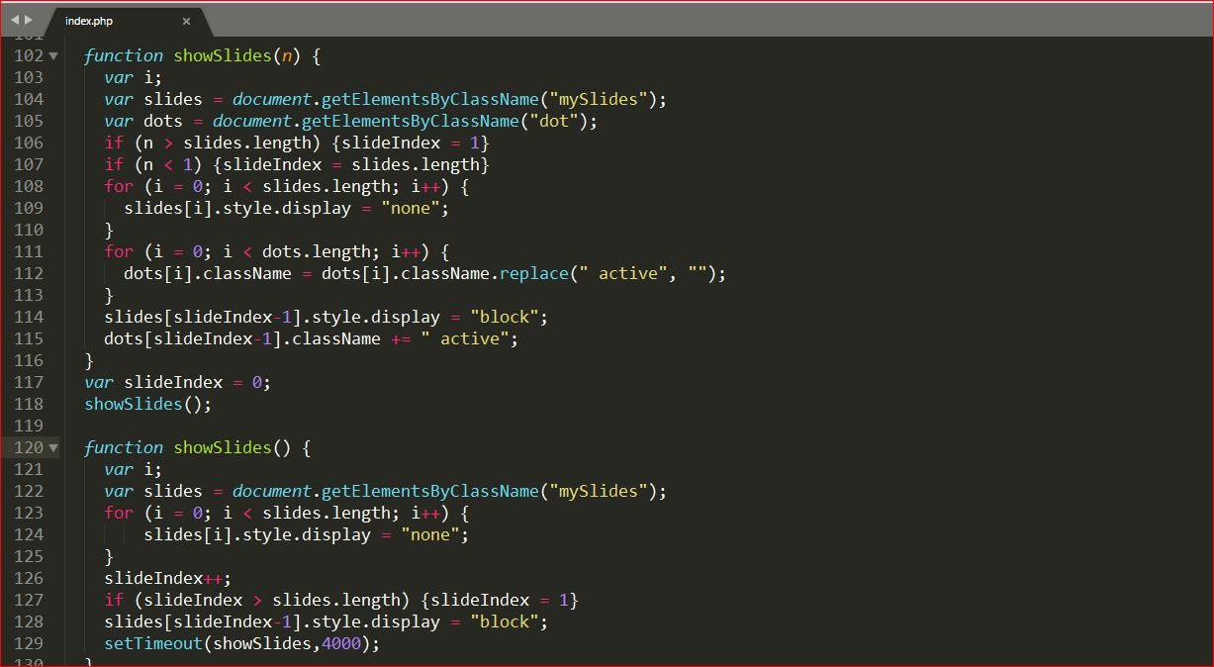

Figure 15 : JavaScript Code for Homepage Slideshow

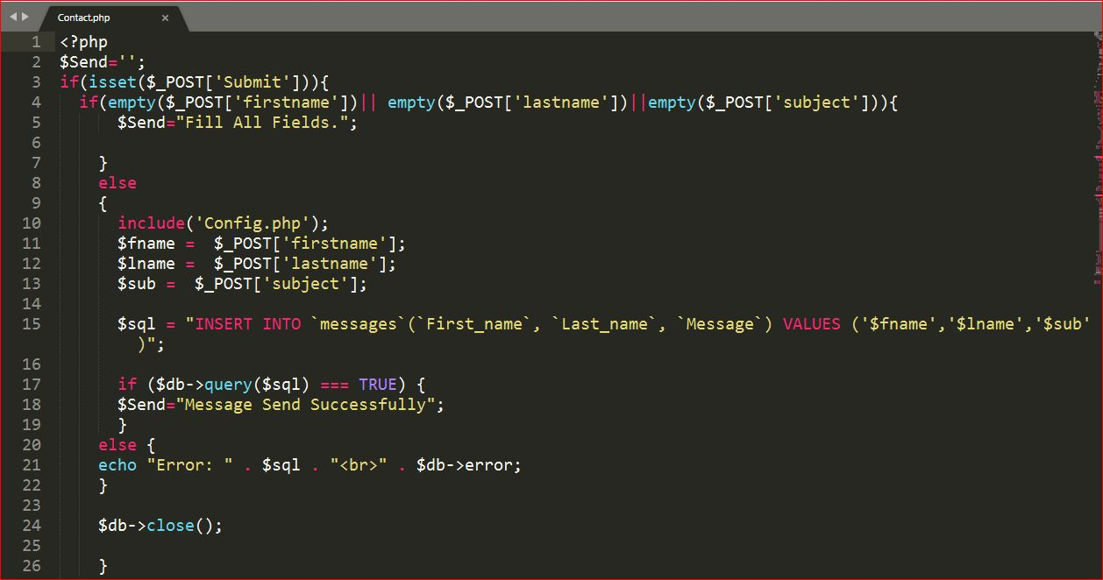

Figure 16 : Getting Message from Users

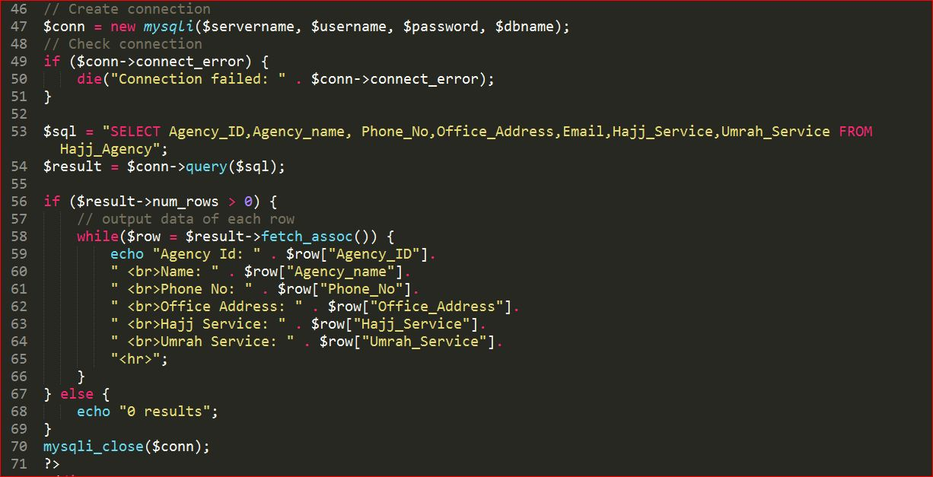

Figure 17 : Generating Hajj Agency Report