**­­­**

**Laboratory No: 02**

*Course title: Computer Graphics & Visualization Laboratory*

*Course code: 352*

**Date of Submission**: 30/04/2018

**Submitted to-**

***Amina Khatun***

*Assistant Professor*

*Department of Computer Science and Engineering*

*Jahangirnagar University*

*Savar, Dhaka*

**Submitted by-**

|  |  |  |  |
| --- | --- | --- | --- |
| Class Roll | Exam Roll | Name | Session |
| 1717 | 150052 | Jarin-E-Tasnim | 2014-15 |

# **Experiment No: 3.a**

**Experiment Name:** Draw a circle using Midpoint Algorithm

# Code:

#include <bits/stdc++.h>

#include<graphics.h>

void pixel(int xc,int yc,int x,int y);

int main()

{

int gd=DETECT,gm,xc,yc,r,x,y,Pk;

initgraph(&gd,&gm,"c:\\turboc3\\bgi ");

printf("*** Mid-Point Subdivision algorithm of circle ***\n");

printf("Enter the value of Xc\t");

scanf("%d",&xc);

printf("Enter the value of Yc \t");

scanf("%d",&yc);

printf("Enter the Radius of circle\t");

scanf("%d",&r);

x=0;

y=r;

Pk=1-r;

pixel(xc,yc,x,y);

while(x<y)

{

if(Pk<0)

{

x=x+1;

Pk=Pk+(2*x)+1;

}

else

{

x=x+1;

y=y-1;

Pk=Pk+(2*x)-(2*y)+1;

}

pixel(xc,yc,x,y);

}

getch();

closegraph();

}

void pixel(int xc,int yc,int x,int y)

{

putpixel(xc+x,yc+y,7);

putpixel(xc+y,yc+x,7);

putpixel(xc-y,yc+x,7);

putpixel(xc-x,yc+y,7);

putpixel(xc-x,yc-y,7);

putpixel(xc-y,yc-x,7);

putpixel(xc+y,yc-x,7);

putpixel(xc+x,yc-y,7);

}

# Output:

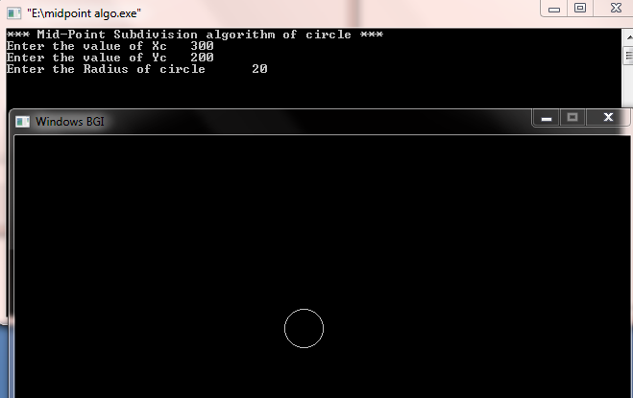

# **Experiment No. 3.b**

**Experiment Name:** Draw an ellipse.

# Code:

#include<bits/stdc++.h>

#include<graphics.h>

#include<conio.h>

using namespace std;

int main(){

int gd = DETECT,gm;

int x ,y;

initgraph(&gd, &gm, "X:\\TC\\BGI");

x = getmaxx()/2;

y = getmaxy()/2;

outtextxy(x-100, 50, "ELLIPSE Using Graphics in C++");

ellipse(x, y, 0, 360, 120, 60);

getch();

closegraph();

return 0;

}

# Output:

