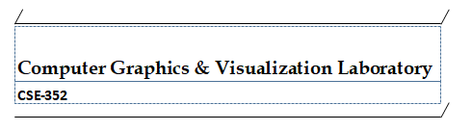

***Lab Report***

Submitted to

*Amina Khatun*

*Assistant Professor*

*Dept. of CSE, JU*

Submitted by

Rumana Islam

Roll: 1718

Semester: 3-2

*Dept. of CSE, JU*

*Date of Submission*

*14.05.18*

**Experiments name:**

1. ***A man Walking in rain with an Umbrella***

Source Code:

#include<conio.h>

#include<stdio.h>

#include<graphics.h>

void displayMan(int x,int y)

{

    circle(x,y,10);

    line(x,y+10,x,y+30);        //neck

    line(x,y+30,x-20,y+40);    //left hand

    line(x,y+30,x+20,y+40);    //right hand

    line(x+20,y+40,x+30,y+30);

    line(x,y+30,x,y+70);        //body

    line(x+30,y+30,x+30,y-90);  //umbrella

    pieslice(x+30,y-30,0,180,55);

}

  int main()

{

    int gd=DETECT, gm,i,d=0,x=50,y=340,shouldMove=1;

    int rx,ry;

    initgraph(&gd,&gm,"C:\\tc\\bgi");

    while(!kbhit())

    {

        cleardevice();

        displayMan(x,340);

        line(0,430,639,430);

for(i=0;i<500;i++)

        {

            rx=rand()%639;

            ry=rand()%439;

            if(rx>=(x-40)&&rx<=(x+110))

                if(ry>=(y-50)&&ry<=479)

                    continue;

            line(rx-10,ry+10,rx,ry);

        }

         if(shouldMove)

        {

            if(d<20)

                d+=4;

            else

                shouldMove=0;

            line(x,y+70,x-d,y+90);

            line(x,y+70,x+d,y+90);

        }

        else

        {

            if(d>0)

                d-=4;

            else

                shouldMove=1;

            line(x,y+70,x-d,y+90);

            line(x,y+70,x+d,y+90);

        }

        delay(200);

        x=(x+10)%639;

    }

    getch();

}

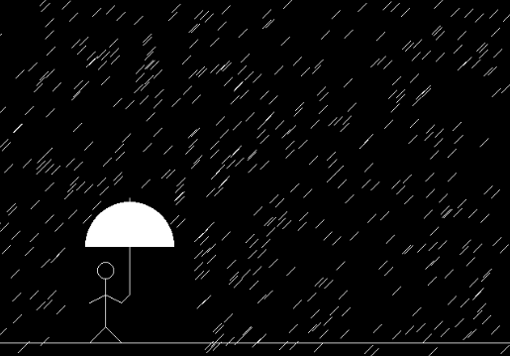

1. ***A kid is flying a kite***

Source Code:

#include<stdio.h>

#include<time.h>

#include<conio.h>

#include<graphics.h>

#include<stdlib.h>

#include<dos.h>

void main()

{

int gd=DETECT,gm;

int x=10,y=480;

initgraph(&gd,&gm,"..**\\**bgi");

while(!kbhit())

{

cleardevice();

if(y==0)

{

y=random(480);

x=random(640);

}

else

{

y=y-1;

x=x+1;

line(x-50,y,x,y-70);

line(x,y-70,x+50,y);

line(x+50,y,x,y+70);

line(x,y+70,x-50,y);

line(x,y-70,x,y+70);

line(x,y+70,x+10,y+140);

line(x,y+70,x-10,y+140);

line(x-50,y,x+50,y);

line(x,y,x+130,y+640);

}

delay(20);

}

closegraph();

restorecrtmode();

}

