**Tên: Nguyễn Hữu Khang**

**MSSV: 2011365**

**LAB 4**

**Question 1:**

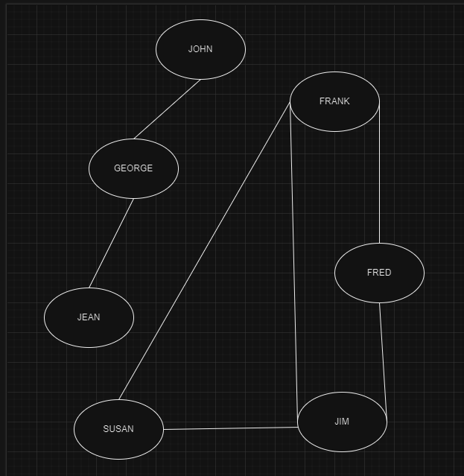

**a)** John only has one friend, his name is George

**b)** Susan’s friends are Frank, Jim.

**c)** Jean only has one friend whose name is George

**d)** Jim’s friends are Susan, Frank and Fred.

**Question 2:**

**a)** Adjacency table

|  |  |  |  |  |  |  |  |  |  |
| --- | --- | --- | --- | --- | --- | --- | --- | --- | --- |
|  | **1** | **2** | **3** | **4** | **5** | **6** | **7** | **8** | **9** |
| **1** | 0 | 1 | 1 | 1 | 0 | 0 | 0 | 0 | 1 |
| **2** | 1 | 0 | 0 | 1 | 0 | 0 | 0 | 1 | 1 |
| **3** | 1 | 0 | 0 | 1 | 1 | 1 | 1 | 0 | 0 |
| **4** | 1 | 1 | 1 | 0 | 0 | 1 | 1 | 0 | 0 |
| **5** | 0 | 0 | 1 | 0 | 0 | 0 | 0 | 0 | 0 |
| **6** | 0 | 0 | 1 | 1 | 0 | 0 | 0 | 1 | 0 |
| **7** | 0 | 0 | 1 | 1 | 0 | 0 | 0 | 0 | 0 |
| **8** | 0 | 1 | 0 | 0 | 0 | 1 | 0 | 0 | 0 |
| **9** | 1 | 1 | 0 | 0 | 0 | 0 | 0 | 0 | 0 |

**b)** Adjacency list.

|  |  |  |  |  |  |  |  |  |
| --- | --- | --- | --- | --- | --- | --- | --- | --- |
| **1** | 2 | 3 | 4 | 9 |  |  |  |  |
| **2** | 1 | 4 | 8 | 9 |  |  |  |  |
| **3** | 1 | 4 | 5 | 6 | 7 |  |  |  |
| **4** | 1 | 2 | 3 | 6 | 7 |  |  |  |
| **5** | 3 |  |  |  |  |  |  |  |
| **6** | 3 | 4 | 8 |  |  |  |  |  |
| **7** | 3 | 4 |  |  |  |  |  |  |
| **8** | 2 | 6 |  |  |  |  |  |  |
| **9** | 1 | 2 |  |  |  |  |  |  |

**c)**

|  |  |  |  |
| --- | --- | --- | --- |
| Đỉnh đang xét | Stack | PopStack | đỉnh còn lại |
| DFS(1) | 1 |  | 2, 3, 4, 5, 6, 7, 8, 9 |
| DFS(2) | 2, 1 |  | 3, 4, 5, 6, 7, 8, 9 |
| DFS(4) | 4, 2, 1 |  | 3, 5, 6, 7, 8, 9 |
| DFS(3) | 3, 4, 2, 1 |  | 5, 6, 7, 8, 9 |
| DFS(5) | 5, 3, 4, 2, 1 | 5 | 6, 7, 8, 9 |
| DFS(6) | 6, 3, 4, 2, 1 |  | 7, 8, 9 |
| DFS(8) | 8, 6, 3, 4, 2, 1 | 8, 6 | 7, 9 |
| DFS(7) | 7, 3, 4, 2, 1 | 7, 3, 4 | 9 |
| DFS(9) | 9, 2, 1 | 9, 2, 1 | Ø |

Order of vertices being pop from stack is:

5, 8, 6, 7, 3, 4, 9, 2, 1

**d)**

|  |  |  |  |  |
| --- | --- | --- | --- | --- |
| Hàng đợi | Đỉnh u (lấy từ hàng đợi) | Hàng đợi (sau khi lấy u ra) | Các đỉnh v kề u mà chưa đánh dấu | Hàng đợi sau khi đẩy những đỉnh v vào |
| (1) | 1 | Ø | (2; 3; 4; 9) | (2; 3; 4; 9) |
| (2; 3; 4; 9) | 2 | (3; 4; 9) | (8) | (3; 4; 9; 8) |
| (3; 4; 9; 8) | 3 | (4; 9; 8) | (5; 6; 7) | (4; 9; 8; 5; 6; 7) |
| (4; 9; 8; 5; 6; 7) | 4 | (9; 8; 5; 6; 7) | Ø | (9; 8; 5; 6; 7) |
| (9; 8; 5; 6; 7) | 9 | (8; 5; 6; 7) | Ø | (8; 5; 6; 7) |
| (8; 5; 6; 7) | 8 | (5; 6; 7) | Ø | (5; 6; 7) |
| (5; 6; 7) | 5 | (6; 7) | Ø | (6; 7) |
| (6; 7) | 6 | (7) | Ø | (7) |
| (7) | 7 | Ø | Ø | Ø |

Order of vertices being pop from queue is:

1, 2, 3, 4, 9, 8, 5, 6, 7

**Question 3:**

**a)**

|  |  |  |  |  |
| --- | --- | --- | --- | --- |
| Đỉnh đang xét | | Stack | PopStack | đỉnh còn lại |
| DFS(A) | A | |  | B, C, D, E, F, G, H, J, K, M |
| DFS(E) | E, A | |  | B, C, D, F, G, H, J, K, M |
| DFS(F) | F, E, A | |  | B, C, D, G, H, J, K, M |
| DFS(H) | H, F, E, A | |  | B, C, D, G, J, K, M |
| DFS(J) | J, H, F, E, A | | F, H, J | B, C, D, G, K, M |
| DFS(D) | D, E, A | |  | B, C, G, K, M |
| DFS(G) | G, D, E, A | |  | B, C, K, M |
| DFS(M) | M, G, D, E, A | |  | B, C, K |
| DFS(K) | K, M, G, D, E, A | | M, K | B, C |
| DFS(C) | C, G, D, E, A | | E, D, G, C | B |
| DFS(B) | B, A | | A, B |  |
|  |  | |  |  |

🡪A, B, E, D, G, C, M, K, F, H, J

**b)**

|  |  |  |  |  |
| --- | --- | --- | --- | --- |
| Hàng đợi | Đỉnh u (lấy từ hàng đợi) | Hàng đợi (sau khi lấy u ra) | Các đỉnh v kề u mà chưa đánh dấu | Hàng đợi sau khi đẩy những đỉnh v vào |
| (A) | A | Ø | (E; B) | (E; B) |
| (E; B) | E | (B) | (F, D) | (B; F; D) |
| (B; F; D) | B | (F; D) | (C) | (F; D; C) |
| (F; D; C) | F | (D; C) | (H; J) | (D; C; H; J) |
| (D; C; H; J) | D | (C; H; J) | (G) | (C; H; J; G) |
| (C; H; J; G) | C | (H; J; G) | Ø | (H; J; G) |
| (H; J; G) | H | (J; G) | Ø | (J; G) |
| (J; G) | J | (G) | Ø | (G) |
| (G) | G | Ø | (M) | (M) |
| (M) | M | Ø | (K) | (K) |
| (K) | K | Ø | Ø | Ø |

🡪 A, E, B, F, D, C, H, J, G, M, K

**c)**

|  |  |  |  |  |  |  |  |  |  |  |  |  |
| --- | --- | --- | --- | --- | --- | --- | --- | --- | --- | --- | --- | --- |
| Đỉnh / Bước | A | B | C | D | E | F | G | H | J | K | M | Cạnh |
| Khởi tạo | - | (A,12) | (A, ~) | (A, ~) | (A, 8)* | (A, ~) | (A, ~) | (A, ~) | (A, ~) | (A, ~) | (A, ~) | Ø |
| 1 | - | (A,12) | (A, ~) | (E, 27) | - | (E, 8)* | (A, ~) | (A, ~) | (A, ~) | (A, ~) | (A, ~) | AE |
| 2 | - | (A, 12) | (A, ~) | (F, 4) | - | - | - | (F, 2)* | (F, 5) | (A, ~) | (A, ~) | AE, EF |
| 3 | - | (A, 12) | (A, ~) | (F, 4) | - | - | (H, 6) | - | (F, 5) | (A, ~) | (H, 1)* | AE, EF, FH |
| 4 | - | (A, 12) | (A, ~) | (F, 4) | - | - | (M, 1)* | - | (M, 2) | (M, 3) | - | AE, EF, FH, HM |
| 5 | - | (A, 12) | (G, 23) | (F, 4) | - | - | - | - | (M, 2)* | (M, 3) | - | AE, EF, FH, HM, MG |
| 6 | - | (A, 12) | (G, 23) | (F, 4) | - | - | - | - | - | (M, 3)* | - | AE, EF, FH, HM, MG, MJ |
| 7 | - | (A, 12) | (G, 23) | (F, 4)* | - | - | - | - | - | - | - | AE, EF, FH, HM, MG, MJ, MK |
| 8 | - | (A, 12)* | (G, 23) | - | - | - | - | - | - | - | - | AE, EF, FH, HM, MG, MJ, MK,  FD |
| 9 | - | - | (B, 3)* | - | - | - | - | - | - | - | - | AE, EF, FH, HM, MG, MJ, MK,  FD, AB |
| 10 | - | - | - | - | - | - | - | - | - | - | - | AE, EF, FH, HM, MG, MJ, MK,  FD, AB, BC |

* Cây phủ tối thiểu gồm các cạnh sau đây: AE, EF, FH, HM, MG, MJ, MK, FD, AB, BC

**Question 4:**

**Bảng duyệt các nút:**

|  |  |  |  |  |  |  |  |  |  |  |
| --- | --- | --- | --- | --- | --- | --- | --- | --- | --- | --- |
| Đỉnh / Bước | 0 | 1 | 2 | 3 | 4 | 5 | 6 | 7 | 8 | Cạnh |
| Khởi tạo | - | (0, 4)* | (0, ~) | (0, ~) | (0, ~) | (0, ~) | (0, ~) | (0, 8) | (0, ~) | Ø |
| 1 | - | - | (1, 8)* | (0, ~) | (0, ~) | (0, ~) | (0, ~) | (0, 8) | (0, ~) | 01 |
| 2 | - | - | - | (2, 7) | (0, ~) | (2, 4) | (0, ~) | (0, 8) | (2, 2)* | 01, 12 |
| 3 | - | - | - | (2, 7) | (0, ~) | (2, 4)* | (8, 6) | (0, 8) | - | 01, 12, 28 |
| 4 | - | - | - | (2, 7) | (5, 10) | - | (5, 2)* | (0, 8) | - | 01, 12, 28, 25 |
| 5 | - | - | - | (2, 7)* | (5, 10) | - | - | (0, 8) | - | 01, 12, 28, 25, 56 |
| 6 | - | - | - | - | (3, 9) | - | - | (0, 8)* | - | 01, 12, 28, 25, 56, 23 |
| 7 | - | - | - | - | (3, 9)* | - | - | - | - | 01, 12, 28, 25, 56, 23, 07 |
| 8 | - | - | - | - | - | - | - | - | - | 01, 12, 28, 25, 56, 23, 07. 34 |

**Đường đi ngắn nhất từ đỉnh 0 đến đỉnh 1 là:**

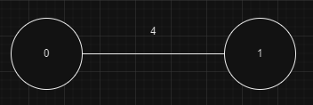

**Đường đi ngắn nhất từ đỉnh 0 đến đỉnh 2 là:**

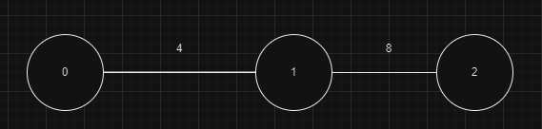

**Đường đi ngắn nhất từ đỉnh 0 đến đỉnh 3 là:**

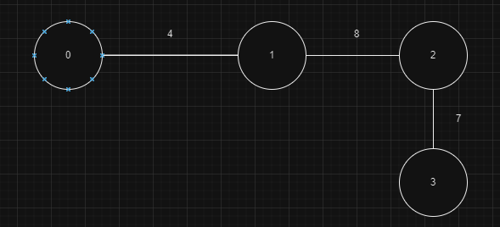

**Đường đi ngắn nhất từ đỉnh 0 đến đỉnh 4 là:**

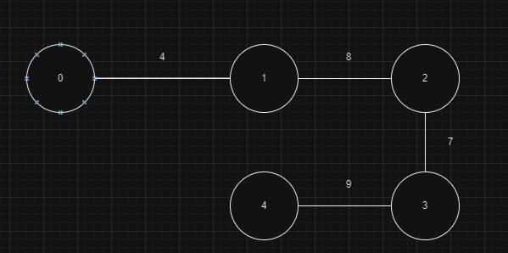

**Đường đi ngắn nhất từ đỉnh 0 đến đỉnh 5 là:**

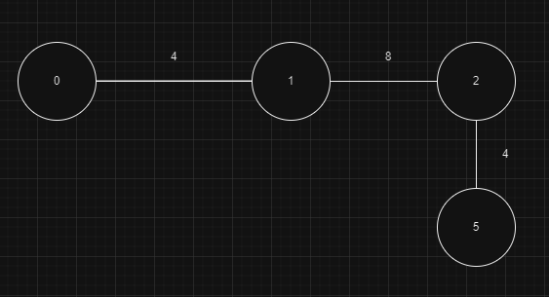

**Đường đi ngắn nhất từ đỉnh 0 đến đỉnh 6 là:**

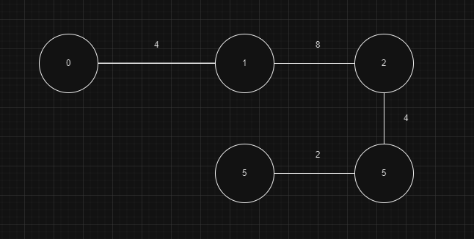

**Đường đi ngắn nhất từ đỉnh 0 đến đỉnh 7 là:**

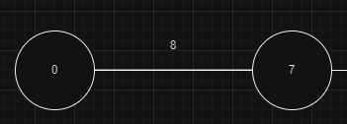

**Đường đi ngắn nhất từ đỉnh 0 đến đỉnh 8 là:**

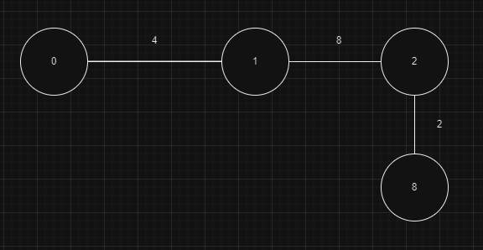

**Question 5:**

**Đồ thị 1:**

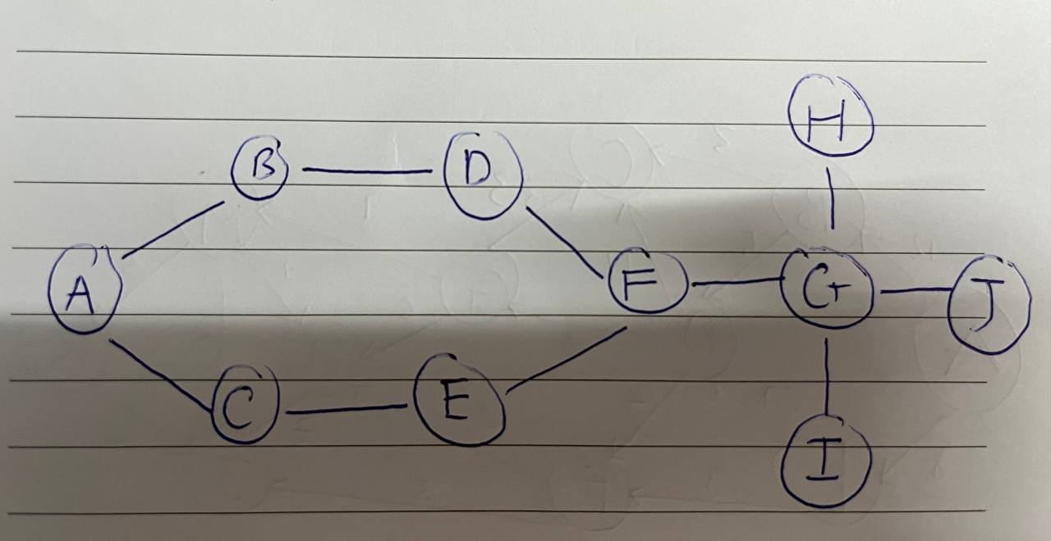

|  |  |  |  |  |  |  |  |  |  |  |
| --- | --- | --- | --- | --- | --- | --- | --- | --- | --- | --- |
|  | **A** | **B** | **C** | **D** | **E** | **F** | **G** | **H** | **I** | **J** |
| **A** | 0 | 1 | 1 | 0 | 0 | 0 | 0 | 0 | 0 | 0 |
| **B** | 1 | 0 | 0 | 1 | 0 | 0 | 0 | 0 | 0 | 0 |
| **C** | 1 | 0 | 0 | 0 | 1 | 0 | 0 | 0 | 0 | 0 |
| **D** | 0 | 1 | 0 | 0 | 0 | 1 | 0 | 0 | 0 | 0 |
| **E** | 0 | 0 | 1 | 0 | 0 | 1 | 0 | 0 | 0 | 0 |
| **F** | 0 | 0 | 0 | 1 | 1 | 0 | 1 | 0 | 0 | 0 |
| **G** | 0 | 0 | 0 | 0 | 0 | 1 | 0 | 1 | 1 | 1 |
| **H** | 0 | 0 | 0 | 0 | 0 | 0 | 1 | 0 | 0 | 0 |
| **I** | 0 | 0 | 0 | 0 | 0 | 0 | 1 | 0 | 0 | 0 |
| **J** | 0 | 0 | 0 | 0 | 0 | 0 | 1 | 0 | 0 | 0 |

**Đồ thị 2:**

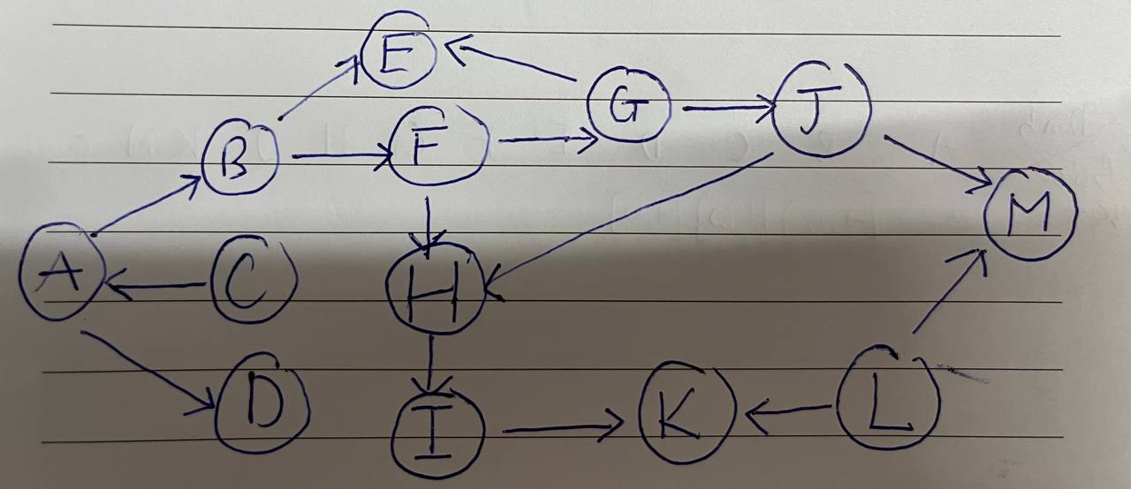

|  |  |  |  |  |  |  |  |  |  |  |  |  |  |
| --- | --- | --- | --- | --- | --- | --- | --- | --- | --- | --- | --- | --- | --- |
|  | **A** | **B** | **C** | **D** | **E** | **F** | **G** | **H** | **I** | **J** | **K** | **L** | **M** |
| **A** | 0 | 1 | 0 | 1 | 0 | 0 | 0 | 0 | 0 | 0 | 0 | 0 | 0 |
| **B** | 0 | 0 | 0 | 0 | 1 | 1 | 0 | 0 | 0 | 0 | 0 | 0 | 0 |
| **C** | 1 | 0 | 0 | 0 | 0 | 0 | 0 | 0 | 0 | 0 | 0 | 0 | 0 |
| **D** | 0 | 0 | 0 | 0 | 0 | 0 | 0 | 0 | 0 | 0 | 0 | 0 | 0 |
| **E** | 0 | 0 | 0 | 0 | 0 | 0 | 0 | 0 | 0 | 0 | 0 | 0 | 0 |
| **F** | 0 | 0 | 0 | 0 | 0 | 0 | 1 | 1 | 0 | 0 | 0 | 0 | 0 |
| **G** | 0 | 0 | 0 | 0 | 0 | 0 | 0 | 0 | 0 | 1 | 0 | 0 | 0 |
| **H** | 0 | 0 | 0 | 0 | 0 | 0 | 0 | 0 | 1 | 0 | 0 | 0 | 0 |
| **I** | 0 | 0 | 0 | 0 | 0 | 0 | 0 | 0 | 0 | 0 | 1 | 0 | 0 |
| **J** | 0 | 0 | 0 | 0 | 0 | 0 | 0 | 1 | 0 | 0 | 0 | 0 | 0 |
| **K** | 0 | 0 | 0 | 0 | 0 | 0 | 0 | 0 | 0 | 0 | 0 | 0 | 0 |
| **L** | 0 | 0 | 0 | 0 | 0 | 0 | 0 | 0 | 0 | 0 | 1 | 0 | 0 |
| **M** | 0 | 0 | 0 | 0 | 0 | 0 | 0 | 0 | 0 | 0 | 0 | 0 | 0 |

**Đồ thị 3:**

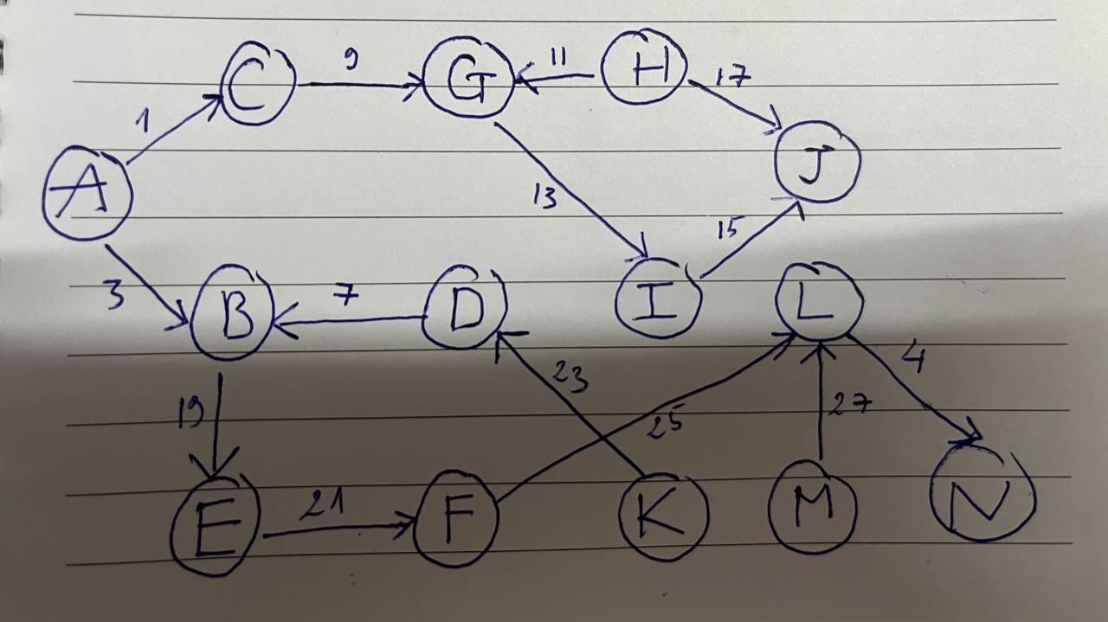

|  |  |  |  |  |  |  |  |  |  |  |  |  |  |  |
| --- | --- | --- | --- | --- | --- | --- | --- | --- | --- | --- | --- | --- | --- | --- |
|  | **A** | **B** | **C** | **D** | **E** | **F** | **G** | **H** | **I** | **J** | **K** | **L** | **M** | **N** |
| **A** | 0 | 3 | 1 | 0 | 0 | 0 | 0 | 0 | 0 | 0 | 0 | 0 | 0 | 0 |
| **B** | 0 | 0 | 0 | 0 | 19 | 0 | 0 | 0 | 0 | 0 | 0 | 0 | 0 | 0 |
| **C** | 0 | 0 | 0 | 0 | 0 | 0 | 9 | 0 | 0 | 0 | 0 | 0 | 0 | 0 |
| **D** | 0 | 7 | 0 | 0 | 0 | 0 | 0 | 0 | 0 | 0 | 0 | 0 | 0 | 0 |
| **E** | 0 | 0 | 0 | 0 | 0 | 21 | 0 | 0 | 0 | 0 | 0 | 0 | 0 | 0 |
| **F** | 0 | 0 | 0 | 0 | 0 | 0 | 0 | 0 | 0 | 0 | 0 | 25 | 0 | 0 |
| **G** | 0 | 0 | 0 | 0 | 0 | 0 | 0 | 0 | 13 | 0 | 0 | 0 | 0 | 0 |
| **H** | 0 | 0 | 0 | 0 | 0 | 0 | 0 | 0 | 0 | 17 | 0 | 0 | 0 | 0 |
| **I** | 0 | 0 | 0 | 0 | 0 | 0 | 0 | 0 | 0 | 15 | 0 | 0 | 0 | 0 |
| **J** | 0 | 0 | 0 | 0 | 0 | 0 | 0 | 0 | 0 | 0 | 0 | 0 | 0 | 0 |
| **K** | 0 | 0 | 0 | 23 | 0 | 0 | 0 | 0 | 0 | 0 | 0 | 0 | 0 | 0 |
| **L** | 0 | 0 | 0 | 0 | 0 | 0 | 0 | 0 | 0 | 0 | 0 | 0 | 0 | 4 |
| **M** | 0 | 0 | 0 | 0 | 0 | 0 | 0 | 0 | 0 | 0 | 0 | 27 | 0 | 0 |
| **N** | 0 | 0 | 0 | 0 | 0 | 0 | 0 | 0 | 0 | 0 | 0 | 0 | 0 | 0 |

**Đồ thị 4:**

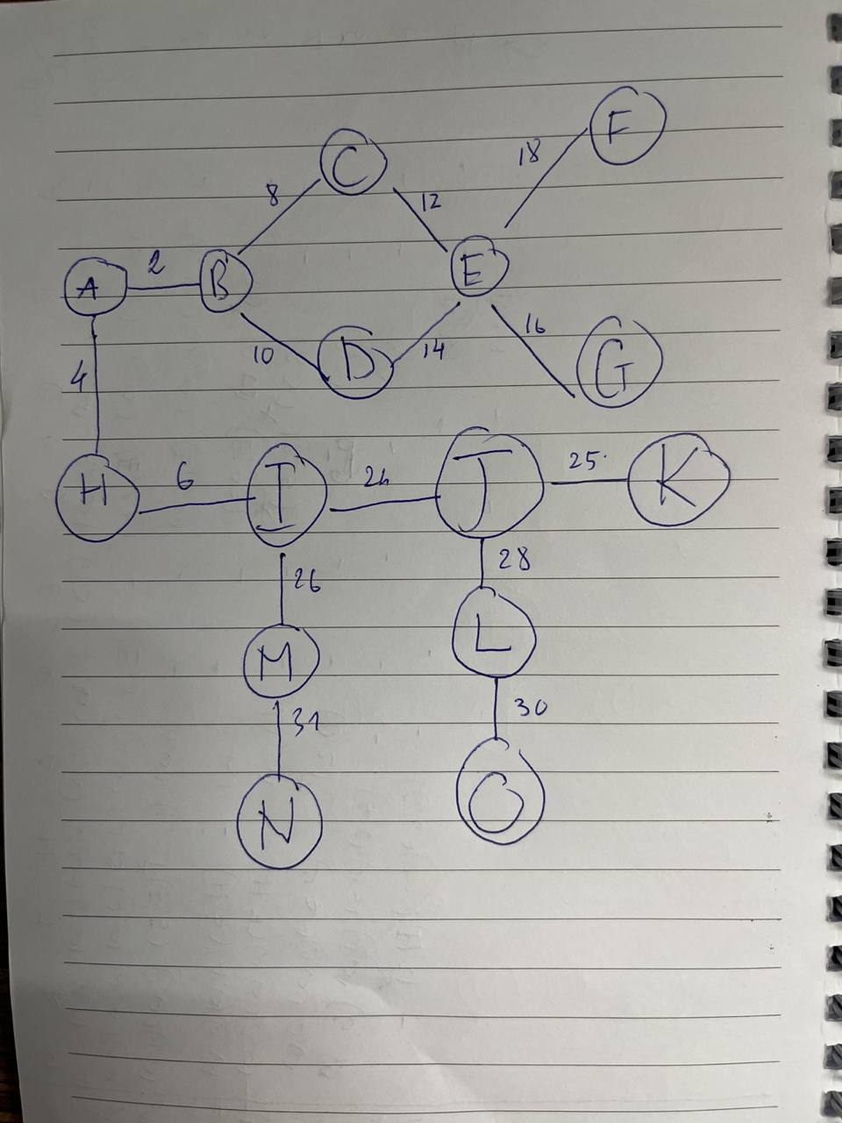

|  |  |  |  |  |  |  |  |  |  |  |  |  |  |  |  |
| --- | --- | --- | --- | --- | --- | --- | --- | --- | --- | --- | --- | --- | --- | --- | --- |
|  | **A** | **B** | **C** | **D** | **E** | **F** | **G** | **H** | **I** | **J** | **K** | **L** | **M** | **N** | **O** |
| **A** | 0 | 2 | 0 | 0 | 0 | 0 | 0 | 4 | 0 | 0 | 0 | 0 | 0 | 0 | 0 |
| **B** | 2 | 0 | 8 | 10 | 0 | 0 | 0 | 0 | 0 | 0 | 0 | 0 | 0 | 0 | 0 |
| **C** | 0 | 8 | 0 | 0 | 12 | 0 | 0 | 0 | 0 | 0 | 0 | 0 | 0 | 0 | 0 |
| **D** | 0 | 10 | 0 | 0 | 14 | 0 | 0 | 0 | 0 | 0 | 0 | 0 | 0 | 0 | 0 |
| **E** | 0 | 0 | 12 | 14 | 0 | 18 | 16 | 0 | 0 | 0 | 0 | 0 | 0 | 0 | 0 |
| **F** | 0 | 0 | 0 | 0 | 18 | 0 | 0 | 0 | 0 | 0 | 0 | 0 | 0 | 0 | 0 |
| **G** | 0 | 0 | 0 | 0 | 16 | 0 | 0 | 0 | 0 | 0 | 0 | 0 | 0 | 0 | 0 |
| **H** | 4 | 0 | 0 | 0 | 0 | 0 | 0 | 0 | 6 | 0 | 0 | 0 | 0 | 0 | 0 |
| **I** | 0 | 0 | 0 | 0 | 0 | 0 | 0 | 6 | 0 | 24 | 0 | 0 | 0 | 0 | 0 |
| **J** | 0 | 0 | 0 | 0 | 0 | 0 | 0 | 0 | 24 | 0 | 25 | 0 | 0 | 0 | 0 |
| **K** | 0 | 0 | 0 | 0 | 0 | 0 | 0 | 0 | 0 | 25 | 0 | 0 | 0 | 0 | 0 |
| **L** | 0 | 0 | 0 | 0 | 0 | 0 | 0 | 0 | 0 | 28 | 0 | 0 | 0 | 0 | 30 |
| **M** | 0 | 0 | 0 | 0 | 0 | 0 | 0 | 0 | 26 | 0 | 0 | 0 | 0 | 31 | 0 |
| **N** | 0 | 0 | 0 | 0 | 0 | 0 | 0 | 0 | 0 | 0 | 0 | 0 | 31 | 0 | 0 |
| **O** | 0 | 0 | 0 | 0 | 0 | 0 | 0 | 0 | 0 | 0 | 0 | 30 | 0 | 0 | 0 |

**Đồ thị 5:**

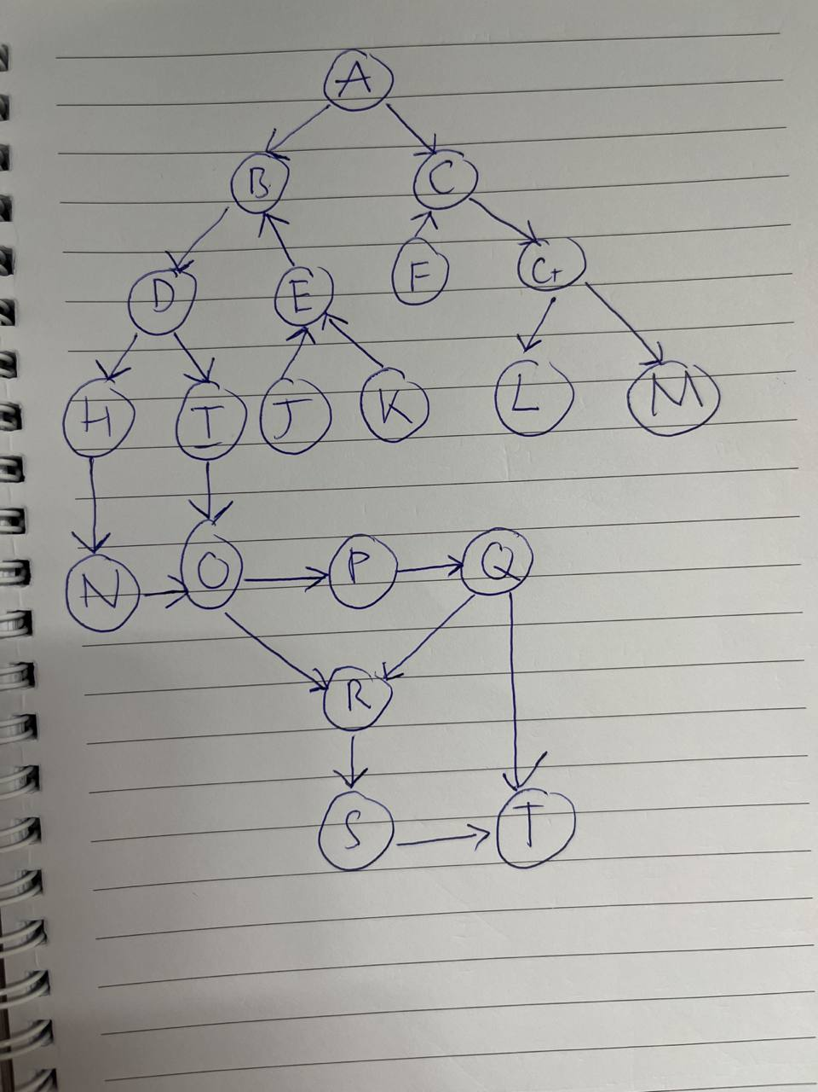

|  |  |  |  |  |  |  |  |  |  |  |  |  |  |  |  |  |  |  |  |  |
| --- | --- | --- | --- | --- | --- | --- | --- | --- | --- | --- | --- | --- | --- | --- | --- | --- | --- | --- | --- | --- |
|  | **A** | **B** | **C** | **D** | **E** | **F** | **G** | **H** | **I** | **J** | **K** | **L** | **M** | **N** | **O** | **P** | **Q** | **R** | **S** | **T** |
| **A** | 0 | 1 | 1 | 0 | 0 | 0 | 0 | 0 | 0 | 0 | 0 | 0 | 0 | 0 | 0 | 0 | 0 | 0 | 0 | 0 |
| **B** | 0 | 0 | 0 | 1 | 0 | 0 | 0 | 0 | 0 | 0 | 0 | 0 | 0 | 0 | 0 | 0 | 0 | 0 | 0 | 0 |
| **C** | 0 | 0 | 0 | 0 | 0 | 0 | 1 | 0 | 0 | 0 | 0 | 0 | 0 | 0 | 0 | 0 | 0 | 0 | 0 | 0 |
| **D** | 0 | 0 | 0 | 0 | 0 | 0 | 0 | 1 | 1 | 0 | 0 | 0 | 0 | 0 | 0 | 0 | 0 | 0 | 0 | 0 |
| **E** | 0 | 1 | 0 | 0 | 0 | 0 | 0 | 0 | 0 | 0 | 0 | 0 | 0 | 0 | 0 | 0 | 0 | 0 | 0 | 0 |
| **F** | 0 | 0 | 1 | 0 | 0 | 0 | 0 | 0 | 0 | 0 | 0 | 0 | 0 | 0 | 0 | 0 | 0 | 0 | 0 | 0 |
| **G** | 0 | 0 | 0 | 0 | 0 | 0 | 0 | 0 | 0 | 0 | 0 | 1 | 1 | 0 | 0 | 0 | 0 | 0 | 0 | 0 |
| **H** | 0 | 0 | 0 | 0 | 0 | 0 | 0 | 0 | 0 | 0 | 0 | 0 | 0 | 1 | 0 | 0 | 0 | 0 | 0 | 0 |
| **I** | 0 | 0 | 0 | 0 | 0 | 0 | 0 | 0 | 0 | 0 | 0 | 0 | 0 | 0 | 1 | 0 | 0 | 0 | 0 | 0 |
| **J** | 0 | 0 | 0 | 0 | 1 | 0 | 0 | 0 | 0 | 0 | 0 | 0 | 0 | 0 | 0 | 0 | 0 | 0 | 0 | 0 |
| **K** | 0 | 0 | 0 | 0 | 1 | 0 | 0 | 0 | 0 | 0 | 0 | 0 | 0 | 0 | 0 | 0 | 0 | 0 | 0 | 0 |
| **L** | 0 | 0 | 0 | 0 | 0 | 0 | 0 | 0 | 0 | 0 | 0 | 0 | 0 | 0 | 0 | 0 | 0 | 0 | 0 | 0 |
| **M** | 0 | 0 | 0 | 0 | 0 | 0 | 0 | 0 | 0 | 0 | 0 | 0 | 0 | 0 | 0 | 0 | 0 | 0 | 0 | 0 |
| **N** | 0 | 0 | 0 | 0 | 0 | 0 | 0 | 0 | 0 | 0 | 0 | 0 | 0 | 0 | 1 | 0 | 0 | 0 | 0 | 0 |
| **O** | 0 | 0 | 0 | 0 | 0 | 0 | 0 | 0 | 0 | 0 | 0 | 0 | 0 | 0 | 0 | 1 | 0 | 0 | 0 | 0 |
| **P** | 0 | 0 | 0 | 0 | 0 | 0 | 0 | 0 | 0 | 0 | 0 | 0 | 0 | 0 | 0 | 0 | 1 | 0 | 0 | 0 |
| **Q** | 0 | 0 | 0 | 0 | 0 | 0 | 0 | 0 | 0 | 0 | 0 | 0 | 0 | 0 | 0 | 0 | 0 | 1 | 0 | 1 |
| **R** | 0 | 0 | 0 | 0 | 0 | 0 | 0 | 0 | 0 | 0 | 0 | 0 | 0 | 0 | 0 | 0 | 0 | 0 | 1 | 0 |
| **S** | 0 | 0 | 0 | 0 | 0 | 0 | 0 | 0 | 0 | 0 | 0 | 0 | 0 | 0 | 0 | 0 | 0 | 0 | 0 | 1 |
| **T** | 0 | 0 | 0 | 0 | 0 | 0 | 0 | 0 | 0 | 0 | 0 | 0 | 0 | 0 | 0 | 0 | 0 | 0 | 0 | 0 |