FPT UNIVERSITY

BOOK STORE & RENTAL
MANAGEMENT SYSTEM
REQUIREMENT & DESIGN SPECIFICATION
Requirements, use cases, business rules and acceptance criteria
Version 1.0
Can Tho, July 2026

Record of Changes
Version | Date | Type | In charge | Change description
1.0 | 19/07/2026 | Added | Development team | Created Requirement & Design Specification for the new physical book sale and rental system.
1.0 | 19/07/2026 | Added | Development team | Defined Book/BookCopy separation, purchase, rental, return, extension, wallet and voucher rules.
1.0 | 19/07/2026 | Added | Development team | Added SQL Server schema, security design, diagrams, URLs and validation plan.

A - Added; M - Modified; D - Deleted.

Table of Contents
- Overview and project scope
- Actors and authorization
- Functional requirements and use cases
- Business rules
- Non-functional requirements
- Screen flow and controller URLs
- Data requirements and database overview
- Acceptance criteria and test scenarios
- Traceability matrix
- Assumptions, exclusions and delivery checklist

I. Overview

1. Purpose
This document specifies the requirements and high-level design of a new web application named Book Store & Rental Management System. The application sells physical books, rents individual physical copies, manages inventory, orders, returns, extensions, customers, staff, vouchers, wallets, payments and revenue.
Reference baseline: Game Account Store RDS v2.3 and Software Design Specification (December 2025). The new system reuses only architectural organization and functional-flow ideas; its entities, database and physical-book business rules are newly designed.

2. Scope
- Public catalog: home page, book list, search, filters and book details.
- Customer account: registration, authentication, password recovery, profile, address and password change.
- Commerce: purchase cart, rental cart, voucher validation, wallet payment and order history.
- Rental lifecycle: reservation, staff confirmation, active rental, extension, return request, late fee, damage/lost fee and deposit refund.
- Back office: inventory, users, staff, vouchers, order processing, activity log and revenue reporting.
- SQL Server database with integrity constraints, indexes, sample data and BCrypt sample accounts.

3. Product distinction
Concept | Definition | Key rule
Book | Bibliographic/product-level information such as ISBN, title, author, publisher and prices. | One Book may have many physical copies.
BookCopy | One physical item in stock with a unique copy code, condition, status and shelf location. | A copy can participate in only one active transaction at a time.
PurchaseOrder | Header for a physical-book sale and delivery information. | A sold copy never returns to available stock.
RentalOrder | Header for a time-limited rental, deposit and return lifecycle. | Rental payment and copy reservation are atomic.

4. Mapping from the sample project
Sample concept | New concept | Decision
Game | Book | Redesigned for ISBN, author, publisher, physical pricing and metadata.
Type | Category | Retained as catalog classification.
GameAccount | BookCopy | Credentials/rank/skin removed; copy code, condition, shelf and stock state added.
Orders / OrderDetail | PurchaseOrder / PurchaseOrderDetail | Physical delivery and one sold copy per detail.
RentAccountGame | RentalOrder / RentalOrderDetail | Header-detail model with due date, fees, deposit and return state.
Cart | Cart / CartItem | Item type distinguishes PURCHASE and RENTAL.
VoucherCustomer | UserVoucher | Tracks per-user usage.
balance / Transaction | Wallet / WalletTransaction | Separated account and transaction ledger.
GameOwner / GameOwned | Removed | No equivalent business need.
MD5 or game credentials | Removed | User passwords use BCrypt only.

II. Actors and Authorization
Actor | Description | Main permissions
Guest | Unauthenticated visitor. | View/search/filter/detail; register; login; forgot password.
Customer | Registered end user. | Profile, address, wallet, cart, purchase, rental, cancel, extension, return request and history.
Staff | Operational employee. | Process purchase/rental orders, returns, extensions and revenue export.
Admin | Highest system authority. | Manage users, staff, categories, books, copies, vouchers, logs and all operational data.

1. Authorization matrix
Module | Guest | Customer | Staff | Admin
Catalog | View | View | View | Manage
Profile / wallet | - | Own data | - | View/lock users
Cart / checkout | - | Own data | - | Oversight
Purchase orders | - | Own history/cancel pending | Process | Full
Rental orders | - | Own history/actions | Process/return/extension | Full
Staff management | - | - | - | Full
Voucher management | - | Apply | - | Full
Revenue | - | - | View/export | View/export
Activity logs | - | - | - | View

Staff cannot create/delete Admin accounts or change Admin authority. Customer-level queries always include the authenticated user identifier.

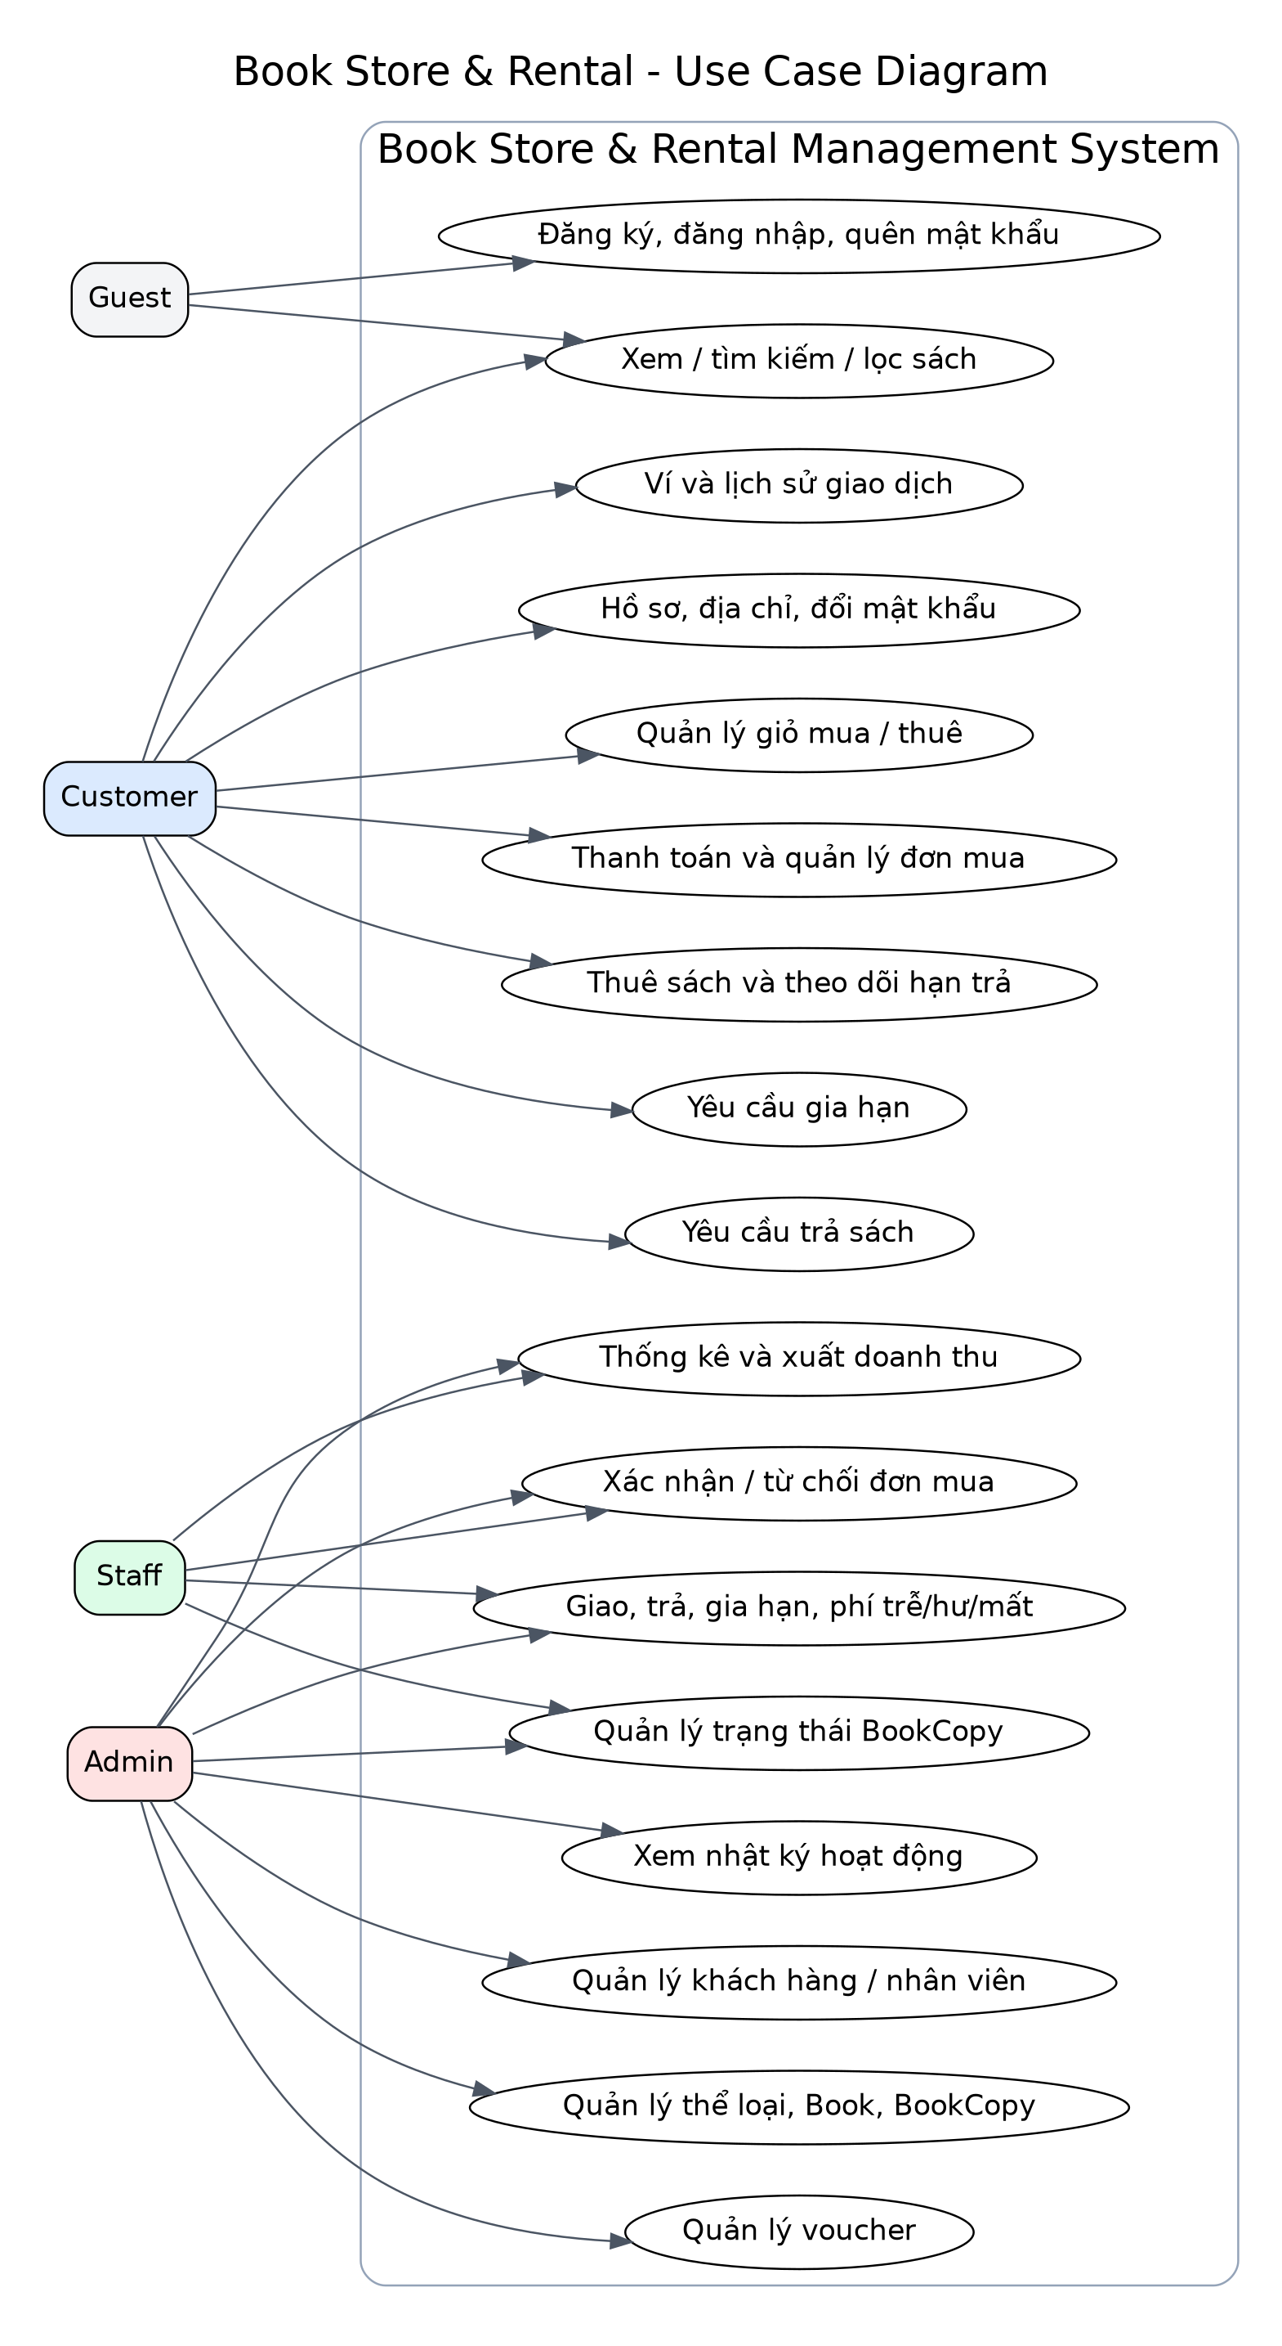
Figure 1. Use Case Diagram - Guest, Customer, Staff and Admin

III. Functional Requirements
ID | Use case | Requirement
FR-AUTH-01 | Register | Guest registers with unique username/email and a BCrypt password.
FR-AUTH-02 | Login/logout | Spring Security authenticates active users and redirects by role.
FR-AUTH-03 | Password recovery | System issues an expiring one-time reset token; the new password is BCrypt encoded.
FR-PROFILE-01 | Profile and addresses | Customer updates name, phone and delivery addresses; only one default active address is allowed.
FR-CAT-01 | Catalog | All visitors can browse, search by title/author/ISBN and filter by category and price.
FR-INV-01 | Book management | Admin creates/updates books, categories, cover images and status.
FR-INV-02 | Physical copy management | Admin creates/updates unique BookCopy records with condition, status and shelf.
FR-CART-01 | Cart | Customer adds, updates or removes purchase/rental lines.
FR-PUR-01 | Purchase checkout | System reserves available copies, validates voucher, charges wallet and creates order atomically.
FR-PUR-02 | Purchase processing | Staff approves, rejects or completes orders; rejection/cancel restores copies and funds.
FR-REN-01 | Rental checkout | System charges rental fee plus deposit and reserves copies atomically.
FR-REN-02 | Rental activation | Staff confirmation sets copies to RENTED and establishes due dates.
FR-REN-03 | Extension | Customer requests extension; Staff approves/rejects; approved fee is charged atomically.
FR-REN-04 | Return | Customer requests return; Staff records condition and computes late/damage/lost fees and deposit refund.
FR-WAL-01 | Wallet | Customer views balance, top-up simulation and immutable transaction history.
FR-VOU-01 | Voucher | Voucher must be active, valid, available, meet minimum order and respect per-user limit.
FR-REP-01 | Revenue | Staff/Admin view totals and export CSV.
FR-LOG-01 | Activity log | Administrative and staff changes are recorded for audit.

1. Detailed customer use cases
Use case | Precondition | Basic flow | Alternative/error flow | Postcondition
Register | Guest; username/email unused. | Submit valid form; encode password; create User, Wallet and Cart. | Duplicate or invalid data returns field errors. | Active Customer can log in.
Purchase checkout | Logged in; address exists; wallet sufficient. | Select copies; validate voucher; reserve copies; create order/payment; debit wallet. | Insufficient copies/funds or invalid voucher rolls back all changes. | PENDING order and RESERVED copies.
Cancel purchase | Owner; order PENDING. | Cancel; restore copies; refund payment; restore voucher usage. | Non-owner or processed order is rejected. | Order CANCELLED; balance restored.
Rental checkout | Logged in; days in allowed range; wallet sufficient. | Calculate rental+deposit; reserve copies; create order; debit wallet. | Any validation failure causes rollback. | PENDING rental order.
Request extension | Rental is RENTING and not overdue. | Select detail and extra days; create pending request. | Pending duplicate/invalid state rejected. | Staff can process request.
Request return | Owner; order RENTING/OVERDUE. | Change status to RETURN_REQUESTED. | Invalid order ownership/status rejected. | Staff sees return queue.

2. Detailed staff/admin use cases
Use case | Actor | Main result
Approve purchase | Staff/Admin | RESERVED copies become SOLD; order becomes CONFIRMED.
Reject purchase | Staff/Admin | Copies become AVAILABLE; wallet and voucher usage are restored.
Approve rental | Staff/Admin | Copies become RENTED; order becomes RENTING; due date is active.
Process return | Staff/Admin | Fees are settled, deposit remainder refunded, copy becomes AVAILABLE/DAMAGED/LOST.
Process extension | Staff/Admin | Fee charged and due date extended, or request rejected.
Manage users/staff | Admin | Create staff and lock/unlock non-Admin users.
Manage catalog | Admin | Create/update categories, books and copies without hard-deleting transaction history.
Manage voucher | Admin | Create/update availability, date range and limits.
Revenue report | Staff/Admin | View totals and export CSV.

IV. Business Rules
Rule | Description
BR-01 | A BookCopy in RESERVED or RENTED cannot be sold or rented in another transaction.
BR-02 | A SOLD BookCopy never appears as available stock.
BR-03 | Purchase/rental payment and BookCopy state changes occur in the same database transaction.
BR-04 | Wallet balance cannot become negative.
BR-05 | Rental checkout requires enough wallet balance for discounted rental fee plus full deposit.
BR-06 | Voucher validity, quantity, minimum order and per-user limit are checked under lock.
BR-07 | Customer can access only orders associated with the authenticated account.
BR-08 | Customer may cancel only a PENDING order.
BR-09 | Valid cancellation/rejection restores wallet balance, voucher use and reserved copies.
BR-10 | On-time undamaged return refunds the remaining deposit.
BR-11 | Late fee equals overdue days multiplied by configured daily late fee.
BR-12 | Damage/lost fees are deducted from deposit; any excess is charged to wallet.
BR-13 | Records referenced by orders are not hard-deleted; status is changed to inactive or terminal state.
BR-14 | All user passwords are BCrypt; MD5 and plain text are prohibited.
BR-15 | One physical copy may appear in multiple historical rental details but only one active rental at a time.

V. Non-functional Requirements
Category | Requirement
Security | Role-based URL authorization, BCrypt strength 12, CSRF enabled for form submissions, ownership checks and input validation.
Integrity | PK/FK/UNIQUE/CHECK/DEFAULT constraints; pessimistic locking for scarce copies, wallet and voucher resources.
Transactionality | Checkout, refund, extension settlement and return settlement use @Transactional boundaries.
Performance | Indexes on username/email, title/author/category, copy status, order status/date, due date and audit fields.
Usability | Responsive Bootstrap/Thymeleaf UI with role-specific navigation and validation messages.
Maintainability | Controller -> Service -> Repository -> Entity layering and package separation by role.
Auditability | Wallet ledger, payment records and activity logs are retained.
Compatibility | Java 17+, Spring Boot 3.5.x, SQL Server and modern browsers.
Reliability | Failed payment or business validation does not leave partial inventory changes.

VI. Screen Flow and URLs

1. Primary navigation flow
- Guest opens Home -> Books -> Book Detail.
- Guest registers or logs in.
- Customer uses Profile/Wallet/Cart -> Purchase or Rental checkout -> Order history.
- Staff opens Staff Dashboard -> Purchase/Rental detail -> Approve/Reject/Return/Extension.
- Admin opens Admin Dashboard -> Books/Copies/Categories/Users/Vouchers/Revenue/Activity Logs.
Area | Representative URLs
Public | /, /books, /books/{id}, /auth/register, /auth/login, /auth/forgot-password
Customer | /customer/profile, /customer/wallet, /customer/cart, /customer/purchases, /customer/rentals
Staff | /staff, /staff/purchases/{id}, /staff/rentals/{id}, /staff/revenue
Admin | /admin, /admin/books, /admin/users, /admin/vouchers, /admin/revenue, /admin/activity-logs

The complete HTTP method and URL catalog is delivered in docs/CONTROLLER_URLS.md.

VII. Data Requirements
Table | Purpose
roles | Role master: CUSTOMER, STAFF, ADMIN.
users | Authentication, profile, status and role.
staff | Staff-specific employee metadata linked one-to-one with users.
addresses | Customer delivery addresses with one filtered default address.
password_reset_tokens | Expiring one-time reset tokens.
categories | Book categories and active status.
books | Book-level ISBN, title, author, publisher, descriptions and prices.
book_copies | Physical copies with unique code, condition, status and shelf.
carts | One customer cart.
cart_items | Purchase or rental cart lines, quantity and rental days.
vouchers | Discount definition, validity, quantity and usage constraints.
user_vouchers | Per-user voucher use count/history.
wallets | One wallet and current balance per user.
wallet_transactions | Immutable debit/credit/refund/top-up ledger.
purchase_orders | Purchase header, delivery, totals, voucher, payment method and status.
purchase_order_details | One sold physical copy per detail.
rental_orders | Rental header, dates, fees, deposit and status.
rental_order_details | Physical copy, daily price, deposit, due/return dates and detail fees.
book_extension_requests | Extension request, extra days, fee and decision.
book_return_records | Return inspection, condition, late/damage/lost fee and deposit refund.
payments | Purchase/rental payment result and amount.
activity_logs | Actor, action, entity and before/after notes.

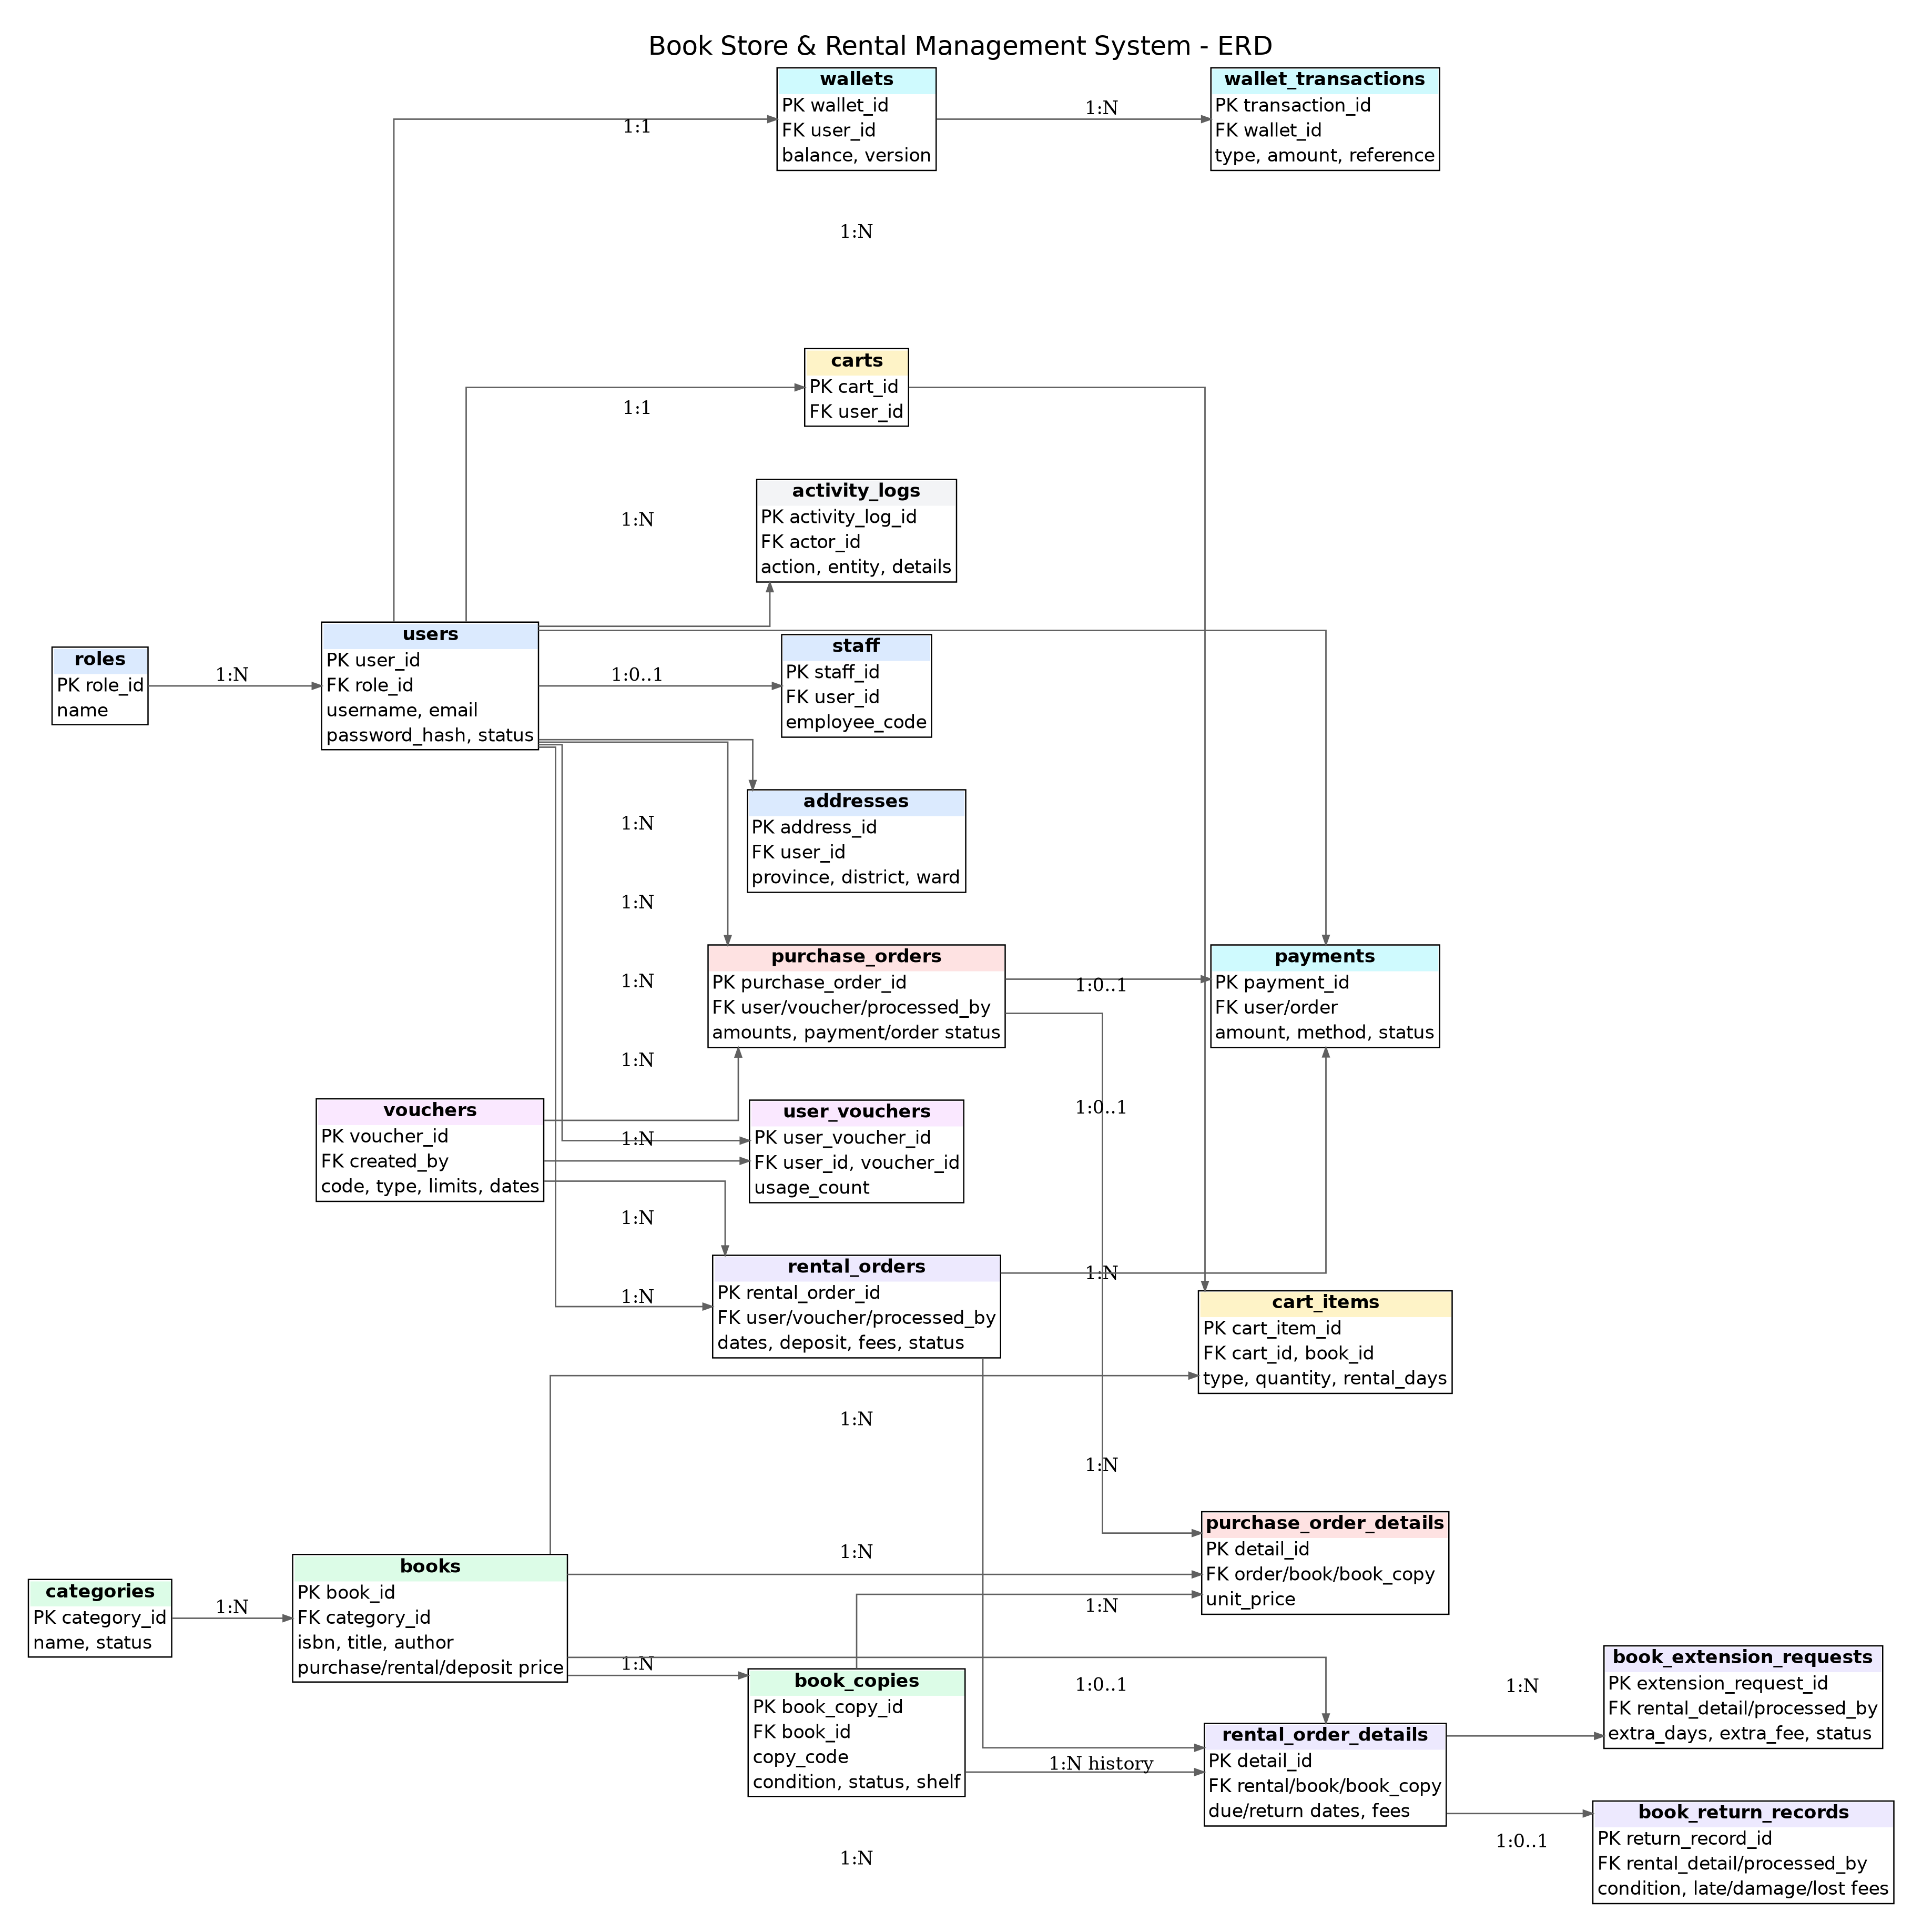
Figure 2. Entity Relationship Diagram - BookStoreRentalDB

VIII. Acceptance Criteria and Test Scenarios
ID | Scenario | Expected result
AT-01 | Register with duplicate email. | Form rejected; no additional User/Wallet/Cart created.
AT-02 | Login using locked account. | Authentication denied.
AT-03 | Two customers checkout the final available copy concurrently. | Only one succeeds; the other receives out-of-stock result.
AT-04 | Purchase checkout with insufficient wallet. | No order/payment debit/reservation is committed.
AT-05 | Use expired or exhausted voucher. | Checkout rejected without changing voucher quantity.
AT-06 | Cancel PENDING purchase. | Order CANCELLED; copy AVAILABLE; wallet/voucher restored.
AT-07 | Staff approves purchase. | Copy SOLD and cannot be selected again.
AT-08 | Rental checkout. | Wallet charged rental+deposit; copies RESERVED.
AT-09 | Staff activates rental. | Copies RENTED; due date shown.
AT-10 | Approve extension with insufficient wallet. | Request and due date remain unchanged due to rollback.
AT-11 | Return on time in good condition. | Copy AVAILABLE; full remaining deposit refunded.
AT-12 | Return late/damaged/lost. | Correct fees applied; copy state and refund match inspection.
AT-13 | Customer opens another customer order URL. | Access rejected/not found.
AT-14 | Staff opens admin user management. | 403 access denied.

IX. Traceability Matrix
Requirement group | Controller | Service | Core entities/tables
Authentication | AuthController | AuthService, CustomUserDetailsService | User, Role, PasswordResetToken
Profile | ProfileController | UserService | User, Address
Catalog/inventory | PublicController, AdminBookController | BookService, FileStorageService | Book, BookCopy, Category
Cart | CartController | CartService | Cart, CartItem
Purchase | PurchaseOrderController, StaffDashboardController | PurchaseOrderService | PurchaseOrder, Detail, Payment, Wallet
Rental/return | RentalOrderController, StaffDashboardController | RentalOrderService | RentalOrder, Detail, ReturnRecord, ExtensionRequest
Wallet/voucher | WalletController, AdminVoucherController | WalletService, VoucherService | Wallet, WalletTransaction, Voucher, UserVoucher
Revenue/logs | AdminRevenueController, AdminDashboardController | RevenueService, ActivityLogService | Payment, ActivityLog

X. Assumptions, Exclusions and Delivery

1. Assumptions
- The deployment has a reachable SQL Server instance and a login with required database privileges.
- Wallet top-up is a local simulation; external payment gateways can be integrated later through the Payment abstraction.
- Shipping is tracked by order status and address fields; external courier API integration is outside this version.
- Email can be enabled by configuration; local test mode displays the reset link when mail is disabled.

2. Explicit exclusions
- Game account credentials, rank, level, skin, VIP, game ownership and digital-account delivery.
- MD5 password storage.
- Hard deletion of historical orders/payments/rental records.
- External payment, courier or tax-invoice services in version 1.0.

3. Delivery checklist
- Complete Maven source project and application configuration.
- Executable SQL Server script with sample data and BCrypt accounts.
- RDS, SDS, ERD, Use Case, Class and Sequence diagrams.
- Controller URL catalog, project tree, setup and test instructions.

