FPT UNIVERSITY

BOOK STORE & RENTAL
MANAGEMENT SYSTEM
SOFTWARE DESIGN SPECIFICATION
Architecture, database, classes, transactions, security and deployment
Version 1.0
Can Tho, July 2026

Record of Changes
Version | Date | Type | In charge | Change description
1.0 | 19/07/2026 | Added | Development team | Created Software Design Specification for the new physical book sale and rental system.
1.0 | 19/07/2026 | Added | Development team | Defined Book/BookCopy separation, purchase, rental, return, extension, wallet and voucher rules.
1.0 | 19/07/2026 | Added | Development team | Added SQL Server schema, security design, diagrams, URLs and validation plan.

A - Added; M - Modified; D - Deleted.

Table of Contents
- Architecture and package design
- Technology and configuration
- Security design
- Database design
- Entity and enum design
- Repository design
- Service design and transaction boundaries
- Controller and Thymeleaf design
- Class and sequence diagrams
- Error handling, logging, testing and deployment

I. Architecture Overview
BookStoreRental is a server-rendered Spring MVC application. It follows Controller -> Service -> Repository -> Entity separation. Controllers bind/validate HTTP input and choose Thymeleaf views; services contain business rules and transaction boundaries; repositories access SQL Server through Spring Data JPA; entities model persistent data.
Reference baseline: Game Account Store RDS v2.3 and Software Design Specification (December 2025). The new system reuses only architectural organization and functional-flow ideas; its entities, database and physical-book business rules are newly designed.

1. Package structure
Package | Responsibility
config | Spring Security, web resources and upload mapping.
controller | Public/shared request handling and global model/error behavior.
controller.customer | Profile, wallet, cart, purchase and rental endpoints.
controller.staff | Order processing, return, extension and revenue endpoints.
controller.admin | Catalog, copies, users/staff, vouchers, logs and revenue management.
dto | Validated web form/input models, avoiding direct entity binding.
entity / entity.enums | JPA model and controlled status values.
repository | JpaRepository interfaces, search queries, entity graphs and locks.
service | Business logic, authorization checks, calculations and transactions.
successfullyDat | Small utilities for money and order-code generation, retained only as an organizational reference to the sample.

2. Request processing
Browser
-> Spring Security filter chain
-> Controller + DTO validation
-> Service (@Transactional where required)
-> Repository / JPA
-> SQL Server
-> Model + Thymeleaf template
-> HTML response

3. Project files
Folder | Java files
config | SecurityConfig.java, WebConfig.java
controller | AuthController.java, GlobalControllerAdvice.java, PublicController.java
controller/customer | CartController.java, ProfileController.java, PurchaseOrderController.java, RentalOrderController.java, WalletController.java
controller/staff | StaffDashboardController.java
controller/admin | AdminBookController.java, AdminDashboardController.java, AdminRevenueController.java, AdminUserController.java, AdminVoucherController.java
dto | AddressForm.java, BookCopyForm.java, BookForm.java, ChangePasswordForm.java, CheckoutForm.java, ProfileForm.java, RegisterForm.java, ResetPasswordForm.java, ReturnProcessForm.java, StaffCreateForm.java, VoucherForm.java
entity | ActivityLog.java, Address.java, BaseEntity.java, Book.java, BookCopy.java, BookExtensionRequest.java, BookReturnRecord.java, Cart.java, CartItem.java, Category.java, PasswordResetToken.java, Payment.java, PurchaseOrder.java, PurchaseOrderDetail.java, RentalOrder.java, RentalOrderDetail.java, Role.java, StaffProfile.java, User.java, UserVoucher.java, Voucher.java, Wallet.java, WalletTransaction.java
entity/enums | BookCondition.java, BookCopyStatus.java, BookStatus.java, CartItemType.java, ExtensionStatus.java, OrderStatus.java, PaymentMethod.java, PaymentStatus.java, RentalStatus.java, ReturnCondition.java, RoleName.java, UserStatus.java, VoucherType.java, WalletTransactionType.java
repository | ActivityLogRepository.java, AddressRepository.java, BookCopyRepository.java, BookExtensionRequestRepository.java, BookRepository.java, BookReturnRecordRepository.java, CartItemRepository.java, CartRepository.java, CategoryRepository.java, PasswordResetTokenRepository.java, PaymentRepository.java, PurchaseOrderDetailRepository.java, PurchaseOrderRepository.java, RentalOrderDetailRepository.java, RentalOrderRepository.java, RoleRepository.java, StaffProfileRepository.java, UserRepository.java, UserVoucherRepository.java, VoucherRepository.java, WalletRepository.java, WalletTransactionRepository.java
service | ActivityLogService.java, AuthService.java, BookService.java, CartService.java, CurrentUserService.java, CustomUserDetailsService.java, FileStorageService.java, PurchaseOrderService.java, RentalOrderService.java, RevenueService.java, UserService.java, VoucherService.java, WalletService.java
successfullyDat | MoneyUtils.java, OrderCodeGenerator.java

II. Technology and Configuration
Component | Design choice
Runtime | Java 17 compile target; compatible with JDK 17 or newer supported JDK.
Framework | Spring Boot 3.5.6; Spring MVC, Data JPA and Security.
Views | Thymeleaf, Bootstrap 5, HTML/CSS/JavaScript.
Database | SQL Server; schema validated by Hibernate (ddl-auto=validate).
Validation | Jakarta Validation DTO constraints and service-level business checks.
Password | BCryptPasswordEncoder strength 12 only.
Reports | CSV output; Apache POI dependency reserved for Excel extension.
Tests | Spring context test with H2 in SQL Server compatibility mode.

1. Maven dependencies
- spring-boot-starter-web, thymeleaf, data-jpa, security, validation and mail.
- thymeleaf-extras-springsecurity6 for role-aware templates.
- mssql-jdbc runtime driver and H2 test database.
- lombok for reducing entity boilerplate.
- apache-poi / poi-ooxml for future Excel report extension.

2. Core application properties
spring.datasource.url=jdbc:sqlserver://localhost:1433;databaseName=BookStoreRentalDB;encrypt=true;trustServerCertificate=true
spring.datasource.username=sa
spring.datasource.password=YourStrongPassword123!
spring.jpa.hibernate.ddl-auto=validate
spring.servlet.multipart.max-file-size=5MB
app.upload.dir=uploads/books
app.rental.max-days=30
app.rental.late-fee-per-day=10000
app.mail.enabled=false

III. Security Design

1. Authentication
- CustomUserDetailsService loads a user by username or email and maps database roles to ROLE_CUSTOMER, ROLE_STAFF or ROLE_ADMIN.
- Only ACTIVE accounts authenticate; locked/inactive states are denied.
- SecurityConfig defines a BCryptPasswordEncoder with strength 12.
- Registration, reset and password-change flows always encode using BCrypt.
- Form login uses a role-aware success handler; logout is POST and invalidates the session.

2. URL authorization
Pattern | Access
/, /books/**, /auth/**, /css/**, /js/**, /images/**, /uploads/** | Public
/customer/** | CUSTOMER
/staff/** | STAFF or ADMIN
/admin/** | ADMIN
Any remaining request | Authenticated

3. Object-level authorization
URL roles are not sufficient by themselves. PurchaseOrderService and RentalOrderService query customer orders by both order ID and current user ID, preventing horizontal privilege escalation.

IV. Database Design
The SQL script creates BookStoreRentalDB from scratch, enables READ_COMMITTED_SNAPSHOT, creates tables in dependency order, applies PK/FK/UNIQUE/CHECK/DEFAULT constraints, creates filtered and search indexes, inserts sample data and finishes with verification SELECT statements.
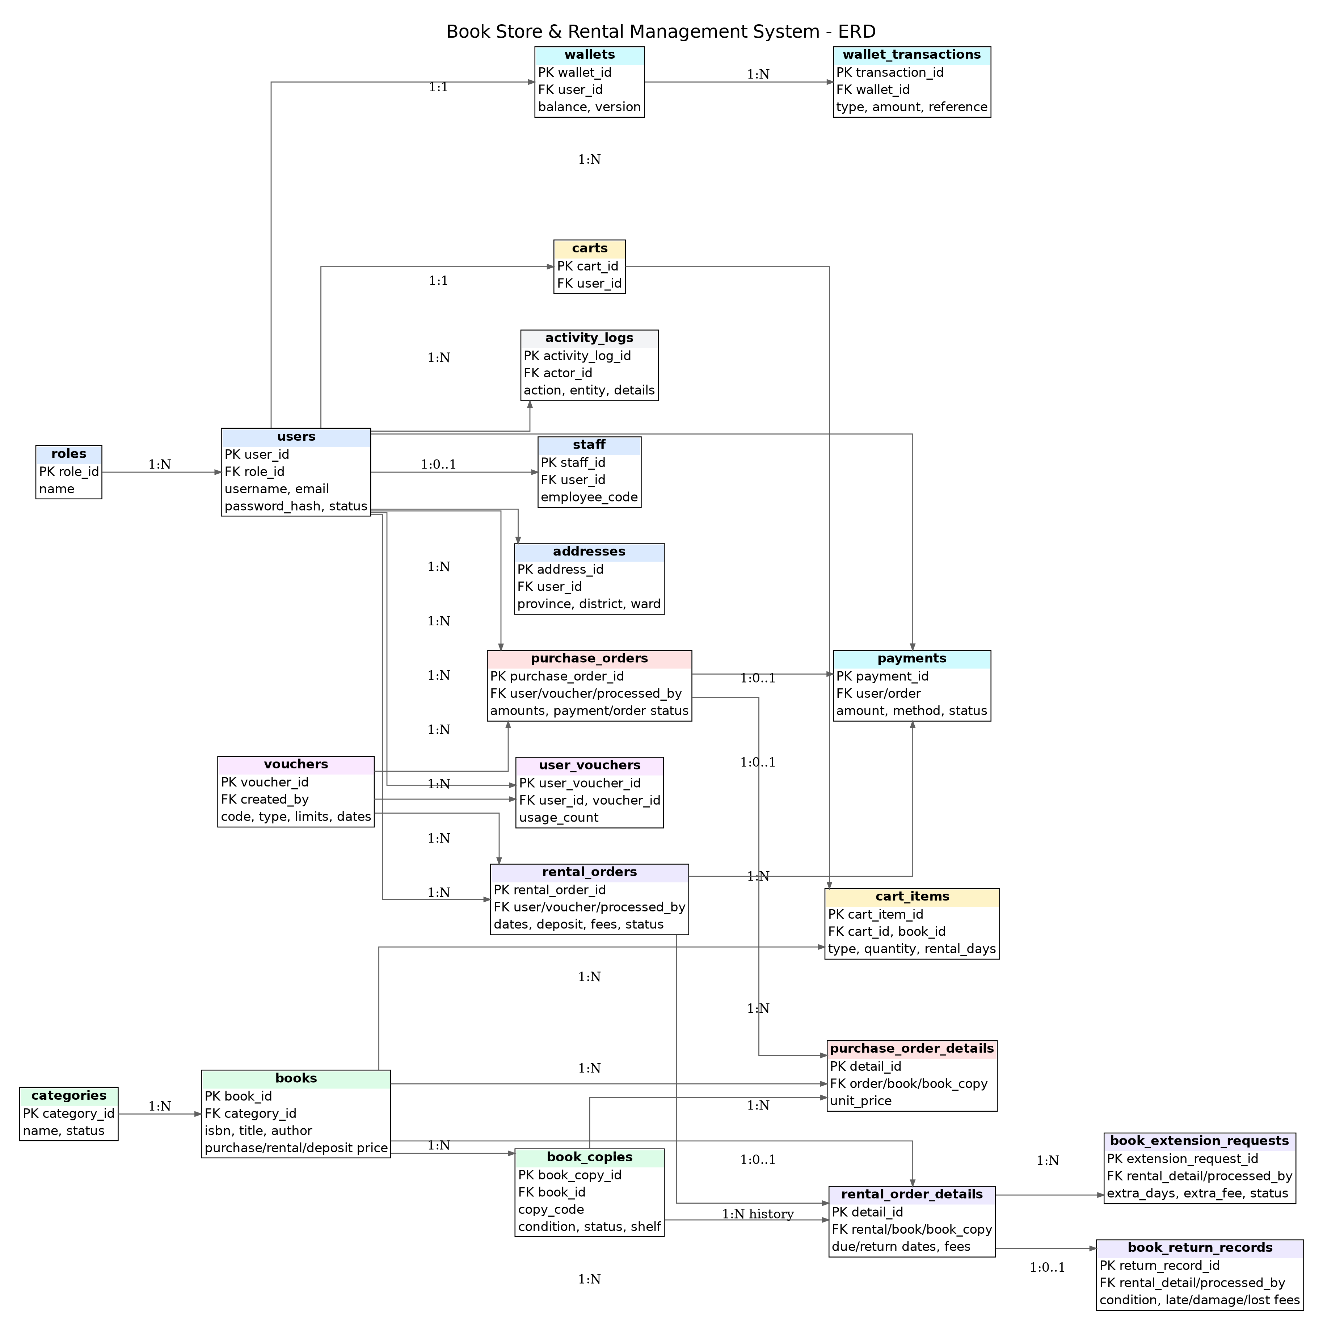
Figure 1. Entity Relationship Diagram

1. Key relationships
Relationship | Cardinality / rule
Role -> User | One role to many users.
User -> Address | One user to many addresses; one active default address via filtered unique index.
Category -> Book | One category to many books.
Book -> BookCopy | One bibliographic product to many physical copies.
User -> Cart -> CartItem | One cart per user; many purchase/rental lines.
User -> Wallet -> WalletTransaction | One wallet per user; many immutable ledger entries.
PurchaseOrder -> PurchaseOrderDetail -> BookCopy | One order to many details; sold copy is unique across purchase details.
RentalOrder -> RentalOrderDetail -> BookCopy | One order to many details; a copy can recur historically, while service/locking prevents concurrent rental.
RentalOrderDetail -> ReturnRecord / ExtensionRequest | Return inspection and zero/many extension history with one pending request at a time.
Purchase/Rental -> Payment | Payment record references exactly one order type through nullable FKs plus check constraint.

2. Constraint strategy
- Unique: username, email, ISBN, copy_code, voucher code, one wallet/cart per user and purchase detail copy uniqueness.
- Check: enum-like status values, positive prices/quantities/days, discount bounds and payment target exclusivity.
- Default: timestamps, active flags, zero balances/fees and initial statuses.
- Foreign keys: no unnecessary cycles; deletion behavior preserves historical integrity.
- Indexes: high-frequency authentication, catalog, availability, order queue, due date, payment and audit queries.

V. Entity and Enum Design
Entity | Selected fields | Design note
User | id, username, email, password, fullName, phone, status, role | Unified Customer/Staff/Admin identity.
Book | isbn, title, author, publisher, year, language, pages, image, purchase/rental/deposit prices, category, status | Book-level product metadata.
BookCopy | copyCode, book, condition, status, shelfLocation | Physical stock unit.
CartItem | cart, book, type, quantity, rentalDays | Same cart supports purchase and rental.
PurchaseOrder | code, user, address snapshot, totals, voucher, payment method, status | Delivery and financial header.
PurchaseOrderDetail | order, book, bookCopy, title/isbn snapshot, unitPrice | Copy-level sale and historical snapshot.
RentalOrder | code, user, dates, fees, deposit, total, status | Rental financial/lifecycle header.
RentalOrderDetail | order, book, copy, daily price, deposit, dates, fees | Copy-level rental history.
Voucher/UserVoucher | code/type/value/dates/quantity/limits; usage count | Global and per-user constraints.
Wallet/WalletTransaction | balance; type, amount, before/after, reference | Current balance plus auditable ledger.
Payment | user, order target, amount, method, status, transaction code | Payment abstraction.
ReturnRecord | condition, returnedAt, fees, depositRefund, note | Immutable return inspection result.
ExtensionRequest | detail, extraDays, requested/approved dates, fee, status | Staff-controlled due-date extension.
ActivityLog | actor, action, entityType/id, detail, IP, timestamp | Administrative audit.

1. Core enums
Enum | Values
BookCopyStatus | AVAILABLE, RESERVED, SOLD, RENTED, MAINTENANCE, DAMAGED, LOST, INACTIVE
BookCondition | NEW, GOOD, FAIR, DAMAGED
RentalStatus | PENDING, CONFIRMED, RENTING, RETURN_REQUESTED, RETURNED, OVERDUE, CANCELLED, REJECTED, LOST
OrderStatus | PENDING, CONFIRMED, PROCESSING, SHIPPING, COMPLETED, CANCELLED, REJECTED
PaymentStatus | PENDING, SUCCESS, FAILED, REFUNDED
WalletTransactionType | TOP_UP, PAYMENT, REFUND, RENTAL_PAYMENT, DEPOSIT_REFUND, PENALTY, EXTENSION_FEE, ADJUSTMENT
ExtensionStatus | PENDING, APPROVED, REJECTED, CANCELLED
ReturnCondition | GOOD, FAIR, DAMAGED, LOST

VI. Repository Design
Repository group | Representative operations
User/Role | Find by username/email; existence checks; list by role/status.
Book/Category | Search title/author/ISBN, category/price filtering and active catalog queries.
BookCopy | Count and select available copies; PESSIMISTIC_WRITE selection for checkout.
Cart | Find cart by user; load/delete/update item lines.
Wallet | Find and lock wallet by user for debit/credit.
Voucher/UserVoucher | Find and lock voucher by code; find usage row by user/voucher.
Orders | Find by user ownership, status queues and dates; entity graphs for details.
Rental detail/extension/return | Find active details, overdue dates, pending extension and return records.
Payment/Activity | Revenue aggregation source and ordered audit history.

EntityGraph is used where controller rendering needs nested order, user, book or copy data after the transaction. Locking queries use PESSIMISTIC_WRITE for inventory, wallet and voucher consistency.

VII. Service Design
Service | Responsibilities / important methods
AuthService | register, createResetToken, resetPassword, changePassword; BCrypt and token lifecycle.
UserService | profile/address updates, create Staff, lock/unlock non-Admin users.
BookService | catalog search, Book/Category/BookCopy CRUD, stock counts and image update.
CartService | get current cart, add/update/remove lines, validate quantity and rental days.
WalletService | topUp, debit, credit/refund and transaction ledger under lock.
VoucherService | validate, consume and restore voucher with date/quantity/user-limit checks.
PurchaseOrderService | checkout, ownership view, cancel/refund, staff approve/reject/complete.
RentalOrderService | checkout, approve/reject, request/process extension, request/process return, mark overdue.
RevenueService | aggregate successful payments/orders and generate CSV.
ActivityLogService | record actor/action/entity details.
FileStorageService | validate/store uploaded cover images and generate safe file names.

1. Transaction boundaries
Operation | Atomic resources | Rollback condition
Purchase checkout | Copy locks/reservation, voucher use, order/details, wallet debit, payment. | Any stock, voucher, validation or wallet failure.
Purchase cancel/reject | Order status, copies, payment refund, wallet credit, voucher restore. | Any refund or persistence failure.
Rental checkout | Copy locks/reservation, voucher use, order/details, wallet debit, payment. | Any validation or financial failure.
Extension approval | Request status, wallet debit, detail due date and fee. | Insufficient wallet or stale rental state.
Return settlement | Return record, fees, wallet debit/credit, copy state, detail/order state. | Any settlement failure.

2. Concurrency control
- Available BookCopy rows are selected with PESSIMISTIC_WRITE before reservation.
- Wallet is locked before changing balance.
- Voucher row is locked before decrementing or restoring quantity.
- A filtered unique index prevents more than one pending extension request per rental detail.
- Service validates current state again after acquiring locks, preventing stale UI decisions.

3. Fee calculations
rentalFee = rentalPricePerDay * rentalDays
discount = voucher applied only to rentalFee
depositAmount = sum(book.rentalDeposit for each selected copy)
checkoutTotal = rentalFee - discount + depositAmount
lateFee = max(0, returnDate - dueDate in days) * configuredLateFeePerDay
penalty = lateFee + damageFee
depositRefund = max(0, depositAmount - penalty)
extraWalletCharge = max(0, penalty - depositAmount)

VIII. Controller and View Design
Controller | Role | Main endpoints/views
PublicController | Public | Home, book list/search/filter, book detail.
AuthController | Public | Register, login page, forgot/reset password.
ProfileController | Customer | Profile, address and password change.
WalletController | Customer | Balance/history and top-up simulation.
CartController | Customer | View/add/update/remove cart lines.
PurchaseOrderController | Customer | Checkout, history, detail and cancel.
RentalOrderController | Customer | Checkout, history, cancel, return and extension requests.
StaffDashboardController | Staff/Admin | Order queues, approve/reject/complete, returns and extensions.
AdminBookController | Admin | Book, category and BookCopy management.
AdminUserController | Admin | List users, create Staff and lock/unlock.
AdminVoucherController | Admin | Voucher CRUD.
AdminRevenueController | Admin | Revenue and CSV export.
AdminDashboardController | Admin | Dashboard and activity logs.

1. Thymeleaf organization
Folder | Purpose
templates/fragments | Shared navigation, flash messages, footer and admin sidebar.
templates/auth | Login, register, forgot and reset password.
templates/public | Home, catalog list and detail.
templates/customer | Profile, wallet, cart, purchase and rental pages.
templates/staff | Operational dashboard and order details.
templates/admin | Dashboard and management screens.
static/css, static/js, static/images | Common styling, behavior and placeholder assets.

2. Validation and error feedback
- DTOs declare @NotBlank, @Email, @Size, @Min/@Max and numeric constraints.
- Controllers return the same form view with field errors when binding fails.
- Services throw business exceptions for insufficient stock/funds, invalid voucher and invalid state transitions.
- GlobalControllerAdvice exposes current user, cart count and consistent flash messages.

IX. Diagrams
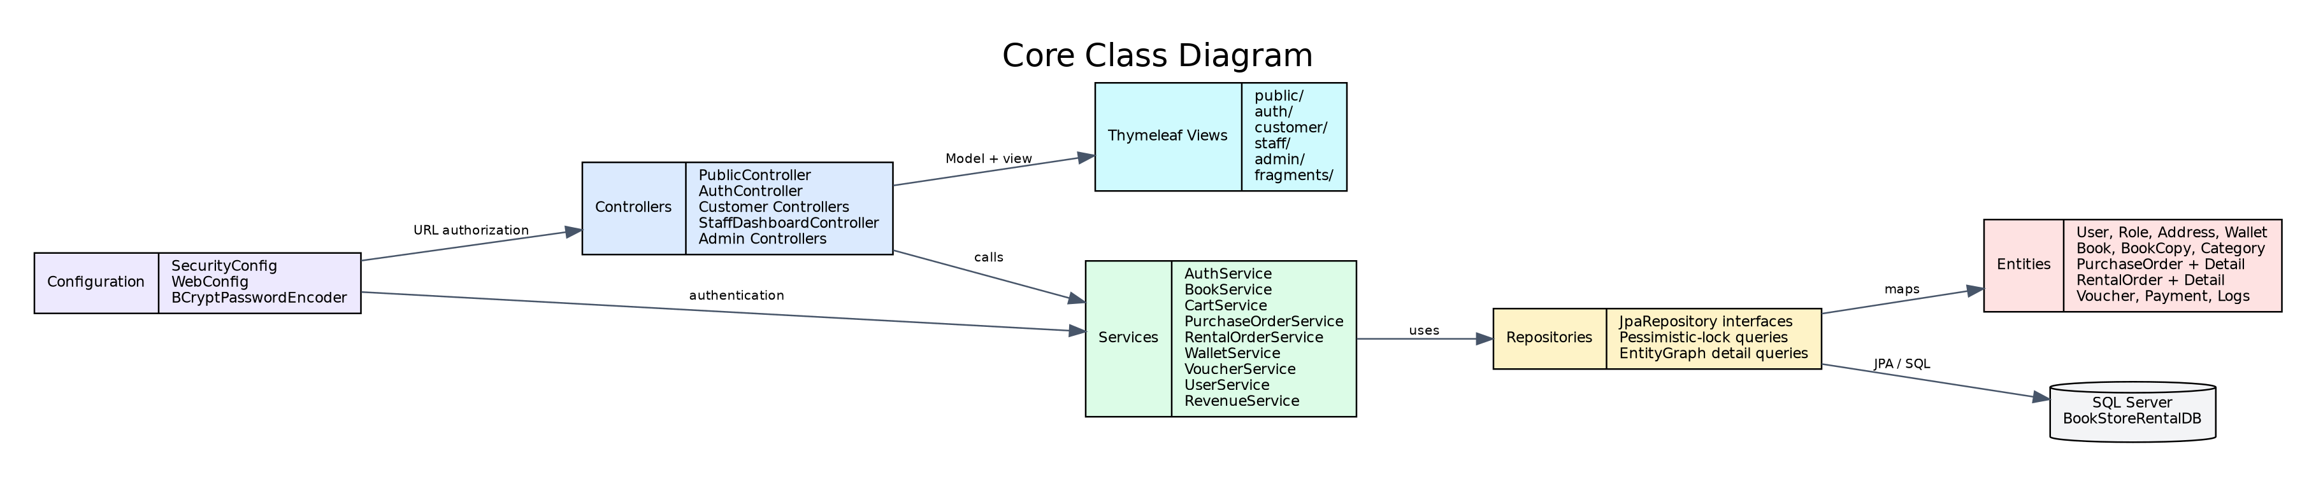
Figure 2. Main Class Diagram
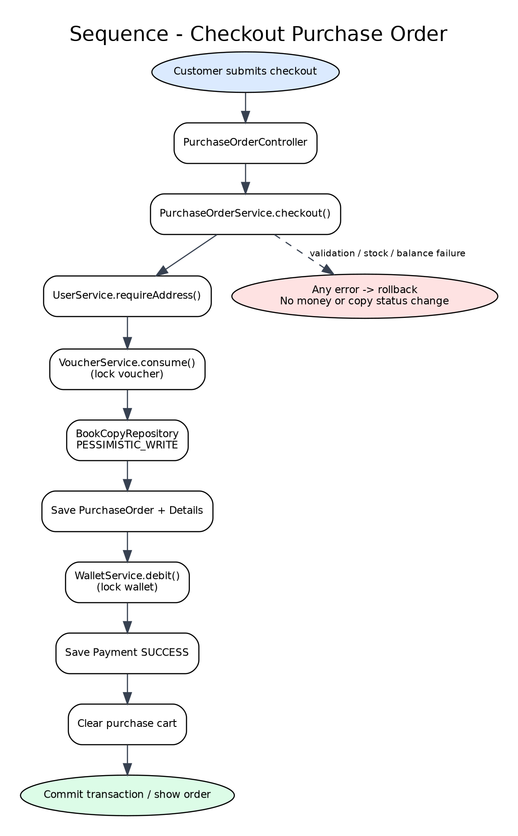
Figure 3. Purchase Checkout Sequence
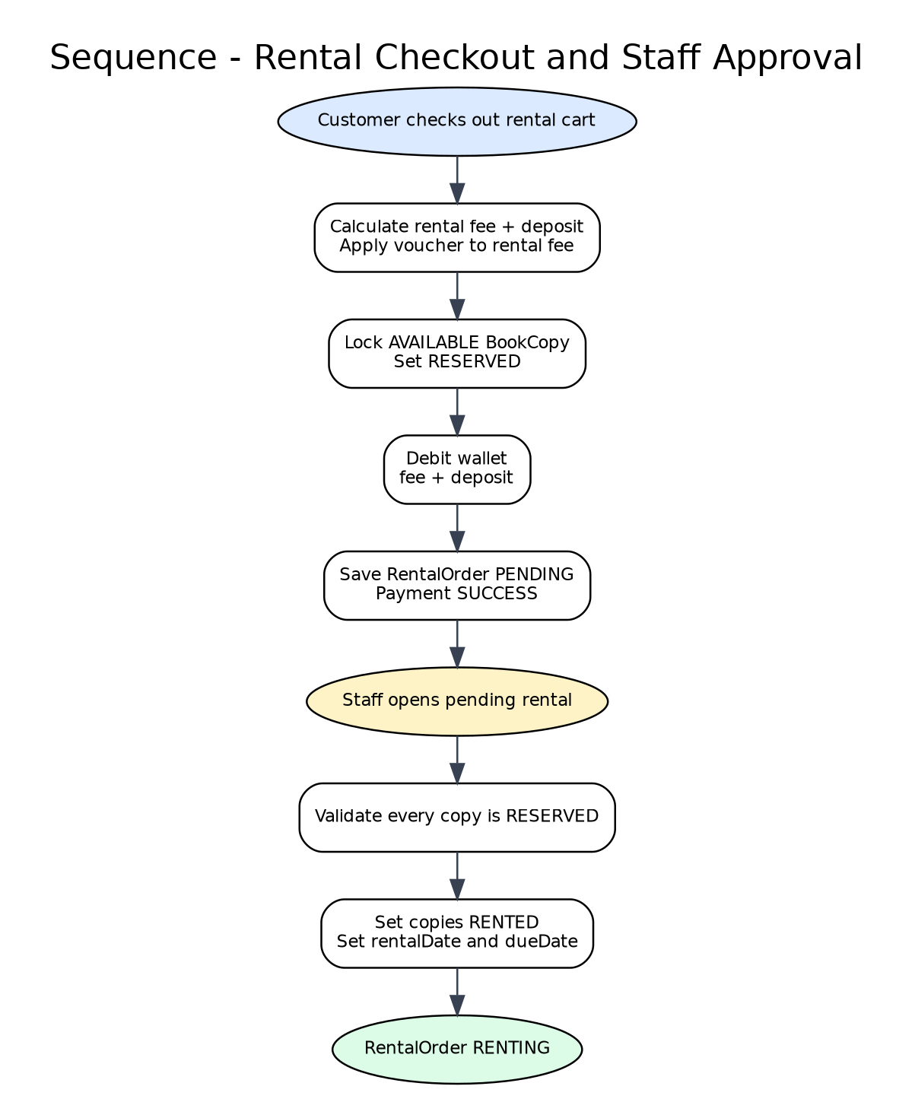
Figure 4. Rental Checkout and Activation Sequence
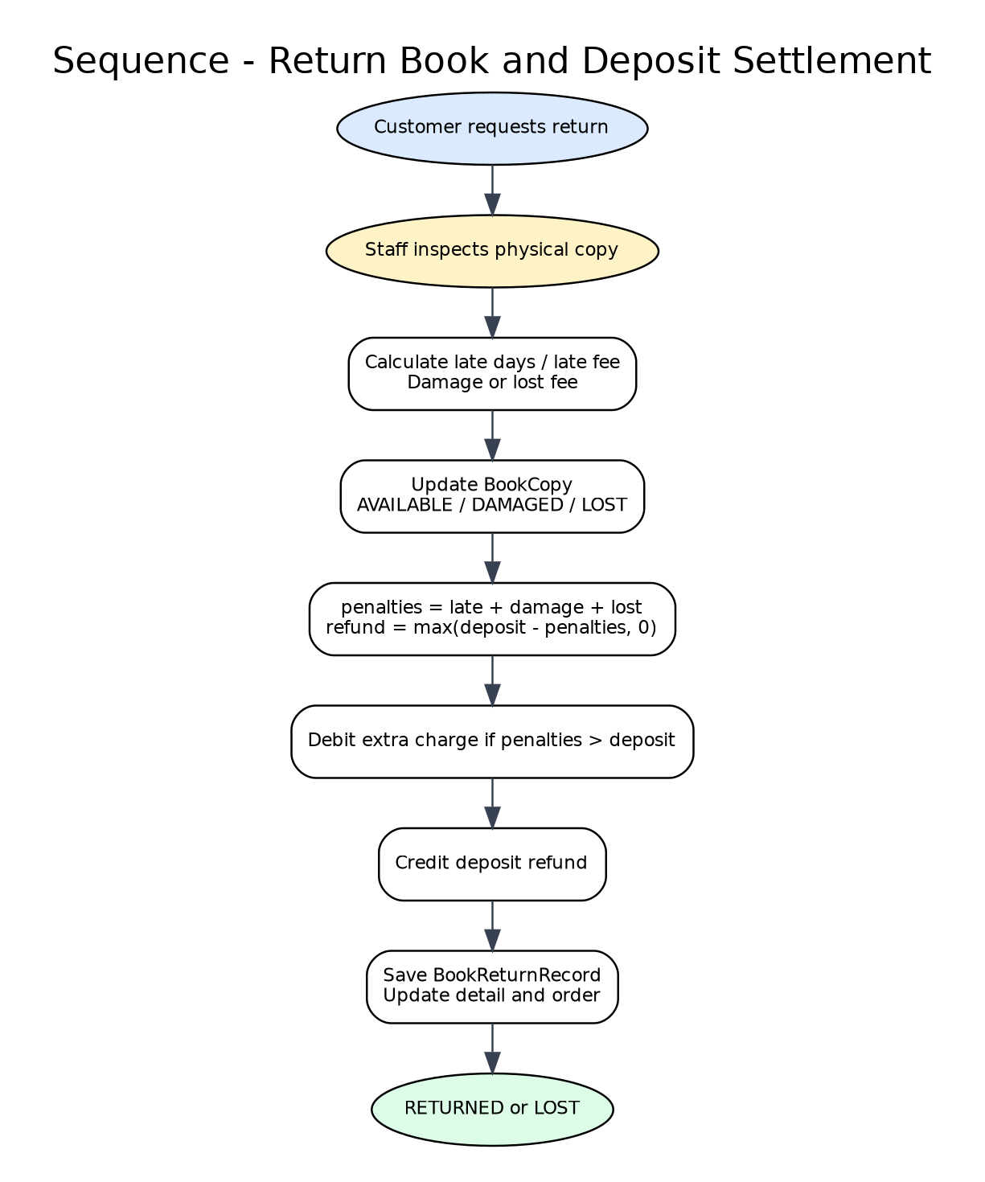
Figure 5. Return Settlement Sequence

X. Error Handling, Logging and Testing

1. Error handling
- Database and business exceptions propagate out of transactional services so Spring can roll back.
- Controllers convert expected business exceptions to user-facing flash errors without exposing stack traces.
- Schema validation catches a missing/outdated database before serving requests.
- Image upload rejects unsafe/unsupported files and uses generated names outside the classpath.

2. Audit and financial evidence
- Every wallet mutation writes a WalletTransaction containing amount and before/after balance.
- Payment stores order target, status, amount and transaction code.
- ActivityLog records administrative/staff actions with entity reference and optional details.

3. Test strategy
Layer | Tests
Context | Spring application context loads using H2 SQL Server compatibility mode.
Repository | Unique/filtered constraints, search, locking and ownership queries.
Service | Checkout success/failure/rollback, voucher limits, refunds, fees and state transitions.
Security | Role URL tests and object ownership tests.
UI | Form validation, navigation, flash messages and responsive rendering.
Integration | Run against SQL Server with the delivered script and sample accounts.

XI. Deployment and Operation

1. Installation sequence
- Install/enable SQL Server and connect using SSMS 20.
- Execute src/main/resources/db/BookStoreRentalDB.sql.
- Set SQL Server URL, username and password in application.properties.
- Open the project in IntelliJ and select JDK 17 or newer.
- Run mvn clean test, then run BookStoreRentalApplication or mvn spring-boot:run.
- Open http://localhost:8080 and test the sample Customer, Staff and Admin accounts.

2. Sample accounts
Role | Username | Password
Admin | admin | Admin@123
Staff | staff | Staff@123
Customer | customer | Customer@123

3. Operational configuration
- Change sample passwords before production use.
- Keep ddl-auto=validate for controlled schema management.
- Configure SMTP and set app.mail.enabled=true for real reset emails.
- Back up SQL Server and the uploads/books directory together.
- Use HTTPS and externalized secrets in production.

XII. Design Verification Status
All main Java sources were syntax-checked and internal method references were compiled with javac --release 17 using local framework stubs. All Thymeleaf templates were parsed successfully. The artifact-generation environment did not contain Maven runtime or SQL Server, so mvn clean test and SQL Server integration testing must be executed on the target machine.

