VIETNAM GENERAL CONFEDERATION OF LABOUR
TON DUC THANG UNIVERSITY
FACULTY OF INFORMATION TECHNOLOGY



PHẠM QUỐC TRIỆU - 522K0010
TRẦN MẠNH KHANG - 522K0016
NGUYỄN HUỲNH THANH HÙNG - 522K0006

Midterm Report

WEB PROGRAMMING WITH NODEJS

HO CHI MINH CITY, YEAR 2025

VIETNAM GENERAL CONFEDERATION OF LABOUR
TON DUC THANG UNIVERSITY
FACULTY OF INFORMATION TECHNOLOGY

PHẠM QUỐC TRIỆU - 522K0010
TRẦN MẠNH KHANG - 522K0016
NGUYỄN HUỲNH THANH HÙNG - 522K0006

Midterm Report

WEB PROGRAMMING WITH NODEJS

Advised by
Prof., Dr. MAI VĂN MẠNH

ABSTRACT
This report presents the implementation of Docker for deploying a Node.js web application. We explore the core concepts of containerization and demonstrate how Docker simplifies development, testing, and deployment processes for modern web applications. Our implementation includes a multi-service architecture with Html frontend, Node.js backend API, and MongoDB database, all orchestrated using Docker Compose. We also implement advanced features such as service scaling, load balancing, and asynchronous communication between services through a message broker. The results demonstrate significant advantages in terms of development consistency, deployment efficiency, and application scalability.

TABLE OF CONTENTS

ABSTRACT 3
TABLE OF FIGURES 5
TABLE OF CHARTS 6
1. Introduction to Docker 7
1.1 Definition and Importance 7
1.2 Key Docker Concepts 7
2. Theoretical Survey 10
2.1 Docker Architecture 10
2.2 Docker and Node.js Integration 11
2.3 Benefits and Challenges of Containerization 11
3. Project Overview 12
3.1 Project Description 12
3.2 Project Context 12
3.3 Service Interactions 12
4. Architecture and Implementation 14
4.1 System Architecture 14
4.2 Docker Compose Implementation 15
4.3 Dockerfiles 18
4.4 Scaling and Load Balancing 19
4.5 Service Decoupling with RabbitMQ 20
5. Results and Discussion 23
5.1 Project Outcomes 23
5.2 Challenges and Solutions 23
6. Conclusion 24
6.1 Key Learnings 24
6.2 Docker's Impact on Development 24
6.3 Future Improvements 24
APPENDIX A: SETUP INSTRUCTIONS 25
APPENDIX B: REFERENCES 26

TABLE OF FIGURES

Figure 1 : Docker Architecture diagram showing client, daemon, and registry relationships 10
Figure 2 : Service Interaction Diagram showing communication flow between frontend, backend, database, and message broker 13
Figure 3 : System Architecture Diagram showing container arrangement and network connections 14

1. Introduction to Docker

1.1 Definition and Importance
Docker is a platform that packages applications and their dependencies into standardized units called containers. These containers are lightweight, portable, and provide consistent environments across different stages of development and deployment.
In modern web development, Docker addresses several critical challenges. It eliminates "works on my machine" problems by ensuring all developers and environments use identical configurations. Containers provide isolation, preventing conflicts between applications or dependencies. Docker simplifies deployment, as containers are easily deployed across different environments with minimal configuration changes. The platform enables quick replication of containers to handle increased load, facilitating scalability. Finally, containers use system resources more efficiently than traditional virtual machines.

1.2 Key Docker Concepts
Docker's functionality revolves around four main concepts: containers, images, Dockerfiles, and Docker Compose.
Containers are runnable instances of Docker images that encapsulate an application and its environment. They are isolated from the host system and other containers, but share the host's OS kernel, making them more lightweight than virtual machines.
Images are read-only templates containing the application code, runtime, libraries, and dependencies. Images are built from instructions in a Dockerfile and can be stored in registries for distribution.
A Dockerfile is a text file containing instructions for building a Docker image. Each instruction creates a layer in the image, which can be cached to speed up subsequent builds.
[Simple Dockerfile example]
FROM node:18
WORKDIR /app
COPY package*.json ./
RUN npm install
COPY . .
EXPOSE 5000
CMD ["node", "server.js"]
Docker Compose is a tool for defining and running multi-container Docker applications. It uses a YAML file to configure application services, networks, and volumes, simplifying the management of complex applications.
[Simple Docker Compose example]
version: '3'
services:
# Web application service
webapp:
image: nginx:alpine
ports:
- "80:80"
volumes:
- ./web:/usr/share/nginx/html
depends_on:
- db
restart: always
environment:
- NGINX_HOST=example.com
- NGINX_PORT=80
# Database service
db:
image: postgres:13
volumes:
- postgres_data:/var/lib/postgresql/data
environment:
- POSTGRES_PASSWORD=mysecretpassword
- POSTGRES_USER=myuser
- POSTGRES_DB=myapp
ports:
- "5432:5432"
# Redis cache service
redis:
image: redis:alpine
ports:
- "6379:6379"
volumes:
- redis_data:/data
volumes:
postgres_data:
redis_data:
Container orchestration tools like Docker Swarm and Kubernetes provide advanced features for container management, scaling, service discovery, and load balancing in larger deployments.

2. Theoretical Survey

2.1 Docker Architecture
Docker uses a client-server architecture consisting of the Docker Client, Docker Daemon (dockerd), and Docker Registry. The Docker Client is the command-line interface that users interact with. The Docker Daemon is the server that manages Docker objects. The Docker Registry stores Docker images for distribution.
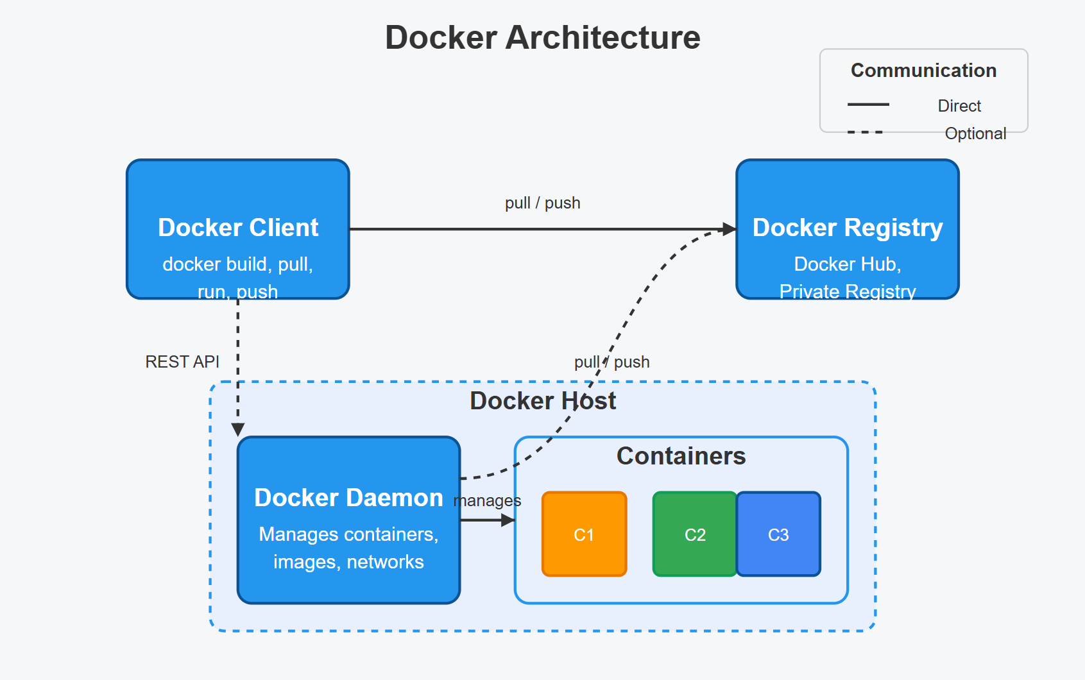
Figure 1: Docker Architecture diagram showing client, daemon, and registry relationships
Under the hood, Docker leverages several Linux technologies. Namespaces provide isolation for containers by creating separate instances of global resources such as process IDs, network interfaces, and mount points. Control groups (cgroups) allow Docker to limit and account for container resource usage (CPU, memory, I/O, etc.), preventing a single container from consuming all system resources. Union file systems enable Docker's layered image structure, allowing multiple file systems to be mounted simultaneously with changes tracked in separate layers.

2.2 Docker and Node.js Integration
Node.js applications particularly benefit from Docker containerization for several reasons. The complex dependency trees in Node.js applications can be fully encapsulated in a container, ensuring all necessary packages are available. Node.js applications typically use environment variables for configuration, which Docker handles efficiently. Node.js is well-suited for microservices architecture, which aligns perfectly with Docker's container model. Docker ensures the development environment closely matches production, reducing unexpected behavior.

2.3 Benefits and Challenges of Containerization
Containerization offers numerous benefits for web development. It creates consistent environments, eliminating discrepancies between development, testing, and production. New team members can get started quickly with a simple docker-compose up command, accelerating onboarding. Applications run independently without interfering with each other, providing service isolation. Containers fit naturally into continuous integration and deployment pipelines, enabling efficient CI/CD integration. Container definitions can be versioned alongside application code, providing version control for infrastructure.
Despite these advantages, containerization presents certain challenges. Teams need to invest time in learning Docker concepts and best practices, creating a learning curve. While minimal, containers do introduce some overhead compared to running applications directly on the host, causing slight performance impacts. Containers require proper configuration to ensure security. Multi-container setups require understanding of Docker's networking capabilities, which can be complex. Managing data that needs to persist beyond a container's lifecycle requires careful planning.

3. Project Overview

3.1 Project Description
For this project, we have developed an POS web application ( restaurant-system ) consisting of multiple services. The frontend is a Html-based single-page application providing the user interface. The backend API is a Node.js Express server handling business logic and data operations. We use MongoDB for data persistence and RabbitMQ as a message broker for asynchronous communication between services.

3.2 Project Context
This project demonstrates how Docker can be used to create a development and deployment environment for a typical modern web application. The application represents a common architecture found in many production systems, with separate services for frontend, backend, and data storage.
We chose Docker for this project because it simplifies the development process by eliminating environment inconsistencies. It enables each service to be developed, tested, and deployed independently. Docker provides a straightforward path to scaling individual components as needed and facilitates easy integration of additional services like message brokers.

3.3 Service Interactions
The services in our application interact in a well-defined manner. The Html frontend communicates with the Node.js backend using RESTful API calls. The Node.js backend connects to MongoDB for data persistence. For operations that don't require immediate response (e.g., order processing, notifications), the backend publishes messages to RabbitMQ queues, which are consumed by dedicated worker services.

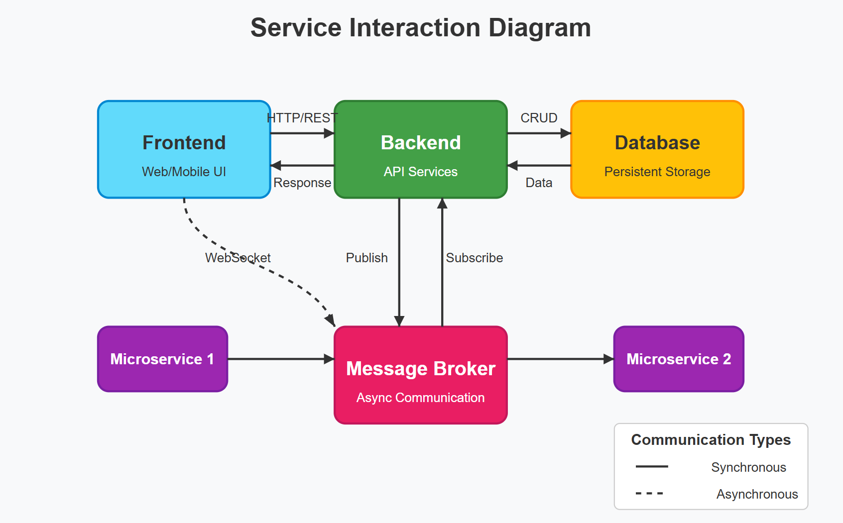

Figure 2: Service Interaction Diagram showing communication flow between frontend, backend, database, and message broker

Architecture and Implementation

4.1 System Architecture
Our Docker implementation follows a microservices architecture pattern, with each service running in its own container. This approach provides modularity, scalability, and resilience to our application.
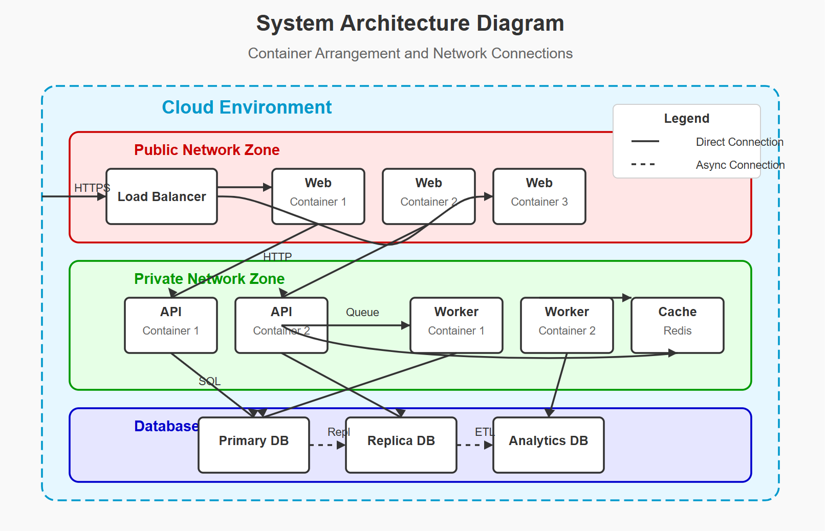
Figure 3: System Architecture Diagram showing container arrangement and network connections
The system consists of several containers. The frontend container hosts our application served by Nginx. The backend container runs our Node.js Express API, with multiple replicas for scaling. We have a database container running MongoDB for data storage and a RabbitMQ container serving as our message broker for asynchronous communication. An Nginx load balancer distributes requests to backend replicas.
All services are connected through Docker networks for secure communication. The frontend-network connects the frontend to the load balancer. The backend-network connects the load balancer to the backend instances. The data-network connects backend instances to MongoDB and RabbitMQ.

4.2 Docker Compose Implementation
Our implementation uses Docker Compose to orchestrate the containers. Docker Compose provides a simple yet powerful way to define, configure, and run multiple containers as a single application.
[Complete docker-compose.yml code]
services:
app:
build: .
ports:
- "5000:5000"
environment:
- NODE_ENV=development
- MONGODB_URI=mongodb://db:27017/vietnam-cuisine
- RABBITMQ_URI=amqp://rabbitmq:5672
volumes:
- .:/app
- /app/node_modules
depends_on:
- db
- rabbitmq
command: sh -c "npm run seed && node server.js"
networks:
- restaurant-network
db:
image: mongo:latest
ports:
- "27017:27017"
volumes:
- mongo-data:/data/db
networks:
- restaurant-network
rabbitmq:
image: rabbitmq:3-management
ports:
- "5672:5672"
- "15672:15672"
volumes:
- rabbitmq-data:/var/lib/rabbitmq
networks:
- restaurant-network
nginx:
image: nginx:latest
ports:
- "80:80"
volumes:
- ./nginx/default.conf:/etc/nginx/conf.d/default.conf
depends_on:
- app
networks:
- restaurant-network
worker:
build:
context: .
dockerfile: worker.Dockerfile
environment:
- NODE_ENV=development
- MONGODB_URI=mongodb://db:27017/vietnam-cuisine
- RABBITMQ_URI=amqp://rabbitmq:5672
depends_on:
- db
- rabbitmq
networks:
- restaurant-network
networks:
restaurant-network:
driver: bridge
volumes:
mongo-data:
rabbitmq-data:
This Docker Compose file defines all our services, their configurations, dependencies, networks, and volumes. The frontend service builds from our frontend Dockerfile and exposes port 80. The load-balancer service uses the Nginx image with a custom configuration file for request distribution. The backend service is configured to have multiple replicas and connects to both MongoDB and RabbitMQ. The database service uses the official MongoDB image with a volume for data persistence. The rabbitmq service runs the official RabbitMQ image with management plugin enabled.

4.3 Dockerfiles
We created specialized Dockerfiles for each of our services to ensure optimal performance and security.

Backend Dockerfile
The backend Dockerfile is optimized for a Node.js Express application.
FROM node:18-alpine
WORKDIR /app
COPY package*.json ./
RUN npm install
COPY . .
EXPOSE 5000
CMD ["node", "server.js"]
WORKER:
FROM node:18-alpine
WORKDIR /app
COPY package*.json ./
RUN npm install
COPY . .
CMD ["node", "server/workers/orderProcessor.js"]
Those Dockerfile starts with the Alpine-based Node.js image for a smaller footprint. It copies package files first to leverage Docker's layer caching mechanism for dependencies. The application code is copied afterward, and the container exposes port 5000 for the API.

4.4 Scaling and Load Balancing
One of the key advantages of our Docker setup is the ability to scale the backend service horizontally. We implement this using multiple backend replicas and an Nginx load balancer.
[Nginx load balancer configuration]
server {
listen 80;
server_name localhost;
location / {
proxy_pass http://app:3000;
proxy_http_version 1.1;
proxy_set_header Upgrade $http_upgrade;
proxy_set_header Connection 'upgrade';
proxy_set_header Host $host;
proxy_cache_bypass $http_upgrade;
}
}
Our Nginx configuration distributes incoming requests across the backend instances using a round-robin algorithm. This ensures no single backend instance becomes a bottleneck. Docker Compose's DNS resolver automatically includes all backend containers in the upstream pool, making scaling as simple as increasing the replica count.

4.5 Service Decoupling with RabbitMQ
To demonstrate service decoupling, we implemented asynchronous communication using RabbitMQ. This pattern is particularly useful for operations that don't require immediate response, could potentially fail and need retrying, or might cause bottlenecks if processed synchronously.
[Message publishing example]
async function publishMessage(queue, message) {
try {
if (!channel) await connect();
await channel.assertQueue(queue, { durable: true });
channel.sendToQueue(queue, Buffer.from(JSON.stringify(message)), {
persistent: true
});
console.log(`Message sent to ${queue}`);
return true;
} catch (error) {
console.error('Error publishing message:', error.message);
return false;
}
}
In our backend service, we publish messages to specific queues when certain events occur, such as order creation or user registration. This allows the main request-response cycle to complete quickly while the more time-consuming processing happens asynchronously.
[Message consuming example]
async function consumeMessages(queue, callback) {
try {
if (!channel) await connect();
await channel.assertQueue(queue, { durable: true });
channel.prefetch(1);
console.log(`Waiting for messages from ${queue}`);
channel.consume(queue, async (msg) => {
if (msg !== null) {
const content = JSON.parse(msg.content.toString());
try {
await callback(content);
channel.ack(msg);
} catch (error) {
console.error(`Error processing message: ${error.message}`);
channel.nack(msg);
}
}
});
} catch (error) {
console.error('Error consuming messages:', error.message);
setTimeout(() => consumeMessages(queue, callback), 5000);
}
}
Worker services consume these messages and process them independently. If processing fails, the message can be requeued and retried. This approach increases the system's resilience and responsiveness.

Results and Discussion

5.1 Project Outcomes
Our Dockerized Node.js application successfully demonstrates several key concepts. We implemented a multi-service architecture with multiple services running in isolated containers. We achieved horizontal scaling by running multiple instances of our backend service. Our load balancing configuration distributes requests evenly among backend instances. We implemented asynchronous communication to decouple services using a message broker. Data is persisted beyond container lifecycles using volumes.

5.2 Challenges and Solutions
During implementation, we encountered several challenges that required creative solutions.
One significant issue was container startup order. Services were starting before their dependencies were ready, causing connection failures. We resolved this by implementing a wait-for-it script to check dependency availability before starting dependent services.
Our initial load balancer configuration was not properly distributing requests across backends. We addressed this by adjusting the Nginx configuration to use round-robin distribution and improving health checks to ensure traffic only went to healthy instances.
Data persistence was another challenge, as we experienced data loss when containers were restarted. We solved this by implementing named volumes for MongoDB and RabbitMQ data, ensuring data survived container lifecycles.
Network connectivity between services in different networks initially posed problems. We resolved this by properly configuring bridge networks and ensuring services were placed in the correct networks for communication.

Conclusion

6.1 Key Learnings
Through this project, we've gained valuable insights into using Docker with Node.js applications. Docker provides significant advantages in terms of consistency, isolation, and deployment simplicity. Containers naturally support a microservices approach, allowing independent scaling and development of different components. Proper network configuration is crucial for container communication in complex setups. Volumes are essential for managing data that needs to survive container lifecycle. Horizontal scaling requires load balancing and stateless services.

6.2 Docker's Impact on Development
Docker has transformed our development workflow in several ways. It eliminated environment inconsistencies between team members, ensuring everyone works with identical setups. It simplified the process of adding new services to the application, as each service can be containerized independently. Docker provides a deployment process that closely mirrors production, reducing surprises when going live. It makes experimentation with different configurations easy through quick container rebuilds.
Docker particularly shines in Node.js development by handling dependency management and environment configuration in a clean, consistent way.

6.3 Future Improvements
For future work, we would consider several enhancements to our implementation. Moving from Docker Compose to Kubernetes would provide more robust orchestration for production environments. Automating the build and deployment process through a CI/CD pipeline would streamline releases. Adding containers for application and container monitoring would improve observability. Implementing auto-scaling based on system metrics would optimize resource usage. Improving container security through best practices would make the system more robust in production.

APPENDIX A: SETUP INSTRUCTIONS

This appendix provides detailed instructions for setting up and running our Dockerized application.
Prerequisites
Before starting, ensure Docker and Docker Compose are installed on your system. Git is also required for cloning the repository.
Running the Application
To run the application, follow these steps:
- Start the application: docker-compose build
docker-compose up -d

- Check the RabbitMQ: docker-compose logs app
If connected then continue. If not wait and check again.

- Access the application:

Frontend:

RabbitMQ Management: http://localhost:15672 (username: guest, password: guest)

- Stop the application: docker-compose down

- To remove volumes when stopping: docker-compose down -v

APPENDIX B: REFERENCES
- Docker Documentation. (2023). Overview of Docker Compose. https://docs.docker.com/compose/
- Node.js Foundation. (2023). Docker and Node.js Best Practices. https://github.com/nodejs/docker-node/blob/main/docs/BestPractices.md
- Nginx. (2023). Using nginx as HTTP Load Balancer. https://docs.nginx.com/nginx/admin-guide/load-balancer/http-load-balancer/
- RabbitMQ. (2023). RabbitMQ Tutorials. https://www.rabbitmq.com/getstarted.html
- MongoDB. (2023). MongoDB Manual: Docker. https://www.mongodb.com/docs/manual/tutorial/install-mongodb-enterprise-with-docker/

