Task1

Task 1 Question: If you were testing this API in a "Staging" environment versus a "Local" environment, how would you change the dbConfig in server.js to ensure sensitive credentials are not leaked in your GitHub history?
Answer:
To avoid leaking sensitive credentials in GitHub history, the database configuration should use environment variables instead of hardcoded credentials. The credentials can be stored in a .env file and loaded using a package such as dotenv. The .env file should be added to .gitignore so that it is not committed to the repository. This allows different environments (Local, Staging, Production) to use different credentials without exposing them in the codebase.

Task 2: API
2.1 Standard Validation:
Method: Post
Endpoint: http://localhost:3000/api/v1/distribution/issue-voucher
Response code: 201
Response body:
{
"status": "SUCCESS",
"pin": "1499094182",
"traceId": "83f075da-0721-47a4-a0bd-b0f6e0e80563"
}

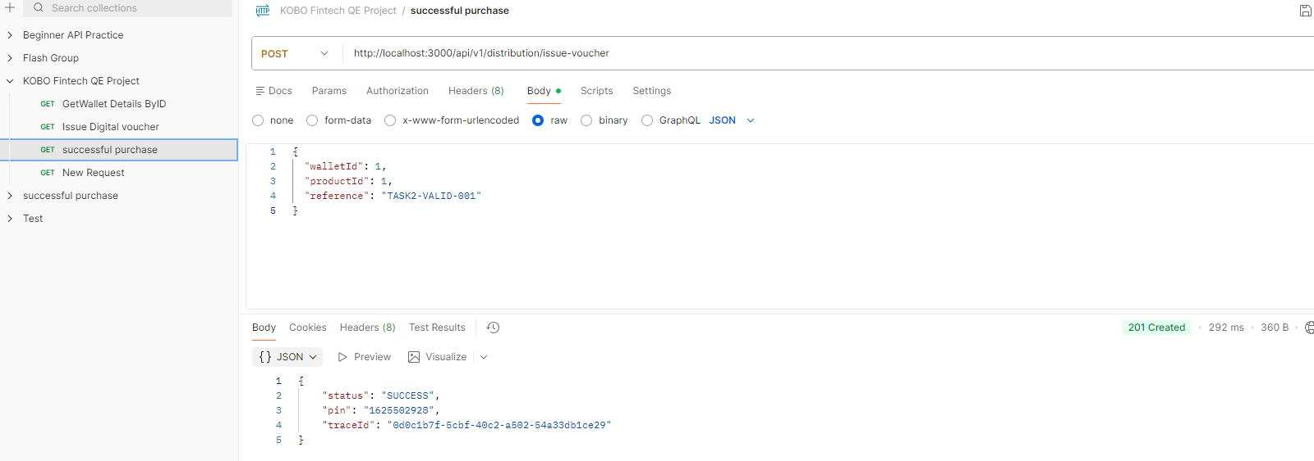

2.2 Business Logic Testing:
Method: Post
Endpoint: http://localhost:3000/api/v1/distribution/issue-voucher
Response code: 201 created
Response body:
{
"status": "SUCCESS",
"pin": "1499094182",
"traceId": "83f075da-0721-47a4-a0bd-b0f6e0e80563"
}

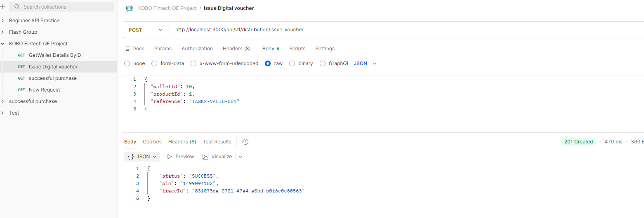

To verify this 1 used data from the table wallet
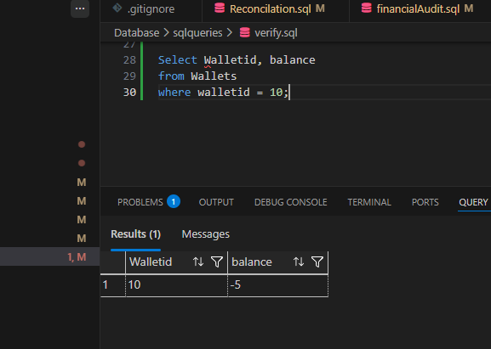
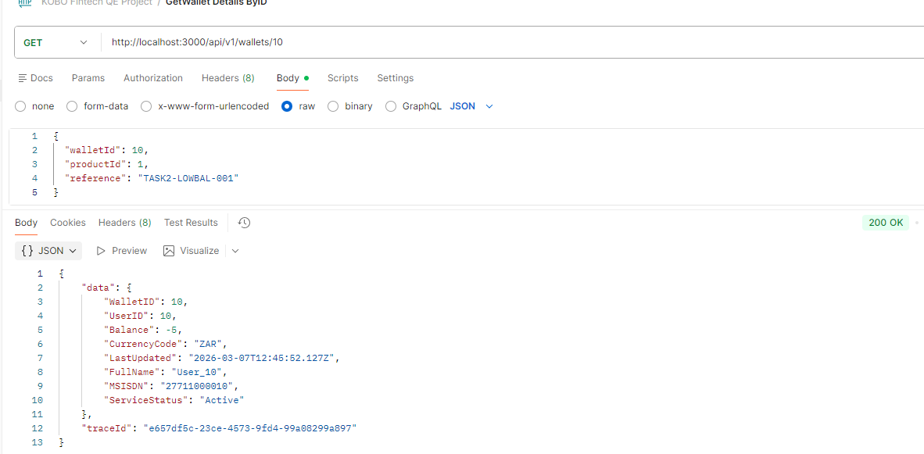

The system should reject the transaction because the wallet balance is insufficient. The response indicates that the voucher was successfully issued even though the wallet balance had insufficient funds.

Findings
Did the system allow the transaction?
Yes.
The system allowed the voucher issuance even though the wallet balance was lower than the product price. The API returned a 201 Created response with status: SUCCESS and generated a voucher PIN.

Did the wallet balance go negative?
Yes.
After the transaction was processed, the wallet balance became negative because the system deducted the product cost despite insufficient funds.

Is this acceptable behavior for a fintech application? Why or why not?
No, this is not acceptable behavior for a fintech application.
Financial systems must enforce strict validation rules to ensure that transactions can only occur when sufficient funds are available. Allowing transactions that result in negative balances can lead to financial losses, inaccurate account balances, and potential exploitation by malicious users.
In a secure fintech system, the transaction should be rejected when the wallet balance is insufficient, and the API should return an error response such as 400 Bad Request with a message indicating insufficient funds. This prevents unauthorized purchases and protects the financial integrity of the system.

2.3 MSISDN Integrity:

Task 3

3.1 Reconciliation Query
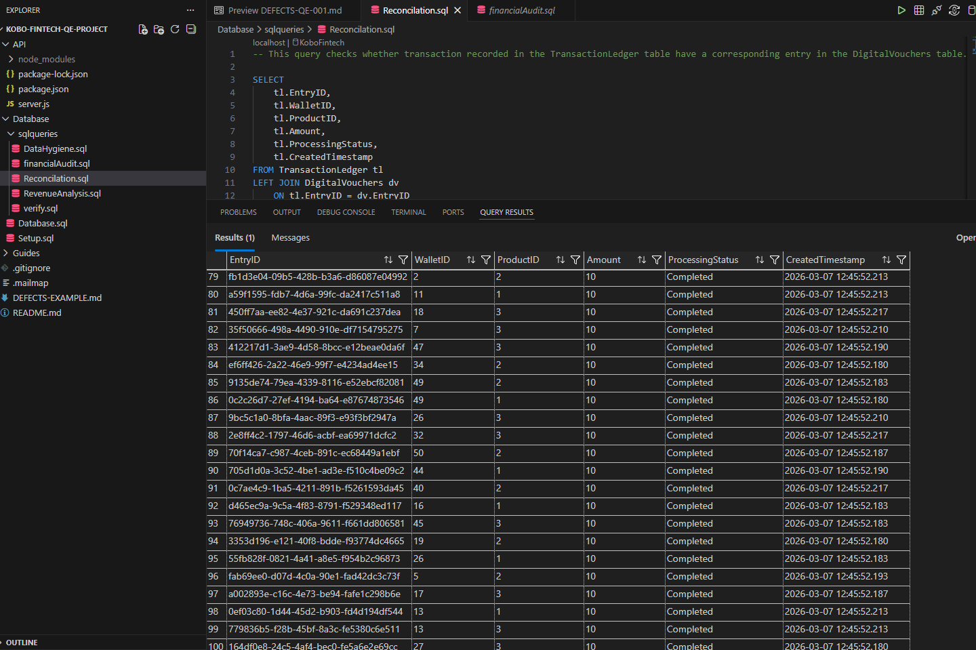

3.2 Financial Audit
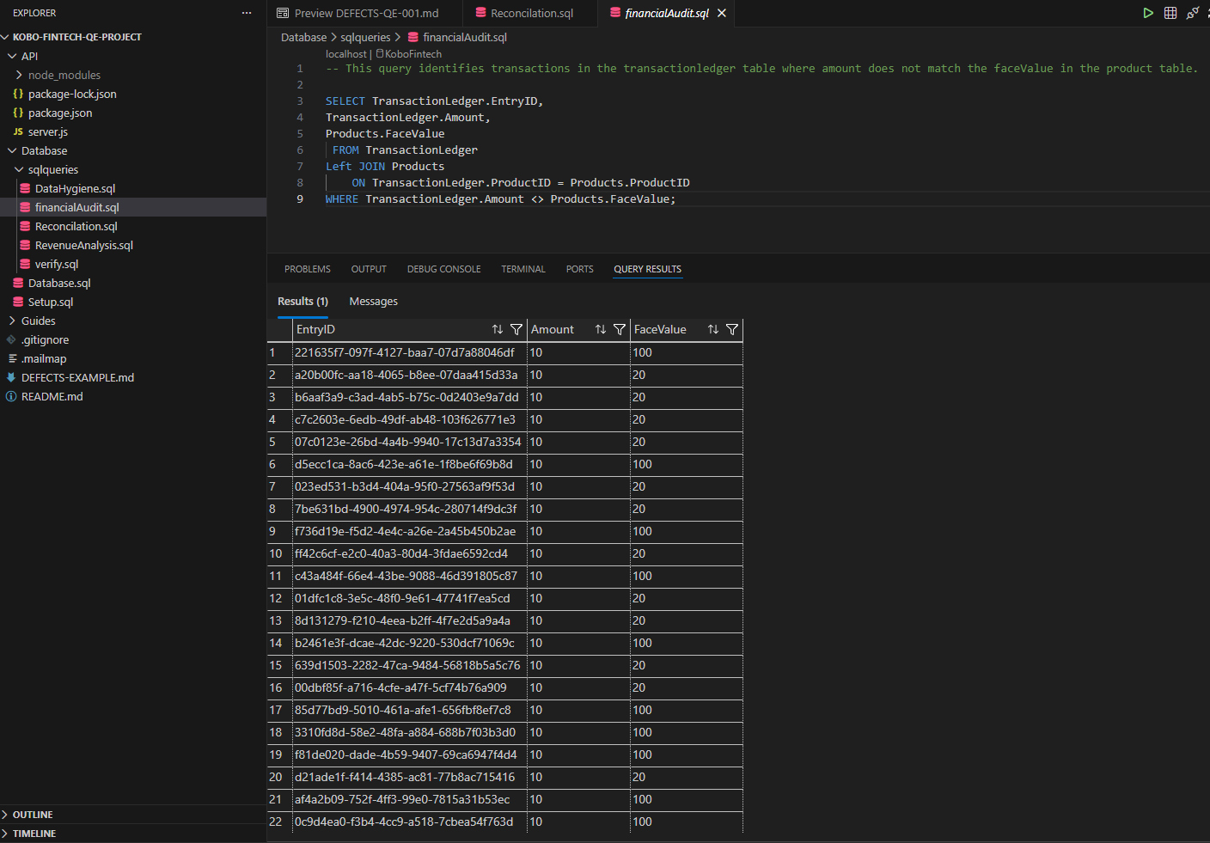

3.3 Data hygiene
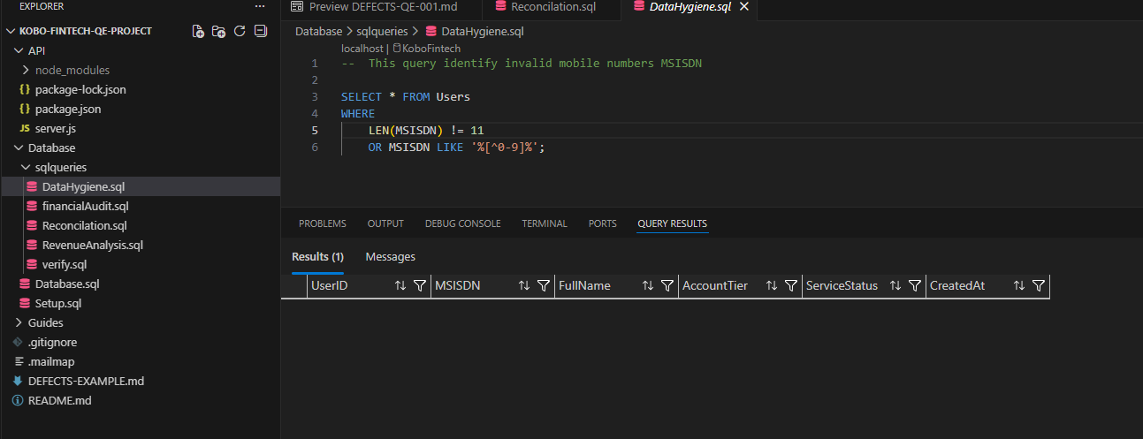

3.4 Revenue Analysis

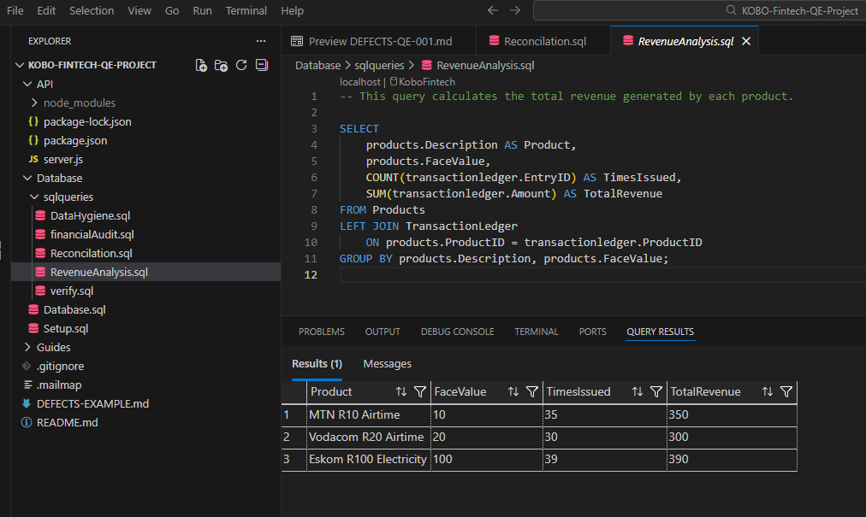
Question:
Task 3 Question: Identify a specific data type used in the database tables that is problematic for banking. Provide a SQL example of why this specific choice is a defect.
Answer:
The database uses the FLOAT data type for financial values such as wallet balances and product prices. This is problematic for banking systems because FLOAT stores approximate values, which can cause rounding errors during calculations.
Example
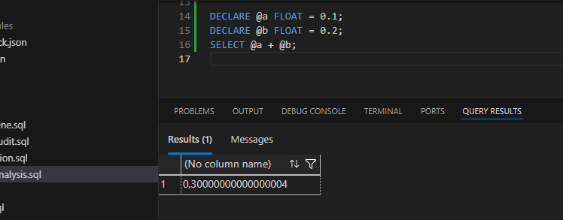
These inaccuracies can lead to incorrect financial records. A better data type for financial values is DECIMAL(18,2), which stores numbers precisely and prevents rounding errors.

Task 4
4.1 Procedural flaws
1. No Balance Validation
The procedure deducts the product price from the wallet balance without verifying whether the wallet has sufficient funds.
Example logic:
UPDATE Wallets
SET Balance = Balance - (SELECT FaceValue FROM Products WHERE ProductID = @ProductID)
WHERE WalletID = @WalletID;
If the wallet balance is lower than the product price, the system will still process the transaction and allow the balance to become negative.
Risk:
Users could obtain vouchers without sufficient funds, resulting in financial loss for the business.

2. No User Status Check
The procedure does not verify whether the user associated with the wallet has an Active service status before processing the transaction.
If a wallet belonging to a Disabled user is used, the transaction will still proceed and a voucher will be issued.
Risk:
Disabled or suspended accounts could still perform financial transactions, creating potential fraud and security risks.

3. No Transaction Handling
The procedure performs three operations:
- Wallet balance update
- Ledger entry insertion
- Voucher generation
However, these operations are not wrapped in a database transaction.
If one of these steps fails (for example the voucher insertion), the previous operations may already have been executed.
Risk:
This could leave the system in an inconsistent state where money has been deducted but no voucher was issued.

4.2 Structural Flaws:
1. Use of FLOAT for Financial Values
The database uses the FLOAT data type for monetary values such as wallet balances and product prices.
FLOAT stores approximate values and can cause rounding errors in calculations.
Correct Data Type:
DECIMAL(18,2)
This ensures precise financial calculations.

2. Lack of Input Validation
The stored procedure does not verify whether the provided @WalletID and @ProductID actually exist in the database.
If invalid IDs are supplied, the procedure may still attempt to process the transaction.
Risk:
This could lead to invalid ledger records or system errors.

3. Missing Data Integrity Checks
The database design does not enforce strict validation rules before transactions occur. For example, the procedure does not validate user status, wallet ownership, or product availability before issuing a voucher.
Risk:
This can allow invalid or unauthorized transactions to be processed.

Task 4 Question: If the system crashed mid-transaction, which table is most likely to end up with "Dirty Data" based on the current logic? How would you fix this?
Answer:
The TransactionLedger table is most likely to contain dirty data.
This is because the stored procedure updates the wallet balance and inserts a ledger entry before generating the voucher. If the system crashes before the voucher is inserted, the ledger entry will exist but the voucher will not.
This results in inconsistent financial records, where the system shows a completed transaction without a corresponding voucher.
Fix
To prevent this issue, the stored procedure should use a database transaction to ensure that all operations are executed as a single unit.

