**Nguyen Nam Khanh – HE191159 – IA1902**

LAB 2 – 3: Install and Use ClamAV

OS Install

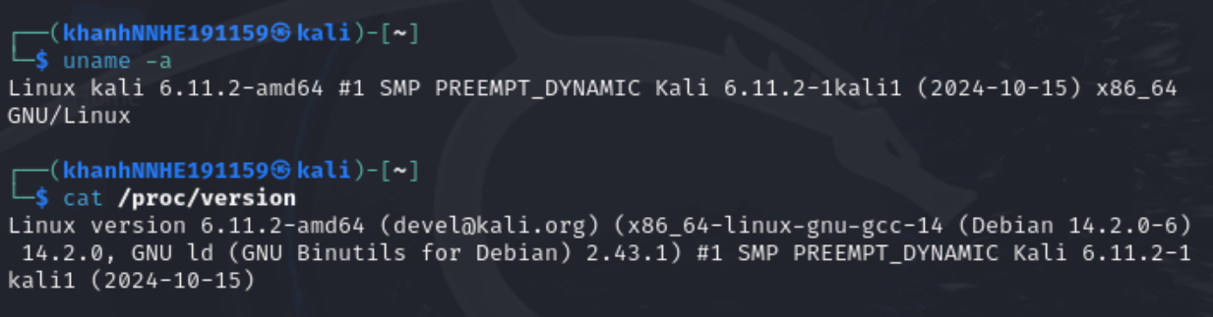

Scan a directory:

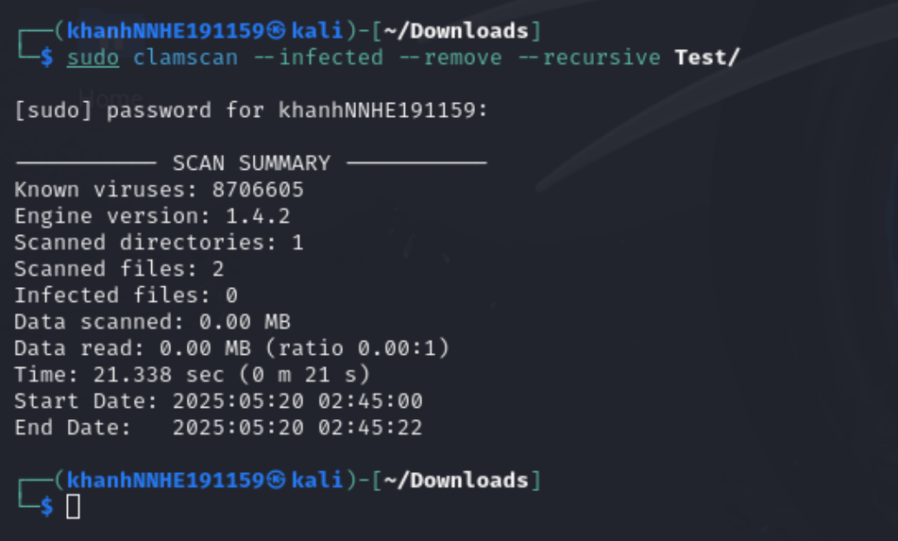

Scan 2 files: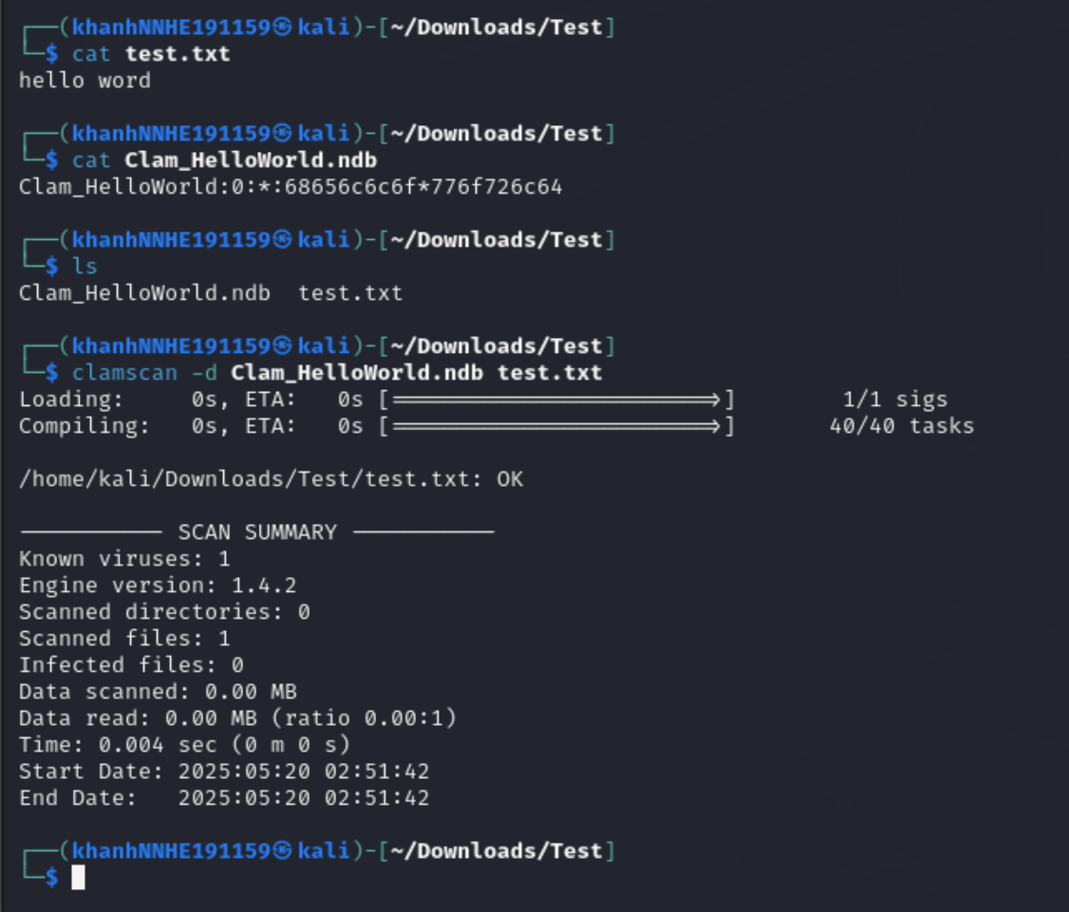

CRACK ME 2:

Open crackme2.exe in x32dbg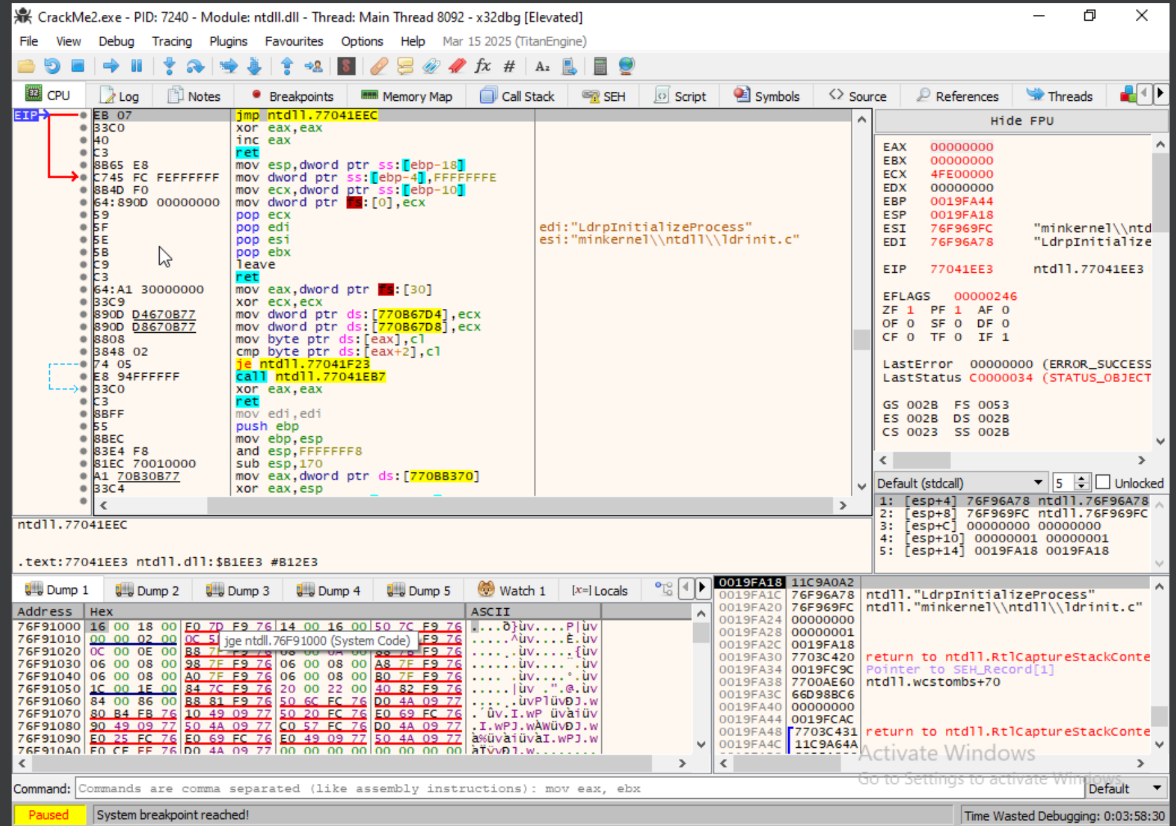

Open notepad and create file keyfile.txt and save with ANSI form in folder Downloads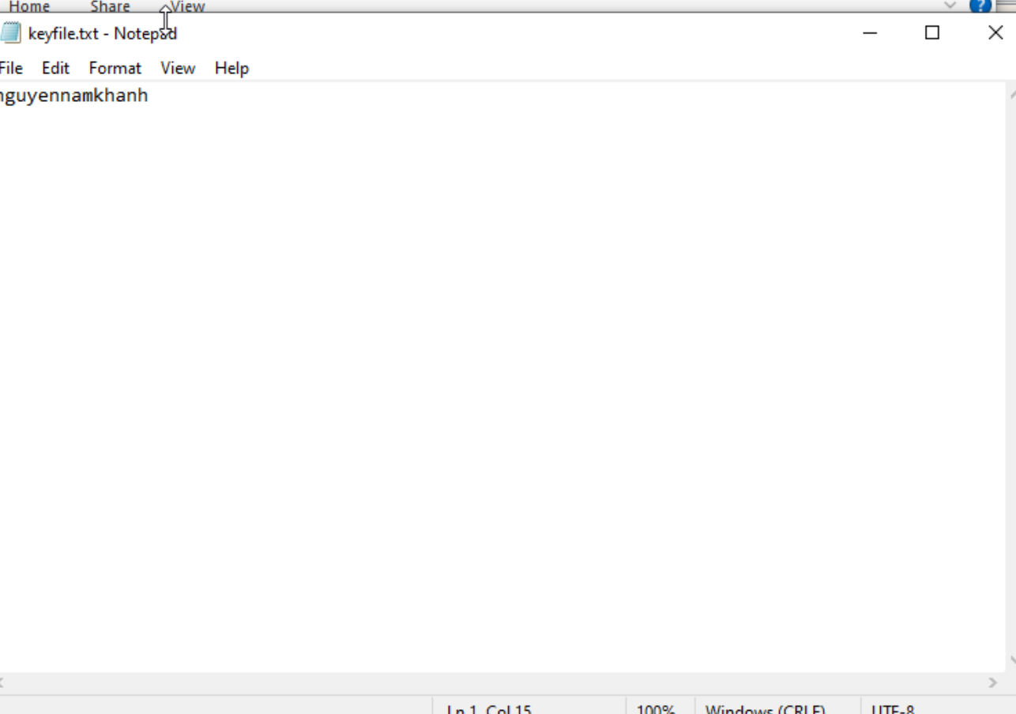

Run again and see a correct ouput