**Nguyen Nam Khanh – HE191159 – IA1902**

LAB 6: Public AV Scanners (VirusTotal, JoeSandbox)

**VIRUS TOTAL**

Upload <https://wildfire.paloaltonetworks.com/publicapi/test/pe> file to check.

Detection: almost tools detected Trojan(42/72 flag)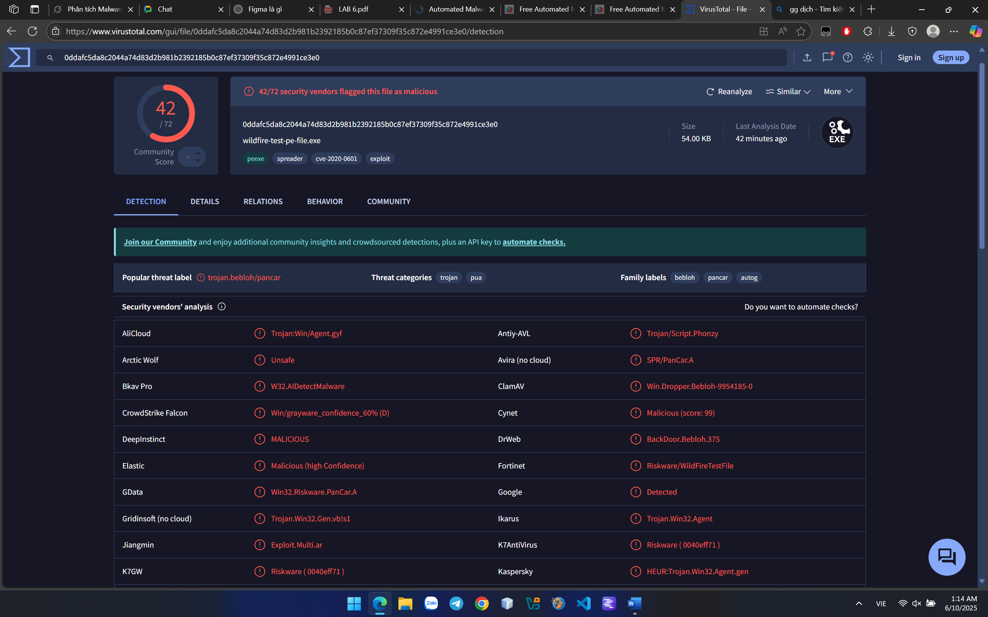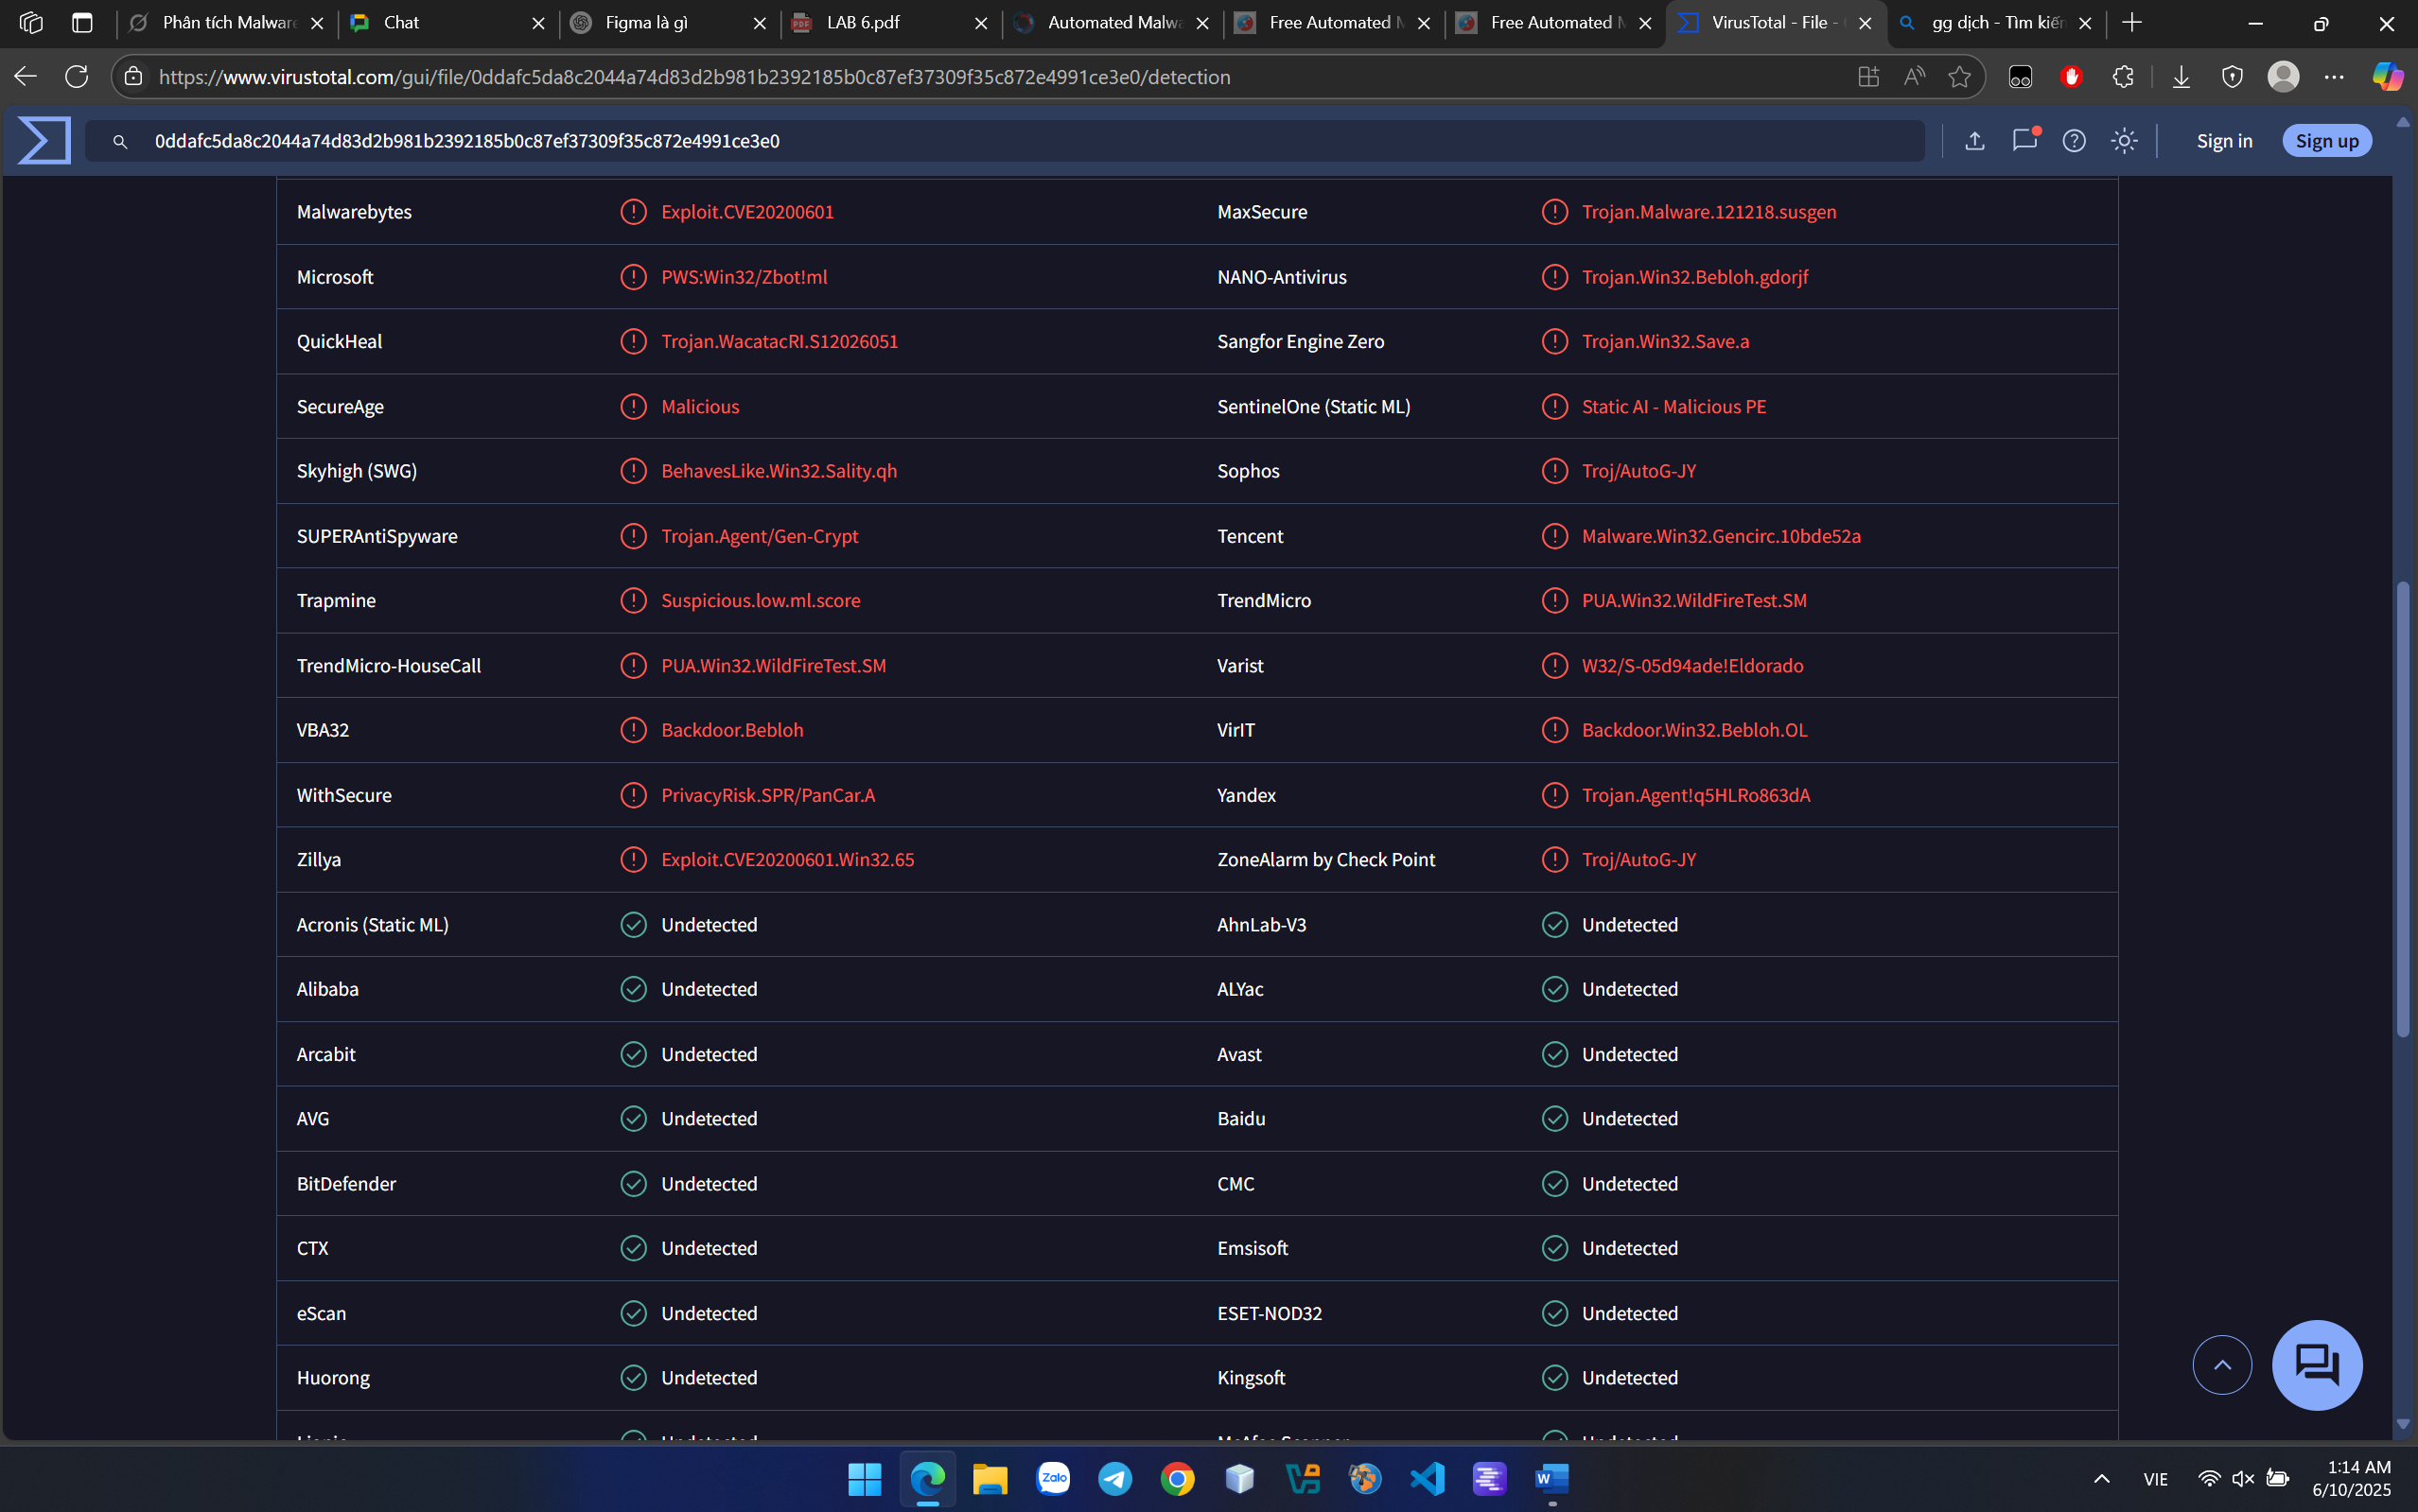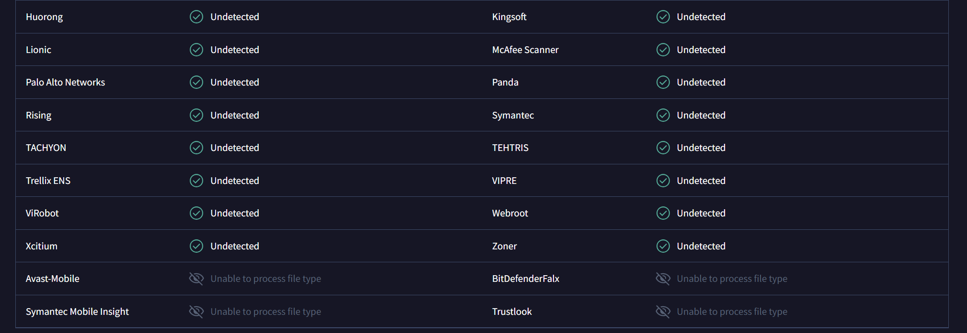

Details about Hash properties and metadata.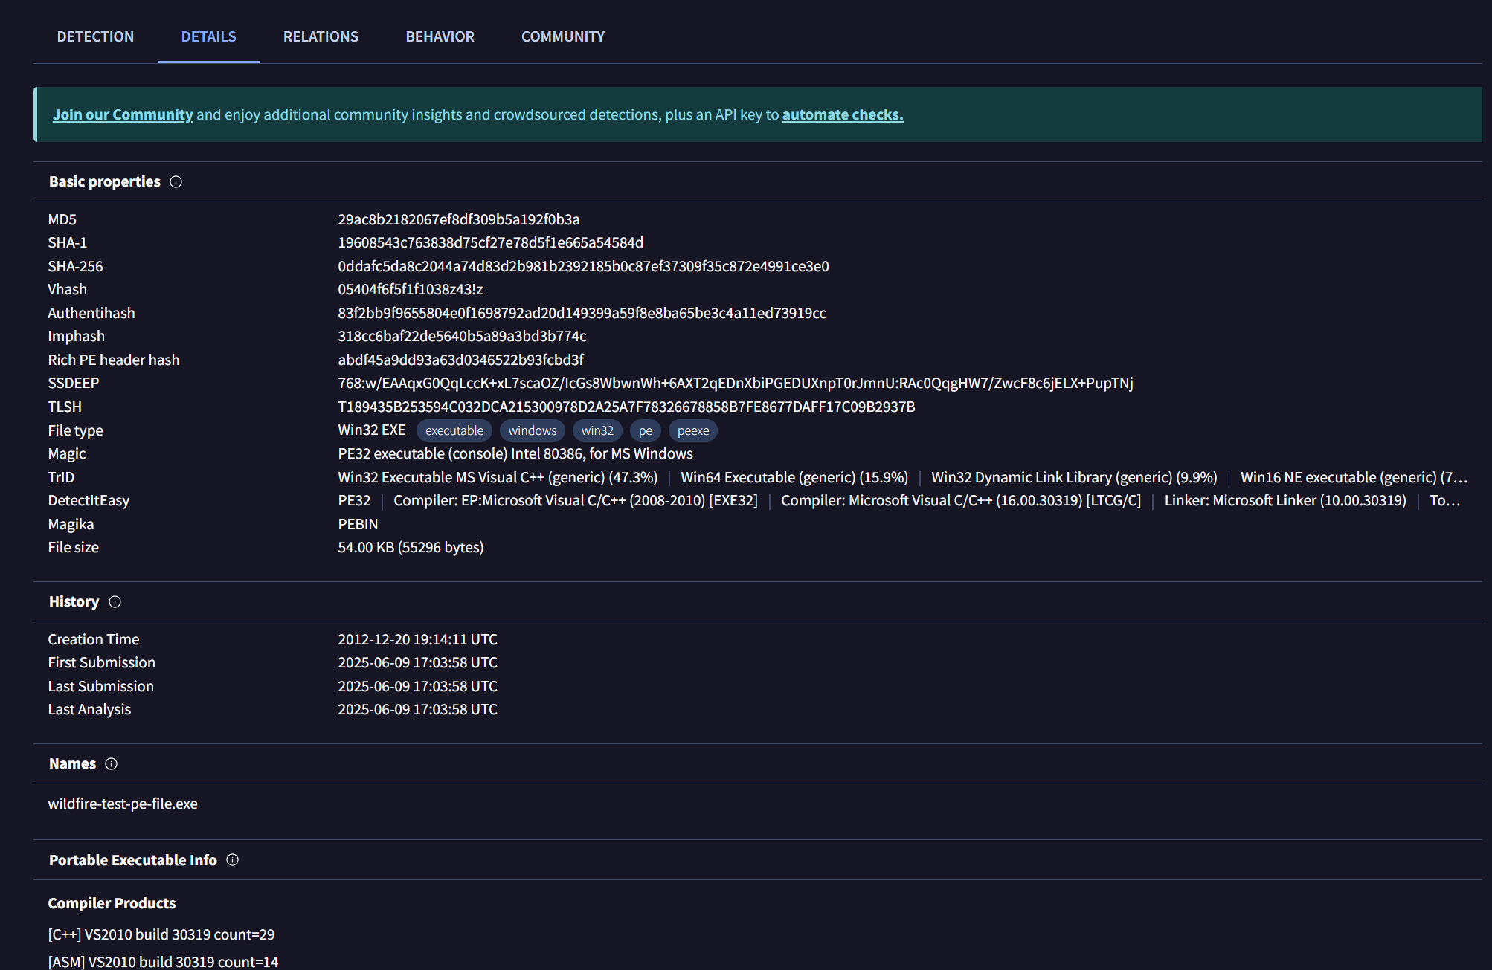

Summary of activities on sandbox: no detections, 8 activities of MITRE signatures (Execution, Persistence, Privilege Escalation,...), 3 Network communications.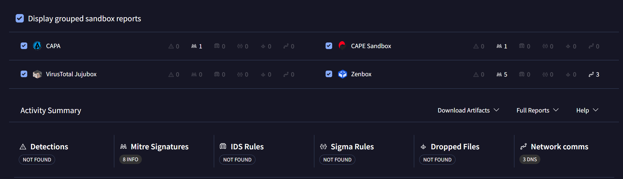

**JOE SANDBOX**

Cause of using JOE tools needs account of company, as a student, I just have ability to inspect of some model report such as **Windows Analysis Report -** [**Automated Malware Analysis Report for SecuriteInfo.com.W32.Heuristic-CO3.Eldorado.27877.25783.exe - Generated by Joe Sandbox**](https://www.joesandbox.com/analysis/1423621/0/html) 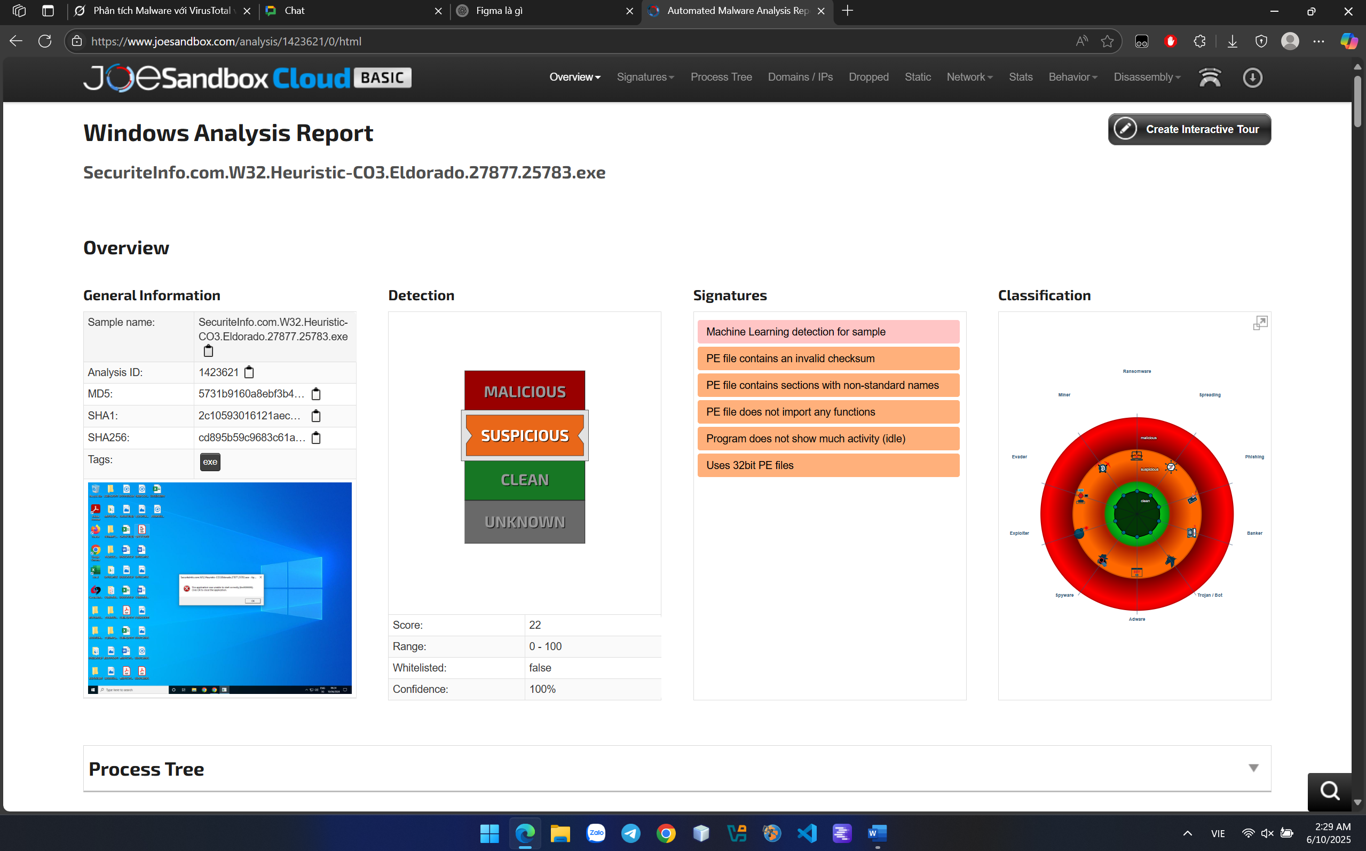

**This file .exe had suspicious detection with score 20, low but more malicious and suspicious than file** paloaltonetworks. With signature of invalid checkum, non-standard name and does not show much activity, these file was suspected to ransomware, spyware or trojan.

**HYBRID ANALYSIS**

Upload <https://wildfire.paloaltonetworks.com/publicapi/test/pe> file to check

Overview Anit-Virus Results.

(Static analysis according to hash and signature)

CrowdStrike Falcon: 60% Malicious

MetaDenfender: 13/25 Malicious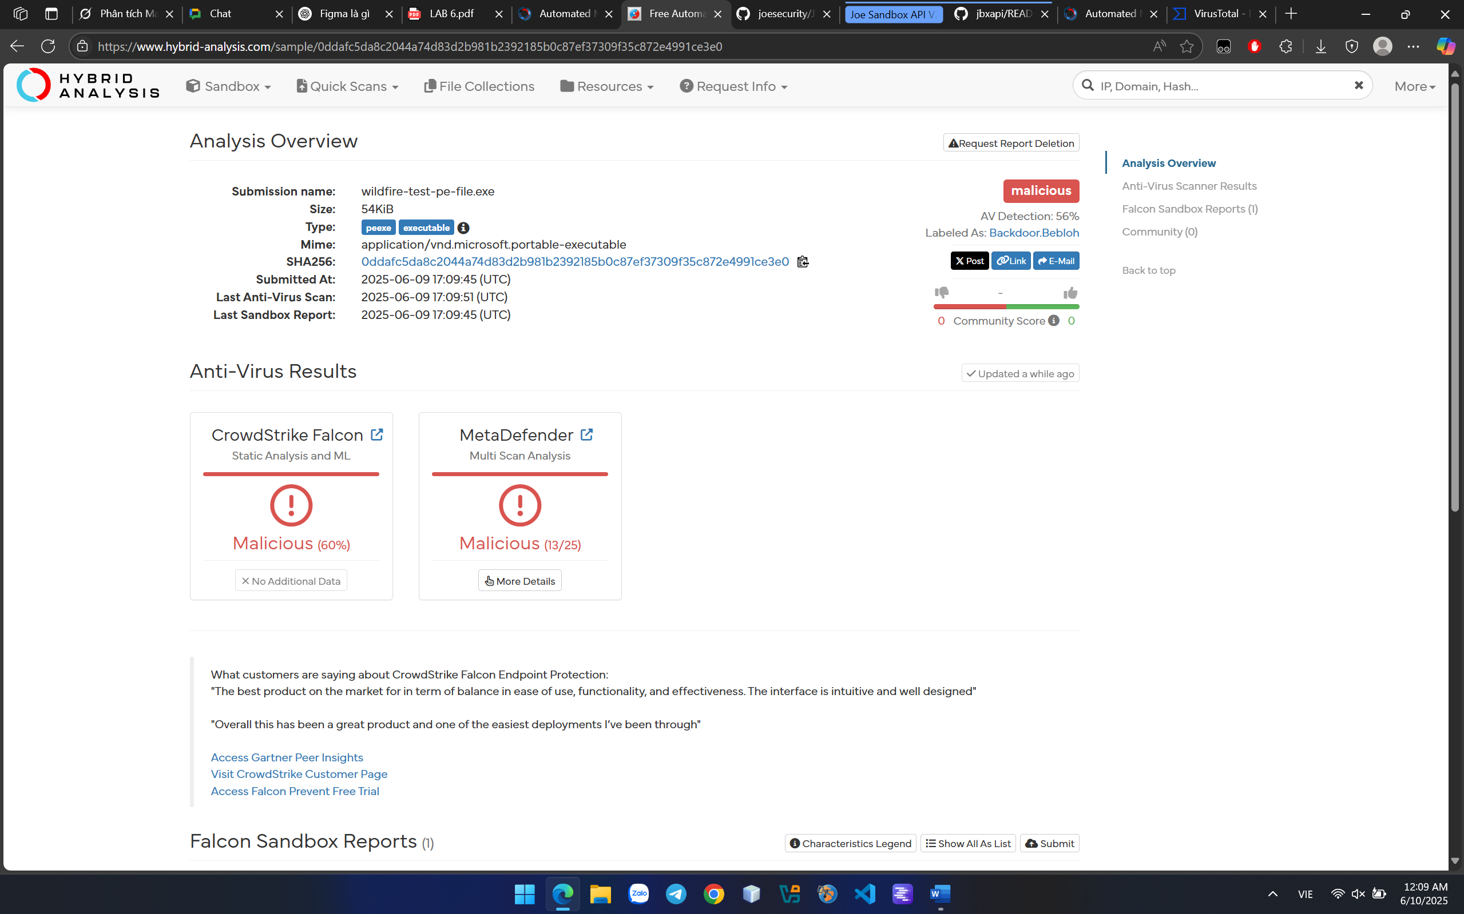

MetaDenfer Multi Scan Analysis Detail: almost related to Trojan and Backdoor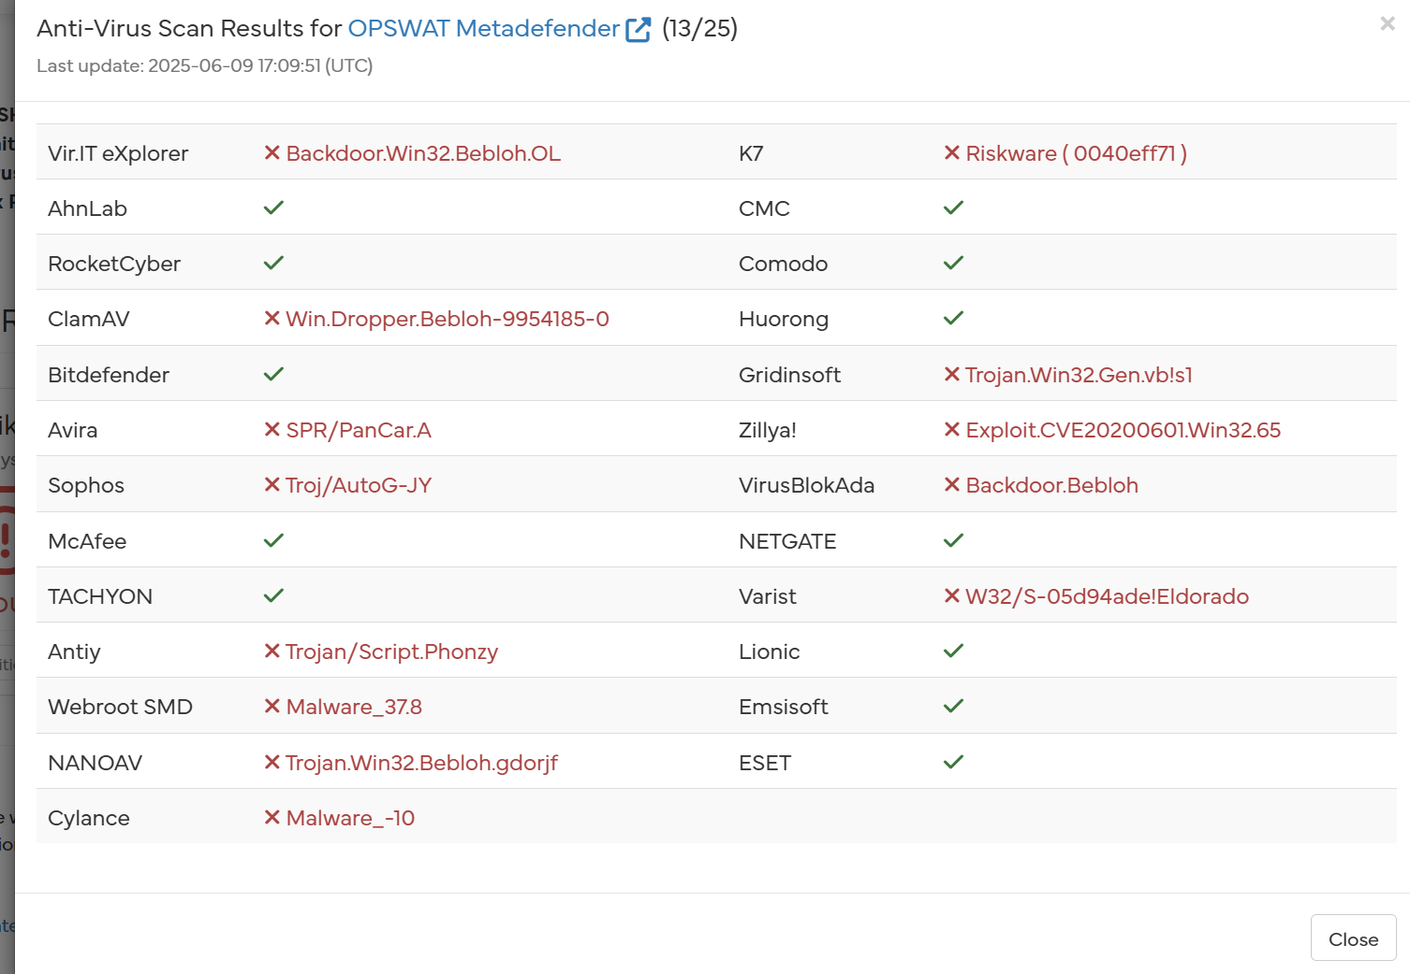

Intergrated Falcon Sandbox report detail: Threat score 37/100 with 61 indicators mapped 39 attack techniques and 9 tatics. (dynamic analysis with monitoring operation of process in virtual enviroment)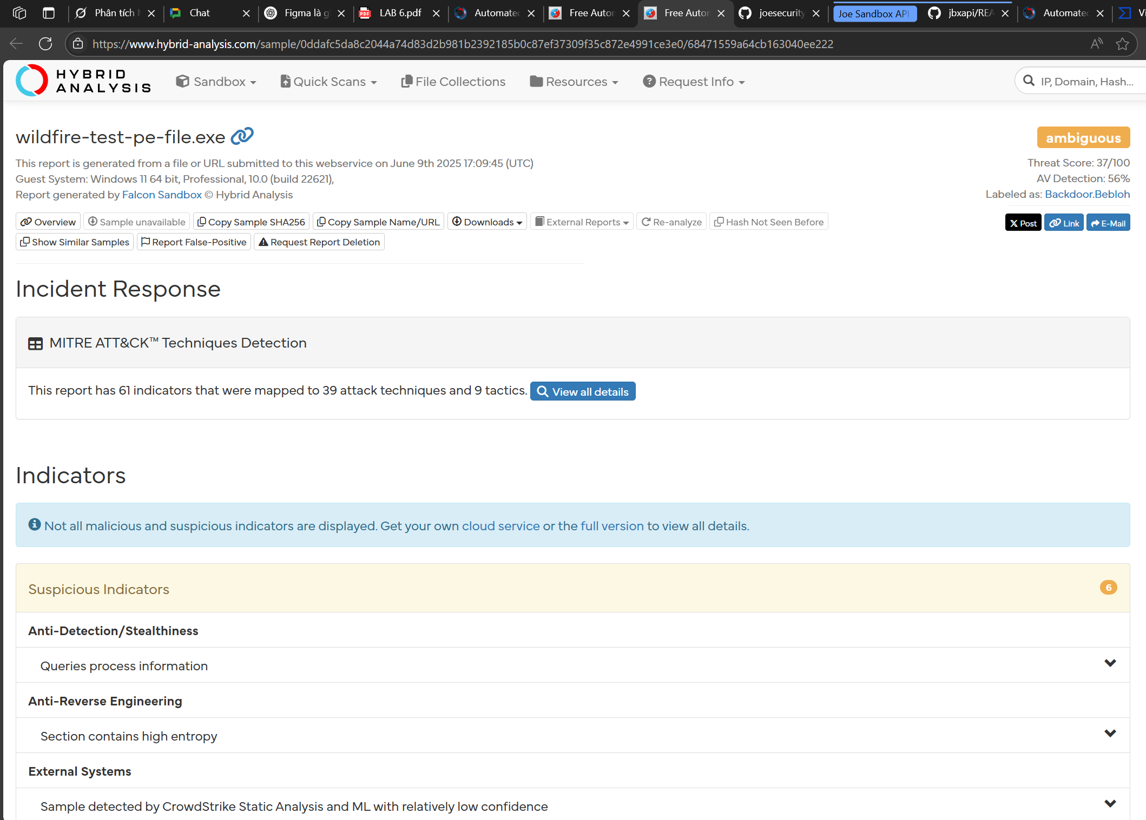

**CRACK ME 5**

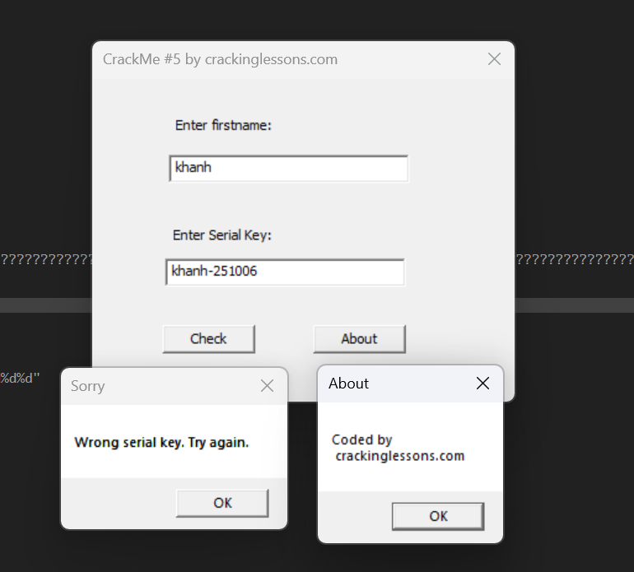

Inspect this file .exe in x32dbg tool.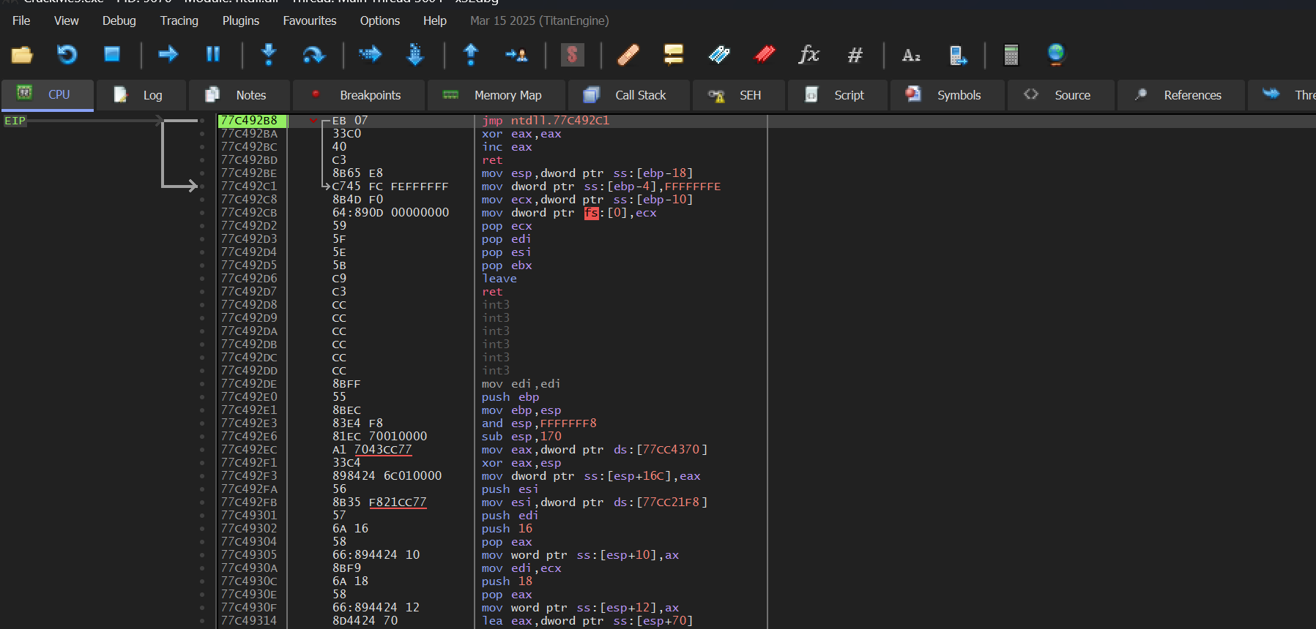

Find string reference to string “Wrong serial key. Try again.”. Click to jump to the line of code of these string.

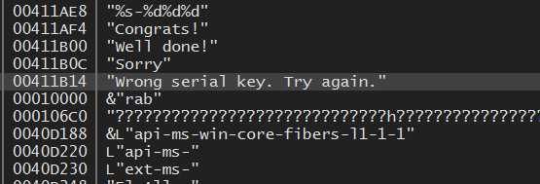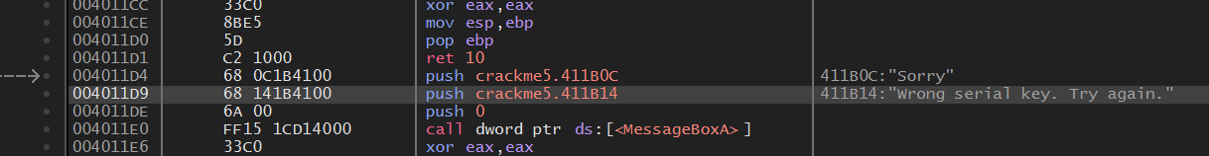

Trace back to the above code to see what operates, leading to this “Sorry” code. 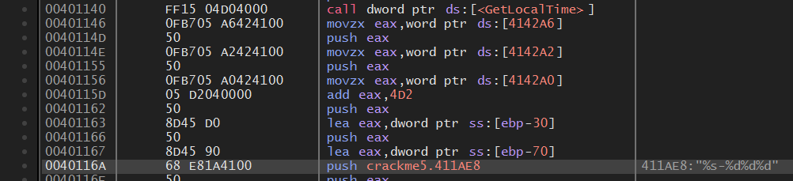Notice to this code part, from function GetLocalTime, analysing variabe EAX. May be, EAX represents for serial key. But now, ignoring it for a bit, we add breakpoint to code line of function GetLocalTime and step into to deeply analyse.

After many times for tracing and putting breakpoint, I get some detail to see.

At the address 0040116A, we have the comment: “411AE8: “%s-%d%d%d””, below this is hint “khanh-325910”, this is likely to be serial key. 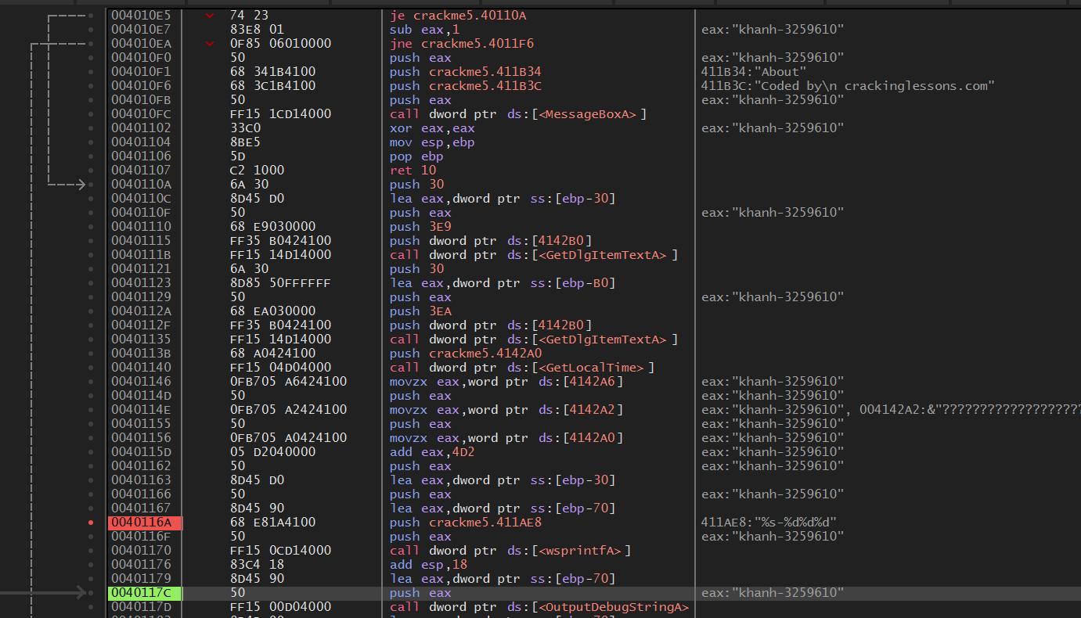

But why we have this form of serial key? The regex “%s-%d%d%d” equal to khanh-325910.

%s is for khanh (the firstname) combine with -%d%d%d to -3259610.

Let trace back again to this part of code below: 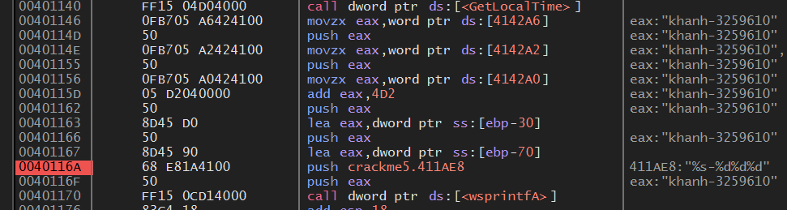

System call GetLocalTime this means get the time schedule of system, at this time is 10th of june 2025. If mapping to regex, we have -2025610, but serial key is -3259610.

Notice to the address 0040115D, after assigning and pushing numbers of month and day to EAX. System assigns number of year to EAX, and at this line of code, adding EAX with 4D2 in hexa (1234 in decimal). 2025 adds with 1234 euqal to 3259. Hence, we have Serial Key: khanh-3259610.

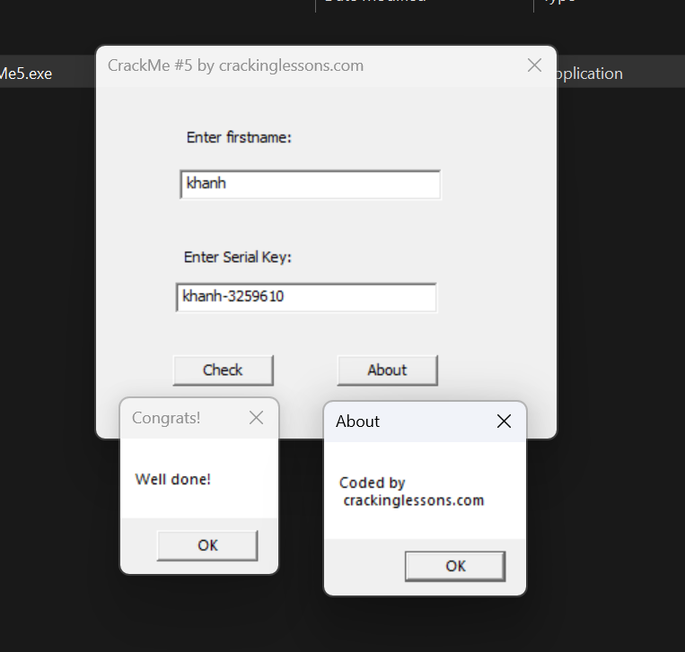

Typing firstname and try the cracked serial key to check.

DONE!!!