**NGUYEN NAM KHANH – HE191159 – IA1902 – IAM302**

**CRACK ME 6**

1. Remove the starting Nag Screen
2. When the button Re-Check is clicked, a pop-up messagebox appears and you should set it to say “Thank you for registering this software”
3. Set the Status box text to: “Clean crack! Good Job!”

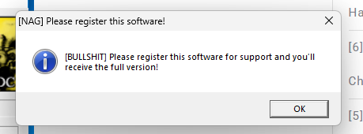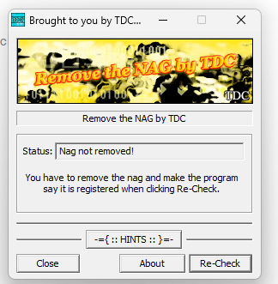

Go to String references to dig into notable string and its line of code.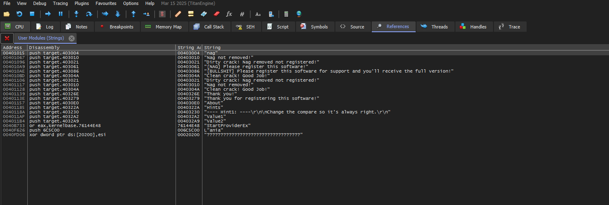

Click the string have [NAG] to see and analyze to remove it.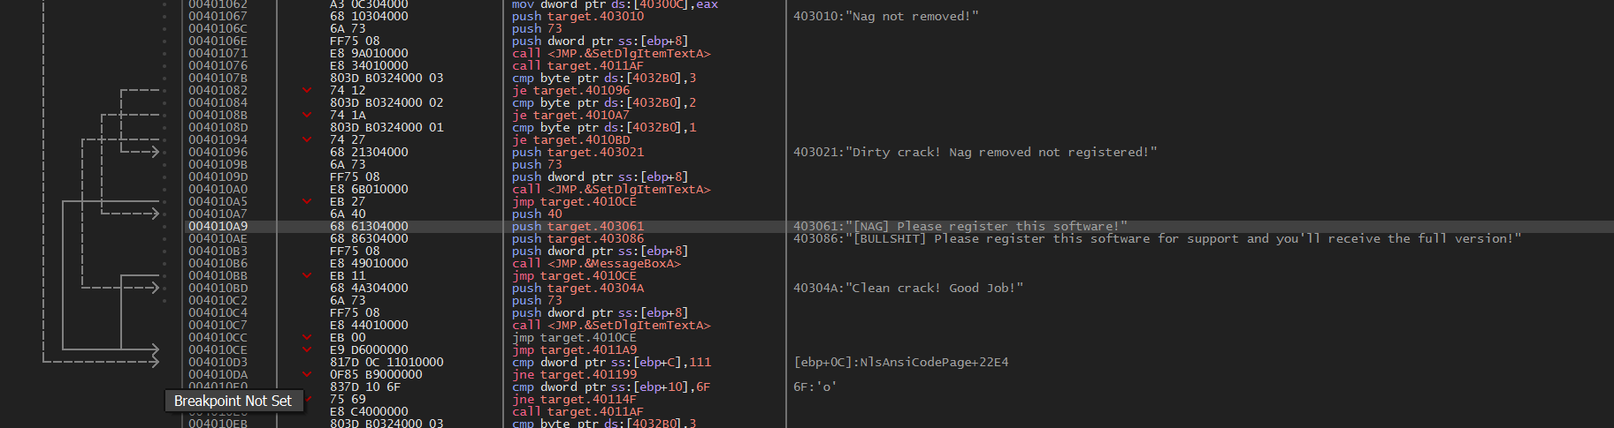

Trace above the code to find how the NAG displayed. And I found that, this NAG is pushed and displayed by the address 00401084 and 00401084. These addresses have command to compare, if byte ptr ds:[4032B0] represent for variable of system equals with 2, the first NAG will be displayed (in this situation, it is always true). So I change the condition comparing with 2 to another number such as 1, to result false.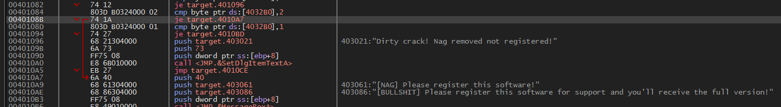 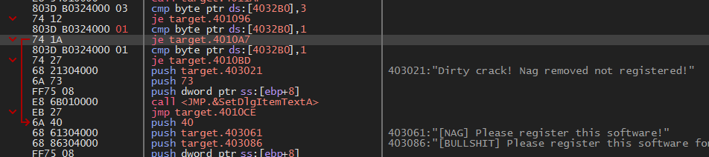

After passing start NAG, we will change status “Nag not removed!” into “Clean crack! Good job!”. So I trace to the line of code having “Nag not removed!”. Tracing above code and found that, we have command “JE” to that string. So I convert Jump Equal to “Nag not removed!” into address of “Clean code…”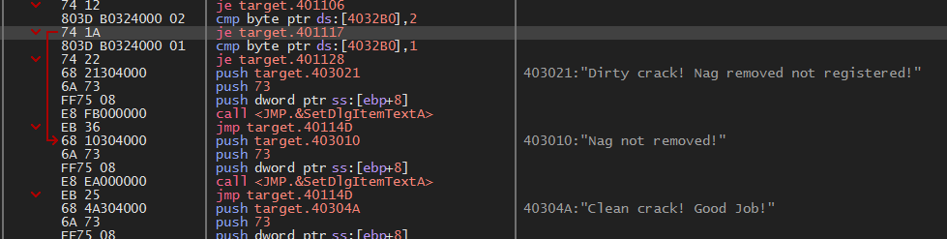

Like below: 401117 => 401128.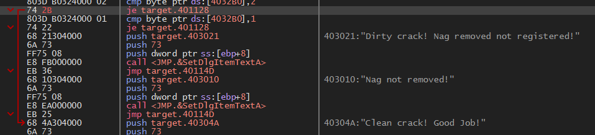

After changing status, I found that the code below will execute to automatically displaying NAG “Thank you! Thank you for registering this sofware!” if we press button Re-check.

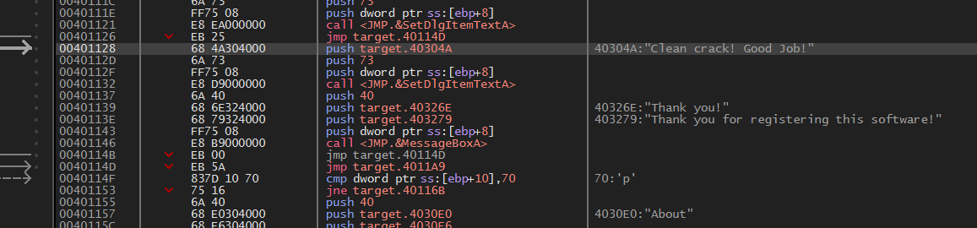

So I patch this file and check the result.

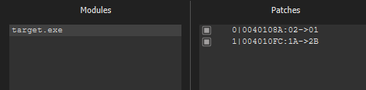

The result:

1.removing starting nag screen 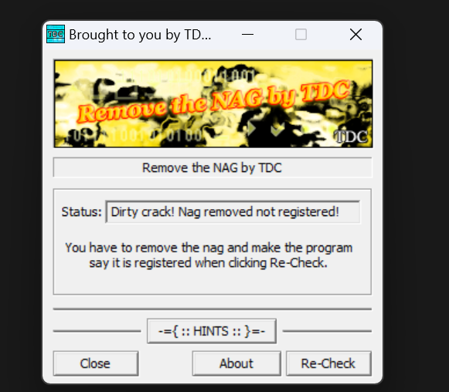

1. When the button Re-Check is clicked, a pop-up messagebox appears and you should set it to say “Thank you for registering this software”
2. Set the Status box text to: “Clean crack! Good Job!”

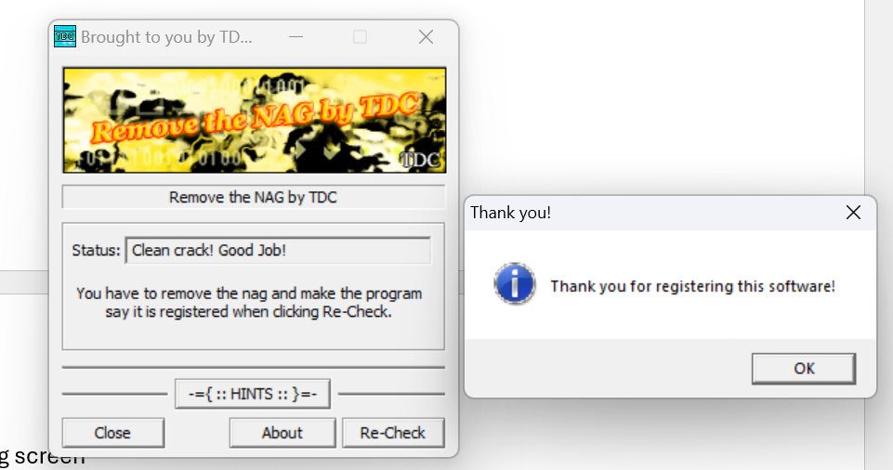

DONE!!!