1. Traverse the following graph using DFS and BFS, starting from vertex J.

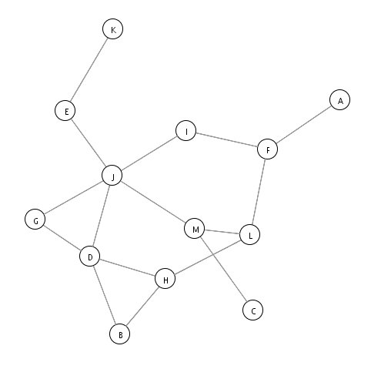

1. Use Dijkstra’s algorithm to find the shortest path from vertex 1 to others.

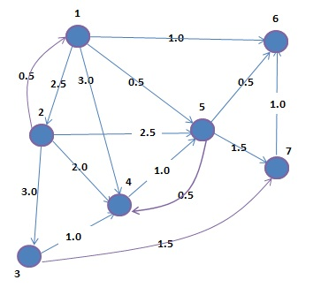

1. For the following graph, produce the MST by using Kruskal's algorithm for (i) and Prim's algorithm for (ii).

(i) (ii)

