Software Development Specification

**ExpenseEase**

Version 1.0

**Revision History**

| **Date** | **Version** | **Description** | **Author** | **Revised by** |
| --- | --- | --- | --- | --- |
| 27/05/2024 | 1.0 | Each member create their own document | Lê Việt Khanh | Tiêu Kim Cương |

|  |  |  |  |
| --- | --- | --- | --- |
| **STT** | **Họ và tên** | **Công việc** | **Nhóm đánh giá** |
| 1 | Lê Việt Khanh | Set up project source  Create views (Navbar, Cancel Header, Action Footer)  Create adapters (Order Apdapter, Ordered Product Adapter)  Create Database and Import Data  Redesigning datamodels  Build API for all datamodels  Build API, methods for getting, setting and storing images  Build SharePreference API  Processing Login Activity, Register Activity with of version 2  Processing Account Activity Update user’s information version 1  Processing Staff Oder Activity  Processing Payment Viewing  Processing Main Activity version 3  Processing List Product Activity version 3  Processing List Search Activity version 2  Processing Detail Product Activity version 2, 4  Processing Order Activity version 1, 2  Write Testcases (120 in total) , SRS, SDS for Main, List Search, Deatil Product, List Product Activities |  |
| 2 | Đỗ Trí Khang |  |  |
| 3 | Nguyễn Văn Dư |  |  |
| 4 | Nguyễn Phương Nhi |  |  |
| 5 | Hà Nguyễn Bình Minh |  |  |

**Table of Contents**

**1.** **Introduction** 5

**1.1** **Overview :** 5

**1.2** **Scope :** 5

**2.** **Functional Requirements** 6

**2.1** **Feature/Component #1: Home Screen** 6

2.1.1 User Interfaces 6

2.1.2 Functional Requirements 6

**2.2** **Feature/Component #2: Menu Screen** 8

2.2.1 User Interfaces 8

2.2.2 Functional Requirements 8

**2.3** **Feature/Component #3: The Account screen** 10

2.3.1 User Interfaces 10

2.3.2 Functional Requirements 10

**2.4** **Feature/Component #4: The Add Total screen** 11

User Interfaces 12

2.4.1 Functional Requirements 12

**2.5** **Feature/Component #5: The total amount screen** 14

2.5.1 User Interfaces 14

2.5.2 Functional Requirements 14

**2.6** **Feature/Component #6: editing and deleting total amounts screen** 16

2.6.1 User Interfaces 16

2.6.2 Functional Requirements 16

**2.7** **Feature/Component #7: The total amount list search screen.** 17

2.7.1 User Interfaces 18

2.7.2 Functional Requirements 18

**2.8** **Feature/Component #8: The fixed expense screen** 20

2.8.1 User Interfaces 20

2.8.2 Functional Requirements 20

**2.9** **Feature/Component #9: The screen for editing and deleting fixed expense screen.** 22

2.9.1 User Interfaces 22

2.9.2 Functional Requirements 22

**2.10** **Feature/Component #10: The screen to add a new fixed expense** 24

2.10.1 User Interfaces 24

2.10.2 Functional Requirements 24

**The screen to add a new fixed expense** 24

**2.11** **Feature/Component #11: The screen to search for a list of fixed expenses.** 26

2.11.1 User Interfaces 26

2.11.2 Functional Requirements 26

**The screen to search for a list of fixed expenses.** 26

**2.12** **Feature/Component #12: The household expenses screen** 28

2.12.1 User Interfaces 28

2.12.2 Functional Requirements 28

**The household expenses screen** 28

**2.13** **Feature/Component #13: Editing and deleting household expenses screen** 29

2.13.1 User Interfaces 30

2.13.2 Functional Requirements 30

**2.14** **Feature/Component #14: The screen for adding new expenses.** 31

2.14.1 User Interfaces 32

2.14.2 Functional Requirements 32

**2.15** **Feature/Component #15: The Categories screen.** 34

2.15.1 User Interfaces 34

2.15.2 Functional Requirements 34

**2.16** **Feature/Component #16: The category addition screen.** 35

2.16.1 User Interfaces 36

2.16.2 Functional Requirements 36

**2.17** **Feature/Component #17: The expense history screen.** 37

2.17.1 User Interfaces 38

2.17.2 Functional Requirements 38

**2.18** **Feature/Component #18: The expense history search screen.** 39

2.18.1 User Interfaces 40

2.18.2 Functional Requirements 40

# **Introduction**

## **Overview :**

**ExpenseEase** is an intelligent expense management application specifically designed for individuals leading busy lives and seeking a simple and convenient way to manage their finances. With an intuitive and user-friendly interface, **ExpenseEase** facilitates effortless tracking and efficient control of daily income and expenses.

This application enables you to input personal financial transactions and seamlessly update expenditures into specific categories. You can categorize expenses into groups such as

* Fixed Expenses, like rent or bank interest
* Daily Expenses, encompassing categories like dining, transportation, shopping, and more.

**ExpenseEase** features an alert function that notifies you when your daily spending surpasses the set budget, aiding in maintaining effective control over personal finances.

Benefits of utilizing **ExpenseEase** include:

* Easy tracking of daily income and expenditures.
* Effective budget planning and money-saving strategies.
* Efficient control over expenses, thereby maintaining personal financial budgets.

## **Scope :**

* Version 1.0
* Android OS: Android 9.0 and up
* Android test devices: Samsung Galaxy A03, Samsung Galaxy S21 FE 5G
* Android screen resolutions: 720x1280, 1080 x 2340
* Only supports vertical screen orientation.

# **Functional Requirements**

## **Feature/Component #1: Home Screen**

### User Interfaces

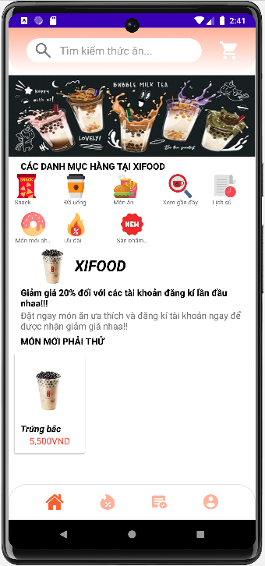

*Image1: Home screen*

### Functional Requirements

|  |  |  |  |
| --- | --- | --- | --- |
| **Item** | **Description** | **Action** | **Response** |
| **Home Screen** | Home Screen has 5 buttons:   * Cart Button * Home Nav Button * Discount Nav Button * Order Nav Button * Account Nav Button   Screen has an Image : App Logo  Screen has an EditText:   * Search Bar EditText   Screen has a ViewFlipper   * Banner ViewFlipper   Screen has 5 TextView:   * “CÁC DANH MỤC HÀNG TẠI XI FOOD” * “XI FOOD” * “Giảm giá 20% đối với các tài khoản mới đăng ký lần đầu nhaa!!!” * “Đặt ngay món ăn ưa thích và đăng ký tài khoản ngay để được nhận giảm giá nhaa!!!” * “MÓN MỚI PHẢI THỬ”   Screen has 2 RecylcleView:   * Category List, each item has:   + An Image View: Category Icon  + TextView : Category Name   * New Product List, each items has:   + An Image View: Product image  + 2 Text View : Product Name, Product Price | N/A | N/A |
| **Cart** | This is the button that linked to Order Screen.   * Find user’s permission in SharePreference * Check that user’s permission is staff or not * If User is a normal user : Go to Cart Screen. * If User is a staff : Go to Staff Order Screen | Tap on the button | * Get permiss from SharePreference * Check User’s permision as a staff or not * Start activity to go to Cart Screen or Staff Order Screen base on user’s permisson |
| **Home Nav** | This is the button that linked to Home Screen. It is ignored now because of being in Home Screen already | N/A | * Set navbar’s active index 0 as active button * ignore onclick action |
| **Discount Nav** | This is the button that linked to List Product Screen.  It passes a key to enssure that List Product Screen show datas as discount list | Tap on the button | * put extra a string as discount category’s key * start activity to go to List Product Screen and display discount list |
| **Order Nav** | This is the button that linked to Order Screen | Tap on the button | * start activity to go to Order Screen |
| **Account Nav** | This is the button that linked to Account Screen | Tap on the button | * start activity to go to Account Screen |
| **App Logo** | This is an image that show the logo of the app | N/A | N/A |
| **Search Bar** | This is the edit text that linked to List Search Screen | Tap on the Edit text | * start activity to go to List Search Screen |
| **Banner** | This is the banner that including 3 of images:   * <https://th.bing.com/th?id=OIP.0QBVEpjVjCxaioYJQBZHOgHaDk&w=350&h=168&c=8&rs=1&qlt=90&o=6&dpr=1.3&pid=3.1&rm=2> * <https://th.bing.com/th?id=OIP.82a09uRdBq-0iIvzxpVT3QHaDL&w=350&h=150&c=8&rs=1&qlt=90&o=6&dpr=1.3&pid=3.1&rm=2> * <https://th.bing.com/th?id=OIP.2J5DAk7KhVokihYW1S4w2gHaDL&w=350&h=150&c=8&rs=1&qlt=90&o=6&dpr=1.3&pid=3.1&rm=2>   It floats each items after 1000ms from left to right | N/A | * load new from left to right after 1000ms |
| **“CÁC DANH MỤC HÀNG TẠI XIFOOD”** | This is the lable of Category List | N/A | N/A |
| **“XIFOOD”** | This is the name of app or of the store. It has link to go to store’s website | Tap on the text | * get app link from database (configs reference) and set link into this textview’s attribute * go to website which set: <https://khanhcan2k4.github.io/xifood> |
| **“Giảm giá 20% đối với các tài khoản mới đăng ký lần đầu nhaa!!!”** | This is the store’s event | N/A | * get app event from database (configs reference) * set into this textview |
| **“Đặt ngay món ăn ưa thích và đăng ký tài khoản ngay để được nhận giảm giá nhaa!!!”** | This is the store’s event’s description | N/A | * get app event description from database (configs reference) * set into this textview |
| **“MÓN MỚI PHẢI THỬ”** | This is the lable of new product list | N/A | N/A |
| **Category List** | This is the list of all categories. Each item include category’s image, category’s name. Each iem linked to List Product Screen | Tap on an Item | * get all categories from database (categories reference) * set data into this list * put extra a string as category’s key * start activity to go to List Product Screen which will display this item’s data |
| **New Product List** | This is the list of new products. each item include product’s image, product’s name, product’s price. Each item linked to Detail Product Screen | Tap on an item | * get new product list from database (categories reference, not child NEW_PRODUCT) * set data into this list * put extra a string as product’s key * start activity to go to Detail Product Screen which will display this item’s data |

## **Feature/Component #2: List Search Screen**

### User Interfaces

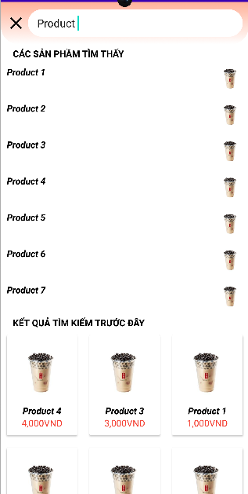

*Image2: Menu Screen*

### Functional Requirements

|  |  |  |  |
| --- | --- | --- | --- |
| **Item** | **Description** | **Action** | **Response** |
| **List Search Screen** | This screen displays list of product which match with what user searched  This screen has a button: Back button  This screen has 2 text views:   * “CÁC SẢN PHẨM TÌM THẤY” * “KẾT QUẢ TÌM KIẾM TRƯỚC ĐẤY”   This screen has 2 Recycle lists:   * Searched List:   + Text view: product’s name  + Image : product’s image   * Used to search List:   + Image: product’s image  + 2 Textviews : product’s name, product’s price | N/A | N/A |
| **“CÁC SẢN PHẨM TÌM THẤY”** | This is the lable of Searched list | N/A | N/A |
| **“KẾT QUẢ TÌM KIẾM TRƯỚC ĐẤY”** | This is the lable of Used to searched list | N/A | N/A |
| **Searched List** | This is the list of products that match user’s search keyword. Each item include product’s image, product’s name. Each iem linked to Detail Product Screen | Tap on an Item | * get all products from database (products reference) * set data that matchs search keyword * put extra a string as product’s key * save key in SharePrefence * start activity to go to Detail Product Screen which will display this item’s data |
| **Used to search List** | This is the list of used to search products. each item include product’s image, product’s name, product’s price. Each item linked to Detail Product Screen | Tap on an item | * get all product keys searched in the past from SharePrefence * set data into this list * put extra a string as product’s key * start activity to go to Detail Product Screen which will display this item’s data |

### 

## **Feature/Component #3: List Product Screen**

### User Interfaces

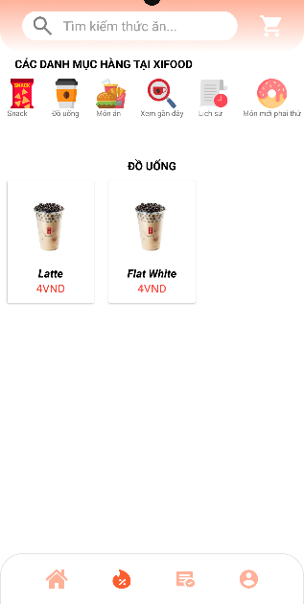

*Image3:* The Account screen

### Functional Requirements

|  |  |  |  |
| --- | --- | --- | --- |
| **Item** | **Description** | **Action** | **Response** |
| **List Product Screen** | This screen displays list of products in a specific category  This screen has 2 textviews:   * “CÁC DANH MỤC HÀNG TẠI XI FOOD” * Category’s name   This screen has 2 Recycle lists:   * category List:   + Text view: category’s name  + Image : category’s icon   * product list:   + Image: product’s image  + 2 Textviews : product’s name, product’s price | N/A | N/A |
| **“CÁC DANH MỤC HÀNG TẠI XI FOOD”** | This is the lable of category list | N/A | N/A |
| **Category name** | This is the lable of the current showing category | N/A | * get key sent by another screen * get all categories from database (categories reference) * get category matches key gotten * show current category’s name |
| **Category List** | This is the list of all categories Each item include category’s icon, category’s name. | Tap on an Item | * get all categories and set into category list * get item clicked and set its product list into product list |
| **Product List** | This is the list of current category’s products. each item include product’s image, product’s name, product’s price. Each item linked to Detail Product Screen | Tap on an item | * get product from current category and set into list * get item clicked’s key * put extra a string as this key * start activity to go to Detail Product Activity |

## **Feature/Component #4: Detail Product Screen**

### User Interfaces

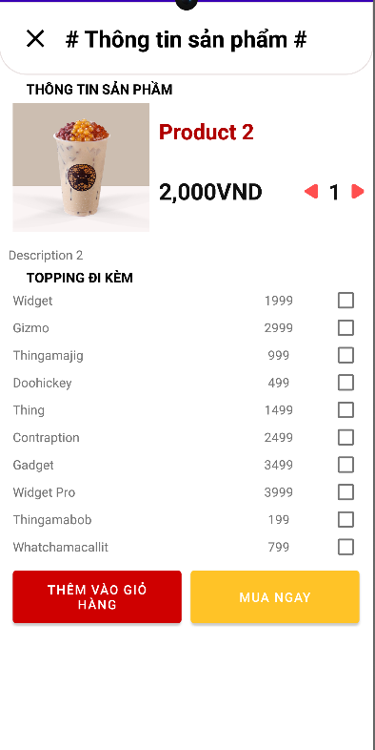

*Image4: The Add Total Screen*

### Functional Requirements

|  |  |  |  |
| --- | --- | --- | --- |
| **Item** | **Description** | **Action** | **Response** |
| **Detail Product screen** | This screen displays the data of a product that clicked on anther screen  This screen has 5 buttons:   * Back Button * Increase Amount Button * Decrease Amount Button * Add To Cart Button * Buy Now Button   This screen has 7 textviews:   * “# Thông tin sản phẩm #” * “THÔNG TIN SẢN PHẨM” * “TOPPING ĐI KÈM” * product’s name * product’s price * product’s description * amount   This screen has an image: product’s image  This screen has a recycle list: Topping list | N/A | N/A |
| **Back** | This is the button that close this screen and back to previous screen | Tap on the button | * finish this screen * start activity reoder to front to back to the previous screen |
| **Increase Amount** | This is the button that increase the amount of product that user want to buy | Tap on the button | * get current amount * if amount < 5 then increase the amount * set amount to Amount text view |
| **Decrease Amount** | This is the button that decrease the amount of product that user want to buy | Tap on the button | * get current amount * if amount > 1 then decrease the amount * set amount to Amount text view |
| **Add To Cart** | This is the button that linked to the Cart Screen. | Tap on the button | * prepare data includes this product showing * add data into cart in database * show alert that “Thêm vào giỏ hàng thành công” |
| **Buy Now** | This is the button that linked to the Purchase Screen | Tap on the button | * prepare data includes this product showing * store a new order with this product into database (orders reference) * put extra a string as this new order’s key * finish this screen * start activity to go to Purchase screen |
| **“# Thông tin sản phẩm #”** | This is the lable showing the topic of this screen | N/A | N/A |
| **“THÔNG TIN SẢN PHẨM”** | This is the lable of the product | N/A | N/A |
| **“TOPPING ĐI KÈM”** | This is the lable of the topping list | N/A | N/A |
| **Product’s name** | This is the name of the product | N/A | N/A |
| **Product’s price** | This is the price of the product | N/A | N/A |
| **Product’s description** | This is the description of the product | N/A | N/A |
| **Amount** | This is the amount of this product that user want to buy | N/A | N/A |
| **Product’s Image** | This is the image of the product | N/A | N/A |
| **Topping List** | This is the list of all the toppings. Each item have topping’s name, topping’s price, checkbox to choose this topping | Tap on an item | This item’s checkbox is checked |