1.The entity must be existence-dependent on its parent entity and it must inherit at least part of its primary key from its parent entity.
2.when entity is existence-dependent on another entity and inherits at least part of its primary key from that entity.
3.Although the preceding solution has no obvious design flaws, it is likely to yield reporting problems. For example, suppose you want to get a count for all
employees who have BBA degrees.
4.used to transform M:N relationships into 1:M relationships. It is a primary key composed of multiple attributes.
6.when an entity is related to itself. For example, a class may be a prerequisite to another class
7.a.

an entity: represented by a rectangle containing the entity name.b.

the cardinality (0,N)
: implied through the use of Crow's Foot symbols
c.

a weak relationship: indicated by a dashed line.d.

strong relationship: indicated by a solid line
8.A composite key is one that consists of more than one attribute. A composite attribute is one that can be subdivided to yield meaningful attributes for each of its components
9.Within the original entity, create several new attributes, one for each component of the original multivalued attribute. For example, the CAR entity's attribute CAR_COLOR can be split to create the new attributes CAR_TOPCOLOR, CAR_BODY-COLOR, and CAR_TRIMCOLOR, which are then assigned to the CAR entity.
Create a new entity composed of the original multivalued attributes components. This new entity allows the designer to define color for different sections of the car. Then, this new CAR_COLOR entity is related to the original CAR entity in a 1:M relationship
10.A derived attribute is an attribute whose value is calculated (derived) from other attributes. The derived attribute need not be physically stored within the database; instead, it can be derived by using an algorithm.
11.
ERD can help to highlight the key entities and specify relationships that can be established between these entities. During the database design, it is realized the transformation of ER model into certain database scheme based on the chosen data model (relational, object, network, etc.). The Crow's Foot notation represent the entity by rectangle containing its name (name must be unique within this model), and relation - by the line which links two entities involved in relationship. The relationship's plurality is graphically indicated by a "plug" on the end of the link, the optionality - by a circle
12.weakly by having course_id as FK in CLASS with class having its own unique PK or strongly by having course_ID composite with another attribute to make a unique key.
13.the composite entity contains at least the primary key attributes of each of the entities that are connected by it. relational database models should not contain M:N relationships - and the composite entity can be used to break up such relationships into 1:M relationships.
14.Desing standards
processing speed
Information requirements
15.A single -valued attribute is one that can have only one value. For example, a person has only one first name and only one social security number. A simple attribute is one that cannot be decomposed into its component pieces. For example, a person's sex is classified as either M or F and there is no reasonable way to decompose M or F.
16.What are multivalued attributes, and how can they be handled within the database design?
Multivalued attributes can have many values，Attributes Just like M:N relationships, multivalued attributes should be broken down further.
Create new attributes new entity .
17.store - 1 always
employees - 0, 1 or more
dependents - 0, 1 or more
orders - 0, 1 or more
order...
18.A store may place many orders. (Note the use of “may” – which is reflected in the ORDER optionality.) • An order must be placed by a store. (Note that STORE is mandatory to ORDER. In this ERD, the order environment apparently reflects a wholesale environment.) • An order contains at least one order line. (Note that ORDER_LINE is mandatory to ORDER, and vice-versa.) • Each order line is contained in one and only one order. (Discussion: Although a given item – such as a hammer – may be found in many orders, a specific hammer sold to a specific store is found in only one order.) • Each order line has a specific product written in it.
19.The composite entity must at least include the primary keys of the entities it references. The combination of these attributes may be designated to be the composite entity's (composite) primary key. Each of the (composite) primary key's attributes is a foreign key that references the entities for which the composite entity serves as a bridge.
20.The DEPENDENT entity will have a composite PK that includes the EMPLOYEE entity's PK and one of its attributes. For example, if the EMPLOYEE entity's PK is EMP_NUM, the DEPENDENT entity's PK might be EMP_NUM + DEP_NUM.
21.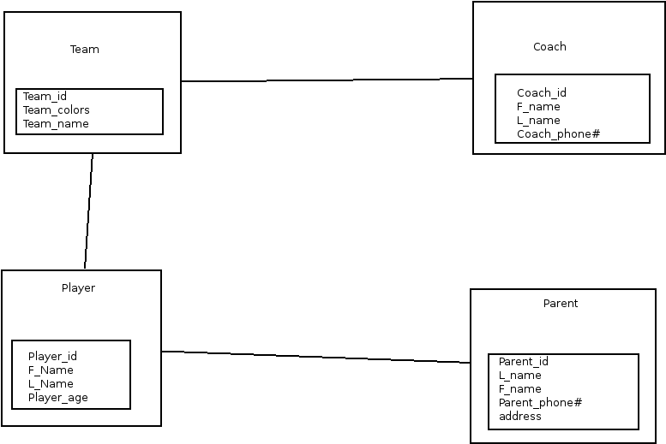
1.
.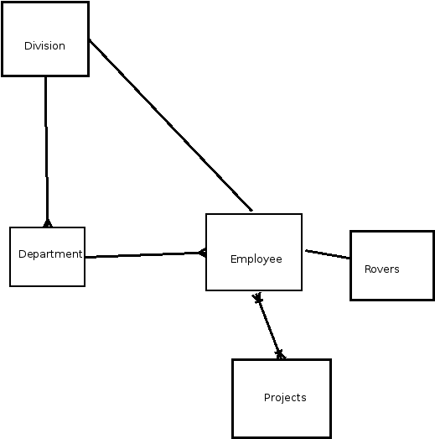

7.



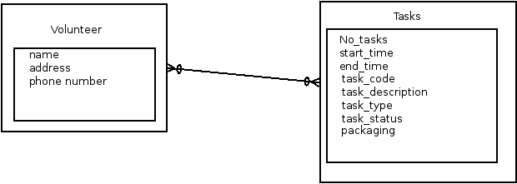

10.

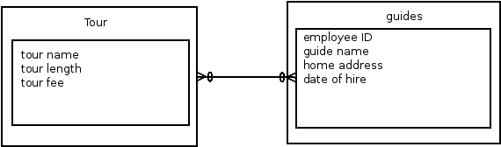
11.

